**Document 6 - Use Case Diagram:**

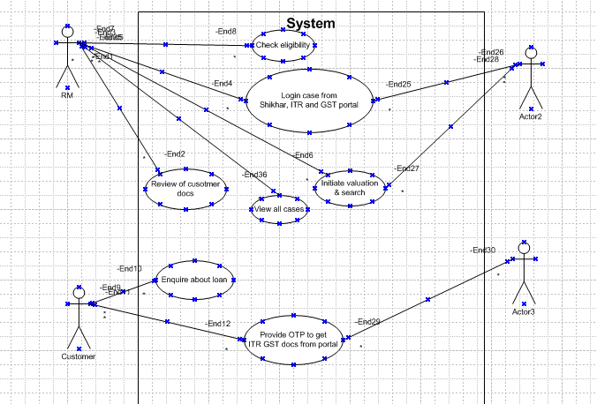

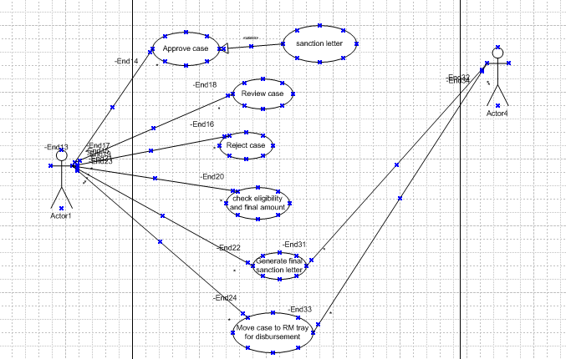

**Document 6 - Activity Diagram:**

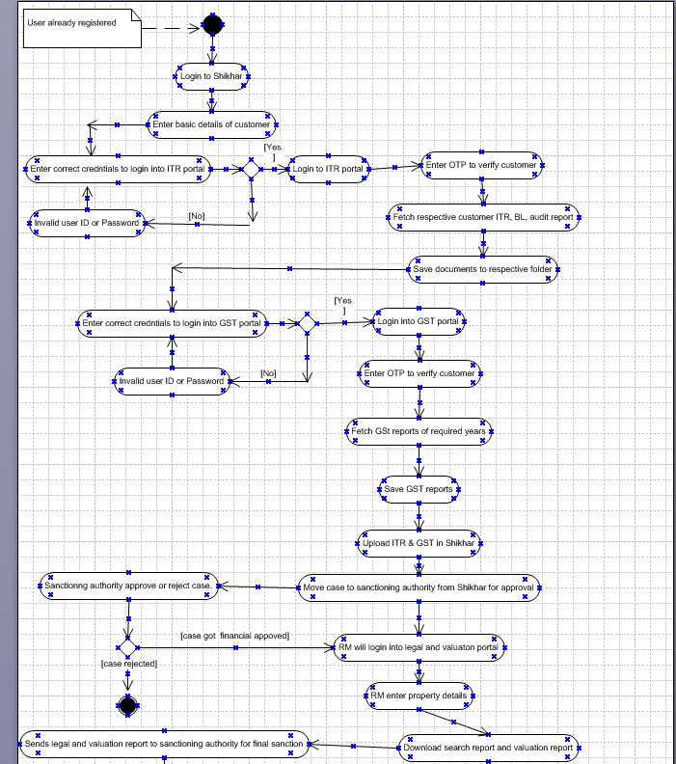

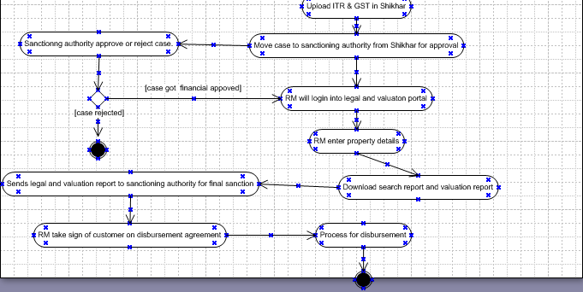

**Document 6 – Use Case Specification Document**

|  |  |  |  |
| --- | --- | --- | --- |
| Use Case Id | UC0001 | | |
| Use Case Name | Login to Valuation portal | | |
| Created By | Krishna | Last Updated By |  |
| Created Date | 21-04-2025 | Last Revision Date |  |
| Actors | Customer, System | | |
| Description | This use case describes how user can login in the app. | | |
| Pre-Condition | User should have application in his system. | | |
| Post Condition | User can successfully log in the application. | | |
| Basic Flow | Step 1: User Clicks on “Sign In”.  Step 2: User enters “User Id”.  Step 3: User Re-enters User Id.  Step 4: User enters “Password”.  Step 5: User Re-enters Password.  Step 6: User enters Mobile No.  Step 7: User enters Validation by OTP received on registered Mobile Number.  Step 8: User enters OTP.  Step 9: User gets Reply “OTP Verification Successful”.  Step 10: User gets “Logged in successfully” Message | | |
| Alternative Flow | At Step 3: If User entered wrong user Id, system will Reply user Id and Re-entered user Id should be same  At Step 5: If User entered wrong Password, system will Reply Password and Re-entered Password should be same  At Step 9: If User enters Invalid OTP system will reply “OTP Validation Failed”. | | |
| Exceptions | If Internet connection fails, system will generate message “Kindly check your Internet Connection”. | | |
| Frequency | High | | |
| Assumptions | It is assumed that User has computer Knowledge. | | |

|  |  |  |  |
| --- | --- | --- | --- |
| Use Case Id | UC0002 | | |
| Use Case Name | Login to legal portal | | |
| Created By | Krishna | Last Updated By |  |
| Created Date | 21-04-2025 | Last Revision Date |  |
| Actors | Customer, System | | |
| Description | This use case describes how user can login in the app. | | |
| Pre-Condition | User should have application in his system. | | |
| Post Condition | User can successfully log in the application. | | |
| Basic Flow | Step 1: User Clicks on “Sign In”.  Step 2: User enters “User Id”.  Step 3: User Re-enters User Id.  Step 4: User enters “Password”.  Step 5: User Re-enters Password.  Step 6: User enters Mobile No.  Step 7: User enters Validation by OTP received on registered Mobile Number.  Step 8: User enters OTP.  Step 9: User gets Reply “OTP Verification Successful”.  Step 10: User gets “Logged in successfully” Message | | |
| Alternative Flow | At Step 3: If User entered wrong user Id, system will Reply user Id and Re-entered user Id should be same  At Step 5: If User entered wrong Password, system will Reply Password and Re-entered Password should be same  At Step 9: If User enters Invalid OTP system will reply “OTP Validation Failed”. | | |
| Exceptions | If Internet connection fails, system will generate message “Kindly check your Internet Connection”. | | |
| Frequency | High | | |
| Assumptions | It is assumed that User has computer Knowledge. | | |

|  |  |  |  |
| --- | --- | --- | --- |
| Use Case Id | UC0003 | | |
| Use Case Name | Login to ITR portal | | |
| Created By | Krishna | Last Updated By |  |
| Created Date | 21-04-2025 | Last Revision Date |  |
| Actors | Customer, System | | |
| Description | This use case describes how user can login in the app. | | |
| Pre-Condition | User should have application in his system. | | |
| Post Condition | User can successfully log in the application. | | |
| Basic Flow | Step 1: User Clicks on “Sign In”.  Step 2: User enters “User Id”.  Step 3: User Re-enters User Id.  Step 4: User enters “Password”.  Step 5: User Re-enters Password.  Step 6: User enters Mobile No.  Step 7: User enters Validation by OTP received on customer’s registered Mobile Number.  Step 8: User enters OTP.  Step 9: User gets Reply “OTP Verification Successful”.  Step 10: User gets “Logged in successfully” Message | | |
| Alternative Flow | At Step 3: If User entered wrong user Id, system will Reply user Id and Re-entered user Id should be same  At Step 5: If User entered wrong Password, system will Reply Password and Re-entered Password should be same  At Step 9: If User enters Invalid OTP system will reply “OTP Validation Failed”. | | |
| Exceptions | If Internet connection fails, system will generate message “Kindly check your Internet Connection”. | | |
| Frequency | High | | |
| Assumptions | It is assumed that User has computer Knowledge. | | |

|  |  |  |  |
| --- | --- | --- | --- |
| Use Case Id | UC0004 | | |
| Use Case Name | Login to GST portal | | |
| Created By | Krishna | Last Updated By |  |
| Created Date | 21-04-2025 | Last Revision Date |  |
| Actors | Customer, System | | |
| Description | This use case describes how user can login in the app. | | |
| Pre-Condition | User should have application in his system. | | |
| Post Condition | User can successfully log in the application. | | |
| Basic Flow | Step 1: User Clicks on “Sign In”.  Step 2: User enters “User Id”.  Step 3: User Re-enters User Id.  Step 4: User enters “Password”.  Step 5: User Re-enters Password.  Step 6: User enters Mobile No.  Step 7: User enters Validation by OTP received on customer’s registered Mobile Number.  Step 8: User enters OTP.  Step 9: User gets Reply “OTP Verification Successful”.  Step 10: User gets “Logged in successfully” Message | | |
| Alternative Flow | At Step 3: If User entered wrong user Id, system will Reply user Id and Re-entered user Id should be same  At Step 5: If User entered wrong Password, system will Reply Password and Re-entered Password should be same  At Step 9: If User enters Invalid OTP system will reply “OTP Validation Failed”. | | |
| Exceptions | If Internet connection fails, system will generate message “Kindly check your Internet Connection”. | | |
| Frequency | High | | |
| Assumptions | It is assumed that User has computer Knowledge. | | |

|  |  |  |  |
| --- | --- | --- | --- |
| Use Case Id | UC0005 | | |
| Use Case Name | Login to application | | |
| Created By | Krishna | Last Updated By |  |
| Created Date | 21-04-2025 | Last Revision Date |  |
| Actors | Customer, System | | |
| Description | This use case describes how user can login in the app. | | |
| Pre-Condition | User should have application in his system. | | |
| Post Condition | User can successfully log in the application. | | |
| Basic Flow | Step 1: User Clicks on “Sign In”.  Step 2: User enters “User Id”.  Step 3: User Re-enters User Id.  Step 4: User enters “Password”.  Step 5: User Re-enters Password.  Step 6: User enters Mobile No.  Step 7: User enters Validation by OTP received on registered Mobile Number.  Step 8: User enters OTP.  Step 9: User gets Reply “OTP Verification Successful”.  Step 10: User gets “Logged in successfully” Message | | |
| Alternative Flow | At Step 3: If User entered wrong user Id, system will Reply user Id and Re-entered user Id should be same  At Step 5: If User entered wrong Password, system will Reply Password and Re-entered Password should be same  At Step 9: If User enters Invalid OTP system will reply “OTP Validation Failed”. | | |
| Exceptions | If Internet connection fails, system will generate message “Kindly check your Internet Connection”. | | |
| Frequency | High | | |
| Assumptions | It is assumed that User has computer Knowledge. | | |

**Document 7 –Screens and Pages**

1. Shikhar Login, Proposal Generation, ITR Portal Login

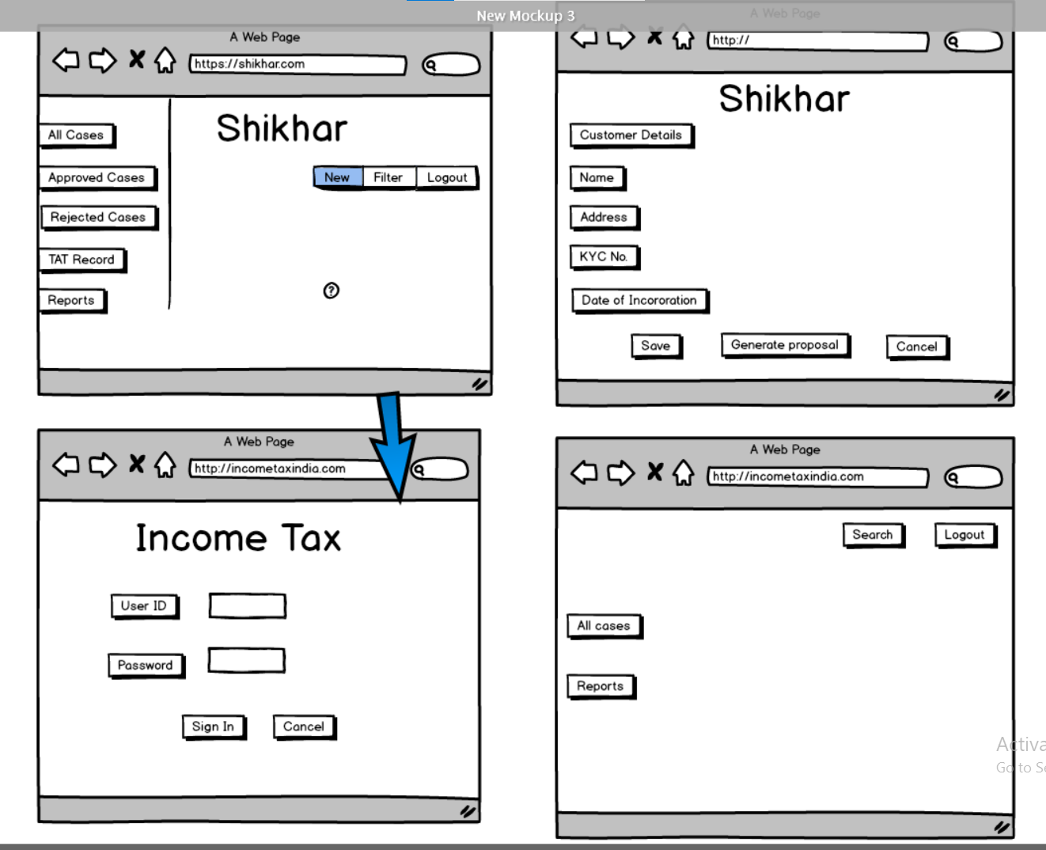

2. ITR, GST Portal Login & OTP authentication

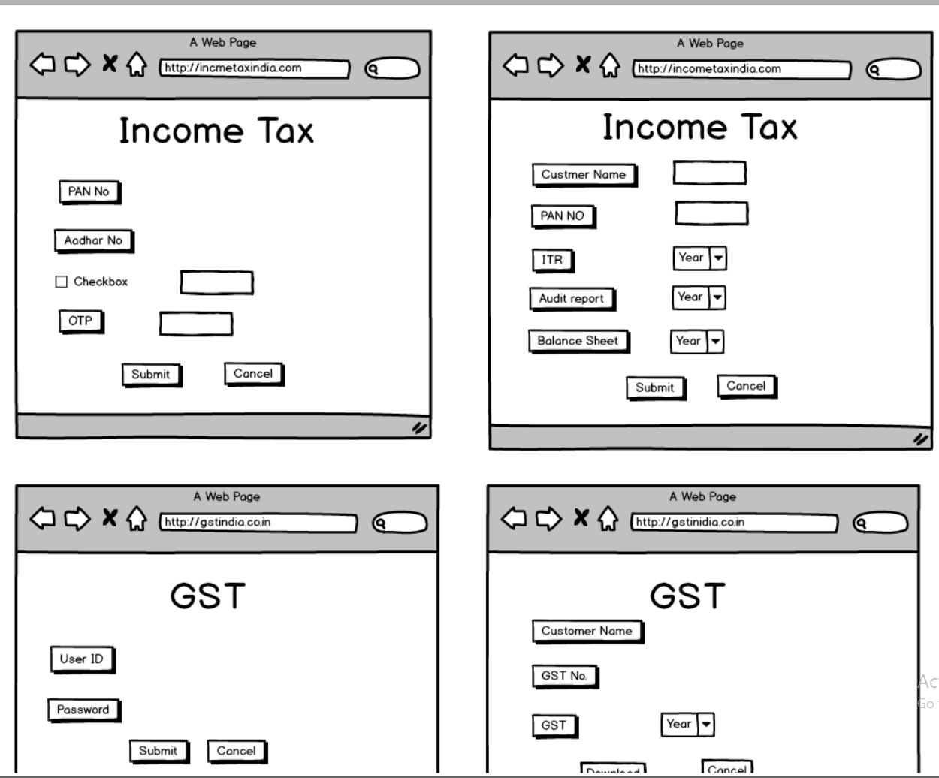

3. Upload Documents, Proposal Movement, Valuation and legal initiation

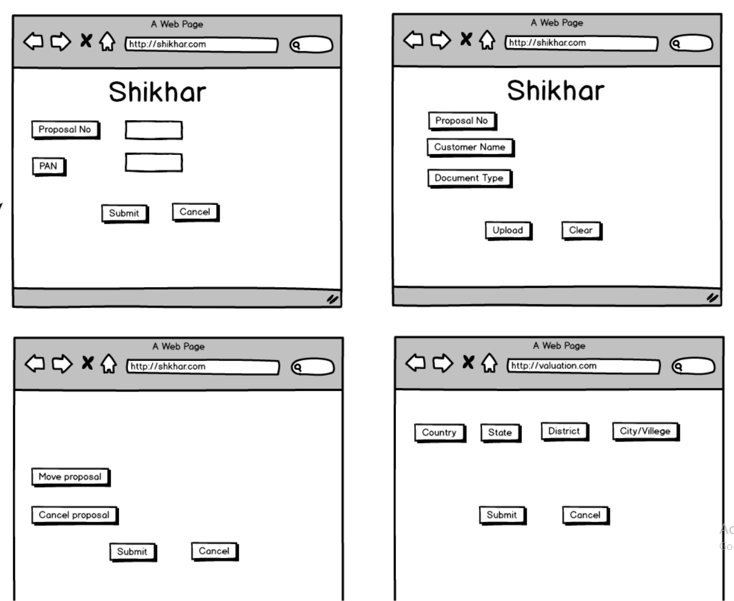

4. Download legal and valuation report and Sanction letter Generation

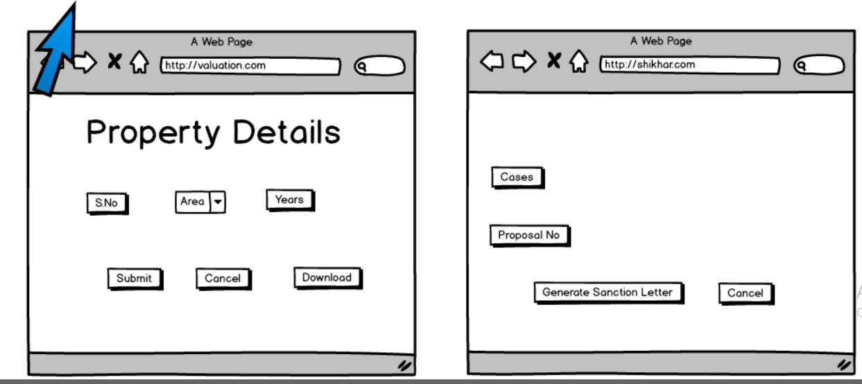

**Document 8 – Visio and Axure**

**Microsoft Visio:**

* Microsoft Visio is a visualization tool which used to draw variety of diagrams which includes ideas and processes.
* Visio is mainly used to draw business diagrams, engineering diagrams, flowchart, floor and map plan, flowchart diagrams.
* Visio is time consumption application used to draw activity and UML diagrams.
* Visio is drag and drop tool where one can drag option and drop it in dashboard so that it will become easy to draw diagrams and shows control flow with activity.
* One can write description for particular activity and can write in while displaying control flow with a condition.

**Axure:**

* Axure is a prototyping tool for creating interacting prototypes which majorly focuses on interface design and interactive designs.
* It includes headings, list box, check box, radio button, tables.
* Axure is a tool which helps me to link one activity with another activity.
* We can follow activity flowchart with linking with each other and create an interface and designs.

**Document 9 – BA Experience**

**1. Requirement Gathering:**

* To gather requirements, we used MOSCOW technique where we sort requirements according to must do, should do, could do, would do and got clarity on priority of requirements.
* Client is not available for some period of time during this phase, as a BA we need to source out point of contacts from his side and get the information ASAP which also helps in getting additional to be value added points (Gold Plating).
* We validate the requirements using FURPS technique so that we can get requirements as per functionality of system, Usability of system, Reliability of system, Supporting requirements and requirements deals with performance of system.
* Out of all requirements, we removed duplicate requirements and sort other requirements.
* Elicitation technique like prototype provides clear idea about requirements.

**2. Requirement Analysis:**

* We draw use case diagrams based on client’s requirement which helps technical team to get better idea about development of project and solution for project.
* We also draw activity diagrams from team developer team get idea about process flow of activities so that team can design accordingly.
* We communicate these diagrams with technical team, some members suggest some rectification in diagrams. We have noted points and make corrections.
* After diagrams preparation, we prepared Business Requirement Document (BRD) and Software Requirement Specification (SRS).
* In BRD and SRS we have mentioned stakeholder’s requirements and software required to develop project after communication with developer team.

**3. Design:**

* From use case diagrams, we prepared test cases as per requirement of customer.
* We communicate with client about design and solution for project.
* We will prepare end user manual.
* We will update Requirement Traceability Matrix (RTM) so that client has to get idea status of project.

**4. Development:**

* We organized JAD sessions with stakeholders and system analysts to identify requirements.
* We will clarify queries of tech team during coding with help of requirement of customer.
* There might be some team members who doesn't agree with the concept or who doesn’t cooperate during JAD sessions. As a BA, we handle the situation gently and had one on one discussion with them. We explained how their actions are going to affect the project and setup healthy environment within the team.
* We referred use case and activity diagrams to developer team to make easier to develop.
* We conducted regular meetings with technical team and client which is quiet challenging. As some team members might not be available for the meeting due to their pre booked work load. We recorded the sessions and provide that to missed one and having one to one discussion later with missed people.

**5. Testing:**

* We prepared use test cases from use cases (as per requirement of customer)
* We provided tested data to client for tested requirements
* We updated Requirement Traceability Matrix (RTM) for completion
* After updating RTM, we took sign off from client over mail and over call.
* After signing off from client, we prepared client for Unit Acceptance Testing (UAT).

**6. Deployment:**

* We forwarded RTM to client which should be attached to project closure document.
* We coordinate to complete and share end user manuals to accomplish project.
* We planned and organized training sessions for project completion.
* We make sure all the candidates attend the meeting.