Question 1 – Functional Requirements - 15 Marks

Ans1)

**Functional requirements**- Functional requirements define the specific behavior, function, or operation of a system.

They describe what the system should do, outlining the necessary tasks, actions, or activities it must perform to achieve its objectives.

Functional Requirements define what the system should do. They include specific behavior, tasks, or functions the system must perform.

For example, in an online agriculture store, functional requirements might include user registration, product listing, payment processing, and order tracking.

In functional req. people involved will be whole Development team & Software team, developers, testers, engineers.

| **Requirement ID** | **Requirement Name** | **Requirement Description** |
| --- | --- | --- |
| FR001 | User Registration and Login | The application should allow farmers and  manufacturers to register and log in  The application should allow the farmers and manufacturers to register and login. |
| FR002 | User Profile Management | User should be able to manage and update their profiles. |
| FR003 | Product Catalog Management | Manufacturers should be able to add, update and delete the product listings (Fertilizers, pesticides, seeds) |
| FR004 | Product search and filtering | Farmers should be able to search for products and apply filters for eg. Product type, price range, brands). |
| FR005 | Product Details Page | The application should display detailed information about each product, including images, description and specifications. |
| FR006 | Shopping Cart | Farmers should be able to add the products to a shopping cart for purchase |
| FR007 | Order Placement | The farmer should be able to place the order for the products in their shopping cart. |
| FR008 | Order Tracking | Farmers should be able to track the status of their orders. |
| FR009 | Payment Gateway Integration | The application should support multiple payment options eg. Credit/debit card, UPI, COD, Etc. |
| FR0010 | Order History | Farmers should be able to view their past orders and order details. |
| FR0011 | Notifications | The application should be able to notify the users about order status, new product arrival , discounts and promotions |
| FR0012 | Review and Rating | Farmers should be able to leave their reviews and rating for the products. |
| FR0013 | Customer Support | The application should have a customer support system for eg. Chat , email or phone support |
| FR0014 | Multilingual Support | The application should support multiple languages to cater to diverse user groups. |
| FR0015 | Location- Based Services | The application should be able to use location service to provide delivery options and estimate the delivery time. |
| FR0016 | Admin Dashboard | Admin should have a dashboard to manage the users, products, Orders and payments. |
| FR0017 | Reporting and Analysis | The application should be able to generate the report on sales, user activity and other key metrics. |
| FR0018 | Discounts and Promotions | Manufacturers should be able to offer discounts and promotions on their products. |
| FR0019 | Inventory Management | Manufacturer should be able to check and update the inventory levels and product availability. |
| FR0020 | Security and Privacy | The application should be able to ensure the security and privacy of the user data. |

**Non- Functional Requirements –** Non -functional requirements will describe the qualities and attributes of the system, focusing on how the system performs, rather than specific behavior or function.

They specify how the system performs its functions, focusing on qualities such as performance, security, usability, and reliability.

For the agriculture store, non-functional requirements could include system response time, data encryption, scalability to handle many users, and ease of use for farmers with limited technical skills.

| **Requirement ID** | **Requirement Name** | **Requirement Description** |
| --- | --- | --- |
| NFR001 | Usability | The application should be User-Friendly with an intuitive interface for all users. |
| NFR002 | Performance | The application should load quickly and handle a large number of users at one time without performance degradation. |
| NFR003 | Scalability | The application should be scalable to accommodate an increasing number of users and products. |
| NFR004 | Reliability | The application should have high availability and minimal downtime. |
| NFR005 | Maintainability | The application should be easy to maintain and update. |
| NFR006 | Compatibility | The application should be compatible with various devices like laptop, tablet, mobile) and browsers. |
| NFR007 | Accessibility | The application should be able to users with disabilities. |
| NFR008 | Security | The application should implement robust security measures to protect against data breach and cyber- attacks |
| NFR009 | Data Integrity | The application should ensure the accuracy and consistency of data over its lifecycle. |
| NFR0010 | Backup and Recovery | The application should have mechanism for data backup and disaster recovery. |
| NFR0011 | Localization | The application should support localization for different region and language. |
| NFR0012 | Compliance | The application should comply with relevant legal and regulatory requirements. |
| NFR0013 | Latency | The application should have low latency to ensure a smooth user experience. |
| NFR0014 | Documentation | The application should have comprehensive documentation for users and developers. |
| NFR0015 | Logging and Monitoring | The application should have logging and monitoring capabilities to track performance and detect issues. |
| NFR0016 | Resource Management | The application should efficiently manage resources for eg. CPU, Memory, etc. to optimize the performance. |
| NFR0017 | User load Testing | The application should be tested to handle pick loads and ensure stability under stress . |
| NFR0018 | Version Control | The application should have version control for managing updated and changes. |
| NFR0019 | Support | The application should offer support services for trouble shooting and resolving user issues. |
| NFR0020 | Interoperability | The application should be able to integrate with other systems for eg. Third party Payment gateways. |

**_____________________________________________________________________________________**

Question 2–Minimum 5 page designs - 15 Marks

Ans2)

**Wireframes-** A wireframe is a basic visual guide that represents the skeletal framework of a website or application. It outlines the structure, layout, and placement of various elements such as headers, footers, navigation menus, and content areas without focusing on design details like colors, fonts, or images.

Wireframes help in understanding the flow and functionality of the interface, allowing stakeholders to agree on the structure before moving on to more detailed designs.

**Mockup-** A mockup is a static design of a web page or application that features many of its final design elements but is not functional.

Mockups are more developed than wireframes, which are the initial sketch of a product. Mockups are also different from prototypes, which are working models of a design that allow user interaction.

Mockups can include visual elements such as: Structure, Layout, Color schemes, Typography, and Editorial copy.

**Prototype**- A prototype is an advanced version of a wireframe that simulates the interactive aspects of the final product. It includes clickable elements and realistic interactions, allowing users to experience and test the application's functionality.

Prototypes can range from low-fidelity (basic interactive mock-ups) to high-fidelity (detailed and highly interactive) and are used to gather feedback, identify usability issues, and refine the user experience before the actual development begins.

Page 1:

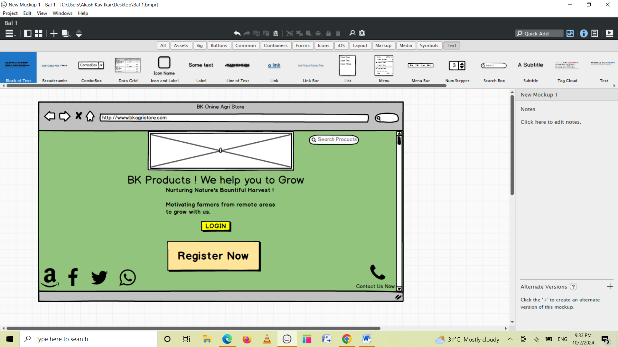

Page 2

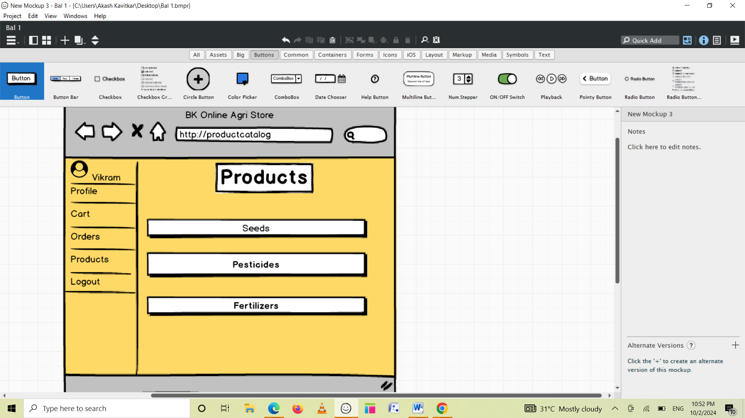

Page3

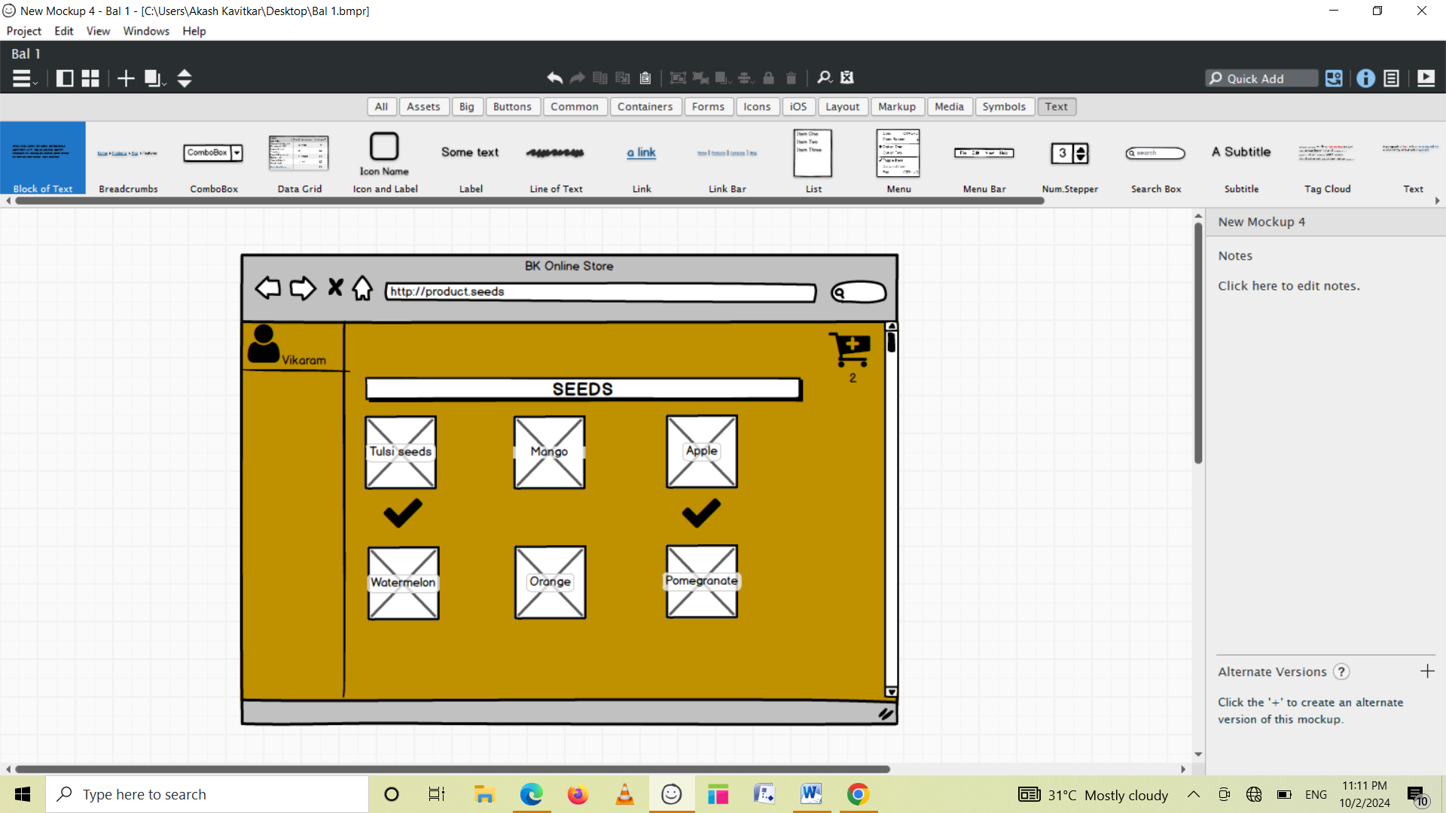

Page 4

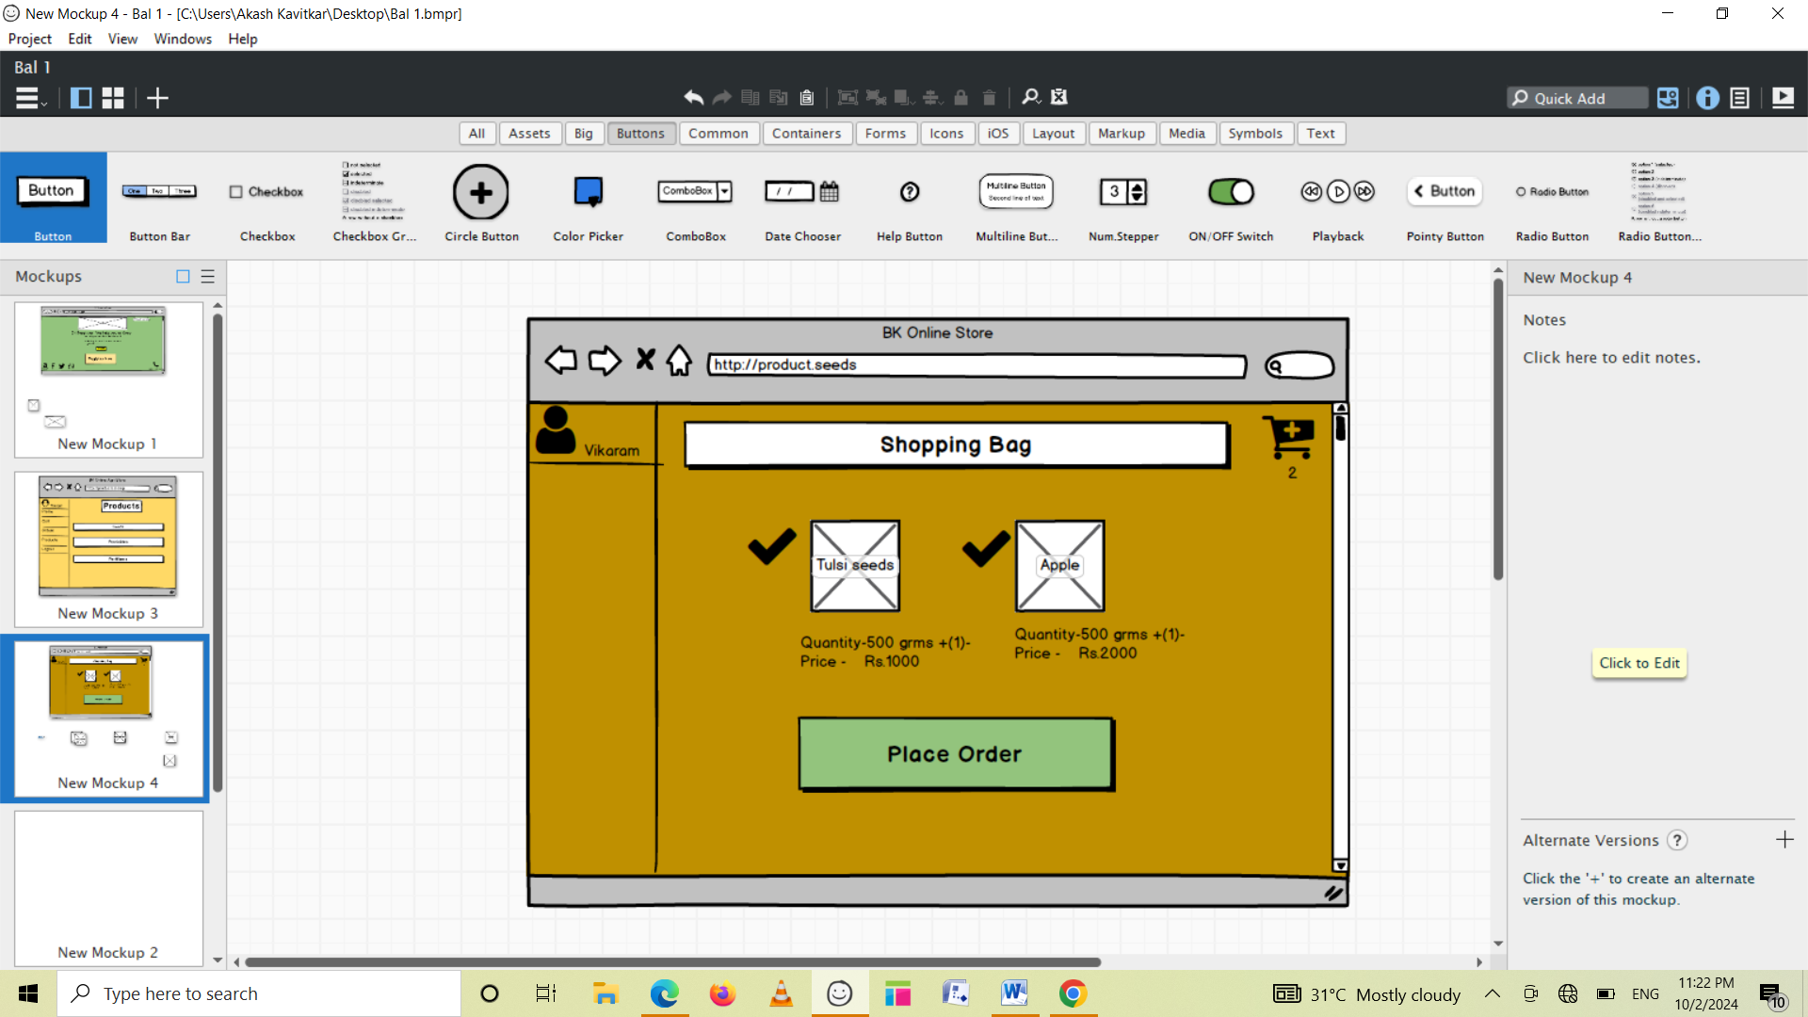

Page 5

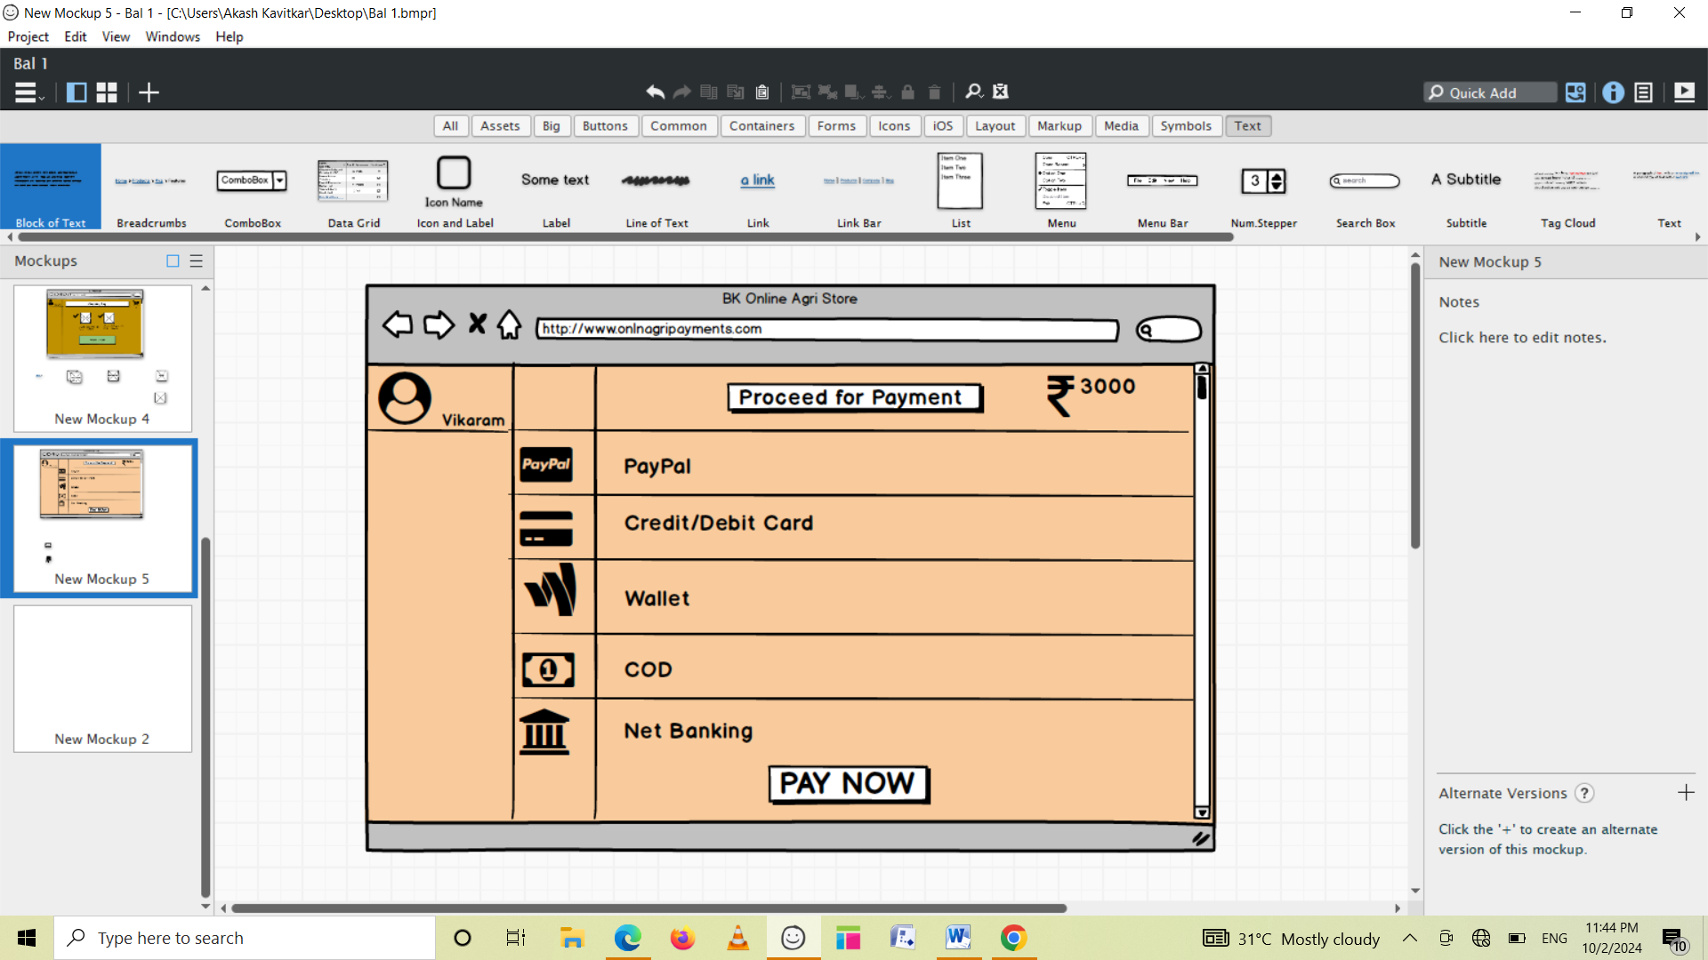

Question3 Tools (Visio, Balsa

Ans3)

Balsmiq and axure are two popular tools used for wireframing and prototyping.

1. **Balsmiq**:- It is a rapid wireframing tool that allows designers to quickly create wireframes and mockups of website and applications.

It has simple and intuitive interface that makes it easy to use and is popular among UX and UI designs.

**2. Axure:-** Axure is a powerful prototyping tool that allows designers to create highly interactive and detailed prototypes of websites and applications. It has a wide range of features that make it popular choice among UX designers, including the ability to create responsive designs, dynamic content and animations.

Balsmiq used for quickly creating low fidelity wireframes, While Axure is better suited for creating more complex , interactive prototypes.

**3. MS Visio**: Microsoft Visio is a diagramming and vector graphics application that is part of the Microsoft Office family.

It was first introduced in 1992 by the Shapeware Corporation. Visio is used to create diagrams such as flowcharts, organizational charts, floor plans, and more. It allows users to add and connect shapes, text, and pictures to show relationships in their data. Users can also give diagrams a professional look with styles, effects, themes, and backgrounds. Additionally, Visio can create dynamic diagrams and link to data from Excel, Access, or SharePoint. It is available for Windows operating systems.

Question 4 – RTM - 6 Mar

A business analyst’s key responsibilities are to keep track of the requirements and make sure that no requirement and make sure that no requirement is missed.

Mr. Henry and peter have approached you regarding the current status of the project. How will you tackle this situation? Prepare RTM

Ans4)

RTM stands for Requirement Traceability matrix. RTM maps all the requirements with the test cases. By using this document one can verify test cases cover all functionality of the application as per the requirements of the customer.

It is a document to Track the requirement throughout the project lifecycle, ensuring that they are met and that no requirement are overlooked.

**Requirements: Requirements of a particular project from the client.**

**Traceability: The ability to trace the tests.**

**Matrix: The data which can be stored in rows and columns form.**

The main purpose of the requirement traceability matrix is to verify that the all requirements of clients are covered in the test cases designed by the testers.  
In simple words, one can say it is a pen and pencil approach i.e., to analyze the two data information but here we are using an Excel sheet to verify the data in a requirement traceability matrix.

| **Req.**  **ID** | **Requirement Name** | **Requirement Description** | **Design** | **Code** | **UT(Unit Testing)** | **CT(Componet Testing)** | **ST(System Testing)** | **SIT** | **UAT(User accepting Testing)** |
| --- | --- | --- | --- | --- | --- | --- | --- | --- | --- |
| FR001 | User Registration | The application should allow farmers and  manufacturers to register and log in  The application should allow the farmers and manufacturers to register. | Complete | Complete | Complete | Complete | Complete | Complete | Complete |
| FR002 | User Profile Management | User should be able to manage and update their profiles. | Complete | Complete | Complete | Complete | Complete | Incomplete | Incomplete |
| FR003 | Product Catalog Management | Manufacturers should be able to add, update and delete the product listings (Fertilizers, pesticides, seeds) | Complete | Complete | Complete | Complete | Complete | Complete | Incomplete |
| FR004 | Product search and filtering | Farmers should be able to search for products and apply filters for eg. Product type, price range, brands). | Complete | Complete | Complete | Complete | Complete | Incomplete | Incomplete |
| FR005 | Product Details Page | The application should display detailed information about each product, including images, description and specifications. | Complete | Complete | Complete | Complete | Complete | Incomplete | Complete |
| FR006 | Shopping Cart | Farmers should be able to add the products to a shopping cart for purchase | Complete | Complete | Complete | Complete | Complete | Incomplete | Incomplete |
| FR007 | Order Placement | The farmer should be able to place the order for the products in their shopping cart. | Complete | Complete | Complete | Complete | Complete | Incomplete | Complete |
| FR008 | Order Tracking | Farmers should be able to track the status of their orders. | Complete | Complete | Complete | Complete | Incomplete | Incomplete | Incomplete |
| FR009 | Payment Gateway Integration | The application should support multiple payment options eg. Credit/debit card, UPI, COD, Etc. | Complete | Complete | Complete | Complete | Complete | Complete | Incomplete |
| FR0010 | Order History | Farmers should be able to view their past orders and order details. | Complete | Complete | Complete | Complete | Complete | Complete | Incomplete |
| FR0011 | Notifications | The application should be able to notify the users about order status, discounts | Complete | Complete | Complete | Complete | Complete | Complete | Incomplete |
| FR0012 | Review and Rating | Farmers should be able to leave their reviews and rating for the products. | Complete | Complete | Complete | Complete | Complete | Complete | Incomplete |
| FR0013 | Customer Support | The application should have a customer support system for eg. Chat , email or phone support | Complete | Complete | Complete | Complete | Complete | Complete | Complete |
| FR0014 | Multilingual Support | The application should support multiple languages to cater to diverse user groups. | Complete | Complete | Complete | Complete | Complete | Complete | Incomplete |
| FR0015 | Location- Based Services | The application should be able to use location service to provide delivery options and estimate the delivery time. | Complete | Complete | Complete | Complete | Complete | Complete | Complete |
| FR0016 | Admin Dashboard | Admin should have a dashboard to manage the users, products, Orders and payments. | Complete | Complete | Complete | Complete | Complete | Complete | Complete |
| FR0017 | Reporting and Analysis | The application should be able to generate the report on sales, user activity and other key metrics. | Complete | Complete | Complete | Complete | Complete | Complete | Complete |
| FR0018 | Discounts and Promotions | Manufacturers should be able to offer discounts and promotions on their products. | Complete | Complete | Complete | Complete | Complete | Complete | Complete |
| FR0019 | Inventory Management | Manufacturer should be able to check and update the inventory levels and product availability. | Complete | Complete | Complete | Complete | Complete | Complete | Complete |
| FR0020 | Security and Privacy | The application should be able to ensure the security and privacy of the user data. | Complete | Complete | Complete | Complete | Complete | Complete | Complete |
| NFR008 | Security | The application should be scalable to accommodate an | Complete | Complete | Complete | Complete | Complete | Complete | Complete |

Q5) Question 5 – 10 Test Case Documents. Prepare 10 Test Case Document

Ans5)

Test case documents detail the specific condition, inputs, actions and expected outcomes for testing a particular feature or functionality of a system.

They are needed to ensure through testing, verify that the system behaves as expected, identify defects, and maintain consistency and coverage across different testing scenarios.

Test case documents helps in ensuring that all aspects of the system are validated before development, reducing the risk of errors in the final product.

Test Case: 1 Login with valid credentials

| **Test Case ID** | ABCD0001 | **Test Case Name** | Login with valid credentials |
| --- | --- | --- | --- |
| **Project ID** | ABCD | **Project Name** | BK Online Agriculture Store |
| **PM ID** | XYZ | **PM Name** | Mr. Vandanam |
| **Test Strategy ID** | ABCD00S1 | **Tester ID** | T12345 |
| **Test Plan ID** | ABCD00P1 | **Tester Name** | Mr. Jason |
| **Test schedule ID** | ABCD0S1 | **Date of Test** | 6th June 2023 |
| **Scenario** | The user enters valid login credentials and click on login button | | |
| **Link to that page:** | http//:www.login | | |
| **Input Data** | User Name- jackd@bkagri  Password- efg009 | | |  |
| **Expected Behavior** | Mandatory fields are marked with * against the field. Password masking. After entering valid user name and password, user is logged in. | | |
| **Actual Behavior** | After entering correct user name and password, user press login button, the user is able to successfully login and redirected to Home page | | |
| **Comments** | You have logged in successfully. Welcome. | | |
| **Result(Pass/Fail)** | Pass | | |

Test Case: 2 Search query

| **Test Case ID** | ABCD0002 | **Test Case Name** | Search query |
| --- | --- | --- | --- |
| **Project ID** | ABCD | **Project Name** | BK Online Agriculture Store |
| **PM ID** | XYZ | **PM Name** | Mr. Vandanam |
| **Test Strategy ID** | ABCD00S2 | **Tester ID** | T12345 |
| **Test Plan ID** | ABCD00P2 | **Tester Name** | Mr. Jason |
| **Test schedule ID** | ABCD0S1 | **Date of Test** | 7th June 2023 |
| **Scenario** | Search for product | | |
| **Link to that page:** | http//:product.catalog | | |
| **Input Data** | Mango seeds  Organic Dried seeds  Quantity 1  500gm  Rs 1000 is cost | | |  |
| **Expected Behavior** | 100 farmers should be visit and order for above data. | | |
| **Actual Behavior** | 75 farmers visited and orders successfully. | | |
| **Comments** | Tester tested and UAT completed updated comment. | | |
| **Result(Pass/Fail)** | Pass | | |
|  |  | | |

Test Case: 3. Add product to cart

| **Test Case ID** | ABCD0003 | **Test Case Name** | Registered user adds product to cart. |
| --- | --- | --- | --- |
| **Project ID** | ABCD | **Project Name** | BK Online Agriculture Store |
| **PM ID** | XYZ | **PM Name** | Mr. Vandanam |
| **Test Strategy ID** | ABCD00S3 | **Tester ID** | T12345 |
| **Test Plan ID** | ABCD00P3 | **Tester Name** | Mr. Jason |
| **Test schedule ID** | ABCD0S3 | **Date of Test** | 6th June 2023 |
| **Scenario** | The user selects the product and adds it to cart | | |
| **Link to that page:** | http//:product.catalog-orgfertz (Organic fertilizer’s page) | | |
| **Input Data** | Product-Organic  Fertilizer- 1kg  Quantity- 5 | | |  |
| **Expected Behavior** | Product should be added to cart with correct quantity. | | |
| **Actual Behavior** | Click on product, select the quantity and click on “Add to Cart” button | | |
| **Comments** | User is able to see product with correct product specification and quantity in his cart. | | |
| **Result(Pass/Fail)** | Pass | | |

Test Case: 4 redirecting to payment page.

| **Test Case ID** | ABCD0004 | **Test Case Name** | Registered user Places order. |
| --- | --- | --- | --- |
| **Project ID** | ABCD | **Project Name** | BK Online Agriculture Store |
| **PM ID** | XYZ | **PM Name** | Mr. Vandanam |
| **Test Strategy ID** | ABCD00S4 | **Tester ID** | T12345 |
| **Test Plan ID** | ABCD00P4 | **Tester Name** | Mr. Jason |
| **Test schedule ID** | ABCD0S4 | **Date of Test** | 10th June 2023 |
| **Scenario** | Product selection done by user and user is directed to Payment page. | | |
| **Link to that page:** | http//:www.bkstorepayment | | |
| **Input Data** | Image of the product,  Price of product  Product specification | | |  |
| **Expected Behavior** | Select the required product. | | |
| **Actual Behavior** | After selecting the product to buy, the page will take you to Payment page to select the mode of payment. | | |
| **Comments** | Order is placed. | | |
| **Result(Pass/Fail)** | Pass | | |

Test Case: 5 selecting the payments method.

| **Test Case ID** | ABCD0005 | **Test Case Name** | selecting the payments method |
| --- | --- | --- | --- |
| **Project ID** | ABCD | **Project Name** | BK Online Agriculture Store |
| **PM ID** | XYZ | **PM Name** | Mr. Vandanam |
| **Test Strategy ID** | ABCD00S5 | **Tester ID** | T12345 |
| **Test Plan ID** | ABCD00P5 | **Tester Name** | Mr. Jason |
| **Test schedule ID** | ABCD0S5 | **Date of Test** | 11th June 2023 |
| **Scenario** | Entering correct payment details for order conformation. | | |
| **Link to that page:** |  | | |
| **Input Data** | Select one of payment options,  Enter payment details . eg. CVV, Credit card number, OTP | | |  |
| **Expected Behavior** | Text confirmation with the order number generated. | | |
| **Actual Behavior** | While making the payment, farmers can select their preferred mode of payment after entering valid payment details and click on “Pay Now” button. | | |
| **Comments** | Payment done. Order is placed. | | |
| **Result(Pass/Fail)** | Pass | | |

Test Case.6 User add the product in the wish list

| **Test Case ID** | ABCD0006 | **Test Case Name** | User add the product in the wish list |
| --- | --- | --- | --- |
| **Project ID** | ABCD | **Project Name** | BK Online Agriculture Store |
| **PM ID** | XYZ | **PM Name** | Mr. Vandanam |
| **Test Strategy ID** | ABCD00S6 | **Tester ID** | T12345 |
| **Test Plan ID** | ABCD00P6 | **Tester Name** | Mr. Jason |
| **Test schedule ID** | ABCD0S6 | **Date of Test** | 11th June 2023 |
| **Scenario** | User add the product in the wish list | | |
| **Link to that page:** | http//:www.bkstorewish | |  |
| **Input Data** | Product- Organic  Seeds- Cabbage  500gm. | |  |  |
| **Expected Behavior** | Product should be added to wishlist | |  |
| **Actual Behavior** | Find the product and click on the ’Add to wishlist’ button | |  |
| **Comments** | Product added to Wishlis successfully. | | |
| **Result(Pass/Fail)** | Pass | | |

Test Case.7 Calculate total cost in cart

| **Test Case ID** | ABCD0007 | **Test Case Name** | Calculate the total cost in cart |
| --- | --- | --- | --- |
| **Project ID** | ABCD007 | **Project Name** | BK Online Agriculture Store |
| **PM ID** | XYZ | **PM Name** | Mr. Vandanam |
| **Test Strategy ID** | ABCD00S7 | **Tester ID** | T12345 |
| **Test Plan ID** | ABCD00P7 | **Tester Name** | Mr. Jason |
| **Test schedule ID** | ABCD0S7 | **Date of Test** | 15th June 2023 |
| **Scenario** | The user calculate the total cost of the product in cart | | |
| **Link to that page:** | http//:www.bkstorecalcart | |  |
| **Input Data** | Product- Select all products in cart | |  |  |
| **Expected Behavior** | The system should display total cost of selected products in cart  Eg. Total Cost- Rs5000/- | |  |
| **Actual Behavior** | Click on “Calculate Total” button | |  |
| **Comments** | Total Cost of cart is shown by the application. | | |
| **Result(Pass/Fail)** | Pass | | |

Test Case.8 Apply coupon code

| **Test Case ID** | ABCD0008 | **Test Case Name** | Apply coupon code |
| --- | --- | --- | --- |
| **Project ID** | ABCD0008 | **Project Name** | BK Online Agriculture Store |
| **PM ID** | XYZ | **PM Name** | Mr. Vandanam |
| **Test Strategy ID** | ABCD00S8 | **Tester ID** | T12345 |
| **Test Plan ID** | ABCD00P8 | **Tester Name** | Mr. Jason |
| **Test schedule ID** | ABCD0S8 | **Date of Test** | 20th June 2023 |
| **Scenario** | The user is able to apply coupon code to get discount | | |
| **Link to that page:** | http//:www.bkstorecouco | |  |
| **Input Data** | Coupon code- Flat20 | |  |  |
| **Expected Behavior** | The system should apply the coupon code and deduct the discounted amount from the total cost. | |  |
| **Actual Behavior** | Enter the coupon code in the given field and click on the “Apply button” | |  |
| **Comments** | Coupon code applied successfully, 20% flat discount applied. | | |
| **Result(Pass/Fail)** | Pass | | |

Test Case.9 Proceed to checkout

| **Test Case ID** | ABCD0009 | **Test Case Name** | Proceed to checkout |
| --- | --- | --- | --- |
| **Project ID** | ABCD0009 | **Project Name** | BK Online Agriculture Store |
| **PM ID** | XYZ | **PM Name** | Mr. Vandanam |
| **Test Strategy ID** | ABCD00S9 | **Tester ID** | T12345 |
| **Test Plan ID** | ABCD00P9 | **Tester Name** | Mr. Jason |
| **Test schedule ID** | ABCD0S9 | **Date of Test** | 25th June 2023 |
| **Scenario** | The user is able to proceed to checkout. | | |
| **Link to that page:** | http//:www.bkstorechcout | |  |
| **Input Data** | User click on checkbox for products to be purchased. | |  |  |
| **Expected Behavior** | The user should be redirected to “Checkout ” page | |  |
| **Actual Behavior** | Click on “Proceed to Checkout”  User redirected to checkout page | |  |
| **Comments** | The user can see selected products and redirected to checkout page. | | |
| **Result(Pass/Fail)** | Pass | | |

Test Case.10 Search for specific product

| **Test Case ID** | ABCD00010 | **Test Case Name** | Search for specific product |
| --- | --- | --- | --- |
| **Project ID** | ABCD00010 | **Project Name** | BK Online Agriculture Store |
| **PM ID** | XYZ | **PM Name** | Mr. Vandanam |
| **Test Strategy ID** | ABCD00S10 | **Tester ID** | T12345 |
| **Test Plan ID** | ABCD00P10 | **Tester Name** | Mr. Jason |
| **Test schedule ID** | ABCD0S10 | **Date of Test** | 30th June 2023 |
| **Scenario** | The user search for a specific product | | |
| **Link to that page:** | http//:www.bkstoresproduct | |  |
| **Input Data** | Seeds- Watermelon Master  Brand- BK AgriEXP  Quantity- 1kg | |  |  |
| **Expected Behavior** | Product successfully displayed | |  |
| **Actual Behavior** | Enter “Seeds-Watermelon”in search bar and press enter. | |  |
| **Comments** | Watermelon seeds of BK AgriEXP brand of 1 kg are displayed successfully. | | |
| **Result(Pass/Fail)** | Pass | | |

Question 6) Question 6 – DB Design – 8 Mark

After the requirements are thoroughly explained to the entire project team by business analyst, the Database architects have decided to do the database design and also to represent the in-flow and out-flow of data.

Draw database schema and ER Diagram

DB Schema is a blueprint that outlines the structure of a database, including its tables, fields, relationships, constrains and other characteristics.

DB Schema is a combination of tables and records

Farmers

Agricultural companies

Billing

Login

For the above components we have to describe how we will describe

| Farmers | Agriculture Companies |
| --- | --- |
| Need farmer’s details like name, email id, mob no. | Product details |
|  | Product price and discount |
| Billing | Login |
| Payment options | Login page for farmers and companies |
| Payment confirmation | Login through mail id or Mob.No. |
| Payment slip | Open the home page which has a product gallery |

After the requirements are thoroughly explained to the entire project team by business analyst, the Database architects have decided to do the database design and also to represent the in-flow and out-flow of data.

Draw database schema and ER Diagram

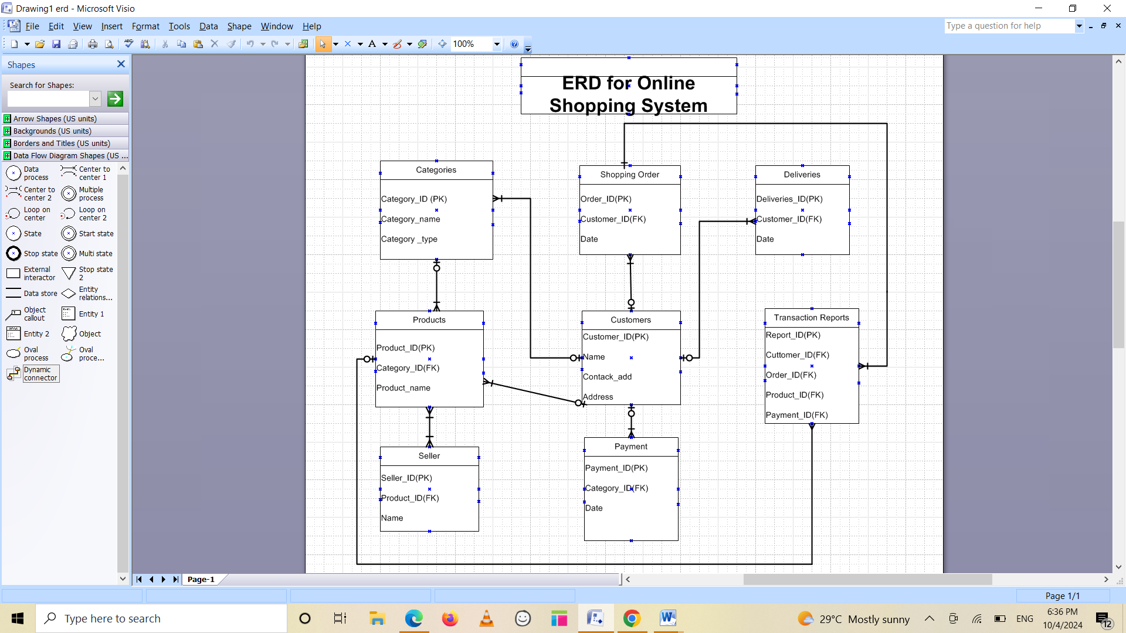

An Entity-Relationship Diagram is a visual representation of the relationships between entities in a database. It depicts the entities (such as tables), attributes (properties of fields), and relationships between them.

Question 7) Data Flow Diagram

Ans7)

**A data flow diagram** (DFD) maps out the flow of information for any process or system. It uses defined symbols like rectangles, circles and arrows, plus short text labels, to show data inputs, outputs, storage points and the routes between each destinations. Data flow charts can range from simple, even hand-drawn process overviews, to in-depth, multi-level DFDs that dig progressively deeper into how the data is handled. They can be used to analyze an existing system or model a new one. Like all the best diagrams and charts, a DFD can often visually “say” things that would be hard to explain in words, and they work for both technical and non-technical audiences, from developer to CEO. That’s why DFDs remain so popular after all these years. While they work well for data flow software and systems, they are less applicable nowadays to visualizing interactive, real-time or database-oriented software or systems.

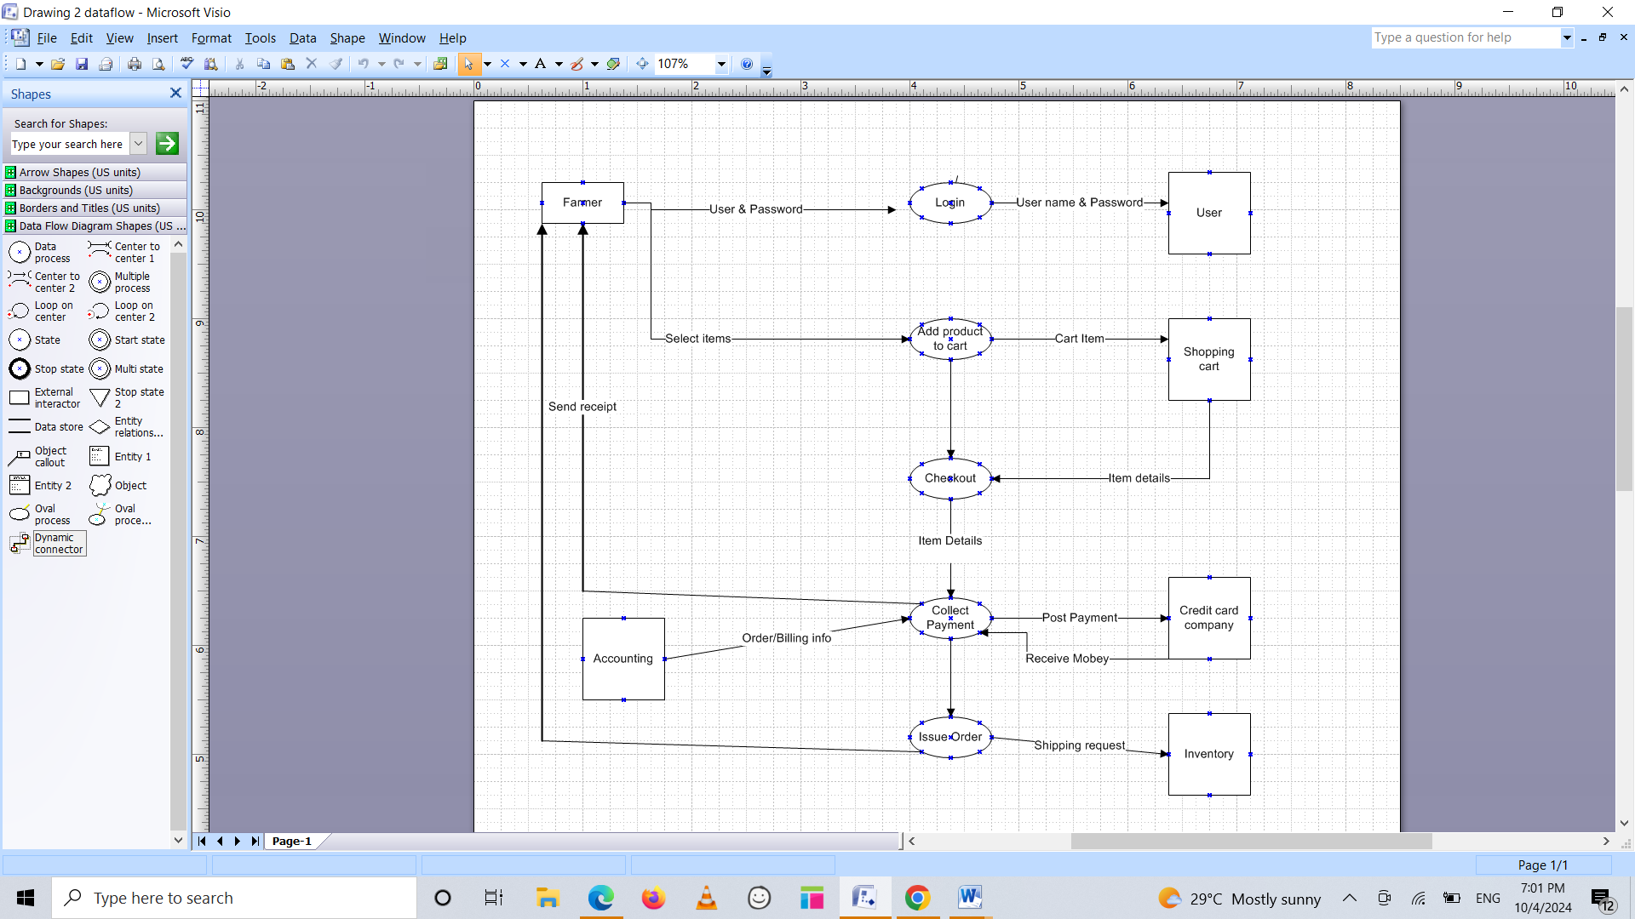

Q Question 8

Answer 8 – As a BA first I will document the change request. Then analyze the change request. Then I will get the approval from project manager. Here the change request is the changes in the govt. taxation structure so I will inform and discuss this with the stakeholders that we have to change our own taxation structure so that our budget to complete this project will be changed.

As a business analyst, we can handle change requests in a project by following the steps below

1. **Understand the Request**: Understand the nature of the request and the reason behind it. Is the request asking for a modification to an existing feature or a new feature altogether?

2. **Analyze the Impact**: Analyze the impact of the request on the project. Will the request require significant changes to the project's scope, timeline, or budget?

3. **Evaluate the Priority**: Evaluate the priority of the request. Is the request critical to the project's success, or can it be deferred to a later phase?

4. **Determine the Type**: Based on the above analysis, determine whether the request is a change request or an enhancement. A change request is a request to modify an existing feature, while an enhancement is a request to add a new feature. Document the Request: Document the request in detail, including the reason behind the request, the impact on the project.

_____________________________________________________________________________________

Answer 9)

As business analyst, we can identify whether a request is a change request or an enhancement by keeping in mind a few points:

1.Understand the Request: Understand the nature of the request and the reason behind it. Is the request asking for a modification to an existing feature or a new feature altogether?

2.Analyze the Impact: Analyze the impact of the request on the project. Will the request require significant changes to the project's scope, timeline, or budget?

3.Evaluate the Priority: Evaluate the priority of the request. Is the request critical to the project's success, or can it be deferred to a later phase?

4. Determine the Type: Based on the above analysis, determine whether the request is a change request or an enhancement. A change request is a request to modify an existing feature, while an enhancement is a request to add a new feature.

By following the above-mentioned points It is a change request situation as a new requirement has been introduced after 3 to 4 months and there is no change in the existing requirement so it is not a case of enhancement, for that, we should process ahead with the change request.

An enhancement is an improvement to existing functionality. With respect to defects, a fault raised around the way a function works (e.g. navigation, position of buttons, usability etc)

 Q.10) Estimations

Estimating the number of man-hours required for a project is a crucial task for a business analyst. The number of man-hours required depends on various factors such as the project's scope, complexity, and the team's experience. To come up with an accurate estimate, we can use estimation techniques such as top-down estimation, parametric estimation, bottom-up/WBS estimation, rough order of magnitude/expert opinion/ballpark estimates, rolling wave estimates, Delphi technique, PERT/Scenario analysis technique, etc.

We have 12 members there who are actually working on this project, so multiplying the 40 hours by 20 and multiplying by 12 members is equal to 9600 hrs. so a total of 9600 man hrs. are required.

BA 3 months

PM - 1 month

Senior Development & java team - 5 months

Tester - 4 months

Java developers - 15 days

PM - 15 days BA - 2 months

Ans 11: To address the situation, below steps can be followed:

1. Get ready, for User Acceptance Testing (UAT); Before reaching out to the client, we need to make sure that the product is fully prepared for UAT. This helps ensure that all requirements have been met, conducting testing of the product and resolving any defects.

2. Reach out to the Client: Once the product is ready for UAT, it's time to get in touch with the client to arrange a time for testing. Provide them with all the information such as the plan, test cases, and any relevant documentation.

3. Conduct User Acceptance Testing: During UAT it will be essential to collaborate with the client as they test the product against their requirements. Working together to identify and resolve any issues that arise.

4. Obtain Approval: Once UAT is successfully completed, obtain approval, from the client confirming their acceptance of the product. This approval has to be documented in a UAT Client Project Acceptance Form.

5. Wrap up the Project; With client acceptance of the product secured it's time to wrap up all project activities systematically. Delivering the product or service and formally closing out all project-related tasks are components of this phase.

We have the option to utilize a project completion document, for the purpose of summarizing the outcomes of the +project encompassing the deliverables insights gained throughout the process and overall achievement of the project. It is important to acquire approval, from the client or stakeholders affirming their acceptance of the deliverables and acknowledging that the project has reached its conclusion.

____________________________________________________________________________________

Q11)

Question 11 – UAT – 6 Marks

To address the situation, below steps can be followed:

1. **Get ready, for User Acceptance Testing** (UAT); Before reaching out to the client, we need to make sure that the product is fully prepared for UAT. This helps ensure that all requirements have been met, conducting testing of the product and resolving any defects.

2. **Reach out to the Client**: Once the product is ready for UAT, it's time to get in touch with the client to arrange a time for testing. Provide them with all the information such as the plan, test cases, and any relevant documentation.

3**. Conduct User Acceptance Testing**: During UAT it will be essential to collaborate with the client as they test the product against their requirements. Working together to identify and resolve any issues that arise.

4. **Obtain Approval: Once UAT is successfully completed**, obtain approval, from the client confirming their acceptance of the product. This approval has to be documented in a UAT Client Project Acceptance Form.

5. **Wrap up the Project**; With client acceptance of the product secured it's time to wrap up all project activities systematically. Delivering the product or service and formally closing out all project-related tasks are components of this phase.

We have the option to utilize a project completion document, for the purpose of summarizing the outcomes of the +project encompassing the deliverables insights gained throughout the process and overall achievement of the project. It is important to acquire approval, from the client or stakeholders affirming their acceptance of the deliverables and acknowledging that the project has reached its conclusion.

_____________________________________________________________________________________

Ans12)

Project closure is a formal written assessment of a project . The purpose of the project closure document is to formally close a project and authorize the handoff. It is a crucial document that helps to ensure that all project stakeholders are aware of the project's completion and that all necessary steps have been taken to close the project.

The document typically includes the following information:

**Project Overview**: A brief summary of the project, including its objectives, scope, and constraints.

**Project Deliverables**: A list of the final deliverables produced by the project.

**Lessons Learned**: A summary of the lessons learned during the project, including what worked well and what could be improved in future projects.

**Project Success**: An assessment of the project's overall success, including whether it met its objectives, stayed within budget, and was completed on time.

**Project Sign-Off**: A formal sign-off from the client or stakeholders indicating that they accept the final deliverables and that the project is complete.

To create a project closure document, you would need to follow the steps below:

**Gather Information**: Collect all the necessary information about the project, including the final deliverables, the lessons learned, and the project's overall success.

**Create the Document**: document creation is required to summarize the project's results. One can use a template for the same.

**Review and Approve**: Review the document with the project team and stakeholders to ensure that all necessary information is included and that everyone agrees with the document's contents.

**Sign-Off:** Obtain formal sign-off from the client or stakeholders indicating that they accept the final deliverables and that the project is complete.

____________________________________________________________________________________