**Waterfall Model Documents part 2**

**Document 6 :**

* **Use Case Diagram :**

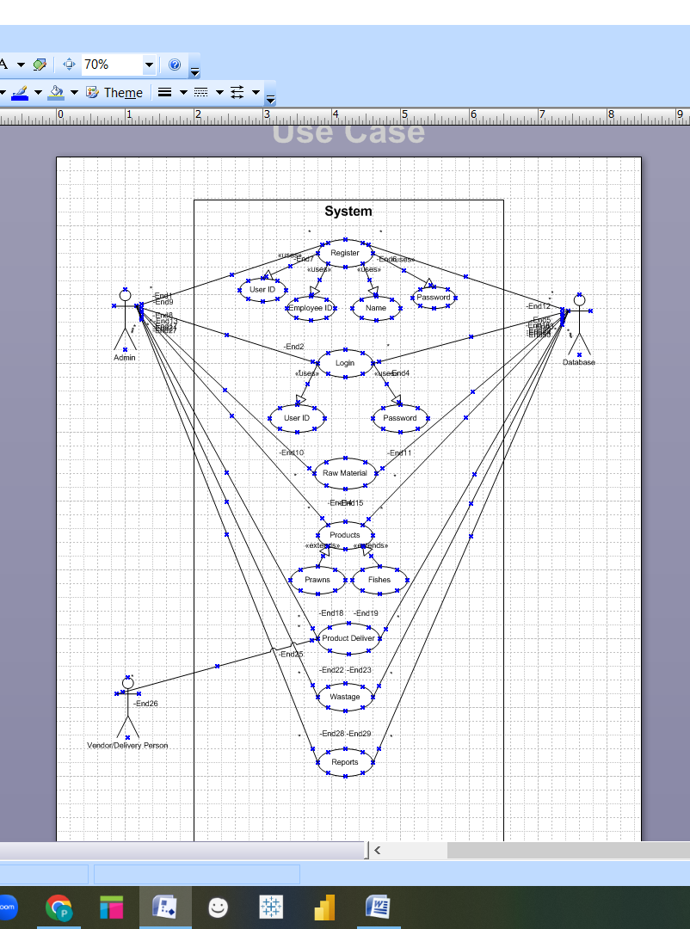

* **Activity Diagram :**

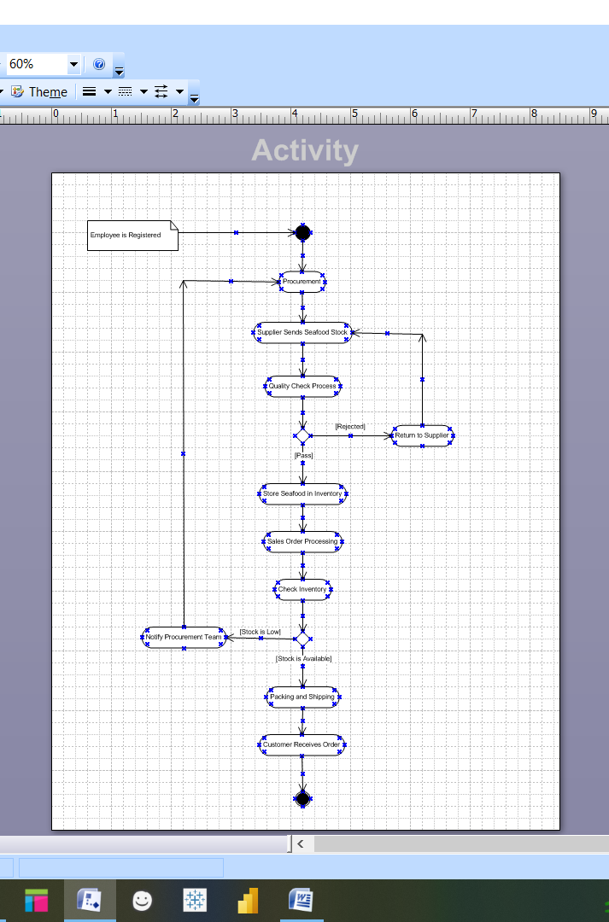

* **Use case Specification Document for Seafood Management Project**

This document defines the use cases for the **Seafood Management ERP** project, describing system interactions between users and the system.

1. **Introduction**

* **Purpose :**

The purpose of this document is to specify the functional use cases of the Seafood Management ERP, ensuring smooth operations across procurement, inventory, sales, quality control, and distribution.

* **Scope :**

This ERP system manages the entire seafood supply chain, including supplier management, inventory tracking, order processing, quality control, and delivery.

* **Actors :**
* **Supplier :** Provides seafood stock.
* **Quality Inspector :** Checks the quality of seafood received.
* **Warehouse Manager :** Manages storage and inventory.
* **Sales Manager :** Oversees orders and sales.
* **Customer :** Places orders for seafood.
* **Logistics Partner :** Handles shipping and delivery.

1. **Use Case List**

|  |  |  |  |
| --- | --- | --- | --- |
| **Use Case ID** | **Use Case Name** | **Actor(s)** | **Description** |
| UC01 | Procure Seafood | Supplier, System | Supplier delivers seafood to the warehouse. |
| UC02 | Perform Quality Check | Quality Inspector, System | Inspect seafood for quality approval. |
| UC03 | Store seafood in inventory | Warehouse Manager, System | Store approved seafood and update stock levels. |
| UC04 | Process Custom Order | Sales Manager, Customer, System | Place an order, check stock, and confirm order processing. |
| UC05 | Pack and ship seafood | Warehouse Manager, Logistics Partner | Package and dispatch seafood for delivery. |
| UC06 | Generate Invoice | Sales manager, System | Generate and send invoice to customer. |
| UC07 | Track Shipment | Customer, Logistics Partner | Allow customers to track their orders status. |
| UC08 | Manager returns & Complaints | Customer, Sales Manager | Handle returns due to quality or delivery issue. |

1. **Use Case Specifications Document**

* **Use Case ID : UC04 – Process Customer Order**

**Use Case Description :**

This use case describes how the system processes a customer’s seafood order, from order placement to delivery.

**Actors :**

* **Primary Actor :** Customer
* **Secondary Actors :** Sales Manger, Warehouse Manager, Logistics Partner.

**Basic Flow (Main Scenario ) :**

1. Customer logs into the system and browses seafood inventory.
2. Customer selects seafood items and add them to the cart.
3. Customer confirms the order and makes payment.
4. System verifies stock availability.
5. If stock is available, system confirms the order.
6. Warehouse manager receives the order notification and prepares shipment.
7. Logistics partner picks up the package and delivers it to the customer.
8. Customer receives the order and confirms delivery.

**Alternate Flow :**

* **Stock Not Available :** If stock is insufficient, the system notifies the customer and suggests alternative products or a backorder option.
* **Payment Failure :** If the payment fails, the system prompts the customer to retry.

**Exceptional Flows :**

* **Customer Cancels Order Before Shipment :** Order is marked as canceled, and the system issues a refund.
* **Delivery Failure :** If the delivery fails, the system notifies customer support.

**Pre –** **Conditions :**

* Customer must be registered in the system.
* System must have updated inventory records.

**Post – Conditions :**

* The order status is updated as “Delivered” upon successful completion.
* Payment and inventory records are updated.

**Assumptions :**

* Customer prefers online payment methods.
* Logistics partners deliver within specified timeframes.

**Constraints :**

* Payment processing must be secure.
* Orders must be shipped within a defined timeframe.

**Dependencies :**

* Order processing depends on inventory management.
* Shipment depends on Logistics Partner availability.

**Inputs and Outputs :**

* **Inputs :** Customer order details, payment details.
* **Outputs :** Order confirmation, invoice, tracking details.

**Business Rules :**

* Only available stock can be sold.
* Orders over a specific amount may qualify for free shipping.

**Miscellaneous information :**

* Customers should receive automated order status updates.

**Document 7 :**

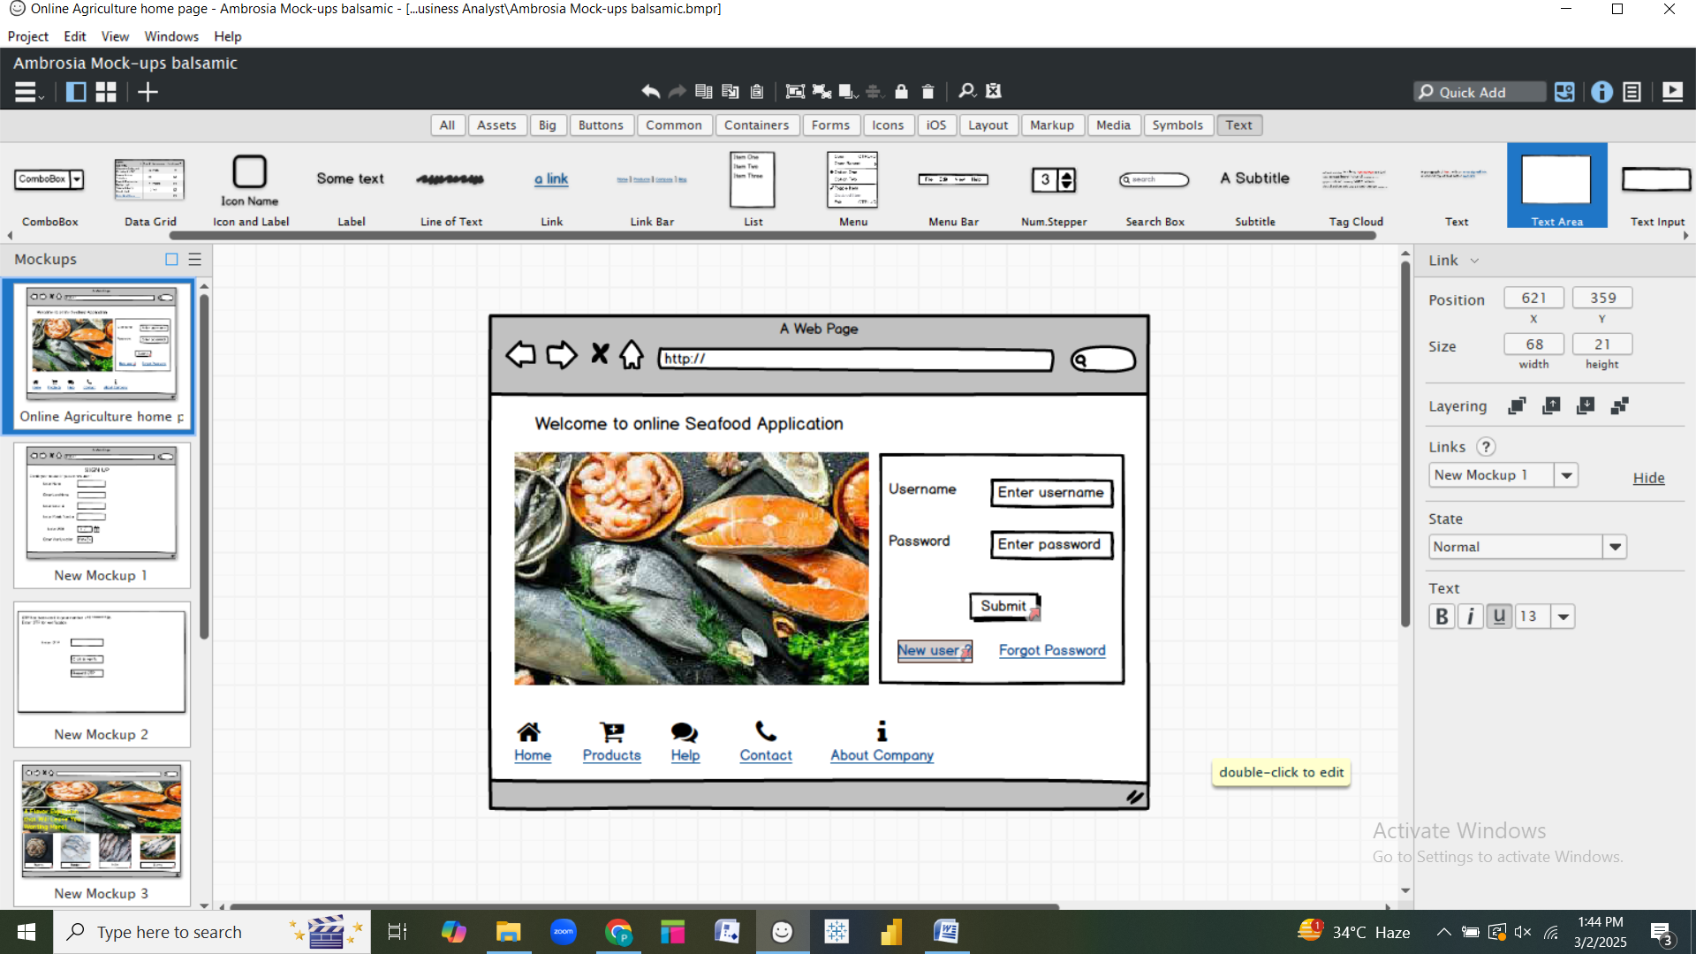

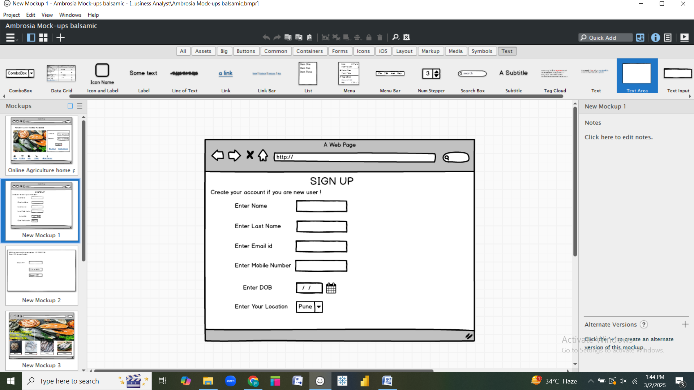

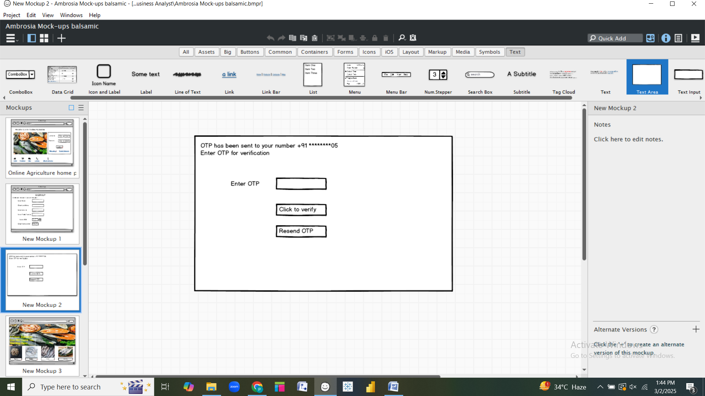

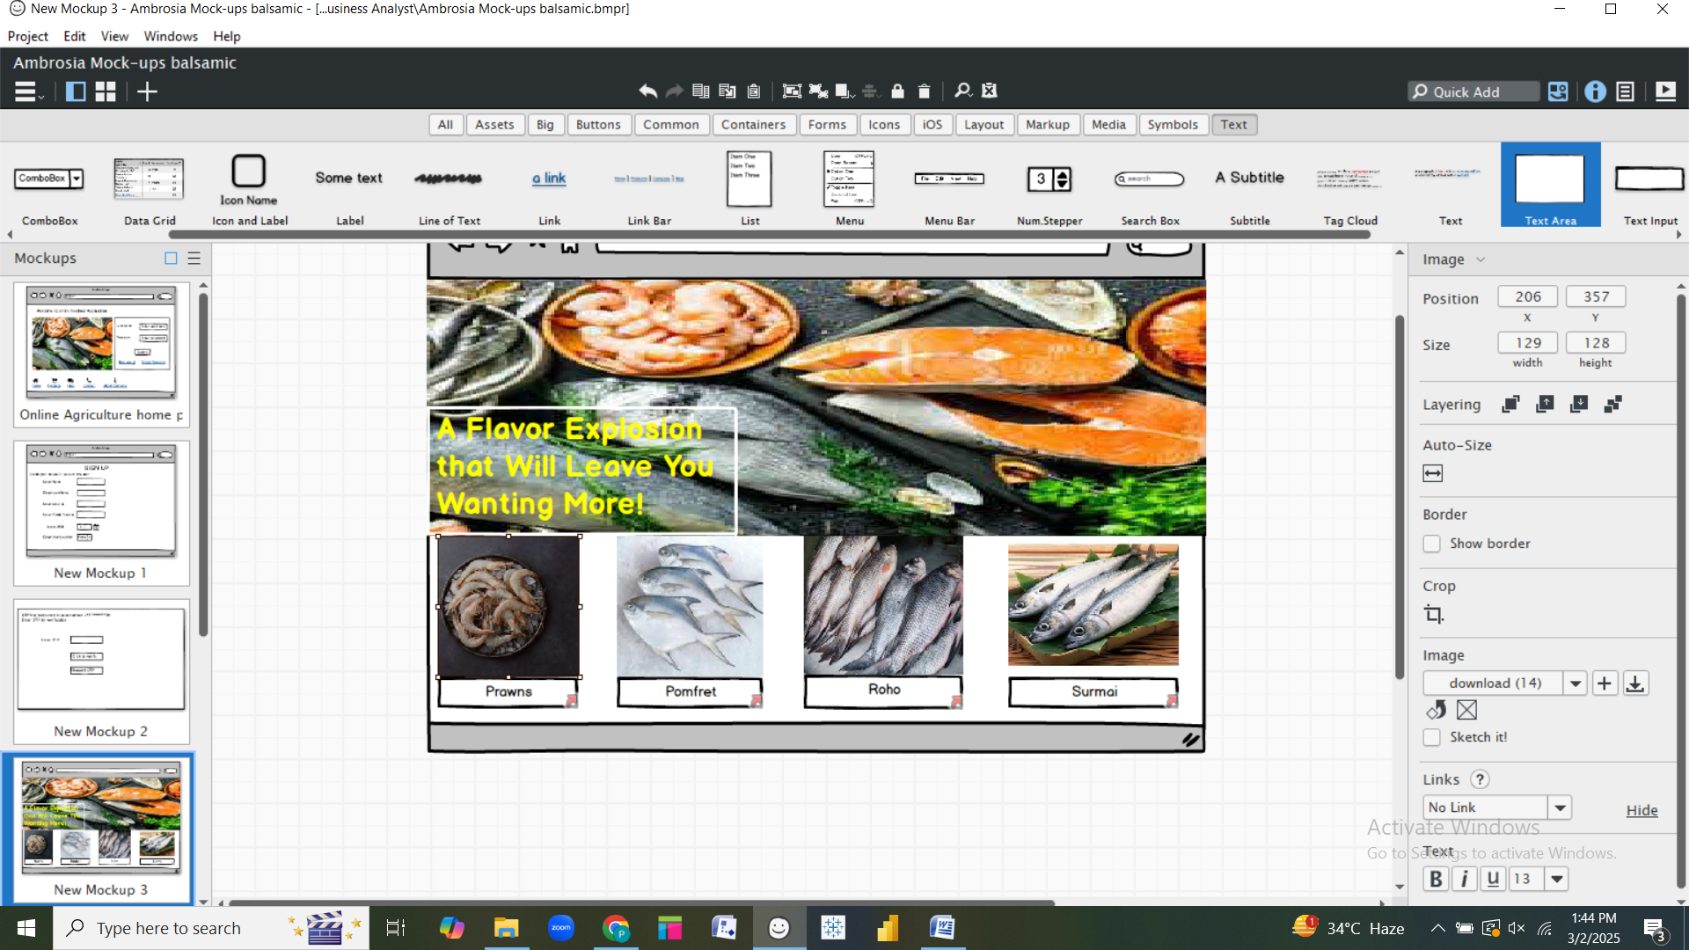

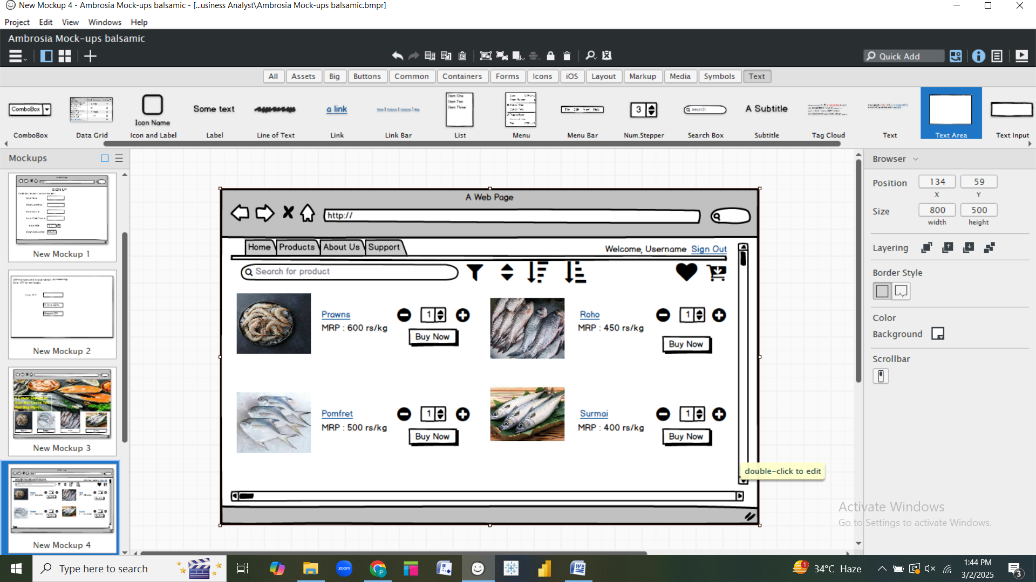

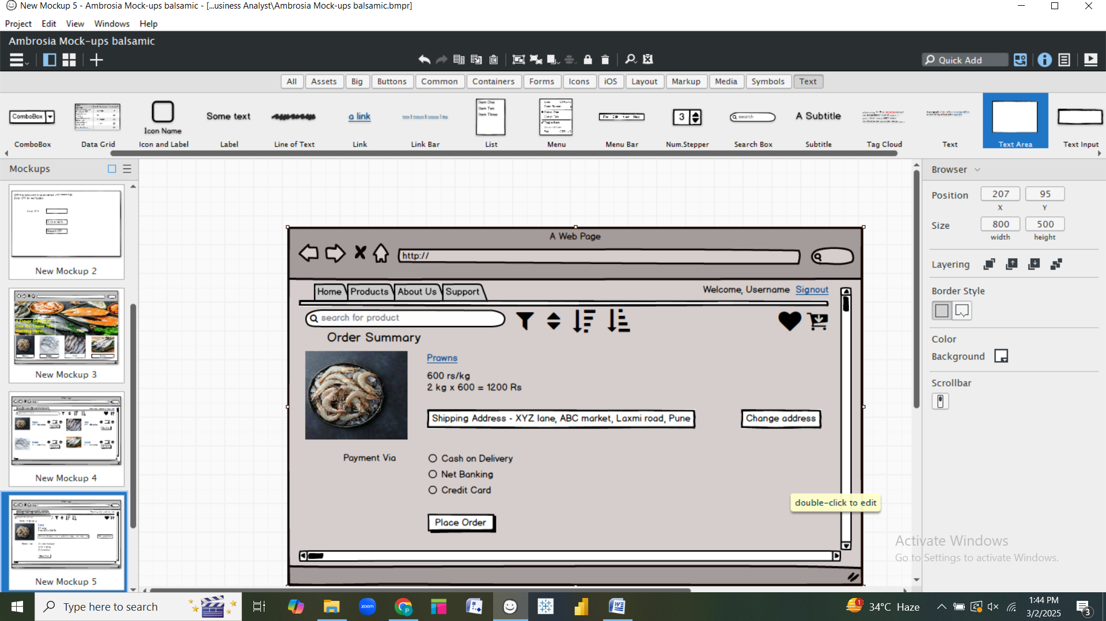

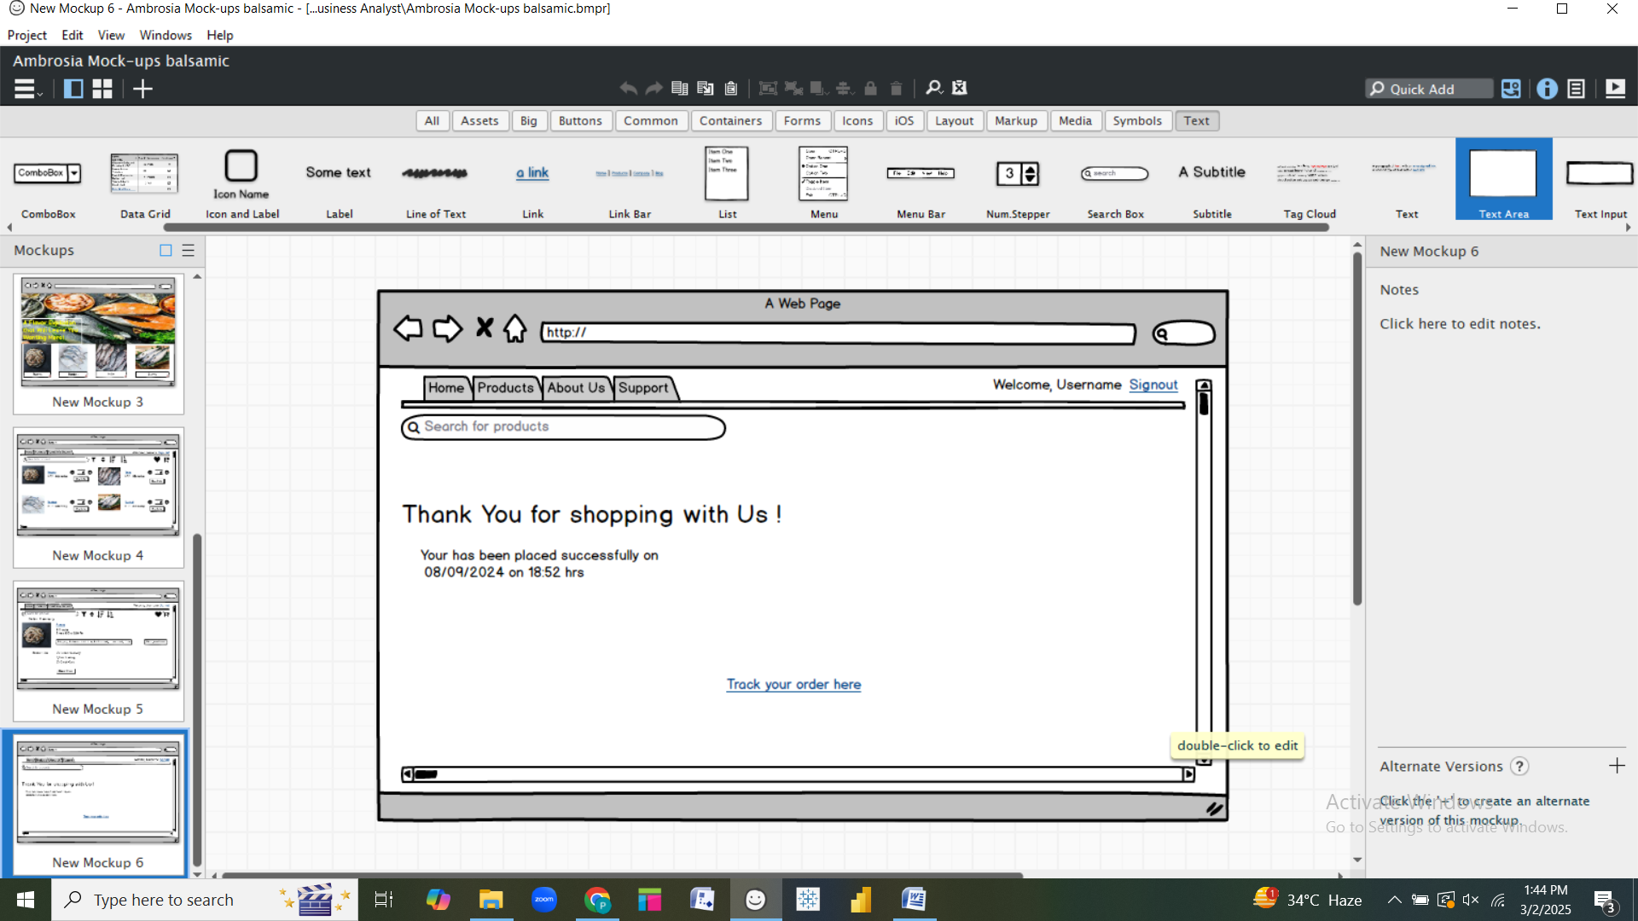

**Document 8 :**

**Tools - Visio and Axure :**

Using **Visio** and **Axure** for the Seafood Management ERP project has been an efficient approach to designing both diagrams and interactive wireframes. **Visio** has been particularly useful for creating structured diagrams like **Use Case Diagrams** and **Activity Diagrams,** providing clarity in system workflows and interactions. It’s drag-and-drop interface and stencil library made it easy to model processes visually. **Axure,** on the other hand, has been instrumental in crafting **interactive UI mock-ups,**  allowing for detailed representation of user journeys. With **Axure’s dynamic panels and prototyping capabilities,** I was able to simulate real-world interactions, making the wireframes highly intuitive. Both tools together provided a structured and interactive way to visualize the ERP system, ensuring a smooth design workflow.

**Document 9**

**My experience as BA in following phases :**

1. **Requirement Gathering :**

In the **Requirement Gathering** phase of the **Seafood Management ERP** project, I followed the **MoSCoW technique** to prioritize requirements into **Must-Have, Should-Have, Could-Have, and Won’t-Have** categories. This approach helped in defining the core functionalities essential for the system while keeping future enhancements flexible.

During this phase, **the client was unavailable for a certain period,** so I proactively identified and coordinated with alternative points of contact to ensure continuity in information gathering. To validate the requirements, I applied the **FURPS model** ( Functionality, Usability, Reliability, Performance, and Supportability ), ensuring that all requirements met business needs and technical feasibility.

A common challenge was the presence of **duplicate or redundant requirements,** which needed to be **identified and eliminated** promptly to maintain clarity and avoid scope creep. Additionally, **prototyping** played a crucial role in refining and clarifying requirements by providing stakeholders with **visual representation of system workflows and UI designs**, leading to more precise and actionable feedback.

1. **Requirement Analysis :**

In the **Requirement Analysis** phase of the **Seafood Management ERP** project, I focused on translating gathered requirements into structured **UML diagrams** and **Activity diagrams** to visually represent system workflows and interactions. These diagrams helped stakeholders and the development team understand key processes such as procurement, inventory management, and order processing.

Once the diagrams were prepared, I **communicated them to the team** for validation. Often, team members had differing viewpoints on certain workflows, requiring revisions based on their feedback. As a **Business Analyst,** it was crucial to consider these perspectives, address concerns, and make necessary modifications while ensuring alignment with business goals.

Additionally, I was responsible for preparing **Business Requirement Specification (BRS)** and **Software Requirement Specification (SRS)** documents, which detailed functional and non-functional requirements. These documents served as a reference for both development and quality assurance teams, ensuring a clear roadmap for implementation.

1. **Design :**

During the **design phase** of the **Seafood Management ERP** project, I focused on ensuring the system’s design alignment with the documented requirements. Using **Use Case Diagrams**, I prepared **test cases** that covered all possible scenarios, including both **positive and negative test cases**. Writing **negative test cases** was particularly important to identify potential system failures and edge cases early in the process.

I maintained continuous **communication with the client** to review **design and solution documents,** ensuring that the proposed system met business objectives. Missing even a single test case could have had a significant impact on later stages of development, so I ensured that all functionalities were thoroughly covered.

Additionally, I **prepared test data** to facilitate smooth testing and **updated the Requirements Traceability Matrix (RTM)** to verify that all business requirements were accounted for in the system design. This approach ensured that the project stayed aligned with stakeholder expectations while minimizing risks during development and testing.

1. **Development :**

In the **Development Phase** of the **Seafood Management ERP** project, my role as **Business Analyst** focused on ensuring smooth collaboration between stakeholders and the technical team. I organized **Joint Application Development ( JAD ) sessions** to bridge the gap between business requirements and system implementation, ensuring that developers fully understood the functional and technical aspects of the project.

During coding, I was actively involved in **clarifying queries from the technical team,** ensuring that development aligned with the documented requirements. At times, some team members disagreed with certain concepts or were uncooperative during discussions. To handle such situations, I conducted **one-on-one discussions,** explaining the impact of their decisions on the project and forecasting a **healthy, collaborative environment.**

I ensured that **diagrams ( Use Case, Activity, and Process Flows ) were referenced** while coding individual units, maintaining alignment with business objectives. Conducting **regular meetings** with both the technical team and the client was a challenge due to scheduling conflicts. To address this, I **recorded sessions** for those who missed them and followed up with **one-on-one discussions** to keep everyone aligned.

1. **Testing :**

During the **Testing Phase** of the **Seafood Management ERP** project, my role as a **Business Analyst** was crucial in ensuring that the system met all functional and business requirements. I began by **preparing test cases based on use cases,** ensuring that all possible scenarios – both positive and negative – were covered.

I performed **high level testing** to validate key functionalities before handing them over to the QA team for detailed testing. Since accurate data is crucial for testing, I coordinated with the **client to request** **necessary test data,** ensuring realistic test conditions.

Throughout the phase, I regularly **updated the Requirements Traceability Matrix (RTM)** to ensure that every requirement had been tested and met. Once the testing phase was complete, I facilitated the **clients sign-off,** confirming that the system was ready for deployment. Additionally, I played a key role in **preparing the client for User Acceptance Testing ( UAT )** by guiding them through the system, providing test scenarios, and addressing any concerns to ensure a smooth transition.

1. **Deployment :**

In the **Deployment Phase** of the **Seafood Management ERP** project, my responsibilities as a **Business Analyst** were centered around ensuring smooth transition from deployment to end-user adoption. I **forwarded the Requirements Traceability Matrix (RTM) to the client,** ensuring that it was included in the **project closure document** to verify that all requirements were met.

Additionally, I **coordinated the completion and distribution of end-user manuals**, providing clear documentation on system usage. To facilitate a seamless transition , I **planned and organized training sessions** for end-users, ensuring they understood how to navigate and operate the system efficiently.

A critical part of this phase was making sure that **all relevant candidates attended the training sessions.** I actively monitored attendance and followed up with any users who missed sessions to ensure that no one was left behind in the onboarding process. This approach helped in achieving a successful system rollout with minimal disruptions.