Waterfall Model Documents

Document 1- Business case document template
➢ Why is this project initiated?
- This project is initiated to modernize Aviva’s Master Data Management (MDM) infrastructure by migrating from an on-premise setup to a cloud-native solution. The goal is to enhance scalability, performance, security, and real-time integration capabilities while aligning with Aviva's broader cloud transformation strategy.
➢ What are the current problems?
- Inability to scale with growing data volumes.
- High maintenance costs for legacy infrastructure.
- Delays in real-time data availability and syncing.
- Manual intervention for data stewardship and governance.
- Limited support for modern data compliance regulations (e.g., GDPR, PIPEDA).

➢ With this project how many problems could be solved?

The project directly addresses at least five critical challenges:
- Scalability and performance bottlenecks
- High operational overhead
- Delayed data accessibility
- Manual governance and poor data quality
- Non-compliance with current security regulations

➢ What are the resources required?

- Time: 12 months
- Budget: ₹9 Crores
- Resource Categories:
  - Hardware Costs – Cloud infra migration and decommissioning on-prem servers.
  - Software Costs – Licensing cloud MDM and integration tools.
  - Training Expenses – Upskilling teams for new cloud tools and workflows.
  - Services Costs – Implementation, testing, and consultancy services.
  - Third-Party Software Evaluation – External tool assessments and POCs.
  - Site Visits – For collaboration across locations.
  - Miscellaneous Expenses – Contingency, documentation, and operational gaps.

➢ How much organizational change is required to adopt this technology?

A moderate-to-high level of change is required, including:
- Re-alignment of data governance practices
- User training and support systems for cloud adoption
- Shift to DevOps and CI/CD for cloud operations
- Changes in access, roles, and permissions structures
- Executive and cross-functional alignment

➢ Time frame to recover ROI?
Estimated 18 to 24 months, considering cost reduction in hardware maintenance, enhanced efficiency, regulatory compliance, and improved decision-making via trusted data.

➢ How to identify Stakeholders?
Stakeholders are identified based on their impact and influence over MDM processes and outcomes.
Key methods include:
- Stakeholder mapping (Influence vs. Interest grid)
- RACI Matrix (Responsible, Accountable, Consulted, Informed)
- Engaging cross-functional representatives from:
  - Business (Claims, Underwriting, Customer Service)
  - Data & IT teams
  - Security, Risk & Compliance
  - MDM Product Owners
  - Executive Sponsors & Project Governance teams

Document 2: BA Strategy

Write BA Approach strategy

1. Elicitation Techniques to Apply:
- Interviews with stakeholders to gather detailed requirements.
- Workshops to promote collaboration and get consensus.
- Surveys/Questionnaires for large user groups.
- Document Analysis of existing processes or systems.
- Observation (Job Shadowing) for real-time understanding.
- Prototyping to visualize expected system behavior.

2. Stakeholder Analysis (RACI/ILS):
- Use a Stakeholder Matrix to assess Influence vs. Interest.
- Define roles using RACI Chart:
  - Responsible: Who does the work (BA, Dev)
  - Accountable: Who owns the outcome (PM, Sponsor)
  - Consulted: Subject Matter Experts, Architects
  - Informed: End users, Operations
- ILS (Information, Logistics, Support): Helps track communication, logistics needs, and support mechanisms for stakeholders.

3. Key Documents to Write:
- Business Requirements Document (BRD)
- Functional Requirements Document (FRD)
- Use Case Document / User Stories
- Process Flows & Wireframes
- Requirement Traceability Matrix (RTM)
- Change Request Forms
- UAT Test Cases and Reports
- Client Sign-off Forms

4. Process for Document Sign-off:
- Conduct a walkthrough session with stakeholders.
- Collect feedback and revise the document as needed.
- Share the final version with version control.
- Use email or workflow tools (e.g., JIRA/SharePoint) for formal sign-off.

5. Approval from Client:
- Submit documents through agreed channels.
- Schedule a review meeting to resolve queries.
- Ensure client signs off via email confirmation or digital signature on the final documents.
- Archive approval documents for compliance.

6. Communication Channels to Establish and Implement:
- Weekly status calls with stakeholders
- Project Management tools (e.g., JIRA, Confluence)
- Emails for formal approvals and follow-ups
- Chat tools like MS Teams/Slack for daily updates
- Dashboards and reports for visual tracking

7. Handling Change Requests:
- Use a Change Request Form (CRF)
- Perform Impact Analysis (cost, time, scope)
- Get approval from Change Control Board (CCB)
- Update BRD/RTM accordingly
- Track changes using version control and logs

8. Updating Project Progress to Stakeholders:
- Send Weekly Status Reports
- Maintain and share a project dashboard
- Highlight risks, blockers, and milestones
- Use RAG (Red-Amber-Green) indicators for clarity
- Conduct monthly steering committee meetings

9. UAT and Client Sign-off Process:
- Create UAT Plan and Test Scenarios based on requirements
- Involve business users to perform UAT
- Document test results and fix defects
- Upon successful UAT, get signoff via Client Project Acceptance Form
- Archive signed documents in project repository

Document 3- Functional Specifications

Project Name | Aviva MDM Modernization – On-Premise to Cloud Migration
Customer Name | Aviva Canada Insurance
Project Version | 001
Project Sponsor | Mr. Karan (Head of Data & Analytics, Aviva)
Project Manager | Mr. Abhay (MDM Transformation Lead)
Project Initiated Date | 01-Apr-2025

Functional Requirement specifications:
Req ID | Req Name | Req Description | Priority
FR0001 | Customer Data Migration | Migrate all customer master records from MDM on-prem to IDMC Cloud MDM | High
FR0002 | Real-time Data Sync | Enable real-time integration between source systems and cloud MDM via APIs | High
FR0003 | Golden Record Creation | Define survivorship rules to ensure accurate golden record formation in cloud MDM | High
FR0004 | Data Quality Validation | Integrate IDQ rules to validate and cleanse customer data pre/post-migration | Medium
FR0005 | Role-based Access | Implement RBAC to ensure user-specific access to MDM entities and attributes | High
FR0006 | Audit and Logging | Maintain audit trails and logs for all create/update/delete operations in cloud MDM | Medium
FR0007 | Reporting & Dashboards | Provide operational dashboards for business teams to track data quality and usage | Low
FR0008 | UAT Support | Allow mock environments and test data setup for UAT validation | High
FR0009 | Change Management | Define a mechanism to support minor config changes post go-live | Medium

Document 4- Requirement Traceability Matrix

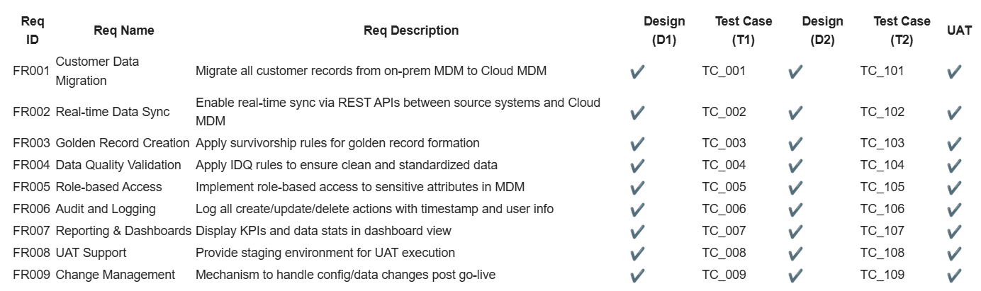

Document 5- BRD Template

1.Document Versions

Date | Version Number | Document Changes
02/05/2025 | 0.1 | Initial Draft

2. Approvals

Role | Name | Title | Signature | Date
Project Sponser | Mr. Abhay |  |  | 02/05/2025
Business Owner | Mr. Ankit |  |  | 02/05/2025
Project Manager | Mr. Pranay |  |  | 02/05/2025
System Architect | Mr. Harshith |  |  | 02/05/2025
Development Lead | Ms. Sunny |  |  | 02/05/2025
User Experience Lead | Mr. Sayan |  |  | 02/05/2025
Quality Lead | Mr. Vijay |  |  | 02/05/2025
Content Lead | Mr. Suchith |  |  | 02/05/2025

3. RACI Chart
In the RASCI model:
R stands for Responsible: These are the individuals or roles responsible for completing the task or making the decision.
A stands for Accountable: This is the person who is ultimately answerable for the completion of the task or the decision-making process. There should be only one person accountable for each task or decision.
S stands for Support: These are the individuals or roles that provide assistance or support to those responsible for completing the task.
C stands for Consulted: These are the individuals or roles that need to be consulted before a decision is made or action is taken. Their input is valuable for the completion of the task.
I stands for Informed: These are the individuals or roles that need to be kept informed about the progress or outcome of the task or decision-making process. They are not directly involved but need to be aware of what's happening.
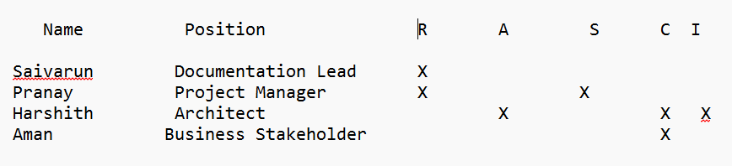

4. Introduction

  - Business Goals

- Enable Aviva to modernize MDM capabilities on a cloud platform for scalability, agility, and regulatory compliance.

4.2 Business Objectives

- The Migrate from legacy MDM to a scalable cloud-native platform.
- Improve data quality, governance, and real-time integration.

4.3 Business Rules
- Firstly, All customer records must follow survivorship rules.
- Matching and merging to adhere to compliance regulations.

4.4 Background
Aviva’s legacy on-prem MDM faced issues like limited scalability, high maintenance, and delayed integration with other systems. The modernization project aims to address these and support future growth.
4.5 Project Objective
- The To deploy a cloud-based MDM platform integrated with enterprise systems, supporting real-time customer data updates, improved stewardship, and analytics readiness.
4.6 Project Scope
4.6.1 In Scope Functionality
- In-scope Golden Record Management
- Real-time & batch integration
- Data stewardship console
- Hierarchy management

4.6.2 Out Scope Functionality

- Downstream application updates
- MDM mobile app version

5. Assumptions
- The Cloud infrastructure is provisioned.
- APIs from source systems are available.

6. Constraints
- The Budget constraints
- Timeline fixed by business quarter deadlines
- Limited legacy documentation

7. Risks
Technological Risks: Incompatibility between legacy formats and cloud ingestion.
Skills Risks: Lack of hands-on cloud MDM expertise.
Political Risks: Resistance from departments reliant on legacy systems.
Business Risks: Delay in customer support operations during migration.
Requirements Risks: Incomplete understanding of downstream dependencies.
Other Risks: Vendor dependency for cloud tool support.

8. Business Process Overview
8.1 Legacy System (AS-IS)
Customer data managed on an on-prem Informatica MDM platform with batch updates and limited integration.
8.2 Proposed (TO-BE)
Cloud-based real-time MDM with improved governance, lineage, survivorship, and integrations.

9. Business Requirements

S.No | Business Requirements | Functionality | Priority
1 | Golden Record Management | Match, merge, and maintain a single source of truth | High
2 | Real-time Integration Support | Enable live data sync with enterprise systems via APIs | High
3 | Data Stewardship Console | Interface for data review, validation, and approval | High
4 | Security and Compliance | Ensure compliance with GDPR, PIPEDA, and secure encryption standards | High
5 | Multi-domain MDM Support | Manage multiple domains like Customers, Policies, and Agents | High

10. Appendices
10.1 List of Acronyms
MDM – Master Data Management
RTO – Recovery Time Objective
RPO – Recovery Point Objective
10.2 Glossary
Survivorship – Rule to determine master record
Stewardship – Human review and correction of records
10.3 Related Documents
- Functional Specifications Document
- Requirement Traceability Matrix

