**AGILE DOCUMENTS**

**Document 1: Definition Of Done**

The Definition of done means the criteria that must be met for a User Story, Feature, or Sprint to be considered "Done" (complete) for the core banking system enhancements project. All team members agreed on below criteria.

It is a checklist of criteria that must be met before considering user story to be finished and ready for the next stage in the development process.

**FOR EXAMPLE:**

**User Story 1:** As a banking staff, I want to process customer transactions (deposits, withdrawals) so that I can improve customer satisfaction and reduce waiting times.

The banking staff want to be able to handle deposits and withdrawals efficiently to serve customers better. The DoD ensures that this functionality is built to a high standard.

Based on checklist below is the explanation of example…

**Produced Code:**

The code must have the deposit and withdrawal features. This code must be complete, meaning it handles all expected scenarios i.e. valid amounts, insufficient funds, calculates and updates account balances etc.).

**Assumptions Met:**

There might be assumptions about transaction limits, how customer data is accessed, error handling, etc. These assumptions were clearly documented within the User Story details (e.g., in the Jira). For example, an assumption might be "Transactions are limited to ₹50000 amount." These assumptions was validated. If an assumption changes during development (e.g., the limit is changed to ₹40000), this change was documented and approved by the Product Owner.

**Clean Build:**

* The entire project, including the new code for deposits and withdrawals, was build successfully on the designated build server. This means the code compiles without errors and was integrated correctly with other parts of the system.

**Unit Tests:**

* Developers has written unit tests to verify that the deposit and withdrawal functions work correctly. These tests covered various scenarios (valid inputs, invalid inputs). All unit tests must pass successfully. For example, a unit test checked that a withdrawal from an account with sufficient funds reduced the balance correctly.

**Environment & Testing:**

**Deployment:**

* The new code was deployed to the test environment which was close to the production environment.

**Device/Browser Testing:**

* The deposit and withdrawal features was tested on all the target devices and browsers specified in the project assumptions document. This ensures that the functionality works correctly on different platforms. For example, tests were run on Chrome and the bank's mobile app on both iOS and Android.

**UX Sign-off:**

* The UX designer reviewed and approved the user interface for the deposit and withdrawal features. This ensured that the interface was user-friendly and consistent with the overall design and approval were formally documented.

**QA Testing:**

* The QA team perform testing of the deposit and withdrawal features which includes testing various scenarios, looking for bugs, and ensuring that the functionality meets the requirements. All bugs (if any) were fixed and tested again. QA team sign off was also taken.

**Acceptance Criteria:**

* The User Story has specific acceptance criteria. For example:
  + "A user can successfully deposit funds into their account."
  + "A user can successfully withdraw funds from their account (if sufficient funds are available)."
  + "The system displays appropriate error messages for invalid inputs."
* These features were tested against above criteria, and all criteria was met.

**Code Quality & Documentation:**

**Refactoring:**

* If any code refactoring (improving the code structure without changing its functionality) was necessary during the development of this User Story, it was completed and tested.

**Configuration or Build Changes:**

* No changes were required however, any changes to the system's configuration or build process required by this User Story was documented.

**Documentation Updates:**

* Any user manuals, technical documentation, or API documentation that needs to be updated to reflect the new functionality was updated.

**Peer Code Review:**

* Another developer must review the code written for this User Story. This helps to catch potential errors and ensure code quality. Any feedback from the code review were addressed.

**Document 2: Product Vision**

**Answer: Product Vision Table**

|  |  |  |  |
| --- | --- | --- | --- |
| **Project Name** | Bancs Application Enhancement |  |  |
| **Venue:** | Pune | **Date:** | 20/01/2025 |
| **Start Time:** | 10am | **End Time:** | 11pm |
| **Client:** | Diligenta |  |  |
| **Stakeholders:** | PO | Developers | Client |
|  | IT Operation | Customer support | Customer |
|  | End user | Regulatory Bodies | Partners |
|  |  |  |  |
| **Scrum Team** | Rajat |  |  |
| **Developer 1** | Kashmira | **Developer 2** | Sonali |
| **Developer 3** | Ankita | **Developer 4** | Frank |
| **Developer 5** | Pushpa |  |  |

**What is your vision, your overarching goal for creating the product?**

|  |  |  |  |
| --- | --- | --- | --- |
| **Vision:** My Vision is to work on banking application and provide a product which delivers solution effectively and addresses both current and future business needs and at the same time add value to end user and all the stake holder.  Goal is to develop application into a more user friendly, scalable, and adaptable as per the business environment particularly for banking sector.   * **Enhance efficiency** by improving automation and workflows and thus leading to faster banking process. * **Enhance user experience** by designing intuitive user interface that reduces user learning curve and user satisfaction. * **Enhance scalability and flexibility** which makes the system adaptable to changing requirements, easy to integrate with new product, service, and other application. * **Supports regulatory compliance** ensuringapplication supports evolving regulations. | | | |
| **Target Group**  Which market segment does the product address?   * Banks (retail, commercial, and digital banks) * Insurance and Wealth Management Companies * Small financial institutions * Regulatory Bodies (for compliance-related needs)   Who are the target users and customers?   * Banking user/staff * IT & System admin * Trader, Analyst, Wealth Manager * Banks, Financial Institution | **Needs**  What problem does the product solve?   * *Slow Adoption and Training****:*** Core banking systems can be hard to understand and require extensive training. * *Integration:* Difficulty integrating new features or third-party systems with the core banking platform will solve the integration problem. * *High Configuration and Maintenance Costs:* High time taken for configuring or enhancing the system results in delay and rising operational costs. * *Data Migration:* Challenges with migrating and managing large customer database securely across multiple product lines.   Which benefit does it provide?   * Better user experience * Flexible & adaptable – System allows quick configuration and integration to new service (mob banking, UPI & wallets) * Automation & Optimization - reduce the need for manual intervention thus increases processing speed increase operational efficiency | **Product**  What product is it?   * It’s the banking application with enhanced functionalities, new user interfaces, and improved integration capabilities with third-party applications, digital banking.   What makes it desirable and special?   * It is customizable and flexible and more Intuitive UI/UX * Its modular designallows the financial institution to adopt the specific features as per there need * More compatibility with third-party systems, payment gateways, mobile apps and flexibility for future upgrades * Itsfocus on security to protect sensitive financial data, with built-in encryption and secure authentication protocols.   Is it feasible to develop the product?   * Yes, the product is feasible to develop with existing core banking frameworks and adding enhancements using modern technologies such as cloud computing, API management, and AI/ML (Artificial Intelligence/Machine Learning) for automation and insights * The development team has the necessary technical expertise of banking sector with adequate and right resource allocation, with right technology for the product. | **Value**  How is the product going to benefit the company?   * *Revenue increase:* By offering new and improved features to financial institutions, the company can capture a larger market in banking sector and attract customers from other banking providers. * *Customer Retention:* Customers will benefit from enhanced functionality, leading to higher customer satisfaction and in turn more customer.   What are the business goals?   * Offer enhance product/platform with new features * Increase market share and Capture more clients in the financial services market * Generate Continuous Revenue leverage subscription models, licensing, and service agreements   What is the business model?   * ***Subscription based licensing:*** Here we will allow financial institutions to pay annually or monthly for access to the software. * ***Professional services:*** Revenue from consulting, training, and implementation services to help customer set up, configure, and integrate the system according to their specific requirements. * **Maintenance and Upgrades:** Recurring revenue from maintenance contracts and periodic upgrades ensures the system stays up to date with new features, security patches |

**Document 3: User stories**

|  |  |  |  |  |  |  |
| --- | --- | --- | --- | --- | --- | --- |
| Story No. | Goal | A. Criteria | Tasks | BV | CP | Priority |
| 1 | As a banking staff, I want to process customer transactions (deposits, withdrawals).  So that I can improve customer satisfaction and reduce waiting times. | Click on deposite/withdrawals. Enter the amount. Hit submit. Show notification of successful/Unsuccessful Deposit/Withdrawals. | * Design/Develop UI for deposit/withdrawal. * Implement transaction processing logic * Implement notification system. | 3 | 8 | Med |
| 2 | As a banking staff, I want to view customer balances  So that I can provide details to customer when requested. | Click on show balance. System should show real time balance. | * Design/Develop UI for balance display. * Implement real-time balance retrieval. | 3 | 5 | Med |
| 3 | As a customer want to access a/c online via mobile app  So that I can perform transaction and manage my finances | Customer can login to mobile app, view balances, transfer fund and see history | * Design/Develop login screen. * Provide payment gateways * Implement authentication logic. | 5 | 13 | High |
| 4 | As a staff want to view loan eligibility based on credit score and history  So that I can loan product can be offered accordingly | Need access to customer credit score and history. System show Eligibility criteria, loan limits, interest rates, and products. | * Design/Develop loan eligibility check UI. * Integrate with credit scoring system. * Define loan product rules. | 1 | 3 | Low |
| 5 | As a customer want to receive notification for my account  So that i stay informed about activities of my account | System should send email/SMS notifications for deposits, withdrawals, and transfers in real time | * Design/Develop notification system. * Implement notification triggers (deposits, withdrawals, transfers). * Configure notification channels (email, SMS). | 3 | 13 | High |
| 6 | As an admin want to monitor system performance and uptime  So that I can ensure system availability all time | Real time access to system dashboard and alert for any issue or downtime | * Set up monitoring tools. * Configure alerts for issues and downtime. * Design/Develop system dashboard. | 1 | 5 | Low |
| 7 | As a staff want to update customer details  So that i can ensure customer record is up to date | System should show fields related to customer name, phone number, account number, address | * Design/Develop customer details update form. * Implement data validation. * Implement data update logic. | 3 | 5 | Med |
| 8 | As a staff want to update customer details.  So that i can ensure customer record is up to date. | System should show fields related to customer name, phone number, account number, address | * Design/Develop customer details update form. * Implement data validation. * Implement data update logic. | 3 | 8 | Med |
| 9 | As a staff I want to update service fees to certain transaction (international payment Etc..)  So that i can collect accurate fee. | System should calculate fees bases on transaction type. The fees should be shown before completing transaction | * Design/Develop fee update UI. * Implement fee calculation logic. * Integrate with transaction processing. | 1 | 3 | Low |
| 10 | As a customer I want to setup auto bill payment (utilities & loan).  So that i don’t miss my dues | System should allow customer to schedule and manage recurring payments. System should send notification for the transaction processed. | * Design/Develop auto bill payment setup UI. * Implement scheduling and payment processing. * Implement notification system. | 5 | 8 | High |
| 11 | As a manager i want to generate report for transaction volume customer feedback.  So that i can assess staff performance | System should generate report on daily, weekly, and monthly based on transaction, customer satisfaction | * Design/Develop report generation tool. * Implement data aggregation and analysis. * Define report formats. | 3 | 5 | Med |
| 12 | As a customer i want to apply for loan via banking app.  So that i can apply from my mobile without visiting bank. | Customer should have access to app login, app should have apply for loan option, with eligibility & upload documents option. | * Design/Develop loan application flow in app. * Implement eligibility check. * Implement document upload. | 1 | 5 | Low |
| 13 | As a customer i want to download bank statement in pdf format from mobile app.  So that i can track my incomes and expenditure | customer should have access to app login. He should have option to download monthly statements for any selected time period in pdf format | * Design/Develop statement download feature. * Implement PDF generation. | 1 | 3 | Low |
| 14 | As a developer i want to integrate third party gateways for ease of banking.  So that i can make payment across various payment methods | system should be integrated and made compatible with external payment system (e.g. Paypal, phonepe etc). System should provide various payment option. | * Design API for payment gateway integration. * Implement integration with specific gateways (e.g., Stripe). | 5 | 8 | High |
| 15 | As an admin want to set permission for loan application s.  So that only authorized users can approve or reject | System should check the restriction placed on operators ID based on role and should provide access to approvals | * Design/Develop permission management UI. * Implement role-based access control. | 3 | 5 | Med |
| 16 | As an admin i want to set up customer notification preferences.  So that customer can receive alerts through various channels (email, sms, whatsapp, push notification) | add option for notification preferences for customer (email, sms, whatsapp, push notification). The customer should have option to opting in for preferences. | * Design/Develop notification preference UI. * Implement channel configuration (email, SMS, etc.). | 1 | 3 | Low |
| 17 | As an customer i want to block my debit/credit card vis mobile app.  So that i can protect my account from unauthorized use/access | add option under profile option for block/unblock the card, after confirming customer identity, select card and then block the card, a pop up should appear stating to confirm the block | * Design/Develop card blocking feature in app. * Implement security measures (verification). | 5 | 8 | High |
| 18 | As an customer i want to track status of my loan application.  So that i can stay updated on my loan approval or rejection. | in mobile app add track status feature, by clicking on which it should ask for loan account number. Later should provide detailed status of the application and expected timeline of approval | * Design/Develop loan status tracking feature. * Implement status update mechanism. | 3 | 8 | Med |
| 19 | As an customer i want to add beneficiaries to my account.  So that i can transfer fund seamlessly to various accounts in my contacts | provide add beneficiaries details feature under profile with details (name, account number, relationship) | * Design/Develop beneficiary management feature. * Implement data validation and storage. | 3 | 5 | Med |
| 20 | As an admin want to audit transaction log.  So that i can audit transaction logs and identify any suspicion. | provide access to lof transaction with date and time of user and transaction details | * Design/Develop transaction log viewer. * Implement search and filtering. | 3 | 5 | Med |
| 21 | As an staff want to track and resolve customer complaints.  So that i can provide timely assistance. | Provide access to complaint log, complaints should be categorized based on type of complaint. | * Design/Develop complaint tracking system. * Implement categorization and assignment. | 1 | 3 | Low |
| 22 | As an staff want to see real time performance matrics (transaction volume, customer service quality).  So that i can take actions to improve the performance | Branch manager should have access to metrics on real time dashboard. Metrics should include AHT and customer satisfaction score. | * Design/Develop real-time dashboard. * Implement data aggregation and display. | 1 | 5 | Low |
| 24 | As an customer want to add multiple bank account to via mobile app.  So that i can mange multiple account via one platform. | Authorised customer with valid login can link multiple accounts | * Design/Develop multi-account linking feature. * Implement security measures. | 5 | 13 | High |
| 25 | As an it amin want auto system backups.  So that data is protected always. | Schedule auto backup every day on time and store. Should be restored if necessary | * Configure backup schedule and storage. * Implement restoration process. * Implement backup monitoring and alerts. | 1 | 5 | Low |
| 25 | As a staff (loan officer) want loan repayment schedule.  So that I can provide loan management support. | System should display detailed loan repayment schedule. Officer can adjust terms or issue reminder to customer. | * Design/Develop loan repayment schedule display. * Implement schedule generation and modification. | 5 | 13 | High |
| 26 | As a customer want to withdraw from atm via mobile.  So that I there is no need to carry debit card | System should provide customer with QR code and mobile app should generate OTP verification | * Design and implement the UI for the withdrawal process * Design QR Code Scanner Integration * Develop functionality to generate OTP requests * Implement UI for OTP input and validation. | 3 | 13 | Med |
| 27 | As an admin want to set permission for loan application.  So that only authorized users can approve or reject. | System should check the restriction placed on operators’ ID based on role and should provide access to approvals | * Design/Develop permission management UI (Approve Loan, Reject Loan). * Implement role-based access control. | 3 | 5 | Med |
| 28 | As a customer want to update my personal identification details in system.  So that my records are up-to-date | System should provide access to authorized customer via mobile app. System should validate the changes provided the required documents are uploaded in system. | * Design/Develop personal details update feature. * Implement data validation and document upload. | 3 | 5 | Med |
| 29 | As a it admin want to apply security patches.  So that vulnerabilities are mitigated and system remains secure. | System should be compatible for upgradation. Security should be able to applied during non-peak hours. System should alert if patches fail. | * Implement patch management process. * Schedule patch application during non-peak hours. * Implement patch failure alerts. | 3 | 8 | Med |
| 30 | As a bank want to conduct user feedback surveys.  So that i can identify areas for improvement. | To collect the survey in regular interval and analyze it for the future system updates. | * Design survey questions. * Implement survey collection mechanism. * Implement data analysis and reporting. | 5 | 8 | High |
| 31 | As a customer want to link external bank account.  So that transfer of funds can be done between accounts | System should allow linking with authorized external bank accounts. Cross bank transfer should be processed securely | * Design/Develop external account linking feature. * Implement security measures for cross-bank transfers. | 1 | 3 | Low |
| 32 | As a developer want to create api endpoints for integration with thrid party services.  So that i can expand the platform capabilities | System should have secure API for third party integration. Documentation and guidelines should be available for the developers. | * Design and develop secure API endpoints. * Create API documentation and guidelines. | 3 | 8 | Med |
| 33 | As a customer want to set limits on my debit/credit card.  So that i can control over my spendings. | System should set transaction/withdrawal limit option, with field to enter figures manually. Notification should be send to customer when limit is about to reach. | * Design/Develop transaction/withdrawal limit feature. * Implement notification system for limit alerts. * Implement daily transaction limit feature. * Implement alerts for exceeded limits | 3 | 5 | Med |
| 34 | As a customer want to link account to social media account of bank.  So that i can get personalized offer and notification. | System should provide option to link to social media and should provide option to On/Off the notification for the same | * Design/Develop social media linking feature. * Implement notification preferences for social media offers. | 3 | 13 | Med |
| 35 | As a admin want multi factor authentication (mfa) for accessing sensitive customer data.  So that customer get enhanced security. | System to provide MFA access to users using sensitive data. System to support various authentication methods (SMS, email, OTP) | * Implement MFA for accessing sensitive data. * Support various authentication methods (SMS, email, OTP). | 5 | 5 | High |
| 36 | As a admin want to set auto password expiration for user.  So that security standard can be maintained | System should auto prompt change password after specific period and send notification too | * Implement auto password expiration feature. * Implement notification system for password expiration. | 1 | 3 | Low |
| 37 | As a developer want to create automated deployment pipelines for banking system.  So that new feature and updates can be rolled out quickly and  safely. | System should support automated deployments with rollback prompt change password after specific period and send notification too | * Set up automated deployment pipeline. * Implement rollback capabilities. | 3 | 5 | Med |
| 38 | As a admin want to set daily transaction limit for customer.  So that customer can be safe from fraud and risk | System to provide option to admin to set limit on transaction. Alert to be triggered if limit exceeded | * Design/Develop personal details update feature. * Implement data validation and document upload. | 3 | 5 | Med |
| 39 | As a developer want to integrate AI tools  So that fraud can be detected and help prevent unauthorized transaction | System to installed with AI algorithms that analyze transaction patterns for anomalies. System to flag/trigger alert if anomalies found. | * Integrate AI algorithms for anomaly detection.· * Implement alert system for suspicious transactions. | 3 | 8 | Med |
| 40 | As a customer want to update my personal identification details in system.  So that my records are up-to-date | System should provide access to authorized customer via mobile app. System should validate the changes provided the required documents are uploaded in system. | * Design/Develop personal details update feature. * Implement data validation and document upload. | 5 | 8 | High |

**Document 4**

**Agile Product Owner (PO) Experience Summary**

In my experience as a Product Owner (PO), I have been deeply involved in development and delivery of the product in collaboration with all stakeholders and Scrum team members.

The key learnings I have gained in the process are as below…

**Market Analysis & Market Demand:** For this I did research to understand the market demand by interacting with stakeholders and customers, which gave me insights of customer problem issues and their needs.

Being PO I assessed the strength and weaknesses of product like ours which gave me visibility to better position our product and improve the areas where competitors are lacking.

This helped me in learning ability to evaluate market and understand how to differentiate our product and deliver value and remain competitive.

**Due Diligence on Market Opportunity:** Due diligence being a thorough study about company, product or service which later helps in taking financial and legal decision helped me evaluate the feasibility and potential of the product. This was done by analyzing potential customer segments, identifying trends, and thus forecasting future growth in the market.

This helped me learn the ability to assess the financial and strategic impact of product development.

**Product Vision and Roadmap:**

Having knowledge and working closely with stakeholders helped me to define and communicate a clear product vision and business objectives. This provided me with the guiding principles for the product's design and functionality.

Based on the market analysis and needs, I developed a roadmap that outlined the key features, and timelines for the product’s development.

This helped me learn how to balance long-term and short-term goals which aligns business needs by roadmap which is adaptable yet focused.

Doing market analysis, due diligence and preparing roadmap helped me in understanding the product and thus we came up with precise product features.

**Managing Product Features and Managing Stakeholder Expectations and Prioritizing Needs:**

I was in constant touch with stakeholders to understand their needs and concerns. This helped in managing expectations, ensuring that stakeholders had realistic views of the product’s its capabilities and timelines. Thus, features/requirements were gathered, prioritized and finalized in communication with stakeholders.

Prioritization of Epics, Stories, and Features (poker, CP/SP, Moscow, Jira) were done based on business value, its complexity, customer impact. This involved collaboration with the team to break down features into manageable tasks. Reprioritization was also done based on evolving business needs and customer feedback.

This helped me refined my skills in negotiation and communication, ensuring that all stakeholders were on the same page. Prioritization was most important in maximizing ROI and at the same time alignment with business goals.

Through constant backlog refinement in interaction with stakeholders helped me adjust priorities quickly in response to shifting business needs

**Sprint: Being PO I regularly reviewed the progress of each sprint**, working closely with the Scrum Master and team members to identify obstacles and ensure that the development was on track to meet sprint goals.

After each sprint, I participated in sprint review, retrospectives to check what went well, what didn’t, and how we could improve the moving forward. This feedback was key to continuous improvement.

Also, every User Story I learned how to effectively define the scope for the sprint and help the team set realistic goals while managing stakeholder expectations.

**User Stories Creation:** Being PO I was responsible for creating user stories that helped me prepare the product backlog**.** Each user story was prepared using below…

Story Number: A unique identifier for each user story.

Tasks: Clear and actionable tasks required to complete the user story.

Priority: Based on business value and impact.

Acceptance Criteria: Conditions that must be met for the user story to be considered complete.

BV & CP (Business Value & Customer Priority): Clear assessment of the business value and customer priority for the feature.

Role as Liaison Between Multiple Stakeholders:

So as a Product Owner, I was the key liaison between different departments, ensuring that the needs of the business were met while maintaining alignment with the development team.

I communicated regularly with business stakeholders to gather requirements and feedback, ensuring that the Scrum team was building a product which is as per expectation.

**Document 5**

**Product and sprint backlog and product and sprint burndown charts**

**Product Backlog**

|  |  |  |  |  |  |  |  |  |
| --- | --- | --- | --- | --- | --- | --- | --- | --- |
| **Story ID** | **User Story** | **Tasks** | **Priority** | | **BV** | **SP** | **Sprint** | |
| 1 | As a Bank Teller, I want to process customer transactions (deposits, withdrawals), so that I can improve customer satisfaction and reduce waiting times. | * Design/Develop UI for deposit/withdrawal. * Implement transaction processing logic * Implement notification system. | High | | 5 | 8 | 1 | |
| 2 | As a Bank Teller, I want to view customer balances, so that I can provide details to customers when requested. | * Design/Develop UI for balance display. * Implement real-time balance retrieval. | High | | 5 | 5 | 1 | |
| 3 | As a Customer, I want to log into the mobile app, so that I can access my accounts. | * Design/Develop login screen. * Implement authentication logic. | High | | 5 | 3 | 1 | |
| 4 | As a Bank Teller, I want to view loan eligibility based on credit score and history, so that loan products can be offered accordingly. | * Design/Develop loan eligibility check UI. * Integrate with credit scoring system. * Define loan product rules. | Medium | | 3 | 5 | 3 | |
| 5 | As a Customer, I want to receive notifications for my account activity, so that I stay informed. | * Design/Develop notification system. * Implement notification triggers (deposits, withdrawals, transfers). * Configure notification channels (email, SMS). | Med | | 3 | 8 | 2 | |
| 6 | As a System Administrator, I want to monitor system performance and uptime, so that I can ensure system availability. | * Set up monitoring tools. * Configure alerts for issues and downtime. * Design/Develop system dashboard. | Low | | 1 | 5 | 4 | |
| 7 | As a Bank Teller, I want to update customer details, so that I can ensure customer records are up-to-date. | * Design/Develop customer details update form. * Implement data validation. * Implement data update logic. | Med | | 3 | 5 | 2 | |
| 9 | As a Bank Teller, I want to update service fees for certain transactions (international payments, etc.), so that I can collect accurate fees. | * Design/Develop fee update UI. * Implement fee calculation logic. * Integrate with transaction processing. | Low | | 1 | 3 | 4 | |
| 10 | As a Customer, I want to set up auto bill payments (utilities & loan), so that I don’t miss my dues. | * Design/Develop auto bill payment setup UI. * Implement scheduling and payment processing. * Implement notification system. | High | | 5 | 9 | 2 | |
| 11 | As a Manager, I want to generate reports for transaction volume and customer feedback, so that I can assess staff performance. | * Design/Develop report generation tool. * Implement data aggregation and analysis. * Define report formats. | Med | | 3 | 8 | 3 | |
| 12 | As a Customer, I want to apply for a loan via the banking app, so that I can apply from my mobile. | * Design/Develop loan application flow in app. * Implement eligibility check. * Implement document upload. | Low | | 1 | 5 | 4 | |
| 13 | As a Customer, I want to download bank statements in PDF format from the mobile app, so that I can track my income and expenses. | * Design/Develop statement download feature. * Implement PDF generation. | High | | 5 | 8 | 2 | |
| 14 | As a Developer, I want to integrate third-party payment gateways, so that I can offer various payment methods. | * Design API for payment gateway integration.* Implement integration with specific gateways (e.g., Stripe). | High | | 5 | 8 | 3 | |
| 15 | As a System Administrator, I want to set permissions for loan applications, so that only authorized users can approve or reject them. | * Design/Develop permission management UI. * Implement role-based access control. | Med | | 3 | 5 | 3 | |
| 16 | As a System Administrator, I want to set up customer notification preferences, so that customers can receive alerts through various channels. | * Design/Develop notification preference UI. * Implement channel configuration (email, SMS, etc.). | Low | | 1 | 3 | 4 | |
| 17 | As a Customer, I want to block my debit/credit card via the mobile app, so that I can protect my account. | * Design/Develop card blocking feature in app. * Implement security measures (verification). | High | | 5 | 8 | 1 | |
| 18 | As a Customer, I want to track the status of my loan application, so that I can stay updated. | * Design/Develop loan status tracking feature. * Implement status update mechanism. | Med | | 3 | 5 | 2 | |
| 19 | As a Customer, I want to add beneficiaries to my account, so that I can transfer funds seamlessly. | * Design/Develop beneficiary management feature. * Implement data validation and storage. | Med | | 3 | 5 | 2 | |
| 20 | As a System Administrator, I want to audit transaction logs, so that I can identify any suspicious activity. | * Design/Develop transaction log viewer. * Implement search and filtering. | Med | | 3 | 8 | 3 | |
| 21 | As a Bank Teller, I want to track and resolve customer complaints, so that I can provide timely assistance. | * Design/Develop complaint tracking system. * Implement categorization and assignment. | Low | | 1 | 5 | 4 | |
| 22 | As a Branch Manager, I want to see real-time performance metrics, so that I can take actions to improve performance. | * Design/Develop real-time dashboard. * Implement data aggregation and display. | Low | | 1 | 5 | 4 | |
| 24 | As a Customer, I want to add multiple bank accounts via the mobile app, so that I can manage them in one place. | * Design/Develop multi-account linking feature. * Implement security measures. | High | | 5 | 8 | 2 | |
| 25 | As a IT Administrator, I want automated system backups, so that data is always protected. | * Configure backup schedule and storage. * Implement restoration process. * Implement backup monitoring and alerts. | Low | | 1 | 5 | 4 | |
| 26 | As a Loan Officer, I want loan repayment schedules, so that I can provide loan management support. | * Design/Develop loan repayment schedule display. * Implement schedule generation and modification. | High | | 5 | 8 | 3 | |
| 27 | As a System Administrator, I want to set permissions for loan applications, so that only authorized users can approve or reject them. | * Design/Develop permission management UI. * Implement role-based access control. | Med | | 3 | 5 | 3 | |
| 28 | As a Customer, I want to update my personal identification details, so that my records are up-to-date. | * Design/Develop personal details update feature.* Implement data validation and document upload. | Med | | 3 | 5 | 2 | |
| 29 | As a IT Administrator, I want to apply security patches, so that vulnerabilities are mitigated. | * Implement patch management process. * Schedule patch application during non-peak hours. * Implement patch failure alerts. | Med | | 3 | 8 | 3 | |
| 30 | As a Bank, I want to conduct user feedback surveys, so that I can identify areas for improvement. | * Design survey questions. * Implement survey collection mechanism. * Implement data analysis and reporting. | | High | | 5 | 13 | 3 |
| 31 | As a Customer, I want to link external bank accounts, so that I can transfer funds between accounts. | * Design/Develop external account linking feature. * Implement security measures for cross-bank transfers. | | Low | | 1 | 8 | 4 |
| 32 | As a Developer, I want to create API endpoints for integration with third-party services, so that I can expand platform capabilities. | * Design and develop secure API endpoints. * Create API documentation and guidelines. | | Med | | 3 | 13 | 3 |
| 33 | As a Customer, I want to set limits on my debit/credit card, so that I can control my spending. | * Design/Develop transaction/withdrawal limit feature. * Implement notification system for limit alerts. | | Med | | 3 | 8 | 2 |
| 34 | As a Customer, I want to link my account to social media accounts, so that I can get personalized offers. | * Design/Develop social media linking feature. * Implement notification preferences for social media offers. | | Med | | 3 | 8 | 3 |
| 35 | As a System Administrator, I want multi-factor authentication (MFA) for sensitive data access, so that customer data is more secure. | * Implement MFA for accessing sensitive data. * Support various authentication methods (SMS, email, OTP). | | High | | 5 | 13 | 2 |
| 36 | As a System Administrator, I want to set auto password expiration for users, so that security standards are maintained. | * Implement auto password expiration feature. * Implement notification system for password expiration. | | Low | | 1 | 5 | 4 |
| 37 | As a Developer, I want to create automated deployment pipelines, so that new features can be rolled out quickly and safely. | * Set up automated deployment pipeline. * Implement rollback capabilities. | | Med | | 3 | 13 | 3 |
| 38 | As a System Administrator, I want to set daily transaction limits for customers, so that customers are safe from fraud. | * Implement daily transaction limit feature. * Implement alerts for exceeded limits. | | Med | | 3 | 8 | 2 |
| 39 | As a Developer, I want to integrate AI tools for fraud detection, so that unauthorized transactions can be prevented. | * Integrate AI algorithms for anomaly detection. * Implement alert system for suspicious transactions. | | Med | | 3 | 13 | 3 |
| 40 | As a Customer, I want to update my personal identification details, so that my records are up-to-date. | * Design/Develop personal details update feature. * Implement data validation and document upload. | | High | | 5 | 8 | 2 |

**Sprint Backlog**

|  |  |  |  |  |  |  |
| --- | --- | --- | --- | --- | --- | --- |
| Story ID | User Story | Tasks | Priority | BV | SP | Sprint |
| 1 | As a Bank Teller, I want to process customer transactions (deposits, withdrawals)... | * Design/Develop UI for deposit/withdrawal. * Implement transaction processing logic * Implement notification system. | High | 5 | 8 | 1 |
| 2 | As a Bank Teller, I want to view customer balances... | * Design/Develop UI for balance display * Implement real-time balance retrieval. | High | 5 | 5 | 1 |
| 3 | As a Customer, I want to log into the mobile app... | * Design/Develop login screen. * Implement authentication logic. | High | 5 | 3 | 1 |
| 12 | As a Customer, I want to apply for a loan via the banking app... | * Design/Develop loan application flow in app. * Implement eligibility check. * Implement document upload. | Low | 1 | 5 | 1 |
| 4 | As a Bank Teller, I want to view loan eligibility... | * Design/Develop loan eligibility check UI. * Integrate with credit scoring system. * Define loan product rules. | Medium | 3 | 5 | 1 |
| 5 | As a Customer, I want to receive notifications for my account activity... | * Design/Develop notification system. * Implement notification triggers (deposits, withdrawals, transfers) * Configure notification channels (email, SMS). | Medium | 3 | 8 | 2 |
| 7 | As a Bank Teller, I want to update customer details... | * Design/Develop customer details update form. * Implement data validation. * Implement data update logic. | Medium | 3 | 5 | 2 |
| 10 | As a Customer, I want to set up auto bill payments... | * Design/Develop auto bill payment setup UI. * Implement scheduling and payment processing. * Implement notification system. | High | 5 | 9 | 2 |
| 6 | As a System Administrator, I want to monitor system performance and uptime... | * Set up monitoring tools. * Configure alerts for issues and downtime. * Design/Develop system dashboard. | Low | 1 | 5 | 2 |
| 17 | As a Customer, I want to block my debit/credit card... | * Design/Develop card blocking feature in app. * Implement security measures (verification). | High | 5 | 8 | 2 |

**Sprint Backlog**

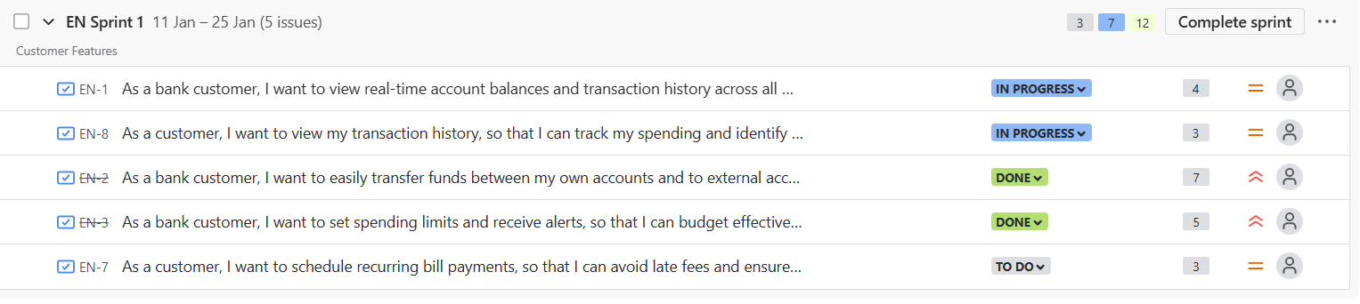

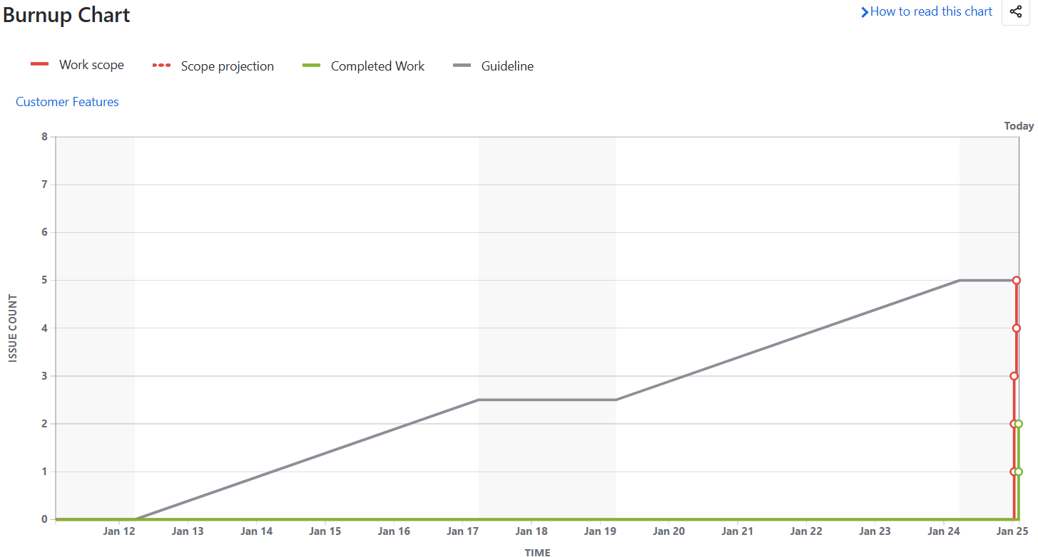

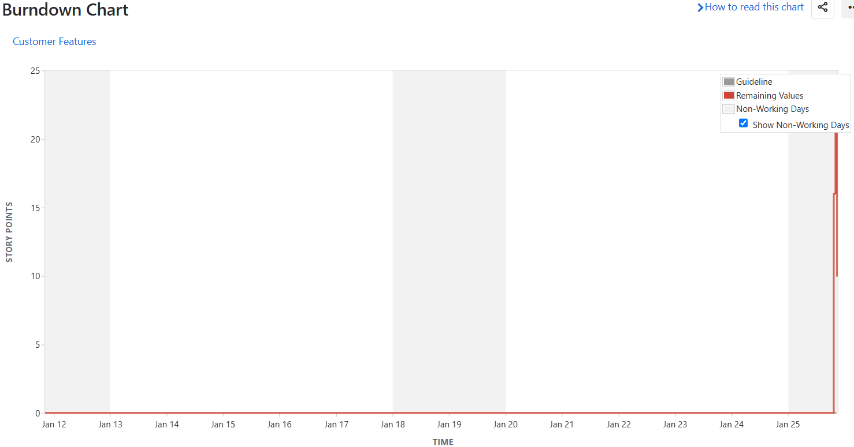

**Security**

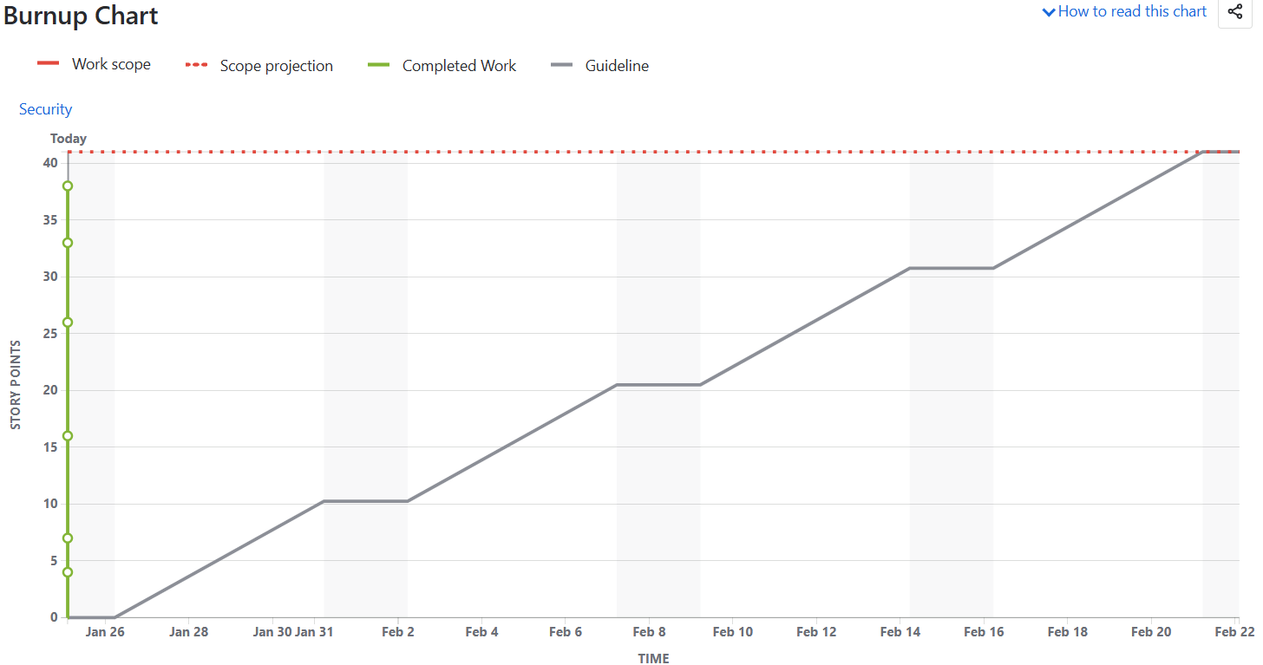

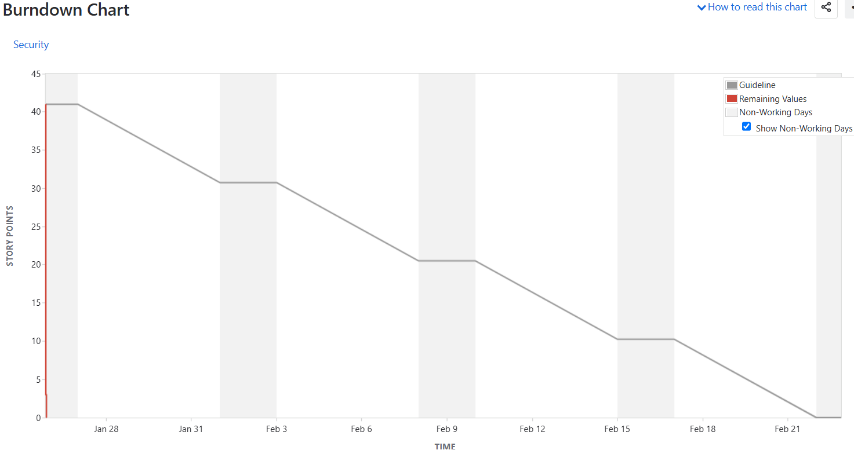

**Document 6**

**Sprint Meeting**

|  |  |
| --- | --- |
| **Date** | **25th Jan 2024** |
| **Time** | **3 pm** |
| **Location** | **MR 1** |
| **Prepared By** | **Alex** |
| **Attendees** | **Alex (PO), John (Scrum Master) Pratham, Arjun (Developer)** |

**Agenda Topic**

|  |  |  |  |
| --- | --- | --- | --- |
| **Topic** | **Presenter** | **Time Alloted** | **Details** |
| **Sprint Goal Review & Clarification** | Product Owner | 15 mins | Review and clarify the Sprint Goal for the upcoming Sprint |
| **Product Backlog Review & Refinement** | Product Owner, Development team | 35 mins | Discuss and refine Product Backlog items (User Stories, Epics) for the upcoming Sprint. |
| **Sprint Backlog Creation** | Development team | 25 mins | Create the Sprint Backlog by selecting User Stories and tasks to be completed within the Sprint |
| **Sprint Planning Poker** | Development team | 30 mins | Conduct Sprint Planning Poker to estimate the effort for selected User Stories |

**Other Information**

|  |  |
| --- | --- |
| **Observers** | **N/A** |
| **Resources** | Whiteboard/Projector, Sticky Notes, Estimation Cards, Project Management Tool – Jira |
| **Special Notes** | Document every action, Ensure clear communication. |

**Meeting Type 2: Sprint review meeting**

|  |  |
| --- | --- |
| **Date** | 14th Jan 2025 |
| **Time** | 3.30pm |
| **Location** | MR1 room |
| **Prepared By** | Name of the Scrum Master or designated individual |
| **Attendees** | Product Owner, Scrum Master, Development Team (Developers, Testers) |

|  |  |  |  |
| --- | --- | --- | --- |
| **Sprint Status** | **Things to demo** | **Quick Updates** | **What’s Next** |
| **Sprint 1** - Feature like ‘Transfer of fund’ & setting the ‘Spending limit’ completed In Sprint 1.  **Development** of feature like ‘Checking the real time account balance’ and ‘Viewing the transaction history’ was on going.  **While** we were yet to start with ‘Scheduling recurring or Auto payment’ feature.  Few of the team member were on emergency leave which acted as impediment in completing the Sprint. However, member was asked to WFH and complete the bare minimum task.  **Sprint 2 –** Features like Biometric Authentication, Data Privacy, Alerts, Fund transfer and pending features from Sprint 1 was also completed. | Testing was done of all the completed features/user stories post which live demonstrations was provided using PPT, screen sharing and live coding to showcase the work.  Feedback was requested from stakeholders on the completed work. | As 2 small sprints were completed each team member were asked to provide the feedback/update on their individual contributions and any challenges faced.  However, there was also a delay in receiving testing environment and issue related to a bit tight schedule. | Issue related leaves which ended up with tight schedule has been addressed and team has been asked to plan their leaves. In case of emergency team should work from home for at least 6 hours.  Upcoming sprints were discussed and backlog was prioritized |

**Meeting Type 3: Sprint retrospective meeting**

|  |  |
| --- | --- |
| **Date** |  |
| **Time** |  |
| **Location** |  |
| **Prepared By** | **Name of the Scrum Master or designated individual** |
| **Attendees** | **Product Owner, Scrum Master, Development Team (Developers, Testers)** |

|  |  |  |  |  |
| --- | --- | --- | --- | --- |
| **Agenda** | **What went well** | **What didn’t go well** | **Questions** | **References** |
|  | Successfully completed User Story: "View Real-time Account Balances", Transfer of fund’ & setting the ‘Spending limit’  There was Effective communication and collaboration within the team.  High-quality code delivered with minimal defects.  Effective use of daily stand-up meetings for quick updates | Emergency/Unexpected leave taken by team which resulted in incomplete Sprint and the features like ‘Scheduling recurring payment’ were added to upcoming Sprint.  Some challenges in clarifying the Acceptance Criteria for User Story 2. Minor communication gap regarding the design of the user interface for  Testing environment delay - We experienced delays in getting the testing environment set up, which impacted our testing timeline. This led to some time stretch at end on Sprint  Unclear Acceptance criteria of user story 3 were not clear which led to some rework. | How can we improve backup plan when people are on leave?  What can be done to ensure the testing environment is available at the start of the sprint?  What strategies can we implement to prevent similar delays in the future.  How can we better clarify and document Acceptance Criteria to avoid misunderstandings? | -Sprint Burndown Chart  -Daily Scrum notes  -User Story completion data  -Impediment log  -Team feedback from surveys |

**Meeting Type 4: Daily Stand-up meeting**

**20th Jan 2025 to 24th Jan 2025**

|  |  |  |  |  |  |  |
| --- | --- | --- | --- | --- | --- | --- |
| **Question** | **Name Role** | **Mon** | **Tue** | **Wed** | **Thur** | **Fri** |
| What did you do yesterday? | Pratham | Worked on the backend logic for the "View Balance" feature. | Integrated the "View Balance" API with the mobile app frontend. | Refactored the "Fund Transfer" code to improve performance. | Started working on the UI for the "Recurring Payments" | Completed the initial UI for "Recurring Payments" |
|  | Arjun | Focused on the frontend development for the "Fund Transfer" feature and implemented the transaction input form and validation. | Tested the "Fund Transfer" feature end-to-end. Fixed a few minor UI bugs. | Worked on the database schema changes required for the "Recurring Payments" | Collaborated with Developer 1 on the backend integration for "Recurring Payments" | Implemented the payment gateway integration for "Recurring Payments." |
| What will you do today? | Pratham | Continue working on the backend logic for "Recurring Payments." | Integrate the payment gateway API with the backend for "Recurring Payments." | Complete the backend logic for "Recurring Payments" and write unit tests. | Work with Developer 2 to integrate the backend with the frontend for "Recurring Payments." | Review and test the complete "Recurring Payments" feature. |
|  | Arjun | Work on the frontend validation for the "Recurring Payments" feature. | Implement the UI for viewing scheduled payments. | Work with Developer 1 on the backend integration for "Recurring Payments." | Complete the frontend development for "Recurring Payments." | Help with testing the "Recurring Payments" feature. |
| What (if any) is blocking your progress? | Pratham | Need clarification from the PO on the exact requirements for handling failed recurring transactions. | None | None | None | None |
|  | Arjun | Waiting for the payment gateway API documentation to be updated. | None | None | None | None |