MOCK -4
A company is having manufacturing plants and warehouses in various parts of the country. They manufacture ice-cream and milk products. They want to build software to achieve two goals.
- Manage the inventory
- Quickest delivery to the customers
ASSIGMENT (1)
- Prepare a BRD which can be presented to the client along with complete development resource plan

BUSINESS REQUIREMENT DOCUMENT (BRD)

Project Name - Inventory and Delivery Management System
Prepared for - Client
Prepared by - Rallabandi Pradeep Chary
Date - 20-09-2025
Version - 1.0

Executive summary
Hello client team as your company engaged in manufacturing and providing delivery service to the customers of ice creams and milk products. It is very great to know that your company operates the multiple manufacturing plants and warehouses and now aims to streamline operations through centrally digitalized platform.
So I am preparing this Business Requirement Document to give an overview of business objectives, functional requirements, technical approach and development , resource plan for building an integrated Inventory and Delivery management system.

Project overview-
To build the application for inventory management and online delivery system to customers
Business objectives-
- Efficient inventory management across all warehouses and manufacturing plants
- Faster order fulfillment and delivery by identifying delivery route and warehouses
- Real time monitoring of stock levels and deliveries
- Improved customer satisfaction through timely delivery and inventory management

Scope-
In Scope –
- Web based dashboards for admins, processors and warehouse staff
- Real time inventory management system
- Intelligent order fulfillment based on stock availability
- Delivery route optimization
- Notifications alerts for low stock, expiry and order updates
- Reporting and analytics dashboards
Out Scope-
- mobile application for customers
- Ai based demand forecasting .
- International warehouse support

Key stakeholders –
- Client project manager for approvals, coordination and User acceptance testing
- Operations teams for warehouse and delivery input
- Development team for system architecture , development and testing
- QA team for testing and validation.

Business Requirements-
* Inventory management requirements
BR.INV-S.NO | Description
BR-IN_M-001 | The system should allow authorized user to add, edit or delete entries for raw materials and final goods at each plant and warehouses
BR-IN_M-002 | The system should track the quantity, batch,manufacture date and expiry date of all inventory items
BR-IN_M-003 | The system should automatically adjust stock levels for goods based on entries done
BR-IN_M-004 | The system should generate alerts when items are below reorder level or nearing to expiry
BR-IN_M-005 | The system should able to track the stock in and out transactions
BR-IN_M-006 | The system should capture the bar codes of stock and gives details about the stock
BR-IN_M-007 | The system should able to generate daily, weekly and monthly inventory reports by locations of warehouse
BR-IN_M-008 | The system should provide dashboards views for every plants and warehouses
BR-IN_M-009 | The system shall support role based access control for admins, warehouse managers, operation teams, processors etc.
BR-IN_M-010 | The inventory management applications should have access in only organization systems

*Delivery management requirements
BR-DVM-S.NO | Description
BR-DVM-001 | Customer should able to login the application and make transaction
BR-DVM-002 | The system should identify the closest warehouse with available stock to reduce the delivery time
BR-DVM-003 | The system should generate delivery schedule and assign delivery person
BR-DVM-004 | The system should integrate with mapping APIs like google maps for route optimization
BR-DVM-005 | The system should allow delivery persons to update delivery status in real time via mobile
BR-DVM-006 | The system should provide customer details accurately to delivery person for quick delivery
BR-DVM-007 | The system should capture customer conformation or signature upon delivery
BR-DVM-008 | The system should notify the customers on order dispatch and estimated delivery
BR-DVM-009 | The system should generate reports on deliveries for appointing more delivery boys for quick delivery service
BR-DVM-010 | The system should track the vehicle routes and delivery time rate

Assumptions –
- Client provides access to current warehouse and delivery data
- Internet connectivity available in warehouses and plants in all states
- Any third-party services for notifications and maps APIs will be procured by the client.
- Client will have good staff for UAT and feedback.

RISKS-
- Delay in requirements finalization
- Third party API limitations or failures
- User adaptation issues
- Changing Scope in middle of development

Success Criteria-
- 99% stock accuracy across locations
- 40% reduction in delivery time
- System uptime will be great
- High level of customer satisfaction

Development and Resources plan –
Role | No. of. Resources | Duration | Comments
Project manager | 1 | Full project | for coordination and client reporting
Business analyst | 2 | 1-2 months | For preparing and tracking documents like BRD, FRS and for UAT also like client liaison
UI/UX Designer | 2 | 1 month | Wireframes and prototypes and UI design
Frontend developer | 4 | 4 months | For Web and mobile application
Backend Developer | 4 | 3 months | For API and data base integration
Testers | 4 | 1 month | for testing and validating
QA team | 2 | 2 months | For manual and automation
UAT | 1 | 1 month | For bug fixing and user testing and feedback
Deployment | 2 | 1 month | For live version
Post launch support | 2 | 1month | For maintenance support and monitoring

Cost estimation resources –
- Fixed price for entire project 44 Crores and the third party integrations like APIs are been excluded
Sign off section –
- Project manager ( )
- Business analyst ( )
- Project sponsor ( )
- Client sign off ( )
- Client team lead ( )

Process flow diagram for inventory management system

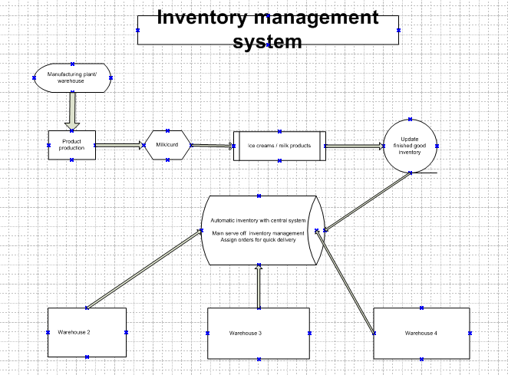

Process flow diagram of quick delivery management
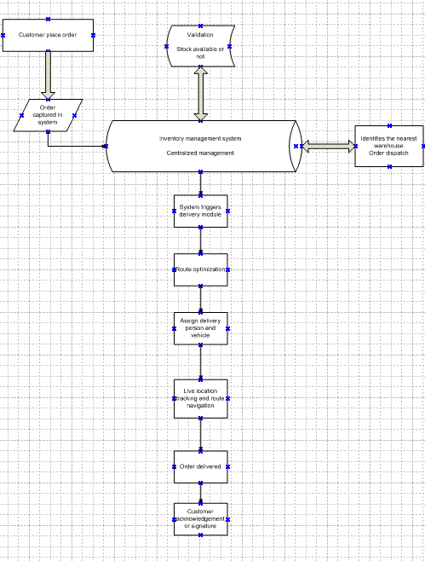
Assignment – 2
Write an introduction letter to a client introducing yourself as a business analyst in charge of working with the client and his team to start the business understanding process.

Introduction letter -

Dear Krishna,
I hope this message finds you well.
My name is Rallabandi Pradeep Chary, and I’m pleased to introduce myself as the Business Analyst assigned to your project. I will be working closely with you and your team to initiate and lead the business understanding phase for the development of your new software

As your primary point of contact during this phase, my role will be to:
- Gain a deep understanding of your current operations, goals and challenges
- Gather and document clear and detailed business requirements
- Ensure alignment between your business needs and the proposed technical solutions
- Facilitate collaboration between your stakeholders and our development team

I’m looking forward to building a strong partnership and helping you design a solution that effectively manages your inventory and enables faster, more efficient deliveries to your customers.
In the coming days, I will schedule a kick-off meeting to begin our discussions, Gather initial inputs and outline the process ahead.
Please feel free to reach out at any time if you have any concerns or would you like to share key documents or context before we begin.
Looking forward to working with you.

Warm regards,
Rallabandi pradeep chary
Business Analyst
Optum tech solutions
Pradeeprallabandi004@gmail.com
Contact- 9963501487

2. Prepare a brief BRD and SRS for a project- Horoscope or Ticketing system or online store.
Brief BRD document for ticketing system
Business Requirement Document
Project Title - Online ticketing system
Prepared by - R. pradeep chary
Client - Krishna ticket service
Date - 25-09-2025

Project overview –
This project involves building a web and mobile based Online ticketing system to allow users to browse, book and manage tickets for various events such as movies, sports and theatre.

Business Objectives –
- Allow users to book events tickets from multiple devices
- Provide real time seat availability and pricing
- Enables organizers to publish and manage their events
- Secure payment and booking conformation system
- Provide digital tickets and customer support
Scope –
In Scope
- User registration
- Event browse and searching
- Seat selection and booking
- Online Payment integration
- Online ticket generation
- Admin and organization dash boards
Out scope –
- Physical ticket delivery
- Third party resale of tickets

Stake Holders-
- Project sponsor
- Event organizers
- End users

Business Requirements-
BR-001 | User should able to do registration and login
BR-002 | User should able to do event browsing and search
BR-003 | User should able to view event details page
BR-004 | User should able to select seat
BR-005 | User should able to book tickets
BR-006 | User should able to do online payment
BR-007 | User should have ticket conformation notifications
BR-008 | User should view order history and management
BR-009 | Organizer can able to create and edit the pricing and ticket management
BR-010 | Admin portal should built for management
Assumption-
User have internet connectivity on their mobiles
Users can understand the guidelines of the applications

Success Metrics-
- Booking error rate less than 0.5%
- 98% customers satisfaction
- More sales and less manual work

Sign off section
- Project manager ( )
- Business analyst ( )
- Project sponsor ( )
- Client sign off ( )
- Client team lead ( )

The brief (SRS) Software Requirement Specification document
SRS
Project title – online ticketing system
Prepared by – R. pradeep chary
Version - 1.0
Date - 25-09-2025

Introduction-
This documents outlines the functional and non-functional requirements for the development of an online ticket booking applications for special events

Scope –
To build the online application for ticketing system in user friendly to customers .

Functional Requirements-
FR-ID | Requirement
FR-001 | The system should allow users to register and login using email and password
FR-002 | The system should display the upcoming movies and events with filtering option
FR-003 | The system should allow users to view event details , movie details and seating layouts and prices
FR-004 | The system should allow the users to select seats and book tickets
FR-005 | The system should process online payment methods securely through payment gateways
FR-006 | The system should send booking conformations through email and sms
FR-007 | The system should allow users to view, download and cancel their tickets
FR-008 | The system should allow all events admins to add and manage their events and movies
FR-009 | The application should save the E ticket so user can view it any time

Non- Functional Requirements
NR-id | Requirement
NR-001 | The system should support at least 4000concurrent users
NR-002 | The system should be mobile responsive and accessible
NR-003 | All users data should be securely maintained
NR-004 | The system should have 99% uptime availability
NR-005 | The system should respond within 2 seconds

System Interfaces
- Payment gateways
- Email server
- SMS gateways

Assumptions –
Internet connectivity is required for all system features
All users may understand the applications guidelines
All payments are online like credit, debit, UPI.

Constraints-
Payment details should be hidden
Compliance with local taxation
Must support both web and mobile browsers

Sign off section
Project manager -
Developer head -
QA head –
3 ERD of creating a support ticket/Ticketing life cycle.

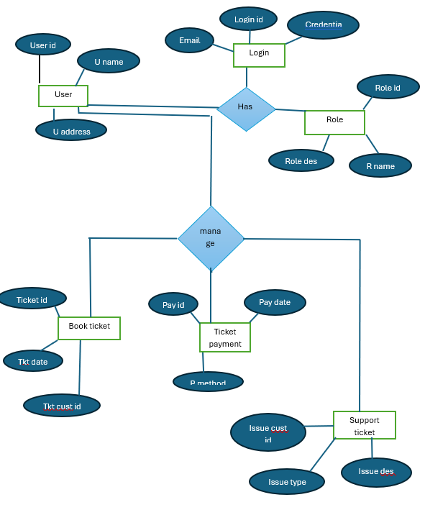

4. User stories of shopping from ecommerce.

User Story NO: 01 | Tasks:1 |  | Priority: HIGH
AS A USER
I WANT TO REGISTER USING EMAIL ID AND PASSWORD
SO THAT I CAN CREATE AN ACCOUNT
BV: 500 |  | CP: 08
Acceptance Criteria :
User input text box for email and password
System checks for valid email format
Password must meet security requirements min 8 characters
If registration is successful user sees a confirmation message
If registration fails user sees an appropriate error message

User Story NO: 02 | Tasks:01 |  | Priority: HIGH
AS A USER
I WANT TO LOGIN SECURELY
SO THAT I CAN ACCESS MY ACCOUNT
BV: 500 |  | CP: 08
Acceptance Criteria :
Screen should include text field for email id and password
Validation for incorrect email and password
Optional to show hide password
Successful login redirects to dashboard

User Story NO: 03 | Tasks:01 |  | Priority: MEDIUM
AS A USER
I WANT TO SIGN UP USING GOOGLE, FACEBOOK OR INSTAGRAM
SO THAT I CAN REGISTER QUICKLY
BV: 100 |  | CP: 05
Acceptance Criteria :
Buttons in facebook, Instagram login are present
Direct flow is initiated upon click
After successful , user should redirect to home page

User Story NO: 04 | Tasks:01 |  | Priority: HIGH
AS A USER
I WANT TO RESET MY PASSWORD
SO THAT I CAN REGAIN ACCESS IF I FORGET IT
BV: 500 |  | CP: 08
Acceptance Criteria :
Forget password button
Link should open password reset flow
User should receives reset email
New password must meet security rules

User Story NO: 05 | Tasks:01 |  | Priority: MEDIUM
AS A USER
I WANT TO UPDATE MY PROFILE INFORMATION
SO THAT I CAN KEEP MY DETAILS CURRENT
BV: 100 |  | CP: 08
Acceptance Criteria :
Fields, name , phone number , address
Updates are saved upon submit button
User gets success failure notifications

User Story NO: 06 | Tasks:01 |  | Priority: HIGH
AS A USER
I WANT TO SEARCH PRODUCTS
SO THAT I CAN BUY NEEDY PRODUCTS IN ONLINE
BV: 100 |  | CP: 05
Acceptance Criteria :
Search text field
Browse product
Select option

User Story NO: 07 | Tasks:01 |  | Priority: HIGH
AS A USER
I WANT TO MAKE PAYMENT ONLINE
SO THAT I CAN BUY PRODUCTS ONLINE
BV: 100 |  | CP: 13
Acceptance Criteria :
Payment option
Select payment method options
Proceed to pay

User Story NO: 08 | Tasks:01 |  | Priority: HIGH
AS A USER
I WANT TO GET PAYMENT NOTIFICATION
SO THAT I CAN GET SATISFIED PAYMENT IS CONFORMED
BV: 500 |  | CP: 08
Acceptance Criteria :
Payment notification should sent to user
Successful notification or Error notification

User Story NO: 09 | Tasks:01 |  | Priority: MEDIUM
AS A USER
I WANT TO ADD PRODUCTS TO MY WISHLIST
SO THAT I CAN SAVE AND BUY THEM LATER
BV: 100 |  | CP: 05
Acceptance Criteria :
My wish list page
Save product buy later option
Submit button

User Story NO: 10 | Tasks:01 |  | Priority: MEDIUM
AS A USER
I WANT TO VIEW AND MANAGE MY WISHLIST
SO THAT I CAN KEEP TRACK OF FAVORITE ITEMS
BV: 100 |  | CP: 05
Acceptance Criteria :
View my wish list on screen
Select option
Order product list

User Story NO: 11 | Tasks:01 |  | Priority: high
AS A USER
I WANT TO VIEW DETAILED INFORMATION ABOUT A PRODUCT
SO THAT I CAN DECIDE WHETHER TO BUY IT OR NOT
BV: 100 |  | CP: 05
Acceptance Criteria :
Click option on more info
View product info

User Story NO: 12 | Tasks:01 |  | Priority: HIGH
AS A USER
I WANT TO SEE MULTIPLE IMAGES OF PRODUCT
SO THAT I CAN KNOW HOW THE PRODUCT LOOKS LIKE
BV: 500 |  | CP: 08
Acceptance Criteria :
View multiple images of product
More images option
Submit button

User Story NO: 13 | Tasks:01 |  | Priority: HIGH
AS A USER
I WANT TO READ PRODUCT REVIEWS
SO THAT I CAN TRUST THE QUALITY
BV: 100 |  | CP: 05
Acceptance Criteria :
Click option on reviews
View product reviews

User Story NO: 14 | Tasks:01 |  | Priority: MEDIUM
AS A USER
I WANT TO MOVE ITEMS FROM WISH LIST TO CART
SO THAT I CAN BUY WHENEVER I WANT
BV: 100 |  | CP: 05
Acceptance Criteria :
Select option on product
Move to cart option
Submit button

User Story NO: 15 | Tasks:01 |  | Priority: MEDIUM
AS A USER
I WANT TO REMOVE ITEMS FROM MY CART
SO THAT I CAN CHANGE MY MIND AND BUY ANOTHER
BV: 100 |  | CP: 05
Acceptance Criteria :
My cart screen option
Remove option from my cart
Submit button

User Story NO: 16 | Tasks:01 |  | Priority: HIGH
AS A USER
I WANT TO GET EMAIL CONFORMATION ON PRODUCT
SO THAT I CAN BE RELAX THAT ORDER IS BOOKED
BV: 500 |  | CP: 13
Acceptance Criteria :
Server needs to send email conformation
My notification option
View All notification

User Story NO: 17 | Tasks:01 |  | Priority: MEDIUM
AS A USER
I WANT TO TRACK MY ORDER
SO THAT I CAN KNOW ITS SHIPPED, PROCESSED,DELIVERED
BV: 500 |  | CP: 13
Acceptance Criteria :
My order option
Track my order option
View the order status

User Story NO: 18 | Tasks:01 |  | Priority: HIGH
AS A USER
I WANT TO VIEW MY ORDER HISTORY
SO THAT I CAN ORDER SAME PRODUCT IF NEEDED
BV: 500 |  | CP: 13
Acceptance Criteria :
My order history option
View order history .

User Story NO: 19 | Tasks:01 |  | Priority: MEDIUM
AS A USER
I WANT TO DOWNLOAD INVOICES OF MY ORDER
SO THAT I CAN KEEP AS PROOF
BV: 100 |  | CP: 05
Acceptance Criteria :
My order screen
Download order invoices option
Submit button

User Story NO: 20 | Tasks:01 |  | Priority: MEDIUM
AS A CUSTOMER
I WANT TO REQUEST A RETURN FOR PRODUCT
SO THAT I CAN RETURN PRODUCT
BV: 100 |  | CP: 05
Acceptance Criteria :
Return product option
Text field for description
Submit button

User Story NO: 21 | Tasks:01 |  | Priority: MEDIUM
AS A USER
I WANT TO RATE THE PRODUCT
SO THAT I CAN HELP OTHER BY REVIEW THE PRODUCT
BV: 100 |  | CP: 13
Acceptance Criteria :
Five star rating option
Clicking on stars should take review
Submit button

User Story NO: 22 | Tasks:01 |  | Priority: MEDIUM
AS A USER
I WANT TO VIEW USER UPLOADED PHOTOS IN REVIEW
SO THAT I CAN CLARITY ON PRODUCT
BV: 100 |  | CP: 13
Acceptance Criteria :
Click options on Review
View product uploaded images
Show all clear customers uploaded images

User Story NO: 23 | Tasks:01 |  | Priority: MEDIUM
AS A USER
I WANT TO CHANGE THE LANGUAGE OF THE WEBSITE
SO THAT I CAN EASILY UNDERSTAND ABOUT PRODUCT
BV: 100 |  | CP: 05
Acceptance Criteria :
My profile setting option
Change language option
View All languages select option
Submit button

User Story NO: 24 | Tasks:01 |  | Priority: MEDIUM
AS A USER
I WANT TO SEE THE PRICES IN MY LOCAL CURRANCY
SO THAT I CAN MAKE ESTIMATION TO BUY
BV: 500 |  | CP: 13
Acceptance Criteria :
View price option
Convert currency according to locations
View the product price

User Story NO: 25 | Tasks:02 |  | Priority: HIGH
AS A ADMIN
I WANT TO REGISTER USING EMAIL ID AND PASSWORD
SO THAT I CAN GET INTO APPLICATION
BV: 500 |  | CP: 3
Acceptance Criteria :
User input text box for email and password
System checks for valid email format
Password must meet security requirements min 8 characters
If registration is successful user sees a confirmation message
If registration fails user sees an appropriate error message

User Story NO: 26 | Tasks:02 |  | Priority: HIGH
AS A ADMIN
I WANT TO LOGIN USING USER NAME AND PASSWORD
SO THAT I CAN ENTER INTO AN APPLICATION
BV: 500 |  | CP: 13
Acceptance Criteria :
Text fields to username and password
Submit button

User Story NO: 27 | Tasks:02 |  | Priority: MEDIUM
AS A ADMIN
I WANT TO ADD THE PRODUCTS INTO APPLICATION
SO THAT I CAN MAKE THE TRANSACTIONS
BV: 500 |  | CP: 13
Acceptance Criteria :
My profile option
Add items option according to role
Submit button

User Story NO: 28 | Tasks:02 |  | Priority: MEDIUM
AS A ADMIN
I WANT TO REMOVE THE PRODUCTS FROM APPLICATION
SO THAT I CAN REPLACE THE PRODUCTS
BV: 100 |  | CP: 13
Acceptance Criteria :
MY management option
Remove items and delete option
Submit button

User Story NO: 29 | Tasks:02 |  | Priority: MEDIUM
AS A ADMIN
I WANT TO UPDATE THE PRODUCTS IN APPLICATIONS
SO THAT I CAN ADD REQUEST FOR NEW PRODUCTS
BV: 500 |  | CP: 13
Acceptance Criteria :
My management option
Update product option
Submit button

User Story NO: 30 | Tasks:02 |  | Priority: MEDIUM
AS A ADMIN
I WANT TO KNOW THE SALES OF PRODUCTS
SO THAT I CAN IMPORT MORE ITEMS ACCORDING TO SALE
BV: 500 |  | CP: 13
Acceptance Criteria :
View monthly sales option
Generate reports according to sales
View and download option

User Story NO: 31 | Tasks:02 |  | Priority:MEDIUM
AS A ADMIN
I WANT TO VIEW LESS SALES OF PRODUCTS
SO THAT I CAN GIVE DISCOUNTS ON THEM
BV: 100 |  | CP: 05
Acceptance Criteria :
View sales option
Generate reports according to sales
View least sales option and download option

User Story NO: 32 | Tasks:03 |  | Priority: HIGH
AS A MARKETING MANAGER
I WANT TO VIEW SALES REPORTS
SO THAT I CAN TARGET THE MARKET
BV: 500 |  | CP: 13
Acceptance Criteria :
Marketing management option
View sales report option
Generate reports according to sales
View reports and download option

User Story NO: 33 | Tasks:03 |  | Priority: MEDIUM
AS A MARKETING MANAGER
I WANT TO VIEW LOW SALES OF PRODUCT
SO THAT I CAN ENHANCE MARKETING STRATEGY
BV: 500 |  | CP: 13
Acceptance Criteria :
View sales report option
View least sales reports according to locations
Download option

User Story NO: 34 | Tasks:03 |  | Priority: MEDIUM
AS A MARKETING MANAGER
I WANT TO TRACK COUPON USAGE
SO THAT I CAN EVALUATE PERFORMANCE
BV: 100 |  | CP: 08
Acceptance Criteria :
View orders history
Track coupons option
View usage of coupons according to locations

User Story NO: 35 | Tasks:03 |  | Priority: MEDIUM
AS A MARKETING MANAGER
I WANT TO CREATE DISCOUNT CODES
SO THAT I CAN OFFER SPECIAL DEALS TO USERS
BV: 500 |  | CP: 13
Acceptance Criteria :
View discounts sections
Create discount codes and offers
Select option on Release
Submit button

