**WATERFALL DELIVERABLES PART-2**

**Question-6**

Q6) Please prepare a use case diagram, activity diagram and a use case specification

document.

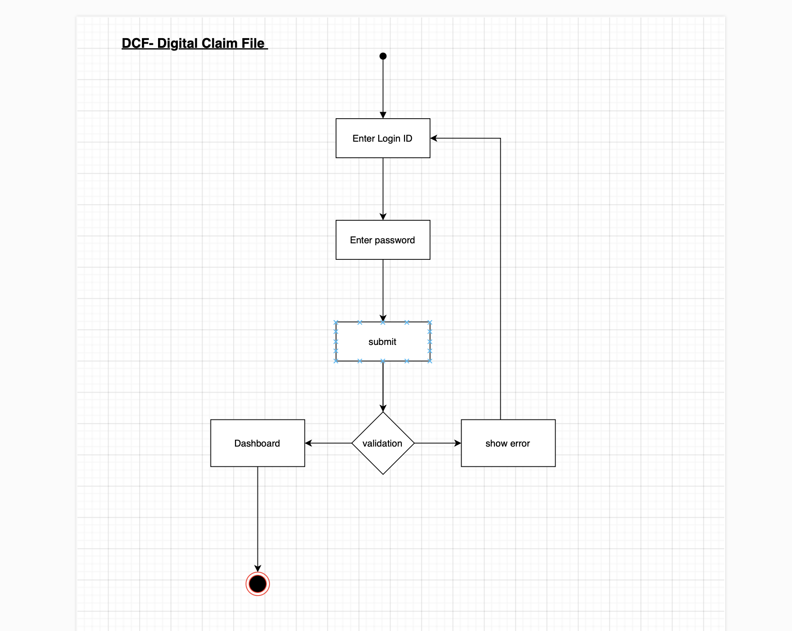

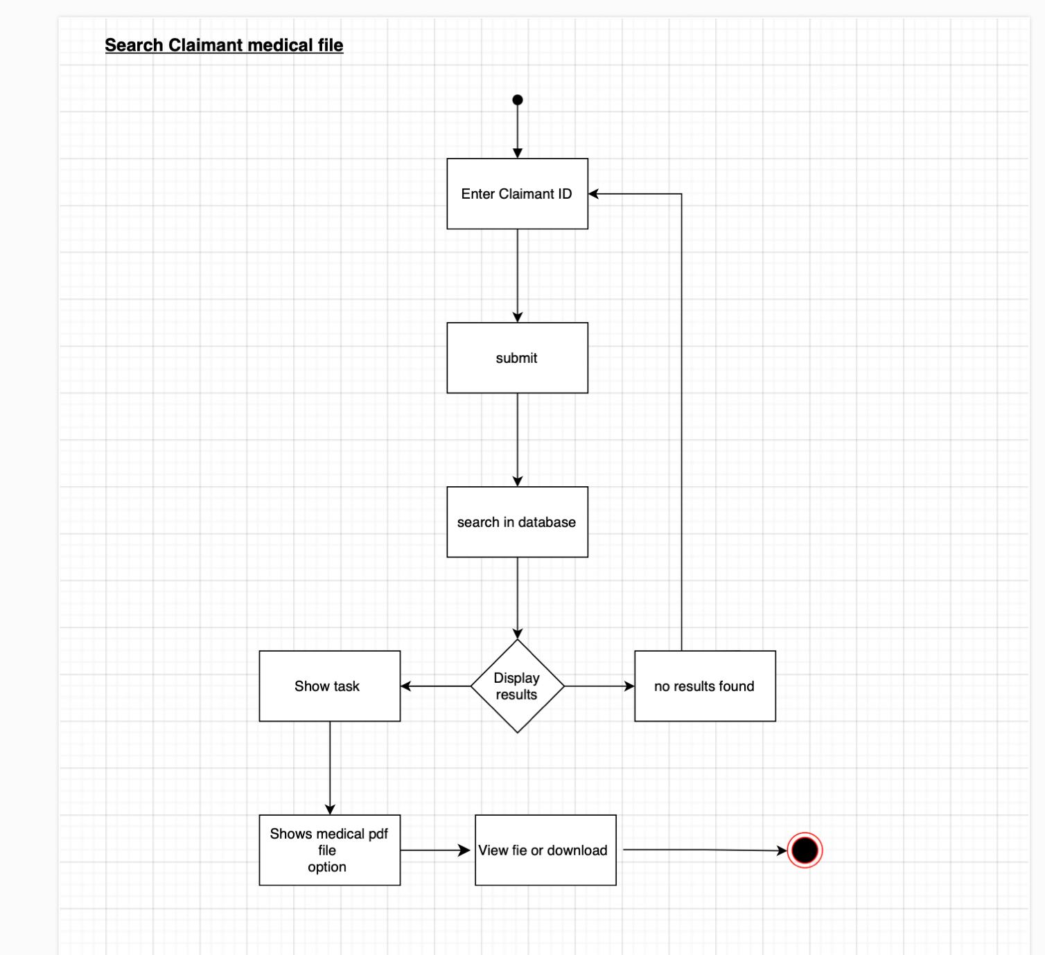

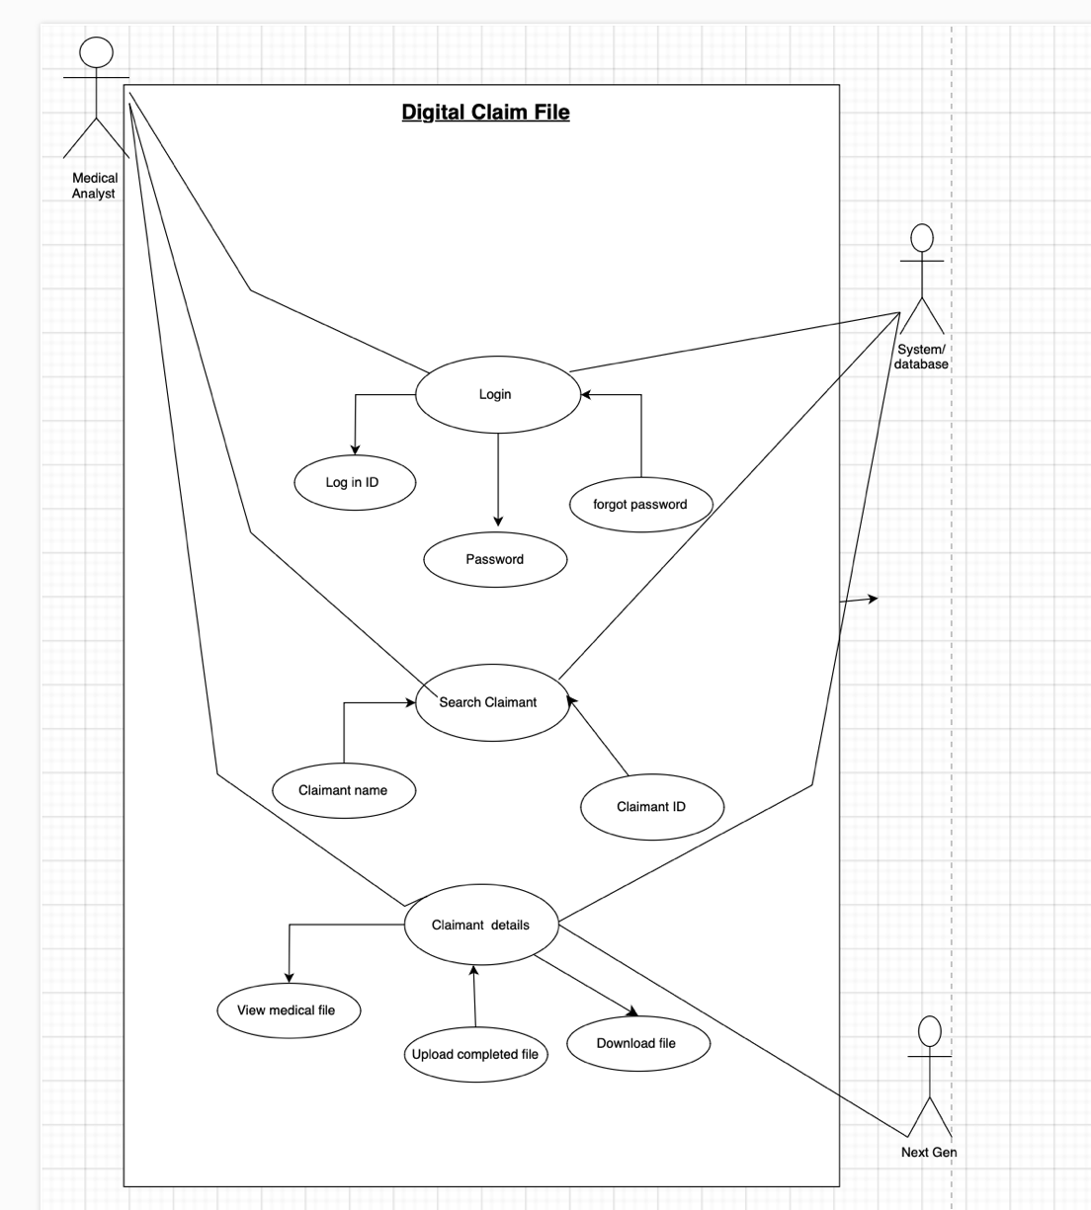

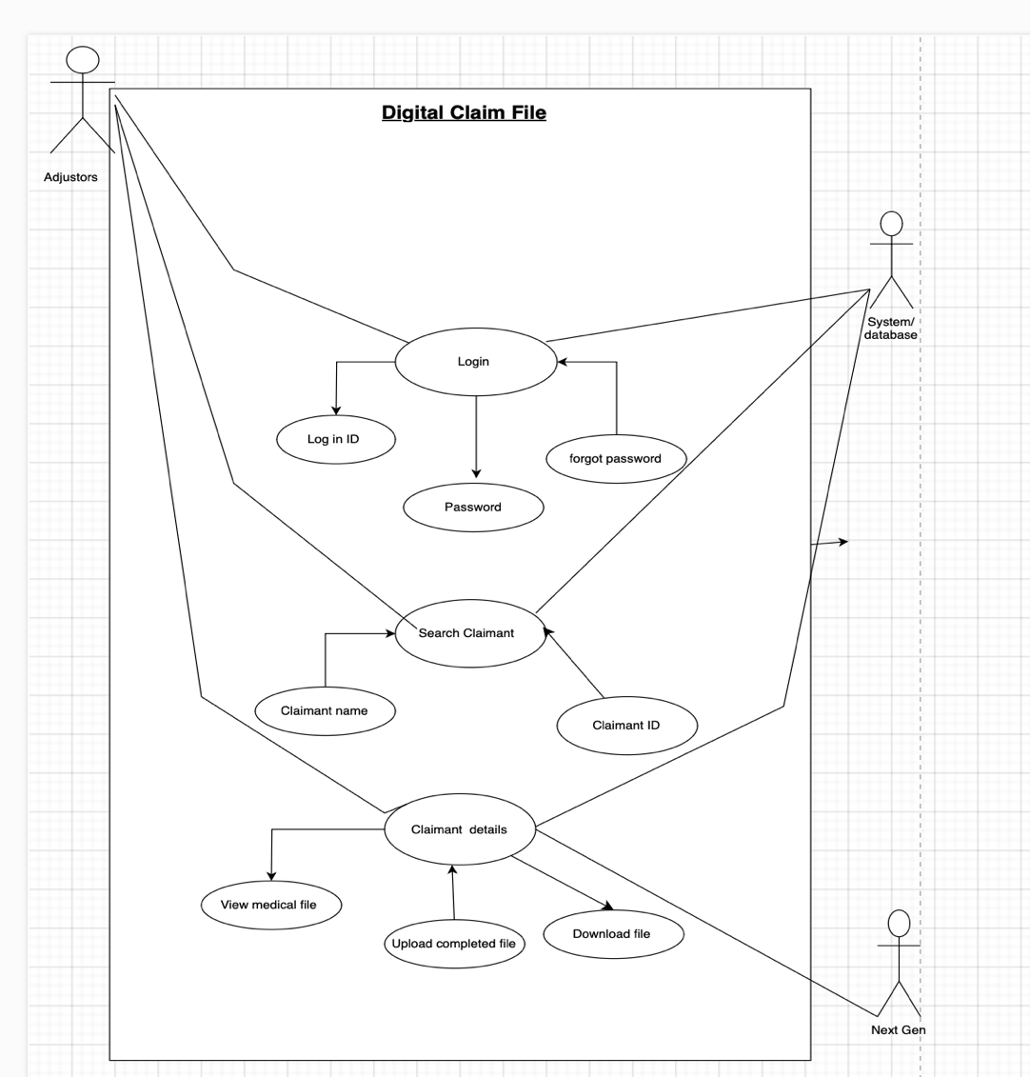

1. **Use case Name :**

Digital Integration of Patient Medical File for Claim Processing

1. **Use case Description**

This use case defines the process of digitalizing patient medical records, including the uploading, editing, and analyzing of patient data. The system integrates with external claim processing systems to streamline the claim submission and validation process.

1. **Actors Primary Actors Secondary actors**

* **Primary Actors**:
* **Medical Analyst :**  Upload and edit patient data, enter medical history, diagnoses, and treatment plans.

Manage the storage and retrieval of patient files and assist with data entry.

* **Insurance Adjustors**: Review and process claims based on the digital medical files , the medical summary analysed and uploaded by Medical Analyst.

• **Secondary Actors**:

* **External Claim Processing System**: Receives claims and returns claim status updates (Next Gen)
* **Data Storage System**: Stores and retrieves medical records in a secure digital format.

1. **Basic Flow**

* Medical professional enters patient data into the system (including medical history and diagnoses).
* Administrative staff uploads the patient data to the central database.
* The insurance agent reviews the data for claim processing.
* The details of claimant is present on Next Gen , On selecting a particular claimants DCF , it lands us on DCF webpage.
* The medical file is then downloaded for further analysis and then once it is completed , it uploaded back on DCF.
* Claims are submitted for validation via the external claim processing system(Next Gen)
* The system processes the claim, and the claim status is updated.

1. ALTERNATE FLOW

* If the medical analyst finds incomplete data or missing medical records, they can request additional information from the Adjustors.
* If the claim is invalid due to errors or mismatched information, the system sends a notification to performer of the task and adjustors.

1. Exceptional flows

* If the system experiences a failure in processing the claim, an alert is sent to the administrative staff to troubleshoot.
* If the patient's medical file is corrupted or cannot be retrieved, the system will notify the medical professional to resolve the issue.

1. Pre- Conditions

* The patient/claimant must have an existing medical file in the system.
* The Next Gen system must be integrated with DCF
* Medical analysts, Adjustors, must have valid login credentials.

1. **Post-conditions**

* The patient's medical file is successfully digitized, analysed, stored, and accessible for claim processing.
* Claims are processed and marked with their current status (approved, pending, or rejected).

1. **Assumptions**

* All patient medical files are digital and accessible via the system.
* The external claim processing system is fully functional and available.

1. **Constraints**

* The system may only store a certain amount of data before requiring additional storage.
* The integration with the external claim processing system must comply with privacy laws (e.g., HIPAA).

1. **Dependencies**

* Dependency on the availability of an integrated claim processing system.
* Dependency on reliable data storage infrastructure.

1. **Inputs and Outputs**

Inputs : Patient medical data in from Next Gen

Output: Digital editable pdf format from DCF , that can be downloaded and uploaded once the analysis is done.

1. **Business Rules**

* Only authorized medical professionals can upload or edit patient data.
* Insurance agents can only view medical records for claim processing purposes.
* Claims must be submitted within a predefined time frame from the treatment date.

1. **Miscellaneous Information**

* Data privacy and security measures must be in place to protect sensitive patient information.

**Question- 7**

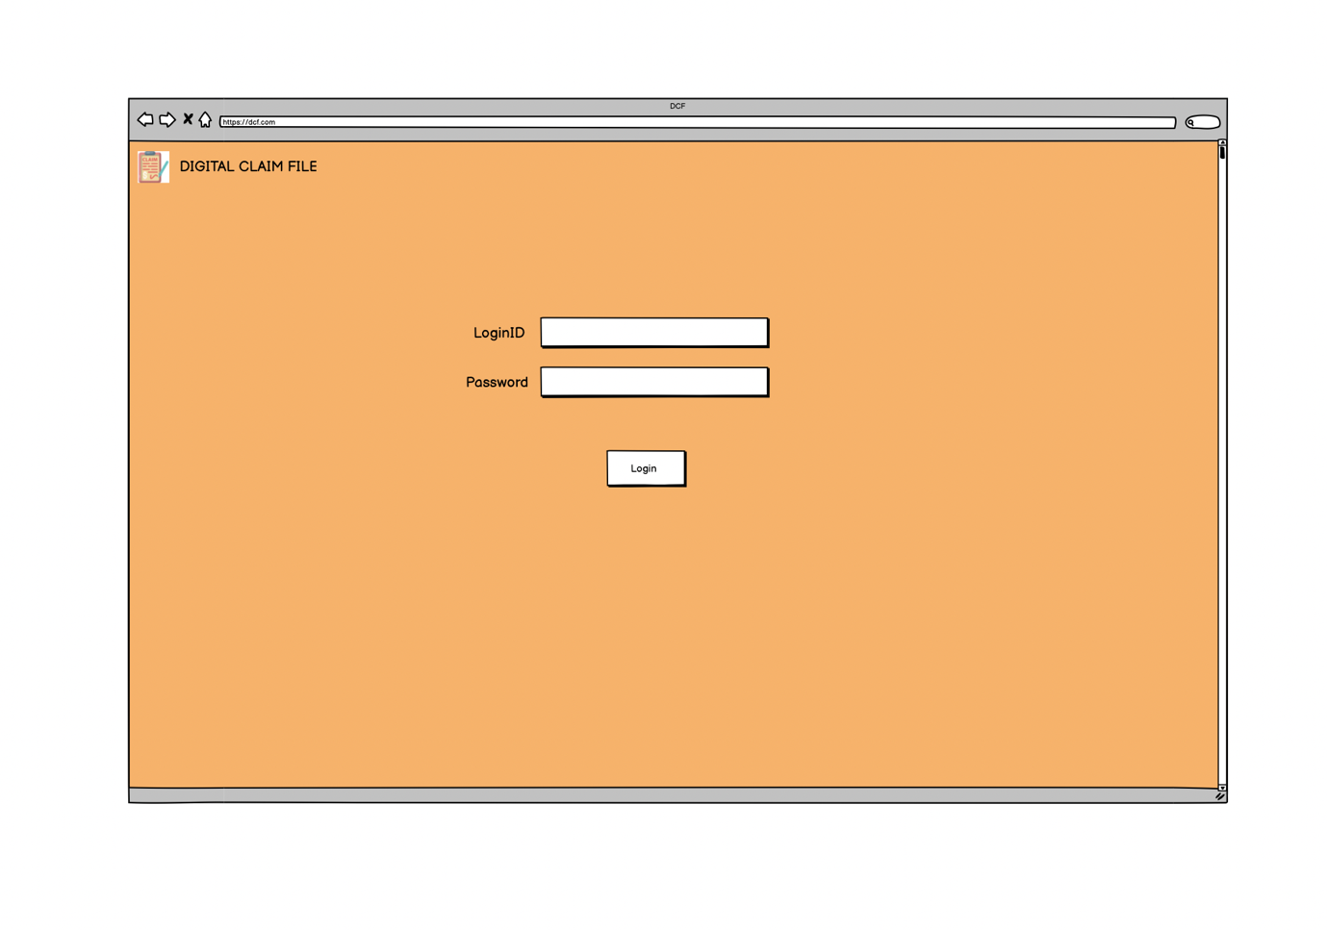

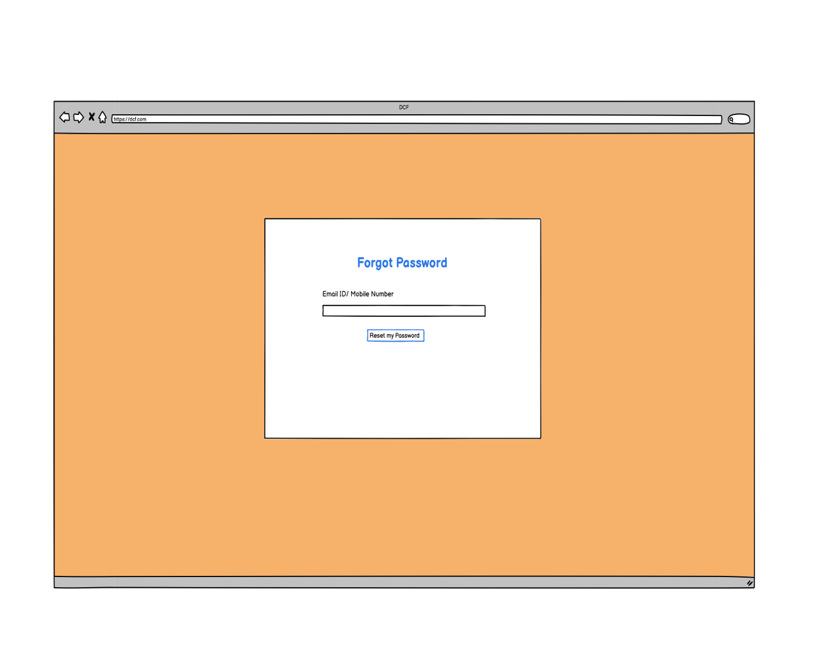

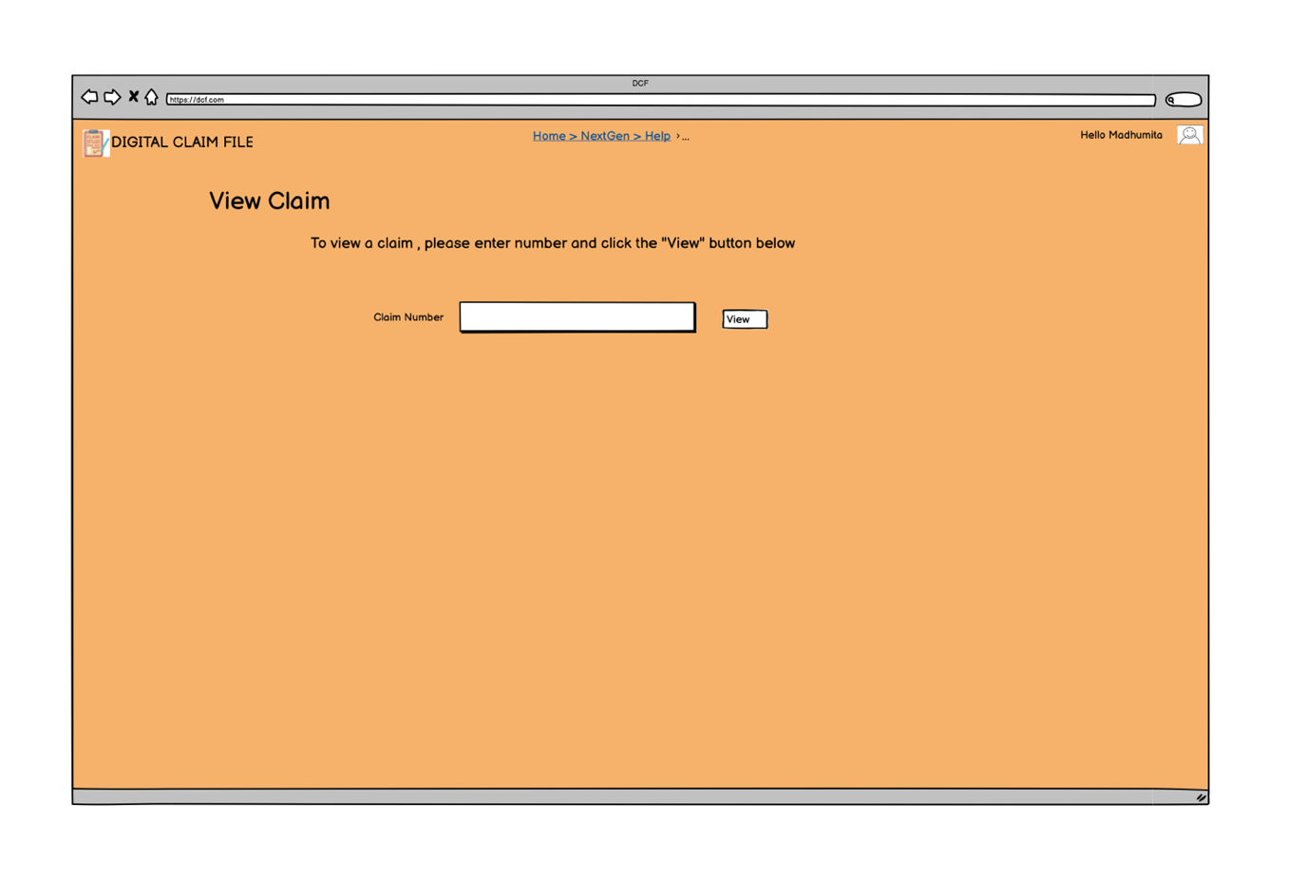

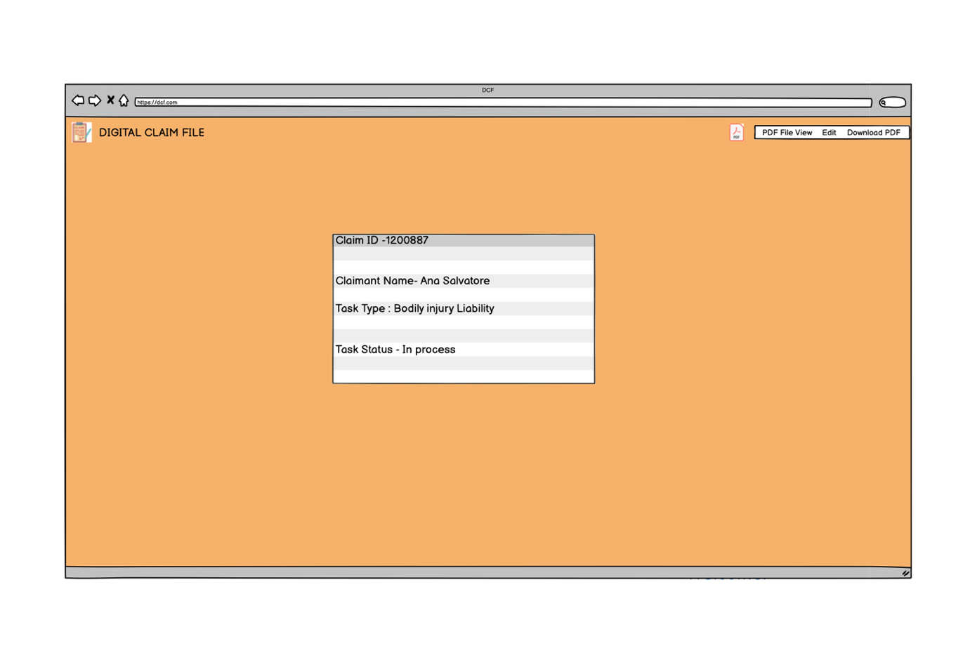

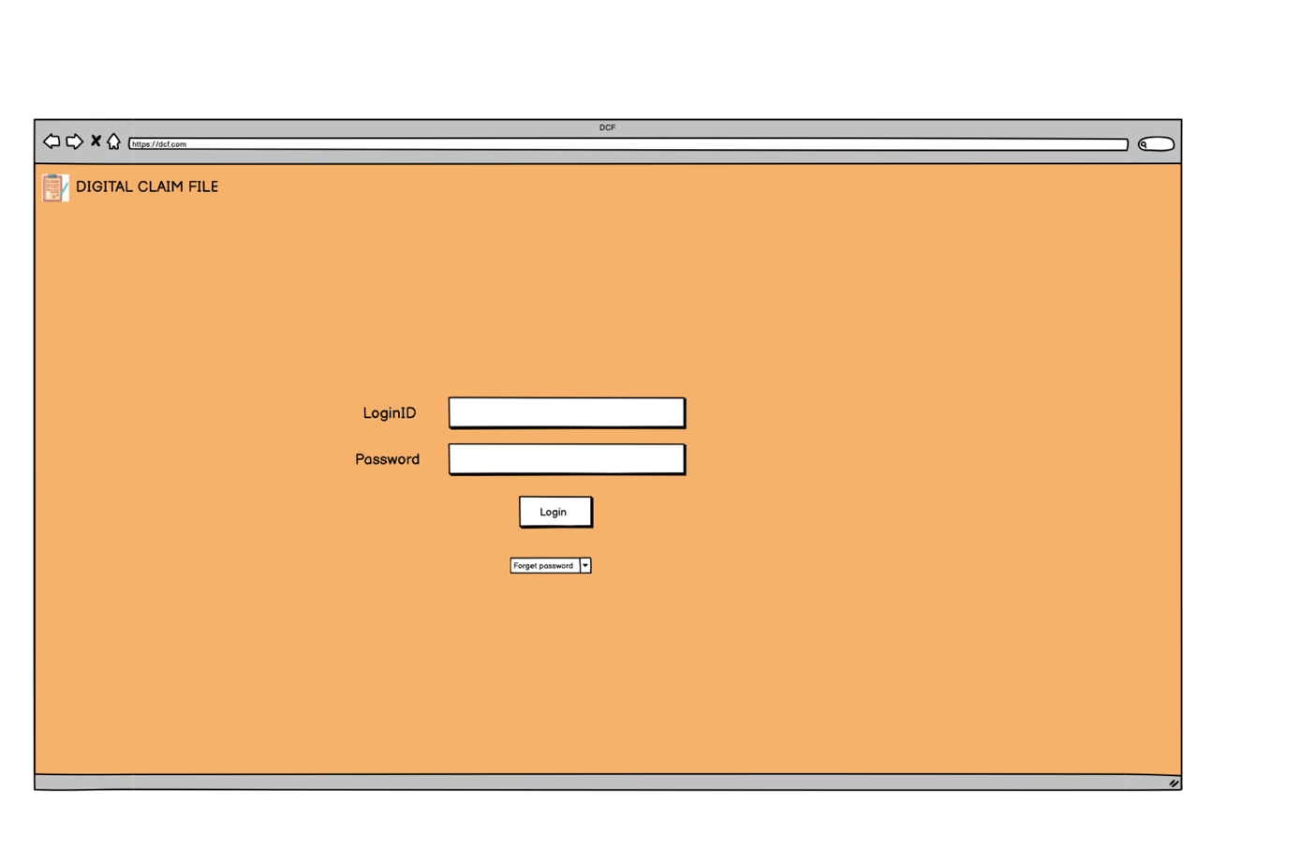

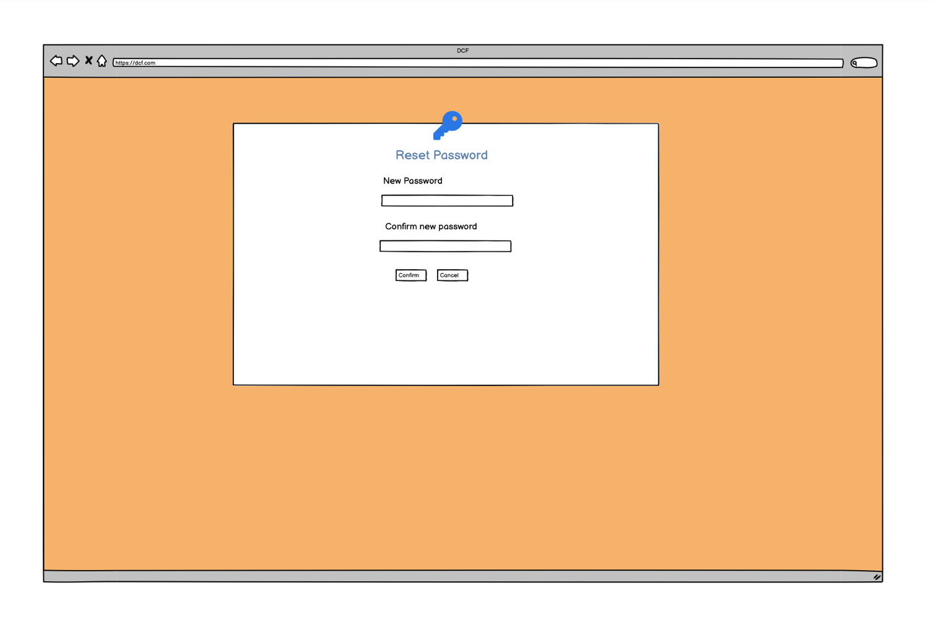

**Question -8**

**Experience using Vision and Balsamiq for the project**

1. MS Visio : It is a diagramming and vector graphics application used to create diagrams, flowcharts, and other visual representations of complex information.

It is used to create professional diagrams, flowcharts, organizational charts, network designs, floor plans, and much more. It's a versatile tool for visually representing processes, systems, and structures, making it popular among business analysts, project managers, and IT professionals.

Features: Pre-Built Templates and Shapes ; Drag-and-Drop Interface ; Integration with Other Microsoft Tools; Customization, Cloud Support

Uses: Swimlane diagrams; Network diagrams; System Diagrams; Charts; Gantt charts.

1. Balsamiq: It is a rapid wireframing tool used to create mock-ups and prototypes of interfaces. Balsamiq is a popular wireframing tool designed to create low-fidelity mock-ups for websites, mobile apps, or any other software application.
2. Azure : It is a more advanced prototyping tool used to create high-fidelity, interactive

wireframes , and prototypes for web and mobile applications. Azure provides a vast array of services, including Infrastructure as a Service (IaaS), Platform as a Service (PaaS), and Software as a Service (SaaS), making it a versatile tool for various use cases.

Uses : App development and hosting; Data storage and backup; Disaster recovery and business continuity; Big data and analytics.

**Question -9**

My experience as BA in the following has following phases :

* 1. Requirement Gathering :

Brainstorming and Protypying.

**Prototyping** is a technique that allows to create a simplified or tangible version of system or product and test it with potential users. It can help you elicit and validate requirements , identify gaps and issues, and improve user satisfaction and engagement.

It would help in : visualizing the system ; validate the requirements, helps generating feedbacks, boosts stakeholders participation.

**Brainstorming :** It can be done either individually or in groups. The ideas collected can then be reviewed/analysed and where relevant included within the system requirements. Ideas can come from what users/stakeholders have seen or experienced elsewhere.

* 1. Requirement Analysis :

**BRS – Business Requirement Specification**

**Introduction**

* **Project Title:** Integration of Digital Claim File with Next Gen
* **Objective:** To enhance the efficiency and accuracy of claim processing by integrating digital claim files with the Next Gen system.
* **Scope:** The integration will allow seamless claim submission, processing, validation, and approval while improving transparency and reducing manual errors.

**2. Business Goals & Benefits**

* Faster claim processing and settlement.
* Reduced manual intervention and paperwork.
* Improved claim validation and fraud detection.
* Enhanced customer experience and satisfaction.
* Reduced TAT.

**3. Key Features & Functionalities**

* Digital claim submission
* Automated validation checks for required documents.
* Integration with insurance policy databases for verification.
* Workflow automation for approvals and rejections.
* Secure storage and retrieval of claim files.

**4. Stakeholders**

* **Insurance Company** – Process and validate claims.
* **Policyholders** – Submit claims digitally.
* **Regulators** – Ensure compliance with industry standards.

**5. High-Level Requirements**

* The system should support multiple digital file formats (PDF, JPEG, PNG, etc.).
* Claims should be trackable with status updates.
* Must comply with data security and privacy regulations.
* Integration with third-party fraud detection tools.

**SRS – Software Requirement Specification**

**1.Introduction**

* **Purpose:** Define functional and non-functional requirements for the digital claim file integration.
* **Scope:** Covers digital claim submission, verification, processing, and settlement.
* **Assumptions:** Users have access to an internet-enabled device for claim submission.

**2. Functional Requirements**

* **User Authentication & Role Management:** Secure login for customers, insurers, and TPAs.
* **Claim Submission Module:** Upload documents, enter claim details, and submit.
* **Claim Validation & Verification:** Cross-check claim details with policy data.
* **Workflow Automation:** Route claims for approval, review, or rejection.
* **Claim Status Tracking:** Users can check real-time status updates.
* **Notifications & Alerts:** Email/SMS updates for claim status changes.

**3. Non-Functional Requirements**

* **Performance:** System should handle high volumes of claims efficiently.
* **Security:** Encryption, role-based access control, and data masking.
* **Scalability:** Must support future enhancements and integrations.
* **Compliance:** Adherence to insurance regulations and data privacy laws.

**4. Technical Requirements**

* **Frontend:** Web-based UI (React, Angular, or similar).
* **Backend:** API-driven architecture (Node.js, Python, Java).
* **Database:** SQL/NoSQL for claim data storage.
* **Integration:** REST APIs for policy data verification and fraud detection.
  1. Design :
* From the use case diagrams, we prepared test cases.

### **User Login**

* **Actor(s):** Medical Analyst
* **Description:** The user logs into the system using credentials.
* **Preconditions:** User must have valid login credentials.
* **Steps:**
  1. User enters login ID and password.
  2. System verifies credentials.
  3. If valid, access is granted; otherwise, an error is displayed.
* **Postconditions:** User is logged into the system.

### **. Forgot Password**

* **Actor(s):** Adjustors
* **Description:** If the user forgets the password, they can reset it.
* **Preconditions:** User must have a registered email/phone number.
* **Steps:**
  1. User clicks "Forgot Password".
  2. System prompts for email/phone.
  3. A reset link/code is sent.
  4. User resets password and logs in.
* **Postconditions:** User sets a new password successfully.

### **3. Search Claimant by Name**

* **Actor(s):** Medical Analyst
* **Description:** The user searches for a claimant using their name.
* **Preconditions:** Claimant must exist in the database.
* **Steps:**
  1. User enters claimant's name.
  2. System searches and displays matching records.
* **Postconditions:** Claimant's details are retrieved.
* **Actor(s):** Adjustors
* **Description:** The user searches for a claimant using their name.
* **Preconditions:** Claimant must exist in the database.
* **Steps:**
  1. User enters claimant's name.
  2. System searches and displays matching records.
* **Postconditions:** Claimant's details are retrieved.

### **4. Search Claimant by ID**

* **Actor(s):** Medical Analyst
* **Description:** The user searches for a claimant using their unique ID.
* **Preconditions:** Claimant ID must be registered.
* **Steps:**
  1. User enters claimant ID.
  2. System verifies and retrieves claimant details.
* **Postconditions:** Claimant's details are displayed.
* **Actor(s):** Adjustors
* **Description:** The user searches for a claimant using their unique ID.
* **Preconditions:** Claimant ID must be registered.
* **Steps:**
  1. User enters claimant ID.
  2. System verifies and retrieves claimant details.
* **Postconditions:** Claimant's details are displayed.

### **5. View Medical File**

* **Actor(s):** Medical Analyst
* **Description:** The user accesses the claimant’s medical file.
* **Preconditions:** Claimant must have an uploaded medical file.
* **Steps:**
  1. User selects "View Medical File".
  2. System retrieves and displays the file.
* **Postconditions:** Medical file is displayed.
* **Actor(s):** Adjustors
* **Description:** The user accesses the claimant’s medical file.
* **Preconditions:** Claimant must have an uploaded medical file.
* **Steps:**
  1. User selects "View Medical File".
  2. System retrieves and displays the file.
* **Postconditions:** Medical file is displayed.

### **6. Upload Completed Claim File**

* **Actor(s):** Medical Analyst
* **Description:** The user uploads a completed claim file.
* **Preconditions:** Claim file must be properly formatted.
* **Steps:**
  1. User selects "Upload File".
  2. System validates and saves the file.
* **Postconditions:** Claim file is uploaded successfully.

### **7. Download Claim File**

* **Actor(s):** Medical Analyst
* **Description:** The user downloads a claim file for review.
* **Preconditions:** The file must exist in the system.
* **Steps:**
  1. User selects "Download File".
  2. System retrieves and provides a download link.
* **Postconditions:** User downloads the claim file.
* **Actor(s):** Adjustors
* **Description:** The user downloads a claim file for review.
* **Preconditions:** The file must exist in the system.
* **Steps:**
  1. User selects "Download File".
  2. System retrieves and provides a download link.
* **Postconditions:** User downloads the claim file.

### **8. System Authentication & Security**

* **Actor(s):** System
* **Description:** Ensures secure access and authentication.
* **Preconditions:** Users must be authenticated.
* **Steps:**
  1. System verifies login credentials.
  2. Grants or denies access based on user role.
* **Postconditions:** Secure access to system features.

### **9. Integration with Next Gen System**

* **Actor(s):** System, Next Gen
* **Description:** The digital claim file is shared with the Next Gen system.
* **Preconditions:** Claim file must be complete and validated.
* **Steps:**
  1. System checks claim file status.
  2. Sends data to Next Gen via API.
  3. Confirms successful transfer.
* **Postconditions:** Claim file is integrated with Next Gen.

### **10. Claim Status Update & Notifications**

* **Actor(s):** System, Users
* **Description:** The system updates claim status and notifies users.
* **Preconditions:** Claim must be under processing.
* **Steps:**
  1. System tracks claim progress.
  2. Updates status (e.g., Pending, Approved, Rejected).
  3. Sends notifications via email/SMS.
* **Postconditions:** Users are informed about claim status
  1. Development :

Clarifying queries of tech team during coding

* There might be some team members who doesn't agree with the concept or who doesn’t cooperate during JAD sessions. As a BA i handle the situation gently and had one on one discussion with them. Explained how their action.
* **Schedule meetings in advance** with buffer time for different time zones.
* **Use recorded sessions** (as you mentioned) to ensure team members don’t miss key discussions.
* Maintain a **shared document (e.g., Google Docs)** summarizing meeting discussions.
  1. Testing

### **User Login Test**

* **Test Case ID:** TC_01
* **Test Scenario:** Verify user login with valid credentials.
* **Preconditions:** User must have valid login credentials.
* **Test Steps:**
  1. Navigate to the login page.
  2. Enter a valid username and password.
  3. Click on the "Login" button.
* **Expected Result:** User is successfully logged in.
* **Status:** Pass/Fail

### **2. Invalid Login Attempt**

* **Test Case ID:** TC_02
* **Test Scenario:** Verify login with incorrect credentials.
* **Preconditions:** User enters incorrect username or password.
* **Test Steps:**
  1. Enter an invalid username or password.
  2. Click on the "Login" button.
* **Expected Result:** System displays an error message: "Invalid username or password."
* **Status:** Pass/Fail

### **3. Forgot Password Functionality**

* **Test Case ID:** TC_03
* **Test Scenario:** Verify password reset process.
* **Preconditions:** User must have a registered email or phone number.
* **Test Steps:**
  1. Click on "Forgot Password".
  2. Enter the registered email/phone.
  3. Click "Submit".
  4. Check for a reset link via email/SMS.
  5. Reset password and log in again.
* **Expected Result:** Password reset is successful, and user can log in with the new password.
* **Status:** Pass/Fail

### **4. Search Claimant by Name**

* **Test Case ID:** TC_04
* **Test Scenario:** Verify claimant search by name.
* **Preconditions:** The claimant must exist in the database.
* **Test Steps:**
  1. Log in to the system.
  2. Enter a valid claimant name in the search field.
  3. Click "Search".
* **Expected Result:** System retrieves and displays claimant details.
* **Status:** Pass/Fail

### **5. Search Claimant by Invalid Name**

* **Test Case ID:** TC_05
* **Test Scenario:** Verify search with an invalid claimant name.
* **Preconditions:** The name does not exist in the system.
* **Test Steps:**
  1. Enter a non-existent name.
  2. Click "Search".
* **Expected Result:** System displays "No records found."
* **Status:** Pass/Fail

### **6. Upload a Completed Claim File**

* **Test Case ID:** TC_06
* **Test Scenario:** Verify successful upload of a claim file.
* **Preconditions:** User must have a valid claim file in the correct format (PDF, JPEG, PNG).
* **Test Steps:**
  1. Log in to the system.
  2. Navigate to "Upload Claim File".
  3. Select a valid file and click "Upload".
* **Expected Result:** File uploads successfully with a confirmation message.
* **Status:** Pass/Fail

### **7. Upload Invalid Claim File Format**

* **Test Case ID:** TC_07
* **Test Scenario:** Verify system behaviour when uploading an unsupported file format.
* **Preconditions:** User selects an unsupported file format (e.g., .exe, .zip).
* **Test Steps:**
  1. Select an invalid file format.
  2. Click "Upload".
* **Expected Result:** System rejects the file and displays an error message: "Unsupported file format."
* **Status:** Pass/Fail

### **8. Download Claim File**

* **Test Case ID:** TC_08
* **Test Scenario:** Verify claim file download functionality.
* **Preconditions:** A claim file must be available for download.
* **Test Steps:**
  1. Log in to the system.
  2. Navigate to "Download Claim File".
  3. Click "Download".
* **Expected Result:** File is successfully downloaded to the user’s device.
* **Status:** Pass/Fail

### **9. Integration with Next Gen System**

* **Test Case ID:** TC_09
* **Test Scenario:** Verify successful claim file transfer to Next Gen.
* **Preconditions:** A claim file must be ready for transfer.
* **Test Steps:**
  1. Log in as an authorized user.
  2. Select a processed claim file.
  3. Click "Send to Next Gen".
* **Expected Result:** File is successfully transferred, and the system confirms integration.
* **Status:** Pass/Fail

### **10. Claim Status Update & Notification**

* **Test Case ID:** TC_10
* **Test Scenario:** Verify real-time claim status updates and notifications.
* **Preconditions:** A claim must be under processing.
* **Test Steps:**
  1. Log in as a claimant.
  2. Navigate to "My Claims".
  3. Check the status updates.
  4. Ensure notifications (SMS/Email) are received.
* **Expected Result:** Status updates reflect correctly, and users receive timely notifications.
* **Status:** Pass/Fail
* Perform high level testing
* Test data is requested by BA from client
* Updated RTM
* Take signoff from client
* Prepare client for UAT
  1. Deployment

RTM

|  |  |  |  |  |  |  |  |  |
| --- | --- | --- | --- | --- | --- | --- | --- | --- |
| **Req ID** | **Req Name** | **Req Description** | **Design** | **D1** | **T1** | **D2** | **T2** | **UAT** |
| FR0001 | Login | A login for all its users  (Adjusters, QAs, Analyst, Customers) | Yes | Completed | Yes | Yes | Yes | Yes |
| FR0002 | Login with ID | User should be able to create log in with email id and password | Yes | Completed | Yes | Yes | Yes | Yes |
| FR0003 | Password  Recovery | If user forgets log in id and password , they should be able to retrieve the account with the help of Reporting Manager | Yes | Completed | Yes | Yes | Yes | Yes |
| FR0004 | Search | Users should be able to search the Claimant details and medical records with Claimant ID /Name. | Yes | Completed | Yes | Yes | Yes | Yes |
| FR0005 | Browse | Users should be able to browse through and view priority Claimant task based on TAT date | Yes | Completed | Yes | Yes | Yes | Yes |
| FR0006 | Find  With  keywords | Users should be able to find appropriate file with keywords. | Yes | Completed | Yes | Yes | Yes | Yes |
| FR0007 | Share | User must be able to view and share the medical records internally with QAs. | Yes | Completed | Yes | Yes | Yes | Yes |
| FR0008 | Download  And upload | The document should be easily downloaded and uploaded, and in editable format. | Yes | Completed | Yes | Yes | Yes | Yes |
| FR0009 | Compliant  standard | Compliant with HIPPA | Yes | Completed | Yes | Yes | Yes | Yes |
| FR0010 | Integrate  With  NG | Push notification from NG | Yes | Completed | Yes | Yes | Yes | Yes |
| FR0011 | Standard  Format  For file  Name. | The document to be uploaded with a defined name format. | Yes | Completed | Yes | Yes | Yes | Yes |

* Forwarded RTM to client which should be attached to project closure document.
* Coordinated to complete and share end user manuals.
* Organized training sessions.
* Made sure all the candidates attend the meeting.