**Document 6- Please prepare a use case diagram, activity diagram and a use case specification document.**Use case diagram  
  
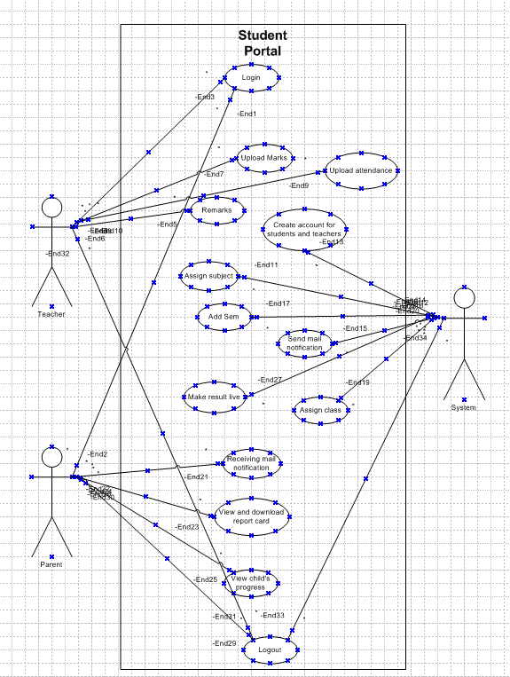

|  |  |  |
| --- | --- | --- |
|  |  | yes  result  More results  Add semester  Assign classes  Assign subjects  Create a/c for teachers and students  Lock a/c  Unsuccessful login  Count>3  Log out  Show possible menus and functions  Login valid  vval  Login to system  Send mail |
|  |  | Notify ADMIN  Notify ADMIN  Save attendance and remarks  Save marks and remarks  Entries valid  Entries valid  Logout  Enters marks in system with remarks  Add attn. with remarks  Unsuccessful login  Receives marks  Receives attendance  Show possible Menus and functions  Lock a/c  Count>3  Login valid  Login to system |
|  |  | View attendance  View child’s progress  View and Download report card  Receive mail notification  Count>3  Unsuccessful login  Login valid  Lock a/c  Logout  Show possible menus andfunctions  Login to system |

Activity Diagram  
  
  
  
**Use Case Specification Document**

**1. Use Case Name: Login**

**Use Case Description:** Allows users to log in to the Grade Hub portal.  
  
**Actors:**

Primary Actors: Teacher, System Administrator

Secondary Actors: Database

**Basic Flow:**

1. User navigates to the login page.

2. User enters username and password.

3. System validates credentials.

4. System displays the dashboard upon successful login.

**Alternate Flow:** *Invalid credentials:*

* System displays an error message.

* User retries login or resets password.

**Exceptional Flows:** *System downtime:*

* User is unable to log in.

* System displays maintenance message.

**Pre-Conditions:**

* User must be registered in the system.

* System must be online.

**Post-Conditions:**

* User is logged in and directed to the dashboard.

**Assumptions:**

* Users have valid credentials.

**Constraints:**

* High load times during peak hours.

**Dependencies:**

* User database authentication service.

**Inputs and Outputs:**

* Inputs: Username, password

* Outputs: Dashboard, error messages  
  
**Business Rules:**\* Passwords must meet security requirements.

* Account lockout after multiple failed attempts.

**Miscellaneous Information:**

* Ensure password reset functionality is available.

**2. Use Case Name: Upload Marks**

**Use Case Description:** Allows teachers to upload students' marks.

**Actors:**

Primary Actors: Teacher

Secondary Actors: Database

**Basic Flow:**

1. Teacher logs into the Grade Hub portal.

2. Teacher navigates to the "Upload Marks" section.

3. Teacher selects the class and subject.

4. Teacher enters or uploads students' marks.

5. System validates the entered marks.

6. System saves the marks to the database.

**Alternate Flow:** *Invalid marks format:*

* System displays an error message.

* Teacher corrects and re-submits marks.

**Exceptional Flows:** *Database error:*

* System displays an error message.

* Teacher retries uploading marks later.

**Pre-Conditions:**

* Teacher must be logged into the system.

* The class and subject must be predefined in the system.

**Post-Conditions:**

* Marks are successfully saved in the system.

**Assumptions:**

* Teachers have the correct marks data.  
  
**Constraints:**

* System performance during high usage times.

**Dependencies:**

* Database service

**Inputs and Outputs:**

* Inputs: Marks data

* Outputs: Confirmation message, error messages

**Business Rules:**

* Marks must be in the correct format.

* Marks entry should follow the academic calendar.

**Miscellaneous Information:**

* Provide a template for marks upload.

**3. Use Case Name: View Report Card**

**Use Case Description:** Allows parents to view and download their child's report card.

**Actors:**

Primary Actors: Parent

Secondary Actors: Database

**Basic Flow:**

1. Parent logs into the Grade Hub portal.

2. Parent navigates to the "View Report Card" section.

3. Parent selects the child's name and term.

4. System retrieves and displays the report card.

5. Parent downloads the report card if needed.

**Alternate Flow:** *No report card available:*

* System displays a message indicating no report card is available for the selected term.

**Exceptional Flows:** *Database error:*

* System displays an error message.

* Parent retries later.  
  
**Pre-Conditions:**

* Parent must be logged into the system.

* Child's academic records must be available.

**Post-Conditions:**

* Report card is viewed or downloaded.

**Assumptions:**

* Parents have valid login credentials.

**Constraints:**

* Report card generation performance.

**Dependencies:**

* Database service

**Inputs and Outputs:**

* Inputs: Child's name, term

* Outputs: Report card, error messages

**Business Rules:**

* Report cards must be finalized before viewing.

* Access permissions for parents must be verified.

**Miscellaneous Information:**

* Ensure report card format is user-friendly.

**2.** Functional Requirements Specification (FRS)

● Use Case Documents

● RTM

● Test Plan

● User Acceptance Testing (UAT) Plan

● Training Materials

● Project Management Plan

**5. Document Sign-off Process:**● Share draft documents with stakeholders for review and feedback.

● Incorporate feedback and revisions as necessary.

● Obtain formal sign-off from stakeholders indicating their acceptance of the documents.

● Maintain version control to track changes and updates.

**6. Client Approvals:**

● Present finalized documents to the client for approval.

● Provide explanations and clarifications as needed to ensure understanding.

● Obtain formal approval from the client through signed agreements or email

confirmation.

**7. Communication Channels:**

● Establish regular meetings with stakeholders to discuss project progress, issues, and

updates.

● Utilize email, project management software, and collaboration tools for asynchronous

communication.

● Maintain an open-door policy for stakeholders to raise concerns or provide feedback.

**8. Change Request Handling:**

● Establish a formal change management process to capture, assess, and prioritize

change requests.

● Evaluate the impact of proposed changes on scope, timeline, and budget.

● Obtain approval from the Change Control Board before implementing changes.

**9. Progress Reporting to Stakeholders:**

● Provide regular updates on project milestones, deliverables, and risks.

● Use status reports, dashboards, and presentations to communicate progress

effectively.

● Highlight achievements, challenges, and upcoming tasks to keep stakeholders

informed.

**10. UAT - Client Project Acceptance:**● Coordinate User Acceptance Testing (UAT) with the client to validate that the software

meets requirements.

● Provide clear instructions and test cases for the client to execute during UAT.

● Obtain sign-off on the UAT - Client Project Acceptance Form once the client confirms

satisfaction with the software functionality.

**4. Use Case Name:** Training Management

**Use Case Description:** Tracks training completed by employees.

**Actors:**

Primary Actors: Teachers

Secondary Actors: Trainer, Database

**Basic Flow:**

1. Trainer assigns training modules.

2. Teachers completes assigned training.

3. System updates training records.

**Alternate Flow:**

Incomplete training:

- System reminds the Teachers of pending training.

**Exceptional Flows:**

System downtime:

- Training cannot be recorded.

- System displays maintenance message.

**Pre-Conditions:**

- Training modules are available.

- System must be online.

**Post-Conditions:**

- Training records are updated.

**Assumptions:**

- Teachers have access to training materials.

**Constraints:**

- Training must be completed within deadlines.  
  
**Dependencies:**

- Training management system, employee database.

**Inputs and Outputs:**

- Inputs: Training module completion

- Outputs: Updated training records

**Business Rules:**

- Teachers must complete mandatory training.

**Miscellaneous Information:**

- Include notifications for upcoming training.

**5. Use Case Name:** Technical Support

**Use Case Description:** Provides technical support for employees.

**Actors:**

Primary Actors: Employee

Secondary Actors: IT_Admin

**Basic Flow:**

1. Employee submits a technical support request.

2. IT_Admin reviews and addresses the issue.

3. System updates the status of the support request.

**Alternate Flow:**

Unresolved issue:

- IT_Admin escalates the issue.

- System updates escalation status.

**Exceptional Flows:**

System downtime:

- Support request cannot be submitted.

- System displays maintenance message.

**Pre-Conditions:**

- Technical issues must be reported.

- System must be online.

**Post-Conditions:**

- Updated status of the support request.

**Assumptions:**

- IT_Admin is available to provide support.  
  
**Constraints:**

- Support must be provided within SLA.

**Dependencies:**

- IT support system, employee database.

**Inputs and Outputs:**

- Inputs: Support request details

- Outputs: Updated support request status

**Business Rules:**

- Support requests must be logged and tracked.

**Miscellaneous Information:**

- Provide feedback mechanism for support provided.  
  
**Document 7- Screens and pages**

**1.**

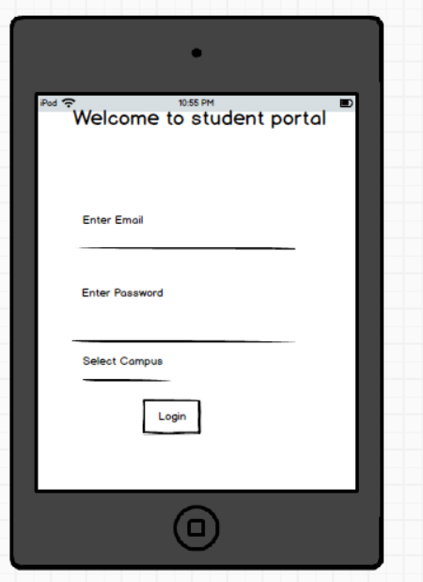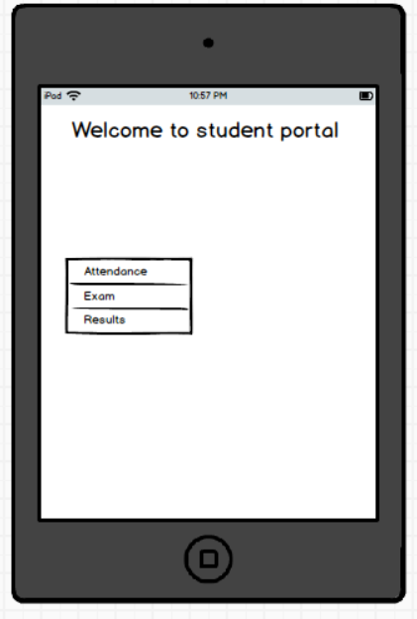  
  
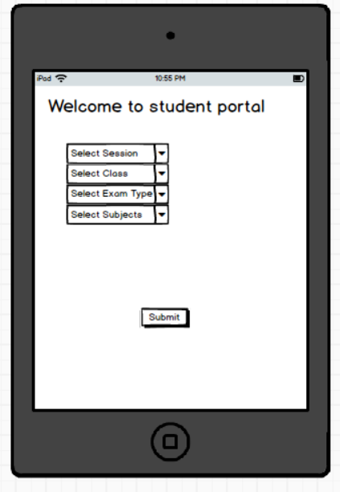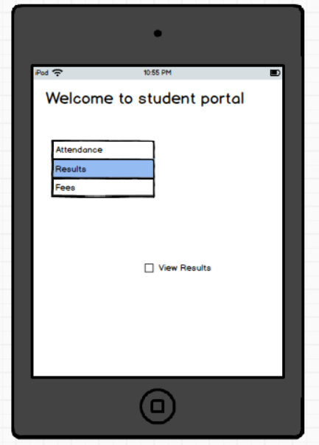

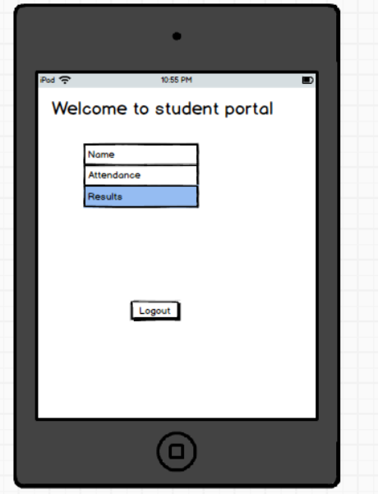  
  
  
  
  
  
  
  
  
  
  
  
**Document 8: Tools - Visio and Axure**

**Experience with Draw.io and Figma**

In this project, I effectively utilized Draw.io and Figma to enhance the design and development

process. Draw.io was instrumental in creating detailed technical diagrams, including flowcharts,

UML diagrams, and network layouts, which facilitated clear communication and planning.

Figma was used to design intuitive user interfaces and interactive prototypes, ensuring a

seamless user experience. The real-time collaboration features of both tools allowed for

efficient teamwork and iterative feedback, leading to a well-organized and visually appealing

Grade Hub portal.  
  
**Document 9: BA Experience**

**1. Requirement gathering:**

* In this project, I leveraged my expertise as a Business Analyst to gather comprehensive

requirements by using MOSCOW technique for the Grade Hub portal.

* Through a combination of stakeholder interviews, workshops, and surveys, I

Meticulously documented the needs and expectations of teachers, administrators, and IT

Staff.  
  
* I validate the requirements using FURPS technique utilizing elicitation techniques such as use case analysis and process mapping, I ensured a thorough understanding of the functional and non-functional requirements.

* My experience in requirement gathering helped create a detailed and precise requirements document, which served as a solid foundation for the successful development and implementation of the Grade Hub portal.

* Prototyping is used to give more specific requirements.  
  
**2. Requirement Analysis:**

* In this project, I utilized my skills as a Business Analyst to perform a thorough

requirements analysis for the GradeHub portal.

* I started by organizing and categorizing the gathered requirements, ensuring clarity and

removing any ambiguities.

* Using detailed analysis techniques, I identified and consolidated duplicate requirements,

ensuring a streamlined and coherent set of needs.

* I shared diagrams with the team for feedback. The team suggestions were incorporated

and made necessary modifications.

* I conducted regular validation sessions with stakeholders to confirm the accuracy and

completeness of the requirements.

* By developing and sharing prototypes, I facilitated stakeholder engagement , refining

the requirements to align perfectly with user expectations. This meticulous approach

ensured a solid foundation for the project's successful implementation.

* Prepare BRS and SRS

**3. Design:**\* From the use case diagrams, we prepare test cases

* Communicate with client on design and solution documents

* Write negative test cases as well along with positive test cases.

* Do not miss a single test case. It might have huge impact on project development in later

stages

* Prepare test data for testing

* Update RTM. This is just as we need to make sure that all the requirements are met.  
  
**4. Development:**● Organized JAD sessions

● Clarifying queries of tech team during coding

● There might be some team members who doesn't agree with the concept or

who doesn’t cooperate during JAD sessions. As a BA i handle the situation

gently and had one on one discussion with them. Explained how their actions

are going to affect the project. Setup healthy environment within the team.

● Referred diagrams to code the Unit

● Conduct regular meetings with technical team and client which is challenging.

Some team members might not be available for the meeting. Recording the

session and providing that to missed one and having one to one discussion

later with that missed person is all i need to do

**5. Testing:**

● Prepare test cases from use cases

● Perform high level testing

● Test data is requested by BA from client

● Updated RTM

● Take signoff from client

● Prepare client for UAT

**6. Deployment:**

● Forwarded RTM to client which should be attached to project closure

document

● Coordinates to complete and share end user manuals

● Plans and organizes training sessions

● Make sure all the candidates attend the meeting

**Adding some more experience points based on my Experience for this projects**

**1. Requirement Gathering:**

**Techniques:**

- Interviews with Teachers parents, and management

- Surveys to collect feedback on current processes

- Review of existing documentation and systems

- Observations of IT/Teachers’ workflows and procedures

**Activities:**

- Conducting one-on-one interviews with stakeholders to understand pain points and

requirements

- Distributing surveys to gather quantitative data on marks entry processes

- Analyzing existing documents such as marks entry system and procedures manuals

- Shadowing management/higher authority to observe current workflows and identify areas

for improvement

**Challenges:**  
  
Gathering comprehensive requirements from diverse stakeholders

- Ensuring alignment between business needs and technical capabilities

- Managing expectations of stakeholders with varying priorities

- Dealing with resistance to change from online process to existing processes

**Steps to Overcome Challenges:**

- Establishing a clear communication plan to engage stakeholders throughout the requirement

gathering process

- Prioritizing requirements based on business impact and feasibility

- Facilitating workshops to resolve conflicting requirements and build consensus

- Providing training and support to help stakeholders adapt to new processes

**2. Requirement Analysis:**

**Techniques:**

- Use Case Analysis to identify user interactions with the system

- Business Process Modeling to visualize teachers’ workflows

- Data Modeling to define data entities and relationships

- Requirement Prioritization to determine critical features

**Activities:**

- Creating use cases to capture system interactions for different user roles

- Modeling current mark entry processes to identify inefficiencies and bottlenecks

- Prioritizing requirements based on business value and dependencies

**Challenges:**

- Managing complexity in marks entry processes and data

- Balancing conflicting requirements from different stakeholders

- Ensuring scalability and flexibility of the system architecture

- Addressing regulatory compliance and data privacy requirements

**Steps to Overcome Challenges:**

- Collaborating closely with teachers subject matter experts to understand detailed

requirements

- Facilitating workshops and discussions to resolve conflicts and reach consensus

- Designing a modular and extensible system architecture to accommodate future changes

- Conducting thorough analysis of regulatory requirements and incorporating them into the

system design

**3. Design:**

**Techniques:**

- System Design to define system components and interactions

- User Interface Design to create intuitive interfaces for users

- Data Design to design databases and data storage mechanisms

- Architecture Design to define the overall system structure.  
  
**Activities:**

- Designing the system architecture with modules for employee management functions

- Creating wireframes and mockups for user interfaces

- Defining database schemas and data storage mechanisms

- Documenting design decisions and rationale for future reference

**Challenges:**

- Balancing usability with functionality in the user interface design

- Integrating with existing HR systems and databases

- Ensuring security and privacy of employee data

- Managing design changes and maintaining consistency

**Steps to Overcome Challenges:**

- Conducting user testing and feedback sessions to iterate on interface designs

- Collaborating with IT teams to integrate with existing systems using standardized protocols

- Implementing robust security measures such as encryption and access controls

- Using version control and documentation tools to track design changes and ensure

Consistency

**4. Development:**

**Techniques:**

- Coding according to design specifications

- Code reviews and unit testing

- Prototyping to validate design concepts

- Continuous Integration to integrate code changes

**Activities:**

- Writing code for backend and frontend components of the software

- Conducting code reviews and unit tests to ensure quality

- Building prototypes to validate key features with stakeholders

- Integrating code changes into the main codebase and deploying to test environments

**Challenges:**

- Meeting deadlines and milestones set in the project plan

- Addressing technical debt and maintaining code quality

- Ensuring compatibility and interoperability with other systems

- Managing dependencies and third-party integrations

**Steps to Overcome Challenges:**

- Breaking down development tasks into smaller, manageable units

- Prioritizing high-impact features and functionalities for early delivery

- Allocating time for refactoring and addressing technical debt

- Implementing automated testing and continuous integration practices to detect and fix

Issues early

**5. Testing:**

**Techniques:**- Unit Testing to test individual components

- Integration Testing to test interactions between components

- System Testing to test the entire system

- User Acceptance Testing to validate against user requirements

**Activities:**

- Writing and executing test cases for different levels of testing

- Identifying and reporting bugs and issues

- Conducting regression testing to ensure new features don't break existing functionality

- Facilitating user acceptance testing with stakeholders

**Challenges:**

- Limited test coverage and resources

- Reproducing and fixing complex bugs reported by testers

- Coordinating testing efforts across different teams and environments

- Balancing time and resources allocated for testing with other project activities

**Steps to Overcome Challenges:**

- Prioritizing test cases based on risk and criticality

- Implementing test automation for repetitive and time-consuming tests

- Establishing clear communication channels between development and testing teams

- Continuously monitoring and adjusting testing efforts based on project priorities and

timelines

**6. Project Live/Implementation/Deployment:**

**Techniques:**

- Deployment Planning to ensure smooth transition to the new system

- User Training to familiarize users with the new software

- Change Management to address resistance and facilitate adoption

- Post-Implementation Review to evaluate project success and identify areas for improvement

**Activities:**

- Planning and coordinating deployment activities with IT and business teams

- Conducting training sessions for Teaching staff and end-users

- Communicating changes and benefits of the new system to stakeholders

- Reviewing project outcomes and gathering feedback for future enhancements

**Challenges:**

- Disruption to Teachers and parents during system rollout

- Resistance to change from employees accustomed to old processes

- Ensuring user adoption and proficiency with the new software

- Evaluating project success and identifying lessons learned for future projects

**Steps to Overcome Challenges:**

- Developing a detailed deployment plan with contingencies for potential issues

- Providing comprehensive training and support to address user concerns and build confidence.  
  
- Engaging stakeholders early and often throughout the implementation process

- Conducting post-implementation reviews to gather feedback and identify opportunities for

Improvement.