Capstone Project 1 – Part -2/3
Q1: 4 Quarterly Audits are planned Q1, Q2, Q3, Q4 for this Project

Stage | Quarter 1  Audit Report (Requirement gathering and Analysis)
Completed | 17 Weeks (Week 1 to Week 17)
Check list | BRD Template, Elicitation result report
 | Grouping of functionalities, UML Diagrams
 | Business to functional req. mapping
 | Client sign-off, Email communication – To, CC, BCC

Stage | Quarter 2  Audit Report (Design and Documentation)
Completed | 27 Weeks (Week 18 to 45)
Check list | Utilization of Tool, Designing Solution
 | Documented Evidence on client communication
 | Stakeholder MOM
 | Email communication – To, CC, BCC

Stage | Quarter 3  Audit Report (Development and Testing)
Completed | 20 weeks (Week 46 to 66)
Check list | JAD session report, End user manual prep document
 | BA and developer MOM, Developing Code
 | Test case summary, Training report to end users
 | Lession learnt document, Email communication – To, CC, BCC

Stage | Quarter 4  Audit Report (Go live and Closure)
Completed | 12 Weeks (Week 66 to 78)
Check list | Final deliverable acceptance and client sign off
 | Transition and handover documents
 | Post implementation feedback, Archive project documentation
 | Email communication – To, CC, BCC

Q2: BA Approach Strategy
BA approach strategy means how the BA will be approaching to complete this project, or whatever the strategies he will be using to complete this project
Elicitation techniques:
Conduct interviews with the stakeholders (Mr. henry, Mr. Pandu, Mr. Dooku, Peter, Kevin, Ben) to gather requirements, organize focus group sessions to understand the needs of the remote area farmers. Conduct surveys and questionnaires to gather a wider perspective.
Stakeholder Analysis:
Conduct RACI (Responsible, Accountable, Consulted, Informed) analysis to determine the roles and responsibilities of each stakeholder. Identify the key stakeholders and prioritize their requirement. Establish effective communication channels with the stakeholders to keep them informed about the progress of the project.
Documents:
Write a Functional requirement document (FRD) to outline the functional and non-functional requirement of the project. Create a Business Requirement Document (BRD) to provide a detailed description of the project’s objectives, scope and deliverables. Develop a Use case document to describe the processes and workflows involved in the project.
Sign off & Approval:
Obtain a sign-off from the stakeholders on the FRD, BRD and use case document. Ensure that the stakeholders understand and agree with the requirements, scope and objectives of the project.
Client’s approval:
Obtain the client’s approval on the project deliverables, budget timeline and approach. Ensure that the client’s expectations are aligned with the project goal and objectives
Communication Channels:
Establish a regular communication schedule with the stakeholder to keep them informed about the project’s progress. Create a communication plan to outline the channels and methods of communication. Schedule regular status meeting with the stakeholders to discuss the project’s progress and address any issues or concerns

Change Requests:
Handle change requests in a structured and systematic manner. Evaluate the impact of each change request on the project scope, timeline and budget. Obtain approval from the stakeholders before implementing the change request.
Progress updates:
Keep the stakeholders informed about the project’s progress through regular status reports and progress meetings. Highlight any risks or issues that need to be addressed. Provide regular progress updates to the stakeholders and seek their feedback.
UAT sign-off:
Conduct User Acceptance Testing (UAT) to validate the project’s deliverables. Obtain sign-off from the client on the UAT results and the Project Acceptance. Ensure that the project meets the client expectations and requirements.

Q3: 3-Tier Architecture:
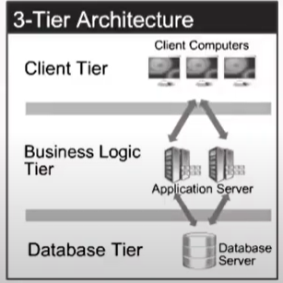

Three-tier architecture is a software architecture that consists of three layers:
Client Tier (Presentation layer)
Business Logic Tier (Application Layer)
Database Tier (Database layer)
Presentation Layer:
The presentation layer is the top layer of the architecture and it is responsible for presenting the user interface to the end users. It is also known as the user interface layer or the client layer. This layer handles the interaction between the user and the system.
Application Layer:
The application layer is the middle layer of the architecture and contains the business logic of the system. It is also known as the logic layer or the server layer. This layer manages the application logic, Data validation and data processing. It communicates with the presentation layer and the database layer.
Database Layer:
The database layer is the bottom layer of the architecture and is responsible for Managing the data storage and retrieval. It is also known as the data layer or the server layer. This layer is responsible for storing and retrieving data from the database management system (DBMS). The database layer provides and interface for the application layer to access and manipulate data.

Q4: BA Approach strategy:
5W 1H: If we need extract consistent requirements then probe in this direction like here, why, What, Who, When and How.
What?
Defines the issue, objective, project, or task at hand. Example: What are we trying to achieve? What is the problem or opportunity?
Who?
Identifies the people involved or impacted. Example: Who are the stakeholders? Who is responsible for action?
Where?
Specifies the location or context. Example: Where is the problem occurring? Where will the project take place?
When?
Pinpoints timing and deadlines. Example: When did the issue appear? When does the project start and finish?
Why?
Uncovers the purpose, cause, or motivation. Example: Why is this project important? Why did the problem happen?
How?
Explores the method or approach. Example: How will solutions be carried out? How do current processes work?
SMART: It provides framework for achieving goals that are specific, measurable, achievable, relevant and time bound
Specific: They should be clear and concise, Focusing on the key issues at hand
Measurable: They should allow for quantifiable results, such as metrics or key performance indicators (KPI’s), which can be used to measure progress.
Achievable: They should be realistic and feasible, taking into account the resources and constraints of the project
Relevant: They should be aligned with the project goals and objectives, and address the stakeholder’s need and concerns.
Time-bound: They should have a specific deadline or timeline attached to them, to ensure that they are completed in a timely manner.

RACI: Understand the roles and responsibilities of all stakeholders involved in the project.
Responsible (R):
The person (or people) who performs the task or work. They are "hands-on" and ensure completion. Every task should have at least one responsible party.
Accountable (A):
The person who owns the work and is ultimately answerable for correct, complete deliverable. Only one person is accountable for each task—this person makes major decisions and delegates work when needed.
Consulted (C):
People who provide information, expertise, or feedback before a task is completed. This is a two-way communication; these could be subject matter experts or stakeholders.
Informed (I):
People who are kept up-to-date on progress or decisions, often with one-way communication. They are not directly involved but need to know about outcomes—examples include leadership or other stakeholders.
Use Case: Develop a deep understanding of how the application will be used by various users.

3 Tier Architecture:
Presentation Layer:
The presentation layer is the top layer of the architecture and it is responsible for presenting the user interface to the end users. It is also known as the user interface layer or the client layer. This layer handles the interaction between the user and the system.
Application Layer:
The application layer is the middle layer of the architecture and contains the business logic of the system. It is also known as the logic layer or the server layer. This layer manages the application logic, Data validation and data processing. It communicates with the presentation layer and the database layer.
Database Layer:
The database layer is the bottom layer of the architecture and is responsible for Managing the data storage and retrieval. It is also known as the data layer or the server layer. This layer is responsible for storing and retrieving data from the database management system (DBMS). The database layer provides and interface for the application layer to access and manipulate data.

Use Case Specs: Develop detailed documentation outlining specific requirements and expected behavior for each use case.
Activity Diagram: Create visual representation of how different activities and process will follow within the application.
Models: Use various models to help stakeholders better understand the system, such as data models and sequence diagrams.
Page designs: Create Mockup and wireframes of the application’s use interface to better understand user needs and preferences.

5. Elicitation Techniques:
- Document Analysis: Document analysis is done through reading a document and understanding a product or process
- Reverse Engineering: Also called back engineering, is the process of extracting knowledge or design information from anything man-made and reproducing it based on extracted information. Often involves disassembling something to analyze its component. Majorly used in migration projects.
- Focus Group: A means to elicit ideas about a specific product or service in an interactive group environment.
- Observation: Shadowing users or doing a part of their job can provide info of existing process, input and output.
- Workshop: A requirement workshop is a structured approach to capture requirements.
- JAD: Joint Application Development has higher customer satisfaction and lower error percentage as user is directly involved in the development process.
- Interview: An interview is systematic approach where BA asks relevant question related to the software and document the same.
- Prototyping: It is attractive idea for complicated and large systems for which there is no manual process or existing system to help determining the requirements.
- Survey/Questionnaire: Questionnaire can be useful for obtaining limited system requirement from the user.
- Brainstorming: brainstorming is an effective way to generate lot of ideas; it is done with and individual or in a group. The ideas collected during brainstorming session are reviewed and analyzed.

6. Which elicitation techniques can be used in this project and justify your selection of Elicitation techniques?

Prototyping: The prototyping techniques can be used to create a working model of the application’s user interface, which can be used to gather feedback from stakeholders and ensure that the requirements are being met. This technique can be particularly useful for gathering requirements related to the user interface and user experience.

Use Case Specs: Use case specifications can be used to capture the functional requirements of the system, by defining the various use case that the system will need to support. This technique can be used to gather requirements related to the interactions between user and the system, as well as the various system functions and feature.

Document Analysis: Document analysis can be used to review existing document such as project charters, business requirements document, and other relevant documents to gather requirements. This technique can be used to gather requirements related to existing business processes and system functionalities.

Brainstorming: Brainstorming can be used to generate new ideas and requirements for the system by bringing together stakeholders to discuss the project. This technique can be used to gather requirements related to new feature or functionalities that have not yet been considered.

Justification for usage of elicitation techniques:
The prototyping techniques can be used in this project because it allows for quick feedback from stakeholders and can help ensure that the final product meet their needs. The use case Specs technique can be used to capture the functional requirement of the system, which is important for any software development project. The document analysis technique can be used to review existing documentation related to the project, which can provide valuable insights into requirements, finally brainstorming can be used to generate new ideas and requirements for the system by bringing together stakeholders to discuss the project.

7. Business Requirement:

ID | Description
BR001 | Application Should have user friendly interface
BR002 | Application should be secured with Encrypted data
BR003 | Application Should allow farmers and sellers to register
BR004 | Application should allow farmers to place order for seeds, pesticides or fertilizers
BR005 | Application should allow farmers to make payment online
BR006 | Application should allow farmers to track their orders
BR007 | Application should get integrated with payment gateway
BR008 | Application should be fast with minimal data usage
BR009 | Application should be able to generate sales report for stakeholders
BR010 | Application should be able to handle large number of user registration and orders.

8. List of Assumptions:
1. The project is web-based application accessible through desktop and mobile devices.
2. The product catalog will contain only details of Fertilizers, Seeds and Pesticide.
3. The application will not store any financial information of the users.
4. The delivery of the products will be outsourced to a third-party logistics company
5. The application will not have any social media integration.

9. Projects Requirement Priority:
Req ID | Req Name | Req Description | Priority
BR001 | User Registration | Farmers and Suppliers can register into the platform | 10
BR002 | Product Catalogue | The app should display a catalog for available products | 9
BR003 | Product Search | User should be able to search for a product | 9
BR004 | Product Filter | User should be able to apply filter a product based on price or ratings | 8
BR005 | Product Details | User should be able to view detailed description of product | 10
BR006 | Add to cart | User should be able to add selected product to cart | 9
BR007 | Manage cart | User should be able to delete the product from cart | 8
BR008 | Checkout | User should able to make online payment | 10
BR009 | Order tracking | User would able to track delivery status | 7
BR010 | Order Cancellation | User would be able to cancel the order before it is shipped | 6
BR011 | Order History | User would be able to view the past order history | 8
BR012 | Payment Gateway | Application should be integrated with UPI payment Gateway | 8
BR013 | Feedback and complaint | User would able to provide feedback about purchased product | 7
BR014 | Call customer care | User would able to call customer care team from app | 5
BR015 | Chat support | User would able to initiate chat from the app | 4
BR016 | Social media integration | The app should integrate with any social media platform | 6
BR017 | Multi Language | User would able to choose desires language | 8
BR018 | Security and privacy | The app should ensure high security and privacy | 10
BR019 | Product availability | The app should update the inventory to check product availability | 9
BR020 | Refund Policy | The app should initiate refund to the original payment mode upon order cancellation | 7

Use case diagram:
Use case diagram is a visual representation of the interaction between users (actors) and a system.
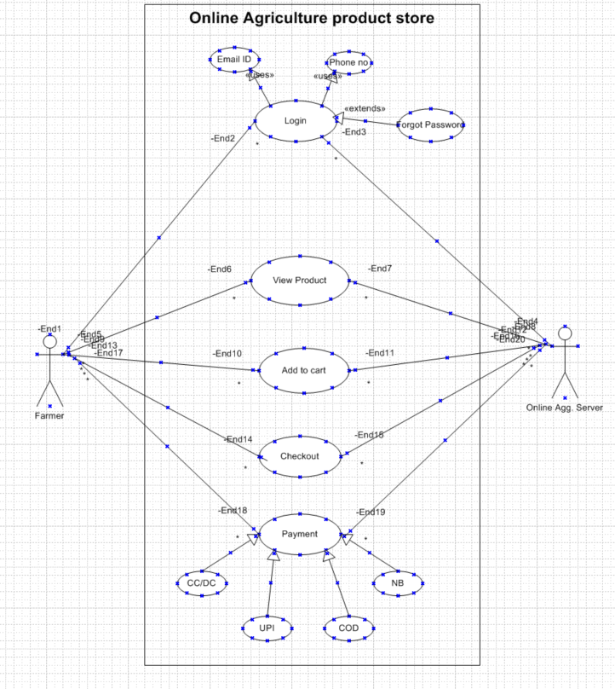

Q11: Use case Specification
A use case specification Document which provides a detailed description of a use case, outlining how users (Actors) will interact with the system to achieve a specific goal.

User Case ID | UC001
Case Name: | New User Registration
Created By: | BA
Date Created: | 16/9/2024
Actor | Farmers
Description: | New Farmers Can Register into app
Pre & Post Condition | User Need to have a valid Phone number or Email ID to Register
Flow: | User will click on Register.  User will enter the Mobile number or Email ID and passoword.  User would be able to login and create profile.
Alternative Flow | Click on Forget password Link.
Exceptions | If Internet connection lost while doing this, System should display msg, Check internet connectivity.
Frequency | High
Assumptions | It is assumed that customer has computer Knowledge.

User Case ID | UC002
Case Name: | Choose from the list of available products.
Created By: | BA
Date Created: | 16/9/2024
Actor | Farmers
Description: | Ragistered user would be able to select and add the product to the cart.
Pre & Post Condition | User must be Ragistred.
Flow: | Ragistered user would be able to search for the product.  Ragistered user would be able to select the product from the list.  User would be able to add the item to the cart or wish list
Alternative Flow | None
Exceptions | If Internet connection lost while doing this, System should display msg, Check internet connectivity
Frequency | High
Assumptions | It is assumed that customer has computer Knowledge

User Case ID | UC003
Case Name: | Checkout and Payment
Created By: | BA
Date Created: | 16/9/2024
Actor | Farmers
Description: | Ragistered User would be able to make payment and place the order
Pre & Post Condition | User must be Ragistered
Flow: | User will select the address for shipment  User will select the payment mode  User will enter the debit/Credit card details, CVV and PIN or UPI  User will enter OTP received from the bank
Alternative Flow | None
Exceptions | If Internet connection lost while doing this, System should display msg, Check internet connectivity
Frequency | High
Assumptions | It is assumed that customer has computer Knowledge

User Case ID | UC004
Case Name: | Cancel the Order
Created By: | BA
Date Created: | 16/9/2024
Actor | Farmers
Description: | Ragistered user would be able to cancel the order
Pre & Post Condition | User must be Register
Flow: | User will click on ‘My account’  User will click on Order History  User will select the order to be cancelled  Selected order will show as cancelled  Refund will be initiated
Alternative Flow | None
Exceptions | If Internet connection lost while doing this, System should display msg, Check internet connectivity
Frequency | Hight
Assumptions | It is assumed that customer has computer Knowledge

User Case ID | UC005
Case Name: | Track the Order
Created By: | BA
Date Created: | 16/9/2024
Actor | Farmers
Description: | Ragistered user would be able to track the order
Pre & Post Condition | User must be Register
Flow: | User will click on Order History  User need to click on Track Order  User would be able to see where the order has reached and an estimated time of delivery  User would be able to call customer care or initiate a chat for any further query or concern
Alternative Flow | Click on Forget password Link
Exceptions | If Internet connection lost while doing this, System should display msg, Check internet connectivity
Frequency | High
Assumptions | It is assumed that customer has computer Knowledge

Q12: Activity Diagram:
An activity diagram is a type of diagram in the Unified Modelling Language (UMP), That visually represents the flow of activities with in a system.

- User Login
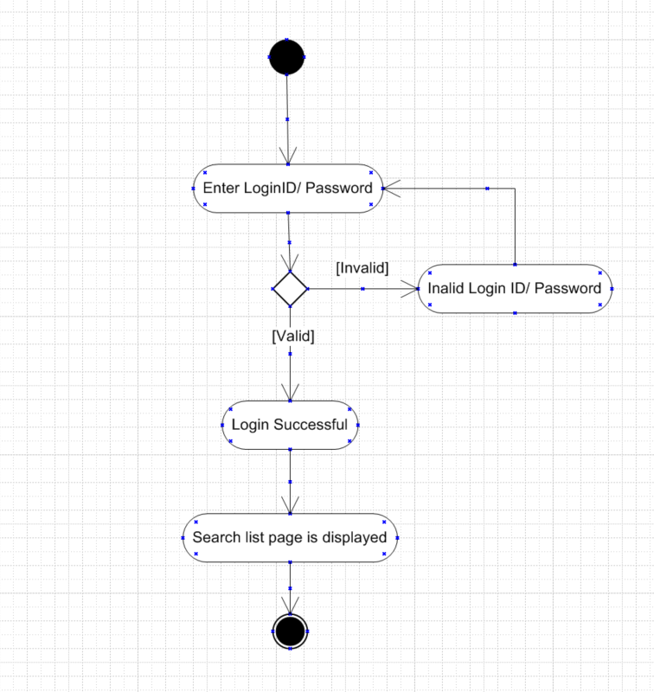

- Search Product
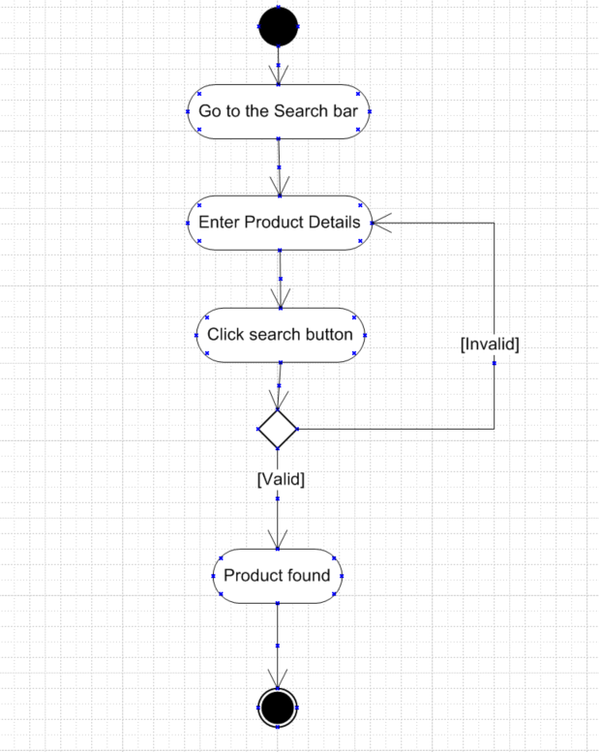

- Add product to Cart
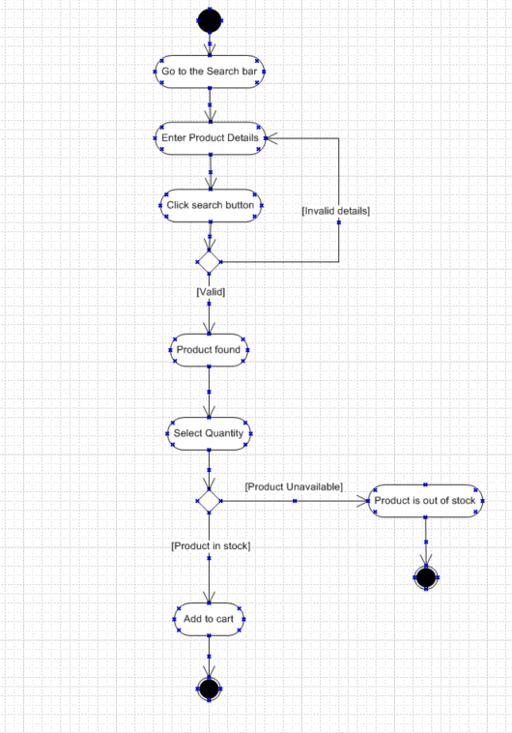

- Making a Payment

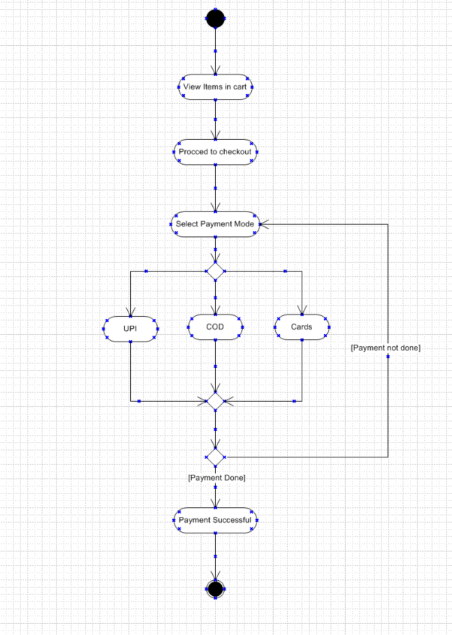

- Delivery

