**Question 1: Audits**

4 Quarterly audits are planned and will be as follows:

|  |  |
| --- | --- |
| Stage | Quarter 1 Audit Report  (Requirement Gathering phase) |
| Completed | 5 Weeks (Week 1 – Week 5) |
| Check Lists | BRD Template |
| Elicitation Techniques and results report. |
| Grouping of functionalities and features |
| Email communications – To, CC, BCC |
| Stage | Quarter 2 Audit Report  (Requirement analysis phase) |
| Completed | 5 Weeks (Week 6 – Week 10) |
| Check Lists | UML Diagrams |
| Business to functional requirements mapping |
| Client sign-off documents. |
| RTM document version control |
| Email communications – To, CC, BCC |
| Stage | Quarter 3 Audit Report  (Design Phase) |
| Completed | 5 Weeks (Week 11 – Week 15) |
| Check Lists | Utilization of tools. |
| Documentation of client communication. |
| Stakeholder MoM (Minutes of Meetings) |
| Email communications – To, CC, BCC |
| Stage | Quarter 4 Audit Report  (Development and Testing phase) |
| Completed | 3 Weeks (Week 16 – Week 8) |
| Check Lists | JAD session reports, Test case summary. |
| End user manual preparation, training report to end users. |
| Developer and BA’s MoM. |
| Lessons learnt documents. |
| Email communications – To, CC, BCC |

**Question 2: BA Approach**

* What Elicitation Techniques to apply?

We have multiple elicitation techniques like Brainstorming, Document Analysis, Reverse Engineering, Focus Groups, Observations, JAD sessions, Workshops, Prototyping and questionaries.

For this project I would choose **Brain Storming or Questionaries’ or** **Focus Groups and Prototyping** as the Elicitation Techniques. Reasons to not to choose other techniques.

* + As there is no previous version of the software to be built, we cannot go with Document Analysis, Observations and Reverse Engineering.
  + Workshops and JAD session require a greater number of participants.
* How to do Stakeholder Analysis? RACI/ILS
  + ILS is a stakeholder analysis approach, where stakeholders are categorized based on their Influence, Legitimacy and Salience. It has three key points: Identifying Stakeholders, Evaluating each factor, Matrix Analysis.
  + A RACI Matrix is a tool to clearly identify the roles and responsibilities of each stakeholder. Its key categorizations are: Responsible, Accountable, Consulted, Informed.
* Documents to write?
  + The important documents are: BRD, FRD, Use Case documents, Test Case Documents, Sign-off documents, etc.
* What process to follow to Sign-off on the documents?
  + Sign-Off is to be taken on SRS as this is the primary and important document. Sign-off can be taken by using E-mail confirmation from client.
* How to take Approvals from the Client?
  + Client approval can be taken by establishing a formal meeting with the clients, keeping them informed and get continuous feedback.
* What Communication Channels to establish and implement?
  + Email, Scheduling regular meetings, Weekly status meetings, bi-weekly sprint reviews, monthly stakeholder updates.
* How to Handle Change Requests?

To handle change requests, a BA should follow the following steps:

* + Document the change request
  + Analyze the change request
  + Get approval from PM
  + Perform feasibility study
  + Impact Analysis
  + Effort estimation to implement the change.
* How to update the progress of the project to the Stakeholders?
  + Review Meetings
  + Status reports in regular intervals (Weekly/ Monthly)
* How to take signoff on the UAT- Client Project Acceptance Form?
  + To take signoff on UAT, BA must ensure the following: UAT preparation, Conduct UAT, fix issues, Acceptance form, Final review meeting, Obtain sign-off.

**Question 3: 3-Tier Architecture**

A 3-tier architecture is a software architecture pattern, that distributes an application into three separate layers:

* Application Layer: The user interacts with the application through this layer. It provides the interface where users can interact with the application. Components are GUI, Screen, pages, etc.
* Business Logic Layer: This includes the business logic and handles core functionalities of the application. It includes APIs, backend services, Government specific rules and regulations, etc.
* Data Layer: This layer manages the data used by application. It includes databases, file storages, etc.

**Question 4: BA Approach Strategy for Framing Questions?**

* 5W1H: It is a framework and used as a tool for gathering information by asking questions: Who, Where, When, What, Why and How?
* SMART: It is a tool and technique to ask right questions to stakeholders. A well-formed requirement should comply with SMART. Specific, Measurable, Attainable, Realistic, Tracible.
* RACI: It is stakeholder analysis tool and used to clearly define the roles and responsibilities of each stakeholder involved in the project. The stakeholders are divided into four categories: Responsible, Accountable, Consulted and Informed.
* 3-tier Architecture: It distributes the application in to 3 layers. Application layer, Business Logic layer and data layer.

The application layer contains the screen, pages, functionalities, etc. of the application and is responsible for user interactions. The Business logic layer contains all the reusable components of an application, APIs, Gov. rules & regulations, etc. The data layer contains database components.

* USE CASES: A use case diagram is a high-diagram, also known as mother of all diagrams. It focuses on how external interfaces will interact with the proposed IT solution.
* USE CASE SPECS: Every use case has its own use case description document, known as use case specification document.
* Activity Diagram: It is a type of UML diagram that represents the flow of activity or actions in a system. It shows the sequence of activities, the flow control and conditions that trigger actions.
* Models: A model is a conceptual model that represents various entities, their attributes and relationships between these entities. Key components of a model are: Entities, Attributes, Relationship, Association.
* Page Designs: It is the last part after functional requirements are feezed.

**Question 5: Elicitation Techniques**

The elicitation techniques are:

* Brain storming
* Document Analysis
* Reverse Engineering
* Focus Groups
* Observation
* Workshop
* JAD Session
* Interview
* Prototyping
* Questionnaire
* Use case specs

**Question 6: This project Elicitation techniques?**

The elicitation technique I would recommend for this project are Prototyping and Brain storming.

As this is a new project and we don’t have any previous version of application, we cannot move forward with document analysis and use case specs.

Since our end users are remote area farmers and some of them are in stakeholders committee, it would be a great idea to do brain storming session with them to know exactly what and how they want a solution to be. Also, with addition to brain storming, I would also suggest Prototyping. The stakeholder can easily understand what a solution will look like and they can contribute with more ideas on looking at the prototype.

**Question 7: 10 Business Requirements**

* BR001 - Farmers should be able to search for available products in fertilizers, seeds, pesticides.
* BR002 - Manufacturers should be able to upload and display their products in the application.
* BR003 - Registration for all users (farmers, agricultural companies)
* BR004 – Login with registered email address and password for all users.
* BR005 – Browse and Search function for products.
* BR006 – Product Catalogue Management.
* BR007 – Purchase and Buy-later feature only after login.
* BR008 – Secure Payment gateway with COD, UPI and Credit/Debit card options.
* BR009 – Order Confirmation and Order status update. Email confirmation
* BR010 – Delivery Tracking feature.

**Question 8: Assumptions**

* Farmer’s have basic knowledge of using online portals and services.
* Transportation and delivery will be efficient and on time.
* Product details and price entered by manufacturers are correct.
* Payment gateway is secure as it will have direct affect in the process.
* Good internet connectivity in remote areas.

**Question 9: Requirements Priority**

|  |  |  |  |
| --- | --- | --- | --- |
| Requirement ID | Requirement Name | Requirement Description | Priority |
| BR001 | Farmers should be able to search for available products in fertilizers, seeds, pesticides. | Search options to directly search for required products without spending much time scrolling. | 6 |
| BR002 | Manufacturers should be able to upload and display their products in the application. | Complete details of products for better understanding with photos. | 8 |
| BR003 | Registration for all users (farmers, agricultural companies) | All users need to register to sell or buy any product. | 10 |
| BR004 | Login with registered email address and password for all users. | Login to make purchases for farmers or sell items for manufacturers. | 9 |
| BR005 | Browse and Search function for products. | Browse through categories for farmers. | 5 |
| BR006 | Product Catalogue Management. | Organize and categorize the products entered by manufacturers. | 7 |
| BR007 | Purchase and Buy-later feature only after login. | User need to login to buy any product or add it to buy later list. | 4 |
| BR008 | Secure Payment gateway with COD, UPI and Credit/Debit card options. | Easy and secure payment gateways to buy products. | 3 |
| BR009 | BR009 – Order Confirmation and Order status update. Email confirmation | Order status in application and confirmation in email and application. | 2 |
| BR010 | Delivery Tracking feature. | Realtime delivery tracking of orders. | 1 |

**Question 10: USE Case diagram.**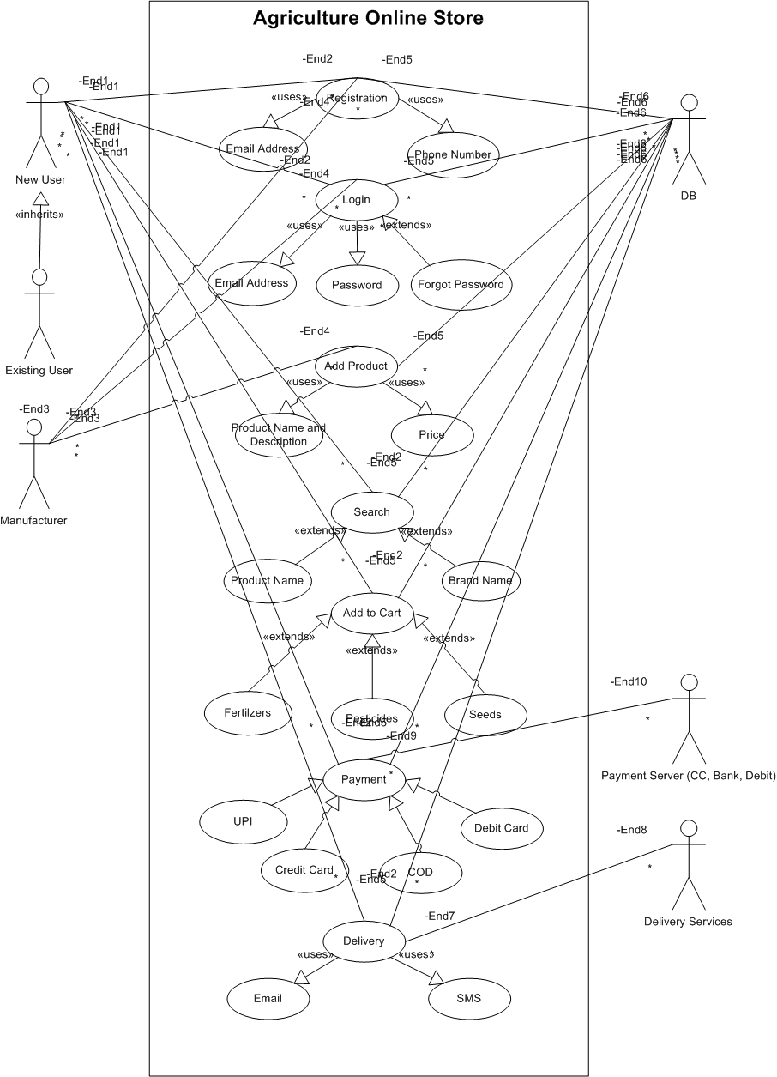

**Question 11: USE Case Specs. (Minimum 5)**

|  |  |
| --- | --- |
| **USE CASE ID:** DC001 | **USE CASE Name:** User Registration |
| **Created By:** Jay Kishan Sahu | **Date Created:** 25/02/2025 |
| 1. **Use Case Description** | This use case describes the registration process in website and application |
| 1. **Actors** | Primary: Farmer, Manufacturer  Secondary: Database Server |
| 1. **Pre-Conditions** | Users have knowledge about the website or application installed in their mobile |
| 1. **Basic Flow** | Step 1. Farmers and Manufacturers register using email address and phone number. |
| 1. **Alternate Flow** | Step 1. If user already registered. The website directs them to login page |
| 1. **Exceptional Flow** | Go to registration page if users have not registered and trying to place order.  “Check internet connection” pop-up, when network goes down. |
| 1. **Post-Conditions** | Users successfully registered |
| 1. **Frequency of Use** | High |
| 1. **Special Requirements** | Basic digital literacy among users. |

|  |  |
| --- | --- |
| **USE CASE ID:** DC002 | **USE CASE Name:** User Login |
| **Created By:** Jay Kishan Sahu | **Date Created:** 25/02/2025 |
| 1. **Use Case Description** | This use case describes the login process in website and application |
| 1. **Actors** | Primary: Farmer, Manufacturer  Secondary: Database Server |
| 1. **Pre-Conditions** | Users have knowledge about the website or application installed in their mobile.  Users are already registered in the system. |
| 1. **Basic Flow** | Step 1. Farmers and Manufacturers login using email address and password. |
| 1. **Alternate Flow** | Step 1. Users are directed to forgot password page, if their credentials are not correct.  Step 2. Users update password and are directed to login page.  Step 3. User’s login using their email address and updated password. |
| 1. **Exceptional Flow** | Go to registration page if users have not registered and trying to place order.  “Check internet connection” pop-up, when network goes down. |
| 1. **Post-Conditions** | Users logged in successfully. |
| 1. **Frequency of Use** | High |
| 1. **Special Requirements** | Basic digital literacy among users. |

|  |  |
| --- | --- |
| **USE CASE ID:** DC003 | **USE CASE Name:** Add Product (Manufacturer) |
| **Created By:** Jay Kishan Sahu | **Date Created:** 25/02/2025 |
| 1. **Use Case Description** | This use case describes the process of adding products. |
| 1. **Actors** | Primary: Manufacturer  Secondary: Database Server |
| 1. **Pre-Conditions** | Manufacturers have successfully logged in the system. |
| 1. **Basic Flow** | Step 1. Manufacturers add products in the system with details like brand name, product name, category, photos and other details. |
| 1. **Alternate Flow** | Step 1. If manufacturers miss out details, the product is not saved and manufacturers receive system warning to add details to save the product in selling list.  Step 2. Manufacturer add all details by filling up all mandatory fields and list the product for selling. |
| 1. **Exceptional Flow** | “Check internet connection” pop-up, when network goes down. |
| 1. **Post-Conditions** | Manufacturers lists products to sell |
| 1. **Frequency of Use** | High |
| 1. **Special Requirements** | Mandatory fields marked with Asterix. |

|  |  |
| --- | --- |
| **USE CASE ID:** DC004 | **USE CASE Name:** Searching Product |
| **Created By:** Jay Kishan Sahu | **Date Created:** 25/02/2025 |
| 1. **Use Case Description** | This use case describes the process of searching products in website and application |
| 1. **Actors** | Primary: Farmer  Secondary: Database Server |
| 1. **Pre-Conditions** | Users have logged in the system |
| 1. **Basic Flow** | Step 1. Farmers search products by brands or type. Also, users can scroll through categories and select product.  Step 2. User select “BUY” option |
| 1. **Alternate Flow** | Step 1. If user is not logged in. On clicking “Buy” option, user is directed to login page.  Step 2. On successful login, the user is directed to the Cart. |
| 1. **Exceptional Flow** | “Check internet connection” pop-up, when network goes down. |
| 1. **Post-Conditions** | Products added to purchase lists. |
| 1. **Frequency of Use** | High |
| 1. **Special Requirements** | Basic digital literacy among users. |

|  |  |
| --- | --- |
| **USE CASE ID:** DC005 | **USE CASE Name:** Add to Cart |
| **Created By:** Jay Kishan Sahu | **Date Created:** 25/02/2025 |
| 1. **Use Case Description** | This use case describes the process of adding product to cart in website and application |
| 1. **Actors** | Primary: Farmer  Secondary: Database Server |
| 1. **Pre-Conditions** | Users have logged in the system |
| 1. **Basic Flow** | Step 1. Farmers search products by brands or type. Also, users can scroll through categories and select product.  Step 2. User select “add to cart” option. |
| 1. **Alternate Flow** | Step 1. If user is not logged in. On clicking “Add to cart” option, user is directed to login page.  Step 2. On successful login, the user is directed to the Cart. |
| 1. **Exceptional Flow** | “Check internet connection” pop-up, when network goes down. |
| 1. **Post-Conditions** | Products added to cart. |
| 1. **Frequency of Use** | High |
| 1. **Special Requirements** | Basic digital literacy among users. |

|  |  |
| --- | --- |
| **USE CASE ID:** DC006 | **USE CASE Name:** Payment |
| **Created By:** Jay Kishan Sahu | **Date Created:** 25/02/2025 |
| 1. **Use Case Description** | This use case describes the payment process in website and application |
| 1. **Actors** | Primary: Farmer  Secondary: Database Server, Payment Server |
| 1. **Pre-Conditions** | Users have logged in, have CC, Debit Card, Bank Account or UPI. Products are in cart. |
| 1. **Basic Flow** | Step 1. Farmer enters delivery address and billing address.  Step 2. Select a payment option for online payment. COD for paying while delivery.  Step 3. Enter payment details.  Step 4. Make payment.  Step 5. Receives payment and order status notification in SMS and email. Can download online receipt generated. |
| 1. **Alternate Flow** | Step 1. If payment fails. User is directed to the “Select Payment Mode” options.  Step 2. Step 2. Select a payment option for online payment. COD for paying while delivery.  Step 3. Enter payment details.  Step 4. Make payment.  Step 5. Receives payment and order status notification in SMS and email. Can download online receipt generated. |
| 1. **Exceptional Flow** | “Check internet connection” pop-up, when network goes down. |
| 1. **Post-Conditions** | Order Placed Successfully. |
| 1. **Frequency of Use** | High |
| 1. **Special Requirements** | Basic digital literacy among users. |

**Question 12: Activity diagram. (Minimum 5)**

