**WATERFALL DELIVERABLES PART -2**

1. **Use Case Specification Document**

* Use Case Name

Integrated Email and Cloud Storage Platform (Mail Smart App)

* Use Case Description

This use case describes the functionality of an integrated platform that allows users to send and receive emails while seamlessly managing file storage in the cloud. Users can attach files from cloud storage to emails, save email attachments directly to cloud storage, and organize files and emails efficiently.

* Actors

Primary Actors:

* End-Users: Uses the platform to send and receive emails, attach files from cloud storage, and save email attachments to cloud storage.
* System Administrator: Manages system settings, user access, and security policies.

Secondary Actors:

* Email Server: Handles email sending, receiving, and storage.
* Cloud Storage Server: Manages file storage, retrieval, and organization.
* Third Party APIs: Integrations with external services (e.g., OAuth for authentication).
* Basic Flow
* User logs into the platform using their credentials.
* User composes a new email.
* User attaches a file from their cloud storage to the email.
* User sends the email.
* Recipient receives the email and downloads the attachment.
* Recipient saves the attachment to their cloud storage.
* User organizes emails and files into folders in the cloud storage.
* Alternate Flow

1. User attaches a file from their local device instead of cloud storage.

* User selects "Upload from device" instead of "Attach from cloud storage."
* File is uploaded to the cloud storage and attached to the email simultaneously.

1. User saves an email attachment directly to cloud storage.

* User opens an email with an attachment.
* User selects "Save to Cloud Storage" instead of downloading the file locally.
* Exceptional Flow

1. Cloud storage is full.

* System notifies the user that the cloud storage limit has been reached.
* User upgrades their storage plan or deletes files to free up space.

1. Email sending fails due to server issues.

* System displays an error message: "Email could not be sent. Please try again later."
* Email  is saved in the "Drafts" folder for later retry.

1. File attachment exceeds size limit.

* System notifies the user: "File size exceeds the allowed limit."
* User compresses the file or uses a file-sharing link instead.
* Pre-Conditions
* User has an active account on the platform.
* User is logged into the platform.
* Cloud  storage and email servers are operational.
* User has sufficient storage space in their cloud account.
* Post-Conditions
* Email is successfully sent and received by the recipient.
* File attachments are saved to the recipient's cloud storage (if applicable).
* User’s cloud storage is updated with new files (if saved).
* System logs the activity for auditing purposes.
* Assumptions
* Users have a stable internet connection.
* Users are familiar with basic email and cloud storage operations.
* The platform supports common file formats for attachments.
* Third-party integrations (e.g., OAuth) are functional and secure.
* Constraints
* Maximum  email attachment size: 25 MB.
* Maximum cloud storage capacity: 5 GB (for free tier users).
* Supported browsers: Chrome, Firefox, Safari, and Edge.
* Platform is available only in English initially.
* Dependancies:
* Email server must support SMTP and IMAP protocols.
* Cloud storage server must support RESTful APIs for file management.
* Third-party authentication services (e.g., Google OAuth) must be integrated.
* Platform must comply with GDPR and other data protection regulations.
* Inputs and Outputs

Inputs:

* User credentials (email and password).
* Email content (subject, body, recipient).
* File attachments (from local device or cloud storage).
* Commands (e.g., "Save to Cloud Storage," "Organize Folder").

Outputs:

* Sent email confirmation.
* Downloaded or saved files in cloud storage.
* Notifications  (e.g., "File saved successfully," "Email sent").
* Error Messages (e.g., "Storage full," "Attachment too large").
* Business Rules
* Free tier users have a storage limit of 15 GB; premium users have 1 TB.
* Emails with attachments larger than 25 MB must use file-sharing links.
* Users can organize files and emails into folders, but folder names must be unique.
* All data (emails and files) must be encrypted at rest and in transit.
* Miscellaneous Information

Security Considerations:

* Two-factor authentication (2FA) is mandatory for all users.
* Regular security audits are conducted to ensure data protection.

Performance Considerations:

* Email delivery should take no more than 5 seconds under normal conditions.
* File upload/download speed should be optimized for large files.

Future Enhancements:

* Integration  with additional third-party cloud storage providers (e.g., Dropbox, OneDrive).
* AI-powered email categorization and file organization.
* Multi-language support for global users.

1. **Use Case Diagram**

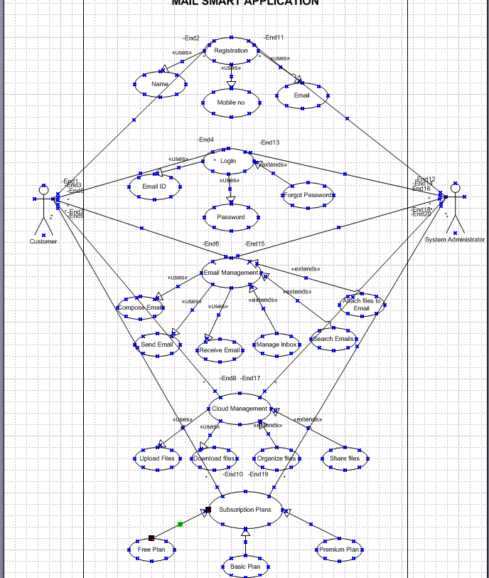

1. **Activity Diagrams**

**User Login**

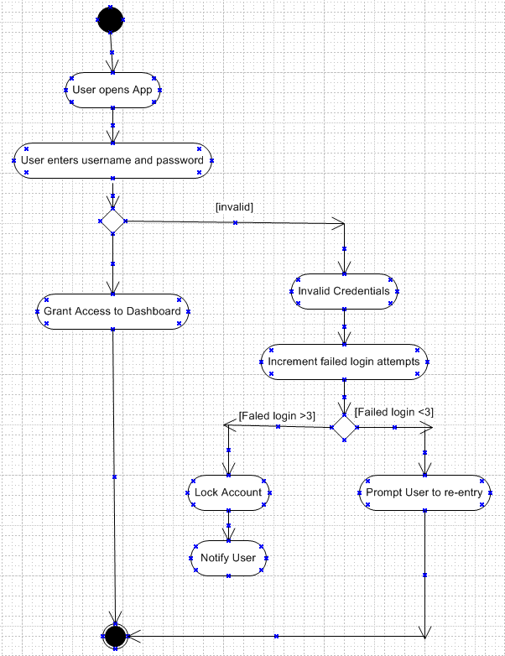

**Email Management**

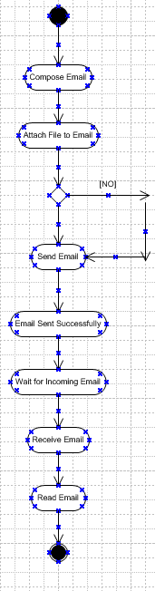

**Cloud Manager**

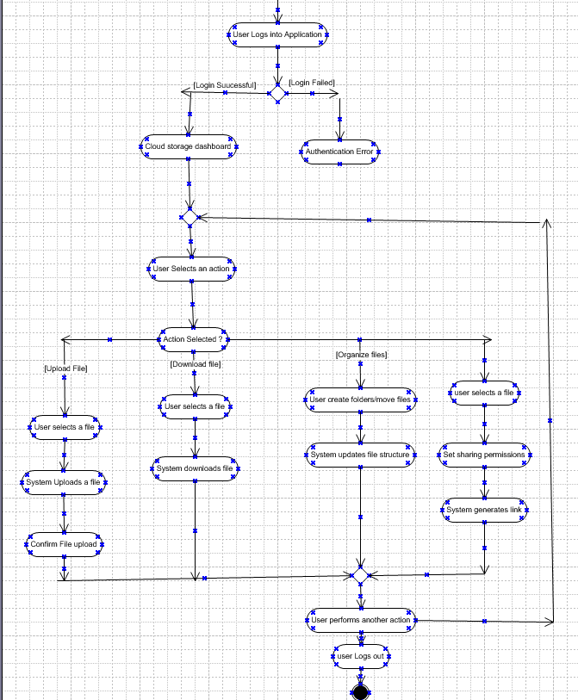

**Subscription Plans**

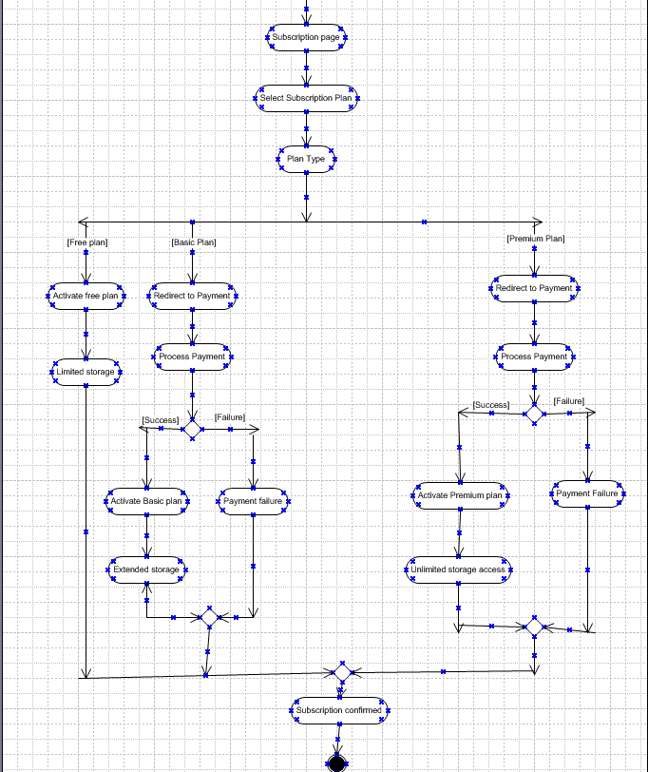

**Payment gateway**

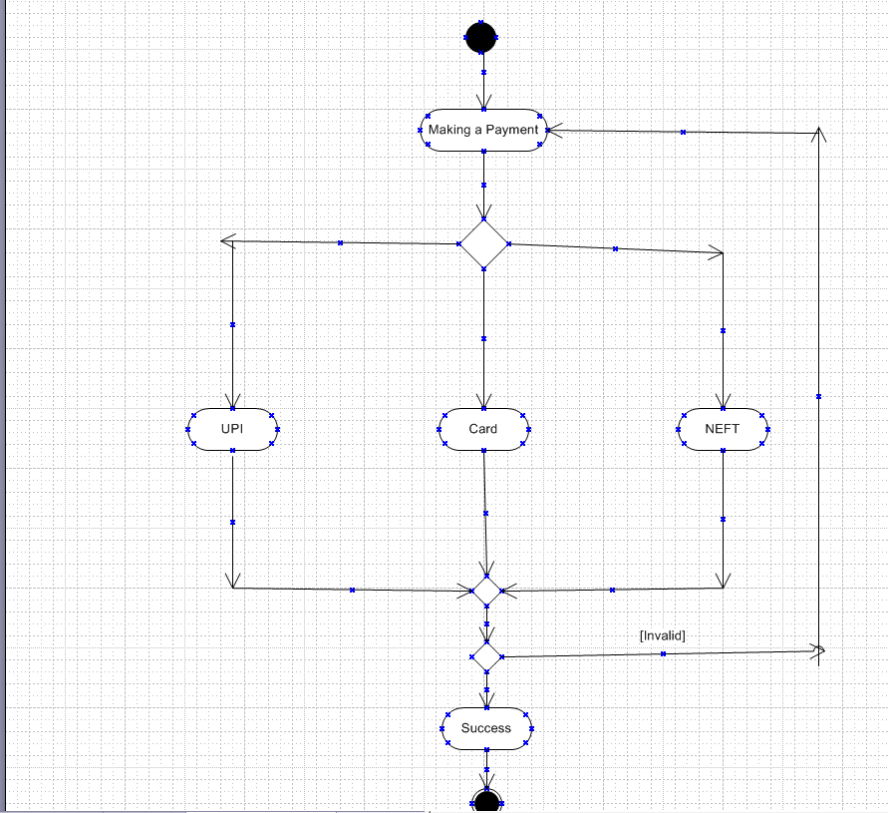

1. **Screens and Pages**

**Registration Page**

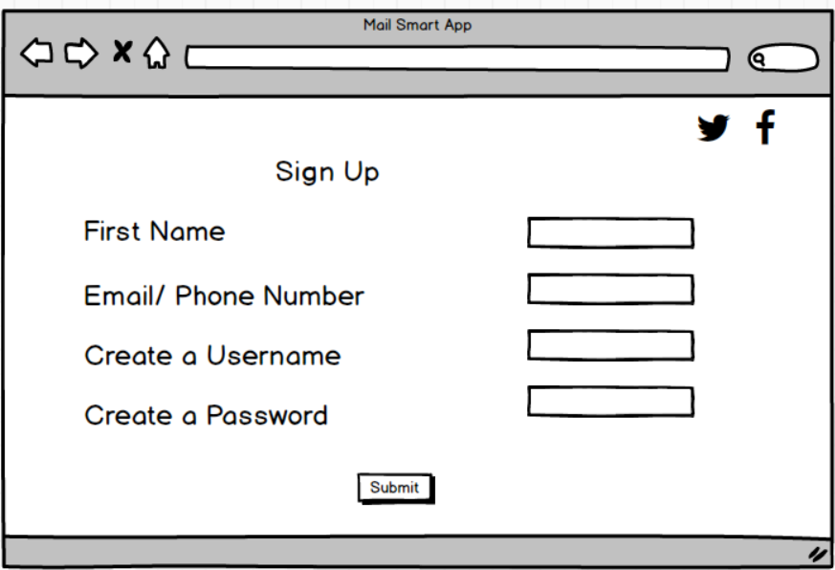

**Login Page**

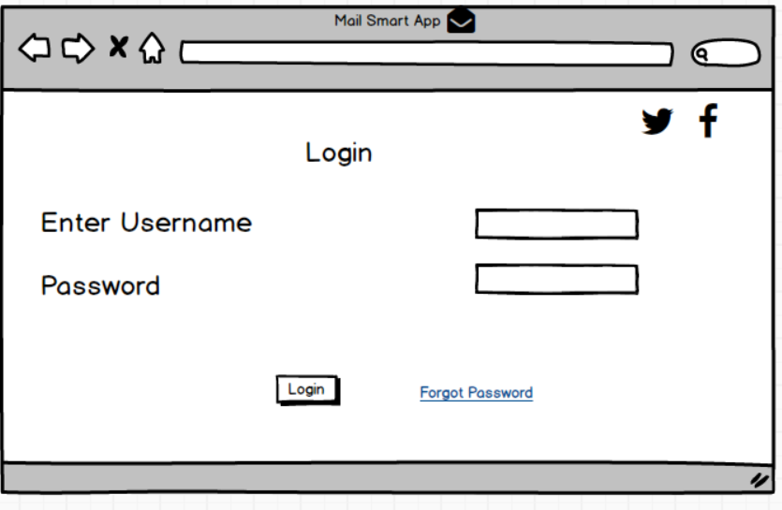

**Email Management**

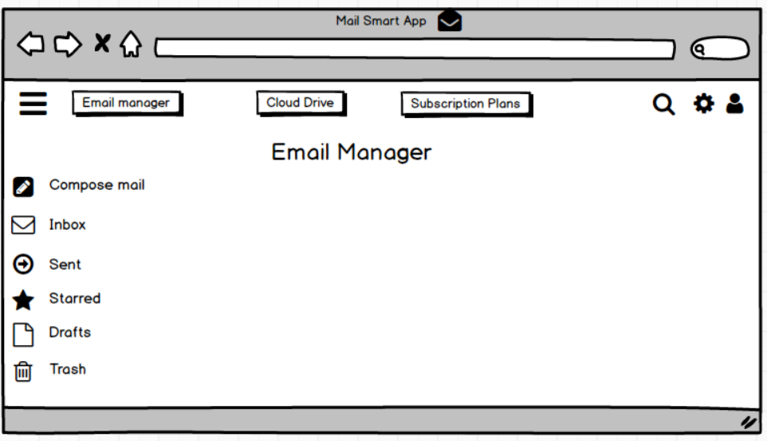

**Cloud Manager**

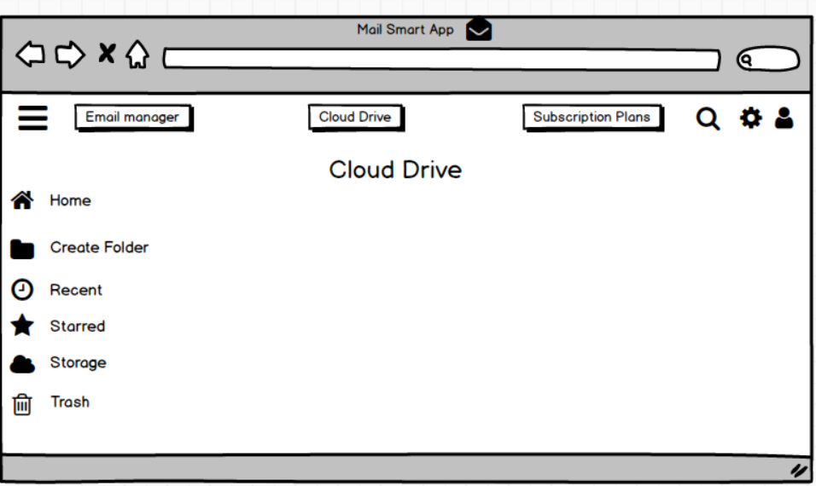

**Subscription Plans**

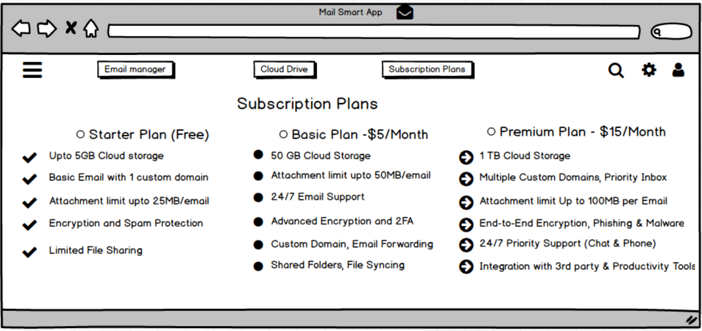

**Payment Page**

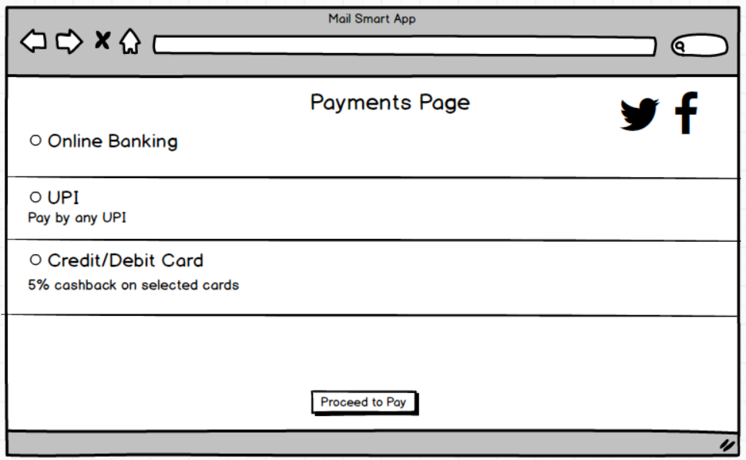

1. **Write a paragraph on your experience using Visio and Axure for the project.**

In my experience using Visio and Balsamiq for the project, both tools played crucial roles in visualizing and refining business processes and system designs. Visio was instrumental in creating detailed process flow diagrams, network architectures, and system workflows, ensuring clarity in process documentation and stakeholder communication. Its extensive library of shapes and connectors made it easier to represent complex workflows with precision. On the other hand, Balsamiq proved invaluable for wireframing user interfaces, allowing for rapid prototyping with a focus on usability and design consistency. The low-fidelity, sketch-like approach of Balsamiq facilitated quick iterations and feedback loops, ensuring that UI/UX considerations were addressed early in the development cycle. Together, these tools streamlined the documentation and design phases, enhancing collaboration between business analysts, developers, and stakeholders.

1. **My experience as BA in following phases:**

* **Requirements Gathering:**

As a business analyst the initial phase involved engaging with stakeholders, including IT teams, business users, and cloud service providers, to understand the business needs and pain points. I conducted stakeholder interviews, workshops, and surveys to gather insights on current email infrastructure, security concerns, integration needs, and compliance requirements.

Challenges:

* Balancing diverse stakeholder expectations and prioritizing requirements.
* Ensuring clarity in requirements to avoid ambiguity during later phases.
* **Requirement Analysis:**

In this phase I worked closely with the technical teams to refine and analyze the gathered requirements. I identified functional and non-functional requirements, prioritized them based on business value, and collaborated with architects to assess feasibility. Risks and dependencies were documented to ensure a seamless transition to cloud-based email solutions.

Challenges:

* Managing conflicting requirements from different departments.
* Ensuring technical constraints were addressed without compromising business needs.
* **Design:**

During the design phase, I facilitated discussions between business stakeholders and technical teams to define system workflows, integration points, and security protocols. I helped in designing data migration strategies and access control policies to ensure compliance with industry standards. Additionally, I participated in UI/UX discussions for end-user experience enhancement.

Challenges:

* Ensuring the design was scalable to accommodate future growth.
* Balancing user experience with technical complexity.
* **Development:**

While the development team implemented the solution, I continued to provide clarifications on business rules and requirement changes. I worked in an Agile environment, participating in sprint planning meetings, backlog grooming, and daily stand-ups to ensure alignment with business goals.

Challenges:

* Managing changes to requirements during development without impacting timelines.
* Ensuring developers had a clear understanding of business priorities.
* **Testing:**

I collaborated with the QA team to define test cases, validate functionalities, and conduct User Acceptance Testing (UAT). I coordinated with stakeholders to ensure the integrated email and cloud solution met performance, security, and compliance expectations before deployment.

Challenges:

* Ensuring comprehensive test coverage for complex integration scenarios.
* Managing stakeholder expectations during UAT.
* **Deployment:**

During deployment, I ensured that end-users received adequate training and documentation. I coordinated post-deployment support activities, collected feedback, and worked with teams to address any issues in a timely manner.

Challenges:

* Minimizing downtime during deployment.
* Addressing user concerns and resistance to change.

Conclusion:

As a Business Analyst, I played a pivotal role in ensuring the email and cloud integration project delivered value to the business. By bridging the gap between stakeholders and technical teams, I ensured that the solution met business needs while adhering to technical constraints. The project resulted in improved efficiency, enhanced collaboration, and secure data management for the organization.