**Agile Documents Part 2**

**Document 1 : Definition Of Done**

**Definition Of Done (DoD)** is a shared agreement among all team members on the criteria that must be met before a backlog item is considered complete. This ensures transparency, quality, and alignment with business requirements.

The DoD is structured as a checklist that ensures :

* **Customer acceptance criteria** are satisfied.
* **Quality criteria** are met to ensure a reliable and maintainable product.
* **Team alignment** on what constitutes “done” at different project levels ( user story, sprint, release ).

***Checklist for Definition of Done***

1. **Development Criteria :**

* **Product code** for all required functionalities.
* **User Story assumptions met** as per business requirements.
* **Project builds without errors** and compiles successfully.
* **Unit tests written and passing** for all developed features.

1. **Testing & Quality Assurance :**

* **Project deployed** on a test environment identical to production.
* **Tests passed** on all required devices, browsers, and platforms.
* **Features validated by UX designer** to ensure usability.
* **QA performed & issues resolved,** including functional, integration, and performance testing.
* **Features tested against acceptance criteria** and meets all defined requirements.

1. **Product Validation & Approval :**

* **Features approved by Product Owner** and aligns with business needs.
* **Refactoring completed,** ensuring clean and maintainable code.
* **Any configuration or build changes documented** for future reference.

1. **Documentation & Deployment Readiness :**

* **End-user documentation updated** for training and support.
* **Technical documentation updated** for developers and IT teams.
* **Peer code review performed** to ensure coding standards and best practices.

By adhering to this **Definition of Done**, Volkswagen Financial Services ensures that each completed feature is high-quality, fully functional, and ready for deployment.

**Document 2 : Product Vision**

|  |  |  |  |
| --- | --- | --- | --- |
| **Scrum Project**  **Name :** | VWFS ( Volkswagen Financial Services ) | | |
| Venue : | Pune |  |  |
| Date : | Start time : 07/08/2022 | End time : 07/08/2023 | Duration : 12 months |
| Client : | Volkswagen |  |  |
| Stakeholder list : | Volkswagen Financial Services Management | Volkswagen Dealerships | Finance & Compliance Teams |
|  | IT & Development Teams | Customers ( Car Buyers Seeking Financing ) |  |
|  |  |  |  |
| Scrum Team | | | |
| Scrum Master : | Mr. Krishna |  |  |
| Product Owner : | Mr. Shivanand |  |  |
| Scrum Developer 1: | Mr. Vaibhav |  |  |
| Scrum Developer 2: | Mr. Daulat |  |  |
| Scrum Developer 3: | Mr. Vinayak |  |  |
| Scrum Developer 4: | Ms. Deepika |  |  |
| Scrum Developer 5: | Ms. Madhuri |  |  |

|  |  |  |  |
| --- | --- | --- | --- |
| ***Vision :***  The Volkswagen Financial Services POS Application aims to **generate quotations & Contracts, maintain inventory data, service records, customer information, and streamline the vehicle financing process** for Volkswagen dealership and customers by providing a **flat, transparent, and user-friendly digital solution.** This application will integrate seamlessly with dealership systems, enabling **real-time loan approvals, compliance checks, and enhanced customer experience,** ultimately driving business efficiency and sales growth. | | | |
| **Target group**  **Market Segment :**    ***Automotive financing industry***, specially Volkswagen dealerships and their customers.  ***Digital financial services*** for faster, paperless loan processing.  **Target Audience :**  *Primary Users (B2B -Volkswagen Dealerships & Finance Teams )*  *End Customers (B2C – Car Buyers seeking for Financing )* | **Needs**  **Seamless integration** with Volkswagen’s CRM, ERP, and financial systems.  ***Reduced system downtime***, transaction failures, and technical issues.  Easiest way to ***generate quotations*** and save customer’s details.  ***Automated and real-time credit approvals*** to speed up financing.  ***User-friendly customer interface*** for easy loan tracking and approvals. | **Product**  A **user-friendly, digital POS solution** integrated with Volkswagen dealership systems to generate quotations, save customer data, offer real-time credit checks, loan approvals, service records , inventory management, and compliance validation. | **Value**  **Value :**    **Speed –** Reduces financing processing time.  **Integration –** Seamlessly connects with existing systems.  **Transparency –** Provides real-time loan status updates to customers.  **Business Growth –** Boosts sales conversions by reducing loan approval delays.  **Business goals :**   * Accelerate financing approvals. * Enhance dealership efficiency. * Ensure compliance with financial regulations. * Reduce operational costs by automating manual loan processes.   **Business Model :**   * **Service fees** from dealerships using the POS system. * **Transaction-based commission** on approved loans. * **Premium API integrations** for financial institutions. |

**Document 3 : User Stories**

|  |  |  |  |
| --- | --- | --- | --- |
| **User Story No: US-001** | **Tasks :01** | | **Priority : Highe** |
| As a Admin  I want to login to the application to view the available showroom stock  So that I can maintain inventory. | | | |
| **BV : 10** | | **CP : 9** | |
| **Acceptance Criteria :**  User can enter login Id and password.  System validates entered credentials.  User is logged in system. | | | |

|  |  |  |
| --- | --- | --- |
| **User Story : US-002** | **Tasks : 3** | **Priority : High** |
| As a sales Manager  I want to generate quotation which include all necessary required information of customer and customer’s requirement.  So that I can save the customer’s data and I can understand the requirement. | | |
| **BV : 9** | **CP : 10** | |
| **Acceptance Criteria :**  User can able to generate quotation  Text box to enter the information  Click on submit  Information saved and quotation generated | | |

|  |  |  |
| --- | --- | --- |
| **User Story No: US-003** | **Tasks : 04** | **Priority : High** |
| As a cur buyer,  I want to submit s financing application through the POS system  So that I can get quick approval for my car purchase. | | |
| **BV : 10** | **CP: 10** | |
| **Acceptance Criteria :**  User can enter personal and financial details  System validates all required fields.  Application is submitted successfully.  Confirmation message is displayed. | | |

|  |  |  |
| --- | --- | --- |
| **User Story : US-004** | **Tasks : 02** | **Priority : Medium** |
| As a dealership finance manager,  I want to perform an instant credit check for a customer,  So that I can determine their loan eligibility immediately. | | |
| **BV : 8** | **CP : 9** | |
| **Acceptance Criteria :**  Dealership manager can enter customer’s CIBIL score and financial details.  System checks and validates the details.  As per credit score loan should be approved or rejected. | | |

|  |  |  |
| --- | --- | --- |
| **User Story : US-005** | **Tasks : 03** | **Priority : Medium** |
| As a showroom Manager  I want to view the showroom’s revenue report  So that I can view the revenue and profits. | | |
| **BV : 8** | **CP : 8** | |
| **Acceptance Criteria :**  Select reports  Select Revenue Reports  Select month and year  Generate Report  Download report in EXCEL | | |

**Document 4 : Agile PO Experience**

Role of the Product Owner (PO) in the Volkswagen Financial Services POS Application Project :

1. **Product Vision & Market Experience :**

The Product Owner (PO) plays a crucial role in defining the **vision, strategy, and execution** of the Volkswagen Financial Services POS Application by leveraging **industry experience and market needs.**

1. **Responsibilities of the Product Owner :**

* Market Analysis :
* Conducts **market research** to identify the demand for a digital POS financing solution.
* Evaluates **existing similar products** in the financial services and automotive industry.
* Analyzes **competitor solutions** and identifies unique value propositions.
* Enterprise Analysis :
* Performs **due diligence** on market opportunities and potential challenges.
* Assesses **business feasibility and ROI** for the Volkswagen Financial Services POS system.
* Product Vision and Roadmap :
* Defines a **clear product vision** aligned with market needs.
* Develops a **high-level product roadmap** with key features and timeline.
* Managing Product Features :
* Engages with stakeholders to gather business and technical requirements.
* **Prioritizes epics, stories, and features** based on business impact and ROI.
* Manages **stakeholder expectations**  and ensures alignment with business objectives.
* Managing the Product Backlog :
* **Prioritizes user stories** based on business and customer needs.
* Continuously **refines the backlog** by reprioritizing tasks based on changing requirements.
* Ensures proper **epic planning and sprint alignment.**
* Managing Overall Iteration Process
* Reviews **sprint process** to ensure alignment with project goals.
* Conducts **reprioritization of sprints and epics** based on business needs.
* Leads **sprint retrospectives** with the Business Analyst to refine processes.

1. **Sprint Meetings & Agile Execution :**

From this project, I have gained experience in handling the following **Agile Scrum meetings :**

* **Sprint Planning Meeting –** Defining sprint scope, backlog items, and goals.
* **Daily Scrum Meetings –** Monitoring progress, addressing blockers, and aligning team efforts.
* **Sprint Review Meeting –** Showcasing completed work and gathering stakeholder feedback.
* **Sprint Retrospective Meeting –** Reviewing sprint performance and identifying improvements.
* **Backlog Refinement Meeting –** Adjusting user stories, reprioritizing, and ensuring clarity.

1. **User Story Creation & Key Elements :**

In this project I have worked on **user story creation,** ensuring they include the following details :

* **Story Number –** Unique ID for tracking.
* **Tasks –** Breakdown of development and testing work.
* **Priority –** Categorization ( High, Medium, Low ) based on business impact.
* **Acceptance Criteria –** Clear conditions that must be met for the story to be considered “done”.
* **BV & CP value ( Business Value & Customer Priority ) –** Ensuring alignment with business goals.

1. **Product Owner as the Communication Bridge :**

As a **Product Owner,** I acted as a **liaison** between different areas of the organization, ensuring :

* **Effective communication with business stakeholders** to align product goals.
* **Collaboration with Scrum teams** to guide development priorities.
* **Regular updates to all teams** on project progress and changes.

The **Product Owner’s vision** for the Volkswagen Financial Services POS application helped define the product’s **features, priorities, and backlog items,** ensuring smooth execution and successful delivery.

**Document 5: Product and sprint backlog and product and sprint burndown charts**

**Product Backlog :**

The Product Backlog is a prioritizes list of all features, enhancements, and bug fixes required for the Volkswagen Financial Services POS application.

|  |  |  |  |  |  |  |
| --- | --- | --- | --- | --- | --- | --- |
| User Story ID | User Story | Tasks | Priority | BV | CP | Sprint |
| US-001 | As a Admin  I want to login to the application to view the available showroom stock  So that I can maintain inventory. | UI Design,  Database setup | High | 10 | 9 | Sprint 1 |
| US-002 | As a sales Manager  I want to generate quotation which include all necessary required information of customer and customer’s requirement.  So that I can save the customer’s data and I can understand the requirement. | UI Form, PDF Generation, Data storage | High | 9 | 10 | Sprint 1 |
| US-003 | As a cur buyer,  I want to submit s financing application through the POS system  So that I can get quick approval for my car purchase. | UI Form, API Integration, Data validation | High | 10 | 10 | Sprint 2 |
| US-004 | As a dealership finance manager,  I want to perform an instant credit check for a customer,  So that I can determine their loan eligibility immediately. | Credit Check API, UI Update | Medium | 8 | 9 | Sprint 2 |
| US-005 | As a showroom Manager  I want to view the showroom’s revenue report  So that I can view the revenue and profits. | Report Generation, Database Queries, UI Design | Medium | 8 | 8 | Sprint 3 |

Sprint Backlog :

|  |  |  |  |  |  |
| --- | --- | --- | --- | --- | --- |
| User Story ID | User Story | Tasks | Owner | Status | Estimated Effort |
| US-001 | Admin login & showroom stock view | UI Design | Developer A | In Progress | 6 hrs |
| US-001 | Admin login & showroom stock view | Database Setup | Developer B | Not Started | 8 hrs |
| US-002 | Generate customer quotation | UI Form | Developer C | Completed | 5 hrs |
| US-002 | Generate customer quotation | PDF Generation | Developer D | In Progress | 6 hrs |
| US-003 | Submit financing application | UI Form & API Integration | Developer A | Not Started | 10 hrs |
| US-003 | Submit financing application | Data Validation | Developer B | Not Started | 5 hrs |
| US-004 | Perform instant credit check | Credit Check API Integration | Developer C | Completed | 7 hrs |
| US-004 | Perform instant credit check | UI Update | Developer D | In Progress | 4 hrs |
| US-005 | View revenue report | Report Generation | Developer A | Not Started | 9 hrs |
| US-005 | View revenue report | Database Queries | Developer B | Not Started | 6 hrs |

**Product Burndown :**

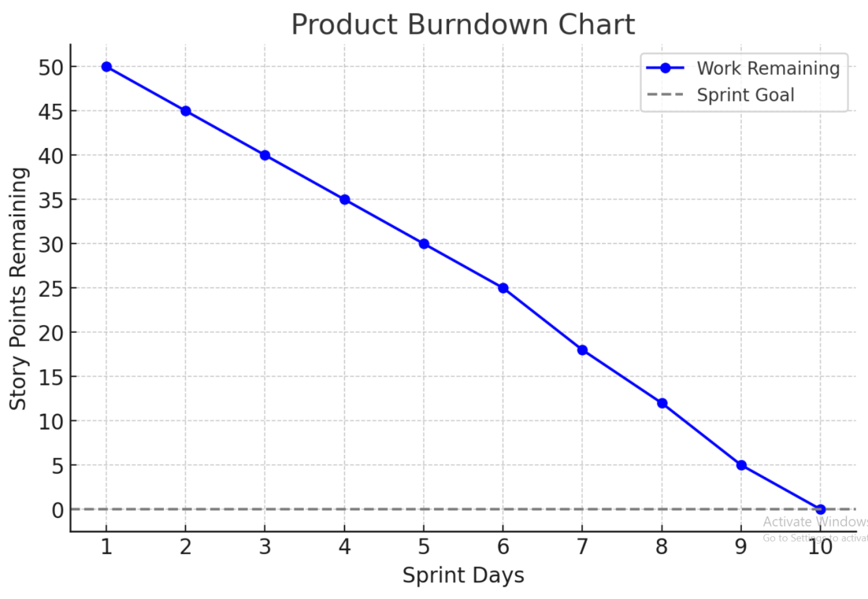

Explanation :

* **X-axis :** Represents **Sprint Days** ( 1 to 10 ).
* **Y-axis** : Shows **Story Points Remaining** ( starting at 50 ).
* **Blur Line :** Indicates the actual progress of completed work.
* **Dashed Line ( Sprint Goal ) :** Represents the goal to complete all work by the end of the sprint.

As seen in the chart, work is being completed consistently, leading to a successful sprint.

**Sprint Burndown :**

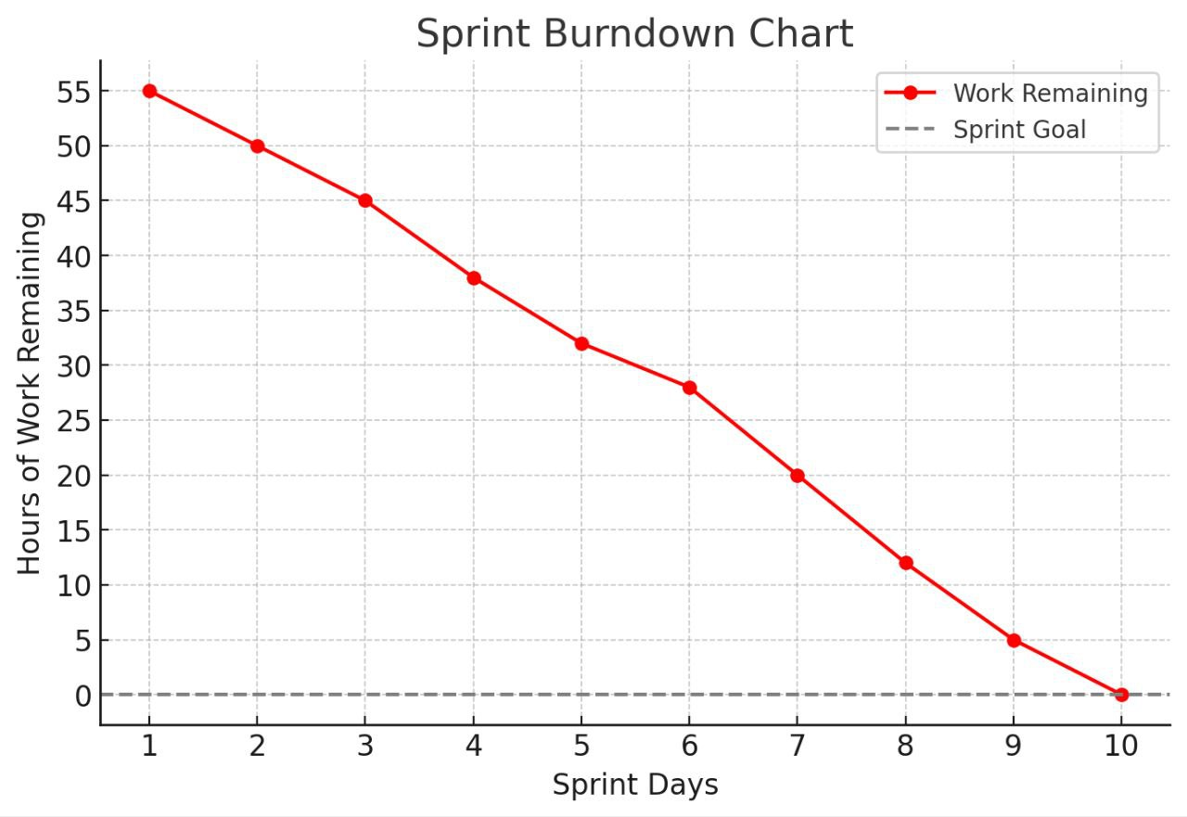

Explanation :

* **X-axis :** Sprint Days (1 to 10)
* **Y-axis :** Hours of work Remaining (starting at 55)
* **Red Line :** Represents actual work completed each day.
* **Dashed Line :** Sprint goal (target to complete all work by day 10)

This chart shows a steady **decrease in remaining work,** ensuring successful sprint completion.

**Document 6 : Sprint Meetings**

**Meeting type 1 : Sprint Planning Meeting**

|  |  |
| --- | --- |
| **Date** | 16/08/2022 |
| **Time** | 10:00 AM |
| **Location** | Pune |
| **Prepared By** | Purbhaji Bharkad |
| **Attendees** | Stakeholders, Project Managers, Development Team, QA Team, Database Administrator, Scrum Master, Product Owner. |

**Agenda Topics**

|  |  |  |
| --- | --- | --- |
| **Topic** | **Presenter** | **Time Allotted** |
| Sprint Goal Discussion | Scrum Master | 10 mins |
| Reviewing Product Backlog Items | Product Owner | 15 mins |
| Prioritizing User Stories for Sprint | Product Owner | 10 mins |
| Task Breakdown & Estimations | Development Team | 20 mins |
| Identifying Dependencies & Risks | Scrum Master | 10 mins |
| Sprint commitment & Scope Finalization | Entire Team | 10 mins |
| Q&A and Next Steps | Scrum Master | 10 mins |

**Other Information**

|  |  |
| --- | --- |
| Observers | All Team Members |
| Resources | Sprint Backlog, JIRA, Required Documents, Burndown Chart. |
| Special Notes |  |

**Meeting Type 2 : Sprint review meeting**

|  |  |
| --- | --- |
| **Date** | 08/09/2022 |
| **Time** | 4:00 Pm |
| **Location** | Pune |
| **Prepared By** | Purbhaji Bharkad |
| **Attendees** | Scrum Team, Product Owner, Stakeholders, Business Analysts |

|  |  |  |  |
| --- | --- | --- | --- |
| **Sprint Status** | **Things to Demo** | **Quick Updates** | **What’s Next** |
| **Sprint Goal**: Implement and test core POS functionalities, including financing applications and credit checks. | Admin login & Stock Management  (US-001) | **Stakeholder Feedback:**  Positive response to the credit check functionality.  Suggested UI improvements for the quotation generation screen. | **Carry Forward Work:**  Complete showroom revenue report feature (US-005).  Finalize API integration for financial reporting. |
| **Completed User Stories :**  US-001: Admin login & showroom stock view.  US-002: Generate customer quotation.  US-003: Submit financing application through POS  US-004: Perform instant credit check | Quotation Generation (US-002) | **Challenges Faced :**  API integration issues caused delays in the revenue report feature.  Initial issues with from validation for financing applications | **Upcoming Sprint Goals:**  Implement payment processing for financing applications.  Enhance reporting & analytics features.  Conduct performance testing on POS application. |
| **Pending User Stories :**  US-005: Perform instant credit check | Financing Application (US-003) | **Fixes Implemented :**  Enhanced from validation for financing applications.  Minor UI changes implemented in the quotation section. | **Testing Focus :**  Validate different financing scenarios.  Ensure smooth POS integration with external credit check providers. |
| **Burndown Chart Analysis:**  Initial estimated effort: 55 hours  Work completed: 48 hours  Remaining effort: 7 hours | Instant Credit Check (US-004) |  | **Next Sprint Planning :**  Schedule backlog refinement meeting.  Prioritize new feature requests from stakeholders. |

**Meeting Type 3: Sprint retrospective meeting**

|  |  |
| --- | --- |
| **Date** | 20/09/2022 |
| **Time** | 10:00 AM |
| **Location** | Pune |
| **Prepared By** | Purbhaji Bharkad |
| **Attendees** | Scrum Team, Product Owner, Scrum Master |

|  |  |  |  |  |
| --- | --- | --- | --- | --- |
| **Agenda** | **What went well** | **What didn’t go well** | **Questions** | **Reference** |
| Review the sprint’s successes and challenges. | Successful implementation of core functionalities (Admin login, financing application, credit check). | API integration issues delayed the revenue report feature. | How can we improve AP integration timelines? | Sprint Backlog & Burndown Chart |
| Identify areas for improvement. | Positive stakeholder feedback on financing application and credit check. | Initial difficulties in financing from validation. | What strategies can we use to prevent last-minute UI changes? | Stakeholder feedback from sprint review |
| Discuss actionable steps for the next sprint. | Collaboration between development and testing teams improved efficiency. | Some last-minute UI changes caused minor delays. | How can we ensure daily stand-ups remain time-efficient? | Issue tracker & Bug reports |
|  | Burndown chart showed steady progress with minimal scope creep. | Daily stand-up sometimes ran longer than scheduled. | Are there any blockers that need immediate attention for the next sprint? |  |

**Meeting Type 4: Daily Stand-up meeting**

|  |  |  |  |  |  |  |  |  |
| --- | --- | --- | --- | --- | --- | --- | --- | --- |
| **Question** | **Name/Role** | **Week “X” (from dd-mm-yyyy to dd-mm-yyyy)** | | | | | | |
| Monday | Tuesday | Wednesday | Thursday | Friday | Saturday | Sunday |
| What did you do yesterday? | Ganesh | Project Alpha’s deliverables | Project Alpha’s deliverables | Project Alpha’s deliverables | Presentation A | Presentation B |  |  |
| Vaibhav |
| Daulat |
| What will you do today ? | Ganesh | Project Beta’s deliverables | Project Beta’s deliverables | Project Beta’s deliverables | Presentation A | Presentation B |  |  |
| Vaibhav |
| Daulat |
| What (if any) is blocking your progress ? | Ganesh | Need to connect with development team |  |  |  |  |  |  |
| Vaibhav |
| Daulat |