Document 1: Definition of Done
The Definition of Done outlines the criteria that must be met for a product increment or backlog item to be considered complete and potentially shippable. The DOD ensures that the team maintains a consistent level of quality and completeness in their work.
For the Darwinbox HR software enhancement project, the Definition of Done ensures that each sprint delivers a functional, tested, and approved increment that aligns with HR and IT requirements.
The best representation of the DoD is a checklist of activities that validate the value and quality of a user story. This checklist includes:
- Acceptance criteria – Ensuring the feature meets HR and employee expectations.
- Quality criteria – Compliance with HR policies, security, and performance standards.
For the Darwin box project, DoD is defined at multiple levels:
- User Story Level – Features meet functional and non-functional requirements.
- Sprint Level – All stories within a sprint are tested and reviewed.
- Release Level – The final product is approved by stakeholders and ready for deployment.
Checklist for DOD:
- Produced code for presumed functionalities
- Code follows best practices and coding standards
- Code is modular, maintainable, and reusable
- Assumptions of User Story met
- Requirements are documented and validated
- Business logic aligns with HRMS (Human Resource Management System) needs
- Project builds without errors
- Build process runs successfully
- Versioning and tagging of build artifacts are done
- Unit tests written and passing
- Unit tests and integration tests pass
- Key functionalities work as expected
- Project deployed on the test environment identical to production platform
- Test environment matches production settings
- Test data reflects real-world HR scenarios
- Tests on devices/browsers listed in the project assumptions passed
- Feature ok-ed by UX designer
- Design consistency across the platform is maintained
- User experience is validated
- QA performed & issues resolved
- Functional, security, and performance testing completed
- All bugs and issues are fixed and verified
- Feature is tested against acceptance criteria
- All business and functional requirements are satisfied
- Any deviations are documented and approved
- Feature ok-ed by Product Owner
- Feature is reviewed and signed off by the Product Owner
- Refactoring completed
- Code is optimized for performance and readability
- Any configuration or build changes documented
- Any changes in configuration or build process are documented
- Documentation updated
- Help guides and release notes are revised
- Peer Code Review performed
- Code is reviewed, and feedback is incorporated

Document 2- Product Vision
Scrum project name | Darwinbox HRMS Enhancement
Venue | Kochi, Kerala
Date: | Start Time:  20-Mar-2025 | End Time:  20-Feb-2025 | Duration:  1 Year
Client | Kotak Securities
Stakeholder List: | Project Stakeholders:  BA  Project Manager  Development Team  Tech Expert  Testing Team  Operations  (Network, Training)  UI Designer | Business Stakeholders:  Project Manager  Business Owner  Business Sponsor  Operations Team  Subject Matter Expert | 3rd Party Stakeholders:  Auditors  Legal Team  Vendor  Manufacturer
Scrum Team:
Role | Team Member
Scrum Master:
Product Owner:
Scrum Developer 1:
Scrum Developer 2:
Scrum Developer 3:
Scrum Developer 4:
Scrum Developer 5:
UI Designer:
Tester:
Business Analyst: | Vishnu UT

Vision: | To enhance and optimize Darwin box HRMS at Kotak Securities for better employee experience, efficiency, and automation.
Target Group | Needs | Product | Value
Employees, HR Team, and Management at Kotak Securities | Employees and HR teams need a more streamlined, automated, and user-friendly HRMS for efficient payroll, leave management, recruitment, and performance tracking. | Enhancing the Darwin box HRMS platform to improve user experience, add automation features, and integrate with other internal systems. | Increased efficiency by 40-60%, reduced manual work for HR, improved employee satisfaction, and better analytics for management decisions.
Document 3: User stories
User stories: are simple descriptions of a feature or requirement from the user's perspective. They help explain how a system should work in a way that is easy to understand, making requirement gathering more straightforward.
Business Value (BV) refers to how important a feature (user story) is to the business. A higher BV means the feature has a greater impact.
Complexity Points (CP) represent the effort required by developers to implement the feature. They help estimate the time and difficulty involved, often rated using CP points (e.g., Poker cards).
Acceptance Criteria define the conditions that a software feature must meet to be considered complete and functional. While user stories describe what a user wants to do, acceptance criteria explain how the system should behave to fulfill that requirement. These criteria ensure the feature meets user expectations and works as intended.
User story 1 - Employee Login
User Story: 1 | Tasks: 1 | Priority: High
Value statement:

AS A USER,
I WANT TO LOGIN
SO THAT I CAN VIEW MY ID
BV: 500 |  | CP: 1
Acceptance Criteria:

User can enter personal details like name, email, and password.

System validates the email format.

User receives a confirmation email upon successful registration.

User story 2 - Leave Request Management
User Story: 2 | Tasks: 1 | Priority: High
Value statement:

AS AN EMPLOYEE,
I WANT TO APPLY FOR LEAVE ONLINE
SO THAT I CAN AVOID MANUAL APPROVALS

BV:500 |  | CP: 1
Acceptance Criteria:

User can apply for leave through the portal.

System shows available leave balance.

Manager can approve/reject leave requests.

User story 3 - Pay slip Download
User Story: 3 | Tasks: 1 | Priority: High
Value statement:

AS A USER,
I WANT TO VIEW AND DOWNLOAD MY PAYSLIP
SO THAT I CAN KEEP TRACK OF MY SALARY
BV: 450 |  | CP: 2
Acceptance Criteria:

User can access and download payslips from the system.

Payslips show salary breakdown with deductions.

User story 4 - Employee Attendance Tracking
User Story: 4 | Tasks: 1 | Priority: High
Value statement:

AS AN EMPLOYEE,
I WANT TO CHECK MY ATTENDANCE RECORDS
SO THAT I CAN TRACK MY WORK HOURS
BV: 500 |  | CP: 3
Acceptance Criteria:

System records attendance via biometric integration.

Employees can view their attendance history.

User story 5 - Expense Reimbursement
User Story: 5 | Tasks: 1 | Priority: Medium
Value statement:

AS AN EMPLOYEE,
I WANT TO SUBMIT EXPENSE CLAIMS
SO THAT I CAN GET REIMBURSED EASILY
BV: 350 |  | CP: 3
Acceptance Criteria:

User can upload receipts and submit claims.

System tracks claim status and approvals.

User story 6 – Recruitment Process Automation
User Story: 6 | Tasks: 1 | Priority: High
Value statement:

AS A RECRUITER,
I WANT TO AUTOMATE HIRING WORKFLOWS
SO THAT I CAN REDUCE PAPERWORK
BV: 600 |  | CP: 2
Acceptance Criteria:

Job applications can be tracked in real-time.

Candidates receive email updates about application status.

User story 7 – Performance Evaluation
User Story: 7 | Tasks: 1 | Priority: Medium
Value statement:

AS A MANAGER,
I WANT TO ASSESS EMPLOYEE PERFORMANCE
SO THAT I CAN PROVIDE FEEDBACK EFFECTIVELY

BV: 450 |  | CP: 3
Acceptance Criteria:

Managers can assign and review employee ratings.

Employees can see their performance history.

User story 8 – Training & Development Portal
User Story: 8 | Tasks: 1 | Priority: Medium
Value statement:

AS AN EMPLOYEE,
I WANT TO ACCESS ONLINE TRAININGS
SO THAT I CAN IMPROVE MY SKILLS
BV: 400 |  | CP: 3
Acceptance Criteria:

Employees can enroll in available training sessions.

System tracks training completion status.

User story 9 – HR Analytics Dashboard
User Story: 9 | Tasks: 1 | Priority: High
Value statement:

AS AN HR EXECUTIVE,
I WANT TO VIEW HR REPORTS
SO THAT I CAN MAKE INFORMED DECISIONS
BV: 550 |  | CP: 2
Acceptance Criteria:

Dashboard shows real-time HR analytics.

Reports can be exported in multiple formats.

User story 10 – Mobile App Access
User Story: 10 | Tasks: 1 | Priority: High
Value statement:

AS AN EMPLOYEE,
I WANT TO USE THE MOBILE APP
SO THAT I CAN ACCESS HRMS FEATURES ON THE GO
BV: 600 |  | CP: 2
Acceptance Criteria:

Employees can log in via mobile app.

Core HRMS functions (leave, payroll, attendance) are available.

Document 4: Agile PO Experience
The Product Owner (PO) plays a key role in shaping the Darwinbox product by combining domain expertise, industry insights, and market needs to ensure the development of a competitive HRMS solution.
Responsibilities of a PO in the Darwinbox Project:
- Market Analysis
Conduct an in-depth assessment of the HR technology market, analyzing competitors, industry trends, and customer pain points. This analysis helps refine Darwinbox’s positioning and ensures that features align with market demand.
- Enterprise Analysis
Identify business opportunities within HR tech, define an efficient architecture, and determine investment priorities. A strong enterprise analysis ensures that Darwinbox remains a strategic solution for organizations aiming to digitize and automate HR processes effectively.
- Product Vision and Roadmap
Define a clear vision for Darwinbox, outlining what the product aims to achieve and how it will transform HR management. Develop a structured roadmap that includes feature releases, integrations, and upgrades to improve usability and efficiency.

- Managing Product Features in Darwinbox
- HR market research & user research to gather insights from HR professionals.
- Employee lifecycle management (recruitment, onboarding, payroll, performance, and exit).
- AI-driven automation for HR workflows.
- Integration capabilities with third-party tools (payroll, attendance, benefits, etc.).
- Customizable dashboards for analytics & insights.
- Mobile-first approach ensuring accessibility for employees and HR teams.
- MVP release & continuous feedback collection to refine features.
- Managing Product Backlog
- Regular backlog refinement before sprint planning to align with HR priorities.
- Categorization of backlog items based on impact (short-term vs. long-term).
- Removing outdated or irrelevant features based on user feedback.
- Strict adherence to the roadmap to prevent scope creep.
- Prioritization based on business value & customer impact.
- Managing Overall Iteration Progress
The iteration manager ensures that each sprint delivers tangible improvements to Darwinbox. They coordinate cross-functional teams, track key milestones, and ensure the development aligns with the overall HR transformation strategy.

- Through this project, I have gained hands-on experience in managing Agile Sprint Meetings, ensuring smooth collaboration between teams and effective product delivery.
- Sprint Planning Meeting
- Identify key HRMS feature requirements for the sprint.
- Determine feasibility and expected delivery timelines within the Scrum framework.
- Align sprint goals with business priorities (e.g., payroll automation, compliance tracking, AI-driven HR insights).
- Daily Scrum Meeting
Helps maintain transparency and track sprint progress effectively.
A 10-minute stand-up where each team member shares updates:
- What they worked on yesterday.
- What they plan to do today.
- Any blockers preventing progress.

- Sprint Review Meeting
- Demonstrate the completed HRMS features (e.g., employee onboarding automation, benefits management, or analytics dashboards) to stakeholders.
- Gather feedback from HR professionals, clients, and internal users.
- Based on feedback, refine product backlog items for enhanced functionality and usability.
- Sprint Retrospective Meeting
- Review sprint performance using a burndown chart.
- Discuss what worked well and areas for improvement.
- Identify process optimizations for faster and more efficient product development.
- Backlog Refinement Meeting
- Analyze the remaining product backlog with the Scrum team.
- Re-prioritize backlog items based on customer needs, compliance updates, or business goals.
- Plan new sprints focusing on critical HR functionalities like performance management automation or AI-based candidate screening.

- Each feature in the Darwinbox HRMS follows a structured user story format to ensure clarity and alignment with HR needs.
User Story
User Story Structure:
As a [type of user],
I want [an action or feature],
So that [benefit or value].

- A list of specific tasks required to complete each user story. These are individual steps or actions needed to implement the feature.
Tasks
Feature: Employee Leave Management System
Tasks:
Develop a "Request Leave" button on the employee dashboard.
Integrate a real-time leave balance tracker.
Implement automated approval workflows based on company policies.
Notify managers and HR via email or in-app notifications.

- Indicates the importance or urgency of the user story in the overall project. Priorities are categorized as High, Medium, or Low based on business impact and user needs.
Priority
Examples in Darwinbox:
High Priority: Critical for the next release (e.g., Automated Payroll Processing)
Medium Priority: Important but can wait for the next iteration (e.g., Custom Employee Reports)
Low Priority: Nice-to-have, can be considered later (e.g., Dark Mode UI Enhancement)

- A set of conditions or criteria that must be met for the user story to be considered complete. Ensures the feature meets HR team expectations.
Acceptance Criteria
Example for Leave Request Feature:
Employee can submit a leave request.
Manager receives a leave approval notification.
System auto-calculates leave balance and restricts invalid requests.

- Defines how the user story benefits the business or HR teams. Helps in prioritizing feature development.
Business Value
Examples in Darwinbox:
High Business Value: Increases efficiency & compliance (e.g., Automated Tax Computation)
Medium Business Value: Adds a useful feature but not critical (e.g., Employee Self-Service Portal Enhancements)
Low Business Value: Minimal impact but enhances user experience (e.g., Personalized HR Dashboards)

- An estimation of the effort required to implement the user story, helping with capacity planning and sprint commitments.
Complexity Points
Simple (1-3 points): UI enhancements, minor API fixes.
Moderate (3-5 points): Workflow automation, integration with third-party systems.
Complex (5-8 points): Custom AI-driven HR insights, compliance automation modules.

- In Scrum, the Product Owner acts as the key liaison between HR teams, business stakeholders, and the development team. They gather requirements from HR leaders, payroll teams, and employees to ensure the platform meets business needs.
- The Product Owner defines the vision for HR automation features, such as payroll processing, leave management, and employee performance tracking. They break these requirements into product backlog items, ensuring the Scrum team develops features that enhance HR efficiency and compliance.

Document 5: Product and sprint backlog and product and sprint burndown charts
The product backlog in Darwinbox HRMS consists of new HR automation features, payroll integrations, employee self-service enhancements, and bug fixes. It is a dynamic list maintained by the Product Owner, ensuring that the highest-priority HR functionalities are delivered first.
Backlog items should be easily added, modified, or removed to maintain agility. The development team works on refining backlog items to improve HR operations, compliance, and workforce engagement.
Product Backlog Table for Darwinbox HRMS
User story  ID | User story | Tasks | Priority | BV | CP | Sprint
US01 | As an HR Manager, I want to add a new employee to the system, so that I can maintain accurate employee records. | Design employee onboarding UI  Develop database integration  Implement role-based access control | High | 500 | 3 | 1
US02 | As an Employee, I want to apply for leave online, so that I can track my leave balance easily. | Create leave request UI  Implement leave approval workflow  Generate email notifications | High | 400 | 2 | 2
US03 | As a Payroll Admin, I want to automate payroll processing, so that I can ensure accurate salary calculations. | Integrate payroll module with attendance  Generate salary slips automatically  Implement compliance tax deductions | High | 600 | 4 | 1
US04 | As an Employee, I want to view my payslip and salary breakdown, so that I can understand my deductions and benefits. | Create employee self-service portal  Integrate payslip download option  Implement multi-device compatibility | Medium | 350 | 2 | 2
US05 | As an HR Manager, I want to track employee performance reviews, so that I can monitor productivity and appraisals. | Develop performance review forms  Integrate manager feedback system  Implement automated reminders | High | 500 | 3 | 2
US06 | As an Admin, I want to manage user roles and permissions, so that I can control access to sensitive data. | Design role-based access control system  Implement admin dashboard for user management  Audit user activity logs | High | 550 | 3 | 3
US07 | As an Employee, I want to update my personal details, so that I can keep my records up-to-date. | Create self-service profile edit page  Enable HR approval for updates  Validate data fields to ensure accuracy | Medium | 300 | 2 | 3
US08 | As a Recruiter, I want to post job openings and track applications, so that I can hire efficiently. | Develop job posting interface  Integrate applicant tracking system  Automate email notifications for applicants | High | 600 | 4 | 4
US09 | As an HR Manager, I want to generate custom HR reports, so that I can analyze workforce data effectively. | Implement report builder tool  Enable export to Excel and PDF  Automate monthly reports | High | 700 | 5 | 4
US10 | As an Admin, I want to implement multi-factor authentication (MFA), so that I can enhance security. | Integrate MFA with login system  Implement OTP-based authentication  Support authentication apps like Google Authenticator | High | 750 | 5 | 5

Product Burndown Chart
A product burn down chart shows how much work remains for the entire project, whereas a sprint burndown chart shows how much work remains in a specific iteration. A product burn down chart collects a larger amount of data.
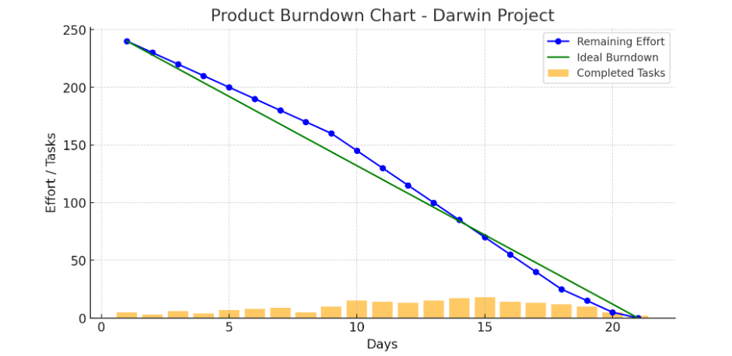

Interpretation:
Remaining Effort (Blue Line & Dots) :
- Shows the actual remaining effort/tasks throughout the project timeline.
- The trend indicates how quickly the team is progressing
Ideal Burndown (Green Line):
- Represents the expected pace of progress for smooth project completion.
- If the actual effort stays close to this line, the project is on track.
Completed Tasks (Orange Bars):
- Indicates the number of tasks completed on each day.
- Higher bars suggest productive days, while shorter bars may indicate bottlenecks.
In this chart;
- The blue line follows the green line closely, meaning the project is progressing at a steady pace.
- There are some deviations where the actual effort is above the ideal line, showing slight delays in some phases.
- Completed tasks are consistent, but some fluctuations suggest varying task complexity.
- The project reaches completion within the expected timeline, indicating effective task management.
Sprint Burndown Chart
It can be used to track the total work remaining in the sprint, and to project the likelihood of achieving the sprint goal. By tracking the remaining work throughout the sprint, a team can manage its progress and respond to trends accordingly.
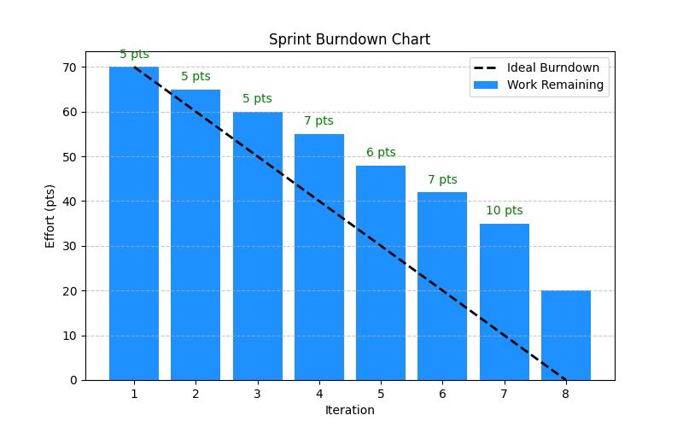
Interpretation:
Initial Sprint Planning & Total Workload:
- The sprint started with 70 points (likely story points or tasks).
- The ideal burndown line (dotted line) represents the expected progress if work were completed evenly across all iterations.
Progress Over Iterations:
- Iterations 1 to 3: The team consistently completed 5 points per iteration, maintaining a steady pace.
- Iterations 4 to 6: A slight fluctuation in work completion, indicating possible challenges (e.g., dependencies, unplanned issues).
- Iteration 7: A higher completion rate, showing improved efficiency.
- Iteration 8: A small amount of work remained, meaning not all planned tasks were completed by the end of the sprint.
Observations & Insights:
- Steady work pace was maintained initially, but progress varied in later iterations.
- The burndown does not fully reach zero, meaning some work was left unfinished.
- The dotted line (ideal burndown) suggests that work should have been completed more evenly.
Document 6: Sprint meetings
Meeting Type 1: Sprint Planning meeting
Date | 23-Mar-2025
Time | 11 am to 1 pm
Location | Kochi, Kerala
Prepared By | Vishnu UT
Attendees | Scrum Master
 | Product Owner
 | Developer 1
 | Developer 2
 | BA | Vishnu UT
 | UI Designer
 | Tester

Agenda Topics
Topic | Presenter | Time allotted
Scopes | BA | 11 am to 11:15 am
Strategy & Planning | SM, BA, PO | 11:15 am to 11:30 am
Resource Management | Scrum Master | 11:30 am to 11:50 am
Billing & invoices | BA | 11:50 am to 12 pm
GD | Product owner | 12 pm to 1 pm

Other Information
Observers | Testing team, SME
Resources | Manpower: Business stakeholder from Kotak Securities, BA, developers and another project team.  Time: 1 Year  Budget: Rs. 2 Cr  Other: Database, internet, past transactions history, reports
Special Notes | Clients would be onboarded virtually from the Darwin Box platform

Meeting Type 2: Sprint review meeting
Date | 29-Mar-2025
Time | 10 am to 12 pm
Location | Kochi, Kerala
Prepared By | Vishnu UT
Attendees | Scrum Master
 | Product Owner
 | Developer 1
 | Developer 2
 | BA | Vishnu UT
 | Tester 1
 | Tester 2

Sprint Status:
Sprint status | Things to Demo | Quick updates | What’s next
Sprint 1: Done | Employee Onboarding module, Leave Management system, Attendance tracking | All features enabled | Deploy in live environment

Meeting Type 3: Sprint retrospective meeting
Date | 01-Apr-2025
Time | 10 am to 12 pm
Location | Kochi, Kerala
Prepared By | Vishnu UT
Attendees | Scrum Master
 | Product Owner
 | Developer 1
 | Developer 2
 | BA | Vishnu UT
 | Tester 1
 | Tester 2

Discussion Points
Agenda | What went well | What didn’t go well | Questions | Reference
Sprint Analysis | All sprint backlog covered in time. Sign-off taken for first iteration | Issues in Payroll processing module | UAT and unit testing needs completion | SME, PO

Meeting Type 4: Daily Stand-up meeting

Question | Name/ Role | Week “X” (from dd-mm-yyyy to dd-mm-yyyy)
 |  | Mon | Tue | Wed | Thurs | Fri
What did  you do  yesterday? | Dev 1 | Worked on employee profile module | Completed profile page UI | Integrated API for employee data | Debugged API responses | Finalized employee workflow
 | Dev 2 | Worked on payroll processing logic | Completed payroll calculations | Validated salary components | Fixed tax deduction issues | Finalized payroll report generation
 | Dev 3 | Worked on attendance tracking | Completed shift management feature | Integrated leave policies | Fixed holiday calendar issues | Deployed attendance module
What will  you do  today? | Dev 1 | Complete profile update functionality | Fix UI inconsistencies | Test profile updates | Deploy profile module | Document API endpoints
 | Dev 2 | Review payroll audit logs | Handle bonus & deductions | Optimize payroll queries | Test payroll calculations | Prepare payroll documentation
 | Dev 3 | Implement real-time attendance sync | Work on biometric integration | Fix data syncing errors | Test attendance reports | Prepare release notes
What (if  any) is  blocking  your  progress? | Dev 1 | API response delays | No issues | UI feedback pending | No issues | Minor CSS issues
 | Dev 2 | Tax calculation discrepancies | Data mismatch in reports | No issues | Payroll approval delays | No issues
 | Dev 3 | Attendance sync failures | No issues | Server downtime | No issues | No issues

