COEPD Prep Exam-3 Part 2/2

# Q. No 1- Difference between Brainstorming and JAD sessions:

Brainstorming and JAD (Joint Application Development) sessions are the collaborative techniques used in software development and also project management and they serve different purposes and are structured differently.

|  |  |  |
| --- | --- | --- |
|  | Brainstorming | JAD sessions |
| **PURPOSE** | To generate wide range of ideas and solutions in a free-flowing manner. | To gather detailed requirements and design solutions collaboratively. |
| **STRUCTURE** | Informal and unstructured. Participants are encouraged to share ideas without criticism or judgment. | Highly structured. Includes a clear agenda and specific objectives. |
| **PARTICIPANTS** | Can include anyone relevant to the topic, often a mix of team members and stakeholders. | Key stakeholders, including business owners, system analysts, developers and sometimes end users. |
| **OUTCOME** | A list of ideas or potential solutions that can be further redefined and evaluated later. | A well-defined set of requirements and design specifications that are agreed upon by all the participants. |
| **USAGE** | Used in early stages of project planning or problem solving to explore possibilities and stimulate creativity. | Used in early stages of system development to ensure that all the stakeholders have a shared understanding of the requirements and design. |

While brainstorming is more about idea generation and creativity, JAD sessions are focused on detailed requirements gathering and collaborative decision making.   
These are used for different purposes at different stages as both of them are valuable.

## Q. No 2- Document analysis:

Document analysis is a crucial technique in project management and requirement gathering process.  
Understanding the document helps in gaining deep understanding of organization’s processes, goals and challenges by examining various reports, contracts and proposals.  
By reviewing the documents helps in identifying long term trends, growth opportunities and potential risks.  
Document analysis can be used to confirm discoveries from other elicitation techniques like interviews and observations. This ensures reliability and credibility of the information gathered.  
Analyzing documents allows for the extraction of valuable insights and information systematically, which can be organized into meaningful structures for easy interpretation. This process enhances   
the efficiency and accuracy of the analysis.  
By Document analysis BA and project managers can ensure that their decisions are well informed, data-driven and aligned with the organization’s objectives.

# Q. No 3- Reverse Engineering:

Reverse engineering is a process that is designed to extract enough data from a product and then be able to reproduce that product. It may involve moving to creating a product from scratch or from pre-developed components. It can be applied to any product (such as computer technology, manufactured products, biological products, chemical products, etc.) to determine how the components are put together and how it works.

Reverse engineering is a useful design and development technique with many potential applications. However, it is always important to get legal advice prior to conducting reverse engineering exercises and doubly so if you intend the outputs of your reverse engineering to become commercially available. There is no single process across industries for reverse engineering it is simply a process by which you take an end product and deduce how it is made and works.

# Q. No 4- Brainstorming and focus groups:

|  |  |  |
| --- | --- | --- |
|  | Brainstorming | Focus groups |
| **PURPOSE** | To generate wide range of ideas and solutions in a free-flowing manner. | To gather feedback and insights on specific idea, product or process from a targeted group of participants. |
| **STRUCTURE** | Informal and unstructured. Participants are encouraged to share ideas without criticism or judgment. | Moderately structured with a skilled moderator guiding the discussion. Often includes a discussion guide and specific questions. |
| **PARTICIPANTS** | Can include anyone relevant to the topic, often a mix of team members and stakeholders. | Usually a small, diverse group of people who represent the target audience or end-users. |
| **OUTCOME** | A list of ideas or potential solutions that can be further redefined and evaluated later. | Qualitative data in the form of feedback, opinions, and attitudes that can be analyzed to inform decisions. |
| **USAGE** | Used in early stages of project planning or problem solving to explore possibilities and stimulate creativity. | Often used after the development of a prototype or concept to understand how the market will respond and to gather detailed feedback. |

Each technique has its own strengths and is used at different stages of the project lifecycle to achieve specific goals.

# Q. No 5- Observation technique

Business analysts use observation techniques to gather information by watching and understanding workplace activities. It is used to identify needs and opportunities, understand business processes, create performance standards, assess solution performance, and facilitate training and development. Observation of activities or job shadowing is the act of studying awork activity as it is being performed. It can be performed in either the user’s work environment or in a recreated test environment. There are two approaches for observation and they are:

Active/noticeable:  
 while observing an activity the observer can ask any questions as they occur. Despite this interruption to the workflow, the observer can quickly understand the reasoning and any undocumented processes within the activity.

Passive/unnoticeable:   
in this approach, the observer does not interrupt the work while the user is performing the work activity. Any questions would be asked once the observation is over. This allows a natural flow of events to be observed without interference by the observer, as well as the measurement of the time and quality of work.

## Q. No6- Conducting Requirements workshop:

Defining the Purpose i.e., Clearly outline the workshop’s objectives and scope and then Stakeholder Analysis which means Identify and invite the right participants, including business analysts, project managers, and key stakeholders. After that, Develop a detailed agenda with specific topics, activities, and time allocations and then Logistics like Arranging the venue, materials, and any necessary technology.

Start with a brief introduction of the workshop’s purpose, vision, and agenda.  
Use icebreakers to help participants get to know each other and feel comfortable.

Establish basic ground rules, such as respecting others’ ideas and staying on topic.  
Facilitation which means actively facilitate the discussion, ensuring all voices are heard and keeping the group focused on the objectives.  
Incorporate activities like brainstorming sessions, group discussions, and visual aids to keep participants engaged.  
Having Real-Time Documentation: Have a scribe to document requirements in real-time, allowing for immediate feedback and adjustments.

Summarizing i.e., Recap the key points and decisions made during the workshop.  
Outline the next steps and assign responsibilities for follow-up actions.  
Collect feedback from participants to improve future workshops.

Lastly, Documentation i.e., Compile and distribute the documented requirements to all participants.  
Schedule follow-up meetings to review and refine the requirements as needed.

By following these steps, you can ensure that your requirements workshop is productive, engaging, and effective in gathering comprehensive project requirements.

## Q. No 7- Interview techniques conducted by BA. Approaches – Structured & unstructured. Differences between open ended questions and close ended questions:

Interview Technique can be used to verify the facts, clarify ambiguity, trigger enthusiasm, engage end users, identify requirements, and the opinions and ideas. It is used to get more information from the people in an formal or informal setting by asking questions and documenting the responses. It involves direct communication with the individuals or a group of people who are part of an initiative. There are two basic types of interviews. They are,

* Structured Interview - in which the interviewer has the predefined set of questions. It is a structured way of interview.  
  Uses close-ended questions to gather data that is easy to compare and analyze.

Minimizes the risk of missing important questions and reduces interviewer .

* Unstructured Interview - in which the interviewer does not have the predetermined set of questions and it may vary based on the stakeholder responses and interactions.  
  Uses open-ended questionss to explore topics in depth and gather rich, detailed information.

Allows the interviewer to probe deeper into interesting or unexpected areas

* Open Ended Questions - Open-ended questions are those that provide respondents with a question prompt and provide them as pace in which to construct their own response.  
  Provides comprehensive insights.

Uncovers information the interviewer may not have anticipated

* Closed-ended questions -Often the answer is a single word or less commonly a short phrase. You are not looking for an explanation or an elaboration to the question in the answer given to the question.  
  Easy to analyze and compare.

Efficient for gathering specifiic data.

Q. No8- Questionnaire technique -  
A questionnaire is a research instrument that consists of a set of questions or other types of prompts that aims to collect information from a respondent.   
A research questionnaire is typically a mix of close-ended questions and open-ended questions.   
Open-ended, long-form questions offer the respondent the ability to elaborate on their thoughts.   
The data collected from a data collection questionnaire can be both qualitative as well as quantitative in nature.  
A questionnaire may or may not be delivered in the form of asurvey, but a survey always consists of a questionnaire.  
A survey or questionnaire is used to elicit business analysis information including information about the customers, products,work practices, and attitudes from a group of people in a structured way and in relatively short period of time.  
Surveys are the preferred elicitation technique when faced with alarge number of stakeholders or when stakeholders are geographically dispersed and you need to gather the sameinformation from them.  
Organizations use questionnaires to gather feedback from employees about job satisfaction, workplace environment, and organizational culture. This helps in making informed decisions to improve employee engagement and productivity.  
Questionnaires are used to collect data on public opinion, demographics, and social issues. This information is crucial for policy-making and public administration.  
After a purchase or service, companies often use questionnaires to get feedback from customers. This helps in understanding customer satisfaction and areas for improvement.

# Q. No 9- Sorting the requirements:

When all the requirements are gathered there are chances of redundancy in those requirements so basically all the scattered requirements are put together and the repetition of requirements are removed which is known as sorting of requirements. The process for sorting is:

1. Identification of requirements.  
2. Dividing the identified requirements into functional and non-functional requirements.  
3. If identified requirements are similar then they are put together and removed.

We will sort the requirements in two ways such as functional requirements and Non-Functional requirements.  
  
Functional requirements define a function that a system orsystem element must be qualified to perform and must be documented in different forms.   
The functional requirements describe the behavior of the system as it correlates to the system's functionality.  
Examples of functional requirements are authentication, business rules, audit tracking, certification requirements, transaction corrections, etc.

Non-functional requirements are not related to the software's functional aspect.  
They can be the necessities that specify thecriteria that can be used to decide the operation instead of specific behaviors of the system.  
Examples - usability, reliability, security, storage, cost, flexibility, configuration, performance, legal or regulatory requirements, etc.

## Q. No 10- Prioritizing the requirements

Large software systems have a few hundred to thousands of requirements. Neither all requirements are equal nor do the implementation teams have resources to implement all the documented requirements. There are several constraints such as limited resources, budgetary constraints, time crunch, feasibility, etc., which brings in the need to prioritize requirements.  
Most customers on their part have a reasonable idea of what they need and what they want. But during requirements elicitation the customer provides the Business Analyst (BA) with all the requirements that he feels will make his work easier. The customer is not wrong on his part; the BA needs to understand the needs of the business to prioritize the requirements.  
Most requirements are interdependent and you will hardly find any requirement that exists independently. To understand why we need a dependency map – let us take a scenario where you have 8requirements X,Y,Z,P,Q,R,M,O and N with priorities, on a 5- level scale where 1 is most critical and 5 least critical, as1,2,1,4,5,1,2,2,3. So, with these priorities it would be logical to begin with requirements X, Z and R.

MoSCoW – This prioritization technique was developed by Dai Clegg of Oracle UK Consulting. It is one of the more widely used techniques for its simplicity and ease of use. The letters of the word MoSCoW stand for Must, Should, Could and Won’t.

* Must have – These are features that must be included before the product can be launched.
* Should haves are features that are not critical for the launch, but are considered to be important and of a high value to the user.
* Could haves are features that are nice to have and could potentially be included without incurring too much effort or cost
* Won’t have - are features that have been requested but are explicitly excluded from scope for the planned duration and maybe included in a future phase of development.

MoSCoW method works better than the numeric rating system as itis much easier for the stakeholders to rate the requirements as Must, Should, Could or Would.

MUST (M)  
Defines a requirement that has to be satisfied for the final solution to be acceptable e .g. The HR system “must” store employee leave history.

SHOULD (S)  
This is a high-priority requirement that should be included if possible, within the delivery time frame. Workarounds may be available for such requirements and they are not usually considered as time-critical or must-haves .e.g. The HR system “should” allow printing of leave letters.

COULD (C)  
This is a desirable or nice-to-have requirement but the solution will still be accepted if the functionality is not included e.g. The HR system “could” send out notifications on pending leave dates.

WON’T or WOULD (W)  
This represents a requirement that stakeholders want to have, but have agreed will not be implemented in the current version of the system. That is, they have decided it will be postponed till the next round of developments e.g. The HR system “won’t” support remote access but may do so in the next release

## Q. No 11- Weekly status reporting

Weekly status reporting is a crucial tool for keeping your team aligned and ensuring that everyone is aware of the progress and challenges faced during the week. Here are some steps and best practices to drive effective weekly status reporting:

### ****Define the Purpose****

Clearly state the purpose of the weekly status report. Is it to track progress, identify blockers, or communicate with stakeholders.  
Identify who will be reading the report. Tailor the content to meet their needs.

### ****Structure the Report****

* **Summary**: Start with a brief summary of the week’s activities.
* **Achievements**: Highlight key accomplishments and milestones reached.
* **Challenges**: Mention any obstacles or issues encountered.
* **Next Steps**: Outline the plan for the upcoming week.
* **Metrics**: Include relevant data and metrics to quantify progress.

### ****Use Templates****

* Utilize templates to maintain consistency and save time.

### ****Encourage Transparency****

* Foster an environment where team members feel comfortable sharing both successes and challenges. This helps in addressing issues promptly and collaboratively.

### ****Review and Feedback****

* Regularly review the reports with your team and provide constructive feedback. This helps in continuous improvement and ensures that the reports remain relevant and useful.

### ****Keep It Concise****

* Ensure that the report is concise and to the point. Avoid unnecessary details that might clutter the report.

A weekly status report is a complete overview of your week at work, covering projects you've completed, ones that are still in progress and upcoming plans for the future.  
A weekly report is a review of your workweek and provides asummary of what you completed, what projects are in progress and plans that outline your workflow for the next week.   
Typically, weekly reports are brief and concise and only one page long. Most professionals send weekly reports on Friday afternoons to establish consistent communication with team members and supervisors. Additionally, a weekly report can benefit both you and your employer by providing insight into important aspects of the work you complete.

## Q. No 12- Meeting minutes document –

A Meeting Minutes Document is a written record of what transpired during a meeting. It typically includes key points discussed, decisions made, and action items assigned. Here are some essential elements often found in meeting minutes:

* Date and Time: When the meeting took place.
* Location: Where the meeting was held.
* Participants: Names of attendees and absentees.
* Agenda Items: Topics discussed during the meeting.
* Motions and Votes: Any proposals made and the outcomes of votes.
* Action Items: Tasks assigned, including who is responsible and deadlines.
* Next Meeting: Date and location of the next meeting.

Meeting minutes serve as an official record, helping those who couldn’t attend stay informed and providing accountability for action items. They are crucial for maintaining transparency and ensuring follow-up on decisions made during the meeting

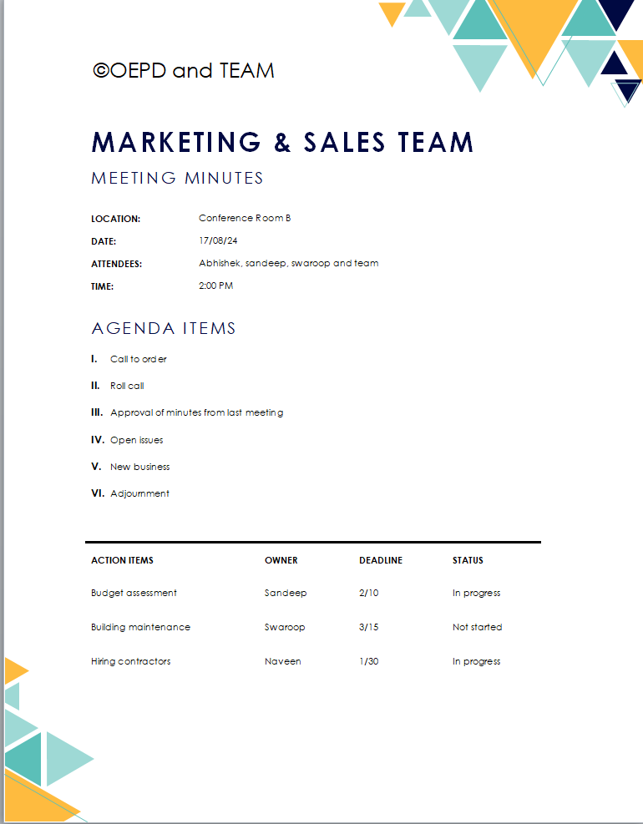

## Q. No 13- Change tracker document

A **Change Tracker Document** is a tool used in project management to log and track changes throughout the life of a project. It helps ensure that all changes are documented, reviewed, and approved before being implemented. [Using a Change Tracker Document helps maintain transparency and control over project modifications, ensuring that all stakeholders are aware of and agree to changes before they are implemented](https://www.projectmanagementdocs.com/template/project-documents/change-log/).

|  |  |  |  |  |  |  |  |
| --- | --- | --- | --- | --- | --- | --- | --- |
| Change no. | Change type | Description of change | Requester | Date submitted | Date approved | Status | Comments |
| 01 | Scope | Added new feature to improve user interface | Amar | 2024-08-01 | 2024-08-05 | Approved | N/A |
| 02 | Schedule | Extended project deadline by 2 weeks | Akbar | 2024-08-10 | 2024-08-12 | Pending | Awaiting approval from stakeholders |
| 03 | cost | Increased budget for additional resources | Antony | 2024-08-15 | 2024-08-17 | Approved | Additional resources required for new feature implementation |
|  |  |  |  |  |  |  |  |

# Q. no 14- Traditional development model and Agile development model

The Traditional Development Model (often referred to as the Waterfall model) and the Agile Development Model are two distinct approaches to software development, each with its own characteristics, advantages, and disadvantages.

## Traditional Development Model (Waterfall)

Sequential Phases: The development process is linear and sequential, with each phase (requirements, design, implementation, testing, deployment, maintenance) completed before the next one begins.

Fixed Requirements: Requirements are gathered at the beginning and are expected to remain unchanged throughout the project.

Documentation: Extensive documentation is created at each phase, ensuring clear and detailed records.

Predictability: The structured approach provides clear milestones and timelines, making it easier to predict project outcomes.

Limited Flexibility: Changes are difficult to implement once the project is underway.

## Agile Development Model

Iterative and Incremental: Development is carried out in small, iterative cycles called sprints, allowing for continuous improvement and adaptation.

Flexible Requirements: Requirements can evolve based on feedback and changing needs throughout the project.

Customer Collaboration: Frequent collaboration with customers and stakeholders ensures the product meets their needs and expectations.

Minimal Documentation: Focus is on working software over comprehensive documentation, though necessary documentation is still maintained.

Adaptability: Agile is highly adaptable to changes, making it suitable for dynamic and complex projects.

These models depends on the project’s complexity, requirements stability, and the need for flexibility and customer involvement. Agile is often preferred for projects with dynamic requirements and a need for rapid delivery, while Traditional is suitable for projects with well-defined requirements and a clear path to completion.

# Q. No 15- Brain storming technique

Brainstorming techniques are versatile tools that can be used in various scenarios to generate creative ideas and solve problems.

* Organizing thoughts, exploring different facets of a problem, and visualizing connections between ideas.   
  Example: Planning a new project or developing a marketing strategy.
* Encouraging quieter team members to contribute ideas without the pressure of speaking up in a group.   
  Example: Generating ideas for product features or improvements.
* Ensuring everyone in the group has a chance to contribute ideas in a structured manner.   
  Example: Team meetings where you need input from all members on a specific issue.
* Identifying strengths, weaknesses, opportunities, and threats related to a project or business.  
   Example: Strategic planning sessions or competitive analysis.
* Exploring different perspectives and thinking styles to evaluate ideas comprehensively.  
   Example: Decision-making processes or problem-solving workshops.
* Innovating and improving existing products or services by asking specific questions.   
  Example: Product development or process improvement sessions.
* Visualizing a sequence of events or steps in a process.  
   Example: Designing user experiences or planning a marketing campaign.
* Generating ideas by imagining how someone else would approach the problem.  
   Example: Creative brainstorming sessions for advertising or content creation.
* Identifying potential problems and obstacles by thinking about how to cause the problem instead of solving it.  
   Example: Risk management or troubleshooting sessions.
* Handling large groups and complex problems by breaking them into smaller, manageable parts.   
  Example: Urban planning or large-scale project development.

These techniques can be adapted to fit various contexts and team dynamics, making them valuable tools for fostering creativity and innovation.

# Q. No16- Reports that Account department will generate

The Accounts Department will generate the following reports:

* Loan Application Status Report:This report will detail the status of all loan applications (approved, rejected, pending).
* Loan Disbursement Report:This report will show the details of loans disbursed, including amounts, dates, and recipients.
* Loan Repayment Schedule Report:This report will outline the repayment schedules for all approved loans.
* Loan Deduction Report:This report will detail the automatic salary deductions made for loan repayments.
* Loan Balance Report**:** This report will show the outstanding loan balances for all employees.

# Q. No 17- Structure of rejection mail:

Dear Sandeep,

We regret to inform you that your loan application dated 17th August 2024 has been rejected. The reason for this decision is due to low cibil score.

If you have any questions or need further clarification, please feel free to contact the HR department.

Best regards,

Abhishek

HR Department

# Q. NO 18- Structure of approval mail:

Subject: Loan Application Approval

Dear Sandeep,

We are pleased to inform you that your loan application dated 05-08-2024 has been approved. Please find below the terms and conditions of the loan, along with the repayment schedule:

Loan Amount: 20,00,000

Interest Rate: 10%

Repayment Start Date:

Monthly Deduction: 40,000

Total Repayment Period: 4years 6months

Please review the terms and conditions carefully. If you agree with the terms, kindly confirm your acceptance by replying to this email.

Best regards,

Abhishek

HR Department

# Q. No 19-Loan applications received report:

|  |  |  |  |  |  |
| --- | --- | --- | --- | --- | --- |
| ****Employee ID**** | Employee name | Application date | Loan amount | Status | Comments |
| 1 | Abhi |  | ₹10,00,000.00 | Approved |  |
| 2 | Swaroop |  | ₹15,00,000.00 | Rejected | Insufficient credit |
| 3 | Kranthi |  | ₹28,00,000.00 | Approved |  |
| 4 | Jonathan |  | ₹12,00,000.00 | Pending | Under review |
| 5 | john |  | ₹6,00,000.00 | Rejected | Incomplete documents |

# Q. No 20- Tools for generating reports:

For generating reports, the following tools can be used:

Microsoft Power BI: For interactive data visualization and business intelligence.

Tableau: For comprehensive data analysis and visualization.

SAP Crystal Reports: For detailed and formatted reporting.

Excel: For basic reporting and data analysis.