**Part 2/2 Evaluation**

Document 6- Please prepare a use case diagram, activity diagram and a use case specification

document.  
**Use Case Diagram: -**  
 

**Use case Specification Document**: -

**1. Login**  
Description -   
Actors – Analysts, Managers  
Precondition – Active internet connection, 2. Browser compatible  
Post condition – Home page should display  
Basic flow – when entered User ID and password is correct  
Alternate flow - entered User ID and password is incorrect, password is incorrect, User ID is incorrect.  
Exceptional flow – forgot User ID, forgot password  
Assumption – Basic computer knowledge to user, English

**2. Register & Login**Description -  
Actors - Analysts, Managers  
Precondition – Active Internet Connection, 2. Browser Compatible  
Post Condition – User able to Register and Login to website  
Basic flow – Home page should display  
Alternate flow – User ID , Password Failed.  
Exceptional Flow -   
Assumption – User should have basic knowledge, have User ID , Password & Company Mail ID.  
Constraint – Both mobile Company Mail ID need to be verified to do successful registration.  
Dependents – user should have Company Mail ID and number to be linked.  
Input – Company Mail ID  
Output – Registration Done and able to login the Website  
Business rules – User ID should use valid Company Mail ID   
Password should use Special Characters as well for Strong security  
MIS Information – Interactive Design and Browser Compatible.

**3. Analyst Summary**Description –  
Actors - Analysts, Managers   
Precondition – Active Internet Connection, 2. Browser Compatible  
Post condition – User able to see Analyst Summary Page and all the information on that page like My Task, News/Events, My Coverage.  
Basic Flow – Analyst Summary Page should display  
Alternate flow – Reload the page and Analyst Summary page should display.  
Exceptional flow – Login Page should Display  
Assumptions – User should have basic knowledge about the GRI platform, have User ID , Password & Company Mail ID.  
Constraint – Both mobile Company Mail ID need to be verified to do successful registration.  
Dependents – user should have Company Mail ID Access and number to be linked.  
Input – Company Mail ID  
Output – – Registration Done and able to login the Website  
Business Rules: User ID should use valid Company Mail ID   
MIS Information – Interactive Design and Browser Compatible

**4. Company Summary**  
Description –  
Actor – Analysts, Managers  
Precondition – Active Internet Connection, 2. Browser Compatible  
Post condition – User able to see Company Summary Page and all the information on that page like Price Charts & Company Events, Company Details, Research Content , GRI Analysts Models.  
Basic Flow – Company Summary Page should display   
Alternate flow – Reload the page and Company Summary page should display  
Exceptional flow – Login Page should Display  
Assumption – User should have basic knowledge about the GRI platform, have User ID , Password & Company Mail ID  
Constraint – Both mobile Company Mail ID need to be verified to do successful registration  
Dependents – User should have Company Mail ID Access and number to be linked.  
Input – Company Mail ID  
Output – Registration Done and able to login the Website  
Business rule – User ID should use valid Company Mail ID  
MIS information – Interactive Design and Browser Compatible

**Activity Diagrams -**

Answer 🡪 Activity Diagram describe the dynamic aspect of the system.

Activity diagram is basically a flowchart to represent the flow from one activity to another activity.











**Document 8- Tools-Visio and Axure**Write a paragraph on your experience using Visio and Axure for the project  
Answer 🡪  
Visio Helps in: -  
**Process mapping**: Visio can be used to create diagrams that show business process flows.

* **Data visualization**: Visio can be used to create diagrams from Excel data or embed Visio diagrams in Power BI dashboards.
* **Collaboration**: Visio can be used to collaborate on diagrams in Microsoft Teams or co-author diagrams in Visio for the web.
* **Documentation**: Visio can be used to document process diagrams in Word, including all the metadata.
* **Sharing**: Visio can be used to share diagrams with others through a browse  
  helps professionals create prototypes, wireframes, visual diagrams, and user interfaces:
* **Prototypes**: Create realistic, functional prototypes without writing code
* **Wireframes**: Create wireframes for your enterprise
* **Visual diagrams**: Create visual diagrams
* **User interfaces**: Create user interfaces
* **Flows**: Create flows
* **Documentation**: Document for development
* **Notes and specifications**: Capture requirements and specifications for developers and stakeholders

**Axure:**I prepare all the Screens and pages required for this project using Axure -

It is very useful and easy to use tool.  
There are different types of Widgets, in that Common, Forms, Menus and tables, Flow these are the types of Widgets that is used.  
We get a page layout, Page interactions, Page Style option in that.  
We can easily make the page designs through Axure.

**Document 9- BA experience**

My Experience as BA in following phases **1. Requirement gathering:**

* To gather requirements, we are having calls with the clients there we discuss all the requirement, note it down and then we receive a mail detailing about the requirement with an example.
* I make sure that the requirements are clearly understood, straightforward, not repeated etc
* I validate the requirements using FURPS technique**.**
* I make sure that the requirements are not repeated, and that requirement makes our system runs smoother and useful for all the Users.

**2. Requirement Analysis:**

* We need to draw UML diagrams to visually describe the requirements
* Activity diagrams also used to describe the process flow
* Communicate the diagrams to team. Some team members might not agree with them and might make changes. As a BA we need to consider the points and make modifications
* Prepare BRS and SRS

**3. Design**:

● By using use case diagrams and taking its reference, I prepare test cases

● Communicate with client on design and solution documents

● I am having an aim to write all the negative test cases as well along with positive test cases.

● I cannot miss a single test case. It might have huge impact on project development in later stages.

● Prepare test data for testing all the test cases.

● Update RTM. This is just as we need to make sure that all the requirements are met.

**4. Development:**

* Organizing meetings with the Stakeholders
* Clarifying queries of tech team during coding.
* There might be some team members who doesn't agree with the concept or who doesn’t cooperate during JAD sessions. As a BA, I handle the situation gently and had one on one discussion with them. Explained how their actions are going to affect the project. Setup healthy environment within the team.
* Referred diagrams to code the Unit.
* Conduct regular meetings with technical team and client which is challenging. Some team members might not be available for the meeting. Recording the session and providing that to missed one and having one to one discussion later with that missed person is all I need to do

**5. Testing:**

* Prepare test cases from use cases
* For ex for one of my requirements I tested the feature for 2 to 3 different companies on stage server before going LIVE
* Then I prepare one excel document which includes all the test cases and its conclusions along with the testing results.
* Then I provide this excel document to the Product Manager
* After getting Approval from Product Manager, I send it to key Stakeholders via Email.
* Then after their approval and user acceptance testing got successfully done
* I update in RTM as requirement DONE testing successfully.

**6. Deployment:**

* Forwarded RTM to client which should be attached to project closure document
* Coordinates to complete and share end user manuals with all the importance and uses of the Feature provided.
* Plans and organizes training sessions for the analysts and provide them guidelines
* Make sure all the candidates attend the meeting

**Document 7- Screens and pages  
  
1. Login Page:**

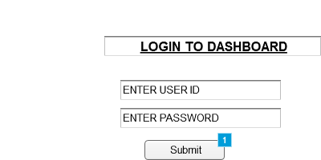

**2. Dashboard Home Page:**

**3. Analyst Summary Page:**   
**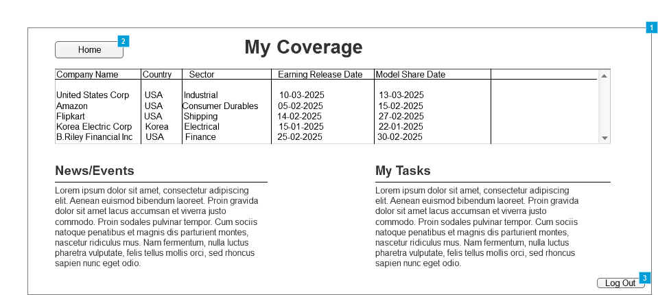  
  
  
  
  
4. Company Summary Page:  
  
**

**5. Research Ops:  
  
**