**Waterfall Project2 – Part -2/2**

**Document 6- Please prepare a use case diagram, activity diagram and a use case specification document.**

**Use Case Diagram**

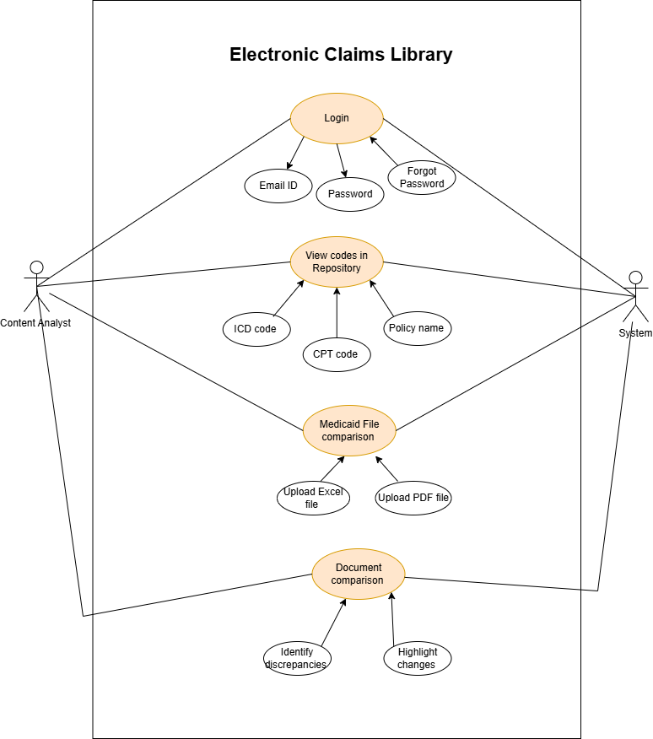

**Activity Diagram**

**Activity diagram for “Login ” use case.**

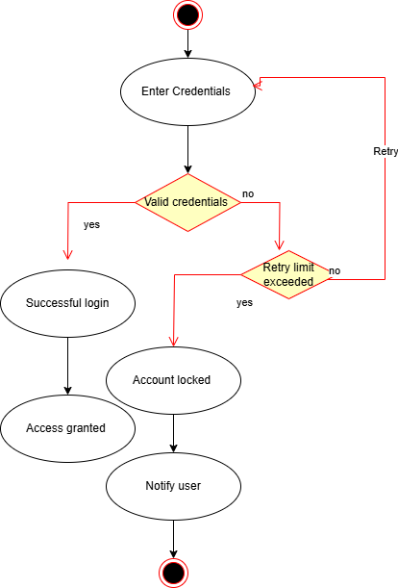

**Activity diagram for “Medicaid file comparison” use case.**

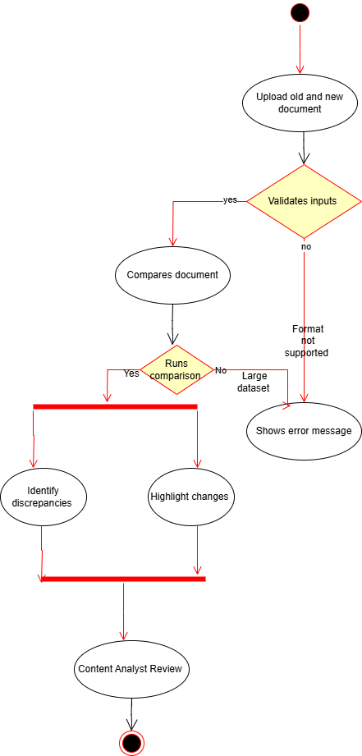

**Use case Specifications**

| **Field** | **Details** |
| --- | --- |
| **Use Case ID** | UC001 |
| **Use Case Name** | Login to Electronic Claims Library |
| **Created By** | Kavya |
| **Last Updated** | 03-03-2024 |
| **Actor(s)** | Content Analyst, System |
| **Description** | This use case allows a registered user (Content Analyst) to log in to the Electronic Claims Library (ECL) to access their account and system features. |
| **Trigger** | The user wants to log in to access their account. |
| **Precondition** | The user must already have an account registered in the system. |
| **Postcondition** | The user is successfully logged into the system and redirected to the dashboard or home page. |
| **Normal Flow** | 1. System displays the 'Login' option.  2. User clicks on the 'Login' button.  3. System displays a login form requesting Email ID and Password.  4. User enters valid Email ID and Password.  5. User clicks on 'Submit' or 'Login'.  6. System validates the credentials.  7. On successful validation, the system logs the user into their account.  8. User is redirected to their account dashboard or home page. |
| **Alternative Flow** | **Step 6A**: If incorrect email or password is entered, the system shows an 'Invalid credentials' error message and allows the user to retry. |
| **Exception Flow** | **E1**: If a technical issue occurs during login, the system shows a 'System error. Please try again later' message. |
| **Priority** | High |
| **Frequency of Use** | Daily or frequent use |
| **Assumptions** | 1. The user has valid login credentials.  2. The user has internet connectivity. |
| **Constraints** | The system should enforce strong password policies and multi-factor authentication (if applicable). |
| **Dependencies** | 1. Requires an existing user account in the system.  2. Database connectivity must be available to validate credentials.  3. Integration with authentication service (e.g., LDAP, OAuth). |
| **Inputs and Outputs** | **Input**: User provides Email ID and Password.  **Output**: User is authenticated and redirected to the dashboard or an error message is displayed. |
| **Business Rules** | 1. Login attempts should be limited to prevent brute-force attacks.  2. System should enforce session timeout for security.  3. Password reset should be available in case of forgotten credentials. |
| **Miscellaneous Information** | 1. The system should log all login attempts for audit purposes.  2. Login failures should trigger an alert after multiple unsuccessful attempts.  3. The login page should be accessible only over a secure HTTPS connection. |

### -----------------------------------------------------------------------------------------

| **Use Case ID** | **UC002** |
| --- | --- |
| **Use Case Name** | View Codes in Repository |
| **Created By** | Kavya |
| **Last Updated** | 04-03-2024 |
| **Actor(s)** | Content Analyst, System |
| **Description** | This use case allows users to view and retrieve medical codes (ICD, CPT, Policy Name) from the repository. |
| **Trigger** | The user wants to access stored codes in the system. |
| **Precondition** | The user must be logged in and have appropriate access permissions. |
| **Postcondition** | The user successfully views the required codes from the repository. |
| **Normal Flow** | 1. System displays the "View Codes" option.  2. User selects "View Codes in Repository".  3. System retrieves and displays stored codes (ICD, CPT, Policy Name).  4. User searches for a specific code or browses the list.  5. System filters and displays relevant results.  6. User selects a code for detailed view.  7. System shows complete details of the selected code. |
| **Alternative Flow** | **Step 3A**: If no codes are found, the system displays "No codes available" message. |
| **Exception Flow** | **E1**: If there is a system error, the system shows a "Repository access failed. Try again later" message. |
| **Priority** | High |
| **Frequency of Use** | Daily or frequent use |
| **Assumptions** | 1. The repository contains medical codes.  2. The user has the necessary permissions to access the repository. |
| **Constraints** | The user must have role-based access control to view the repository. |
| **Dependencies** | Requires user authentication (Login use case must be completed successfully). |
| **Inputs and Outputs** | **Input**: User request to view stored codes. **Output**: List of ICD, CPT, and Policy Name codes displayed. |
| **Business Rules** | 1. Only authorized users can access the repository.  2. The repository should be updated regularly with the latest codes.  3. The system should support keyword-based search for quick code retrieval. |
| **Miscellaneous Information** | The system should log all user activities related to code access for audit purposes. |

**----------------------------------------------------------------------------------------------------**

| **Field** | **Details** |
| --- | --- |
| **Use Case ID** | UC003 |
| **Use Case Name** | Medicaid File Comparison |
| **Created By** | Kavya |
| **Last Updated** | 20-03-2024 |
| **Actor(s)** | Content Analyst, System |
| **Description** | This use case allows the Content Analyst to upload Medicaid files (Excel or PDF) to compare and identify discrepancies in healthcare claim policies. |
| **Trigger** | The user wants to compare Medicaid files to ensure accuracy in claim policies. |
| **Precondition** | 1. The user must be logged into the system.2. The Medicaid files must be available for upload. |
| **Post condition** | The system successfully compares the uploaded Medicaid files and provides a report on discrepancies. |
| **Normal Flow** | 1. User navigates to the "Medicaid File Comparison" section.  2. System prompts the user to upload the required Medicaid files (Excel or PDF).  3. User selects and uploads the files.  4. System validates the file format and content.  5. System compares the uploaded files.  6. System identifies discrepancies, missing codes, or policy differences.  7. System generates a detailed report on the comparison results.  8. User reviews and downloads the report. |
| **Alternative Flow** | **Step 4A**: If the uploaded file format is incorrect, the system displays an error message and prompts the user to upload a valid file.**Step 6A**: If no discrepancies are found, the system notifies the user that the files match. |
| **Exception Flow** | **E1**: If the file upload fails due to system issues, the system shows a "File upload failed. Please try again later" message.**E2**: If the system cannot process the comparison, it displays a "Comparison error. Please contact support" message. |
| **Priority** | High |
| **Frequency of Use** | Weekly or as needed for Medicaid policy verification. |
| **Assumptions** | 1. The user has the necessary permissions to upload Medicaid files.  2. The system can handle large files efficiently. |
| **Constraints** | 1. File uploads should be limited to specific formats (Excel, PDF).  2. Maximum file size restrictions should be enforced.  3. Comparison processing time should be optimized for efficiency. |
| **Dependencies** | 1. Requires a functional file upload module.  2. Requires a document comparison algorithm integrated into the system.3. Database must store historical Medicaid data for accurate comparison. |
| **Inputs and Outputs** | **Input**: User uploads Medicaid files (Excel, PDF).  **Output**: System generates a report highlighting differences and discrepancies. |
| **Business Rules** | 1. System should support version control for Medicaid policy documents.  2. File comparison should be case-insensitive but should flag major formatting differences.  3. Users should be able to download the comparison results in PDF format. |
| **Miscellaneous Information** | 1. System should log all comparison activities for audit purposes.  2. If multiple users upload files simultaneously, the system should manage resources efficiently to prevent slowdowns.  3. A notification should be sent to the user once the comparison is complete. |

**------------------------------------------------------------------------------------------------------------------------**