**PROJECT: INVENTORY MANAGEMENT SYSTEM**

**PROJECT ID: 01IMS150125**

**VERSION: IMS001**

**AUTHOR: VIKASH KUMAR SINGH**

Contents

1. Document Revisions 3

2. Approvals 3

3. RASCI Chart for This Document 3

**Codes Used in RASCI Chart** 3

RASCI Chart 4

4. Introduction 4

4.1 Business Goals 4

4.2 Business Objectives 4

4.3 Business Rules 5

4.4 Background 5

4.5 Project Objective 5

4.6 Project Scope 5

4.6.1 In-Scope Functionality 5

4.6.2 Out-of-Scope Functionality 5

5. Assumptions 5

6. Constraints 5

7. Risks 6

Technological Risks 6

Skills Risks 6

Political Risks 6

Business Risks 6

Requirements Risks 6

Other Risks 6

8. Business Process Overview 6

8.1 Legacy System (AS-IS) 6

8.2 Proposed Recommendations (TO-BE) 6

9. Business Requirements 7

10. Appendices 8

10.1 List of Acronyms 8

10.2 Glossary of Terms 8

10.3 Related Documents 8

# **1. Document Revisions**

|  |  |  |
| --- | --- | --- |
| Date | Version Number | Document Changes |
| 15/07/2024 | 0.1 | Initial Draft |
| 15/07/2024 | 0.2 | Additional functional requirement for Login was added |
| 16/07/2024 | 1.0 | RACI Matrix was updated |
| 16/07/2024 | 1.1 | Improvement and suggestion provided in design |
|  |  |  |
|  |  |  |
|  |  |  |

# **2. Approvals**

|  |  |  |  |  |
| --- | --- | --- | --- | --- |
| **Role** | **Name** | **Title** | **Signature** | **Date** |
| Project Sponsor | XYZ | Business Unit Head |  |  |
| Business Analyst | Vikash kumar singh | Sr. BA |  |  |
| Project Manager | Virendra Singh | PM |  |  |
| SPOC | XYZ | SME, Capital Bank |  |  |
| Java Developer 1 | ABC | Sr Java Developer |  |  |
| Java Developer 2 | XYZ | Associate Java Developer |  |  |
| Java Developer 3 | ABC | Associate Java Developer |  |  |
| Tester1 | XYZ | QA Engineer |  |  |
| Tester 2 | ABC | Sr. S/W tester |  |  |
| N/W Admin | XYZ | Sr. N/W Admin |  |  |
| DB Architect | ABC | DB Architect |  |  |

# **3. RASCI Chart for This Document**

## **Codes Used in RASCI Chart**

* **R:** Responsible
* **A:** Accountable
* **S:** Supportive
* **C:** Consulted
* **I:** Informed

### ****RASCI Chart****

|  |  |  |  |  |  |  |  |
| --- | --- | --- | --- | --- | --- | --- | --- |
| **Name** | **Position** | **\*** | **R** | **A** | **S** | **C** | **I** |
| Neha Singh | Business Unit Head |  |  |  |  |  |  |
| Vikash Kumar Singh | Sr. BA |  |  |  |  |  |  |
| Virendra Singh | PM |  |  |  |  |  |  |
| XYZ | SME, Capital Bank |  |  |  |  |  |  |
| ABC | Sr Java Developer |  |  |  |  |  |  |
| XYZ | Associate Java Developer |  |  |  |  |  |  |
| ABC | Associate Java Developer |  |  |  |  |  |  |
| XYZ | QA Engineer |  |  |  |  |  |  |
| ABC | Sr. S/W tester |  |  |  |  |  |  |
| XYZ | Sr. N/W Admin |  |  |  |  |  |  |
| ABC | DB Architect |  |  |  |  |  |  |

# **4. Introduction**

## **4.1 Business Goals**

* To efficiently manage inventory levels across manufacturing plants and warehouses.
* To enable the quickest delivery of ice-cream and milk products to customers, ensuring customer satisfaction and loyalty.

## **4.2 Business Objectives**

* Develop a centralized software system to track and manage inventory.
* Optimize delivery routes to ensure timely delivery.
* Provide real-time inventory and delivery status updates.

## **4.3 Business Rules**

* Inventory thresholds must trigger alerts to avoid stockouts or overstocking.
* Delivery timelines must adhere to the predefined SLA (Service Level Agreement).
* Data must be synchronized across all plants and warehouses.

## **4.4 Background**

The company currently faces challenges in managing inventory and ensuring timely deliveries due to fragmented systems and lack of visibility across locations. This project aims to address these inefficiencies.

## **4.5 Project Objective**

To design and implement a software solution that centralizes inventory management and optimizes delivery operations.

## **4.6 Project Scope**

### ****4.6.1 In-Scope Functionality****

* Inventory tracking and management.
* Delivery route optimization.
* Real-time data synchronization.
* User dashboards for inventory and delivery status.

### ****4.6.2 Out-of-Scope Functionality****

* Customer-facing applications.
* Integration with third-party logistics providers.

# **5. Assumptions**

* All manufacturing plants and warehouses will have internet connectivity.
* Existing hardware infrastructure is compatible with the proposed system.

# **6. Constraints**

* Budget limitations may impact the timeline.
* Training staff on the new system may take additional time.

# **7. Risks**

## **Technological Risks**

* Integration challenges with legacy systems.

## **Skills Risks**

* Limited technical expertise among staff.

## **Political Risks**

* Resistance to change from internal stakeholders.

## **Business Risks**

* Delay in software implementation may lead to operational inefficiencies.

## **Requirements Risks**

* Unclear or changing requirements may impact development timelines.

## **Other Risks**

* Data security concerns during system migration.

# **8. Business Process Overview**

## **8.1 Legacy System (AS-IS)**

* Manual inventory management.
* Lack of centralized data storage.

## **8.2 Proposed Recommendations (TO-BE)**

* Centralized software for real-time inventory tracking.
* Automated delivery route optimization.

GOAL

AS-IS

TO- BE

TIME

# **9. Business Requirements**

|  |  |  |  |
| --- | --- | --- | --- |
| **Sr. No** | **Requirement Name** | **Requirement Description** | **Priority** |
| BR001 | Customer Login Access | Existing customers should be able to log in using their credentials. | High |
| BR002 | Customer Registration | The system should capture and store the details of customers during registration, including contact and address. | High |
| BR003 | Inventory Tracking | The system should track the quantity and types of products in manufacturing plants and warehouses in real-time. | High |
| BR004 | Order Placement | Customers should be able to place orders through an online interface specifying product type and quantity. | High |
| BR005 | Delivery Route Optimization | The system should suggest the quickest delivery routes for fulfilling customer orders based on inventory location. | High |
| BR006 | Inventory Forecasting | The system should analyze historical data to predict inventory requirements for each location. | Medium |
| BR007 | Stock Alerts | The system should send notifications when the stock level of any product falls below a predefined threshold. | High |
| BR008 | Delivery Tracking | Customers should be able to track their delivery status in real-time through a web or mobile application. | Medium |
| BR009 | Manufacturing Capacity Utilization | The system should provide reports on the manufacturing capacity utilization of each plant. | Low |
| BR010 | Customer Feedback Collection | The system should allow customers to provide feedback on product quality and delivery experience. | Medium |

# **10. Appendices**

## **10.1 List of Acronyms**

* SLA: Service Level Agreement
* AML: Anti-Money Laundering

## **10.2 Glossary of Terms**

* **Inventory Management**: The process of ordering, storing, and using a company's inventory.
* **Delivery Optimization**: The process of improving delivery operations for efficiency.

## **10.3 Related Documents**

* FRD- Functional Requirement Document
* BRD- Business Requirement Document
* Change request document.

**Assignment 1:**

2. Prepare process flow diagram using your imagination.

**Process Flow diagram (UML Diagram)**

Pick & Pack order at warehouse

Manufacturing Plant

Dispatch & Real Time tracking

Inventory Auto-adjustment+reporting+Notification

Delivery Completion & proof (photo/Signature)

Assign delivery partner+route optimization

System identifies nearest warehouse with stocks

Customer Places order(Web portal/mobile App)

Inventory sync with warehouses(real Time)

Update Inventory in Central System

Product Packaging

**Assignment 2:**

Write an introduction letter to a client introducing yourself as a business analyst in charge of working with the client and his team to start the business understanding process.

**Vikash Kumar Singh**  
Business Analyst  
IT Technologies  
Vikash.singh@gmail.com  
8080*****  
30/01/2025

**RAM**   
Product Owner  
XYZ ice-cream pvt tld  
Mumbai

**Subject:** Introduction & Kickoff – Business Analysis for Inventory & Delivery Optimization

Dear RAM,

I hope this email finds you well. My name is Vikash Kumar Singh and I am a Business Analyst at IT Technologies. I am excited to introduce myself as your point of contact for the upcoming collaboration aimed at enhancing your inventory management and optimizing delivery processes for your ice-cream and milk product distribution.

Our primary goal is to gain a deep understanding of your current operations, challenges, and expectations so that we can design a tailored software solution that improves efficiency, ensures real-time inventory tracking, and streamlines the quickest possible deliveries to your customers.

To begin this journey, I would like to schedule an initial discussion with you and your team. This will help us gather key business insights, understand your workflows, and define the critical requirements for the project. Please let me know a convenient time for this meeting.

I look forward to working closely with you and your team to create a robust solution that aligns with your business objectives. Please feel free to reach out if you have any immediate questions or concerns.

Looking forward to our collaboration.

Best regards,  
**Vikash Kumar Singh**  
Business Analyst  
IT technologies  
Vikash.singh@gmail.com  
80080****

**Assignment 2:**

2. Prepare a brief BRD and SRS for a project- Horoscope or Ticketing system or online store.

# **Business Requirements Document (BRD) –**

## **1. Document Revisions**

|  |  |  |  |
| --- | --- | --- | --- |
| **Version** | **Date** | **Description** | **Author** |
| 1.0 | [Date] | Initial Draft | [Your Name] |
| 1.1 | [Date] | Reviewed & Updated | [Reviewer Name] |

## **2. Approvals**

|  |  |  |  |
| --- | --- | --- | --- |
| Name | Designation | Signature | Date |
| Vikash | BA |  |  |
| Ankit | PM |  |  |

## **3. RASCI Chart for This Document**

### ****Codes Used in RASCI Chart****

* **R** – Responsible
* **A** – Accountable
* **S** – Supportive
* **C** – Consulted
* **I** – Informed

### ****RASCI Chart****

|  |  |  |  |  |  |
| --- | --- | --- | --- | --- | --- |
| Task | Business Analyst | Project Manager | Developer | QA | Client |
| Requirement Gathering | R | A | C | I | S |
| Documentation | R | A | C | I | S |
| Development | I | C | R | S | A |
| Testing | I | C | S | R | A |
| Approval | C | A | I | I | R |

## **4. Introduction**

### ****4.1 Business Goals****

Swastik Online Store aims to establish a robust e-commerce platform to sell groceries, dairy products, and household essentials with seamless order management and optimized delivery logistics.

### ****4.2 Business Objectives****

* Provide a user-friendly online shopping experience.
* Implement a secure and efficient order processing system.
* Enhance inventory tracking and order fulfillment.
* Optimize delivery routes for faster deliveries.

### ****4.3 Business Rules****

* Customers must register before placing orders.
* Minimum order value for free delivery: ₹500.
* Returns accepted within 7 days for eligible products.
* Inventory updates occur in real-time.

### ****4.4 Background****

Swastik Online Store is expanding its physical retail presence to an online marketplace to increase sales, reach a wider audience, and provide convenience to customers.

### ****4.5 Project Objective****

To develop a scalable, secure, and high-performing e-commerce platform with inventory management and delivery optimization capabilities.

### ****4.6 Project Scope****

#### ****4.6.1 In-Scope Functionality****

* User Registration & Authentication
* Product Catalog Management
* Shopping Cart & Order Placement
* Payment Gateway Integration
* Inventory Management
* Order Tracking & Delivery Management
* Customer Support & Feedback

#### ****4.6.2 Out-of-Scope Functionality****

* Physical store operations
* International shipping
* Third-party vendor integrations

## **5. Assumptions**

* Customers will have access to smartphones and the internet.
* Payment gateways will support major digital payment options.
* Adequate server infrastructure is available for hosting the platform.

## **6. Constraints**

* Budget constraints may limit advanced features.
* Delivery service coverage limited to certain regions.
* Compliance with local taxation and e-commerce regulations.

## **7. Risks**

### ****Technological Risks****

* Security threats such as data breaches.
* Scalability issues with growing user base.

### ****Skills Risks****

* Shortage of skilled developers for complex integrations.

### ****Political Risks****

* Changes in e-commerce regulations impacting operations.

### ****Business Risks****

* Market competition from established e-commerce platforms.

### ****Requirements Risks****

* Evolving customer expectations requiring frequent updates.

### ****Other Risks****

* Technical failures affecting order processing and delivery.

## **8. Business Process Overview**

### ****8.1 Legacy System (AS-IS)****

Currently, Swastik operates via physical stores with manual inventory tracking and offline order processing.

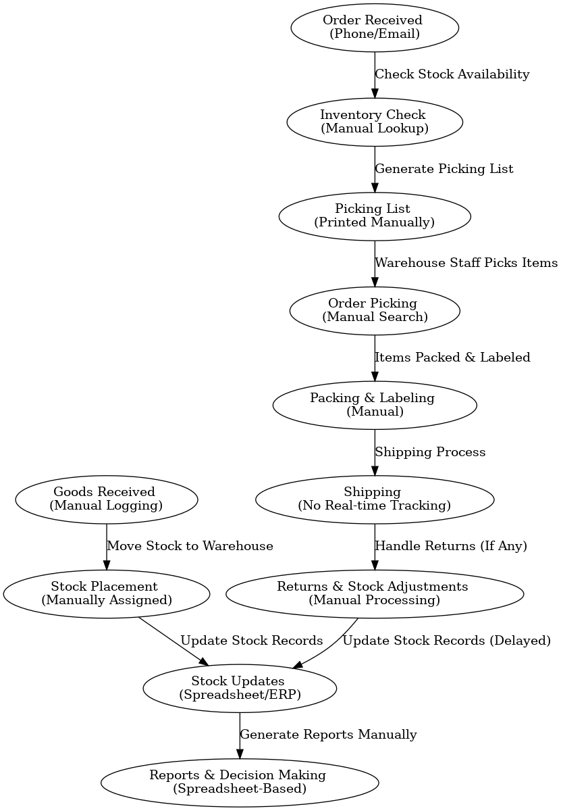

### ****8.2 Proposed Recommendations (TO-BE)****

* A digital storefront with automated inventory management.
* Real-time order tracking for customers.
* AI-based delivery optimization to reduce delivery time.

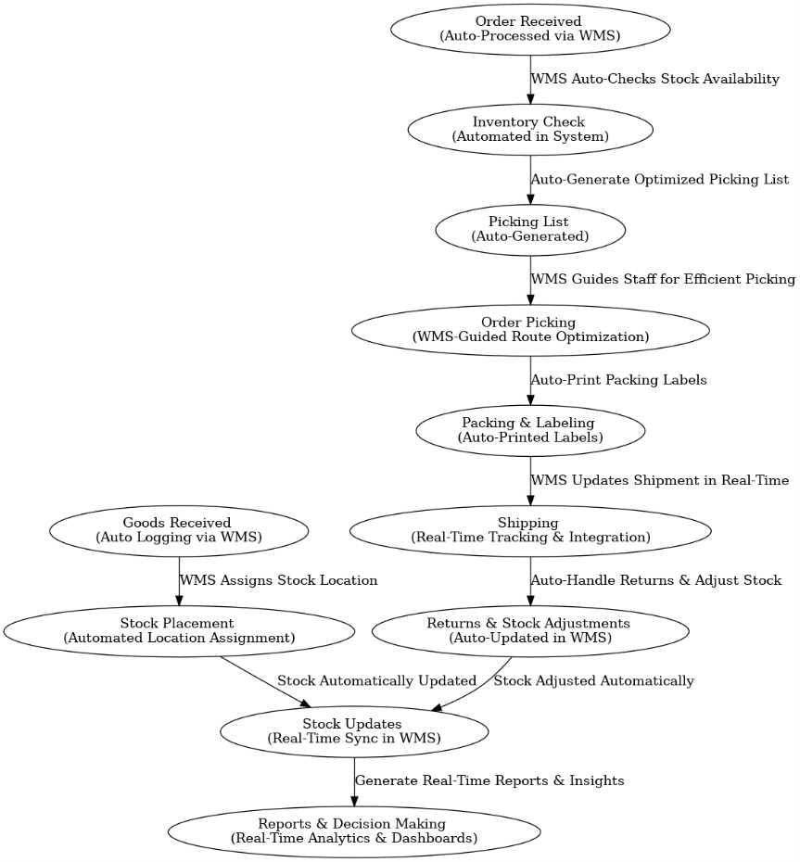

## **9. Business Requirements**

|  |  |  |
| --- | --- | --- |
| ID | Requirement | Priority |
| BR-01 | User registration and login | High |
| BR-02 | Product search and filtering | High |
| BR-03 | Shopping cart functionality | High |
| BR-04 | Secure payment gateway integration | High |
| BR-05 | Order tracking and status updates | Medium |
| BR-06 | AI-based delivery route optimization | Medium |
| BR-07 | Customer feedback and support system | Low |

## **10. Appendices**

### ****10.1 List of Acronyms****

|  |  |
| --- | --- |
| Acronym | Definition |
| BRD | Business Requirements Document |
| RASCI | Responsible, Accountable, Supportive, Consulted, Informed |

### ****10.2 Glossary of Terms****

|  |  |
| --- | --- |
| Term | Definition |
| E-commerce | Buying and selling goods online |
| Inventory Management | Tracking and managing stock levels |

### ****10.3 Related Documents****

* Software Requirements Specification (SRS)
* Project Plan
* Test Strategy Document

**ERD of Diagram for a support ticket/Ticketing life cycle**

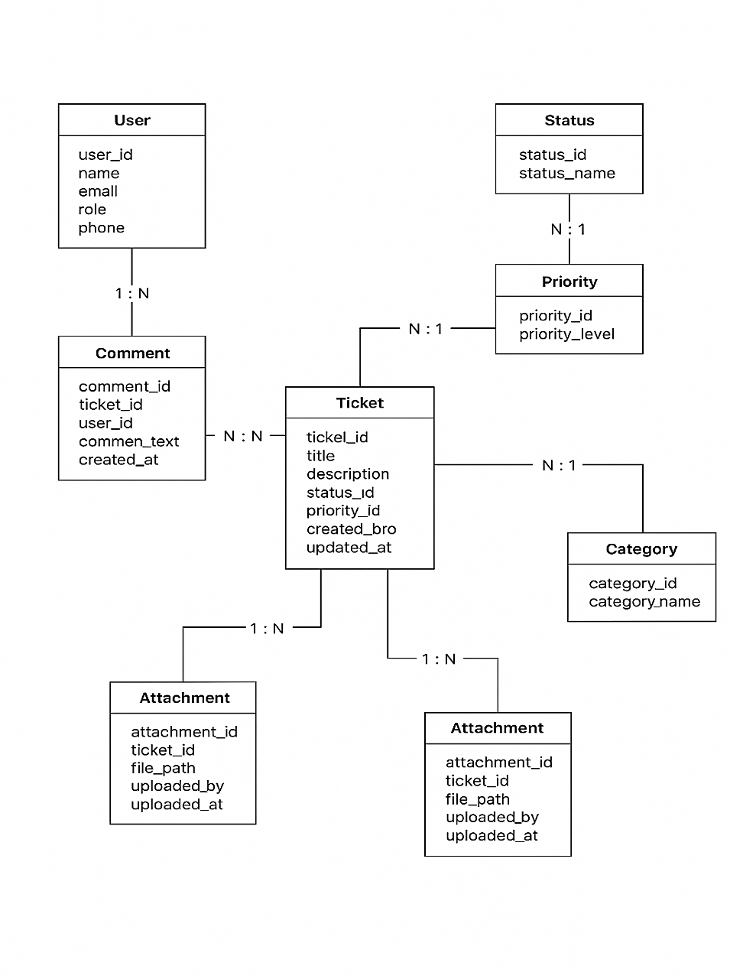

**Assignment 2:**

4. User story of shopping from ecommerce.

|  |  |  |  |  |  |  |
| --- | --- | --- | --- | --- | --- | --- |
| **User Story No** | **Task** | **Priority** | **User Story** | **BV** | **CP** | **Acceptance Criteria** |
| 1 | User Registration | Highest | **As a customer**, I want to create an account on the e-commerce platform so that I can browse and purchase products. | 500 | 5 | - Should have a valid email/phone number- Send successful registration notification- Form should not be processed if incorrect details are entered- Show error message for incorrect credentials- Show pop-up message for network issues |
| 2 | Product Search & Filtering | High | **As a customer**, I want to search for products using keywords and filters so that I can quickly find what I need. | 400 | 4 | - Display relevant products for search keywords- Provide filters (category, price, brand, ratings)- Show appropriate message if no products are found- Provide autocomplete suggestions |
| 3 | Add to Cart | High | **As a customer**, I want to add products to my cart so that I can purchase multiple items in one order. | 450 | 4 | - Allow adding multiple products to the cart- Display product name, price, quantity, and total cost- Enable users to update quantity or remove items- Show confirmation message when an item is added |
| 4 | Checkout & Payment | Highest | **As a customer**, I want to complete my purchase through a secure checkout process so that I can receive my order safely. | 600 | 6 | - Allow users to review order before payment- Provide multiple payment options (credit/debit cards, wallets, COD, UPI)- Show confirmation message for successful payment- Display error message for failed transactions |
| 5 | Order Tracking | Medium | **As a customer**, I want to track my order status so that I can know when it will arrive. | 300 | 3 | - Show order status updates (processing, shipped, delivered)- Provide tracking details with estimated delivery date- Send notifications for order updates |
| 6 | Wishlist Feature | Medium | **As a customer**, I want to save products to my wishlist so that I can purchase them later. | 250 | 3 | - Allow users to add/remove products from wishlist- Provide access to wishlist from account dashboard- Notify users when wishlist items go on sale |
| 7 | Customer Reviews & Ratings | Medium | **As a customer**, I want to leave reviews and ratings for purchased products so that I can share my experience with others. | 350 | 3 | - Allow users to submit reviews and rate products (1-5 stars)- Display reviews on product pages- Enable filtering of products based on ratings |
| 8 | Apply Discount Coupons | High | **As a customer**, I want to apply discount coupons during checkout so that I can save money on my purchase. | 400 | 4 | - Allow users to enter valid coupon codes at checkout- Reflect discounts in total order amount- Show error message for invalid/expired coupons |
| 9 | Customer Support Chat | High | **As a customer**, I want to chat with customer support so that I can resolve my issues quickly. | 500 | 5 | - Provide live chat for queries- Offer automated responses for common questions- Allow escalation to a live agent |
| 10 | Return & Refund Process | High | **As a customer**, I want to request a return or refund so that I can get my money back if I am not satisfied with my purchase. | 550 | 5 | - Allow users to initiate return requests within a specified time- Process refunds within the given timeframe- Send updates on return/refund status |