**Question1. Identify Business Process Model for Online Agriculture Store:**

* **Goal**: To bridge the gap between farmers and companies through an App.
* **Inputs**: Customer data and needs, marketing campaigns, trained employees.
* **Resources**: Warehouses, software, office space, delivery partners, internet connectivity.
* **Outputs**: Efficiency, sales revenue, easy navigation to connect farmers and product companies.
* **Activities**: Excellent customer service, partnering with leading product companies, delivering at farmer’s location
* **Value**: user friendly experience, customer satisfaction and wide reach.

**Question2.** **Aspects he should consider as Strengths, as Weaknesses, as Opportunity and as Threat**

|  |  |
| --- | --- |
| **Strengths:**  **- Strong brand recognition.**  **-bridging the gap in remote locations. -Making it user friendly to farmers to buy products whenever required.** | **Weaknesses: -supply chain disruptions.**  **-** invento**ry management** **issues.**  **-internet network availability.** |
| **Opportunities: -wide reach of products to farmers.**  **-Making it easy to buy, time saving. -** D**irectly communicating with companies** | **Threats: - Basic education might be necessary -basic knowledge of technology is required.**  **-change in customer spending** ha**bits.** |

**Question3. Feasibility study  
Budget:**

Amount assigned to the project **-2crore INR**costs estimated**-1.8cr INR  
  
Technology:** Based on data based servers, Payment gateways , Security , API’s  
web server: Apache, Nginx  
Database Server : MySQL  
Programming language: PHP, Python, Ruby  
Content Management system: WordPress, Drupal, Ruby  
Total-56 lakhs  
 **Hardware:**   
Web servers: Dell Poweredge, HP ProLiant, IBM System x  
DataBase Servers: Dell Poweredge, HP ProLiant, IBM System x  
Load balancers: F5 Big- IP, Cirix NetScaler, HAProxy

Storage Devices: Dell EqualLogic, HP 3PAR, NetApp FAS  
Total cost -35lakhs  
  
**Software:**Content Management System: Wordpress, Drupal, Magento  
Ecommerce platform: Soony AGRO  
Payment Gateway: Paypal, BHIM, Paytm  
Security Applications: SSL certificate, Firewall, Anti-Malware  
Total cost: 45lakhs  
**Resources- 44 Lakhs**Project manager: 1lakh  
Senior java Developers: 75000/month  
Business analyst: 50000/month  
java development team:160000 /- per month  
Network admin: 60000/month  
DataBase Admin:50000/month  
Testers :50000/month **Budget:** Various costs involve such as Development costs , hardware costs making around a cost of **2crore INR**.  
**Time frame:** Based on resources and no. of features it would be 18 months.

**Question4. Gap analysis**

**Current state**

* **Facing difficulties in procuring fertilizers which are important for the farm.**
* **Facing difficulties in buying seeds for farming certain crops.**
* **Lack of pesticides which greatly help in reducing pests in crops.**

**Desired state**

* To build online store to facilitate farmers to buy seeds, pesticides, and fertilizers from anywhere through internet connectivity and should be user friendly.
* To make an online agriculture product store to facilitate remote area farmers to buy agriculture products.
* Through the Online Web / mobile Application, Farmers and Companies (Fertilizers, seeds and pesticides manufacturing Companies) should communicate directly with each other.
* The application should be able to accept the product details from the manufacturers and should be able to display them to the Farmers. Farmers will browse through these products and select the products what they need and request to buy them and deliver them to farmers location.

**Question.5 – Risk Analysis**

**Internal Risks:**

* **Technical issues and system downtime.**
* **Lack of trained employees.**

**External Risks:**

* **Lack of education or knowledge on how to use the app.**
* **Availability of Mobile network for internet connectivity.**
* **Availability of smart phones.**

**BA Risks:**

* **Lack of knowledge on the domain.**
* **Change in client requirements.**

**Project based risks:**

* **Scope and stakeholder risks.**

**Question.6: RACI Matrix**

|  |  |  |  |
| --- | --- | --- | --- |
| **Payment Process** | | | |
| **RACI** | **Name of the Person** | **Designation** | **Details** |
| **Responsible** | Mr. Karthik | Delivery Head | Email: [**KarthikDH@gmail.com**](mailto:KarthikDH@gmail.com) ph no: 912345674 Reach out time: 10AM-1PM IST |
| Ms. Juhi | Sr Software Developer | Email: [**JuhiSD01@gmail.com**](mailto:JuhiSD01@gmail.com) ph no:978945612 Reach out time: 10AM-1PM IST |
| Mr. Pandu | Financial Head | Email: [**Pandu.FH007@gmail.com**](mailto:Pandu.FH007@gmail.com) ph no: 987451268 Reach out time: 10AM-12PM IST |
| **Accountable** | Mr. Vandanam | Project Head | Email: [**VandanamPr_H@gmail.com**](mailto:VandanamPr_H@gmail.com) ph no: 87412596 Reach out time: 10AM-4PM IST |
| Mr. Abhishek | Business analyst | Email: [**Abhishek007@gmail.com**](mailto:Abhishek007@gmail.com) ph no: 8500094898 Reach out time: 10AM-2PM |
| Mr. Dooku | Project Coordinator | Email: [**dooku_du@gmail.com**](mailto:dooku_du@gmail.com) ph no: 78451269 Reach out time: 10AM-1PM IST |
| **Consulted** | Mr. Mike | Network Admin | Email: [**Mike_NA@gmail.com**](mailto:Mike_NA@gmail.com) ph no: 845127569 Reach out time: 10AM-1PM IST |
| Mr. Arnav | Hr Head | Email: Arnav [**_Hr@gmail.com**](mailto:_Hr@gmail.com) ph no: 947512587 reach out time: 10AM-1PM IST |
| Mr. Kamal | Technical- SME | Email: [**Kamal_tSMe@gmail.com**](mailto:Kamal_tSMe@gmail.com) ph no: 9451247854 Reach out time: 10AM-1PM IST |
| **Informed** | Mr.Henry | Sponser | Email: [**Henry_DH@gmail.com**](mailto:Henry_DH@gmail.com) Ph no: 78451296 Reach out time: 10AM-2PM IST |
| Mr. Karthik | Delivery Head | Email: [**KarthikDH@gmail.com**](mailto:KarthikDH@gmail.com) ph no: 912345674 Reach out time: 10AM-1PM IST |
| Mr. Ben | Business Analyst(Client) | Email:Ben_10BA@gmil.com ph no: 6142782457 Reach out time: 10AM-3PM IST |

**Question.7 Business Case Document**

|  |  |
| --- | --- |
| BUSINESS CASE DOCUMENT | |
| OBJECITVE/ AIM | To Bridge the gap between manufacturers and farmers through an user friendly app. |
| CURRENT ISSUES | Difficulties in procuring required agricultural products. |
| DESIRED OUTPUT | Placing the orders through the App and getting it delivered to the door step. |
| RESOURCES REQUIRED | A Project management and Developing team of 12 members for delivering the app. |
| CHANGES REQUIRED | * Organisation has to include someone or hire an SME . * Incorporating V-model and adopting it, if waterfall model is used previously. |
| TIME FRAME TO RECOVER ROI | 1year |
| STAKEHOLDERS IDENTIFICATION | List out stakeholders and RACI MATRIX depending on functionalities, phases and process. |
|  |  |

**Question.8: SDLC Methodologies**

**1. Sequential-waterfall** Most common and classic of life cycle models, referred to as a linear-sequential life cycle model. Each phase must be completed in its entirety before the next phase can begin. At the end of each phase, a review takes place to determine if the project is to be proceeded or discarded. Easy to understand and use.

**2. Iterative-RUP**

**An incremental and iterative software development process consisting 4 project life cycle phases i.e., Inception, Elaboration, Construction and transition. It develops iteratively, manages requirements, employs a component-based architecture.**

**3. Evolutionary-spiral**

**This methodology gives more emphases placed on risk analysis. It has four phases: Planning, Risk analysis, Engineering and Evaluation. Keeping a baseline spirl, starting in the planning phase, requirements are gathered and risk is assessed. This methodology is good for large and critical projects.**

**4. Agile-scrum  
 This is a project management system that relies on incremental development. Most popular and widely uses framework in agile development. Agile is a process that manage a project by breaking it down into several stages to promote steady improvements at every stage. This methodology has 4 main values and 12principles.**

**Question.9- Waterfall RUP Spiral and scrum models**

**1. Waterfall model**

**A model that follows a structured approach with each phase having specific deliverables and a review which takes place at the end of each phase to determine if the project has to be proceeded or discarded. This model works for smaller projects where requirements are very well understood. Most common life cycle model also refered to as a linear-sequential life cycle model.**

**2. RUP- Rational unified process**

**The RUPdescribes what is to be produced, the necessary skills required and step-by-step explanation describing how specific development goals are to be achieved. This process consists project life cycles namely Inception, Elaboration, construction and transition.**

**3. Spiral**

**This software repeatedly passes through the phases of planning, risk analysis, engineering and evaluation. Keeping a baseline spiral, strating in the planning phase, requirements are gathered and risk is assessed. A prototype is produced at the end of risk analysis phase. Highly efficient in risk analysis. Good for large and mission critical projects.**

**4. Scrum**

**This is implemented either at the beginning or when you sense the project is falling behind schedule. It is implemented when faster delivery is required. This is done by scrum team which is also involved by scrum master who monitors the performance of the team within the sprint.**

**Question.10 Waterfall vs V-Model**

|  |  |
| --- | --- |
| **Waterfall** | **V-Model** |
| * Follow sequential approach. * A structured approach having specific deliverables. * When on phase ends, next phase begins. * At the end of each phase a review takes place to determine if the project is running fine. * Works for small projects. * Requirements are very well understood. | * A verification and validation method. * Each phase must be completed before next phase begins. * Testing is planned in parallel with corresponding phase of development. * Defects are found at early stage. * Works well for small projects. * Any changes in midway must be updated in the test documents along with the |

**Question.11 Justify your choice**

As a BA I would choose V-model because of thevalidation and verification required to make an app. As we need to make an app , it requires testing at each phase which can be planned at each corresponding phase in this model. There might be changes midway which is acceptable in this model unlike waterfall model.This model is more suitable for making the app because of its proactive defect tracking which helps to find defects at early stages.

**Question.12 Gantt chart**

|  |  |  |  |  |  |  |  |  |  |  |  |  |  |
| --- | --- | --- | --- | --- | --- | --- | --- | --- | --- | --- | --- | --- | --- |
| GANTT CHART | | | | | | | | | | | | | |
|  | RG | RA | DESIGN | DEV1 | TEST1 | DEV2 | TEST2 | DEV3 | TEST3 | DEV4 | TEST4 | CHANGE REQ | UAT |
| PM |  |  |  |  |  |  |  |  |  |  |  |  |  |
| BA |  |  |  |  |  |  |  |  |  |  |  |  |  |
| DESIGN |  |  | **1MONTH** |  |  |  |  |  |  |  |  |  |  |
| DEVELOPMENT |  |  |  | **2MONTHS** |  | **1.5MONTHS** |  | **2MONTHS** |  | **1.5MONTH** |  |  |  |
| TESTER |  |  |  |  | **1MONTH** |  | **1.5MONTHS** |  | **1MONTH** |  | **1.5MONTH** |  |  |
| DB, NW ADMIN |  |  | **1MONTH** |  |  |  |  |  |  |  |  |  |  |
| TIME | **2MONTHS** | **1MONTH** | **1MONTHS** | **2MONTHS** | **1MONTH** | **1.5MONTHS** | **1.5MONTHS** | **2MONTHS** | **1MONTH** | **1.5MONTHS** | **1.5MONTHS** | **1MONTH** | **1MONTH** |

**Question.13 Fixed bid vs Billing projects.**

**FIXED BID PROJECTS:**

**A fixed-bid project is a type of contract where the client and the service provider agree on a fixed price for a specific software service at the beginning of the engagement. The price remains constant throughout the development of the product, regardless of the number of hours worked .**

**Fixed-bid projects are duration-based** and require a start and end date . They can provide cost certainty, simplicity, and budgeting advantages to clients . However, they can also create tension between the development team and the client, and neither side endsup happy . In reality, software development is complex, and features change, APIs don’t work, and client timeframes shift . Therefore, fixed-bid software projects are not always a good solution **.**

**BILLING PROJECTS:**

A model used in a variety of industries in which a client is charged for the actual time and materials used in a project. This model is often used when the project scope is not well defined or is subject to change. It can be a beneficial option for both the client and the service provider. It offers flexibility and transparency for the client, allowing them to only pay for the exact services and materials they need. For the service provider, it allows them to bill for unique or one-off projects accurately and can also be a more secure and predictable source of income than other billing models.

It offers the client and service provider flexibility. If the scope of the project changes, the client only pays for the additional time and materials required rather than a whole new fixed-price contract. Service providers also benefit from the flexibility of billing models as they can adjust their hours worked or materials used to match the client’s budget. With billing, the client knows exactly what they are paying for and can see how the project cost is broken down by time and materials. It can benefit clients who want more control over their project costs.

**Question.14,15,16,17,18,19,20- Timesheets**

|  |  |  |  |  |
| --- | --- | --- | --- | --- |
| Requirement Gathering phase | | | | |
| **S.no** | **Tasks** | **Start time** | **End time** | **Duration** |
| 1 | Business objective | 9:00AM | 10:00AM | 1Hr |
| 2 | Brainstorming | 10:00AM | 12:00PM | 2hrs |
| 3 | Identifying stakeholders | 12:00PM | 1:00PM | 1Hr |
| 4 | Interview | 2:30PM | 4:30PM | 2Hrs |
| 5 | Team meeting | 5:00PM | 6:00PM | 1Hr |
|  |  |  |  |  |

|  |  |  |  |  |
| --- | --- | --- | --- | --- |
| Requirement Analysis | | | | |
| **S.no** | **Tasks** | **Start time** | **End time** | **Duration** |
| 1 | Preparing doc-BRD,FRS | 9:00AM | 10:00AM | 1Hr |
| 2 | Working on UML, ACTIVITY diagrams | 10:00Am | 12:00PM | 2Hrs |
| 3 | Team meeting | 12:00PM | 1:00PM | 1Hr |
| 4 | Approval with Team Leads | 2:30PM | 4:00PM | 1:30Hrs |
| 5 | Documents for signoff from client | 5:00PM | 6:30PM | 1:30Hrs |
|  |  |  |  |  |

|  |  |  |  |  |
| --- | --- | --- | --- | --- |
| Design phase | | | | |
| **S.no** | **Tasks** | **Start time** | **End time** | **Duration** |
| 1 | Team meeting with design team | 9:00AM | 10:30AM | 1:30Hrs |
| 2 | Preparing test cases (usecase diagram) | 10:30 | 1:00PM | 1:30Hrs |
| 3 | Meeting with client and design team | 2PM | 3PM | 1Hr |
| 4 | Preparation of end user manuals (BA) | 3PM | 5:30PM | 2:30Hrs |
| 5 | Team meeting by BA regarding updates | 6PM | 7PM | 1Hr |
|  |  |  |  |  |

|  |  |  |  |  |
| --- | --- | --- | --- | --- |
| Development phase | | | | |
| **S.no** | **Tasks** | **Start time** | **End time** | **Duration** |
| 1 | JAD session by BA | 9:00AM | 10:00AM | 1:30Hrs |
| 2 | Doubt clarifying session with Tech team | 10AM | 12:00AM | 2Hrs |
| 3 | Developers refer diagrams and transient of BA | 2PM | 3PM | 1Hr |
| 4 | Update end user manuals | 3:00PM | 5:30PM | 2:30Hrs |
| 5 | Update RTM | 6:00PM | 7:30PM | 1:30Hrs |
|  |  |  |  |  |

|  |  |  |  |  |
| --- | --- | --- | --- | --- |
| Testing phase | | | | |
| **S.no** | **Tasks** | **Start time** | **End time** | **Duration** |
| 1 | Preparing test cases from use cases | 9:00AM | 11:00AM | 2Hrs |
| 2 | Testing by BA | 11AM | 1PM | 2Hrs |
| 3 | UAT for client by BA | 2PM | 3PM | 1Hr |
| 4 | Requesting test data by BA from client | 3PM | 5:30PM | 2:30Hrs |
| 5 | End user manual updating | 6:00PM | 7:00PM | 1Hr |
|  |  |  |  |  |

|  |  |  |  |  |
| --- | --- | --- | --- | --- |
| Deployment and implementation phase | | | | |
| **S.no** | **Tasks** | **Start time** | **End time** | **Duration** |
| 1 | Forwarding RTM to client or PM | 9:00AM | 10:30AM | 1:30Hrs |
| 2 | Completion and sharing end user manuals | 11AM | 1PM | 2Hrs |
| 3 | Planning, organizing training sessions for end users | 3PM | 5:30PM | 2:30Hrs |
| 4 | Prepares lesson learnt from project and to be noted for further projects | 6PM | 7PM | 1Hr |
|  |  |  |  |  |
|  |  |  |  |  |

**Question.21 Audits:**

|  |  |  |  |  |  |  |
| --- | --- | --- | --- | --- | --- | --- |
|  |  |  |  |  |  |  |
| **Stages** | **Requirement gathering and analysis phase** | | | |
| Completed | MONTH 1-3 | |  |  |
| Checklist |  | | | |
|  | Checking with the requirement fulfillment | | | |
|  | Verifying all the user needs taken into account | | | |
|  | Several elicitation techniques are done | | | |
|  | updating requirements | | | |
|  | get validated from stakeholders | | | |
|  | | | | |
|
|
| **Stages** | **Design/Dev/Testing phase 1** | | | |
| Completed | MONTH 3-6 | |  |  |
| Checklist |  | | | |
|  | finalized designs to be shown to client | | | |
|  | validating design from client and updating if any changes | | | |
|  | completed the coding of design phase 1 | | | |
|  | Proceeded to test phases | | | |
|  | Updated every step in phase 1 | | | |
|  | | | | |
|
|
| **Stages** | **Design/Dev/Testing phase 2** | | | |
| Completed | MONTH 6-9 | |  |  |
| Checklist |  | | | |
|  | finalized designs to be shown to client | | | |
|  | validating design from client and updating if any changes | | | |
|  | completed the coding of design phase 2 | | | |
|  | Proceeded to test phases | | | |
|  | Updated every step in phase 2 | | | |
|  | | | | |
|
|
| **Stages** | **Design/Dev/Testing phase 3** | | | |
| Completed | MONTH 9-12 | |  |  |
| Checklist |  | | | |
|  | finalized designs to be shown to client | | | |
|  | validating design from client and updating if any changes | | | |
|  | completed the coding of design phase 3 | | | |
|  | Proceeded to test phases | | | |
|  | Updated every step in phase 3 | | | |
|  | | | | |
|
|
| **Stages** | **Design/Dev/Testing phase 4** | | | |
| Completed | MONTH 12-15 | |  |  |
| Checklist |  | | | |
|  | finalized designs to be shown to client | | | |
|  | validating design from client and updating if any changes | | | |
|  | completed the coding of design phase 4 | | | |
|  | Proceeded to test phases | | | |
|  | Updated every step in phase 4 | | | |
|  | | | | |
|
|

**Question.22 BA Approach strategy**

**1.Elicitation Techniques:** As a BA my approach of elicitation i n this respective case would be :

* Focus group- By understanding the needs and perspective of stakeholders by group discussion as there can be two groups’ i.e. homogeneous -individuals of similar characteristics and heterogeneous -individuals with diverse backgrounds and perspectives.
* JAD (joint application development): Collaborating with the stakeholders and system analysts to indentify the needs and requirements in a concentrated and focused effort.
* Brainstorming: A technique to generate ideas and solutions by group discussion so that we can get an idea what actually the stakeholder wants.
* Workshops: A facilitated group discussion for eliciting requirements or ideas to get an clear picture about stakeholder requirements.

**2. Stakeholder Analysis RACI/ILS:** I would like to do this analysis firstly by identifying stakeholders, listing them out, proceeding with RACI matrix.

**3. Documents to Write:**

* Business case document
* Business required document(BRD)
* URD(User required document)
* FRD(functional required document),
* RTM(Requirement traceability matrix).

**4. Process to follow to Sign off on the Documents:** Send document to project head or manager and respective domain head to sign off the documents.

**5. How to take Approvals from the Client**: After getting sign off from the documents I prepared from the team, I will proceed to get approvals from client.

**6. What Communication Channels to establish n implement:** Mostly important mails are followed-up by phone call, by copying the all project mails to the Project manager and all the clients mail should be acknowledged.

**7. How to Handle Change Requests:**

As a BA, I need to do some preliminary analysis to get an idea about whether to proceed with the change request or to put it in front of higher authorities with proper study,

1. Feasibility study- to accept the change

2. Impact analysis-to measure change to a project

3. Effort estimation-to implement the change in a project. And then document it and share it with higher authorities whether to proceed with the change request given the repercussions we need to face it (like, project scope might increase, budget might increase, final release of the product will be delayed..etc)

**8. How to update the progress of the project to the Stakeholders:** Every update in the project taking place should be updated to stakeholders by showing the work progress through time sheets and followed up by meetings when required and intimating them about every minute update.

9. **How to take signoff on the UAT**- **Client Project Acceptance Form**: Gather the necessary information, create the document, and track progress, review the documents with user feedback and update

**Question23. 3-Tier Architecture**

A software application architecture that organizes applications into three essential layers those are

1. APPLICATION LAYER or tier
2. BUSINESS LOGIC LAYER or tier
3. DATA LAYER or tier

With the help of an example, a Farmer looking for seeds in the application.

The farmer/client searches for the particular seed in the application (i.e., front end) ,the Business logic layer connects with different manufacturers regarding the particular seed and checks with the Database layer if the seeds are available or not and responds accordingly. After this, it show various varieties available in a list and the farmer can select the required product according to the availability, location, price and brand.

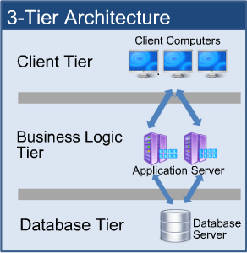

**Question.24 BA approach strategy for framing questions**

In these given strategies :5W 1H – SMART – RACI – 3 Tier Architecture – Use Cases, Use case Specs, Activity Diagrams, Models, Page designs.

I would like to use,

1.5W 1H- (why, what, when, which, who, how)- 5W,1H method, it helps me to come to a conclusion the main objective and goal of the project, and what are the important things to be taken into consideration, and make research about analyze what and which question are to be asked and to whom should I ask the relevant information.

2.RACI- And by using RACI which helps me to identify stakeholders, list them out, and gain knowledge which stakeholder is responsible for particular information, and it becomes easy and hassle free for me to consult the relevant stakeholders respectively.

3. Use Case Diagrams- choosing Use case diagrams helps me to get the clear idea of what the end user needs and how the flow should takes place, and when I show it to the design team and project manager and client (if possible) the visual experience gives more picturesque idea, and can proceed with any changes or updating if required.

**Question.25 Elicitation techniques**

Elicitation Techniques helps in fetching required information from respective stakeholders in various ways,

* **Brain storming** sessions help in generating new ideas and solutions. These sessions can be used at any stage of the project life cycle, but they tend to work best when the project is just getting started. They are especially useful if you have a lot of ideas that need to be prioritized or if you want to brainstorm solutions before you start writing code.
* **Document analysis**- analyzing existing documents to understand the business processes and requirements.
* **Reverse Engineering**- The processes of extracting knowledge or design information from anything man-made and re-producing it or re-producing anything based on the extracted information. Basically, analyzing backward from the solution to understand the data, processes, and business rules.
* **Focus groups**- means to get ideas and attitude about the particular product, or opportunity in an interactive group environment. The participants share their preferences, needs, and impressions.
* **Observations**-Observing stakeholders in their work environment to understand their needs as well as their processes which helps in getting to know more about the existing processes, inputs and outputs.
* **Workshop**- A structured approach to fetch requirements. It is like a group discussion to elicit ideas or requirements.
* **JAD (Joint Application Development)** – A methodology that involves continuous interactions with the users and different designers of the system in development. An application developed in the JAD has minimal errors and has higher customer satisfaction because of the customer involvement in the development process.
* **Interview**- A approach with the stakeholders one- on- one to understand the requirements, perspectives and their needs.
* **Prototyping-** an Approach in which the solution is visualized so as to make it easy for the stakeholders which helps in understanding the requirements or needs better.
* **Questionnaire**-A group discussion techniques which helps to generate various ideas and solutions. This process can be useful for obtaining limited system requirements details from the stakeholders.

**Question.26 –This Project Elicitation techniques**

1. Brainstorming- we as team of individuals can give our own ideas and leads to be taken in to consideration given each individual have idea about the requirement and gather different perspective of how to approach a problem and get an effective solution to it in further discussions.

2. Focus groups-With having the focused group such as homogeneous(individuals with similar characteristics i.e. one group might be farmer only and another might be manufacturers alone) can help the need or effective solution or outcome to their problems being faced and can get a view on how they want it to be treated and another being heterogeneous (individuals being stakeholders i.e. peter, Kevin, Ben in this case and manufacturers and other stakeholders in the orders can give their insights or get an idea after listening to all the stakeholders view on how to approach a solution to problem.

3. JAD(Joint Application Development)- In this technique, we need to include all the subject matter experts, end users and all the business and project stakeholders given all get equal treatment during the process and draft the document with the information captured through refined analysis and open questions or issues to be looked into and get an positive outcome to deliver a product with high quality.

**Question.27 – 10 Business Requirements**

|  |  |  |  |
| --- | --- | --- | --- |
| S.NO | BR-CODE | REQUIREMENT | DESCRIPTION |
| 1 | BR0001 | Registration | New customers should sign up/register before login to buy anything |
| 2 | BR0002 | Login | Registered customers should login to buy |
| 3 | BR0003 | Search | Customers should be able to search the products in categorywise |
| 4 | BR0004 | Browse | Customer should be able to view the whole available catalogue |
| 5 | BR0005 | Upload and display | Manufacturer must Upload/display products. |
| 6 | BR0006 | Add to cart/buy now | Customers should be able to add products to cart or can buy a product if the customer wants only a specific product by clicking buy now. |
| 7 | BR0007 | Payment | Customer can proceed via payment gateways |
| 8 | BR0007 | Track delivery | Customer should be able to track delivery via email/sms |
| 9 | BR008 | Logout | Option of logout should be available |
| 10 | BR0010 | Reviews | Option of reviewing the products to customers. |

**Question.28- Assumptions**

* Both manufacturers and customers/farmers should have basic knowledge of using the app.
* Manufacturers and famers should have phone/laptop.
* A registered account (like gmail ) is necessary.
* Manufacturers and Farmers should be aware of online transactions like internet banking and UPI and must have bank accounts linked to it.

**Question.29- The Project Requirements Priority**

|  |  |  |  |  |
| --- | --- | --- | --- | --- |
| S.NO | BR-CODE | REQUIREMENT | DESCRIPTION | PRIORITY |
| 1 | BR0001 | Registration | New customers should sign up/register before login to buy anything | 5 |
| 2 | BR0002 | Login | Registered customers should login to buy | 8 |
| 3 | BR0003 | Search | Customers should be able to search the products in categorywise | 7 |
| 4 | BR0004 | Browse | Customer should be able to view the whole available catalogue | 6 |
| 5 | BR0005 | Upload and display | Manufacturer must Upload/display products. | 7 |
| 6 | BR0006 | Add to cart/buy now | Customers should be able to add products to cart or can buy a product if the customer wants only a specific product by clicking buy now. | 8 |
| 7 | BR0007 | Payment | Customer can proceed via payment gateways | 9 |
| 8 | BR0007 | Track delivery | Customer should be able to track delivery via email/sms | 9 |
| 9 | BR008 | Logout | Option of logout should be available | 2 |
| 10 | BR0010 | Reviews | Option of reviewing the products to customers. | 1 |

**Question.30 Use case diagram**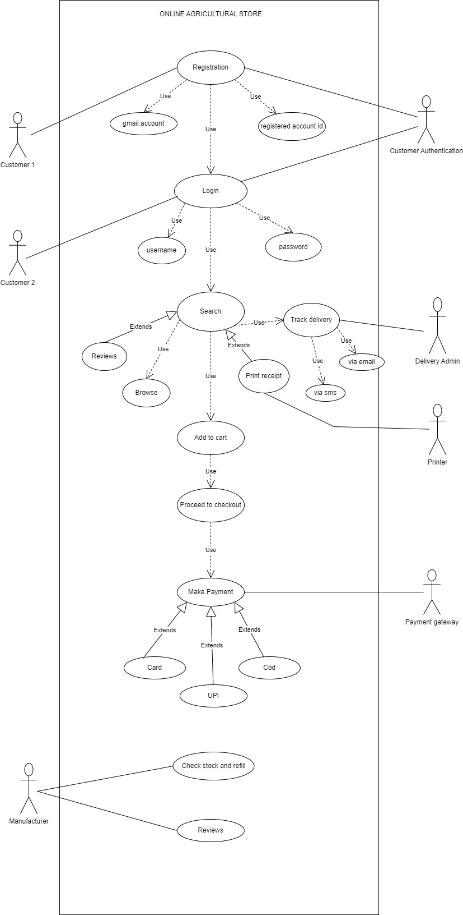

**Question.31 Use case specs**

|  |  |
| --- | --- |
| **USE CASE ID** | US001 |
| **USE CASE NAME** | Registration |
| Created By | MR.ABC, last updated by…,DEC 3th2023 |
| Date Created | Nov 25th 2023, Last Revision ,Date Dec1st 2023 |
| Actor | Customer 1. |
| Description | This use case describes how and customer 1 and need to register before logging in |
| Pre-Condition | The user must have prior Gmail or relevant account to register and get User id and Password. |
| Post-Condition | The user successfully directed to login page after successfully registering. |
| Normal Flow/Basic flow | 1.Customer1 must have to register first to login and proceed, who should have Gmail or relevant account to register.  2.The Customer 1 must fill all the details about his personal information and address to which item has to be delivered and contact number. 3.The system navigates the customer1 to their respective mail and confirms the password and mail. 4.the System navigates the new customer to login page after confirmation. 5.End of Basic Flow. |
| Alternative Flow | 1.To register the customer 1 has to Gmail or any relevant account. 2.If the customer1 doesn’t have relevant mail id, he isn’t allowed to register as it is mandatory to have those details to register, then he has to register for Gmail or relevant id with respective information.  3.Then the customer 1 during the registration process is then asked to answer the security question asked during registration. 4. or the system navigates them to the mail id /contact number with otp. 5. And confirms the persons user id and asks to fulfill mandatory password guidelines.  6.Then the system navigates the customer1 to login page. |
| Assumptions | 1.The users are mandatory to have Gmail or relevant id to register. 2.customer1 must have knowledge with computer. |

|  |  |
| --- | --- |
| **USE CASE ID** | US002 |
| **USE CASE NAME** | Search |
| Created By | MR.ABC, last updated by…,DEC 3th2023 |
| Date Created | Nov 25th 2023, Last Revision ,Date Dec1st 2023 |
| Actor | USER/CUSTOMER |
| Description | This use case describes how customer can search the required product in the search bar |
| Pre-Condition | NA |
| Post-Condition | The system navigates them to the searched item catalog |
| Normal Flow/Basic flow | 1.The basic flow starts when the customer is directed to home page from login. 2.The user then can search through the search button given at the top. 3.or the user can search the required items in the given highlighted category sections. 4. The system then directs the customer to the required catalog of the product. |
| Alternative Flow | NA |
| Assumptions | NA |

|  |  |
| --- | --- |
| **USE CASE ID** | US003 |
| **USE CASE NAME** | Add to cart/Buy Now |
| Created By | MR.ABC, last updated by…,DEC 3th2023 |
| Date Created | Nov 25th 2023, Last Revision ,Date Dec1st 2023 |
| Actor | User/Customer |
| Description | This use case describes how a customer can add the product in the cart or buy directly |
| Pre-Condition | Na |
| Post-Condition | the system navigates them to buy the item. |
| Normal Flow/Basic flow | 1.The user/customer after searching the item and directed to the catalog of different brands and different types of the same product having bunch of items displayed to them. 2.As the system navigates them to the catalog after searching, then the user can be able to see catalog. 3.The customer can select a desired brand product or type of product. 4.Then the system navigates to the particular selected product and its detailed information is displayed. 5.The page displays the quantity to choose from or to directly buy the product from option BUY NOW or add the item to cart from ADD TO CART option so that he can add another item or if he wanted to search another item and decide later on at the cart page. |
| Alternative Flow | NA |
| Assumptions | NA |

|  |  |
| --- | --- |
| **USE CASE ID** | US004 |
| **USE CASE NAME** | Payment |
| Created By | MR.ABC, last updated by…,DEC 3th2023 |
| Date Created | Nov 25th 2023, Last Revision ,Date Dec1st 2023 |
| Actor | Customer-primary actor payment gateway-secondary actor |
| Description | This use case describes how a customer is directed to payment process. |
| Pre-Condition | Customer need to have online payment to proceed with payment |
| Post-Condition | NA |
| Normal Flow/Basic flow | 1.The customer is navigated to checkout page when the customers confirm on adding the product to cart or buy now option. 2.Then the system navigates the customer to payment process page. 3.The customer must select the payment options either by card(debit/credit) or UPI payment. 4. then after selecting the required payment gateway either they are directed to enter card details or to give Upi inputs. 5. and navigates the system to respective payment gateway process. 6. During the payment process, the system navigated to bank server or mobile UPI payment application. 7.After the payment done, the system navigates the customer to print the required payment receipt .8. end of the basic flow of payment use case. |
| Alternative Flow | 1.when the customer is navigated to payment process page, if the customer gives invalid password or card details or if time delay is achieved while payment or any disconnectivity in the internet acquires or any server down issues cause failure of payment and redirects to the payment process page again to enter details. |
| Assumptions | The customer need to have online payment service to pay via card(credit/debit) or via UPI Payment. |

|  |  |
| --- | --- |
| **USE CASE ID** | US005 |
| **USE CASE NAME** | Track delivery |
| Created By | MR.ABC, last updated by…,DEC 3th2023 |
| Date Created | Nov 25th 2023, Last Revision ,Date Dec1st 2023 |
| Actor | Customer-Primary actor Delivery Admin- secondary actor |
| Description | This use case describes how a customer is delivery status page. |
| Pre-Condition | Order should be confirmed and payment should be done to go to tracking the delivery page. |
| Post-Condition | Customer can check the status of delivery i.e. when the product is going to be delivered, and track the location of the product where it has reached etc. |
| Normal Flow/Basic flow | 1.After the confirmation of the payment from the admin, the system directs them to track the delivery page .2.and asks the customers t check the details of address and contact number. 3. And the system gives option to change any details in the delivery location or contact info or any other information. 4. then the system confirms the location and gives the delivery date. 5. the delivery page shows details the navigation from the store to the delivery agent location to the in transit details giving where the product is there and updates its location and time. 6. customer can check all the info whenever they want to get info or status of the product. |
| Alternative Flow | NA |
| Assumptions | NA |

3**2. Activity diagrams**

***Login page:***

|  |
| --- |
| ***LOGIN PAGE AD.drawio.png*** |

Customer page:

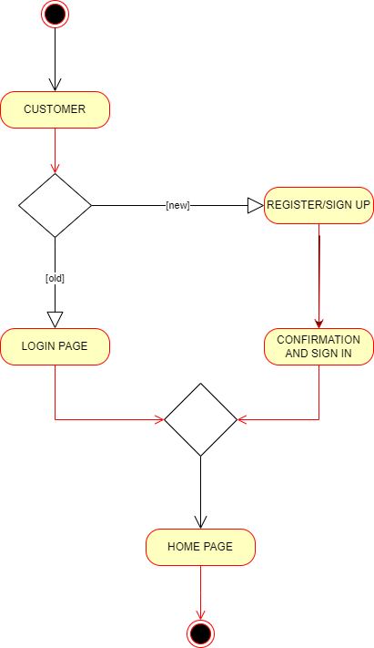

Search page: 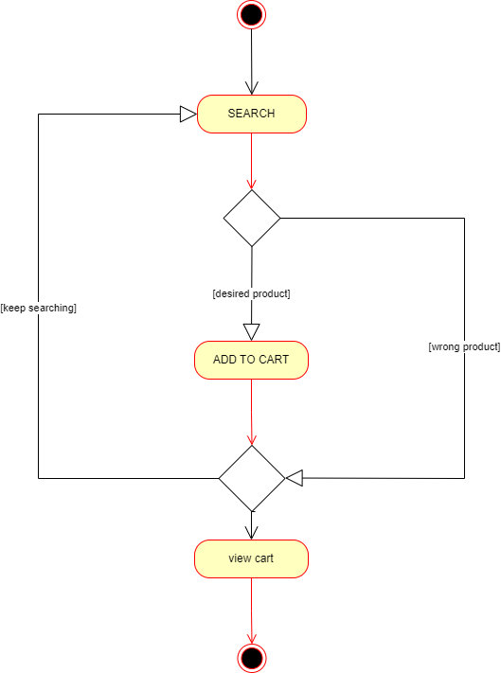

***Payment page:*** 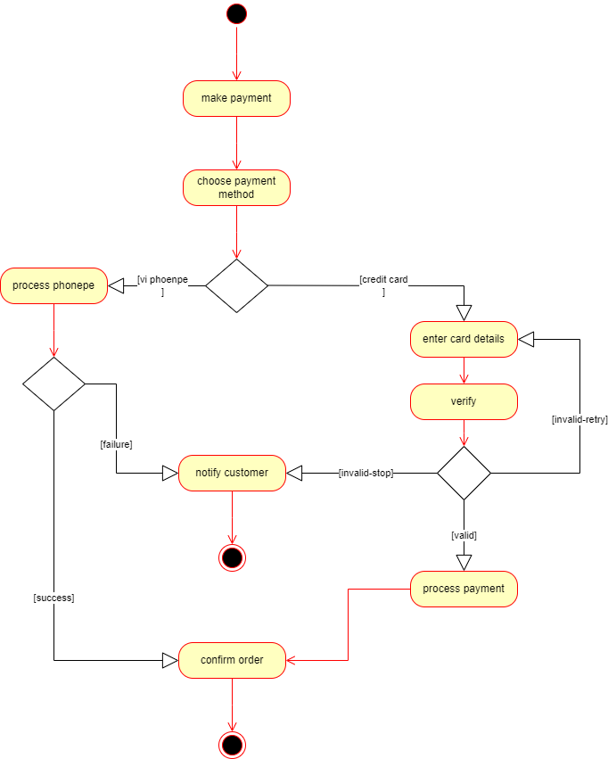

**Track delivery page:**

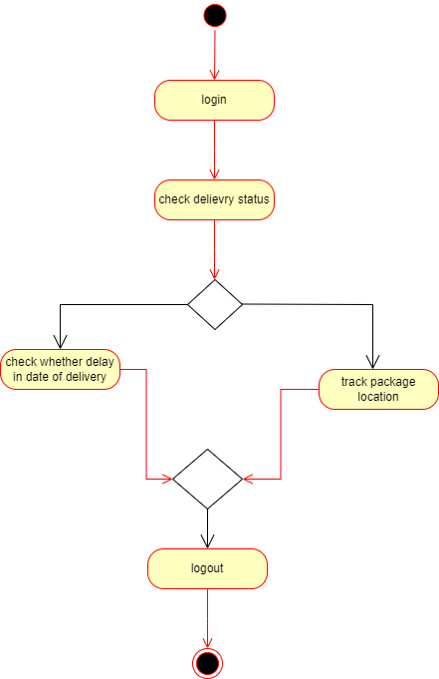

**33. Functional requirements**

|  |  |  |  |
| --- | --- | --- | --- |
| **S.NO** | **FR-CODE** | **REQUIREMENT** | **DESCRIPTION** |
| 1 | FR-0001 | Login/Registration | New customers has to register first and then login to buy any product. Old customer should be directly allowed to login with id and password. |
| 2 | FR-0002 | Search | Customers should be allowed to search the product they wish to buy. |
| 3 | FR-0003 | Browse | Customers should be allowed to browse products in the category they choose. |
| 4 | FR-0004 | Add to cart | allow customers to add the product to cart if they want to choose any other category item and add if they want |
| 5 | FR-0005 | Buy now | Allow customers if they want to buy directly and direct them to payment page |
| 6 | FR-0006 | Order management | Allow customers to delete the item at the checkout portal or allow them to add more number of pieces, if they want. |
| 7 | FR-0007 | Payment through Card | Customers should be allowed to buy through different types of cards(debit/credit) services. |
| 8 | FR-0008 | Payment through UPI | customers should be allowed to buy through UPI payments if they have online banking services |
| 9 | FR-0009 | Reviews | Allow customers to leave reviews after receiving the product. |
| 10 | FR-0010 | Wish list | Allow customers to add their choice of variety of categorized items to wish list to buy them later. |
| 11 | FR-0011 | Recommendations | While looking for the product, customers might be allowed to view some products related to the searched item, they will take a look if they want to . |
| 12 | FR-0012 | Track status/Delivery | Allow customers to track their order from the very point they ordered any item. |
| 13 | FR-0013 | Print Acknowledgment | Allow customers to get their acknowledgement to print the payment or order details for reference. |
| 14 | FR-0014 | Cancel the order | customers can be allowed to cancel the order if they want, but within some time span after ordering |
| 15 | FR-0015 | Return/Refund | Customers should be allowed to return the product if they are not satisfied with the product or service, and allow a refund. |
| 16 | FR-0016 | Exchange | Allow customers to exchange the product if they mistakenly ordered one item in the place of other |
| 17 | FR-0017 | Refilling stock | allow manufacturers to check upon stock to refill them or to remove them depending on the demand of the product |
| 18 | FR-0018 | Checking the reviews | manufacturers should be allowed to check reviews and reflect upon product insights |
| 19 | FR-0019 | Coupons/Discount | Allow customers to add coupons or discount if they want to avail those and given by manufacturers on their first purchase. |
| 20 | FR-0020 | Track Delivery | Allow manufacturers to check the safe and timely delivery of the item to fulfill customer satisfaction |

**34. Minimum 5 page design  
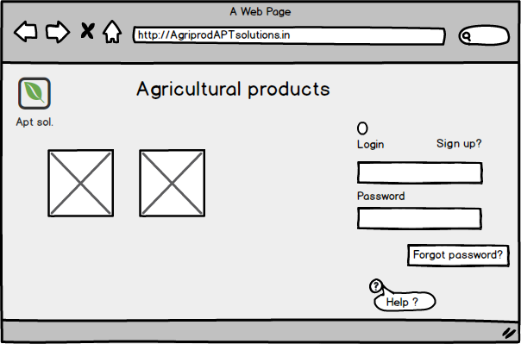  
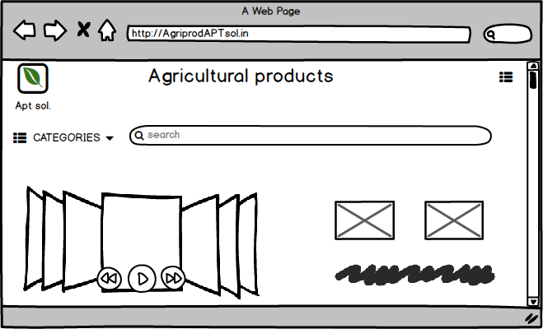  
  
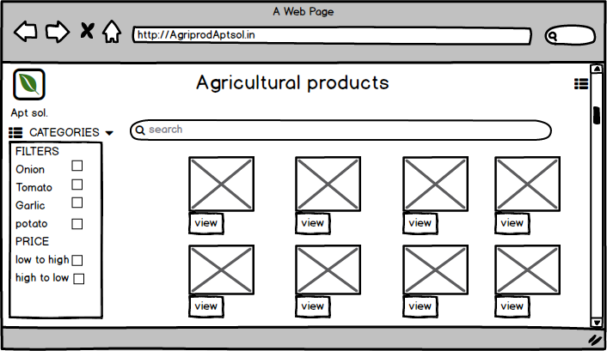  
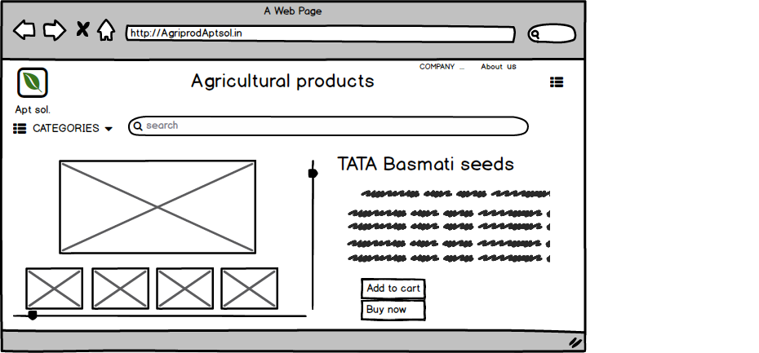  
  
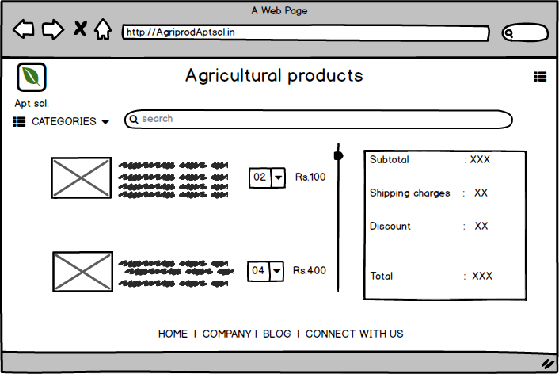  
  
Question.35 Question 35 – Tools (Visio, Balsamiq)**

I used Draw.io and Balsamiq

* Draw.io is an online diagramming tool that allows you to create flowcharts, diagrams, mind maps, organization charts, and much more. A web-based application. It is fully integrated with Google Drive. This means that you can automatically save the results of your work in your Google Workspace or Gmail account.
* Balsamiq Wireframe a user interface design tool for creating wireframes (sometimes called mockups or low-fidelity prototypes)

**Question.36 RTM**



**Question.37- 10 Test case Documents**

|  |  |  |  |  |  |
| --- | --- | --- | --- | --- | --- |
|  |  |  |  |  |  |
| **First Test Case** | | | | | |
| **Test case ID** | 1234 | **Test case name** | Search seeds | | |
| **Project ID** | 1111 | **Project name** | AGRI STORE | | |
| **PM ID** | 2222 | **PM Name** | Vandanam | | |
| **Test Strategy ID** | 3333 | **Tester ID** | 4444 | | |
| **Test plan ID** | 3421 | **Tester Name** | Alekya | | |
| **Test Schedule ID** | 159 | **Date of Test** | 11-12-2023 | | |
| **Scenario** | Search for the seeds | | | | |
| **Link to that page** |  | | | | |
| **Input Data** | Set 1 Brinjal seeds Hybrid or organic 50gms Brand name :Tata | Set 2 corriander seeds Hybrid or natural 100gms brand name :good life | Set 3 Beans plant vairation or creeper 150gms brand name: reliance | Set 4 Apple hybrid or natural 100gms brand name :kashmir apple | Set 5 Roses colors red or pink or yellow hybrid or natuarl brand name: Southroses |
| **Expected behavior** | Show 16 varieties in 4 columns and 4 rows | | | | |
| **Actual behavior** | Due to advertisement slots, it is showing 15 varieties in 5 columns and 3 rows | | | | |
| **Comments** | Can proceed further | | | | |
| **Result(Pass/Fail)** | pass | | | | |
|  |  |  |  |  |  |
|  |  |  |  |  |  |
| **Second Test Case** | | | | | |
| **Test case ID** | 2345 | **Test case name** | Search fertilizers | | |
| **Project ID** | 1111 | **Project name** | AGRI STORE | | |
| **PM ID** | 2222 | **PM Name** | Vandanam | | |
| **Test Strategy ID** | 1010 | **Tester ID** | 5555 | | |
| **Test plan ID** | 5432 | **Tester Name** | Alekya | | |
| **Test Schedule ID** | 160 | **Date of Test** | 11-12-2023 | | |
| **Scenario** | Search for fertilizers | | | | |
| **Link to that page** |  | | | | |
| **Input Data** | Set 1 Nitrate fertilizers liquid or granular quantity Brand name :yalabella | Set 2 Urea fertilizers liquid or granular quantity Brand name :bellayala | Set 2 Micronutrient fertilizers liquid or granular quantity Brand name :yararega | Set 2 calcium nitrate fertilizers liquid or granular quantity Brand name :yeravita | Set 2 Compound fertilizers liquid or granular quantity Brand name :yarasuna |
| **Expected behavior** | Show 16 varieties in 4 columns and 4 rows | | | | |
| **Actual behavior** | Due to advertisement slots, it is showing 15 varieties in 5 columns and 3 rows | | | | |
| **Comments** | Can proceed further | | | | |
| **Result(Pass/Fail)** | pass | | | | |
|  |  |  |  |  |  |
|  |  |  |  |  |  |
| **Third Test Case** | | | | | |
| **Test case ID** | 3456 | **Test case name** | Search pesticides | | |
| **Project ID** | 1111 | **Project name** | AGRI STORE | | |
| **PM ID** | 2222 | **PM Name** | Vandanam | | |
| **Test Strategy ID** | 7893 | **Tester ID** | 6666 | | |
| **Test plan ID** | 6543 | **Tester Name** | Alekya | | |
| **Test Schedule ID** | 161 | **Date of Test** | 11-12-2023 | | |
| **Scenario** | Search for the pesticides | | | | |
| **Link to that page** |  | | | | |
| **Input Data** | Set 1 Neem pesticide liquid 200ml Brand name Bazera | Set 2 Insecticide liquid 100ml Brand name pegasus | Set 3 Organic fungicide liquid 20ml Brand name: ugao | Set 4 Insecticide for Aphids liquid 250ml Brand name :Go garden | Set 5 Fipronil liquid 50ml Brand name :Bayer Jump |
| **Expected behavior** | Show 16 varieties in 4 columns and 4 rows | | | | |
| **Actual behavior** | Due to advertisement slots, it is showing 15 varieties in 5 columns and 3 rows | | | | |
| **Comments** | Can proceed further | | | | |
| **Result(Pass/Fail)** | pass | | | | |
|  |  |  |  |  |  |
|  |  |  |  |  |  |
| **Fourth Test Case** | | | | | |
| **Test case ID** | 4567 | **Test case name** | Search seeds | | |
| **Project ID** | 1111 | **Project name** | AGRI STORE | | |
| **PM ID** | 2222 | **PM Name** | Vandanam | | |
| **Test Strategy ID** | 4567 | **Tester ID** | 7777 | | |
| **Test plan ID** | 7654 | **Tester Name** | Alekya | | |
| **Test Schedule ID** | 162 | **Date of Test** | 11-12-2023 | | |
| **Scenario** | Filter Results | | | | |
| **Link to that page** |  | | | | |
| **Input Data** | show whether customer wants high rating products or low rating products | Ask whether customer wants Fast delivery or standard delivery | Ask whether pricing the item from high to low or low to high | show whether customer prefers which brand | ask customer for high popularity or low popular or high discounter products |
| **Expected behavior** | Should prioritize the given details and show and have it in a column in the right corner of the page. | | | | |
| **Actual behavior** | Same as expected. | | | | |
| **Comments** | No comments | | | | |
| **Result(Pass/Fail)** | pass | | | | |
|  |  |  |  |  |  |
|  |  |  |  |  |  |
|  |  |  |  |  |  |
| **Fifth Test Case** | | | | | |
| **Test case ID** | 5678 | **Test case name** | Product details testing | | |
| **Project ID** | 1111 | **Project name** | AGRI STORE | | |
| **PM ID** | 2222 | **PM Name** | Vandanam | | |
| **Test Strategy ID** | 2316 | **Tester ID** | 8888 | | |
| **Test plan ID** | 8765 | **Tester Name** | Alekya | | |
| **Test Schedule ID** | 163 | **Date of Test** | 11-12-2023 | | |
| **Scenario** | is it showing product details properly | | | | |
| **Link to that page** |  | | | | |
| **Input Data** | should show description of the product | should show different quantities to select | should show color/variation in flowers | is it showing 5 images of the product | is the page includes relevant recommendations? |
| **Expected behavior** | Should highlight the qualities of the product and include relavant recommendations at the buttom of the page. | | | | |
| **Actual behavior** | Same as expected | | | | |
| **Comments** | No comments | | | | |
| **Result(Pass/Fail)** | pass | | | | |
|  |  |  |  |  |  |
|  |  |  |  |  |  |
|  |  |  |  |  |  |
| **Sixth Test Case** | | | | | |
| **Test case ID** | 6789 | **Test case name** | Payment process | | |
| **Project ID** | 1111 | **Project name** | AGRI STORE | | |
| **PM ID** | 2222 | **PM Name** | Vandanam | | |
| **Test Strategy ID** | 3546 | **Tester ID** | 9999 | | |
| **Test plan ID** | 9876 | **Tester Name** | Alekya | | |
| **Test Schedule ID** | 164 | **Date of Test** | 11-12-2023 | | |
| **Scenario** | payment process | | | | |
| **Link to that page** |  | | | | |
| **Input Data** | whether the user uses credit/debit card | if user want to go with UPI payment, then should be allowed to fill details | give disclaimer to customer about the redirecting of the page to payment page | have disclaimer to check internet connectivity | email confirmation after confirming the order |
| **Expected behavior** | Payment process timer has take 10sec from one page to another, and a disclaimer should popup while redirecting to the bank server to not to go back or press any button. | | | | |
| **Actual behavior** | Processing form one page to another is taking 15secs,which is fine,but if possible we need to make it 10sec. | | | | |
| **Comments** | Taking 15sec fine, but if possible we need to make it 10sec. | | | | |
| **Result(Pass/Fail)** | pass | | | | |
|  |  |  |  |  |  |
|  |  |  |  |  |  |
|  |  |  |  |  |  |
| **Seventh Test Case** | | | | | |
| **Test case ID** | 9632 | **Test case name** | Checkout page testing | | |
| **Project ID** | 1111 | **Project name** | AGRI STORE | | |
| **PM ID** | 2222 | **PM Name** | Vandanam | | |
| **Test Strategy ID** | 1478 | **Tester ID** | 4444 | | |
| **Test plan ID** | 2369 | **Tester Name** | Alekya | | |
| **Test Schedule ID** | 165 | **Date of Test** | 11-12-2023 | | |
| **Scenario** | Checkout page | | | | |
| **Link to that page** |  | | | | |
| **Input Data** | display order summary | give option to edit or any changes in address | select the delivery date, whether standard or fast delivery and their shipping costs | show payment options- card: debit/credit or UPI Payment | order management(increasing or decreasing quantity) |
| **Expected behavior** | Need to give option to add another address for work or home so that customer can select the delivery address without any hustle. | | | | |
| **Actual behavior** | Same as expected | | | | |
| **Comments** | No comments | | | | |
| **Result(Pass/Fail)** |  | | | | |
|  |  |  |  |  |  |
|  |  |  |  |  |  |
|  |  |  |  |  |  |
| **Eighth Test Case** | | | | | |
| **Test case ID** | 2424 | **Test case name** | Valid user name and password | | |
| **Project ID** | 1111 | **Project name** | AGRI STORE | | |
| **PM ID** | 2222 | **PM Name** | Vandanam | | |
| **Test Strategy ID** | 2584 | **Tester ID** | 2222 | | |
| **Test plan ID** | 4242 | **Tester Name** | Alekya | | |
| **Test Schedule ID** | 166 | **Date of Test** | 11-12-2023 | | |
| **Scenario** | Test for valid username and password | | | | |
| **Link to that page** |  | | | | |
| **Input Data** | username should be unique | user name should not be same as mail id | password should be of length -8-12 | password should contain all the different characters-number, special character, small case and big case alphabets | verify the password strength |
| **Expected behavior** | Should show a sign to mandatory fields and give the password and username details as a disclaimer or in a popup manner while entering. | | | | |
| **Actual behavior** | Same as expected | | | | |
| **Comments** | no comments | | | | |
| **Result(Pass/Fail)** | pass | | | | |
|  |  |  |  |  |  |
|  |  |  |  |  |  |
|  |  |  |  |  |  |
| **Ninth Test Case** | | | | | |
| **Test case ID** | 1357 | **Test case name** | Customer validation | | |
| **Project ID** | 1111 | **Project name** | AGRI STORE | | |
| **PM ID** | 2222 | **PM Name** | Vandanam | | |
| **Test Strategy ID** | 9514 | **Tester ID** | 1100 | | |
| **Test plan ID** | 7531 | **Tester Name** | Alekya | | |
| **Test Schedule ID** | 167 | **Date of Test** | 11-12-2023 | | |
| **Scenario** | validate the customer | | | | |
| **Link to that page** |  | | | | |
| **Input Data** | check whether is customer 1/2 | if customer 2 ask to login with their respective username and password | if customer 1ask to sign up an register | if customer 1 ask to fill details about address and contact details | After registration, ask the customer 1 to login with their details and password after confirmation |
| **Expected behavior** | Redirect to the sign up page if customer 1 or direct them to sign in if customer 2 | | | | |
| **Actual behavior** | Same as expected. | | | | |
| **Comments** | no comments | | | | |
| **Result(Pass/Fail)** | pass | | | | |
|  |  |  |  |  |  |
|  |  |  |  |  |  |
|  |  |  |  |  |  |
| **Tenth Test Case** | | | | | |
| **Test case ID** | 8642 | **Test case name** | Checking stock by seller | | |
| **Project ID** | 1111 | **Project name** | AGRI STORE | | |
| **PM ID** | 2222 | **PM Name** | Vandanam | | |
| **Test Strategy ID** | 2626 | **Tester ID** | 3333 | | |
| **Test plan ID** | 2468 | **Tester Name** | Alekya | | |
| **Test Schedule ID** | 168 | **Date of Test** | 11-12-2023 | | |
| **Scenario** | Manufacturer checking stock | | | | |
| **Link to that page** |  | | | | |
| **Input Data** | after login, manufacturer should be able to check the total stock | manufacturer should be able to check reviews of the products given by client | manufacturer should be able to see statistics about which product is going more and which product is not going properly | manufacturer be able to manage profits and losses | Manufacturer should be able to look the status in which product the returns are more. |
| **Expected behavior** | Should be able to view the stock details with their reviews and number of positive and negative ratings. | | | | |
| **Actual behavior** | Showing positive details but not negative reviews | | | | |
| **Comments** | If possible also show statistics with the profits and delivery system is effective. | | | | |
| **Result(Pass/Fail)** | Fail | | | | |

**Question 38 – DB Design**

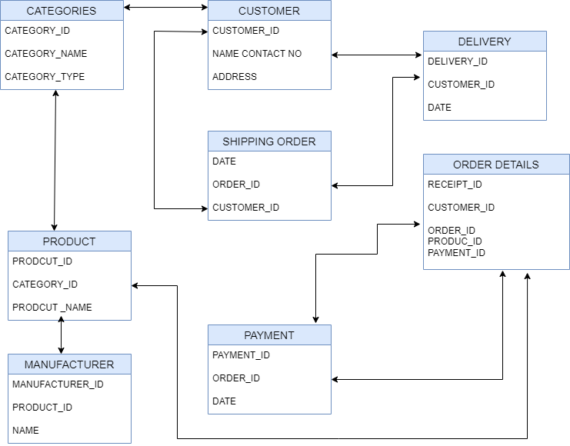

**Question 39 – Data Flow Diagram**

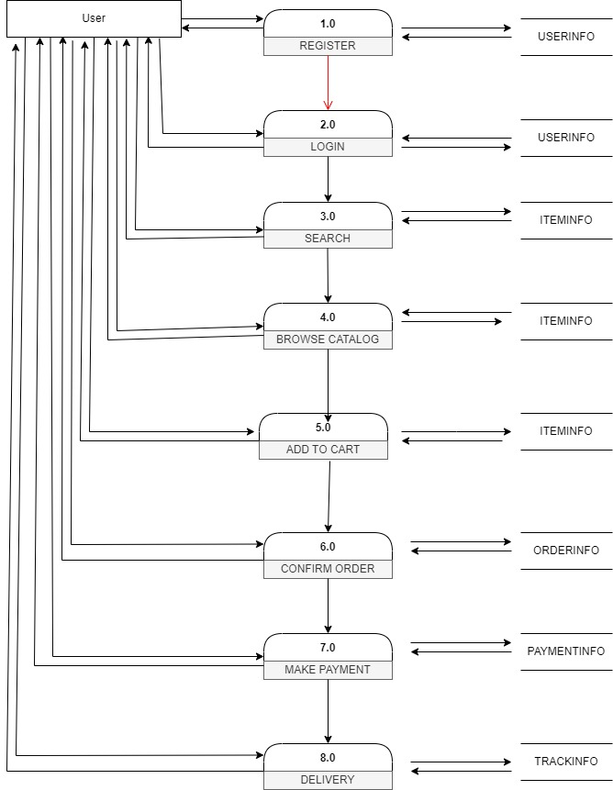

**Question 40 – Change Request**

As a BA,I first have to do 3 Analysis to proceed with the Change Request, namely,

1. Feasibility study- to accept the change

2. Impact analysis-to measure change to a project

3. Effort estimation-to implement the change in a project.

And then, Document the change request and analysis it and get approved by the Project or Change manager to get initiation in the project for change or not.

As the Change request affects the project scope we as a BA also need to consider any major changes or minor changes are being requested and act accordingly which effects the duration, cost, and resources.

As in the given question it is said the that there is a change in Tax Structure due to the change in Govt change in tax structure.

So, it’s nothing but a Enhancement to the product not the change request, as it doesn’t add any new feature in to the project, just a structure at the billing has to be changed.

**Question 41 – Change Request Vs an Enhancement**

**Q:As the project is in process, Ben and Kevin have contacted you. The reason is to inform you that they want the Farmers to sell their crop yields through this application i.e. Farmers should be able to add their crop yields or products and display to general public and should be able to sell them. They also want to introduce Auction system for their Crop yields. As a BA, what will be your response? Is this a change request or an enhancement???**

As a BA,I don’t refer it to be only an enhancement, rather I feel it is a proper change request. Though client might be mistaken it as a small feature to be added in the present completed project, but in the previous requirement only Manufacturers are the sellers where farmers are only to buy the required products.

Now we have to give access to the farmers as a seller and avail the app to the public as well to buy the products and work on auction system for crop yields.

So it increases the project scope more in terms of cost and duration to complete the project and finalize it and the app must hold the inflow and out flow of the users, resources to be used are also affected (database, team..etc).

**Question 42 – Estimations**

Man hours effect the estimation of project cost, since those are the main resources to be regarded for the completion of a project.

There are 3 types of projects, namely,

1. Small Projects: up to 500 Man-Hours

2. Medium Projects: 500-1000 Man-Hours

3. Large Projects: Above 1000 Man-Hours.

In this given project, provided 12-14 trained resources and new infrastructure is also not need with 18months as the whole duration to complete the project.

I as a BA consider it to be a MEDIUM PROJECT.

**Question 43 – UAT (USER ACCEPTANCE TESTING)**

UAT also called as beta testing or end-user testing, is a phase of software development in which the software is tested in the "real world" by the intended audience or business representative.

As Business Analyst to the project, I need to take care of some more steps to get a sign off from Stakeholders during this UAT process.

1. PLANNING- Blue prints are made to implement UAT Testing considering all the minor details of the features which covers the minimum standards for accepting the test

2. DESIGNING AND UAT TESTERS-We design different types of Test cases to go through and assign them to a team of tester and end users for UAT testing who take care of the minute details in the software and meet the criteria for implementation. The end users must consist of subject matter expert and who can understand the issue and report the problem.

3. FIXING BUGS (if any)- The reported problem is then given to the developers to fix the bugs by working in them and making those software error free.

5. SIGN OFF-After removing all the BUGS and after the tester confirming to the completion and fixing the bugs. Then all the stakeholders come to a conclusion that the software is ready is good to GO LIVE and Sign it off.

**Question 44 – Project Closure Document**

|  |  |  |  |
| --- | --- | --- | --- |
| ***S.NO*** | ***POINTS TO INCLUDE*** | ***DETAILS*** | ***REFERENCE LINK*** |
| 1 | **Did the client signed off on the UAT testing** |  |  |
|  | Date of the signoff: | 12-Dec-23 |  |
|  | Name of the client: | Kevin |
| **2** | **Objectives of the project** |  |  |
|  | Connecting manufacturers with farmers | Achieved |  |
|  | To make online agriculture product store(app) | Achieved |
|  | User-friendly application | Achieved |
|  | with 3 categories(seeds, pesticides, fertilizers) | Achieved |
| **3** | **Functionalities worked on** |  |  |
|  | Secure delivery of the product | Achieved |  |
|  | easy to use payment gateway | Achieved |
| **4** | **Infrastructure** |  |  |
|  | Trained resources available | Achieved |  |
|  | laptops and office resources also available | Achieved |
| **5** | **Funding** |  |  |
|  | Amount approved | **2cr** |  |
|  | Amount used | 1.95cr |
| **6** | **Overall project information** |  |  |
|  | Customer satisfaction | Achieved |  |
| **7** | **Value to the company** |  |  |
|  |  | Positive:95% -Company has strong trained customer helping the final product quality to be high. -customer satisfaction is high. -User-friendly application |  |
|
|
|
|
|
|