**Business Requirements Document (BRD)**

## **For Inventory and Delivery Management System**

**Client**: [Ice-Cream & Dairy Company Name]

**Prepared by**: [XXXXXX]

**Date**: [2/5/2025]

## **Project Overview**

The purpose of this project is to design and implement an **Inventory and Delivery Management System** for [Client Name], which operates manufacturing plants and warehouses across the country. The software aims to streamline inventory management and ensure the quickest delivery of ice-cream and milk products to customers.

## **Business Objectives**

|  |  |  |  |  |  |  |  |  |  |  |
| --- | --- | --- | --- | --- | --- | --- | --- | --- | --- | --- |
| | **Objective** | **Description** | | --- | --- | | Manage Inventory | Maintain real-time visibility of raw materials, finished goods, and warehouse stock levels | | Ensure Quick Delivery | Optimize order fulfilment by dynamically assigning deliveries from the nearest warehouse | | Reduce Wastage | Track expiry-sensitive products (perishables) to minimize spoilage | | Improve Customer Experience | Enable faster deliveries with order tracking and notifications | |

## **In Scope**

* Manufacturing plant and warehouse inventory tracking
* Customer order management
* Delivery and route optimization
* Reporting and analytics
* User role management (Admin, Warehouse Manager, Delivery Agent)

### **Out of Scope**

* Invoicing and payments
* Third-party vendor management
* International logistics

## Functional Requirements

|  |  |  |  |  |  |  |  |  |  |  |  |  |
| --- | --- | --- | --- | --- | --- | --- | --- | --- | --- | --- | --- | --- |
| | **Module** | **Requirement** | | --- | --- | | Inventory Management | Track incoming materials, finished goods, expiry, warehouse transfers | | Order Management | Customer orders, order status tracking, warehouse allocation | | Logistics & Delivery | Route optimization, assign nearest warehouse, delivery status updates | | Reporting & Analytics | Inventory reports, order fulfilment reports, delivery KPIs | | User Management | Role-based access control for Admin, Managers, Delivery Agents | |

## **Non-Functional Requirements**

|  |  |  |  |  |  |  |  |  |  |  |  |  |
| --- | --- | --- | --- | --- | --- | --- | --- | --- | --- | --- | --- | --- |
| | **Requirement** | **Details** | | --- | --- | | Scalability | Support up to 50 warehouses and 100,000 SKUs | | Availability | 99.9% uptime | | Security | Role-based access, data encryption | | Performance | Response time < 3 seconds for key operations | | Mobile Access | Responsive UI + mobile app for delivery agents | |

## **Assumptions & Constraints**

* Client will provide data on current inventory and warehouse locations
* Delivery agents will use Android smartphones
* Integration with Google Maps API for route optimization

## **Project Development Plan**

|  |  |  |  |  |  |  |  |  |  |  |  |  |  |  |  |  |  |  |  |  |  |  |  |  |
| --- | --- | --- | --- | --- | --- | --- | --- | --- | --- | --- | --- | --- | --- | --- | --- | --- | --- | --- | --- | --- | --- | --- | --- | --- |
| | **Phase** | **Duration** | **Deliverables** | | --- | --- | --- | | Requirement Gathering & Analysis | 3 weeks | Final BRD, Use Case Diagrams | | System Design (UI/Architecture) | 4 weeks | Wireframes, ER Diagram, System Design | | Development – Phase 1 (Inventory, Order Modules) | 6 weeks | Inventory Management, Order Management modules | | Development – Phase 2 (Logistics, Reporting, User Management) | 6 weeks | Delivery & Reporting modules | | Testing (UAT + QA) | 4 weeks | Test cases, UAT sign-off | | Deployment & Training | 2 weeks | Live system, Training materials | | Support & Maintenance | 6 months (post go-live) | Bug fixes, enhancements | |

Total Estimated ; 6 Months

## **Resource Plan**

|  |  |  |  |  |  |  |  |  |  |  |  |  |  |  |  |  |  |  |  |  |  |  |  |  |  |  |  |
| --- | --- | --- | --- | --- | --- | --- | --- | --- | --- | --- | --- | --- | --- | --- | --- | --- | --- | --- | --- | --- | --- | --- | --- | --- | --- | --- | --- |
| | **Role** | **Quantity** | **Responsibility** | | --- | --- | --- | | Business Analyst | 1 | Requirements gathering, documentation | | Project Manager | 1 | Project planning and coordination | | Backend Developer | 2 | API development, database management | | Frontend Developer | 2 | UI development (web + mobile) | | QA Tester | 1 | Test planning, execution | | UI/UX Designer | 1 | Wireframes, prototypes | | DevOps Engineer | 1 | Deployment, server management | | Trainer (optional) | 1 | User training & documentation | |

## **Estimated Budget**

|  |  |  |  |  |  |  |  |  |  |  |  |  |
| --- | --- | --- | --- | --- | --- | --- | --- | --- | --- | --- | --- | --- |
| | **Item** | **Estimated Cost** | | --- | --- | | Software Development | ₹XX,XX,XXX | | Hosting & Cloud | ₹X,XX,XXX/year | | Support & Maintenance | ₹X,XX,XXX/year | | Training | ₹X,XX,XXX | | **Total** | ₹XX,XX,XXX | |

## **Approval**

|  |
| --- |
|  |
| | **Name** | **Role** | **Signature** | **Date** | | --- | --- | --- | --- | | [Client Name] | Client Representative |  |  | | [Your Name] | Project Manager |  |  | |

Process Flow Chart

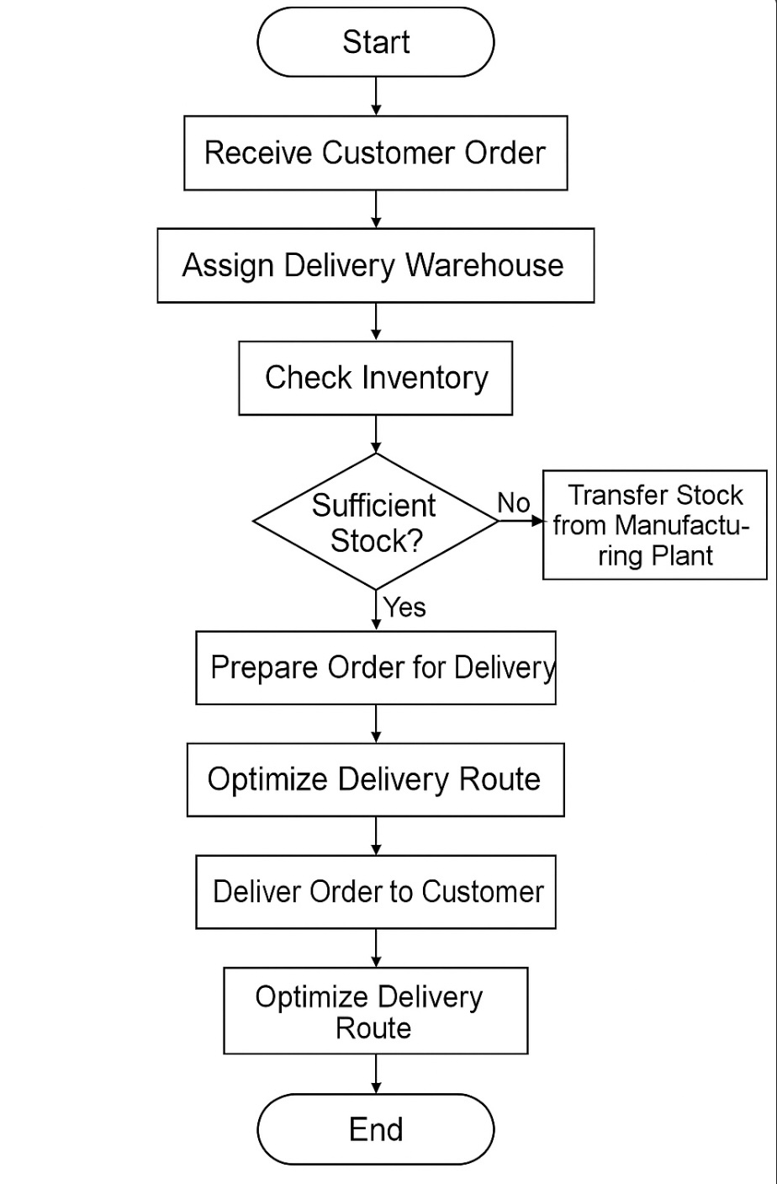

Assignment 2

1, Write an introduction letter to a client introducing yourself as a business analyst in charge of working with the client and his team to start the business understanding process?

**Subject:** Introduction – Your Business Analyst for [Project Name]

Dear [Client’s Name],

I hope this message finds you well.

My name is [Your Full Name], and I am pleased to introduce myself as the **Business Analyst** assigned to collaborate with you and your team on the [Project Name] initiative. I will be your primary point of contact throughout the **business understanding and requirement gathering** phase of this project.

My role will focus on closely engaging with you and key stakeholders to:

* Understand your business goals, current challenges, and future aspirations
* Gather, document, and analyse your functional and technical requirements
* Ensure that the solution we design fully aligns with your operational needs and adds tangible value

Over the next few weeks, I look forward to facilitating discussions, workshops, and walkthroughs that will help us clearly define the scope and objectives of the project. Open communication and collaboration will be key to our mutual success, and I am committed to making this process smooth and productive for you.

Please feel free to reach out to me anytime if you have questions, ideas, or would like to schedule our initial discussions.

Thank you, and I look forward to working with you and your team.

Warm regards,

**[**Ajas Asharaf**]**

Business Analyst

[Your Company Name]

[Your Contact Number]

[Your Email ID]

2, Prepare a brief BRD and SRS for a project- Horoscope or Ticketing system or online store.

# Business Requirements Document (BRD)

## **Project Title:**

## Online Store System

**Prepared by**: [Ajas Asharaf]

**Date**: [Insert Date]

**Client**: [Client Name]

## **Project Overview**

The purpose of this project is to develop an **Online Store** platform that allows customers to browse, purchase, and get delivery of a variety of products online, while providing administrators tools to manage products, orders, and inventory efficiently.

## **Business Objectives**

|  |  |  |  |  |  |  |  |  |  |  |
| --- | --- | --- | --- | --- | --- | --- | --- | --- | --- | --- |
| | **Objective** | **Description** | | --- | --- | | Enable Online Sales | Customers can browse, search, and buy products | | Streamline Order Processing | Allow seamless order placement, payment, and tracking | | Manage Inventory | Real-time inventory updates and stock management | | Improve Customer Experience | Offer a smooth, secure, and responsive shopping experience | |

## **Scope**

### In Scope

* Product catalogue management
* Shopping cart & checkout process
* Order management & tracking
* Customer account management
* Payment gateway integration

### Out of Scope

* Supplier/vendor management
* International shipping

## Key Stakeholders

|  |  |  |  |  |  |  |  |  |  |  |
| --- | --- | --- | --- | --- | --- | --- | --- | --- | --- | --- |
| | **Role** | **Stakeholder** | | --- | --- | | Sponsor | [Client Name] | | Product Owner | [Client Name] Representative | | Development Team | [Your Company Name] | | End Users | Customers (buyers), Admin users | |

## High-Level Requirements

* Customers can **search**, **browse**, and **filter** products
* Customers can **register**, **login**, and **manage accounts**
* Customers can **add products to cart** and **checkout**
* Admin can **add/update/delete products** and **manage inventory**
* Admin can **view/manage orders** and **generate reports**

# Software Requirements Specification (SRS)

## **Project Title**

## **: Online Store System**

**Prepared by**: [Ajas Asharaf]

**Date**: [Insert Date]

## **Introduction**

This document specifies the functional and non-functional requirements for the development of an **Online Store System**.

## Functional Requirements

|  |  |  |  |  |  |  |  |  |  |  |  |  |  |  |
| --- | --- | --- | --- | --- | --- | --- | --- | --- | --- | --- | --- | --- | --- | --- |
| | **Module** | **Requirement** | | --- | --- | | User Registration & Login | - Customers can register and login  - Password recovery | | Product Catalog | - Search, filter, and view product details  - Categories and sub-categories | | Shopping Cart | - Add/remove/update items  - View cart summary | | Checkout & Payments | - Enter shipping details  - Process payment (via gateway) | | Order Management | - View order history and status | | Admin Panel | - Manage products (CRUD)  - Manage orders  - Inventory management  - Generate reports | |

## **Non-Functional Requirements**

|  |  |  |  |  |  |  |  |  |  |  |
| --- | --- | --- | --- | --- | --- | --- | --- | --- | --- | --- |
| | **Requirement** | **Details** | | --- | --- | | Performance | System should respond in <2 seconds | | Security | SSL encryption, secure payment integration | | Usability | Responsive design for mobile & desktop | | Availability | 99.9% uptime | |

## **Assumptions & Constraints**

* Payment gateway account (Stripe, Razorpay, etc.) will be provided by client
* System will support transactions in INR (Indian Rupee)

## **System Interfaces**

|  |  |  |  |  |  |  |
| --- | --- | --- | --- | --- | --- | --- |
| | **Interface** | **Description** | | --- | --- | | Payment Gateway | Integrate for payment processing | | Email/SMS. | Send notifications to customers (order confirmations, etc.) | |

## **User Roles**

|  |  |  |  |  |  |  |
| --- | --- | --- | --- | --- | --- | --- |
| | **Role** | **Permissions** | | --- | --- | | Customer | Browse, buy, manage account | | Admin | Manage products, orders, customers | |

**Q3,** Make an ERD of creating a support ticket/Ticketing life cycle.

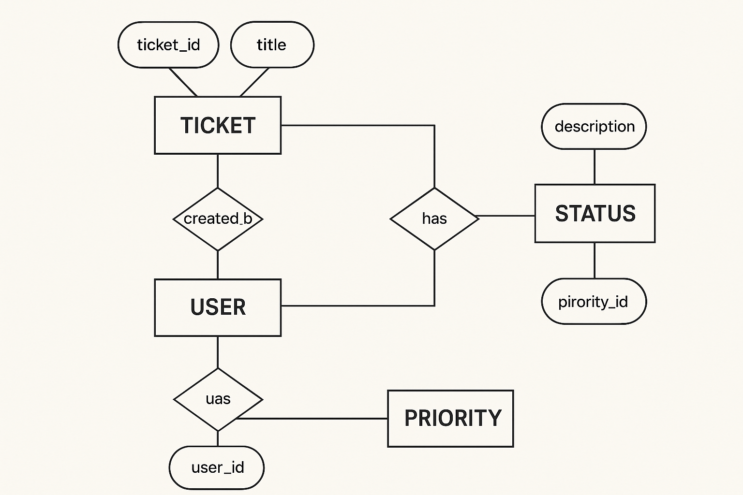

**Q4,** User story of shopping from ecommerce?

|  |  |  |  |  |
| --- | --- | --- | --- | --- |
| User Story | BV | CP | Priority | Acceptance Criteria |
| As a user, I want to register an account so that I can shop online | 500 | 2 | High | User can register using email and password; confirmation email is sent |
| As a user, I want to log into my account so that I can access my profile and orders | 500 | 1 | High | User can log in with correct credentials and view dashboard |
| As a user, I want to reset my password so that I can regain access | 500 | 2 | High | User receives password reset link and can successfully set a new password |
| As a user, I want to browse products by category so that I can easily explore items | 500 | 2 | High | User can navigate through clearly defined product categories |
| As a user, I want to search for products by name so that I can find specific items | 500 | 3 | High | Search returns relevant products within 2 seconds |
| As a user, I want to filter products by price, brand, and rating so that I can narrow results | 100 | 3 | Medium | User can apply multiple filters and see updated product list instantly |
| As a user, I want to view product details so that I can make purchase decisions | 500 | 2 | High | Product page shows name, price, description, images, and availability |
| As a user, I want to add products to my shopping cart so that I can buy multiple items | 500 | 2 | High | Selected product is added to cart and visible in cart summary |
| As a user, I want to checkout and make payment so that I can complete my purchase | 500 | 4 | High | User can enter shipping details, choose payment method, and place order successfully |
| As a user, I want to track my order so that I know when it will be delivered | 500 | 3 | High | Order status updates are visible in user dashboard with estimated delivery date |
| As a user, I want to view product images so that I can see how the item looks | 500 | 2 | High | Product images are clear and zoomable on product page |
| As a user, I want to update quantity in cart so that I can adjust my order | 500 | 2 | High | User can change item quantity in cart and total price updates |
| As a user, I want to remove items from cart so that I can modify my purchase | 500 | 1 | High | User can remove item and cart updates instantly |
| As a user, I want to save items in a wishlist so that I can buy them later | 500 | 3 | Medium | User can save product to wishlist and access it from account |
| As a user, I want to enter and save shipping addresses so that I can checkout quickly | 500 | 3 | High | User can enter multiple addresses and select during checkout |
| As a user, I want to apply discount codes so that I can save money | 500 | 2 | Medium | Valid discount code applies discount to total price |
| As a user, I want to receive order confirmation via email so that I know my order is placed | 500 | 2 | High | Order confirmation email sent immediately after checkout |
| As a user, I want to view past orders so that I can reorder easily | 500 | 2 | Medium | User can view all past orders with details |
| As a user, I want to cancel an order before it ships so that I can change my mind | 500 | 3 | Medium | User can cancel order if status is not 'Shipped' |
| As a user, I want to return a product so that I can get a refund or replacement | 500 | 4 | Medium | User can initiate return within return window |
| As a user, I want to rate a product so that I can share my experience | 100 | 2 | Medium | User can give 1–5 stars rating after purchase |
| As a user, I want to write a product review so that I can help other buyers | 100 | 3 | Medium | User can submit text review after purchase |
| As a user, I want to receive email/SMS notifications on order status so that I stay informed | 500 | 2 | High | User receives updates on status changes |
| As a user, I want to subscribe/unsubscribe to promotional emails so that I can control communication | 100 | 2 | Medium | User can opt-in/out of promotional emails from account settings |
| As a user, I want to contact customer support via chat so that I can get help quickly | 500 | 5 | Medium | User can access live chat support from help section |
| As a user, I want to submit a support ticket so that I can resolve complex issues | 100 | 4 | Medium | User can create and track support tickets |
| As a user, I want to view FAQs so that I can solve common problems myself | 100 | 2 | Medium | User can access categorized FAQs from help center |
| As a user, I want to securely store payment methods so that I can checkout faster | 500 | 3 | Medium | User can save and manage card/payment details |
| As a user, I want to receive invoice copies via email so that I have purchase proof | 500 | 2 | Medium | Invoice PDF is attached in order confirmation email |
| As a user, I want to share product links so that I can recommend to friends | 100 | 2 | Medium | User can share product via social/share link |
| As a user, I want to compare products side by side so that I can choose the best one | 500 | 3 | Medium | User can select products to compare features |
| As a user, I want to view recently viewed items so that I can revisit them easily | 100 | 2 | Medium | User sees list of recently viewed products on homepage |
| As a user, I want to get personalized product recommendations so that I can discover relevant products | 500 | 5 | Medium | User sees recommendations based on browsing/purchase history |
| As a user, I want to participate in flash sales so that I can avail discounts | 500 | 3 | Medium | User can see countdown and join flash sale events |
| As a user, I want to receive alerts for back-in-stock items so that I can buy them | 500 | 3 | Medium | User receives email/SMS when product is restocked |
| As a user, I want to choose gift wrapping so that I can send products as gifts | 100 | 2 | Low | Gift wrap option available during checkout |
| As a user, I want to set delivery instructions so that the delivery is convenient | 100 | 2 | Medium | User can add delivery notes at checkout |
| As a user, I want to access the store via mobile app so that I can shop anywhere | 500 | 5 | High | All core e-commerce features available in mobile app |
| As a user, I want to enable two-factor authentication so that my account is secure | 500 | 3 | Medium | User can enable 2FA with OTP or authenticator app |