Question 1) Write Agile Manifesto.

Answer) Agile Manifesto is a document that outlines the 4 basic values and 12 principles of Agile that guides Agile Software Development.

The four Agile values are:

1. Individuals and interactions over processes and tools
2. Working Software over comprehensive documentation.
3. Customer collaboration over customer negotiation.
4. Responding to change over following a plan.

The twelve Agile principles are:

1. Customer satisfaction through early and continuous delivery of valuable software.
2. Welcome changing requirements, even late in development, to deliver competitive advantage.
3. Deliver working software frequently, from a few weeks to a few months, with a preference for shorter timescales.
4. Collaboration between business stakeholders and developers throughout the project.
5. Build projects around motivated individuals and trust them to get the job done.
6. Prioritize face-to-face communication for conveying information effectively.
7. Working software is the primary measure of progress.
8. Agile processes promote sustainable development for all stakeholders.
9. Maintain a constant focus on technical excellence and good design.
10. Simplicity—the art of maximizing work not done—is essential.
11. Teams should self-organize to produce the best architectures, requirements, and designs.
12. Reflect regularly on how to become more effective and adjust behavior accordingly.

Question 2) Write minimum 40 User stories and their Acceptance Criteria along with their BV and CP

Answer) User Story: A User Story is something where we will have the following information As a User, I want to, so that.

|  |  |  |
| --- | --- | --- |
| User Story No.1 | Tasks: 2 | Priority: HIGHEST |
| AS A DELIVERY BOY |  |  |
| I WANT TO REGISTER IN SCRUM FOODS |  |  |
| SO THAT I CAN DELIVER ORDER |  |  |
| BV: 500 | CP: 02 |  |
| ACCEPTANCE CRITERIA:  Registration Screen  Text Boxes for User Name, Password, ID, Mobile No. Email, Address, Phn no.  Click on Register button  Send Successful notification to the user. | | |

|  |  |  |
| --- | --- | --- |
| User Story No.2 | Tasks: 2 | Priority: HIGHEST |
| AS A CUSTOMER |  |  |
| I WANT TO ADD THE ADDRESS |  |  |
| SO THAT I CAN GET THE ORDER TO MY ADDRESS |  |  |
| BV: 500 | CP: 02 |  |
| ACCEPTANCE CRITERIA:  Text Box to enter the address.  Business Rules: Within the radius of 5 km. |  |  |
|  |  |  |

|  |  |  |
| --- | --- | --- |
| User Story No.3 | Tasks: 2 | Priority: HIGHEST |
| AS A RESTAURANT OWNER |  |  |
| I WANT TO VIEW ORDERS |  |  |
| SO THAT I CAN VIEW THE LIST OF ORDERS. |  |  |
| BV: 500 | CP: 02 |  |
| ACCEPTANCE CRITERIA:  View Orders, Display List of orders in the tabular form. | | |

|  |  |  |
| --- | --- | --- |
| User Story No. 4 | Tasks: 2 | Priority: HIGHEST |
| AS A CUSTOMER |  |  |
| I WANT TO SELECT THE PAYMENT MODE. |  |  |
| SO THAT I CAN MAKE PAYMENT OF MY CHOICE | | |
| BV: 500 | CP: 03 |  |
| ACCEPTANCE CRITERIA:  Display payment modes, radio buttons to select payment modes, payments button.  Business Rule: Can select only one payment mode. | | |

|  |  |  |
| --- | --- | --- |
| User Story No.5 | Tasks: 2 | Priority: HIGHEST |
| AS AN ADMIN |  |  |
| I WANT TO VIEW THE RESTAURANTS |  |  |
| SO THAT I CAN APPROVE THEIR REGISTRATION. | | |
| BV: 500 | CP: 02 |  |
| ACCEPTANCE CRITERIA:  List of restaurants, select restaurants, verify restaurant details, approve button, reject button, notification to the restaurant. | | |

|  |  |  |
| --- | --- | --- |
| User Story No.6 | Tasks: 2 | Priority: LOW |
| AS A CUSTOMER |  |  |
| I WANT TO VIEW THE PRICE |  |  |
| SO THAT I CAN ORDER THE FOOD. | | |
| BV: 50 | CP: 1 |  |
| ACCEPTANCE CRITERIA:  Display the price in the list of menu items. | | |

|  |  |  |
| --- | --- | --- |
| User Story No.7 | Tasks: 2 | Priority: LOW |
| AS A CUSTOMER  I WANT TO VIEW THE CONTACT NUMBER OF DELIVERY BOY  SO THAT I CAN CONTACT THE DELIVERY BOY FOR THE STATUS. | | |
| BV: 50 | CP: 01 |  |
| ACCEPTANCE CRITERIA:  1.Display the delivery boy mobile number.  2. Display the delivery boy name in tracking field.  3. Display the delivery boy picture. | | |

|  |  |  |
| --- | --- | --- |
| User Story No.8 | Tasks: 2 | Priority: MEDIUM |
| AS A RESTAURANT OWNER |  |  |
| I WANT TO PROVIDE THE SLOTS |  |  |
| SO THAT CUSTOMER CAN CHECK OPENING AND CLOSING HOURS. | | |
| BV: 100 | CP: 02 |  |
| ACCEPTANCE CRITERIA:   1. Click on restaurant dashboard. 2. Add from time to time. 3. Click on submit. 4. Display updated successfully. | | |

|  |  |  |
| --- | --- | --- |
| User Story No.9 | Tasks: 2 | Priority: HIGH |
| AS BUSINESS OWNER  I WANT TO VIEW THE RESTAURANT’S REVENUE REPORT  SO THAT I CAN VIEW THE RESTAURANT’S REVENUE. | | |
| BV:200 | CP: 03 |  |
| ACCEPTANCE CRITERIA:  Select Reports  Select Revenue Reports  Select to and from date  Select Region (can select all)  Generate Report  Download Report in Excel | | |

|  |  |  |
| --- | --- | --- |
| User Story No. 10 | Tasks: 3 | Priority: HIGH |
| AS A REG ADMIN  I WANT TO MANAGE THE REGIONAL RESTAURANTS  SO THAT I CAN TRACK THE PERFORMANCE OF REGINAL RESTAURANTS. | | |
| BV: 200 | CP: 03 |  |
| ACCEPTANCE CRITERIA:  CLICK ON PERFORMANCE OF RESTAURANTS.  Select from date to date  Click on generate report which includes restaurant’s name id, revenue  Click on download report should be in excel. | | |

|  |  |  |
| --- | --- | --- |
| User Story No. 11 | Tasks: 2 | Priority: MEDIUM |
| AS AN ADMIN  I WANT TO SEE THE REGIONAL REVENUE REPORTS,  SO THAT I CAN VIEW THE REGIONAL PERFORMANCE. | | |
| BV: 100 | CP: 03 |  |
| ACCEPTANCE CRITERIA:  Select regional dropdown  View performance of each rest of that region in tabular form which includes rest name, revenue generated.  Download in Excel or PDF | | |

|  |  |  |
| --- | --- | --- |
| User Story No. 12 | Tasks: 2 | Priority: HIGH |
| AS A CUSTOMER  I WANT TO CHAT WITH REG ADMIN  SO THAT I CAN REQUEST FOR REFUND. | | |
| BV: 200 | CP: 02 |  |
| ACCEPTANCE CRITERIA:   1. BR-All Mandatory 2. Text box fields 3. Display order ID 4. Text box for description 5. Submit button 6. Generate Issue ID 7. Display Successful | | |

Question 3) What is an epic? Write 2 epics.

Answer) An Epic is a large User story or collection of related User stories that represents a significant feature or functionality.

Ex: **Epic - Restaurant ratings and reviews**

US – As a User, I want to view ratings and reviews for restaurants on Scrum foods, so that I can make informed decisions about where to order the food from.

US – As a User, I want to provide ratings and reviews for restaurants on Scrum foods so that I can share my experiences with other users and contribute to the community.

**Epic – Schedule Orders**

US – As a User I want to schedule food orders in advance on Scrum foods so that I can plan meals ahead of time and avoid last minute hassles.

US – As a User I want to have the flexibility to choose specific delivery time slots for schedule orders on Scrum foods.

Question 4) What is the difference between BV and CP?

Answer) Business Value represents the overall value that a User story or feature brings to the business or organization.

The techniques used for BV are Moscow, & Currency notes technique

BV represents the over all value that a user story or a feature brings to the business or Organization.

It also refers to the benefits that a feature can bring to the Business such as Revenue generation, more visibility, traffic, more savings etc.

Complexity Points or story points represent the importance and urgency of a User story from the perspective of the customer or end user.

The techniques used in CP are Planning Poker.

Question 5) Explain about Sprint.

Answer) A Sprint is a time boxed period during which the development team works to deliver a potentially shippable product increment. It is a fixed length event, period of work in Agile and Scrum Methodologies. Here ideas are turned into values.

All the necessary work to achieve the product goal including Sprint Planning, Daily Scrum, Sprint Review and Sprint retrospective meetings happens within the Sprints.

They generally last for two weeks and during this the development team focuses on completing a specific amount of work.

**Sprint Goal:** Sprint Goal is the single objective for a Sprint. It’s a commitment by the developers which provides flexibility in terms of the exact work needed to achieve it.

The Sprint events are 1) **Sprint Planning:** This meeting occurs at the beginning of each Sprint and involves the entire Scrum team.

The Product Owner shares the prioritized product backlog items and the development collaborates to select the items they will work on during the Sprint.

The Team also defines the Sprint goal and creates a Sprint backlog which outlines the specific tasks required to complete the selected backlog items.

**Daily Scrum**: This short daily meeting typically lasting 15 minutes involves the development team. Each team member shares their progress since the last standup discusses any impediments or challenges they are facing and communicates their plan for the day. The focus is on coordination, transparency and identifying any potential roadblocks. What did you do Yesterday ? what will you do today? Are there any impediments or blockers preventing you from doing your work?

**Sprint Review**: At the end of each Sprint the Sprint review happens. The development team presents the work completed during the Sprint to the stakeholders including the product owner and possibly customers or users. The team demonstrates the functionality or features implemented and gathers feedback. The purpose is to assess progress gather input and determine potential adjustments to the product backlog.

**Sprint Retrospective**: Immediately following the Sprint review the Sprint retrospective occurs. It is a dedicated session for the Scrum team to reflect on the Sprint identify what went well in this Sprint and the areas of improvement and discuss potential adjustments to their processes. The focus is on continuous learning adaptation and enhancing the teams effectiveness.

**Incremental Delivery:** Its an Agile approach where the practice of breaking down the Product/Project into smaller functional pieces happens. These can be developed and delivered over time.

Rather than all at once the product is developed and delivered in small functional increments. Each increment adds new features or improvements while ensuring the products remain usable.

Question 6) Explain Product Backlog and Sprint Backlog.

Answer)

|  |  |  |
| --- | --- | --- |
| **S. No.** | **Product Backlog** | **Sprint Backlog** |
| **1.** | Anything that’s needed to accomplish the Product Vision | Anything that is needed to fulfil the Sprint goal. |
| **2.** | Product owner owns | Development team owns |
| **3.** | Contains requirements, defects, tasks | A subset of product backlog items defined as a priority by the PO |
| **4.** | Everyone contributes to the Product Backlog | Only the development team contributes to the Sprint backlog |
| **5.** | Product backlog refinement meeting is to refine the product backlog | Sprint planning meeting is to refine the Sprint backlog items. |
| **6.** | Product backlog evolves and changes will be done by the PO through the Product lifecycle | No changes are allowed to the Sprint backlog items once the Sprint has started. |
| **7.** | Release burndown metric is used | Sprint burndown metric is used |
| **8.** | Estimation is done at a User Story level | Estimation is done at the activity or task level |
| **9.** | Daily standup doesnot discuss about PBI | They discuss the Sprint backlog in accordance with the Sprint goal. |
| **10.** | Long term (Product Life cycle) | Short term (Sprint duration) |

Question 7) What is Impediments Log? Write 2 Impediments.

Answer) An Impediments log is also known as an issue log or obstacle log, is a document or tool used in Agile Software Development to track and manage obstacles, bottlenecks or any factors that impede the progress of a Project or Team. A Scrum master maintains it and works to resolve the issues.

Ex: Delivery partner shortage in specific region

Restaurants face verification issues delaying their availability on the Platform.

Users are unable to complete orders due to a third party payment gateway issue.

Question 8) Explain the Velocity of the Team.

Answer) Velocity refers to the measure of the amount of work a development team can complete during a Sprint.

The calculation of Velocity is performed by the development team itself as they are responsible for estimating the effort required to complete each user story or backlog item.

Question 9) Draw Sprint burndown and Product burn down charts.

Answer) A Sprint burndown chart is a graphical representation that tracks the remaining work in a Sprint day by day. It helps the team monitor progress and stay on track to complete the Sprint backlog within Sprint duration.

Product Burndown chat tracks the over all progress of the Product by showing the remaining work across multiple Sprints.

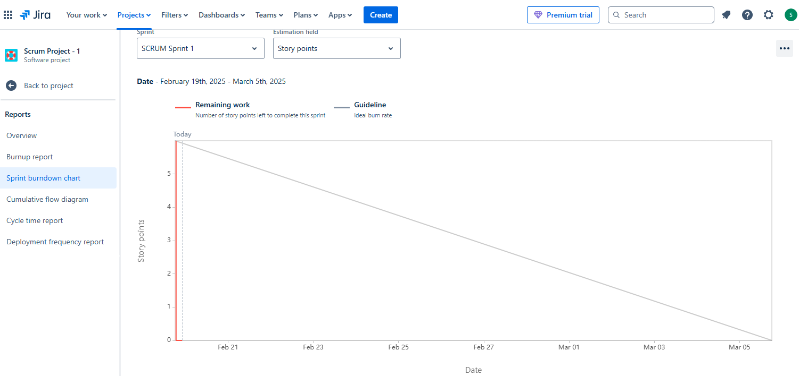

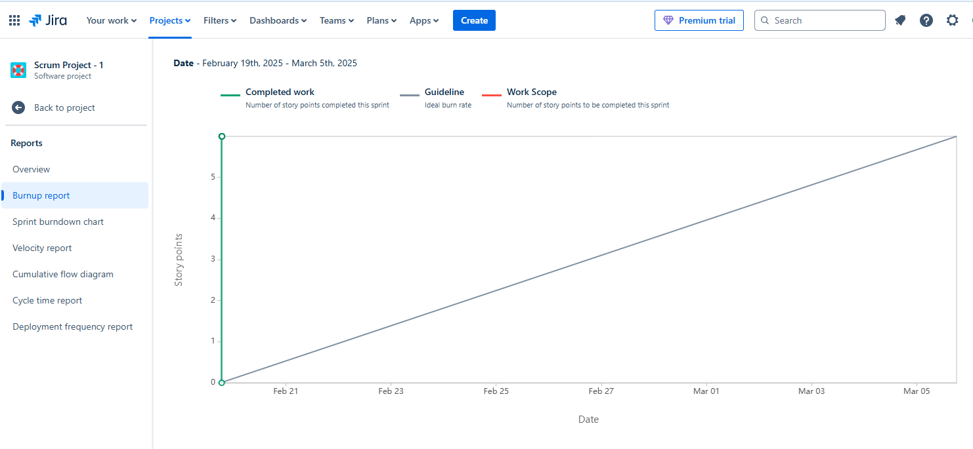.

Question 10) Explain about Product Grooming.

Answer) Product Grooming also known as Backlog grooming or refinement is an important activity in Agile Software development that involves reviewing prioritizing and refining items in the Product backlog.

The goal of product grooming is to ensure that the backlog is well prepared, organized and ready for implementation in upcoming Sprints.

It is typically a collaborative effort involving the product owner development team and other relevant stakeholders.

Question 11) Explain the roles of Scrum Master and Product Owner.

Answer)

|  |  |
| --- | --- |
| **Product Owner** | **Scrum Master** |
| Collaborates with all Stakeholders and brings the vision of a Project into the Product backlog. | Act as a team coach and is responsible for maintaining the quality of the product. |
| Responsible for completing the Project on time. Acts as an intermediary between the development team and the customers. | Ensures the Scrum framework is followed and helps the development team create a quality product. |
| Responsible for the Project backlog, the timely completion of the Product, and providing updates to the Clients and Stakeholders. | Accountable for the quality of the entire Project and for giving updates to management about completion of the Product. |
| Reports to Top Management and Clients | Reports to top management about the efficiency of the team and the quality of the Product. |
| Communication and Leadership skills creativity critical thinking and a sharp mind are key assets for any Product Owner. | Thorough knowledge of Scrum theory and practices. Being able to lead a team but without a sense of authority. |

Question 12) – Explain all Meetings Conducted in Scrum Project.

Answer) **Sprint Planning:** This meeting occurs at the beginning of each Sprint and involves the entire Scrum team.

The Product Owner shares the prioritized product backlog items and the development collaborates to select the items they will work on during the Sprint.

The Team also defines the Sprint goal and creates a Sprint backlog which outlines the specific tasks required to complete the selected backlog items.

**Daily Scrum**: This short daily meeting typically lasting 15 minutes involves the development team. Each team member shares their progress since the last standup discusses any impediments or challenges they are facing and communicates their plan for the day. The focus is on coordination, transparency and identifying any potential roadblocks. What did you do Yesterday ? what will you do today? Are there any impediments or blockers preventing you from doing your work?

**Sprint Review**: At the end of each Sprint the Sprint review happens. The development team presents the work completed during the Sprint to the stakeholders including the product owner and possibly customers or users. The team demonstrates the functionality or features implemented and gathers feedback. The purpose is to assess progress gather input and determine potential adjustments to the product backlog.

**Sprint Retrospective**: Immediately following the Sprint review the Sprint retrospective occurs. It is a dedicated session for the Scrum team to reflect on the Sprint identify what went well in this Sprint and the areas of improvement and discuss potential adjustments to their processes. The focus is on continuous learning adaptation and enhancing the teams effectiveness.

**Backlog Grooming (Refinement):** This meeting involves the product owner and development team and focuses on reviewing, refining, and estimating backlog items for upcoming sprints. It ensures that the backlog is well prepared and ready for implementation.

**Release Planning:** This meeting occurs at the start of a Project or major release and involves PO, Dev team & Stakeholders. It aims to discuss and plan the high level scope timeline and goals for the Project or release.

**Ad hoc Meetings:** These meetings may be scheduled as needed to address specific topics or issues such as resolving impediments, discussing technical challenges or conducting additional planning or collaboration sessions.

Question 13) Explain Sprint size and Scrum size.

Answer)  **Sprint Size:** The Sprint size refers to the length or duration of a Sprint in Scrum. A Sprint is a time boxed period during which the development team works to deliver a potentially shippable product increment. The Sprint size is determined during the Project planning phase and typically ranges from one to four weeks. The most common sprint duration is two weeks, but it can vary depending on the Project’s needs, complexity and team dynamics.

**Scrum Size:** The Scrum team size refers to the number of individuals who collaborate together to deliver the product increment in Scrum. The Scrum team is self organizing and cross functional typically consisting of a product owner a Scrum master and the development team. The recommended scrum team size is small ideally 5 to 9 members to enable effective communication, collaboration, and flexibility. However there are no strict rules regarding the team size and it may vary depending on the specific Project requirements and Organization.

Question 14) Explain DoR & DoD.

Answer) **Definition of Ready (DoR) (Functional):** The Definition of Ready defines the criteria that a User story must meet before it is considered ready to be included in a Sprint. It ensures that the team has sufficient information and clarity about the User story reducing the likelihood of misunderstandings or delays during the Sprint.

* The User story has a clear and concise description including the expected behaviour or functionality.
* The acceptance criteria for the user story are well defined and agreed upon by the product owner and the development team.
* Any necessary design or wireframes related to the user story are available.
* The User story is appropriately sized or estimated in story points or other relevant units.
* Any dependencies or external resources needed for the user story are identified and accessible.

**Definition of Done (DoD):** The Definition of Done outlines the criteria that a user story or any other backlog item must meet to be considered complete and ready for release. It establishes a shared understanding of what it means for work to be considered “done” and ensures that all necessary aspects such as quality testing and documentation are addressed.

* The code for the user story is implemented reviewed and merged into the main codebase.
* Automated tests are created and passed ensuring that the implemented functionality functions correctly and does not introduce regressions.
* The user story is thoroughly tested and validated against the defined acceptance criteria.
* The user interface or user experience aspects related to the user story are implemented and reviewed.
* The User story is documented including any relevant instructions guides or release notes.
* The Product owner has reviewed and accepted the user story as meeting the expected requirements.

Question 15) Explain Prioritization Techniques and MVP.

Answer) **MoSCoW** is prioritization technique used in Business Analysis and Software development to reach a common understanding with stakeholders on the importance they place on delivery of each requirement also known as MoSCoW Prioritization or MoSCoW Analysis.

MoSCoW stands for Must Should Could and Would.

M – Must have this requirement to meet the business needs.

S – Should have this requirement if possible, but project success does not rely on it.

C- Could have this requirement if it does not affect anything else in the Project.

W – Would like to have this requirement later, but it won’t be delivered this time.

**MVP – Minimum Viable Product** is the **simplest version** of a product that includes only the **core features** required to solve a problem and deliver value to early users. It allows businesses to launch quickly, gather feedback, and improve iteratively.

Question 16) Difference between Business Analyst and Product Owner.

Answer)

|  |  |
| --- | --- |
| **Product Owner** | **Business Analyst** |
| Manages the Product Backlog and prioritize features. | Analyses Business needs and defines requirements |
| Owns the product vision and ensures backlog aligns with business goals | Supports PO by gathering requirements and ensuring clarity. |
| Collaborates with Stakeholders and development teams. | Work closely with Business users and technical teams. |
| Makes Final decisions on feature prioritization and product scope | Provides insights but doesn’t make final product decisions |
| Product roadmap, backlog grooming, release planning | BRD, FRD, User stories, Flowcharts, data models |
| On going visioning | Requirements Strategy |
| Owns the products success and delivery | Focuses on business processes and requirement clarity |
| Focuses on a specific products lifecycle | Works across multiple projects or products. |
| Clearly express PBI’s | Needs Analysis |
| Order PBI’s | Non Functional requirements |
| Optimize value of Developers work | User stories |
| Manage Product Backlog | Data Modelling |
| Maintains Transparency | Project Focus, Conflict resolution |
| Ensure Developers have necessary details to work on | Prioritization of stories, facilitation for smooth project execution. |

Question 17) Prepare a sample Resume of 3yrs exp Product Owner.

