**Assignment - 1  
Business Requirements Document (BRD)**

1. **Project Title:**Ice Cream and Milk Manufacture and Inventory Management System
2. **Project Overview:**Company has manufacture plants and warehouse worldwide, manufactures ice creams and milk products. Delays or inefficiencies in inventory management and delivery logistics can result in the product wastage and customer dissatisfaction. To address this, a centralized software solution is proposed that integrates inventory visibility and real – time logistic optimization. The aim is to build a software to achieve goals:

* To manage the inventory across all location’s world wide
* Mage quick delivery to the customer and logistics efficiently

1. **Business Objectives:**

* Real time inventory tracking across all the locations efficiently.
* Stock automations alerts as and when required.
* Improve customer satisfaction by maintaining timely delivery.
* Reduce wastage and over-stock situations.
* Enable data-driven decisions through dashboards and alerts.

1. **Scope of the Project:**

**In-Scope:**

* Inventory management system across all warehouses and plants nationwide.
* Integration with logistics and GPS management system for real time delivery tracking.
* Reporting dashboard for inventory, sales, and delivery performances.
* Customer website or portal for managing customer orders and tracking.
* Role-based user access for internal users and logistics teams.
* Alerts for low stock and near expiry goods.

**Out-of-Scope:**

* Manufacturing automation and production control
* Financial maintenance or accounting module
* External accounting or ERP integration at this phase.

1. **Business Requirements:**

**Functional Requirements:**

* **FR001:** Inventory modification ( Create, Read, Add, Update, Remove ) using location
* **FR002:** Alert system for low – stock and near expiry products.
* **FR003:** Route optimization based on real-time traffic and distance.
* **FR004:** Order management system with estimated delivery time.
* **FR005:** Customer order tracking and feedback collection.
* **FR006:** User management and access control.
* **FR007:** Integration with logistic partner

**Non-Functional Requirements:**

* **NFR001:** The system must be accessible 24/7.
* **NFR002:** Must support high customer order volume during peak time.
* **NFR003:** Responsive UI/UX for web and mobile application.
* Integration with third party and GPS and logistics APIs.
* Secure data storage and user privacy compliance.

1. **Key Stakeholders:**

|  |  |
| --- | --- |
| **Stakeholder** | **Role** |
| Project Sponsor | Approves Budget and Scope of the project |
| Operations Manger | Overseas plane and warehouse processes |
| Logistic Manager | Manges delivery logistics |
| IT Head | Integration and infrastructure management |
| Business Analyst | Gathers and define business requirements |
| Development Team | Writes code, build and deliver the solution |
| QA / Testing Team | Test system quality and performance |
| Customers | End users |

1. **Assumptions:**

* All warehouses and plants have high speed and active internet connection.
* Delivery partner must use GPS enable devices for live tracking.
* Integration with external logistics and API is possible.

1. **Constraints:**

* Near–Expiry or perishable products to be prioritized in routing.
* Limited budget for external software tool.
* Overseas coverage with different time zones and conditions.
* Staff training and technology adoption in remote plants and warehouses.

1. **Cost-Benefit Analysis:**

|  |  |
| --- | --- |
| **Category** | **Estimated Cost** |
| Software Development | $50,000 |
| Infrastructure | $20,000 |
| Training and Deployment | $10,000 |
| Maintenance | $10,000 |

1. **Development Plan:**

|  |  |  |
| --- | --- | --- |
| **Phase** | **Duration** | **Deliverables** |
| Requirements Gathering | 2 weeks | BRD, Uses cases, Process flow |
| Requirement Analysis | 1 week | Review, Prioritize requirements |
| Design | 2 weeks | Wireframes and Architecture |
| Development – Sprint 1 | 4 weeks | Inventory Management Module |
| Development – Sprint 2 | 4 weeks | Order Management & Customer Portal |
| Development – Sprint 3 | 2 weeks | Tracking & Route optimization |
| Testing | 2 weeks | QA Testing & Bug fixing |
| Training User & UAT | 1 week | User training and feedback |
| Market Release / Deployment | 2 weeks | Deployment and monitoring |

1. **Resource Plan:**

|  |  |  |  |
| --- | --- | --- | --- |
| **Role** | **Count** | **Duration** | **Responsibility** |
| Business Analyst | 1 | 6 months | Gathering Requirements and Managing Stakeholders |
| UI/UX Designer | 1 | 3 months | Software application interface design |
| Backend Developer | 2 | 6 months | Application development, Database development |
| Frontend Developer | 2 | 6 months | UI Development |
| QA | 1 | 3 months | Bug checking and Performance |
| Project Manger | 1 | 6 months | Planning, Tracking, Reporting |
| DevOps Engineer | 1 | 3 months | Deployment and Maintenance |

**Process Flow Diagram:**

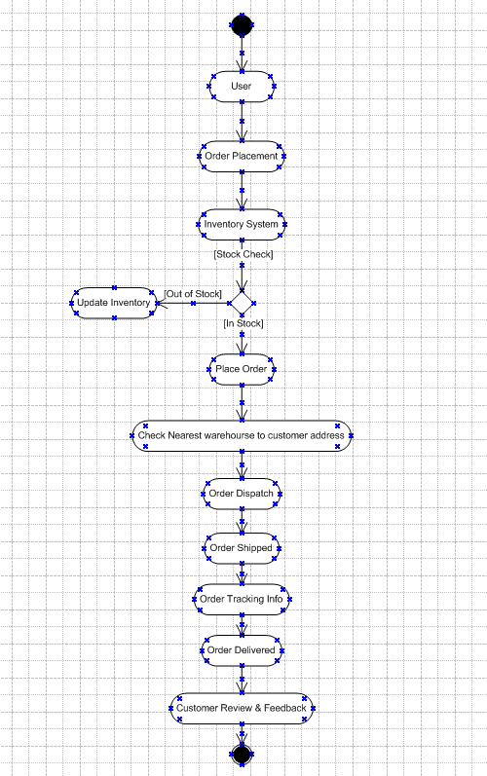

**Assignment – 2**

1. **Introduction Letter to Client**

**Subject:** Business Analyst for Ticketing System Project

Dear Client,

Hope you are doing well.

My name is Akshay Kumar, and I’ve been assigned as Business Analyst for your upcoming Ticket System Project. I will be responsible for working closely with you and the responsible stakeholders to capture the requirements, define the scope and ensure the solution is developed to meet your organization goals.

My primary focus will be understanding your current ticket resolution process, identifying the gaps and inefficiencies and ensuring that the new system streamlines ticket logging, assignment, tracking and resolutions while meeting the Service Level Agreement (SLAs).

I look forward to a productive collaboration as we shape this system to support your growing support operations.

Regards,

Akshay Kumar

Business Analyst

ABC Technology Solutions

[Akshay@company.com](mailto:Akshay@company.com) | 9214745879

1. **BRD and SRS for Ticketing System**

**Project Title:**

Ticketing System for Issue Resolution

**Objective:**

To build a simple and efficient system for logging, tracking, resolving issues within a reasonable timeframe without missing follow ups and confusions.

**Business Requirements:**

* A system for users to log their issues with details
* Prioritization based on urgency (High, Medium, Low)
* Agents to manage tickets raised by customer and easily communicate with users
* Admins to track performance, SLA breaches
* Everyone to stay in sync with automatic updates

**Software Requirements Specifications (SRS):**

**Functional Requirements:**

* Allow users to raise tickets with a title, description, category, and priority
* Auto-assign tickets to available agents in the right department
* Let agents update ticket status, add internal notes, and respond to users
* Send notifications when there’s a response or status change
* Track how long a ticket has been open and alert if it’s about to breach SLA
* Show reports on open vs. resolved tickets, agent workload, etc.

**Non-Functional Requirements:**

* Should be able to adopt well with mobile application and desktop
* Need to be secure, especially when storing the sensitive customer information
* Should be able to handle peak customer volume
* Information backup is needed in case something goes wrong.

**ERD for Ticketing Life Cycle:**

* User can raise multiple tickets for multiple issues
* Each ticket belongs to a user and will be assigned to one support agent
* Ticket status changes based on the actions by the support agents. Status like Open, In Progress, Resolved and Closed.
* Agent and Users can comment their responses in the ticket threads.
* SLA rules help decide when a ticket should be resolved, based on its type and priority

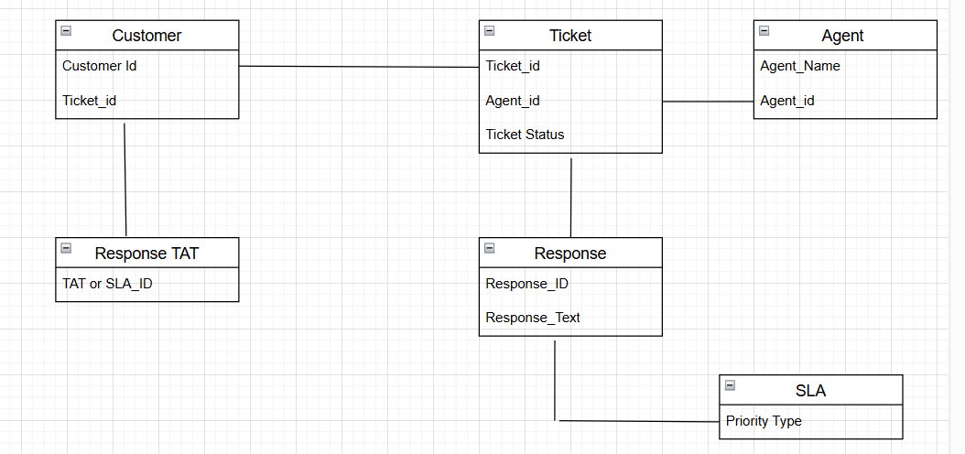

**User story of shopping from ecommerce:**

**User Story:** Add items to cart and checkout

| **Tasks** | Customer Placing Order |
| --- | --- |
| **Priority** | High |
| **Business Value (BV)** | 500 |
| **Complexity Points (CP)** | 9 |
| **Value Statement** | As a customer,  I want to add items to cart and proceed to checkout  so that I can order the products I need and get it delivered |
| **Acceptance Criteria** | * Items can be added to the cart from the product listing page or product detail page. * Customer can view, update quantity, or remove items from the cart. * Checkout by providing shipping address and payment details. * Confirmation page should show a summary of the order before placing it. * An order confirmation email should be sent upon successful order placement. |