Project Talent Bridge Part – 2

Document 6- Please prepare a use case diagram, activity diagram and a use case specification document.

Use Case Diagram
Use Case: Candidate Job Application Lifecycle
Includes key interactions like Register, Login, Apply for Job, Track Application Status, Receive Notification, Update Profile.
Actors:
Primary: Candidate
Secondary: Recruiter, System (Automated Notification Service)

Activity diagram

An Activity Diagram is a UML (Unified Modeling Language) diagram that visually represents the flow of activities or actions in a process.
Think of it like a flowchart with superpowers — it shows how steps connect, where decisions happen, and how the process branches or merges.

Use Case Specification Document
Use Case Name:
Apply for a Job

Use Case Description:
This use case describes how a registered candidate applies for an open job position through the Talent Bridge platform.

Actors:
Primary Actor: Candidate
Secondary Actors: Recruiter, System

Basic Flow:
1. Candidate logs into the Talent Bridge platform.
2. System displays a list of open job positions.
3. Candidate selects a job to view details.
4. Candidate clicks "Apply".
5. System prompts for resume/CV upload (if not already uploaded).
6. Candidate submits application.
7. System displays confirmation message and sends notification.
8. Recruiter receives application in their dashboard.

Alternate Flow:
AF1: Resume Already Uploaded
- System skips the upload step if resume is already uploaded.

AF2: Candidate Withdraws
- Candidate can withdraw application before recruiter review.

Exceptional Flows:
EF1: Candidate Not Logged In – System redirects to login page.
EF2: Incomplete Profile – System prompts profile completion.
EF3: System Error – Error message shown; candidate can retry.

Pre-Conditions:
Candidate must have a valid account and be logged in. Profile must be complete.

Post-Conditions:
Candidate’s application is recorded. Recruiter is notified. Candidate receives tracking ID.

Assumptions:
Candidate understands how to navigate the platform. Jobs listed are actively open.

Constraints:
Candidate can apply only once per job. Application window must be open. File size limit of 2 MB.

Dependencies:
System must integrate with resume parser. Notification service must be functional.

Inputs and Outputs:
Inputs: Candidate login credentials, job selection, resume.
Outputs: Confirmation message, recruiter dashboard update.

Business Rules:
Candidates may not apply for the same job more than once. Application must be tracked. Notifications must be triggered on status changes.

Miscellaneous Information:
Candidate's application data should be stored securely. The platform must log all actions for audit purposes.

Document 7- Screens and pages
Please follow the following steps to create the mock-ups
    - Kindly use balsamic or Axure.
    - Always start with a home page of an application.
    - Take a feature and follow it to the end
      - Eg: Home page of SCRUM Foods
      - Select Login- Create a login page
      - Let’s assume, you want to search a restaurant
      - Search page- Type the restaurant name and select the dish
      - Add to cart page
      - Payment page
      - Logout page

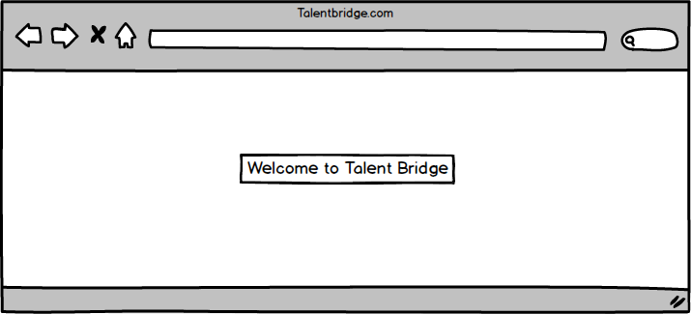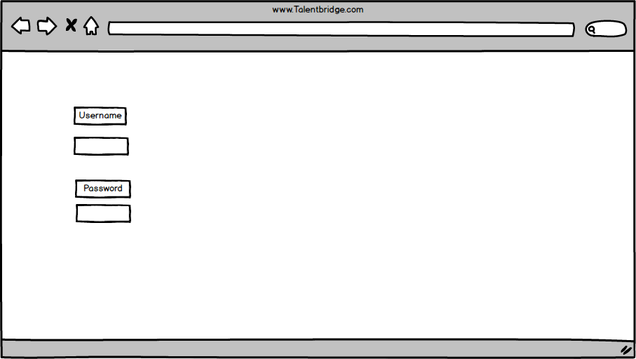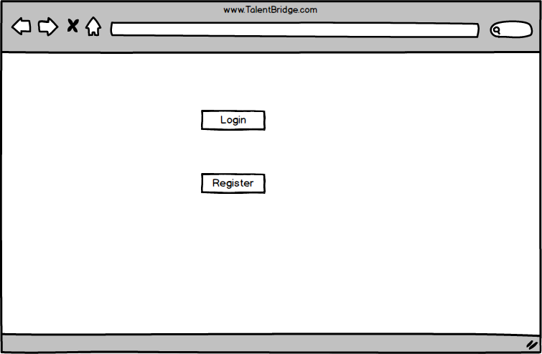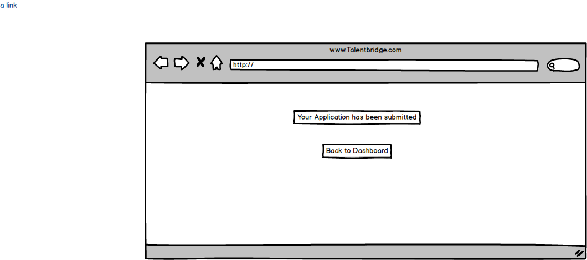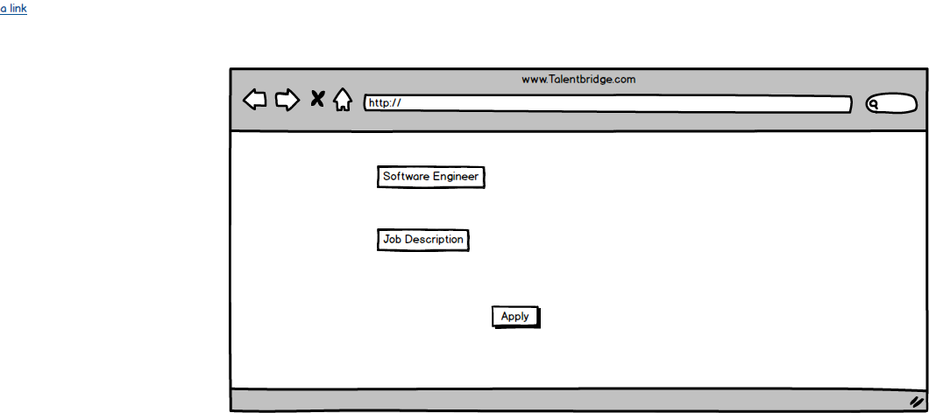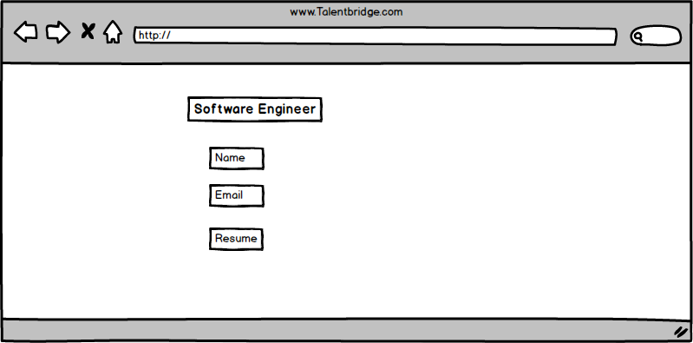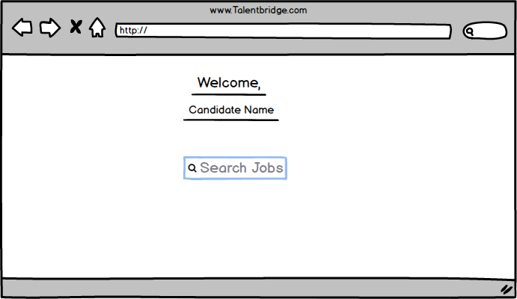

Document 8- Tools-Visio and Axure
Write a paragraph on your experience using Visio and Axure for the project.

Microsoft Visio:
Microsoft Visio is software for drawing a variety of diagrams. These include flowcharts, org charts, building plans, floor plans, data flow diagrams, process flow diagrams, business process modeling, swimlane diagrams, 3D maps, and many more.
Microsoft Visio was used to create visual diagrams that represented business processes and workflows. This helped all stakeholders—including non-technical team members—clearly understand the current (AS-IS) and proposed (TO-BE) processes of the recruitment system.
I Used Visio in Project Talent Bridge:
Created AS-IS and TO-BE Process Flow Diagrams to explain existing vs improved hiring flow.
Designed Use Case Diagrams to represent interactions between system and actors (e.g., Candidates, Recruiters).
Built Activity Diagrams to capture step-by-step workflows like "Candidate Application Flow" or "Recruiter Shortlisting Flow".

The mockups were created in a Balsamiq-style format to visualize the application flow. Balsamiq and Axure are popular tools used for creating low-fidelity wireframes that help Business Analysts, UI/UX Designers, and Developers understand the screen flow and layout of the system.

Document 9- BA experience

This document outlines my experience as a Business Analyst (BA) during the different phases of the Software Development Life Cycle (SDLC) for the Project Talent Bridge. It includes detailed responsibilities, techniques, and diagrams used in each phase.

My experience as BA in following phases:
- Requirement gathering:

- To gather requirements, we used the MoSCoW technique to prioritize features as Must have, Should have, Could have, and Won’t have.
- The client was unavailable for some period during this phase, so as a BA, I sourced alternate points of contact to ensure timely information gathering.
- I validated the requirements using the FURPS technique (Functionality, Usability, Reliability, Performance, Supportability).
- I identified and removed duplicated or repeated requirements.
- Prototyping was used to get more specific requirements and to confirm assumptions.

MoSCoW Prioritization Table

Requirement | Priority | Justification
Candidates must register and login | Must | Core feature to access the platform
Allow resume upload in multiple formats | Should | Improves UX but not mandatory
AI-based job match | Could | Good to have; not in MVP
Support for 3rd party job portals | Won’t | Out of scope for Phase 1

- Requirement Analysis:
- From Created UML diagrams (like Use Case Diagrams) to visualize system behavior.
- Created Activity Diagrams to represent workflows and process flows.
- Communicated diagrams with the team and handled revisions based on feedback.
- Prepared BRS (Business Requirement Specification) and SRS (Software Requirement Specification) documents.

- Design:

- Prepared test cases derived from the Use Case Diagrams.
- Discussed and aligned solution documents and designs with the client.
- Designed both positive and negative test cases for complete coverage.
- Ensured no test cases were missed, preventing future development risks.
- Created test data in alignment with requirements.
- Updated the RTM (Requirements Traceability Matrix) to ensure every requirement is covered by test cases.

Req ID | Req Name | Req Description | Design | D1 | T1 | D2 | T2 | UAT
FR0001 | Login | Secure login for all users | Yes | Yes | Yes | Yes | Yes | Yes
FR0002 | View Jobs | View job list with filters | Yes | Yes | Yes | Yes | Yes | Yes
FR0003 | Apply Job | Apply with resume and cover | Yes | Yes | Yes | Yes | Yes | Yes
FR0004 | Track Status | View real-time updates | Yes | Yes | Yes | Yes | Yes | Yes
FR0005 | Feedback | Feedback posted by recruiters | Yes | Yes | Yes | Yes | Yes | Yes
FR0006 | Messaging | Chat module | Yes | Yes | Yes | Yes | Yes | Yes

- Development:
- Organized Joint Application Development (JAD) sessions with stakeholders.
- Clarified queries from the development team during the coding phase.
- Managed difficult situations by initiating one-on-one discussions with uncooperative team members, emphasizing the impact of collaboration.
- Used diagrams to assist developers in coding the correct logic.
- Held regular meetings with the technical team and client. Recorded sessions and shared with absent members; followed up with one-on-one explanations.

- Testing:
- Derived test cases directly from Use Cases to ensure requirement coverage.
- Performed high-level system testing for validation.
- Requested test data from the client when internal data was insufficient.
- Updated the RTM based on executed test cases.
- Took client sign-off after successful testing.
- Prepared the client for UAT (User Acceptance Testing) through sessions and documentation.

- Deployment:
- Forwarded the final RTM document to the client, attaching it to the project closure documents.
- Coordinated with the documentation team to complete and distribute end-user manuals.
- Planned and organized training sessions for end users.
- Ensured all intended participants attended training and followed up with those who missed.

