**Question 1: Functional Requirements. -**Identify a minimum of 20 functional requirements.

Ans:

|  |  |  |  |
| --- | --- | --- | --- |
| **Req ID** | **Req Name** | **Req Description** | **Priority** |
| **FR001** | **Registration** | Registration of users using their email ID and password | **10** |
| **FR002** | **Login** | Log in to all its users using the email ID and password | **10** |
| **FR003** | **Forgot Password Page** | Upload & Display | **10** |
| **FR004** | **Log in Via Gmail/Facebook Page** | It should allow users to log in to the page via Gmail or Facebook credentials | **9** |
| **FR005** | **Log in via Mobile OTP (without email)** | It allows users to enter their mobile number and log in directly via just OTP | **9** |
| **FR006** | **Upload & Display** | Facilitate the option to upload images of the products and item details, and it should automatically organize and get updated in the e-commerce website as soon as you hit the “Publish” Button. | **8** |
| **FR007** | **Search** | Farmers should be able to search for available products in fertilizers, seeds, and pesticides. | **8** |
| **FR008** | **Catalog** | A product catalog of fertilizers and pesticides has to be created. | **8** |
| **FR009** | **Product Browsing** | Product browsing has to be enabled within the product catalog. | **7** |
| **FR010** | **Buy Later** | Create a Buy Later list only for logged-in users. | **1** |
| **FR011** | **Payment Option** | The payment process & option have to be enabled. | **7** |
| **FR012** | **Pay Later Option** | Integration of the pay later option from the company called “Simpl” | **2** |
| **FR013** | **Payment Processing** | Addition of Payment Gateway, which should include Credit/Debit Card, Cash on Delivery, and UPI for user convenience. | **7** |
| **FR014** | **Status Confirmation** | After a successful or failed order status, users should be informed by email of order confirmation | **6** |
| **FR015** | **Track Delivery** | Product Delivery tracking has to be enabled. | **6** |
| **FR016** | **Return Option** | Facilitate the entry of the details of the return and the reason for the return | **4** |
| **FR017** | **Change Delivery Address Page** | Allows changing or updating the delivery address or phone number, or delivery instructions. | **2** |
| **FR018** | **Order Management Page** | Allow users to view their previous and existing orders without the “buy again” option. | **2** |
| **FR019** | **Post Order Review** | Facilitate the option to give a post-order review, which makes genuine feedback after using the product. | **2** |
| **FR020** | **Customer Service & Reward Points** | Allow customers to contact the seller for any kind of post-purchase enquiry or service & enable for Reward Option for re-purchase of the item. | **4** |

**Question 2:** Make a 5-wireframe and prototypes

**Ans: Login**

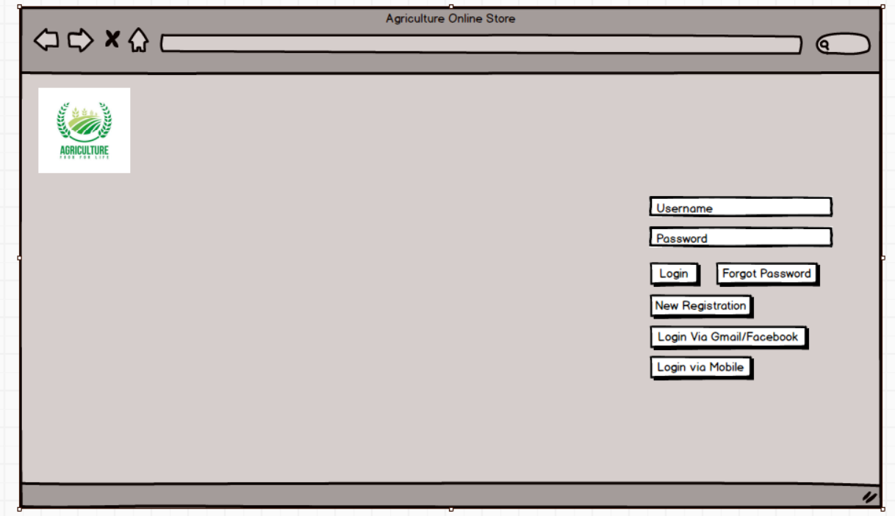

**Search**

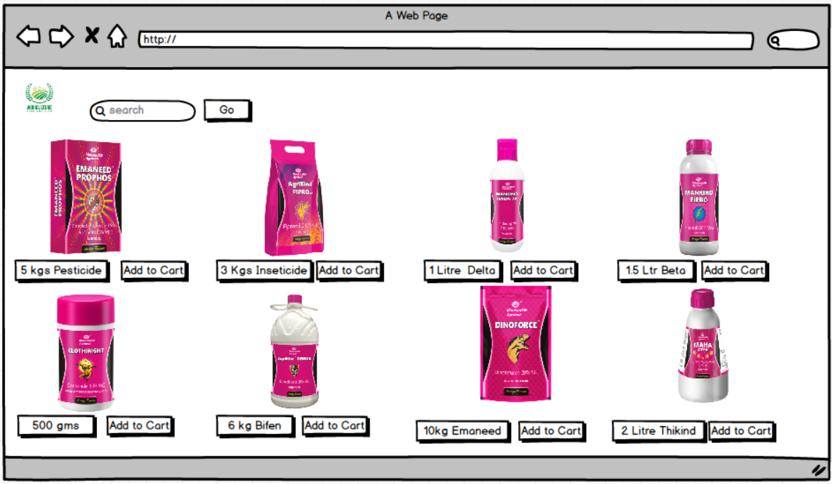

**Add to Cart**

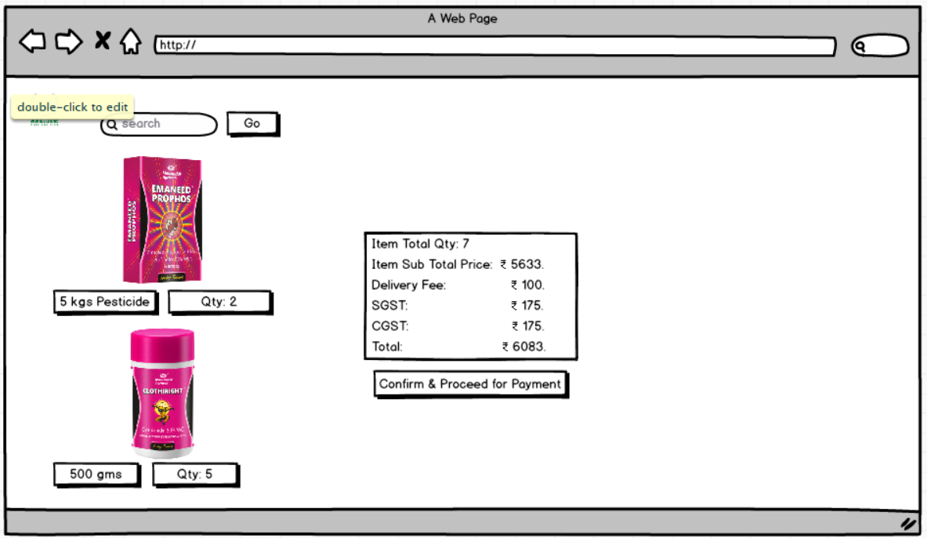

**Payment**

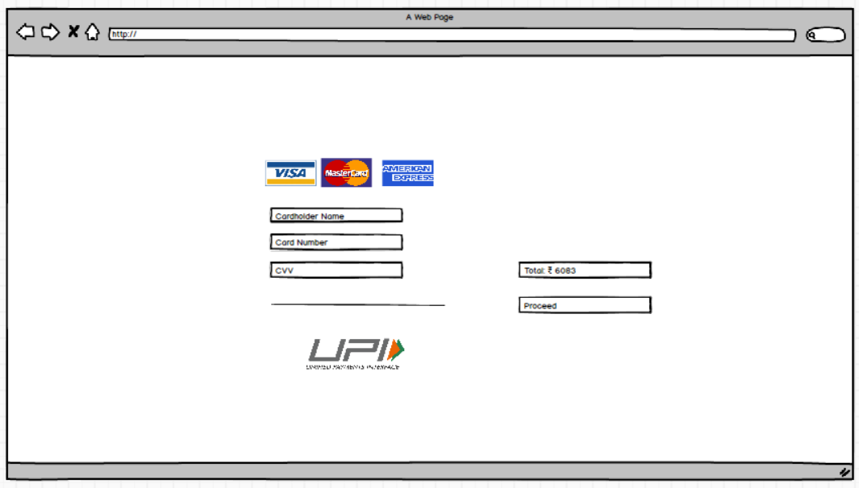

**Logout**

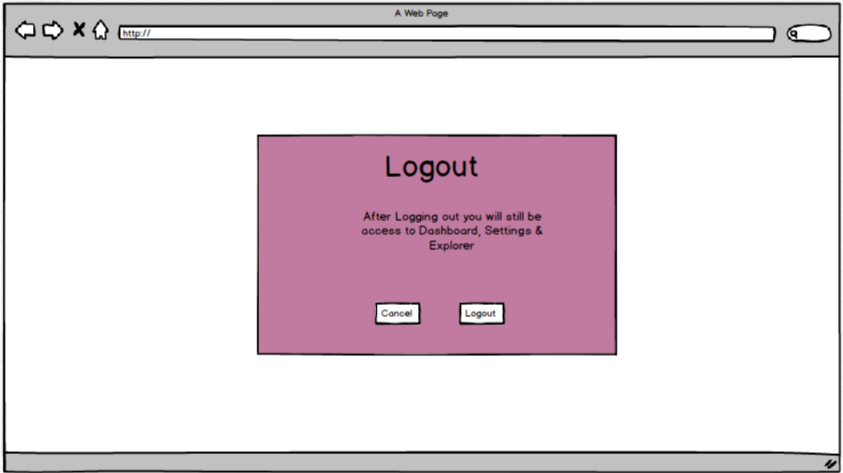

Question 3: Make a note of the Tools, which you are using for above concepts.( Balsmiq, MS Visio, Axure.

Ans:

Balsamiq: Balsamiq is a low-fidelity wireframing tool used in software design to create simple, sketch-style prototypes of user interfaces. It helps designers and teams quickly visualize layout ideas without getting caught up in visual details. This encourages collaboration, early feedback, and fast iterations. Balsamiq is especially useful in the early stages of development, allowing stakeholders to understand and refine functionality before investing time in detailed design or coding.

Question 4 : Prepare RTM

**Click on the** [**Link**](https://docs.google.com/spreadsheets/d/1oZ2U3SpePotbgssQdRTd2OKnXKdXVxNn0eFCg5iia-0/edit?usp=drive_link) **to view it RTM**

**Question 5: Prepare 10 Test Case Documents.**

|  |  |  |  |  |  |
| --- | --- | --- | --- | --- | --- |
| **Project ID** | P75632 | **Project Name** | Agriculture online Store | | |
| **PM ID** | PM614 | **PM Name** | Mr. Vandanam | | |
| **Test Strategy ID** | TSR659 | **Tester ID** | T65546 | | |
| **Test Pln ID** | TP9654 | **Tester Name** | Ms. Alekya | | |
| **Test Schedule ID** | TSD653 | **Date of Test** | 30-Apr-25 | | |
| **Scenario** | Search for Product | | | | |
| **Link to that Page** | [www.onlineagriculturestore.com](http://www.onlineagriculturestore.com/) | | | | |
| **Input Data** | Set 1  Pesticide for fresh Farm Low on Chemicals Fertilizers Floral Seeds | Set 2 Mango seed & liquid fertilizer 10 kg Tin quick delivery option | Set 3 Agricultural pesticide 10 days delivery integrated with Post office for low cost delivery | Set 4 Vegetable Hybrid seeds Same day 15 mints delivery Integrated with Zepto App | Set 5 Hybrid breed seeds Minimum order qty is 100 kg Only gets delivered once a week |
| **Expected Behaviour** | 17 Variants | Mango colored box | Multiple delivery option should be visible for this product | Zepto logo should appear | Delivery slots should be visible to select |
| **Actual Behaviour** | 13 Variants Visible | White color is populating | Delivery option is invisible | Appearing as intended | Visible |
| **Comments** | 4 Designs are not populating from the database(probably Data is not getting updated quickly) | Due to latency issue | Version control is not in place, multiple delivery option is not coming up on the page | Success | Working as intended |
| **Result(Pass/Fail)** | Fail | Fail | Fail | Pass | Pass |

**Question 6: Prepare Database Schema & ERD**

Please click on the [**link**](https://docs.google.com/spreadsheets/d/1cQwuzpV8s4yOxVNNhhqoYBNQIwfgHf4dHc-H6cSkC9Q/edit?gid=630703926#gid=630703926) to view the Database Schema & ERD.

**Question 7: What is a data flow diagram? Draw a data flow diagram to represent the in-flow and out-flow of data when a Farmer is placing an order for the product.**

**Ans:** A Data flow Diagram(DFD) is a graphical representation used in software design show how data moves through a sytem. It illustrates the flow of information, the processes that transform data, and how data is stored. DFDs are useful for understanding system fuctionaility and data handling without getting into implementation details like code or databases.

**1st level User side DFD**

Farmer

**s**

PymentMst

OrderMst

UserMst

ItemMst

UserMst

ItemMst

Buy Item

Make Payment

3.0 Search Item

Account

UserMst

2.0 Login

1.0 Registration

Make Order

**Question: 8: Due to change in the Government Taxation structure. we should change the Tax structure How do you handle change requests in a project?**

**Ans:**

1. Understand the scope of change.: Understand how much much percentage does the Govt has brought changes to the **tax** **structure** and do we need to change the whole software or only invoicing part is enough or it should be applied to historical data as well or not.
2. Determines whether the change is inside /outside the scope.: Synchronize with CCB(Change control board) whether the changes would impact hugely on project timeline/if its coming inside scope or outside scope.
3. 3. Do the analysis.: Analyse if the quoted prices for the project is coming under project scope or it has to be re-quoted for additional costing and timing of the project.
4. Approve or reject the change request.: Depending on the scope and price, CCB will approve or deny the changes, we will inform the sponsor and business stakeholders regarding the same.
5. Communicate and implement the approved change request.: If its coming under the budget and project scope, we will intimate and proceed to make the changes within the same project budget and timeline.

**Question:9 As the project is in process, Ben and Kevin have contacted you. The reason is to inform you that they want the Farmers to sell their crop yields through this application i.e. Farmers should be able to add their crop yields or products and display to general public and should be able to sell them. They also want to introduce Auction system for their Crop yields.**

**As a BA, what will be your response?**

**Is this a change request or an enhancement???**

**Ans:** In this case, adding an auction on their crop yields to the application would be considered as an enhancement as it involves adding new features to the system. As a Business Analyst, I will document the requirements and work with the development team to determine the **feasibility** and **impact** of the new features. I will consider the potential benefits, risks, and costs associated with the enhancements before making any recommendation to the client.

**Question: 10** Come up with estimations – How many Manhours are required?

**Ans:**

Man-hours are the required efforts of the resources to complete a project. There are 3 types of projects.

Small: Up to 500 hours.

Medium Up to 1000 hours.

Large up to 1500 hours.

* As per the case study, the duration of the project is 18 months and the current team size is around 15. A**dditional manhours are not required (as we already have 15 resources working 40 hours per week**). This will come under a medium project.
* As the trained resources are available, trainers are not required.
* As the structure of the project is available, New and enhanced infrastructure is not required.

**Question 11: The Project has finally completed all the stages, i.e., design, development, testing, etc. Now, it is the role of a business analyst to contact the client for testing of the final product and have to complete it. How are you going to handle this situation? And once it is done, what will be the process to close the project?**

**Explain the UAT Acceptance process.**

**Ans:**

**Planning**: In thisstep, blueprints are made to implement UAT testing for every feature that needs to be tested, and minimum standards for accepting the test.

**Designing**: Here, the Test cases are designed to hide all the possibilities of software packages in a real-world environment.

**UAT Testers**. A Testing team consists of end users who meet the criteria for implementing testing, The end user must have expertise in the subject matter, the ability to report the problems.

**Bug fixing**: Whatever Bugs are found in the UAT Testing, the development team should work on them and make it software error free.

**Sign Off**: After removing all the bugs, the testing team indicates acceptance of the completion of the bugs. In this phase, all the stakeholders come to a conclusion that the software is ready to “**GO LIVE**” and **sign it off**.

**Question 12: Explain the Project closure document**

**Ans:** A project closure document is a formal record document that summarizes and evaluates the outcomes of a project, ensuring all activities are completed and objectives are met. It serves as a crucial step in formally ending a project and helps assess its success, identify lessons learned. And facilitate knowledge transfer for future projects.

|  |  |  |  |
| --- | --- | --- | --- |
| **S. No** | **Points to Include** | **Details** | **Reference Link** |
| **1** | **Did the client signed off on the UAT Testing** | | **Business Scope Document.docx** |
|  | Date of the signoff | 11th April 2025 |
|  | Name of the resource | Mr. Henry. |
| **2** | **Objectives of the project** | |
|  | User Friendliness | Achieved |  |
|  | Customer Satisfaction | ROI in 6 months |  |
|  | More Categories | Achieved |  |
| **3** | **Functionalities worked on** | |  |
|  | Secure payment processing | Achieved |  |
|  | Categories & Auctions | Achieved |  |
| **4** | **Infrastructure** |  |  |
|  | Software installed | Achieved |  |
|  | Laptops purchased | Achieved |  |
| **5** | **Funding** | |  |
|  | Amount approved | 2 crores | **Finance breakdown.docx** |
|  | Amount used | 1.8 crores |
| **6** | **Overall project information** | |  |
|  | Escalations | 40 |  |
|  | Customer Satisfaction | Very much satisfied. |  |
| **7** | **Value to the company** | |  |
|  | Positive/Negative | Positive 95% -The Company has gained an edge over other companies in the market, and gained an image in front of the competitors. --Increased clients -Trained employees - New project pipelines increased. |  |