CAPSTONE PROJECT 1 PART 3

QUESTION NO: 1
- FUNTIONAL REQUIREMENTS
REQUIREMENT ID | REQUIREMENT NAME | DESCRIPTION
FR001 | REGISTRATION | THE USER SHOULD BE EASILY GET REGISTER INTO APPLICATION
FR002 | LOGIN | THE USER SHOULD EASILY ABLE TO LOGIN INTO APPLICATION
FR003 | SEARCH | THE USER SHOULD EASILY SEARCH THE PRODUCTS BY SEARCH OPTION.
FR004 | UPLOAD | THE MANUFACTURE SHOULD ABLE TO UPLOAD ALL THE PRODUCTS IN THE APPLICATION
FR005 | DISPLAY | USER SHOULD ABLE TO SEE THE OFFERS AND DISCOUNT IN THE APPLICATION
FR006 | ADD TO CART | USER SHOULD ABLE TO KEEP PRODUCTS IN WISH LIST .
FR007 | PAYMENT | USER SHOULD ABLE TO PAY BY ALL CARDS,UPI,BANK TRANSFER AND (COD)
FR008 | EMAIL CONFORMATION | USER SHOULD GET EMAIL CONFORMATION ABOUT THE PRODUCT AND PAYMENT.
FR009 | TRACK DELIVERY | USER CAN ABLE TO TRACK THE DILIVERY OF PRODUCT.
FR010 | GET DETAILS (or) INFO | USER SHOULD ABLE TO GET DETAILS ABOUT THE PRODUCT

- NONFUNCTIONAL REQUIREMENT.
REQUIREMENT  ID | REQUIREMENT NAME | DESCRIPTION
NFR001 | PERFORMANCE | THIS APPLICATION MUST LOAD IN 4 SECONDS
NFR002 | USABILITY | THIS APPLICATION SHOULD BE USER FRIENDLY
NFR003 | SECURITY | THIS APPLICATION SHOULD ENSURE THE USER AUTHRNTICATION
NFR004 | COMPATIBILITY | THIS APPLICATION MUST BE COMPATIBLE WITH CHROME ,UC BROWSER,EDGE ETC.
NFR005 | RESPONSE TIME | THE APPLICATION MUST REPOND TO INPUT WITH IN 2 SECONDS
NFR006 | SCALABILITY | THE APPLICATION MUST BE SCALABLE UPTO 4000 USERS
NFR007 | MAINTAINABILITY | THE MEAN TIME TO RESTORE THE APPLICATION MUST NOT BE MORE THAN 10 MINTUES
NFR008 | PORTABLITY | THE APPLICATION SHOULD BE ABLE TO RUN ON MOBILE,LAPTOPS,OPERATION SYSTEMS .
NFR009 | RELIABILITY | THE SYSTEM SHOULD ABLE TO HANDLE AND RECOVER ERRORS WITHOUT INCORRECT DATA AND DATA LOSS.
NFR010 | LOCALIZATION | THE APPLICATION SHOULD BE HANDLE EVERY LANGUAGE LIKE TELUGU , HINDI,TAMIL,ENGLISH.

QUESTION : 2
MAKE WIREFRAMES AND PROTOTYPES

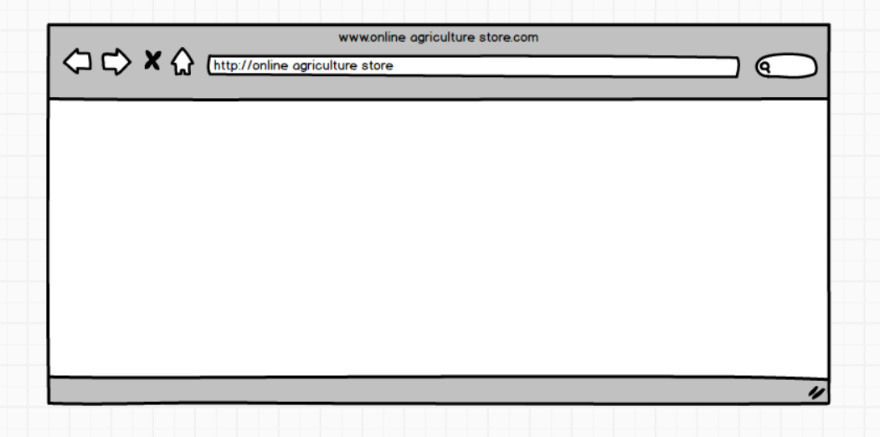

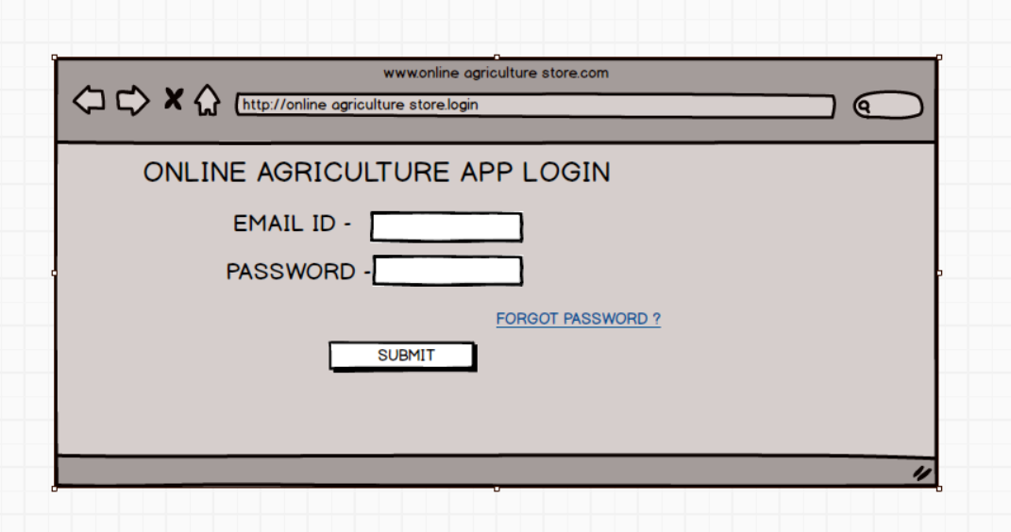

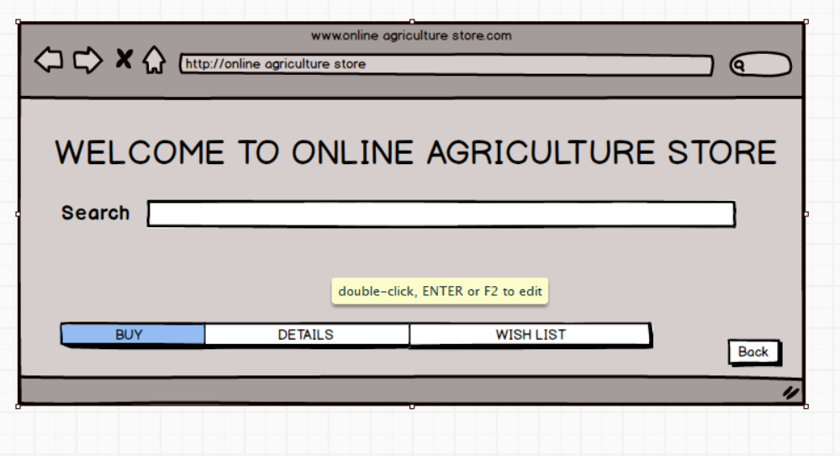
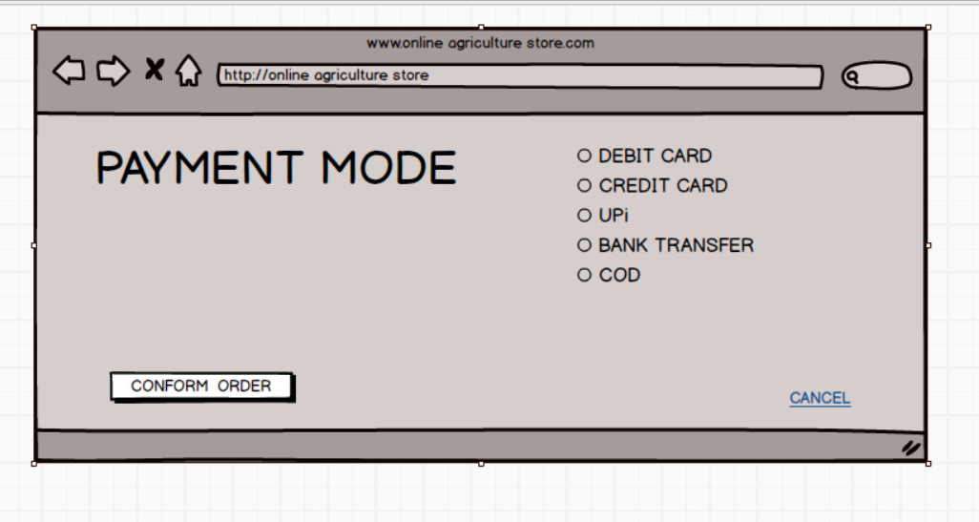

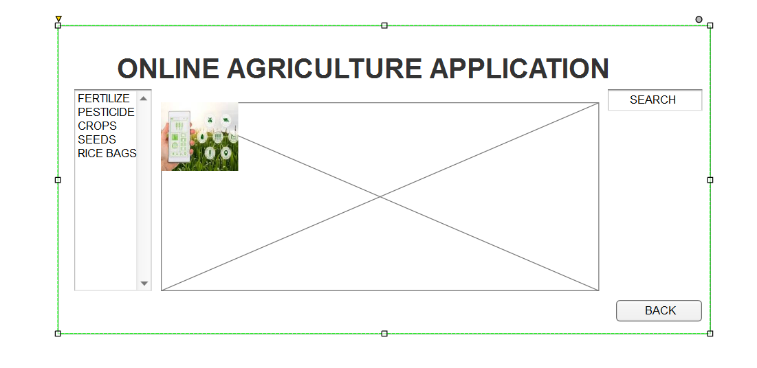

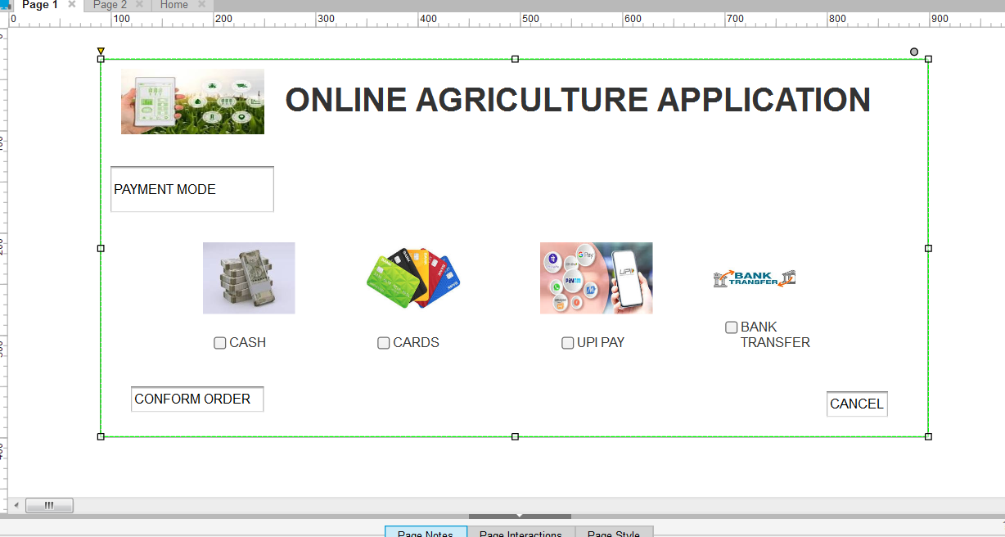

QUESTION : 3
WRITE A NOTE ON TOOLS

MICROSOFT VISO TOOL :
THE MICROSOFT Visio IS A DIAGRAMMING APPLICATION USED TO CREATE A WIDE RANGE OF VISUAL CONTENT. SOME OF THEM ARE

- FLOWCHARTS
Visio is been primarily used to create various types of diagrams such as flow charts, process maps workflows etc.

- ORGANIZATIONAL CHARTS
Visio facilitates the creation of organizational structure diagrams showing relationships and team structure

- NETWORK DIAGRAMS
User can create visual representation of computer networks including devices connections.

- FLOOR PLANS
Viso can be also used to design floor plans and building layouts.

- UML DIAGRAMS
Viso can be used for draw the unified modelling language diagrams for getting
clarity to technical team on requirement

- BUSINESS PROCESS MODELS
Visio supports the creations of diagrams that illustrate business processes and work flows

- DATA VISUALIZATION
Visio allows users to connect to data sources such as excel or share point and visualize data in various diagrams format

- COLLABORATION
Visio enables users to share and collaborate on diagrams with others facilitating communication and team work

- TEMPLATE AND SHADES
Visio offers wide variety of templates and shapes for different types of diagrams.

2 BALSAMIQ

Balsamiq is low-fidelity wire framing tool used by user interface designers, business analyst and developers to sketch user interface mock ups quickly.

The purpose of Balsamiq is to create wire frames for websites, apps and software interfaces.

It helps in brainstorming collaboration and early feedback and it is ideal for visualizing and communicating layout and functionality during the planning phase of development
- Key features

-Drag and drop interface-
it is easy for anyone regardless of design experience to create wire frames

-Prebuilt UI components –
it offers a rich library of pre made UI controls, icons and templates (Ex – buttons, text fields, forms, images, charts, etc)

-Multiple styles –
Balsamiq offers different styles like draft, sketch, presentation to suit various stages of the design process from rough ideation to more refined presentation

Reusable symbols –
Users can create and customize reusable UI elements (or) symbols to save time and repetitive task

(3) AXURE RP

The Axure RP a leading UX prototyping and wireframing tool it is a powerful and comprehensive designed application for UX (user experience) professional to create highly interactive prototypes, wire frames and specifications for website and application. It allows designers to visualize and test their concepts before the development phase effectively mimicking the behaviour of a live application
Key Features :
Interactive prototyping:
- Drag and drop interface -
Easily place , resize and format widgets (buttons,text fields , images etc.) for
building layouts
- Conditional logic and dynamic content
Create complex interactions such as displaying or hiding elements , showing different stages of a panel , or performing calculations based on user input .
- Event triggers , conditions and actions
Define how elements respond to user actions like clicks ,hovers ,swipes or key board inputs along with specific conditions that must be met for an interaction to occur

As I used the axure rp for the online agricultural application in this project this tool is very great to use as it enables creation of high-fidelity, functional prototypes that closely resemble the final product leading to more accurate user testing and feedback.

Question 4
Creating the RTM
REQ ID | NAME OF REQUIREMENT | DESCRIPTION | D1 | T1 | T4 | UAT
FR001 | REGISTRATION | THE USER SHOULD BE EASILY GET REGISTER INTO APPLICATION | COMPLETE | COMPLETE | COMPLETE | COMPLETE
FR002 | LOGIN | THE USER SHOULD EASILY ABLE TO LOGIN INTO APPLICATION | COMPLETE | COMPLETE | COMPLETE | COMPLETE
FR003 | SEARCH | THE USER SHOULD EASILY SEARCH THE PRODUCTS BY SEARCH OPTION. | COMPLETE | COMPLETE | COMPLETE | COMPLETE
FR004 | UPLOAD | THE MANUFACTURE SHOULD ABLE TO UPLOAD ALL THE PRODUCTS IN THE APPLICATION | COMPLETE | COMPLETE | COMPLETE | COMPLETE
FR005 | DISPLAY | USER SHOULD ABLE TO SEE THE OFFERS AND DISCOUNT IN THE APPLICATION | INCOMPLETE | INCOMPLETE | INCOMPLETE | INCOMPLETE
FR006 | ADD TO CART | USER SHOULD ABLE TO KEEP PRODUCTS IN WISH LIST . | INCOMPLETE | INCOMPLETE | INCOMPLETE | INCOMPLETE
FR007 | PAYMENT | USER SHOULD ABLE TO PAY BY ALL CARDS,UPI,BANK TRANSFER AND (COD | COMPLETE | COMPLETE | COMPLETE | COMPLETE
FR008 | EMAIL CONFORMATION | USER SHOULD GET EMAIL CONFORMATION ABOUT THE PRODUCT AND PAYMENT. | COMPLETE | COMPLETE | COMPLETE | COMPLETE
FR009 | TRACK DELIVERY | USER CAN ABLE TO TRACK THE DILIVERY OF PRODUCT. | COMPLETE | COMPLETE | COMPLETE | COMPLETE
FR010 | GET DETAILS | USER SHOULD ABLE TO GET DETAILS ABOUT THE PRODUCT | COMPLETE | COMPLETE | COMPLETE | COMPLETE

REQ ID | REQUIREMENT NAME | DESCRIPTION | D1 | T1 | T4 | UAT
NFR001 | PERFORMANCE | THIS APPLICATION MUST LOAD IN 4 SECONDS | COMPLETE | COMPLETE | COMPLETE | COMPLETE
NFR002 | USABILITY | THIS APPLICATION SHOULD BE USER FRIENDLY | COMPLETE | COMPLETE | COMPLETE | COMPLETE
NFR003 | SECURITY | THIS APPLICATION SHOULD ENSURE THE USER AUTHRNTICATION | COMPLETE | COMPLETE | COMPLETE | COMPLETE
NFR004 | COMPATIBILITY | THIS APPLICATION MUST BE COMPATIBLE WITH CHROME ,UC BROWSER,EDGE ETC. | COMPLETE | COMPLETE | COMPLETE | COMPLETE
NFR005 | RESPONSE TIME | THE APPLICATION MUST REPOND TO INPUT WITH IN 2 SECONDS | COMPLETE | COMPLETE | COMPLETE | COMPLETE
NFR006 | SCALABILITY | THE APPLICATION MUST BE SCALABLE UPTO 4000 USERS | INCOMPLETE | INCOMPLETE | INCOMPLETE | INCOMPLETE
NFR007 | MAINTAINABILITY | THE MEAN TIME TO RESTORE THE APPLICATION MUST NOT BE MORE THAN 10 MINTUES | COMPLETE | COMPLETE | COMPLETE | COMPLETE
NFR008 | PORTABLITY | THE APPLICATION SHOULD BE ABLE TO RUN ON MOBILE, LAPTOPS, OPERATION SYSTEMS. | COMPLETE | COMPLETE | COMPLETE | COMPLETE
NFR009 | RELIABILITY | THE SYSTEM SHOULD ABLE TO HANDLE AND RECOVER ERRORS WITHOUT INCORRECT DATA AND DATA LOSS. | COMPLETE | COMPLETE | COMPLETE | COMPLETE
NFR010 | LOCALIZATION | THE APPLICATION SHOULD BE HANDLE EVERY LANGUAGE LIKE TELUGU, HINDI, TAMIL, ENGLISH. | COMPLETE | COMPLETE | COMPLETE | COMPLETE

QUESTION – 5
PREPARE A TEST CASE DOCUMENTS
TEST CASE SPECIFICATION FOR LOGIN
TEST CASE ID |  | TC001 |  | TEST CASE NAME |  | LOGIN-1
PROJECT ID |  | P01 |  | PROJECT NAME |  | AGRI-1
PM ID |  | P001 |  | PM NAME |  | MR VANDANAM
TEST STRATEGY ID |  | ST001 |  | TESTER ID |  | J004
TEST PLAN ID |  | TP001 |  | TESTER NAME |  | MR JASON
TEST SCHEDULE ID |  | TS001 |  | DATE OF TEST |  | 19-06-2025
SCENARIO – login to online Agriculture store
PROCEDURE – 1) click on login button 2) verify email and password
LINK TO THAT PAGE - www.agriculturestore.com
INPUT DATA | Mail id:pradeep@04  Password: rpc0444 |  | email:srinu@004  Password: rsc0044 |  | email: pandu@4  Password: rs0004 |  | email: Lisa  Password: rlc0404
EXPECTED BEHAVIOUR | User able to login |  | System user able to see home page |  | Error displayed user redirected to login page |  | User change password, gets OTP , password changed
ACTUAL BEHAVIOR | As expected |  | As expected |  | As expected |  | As expected
COMMENTS | Admin should keep screen on before it logged out
RESULTS  PASS/FAIL | pass |  | pass |  | Pass |  | pass

2-
TEST CASE SPECIFICATION FOR SEARCH
TEST CASE ID |  | TC002 |  | TEST CASE NAME |  | SEARCH
PROJECT ID |  | P01 |  | PROJECT NAME |  | AGRI-1
PM ID |  | P001 |  | PM NAME |  | MR VANDANAM
TEST STRATEGY |  | ST001 |  | TESTER ID |  | J004
TEST PLAN ID |  | TP002 |  | TESTER NAME |  | MR JASON
TEST SCHEDULE ID |  | TS002 |  | DATE OF TEST |  | 19-06-2025
SCENARIO – BY ENTERING IN OPTION SEARCH IT SHOULD SHOW THE PRODUCTS
PROCEDURE – ADMIN SHOULD CLICK ON SEARCH
LINK TO THAT PAGE- www.agriculturestore.com
INPUT DATA | PESTICIDES |  | SEEDS |  | CROPS |  | MOTORS
EXPECTED BEHAVIOUR | SHOWS ALL PRODUCTS BY SEARCH
ACTUAL BEHAVIOR | AS EXPECTED |  | AS EXPECTED |  | AS EXPECTED |  | AS EXPECTED
COMMENTS | SHOWS PARTICULAR PRODUCTS ADMIN SEARCHED FOR
RESULTS  PASS/FAIL | PASS |  | PASS |  | PASS |  | PASS

3-
TEST CASE SPECIFICATION FOR REGISTER
TEST CASE ID |  | TC003 |  | TEST CASE NAME |  | REGISTER
PROJECT ID |  | P01 |  | PROJECT NAME |  | AGRI-1
PM ID |  | P001 |  | PM NAME |  | MR VANDANAM
TEST STRATEGY |  | ST001 |  | TESTER ID |  | J004
TEST PLAN ID |  | TP003 |  | TESTER NAME |  | MR JASON
TEST SCHEDULE ID |  | TS003 |  | DATE OF TEST |  | 19-06-2025
SCENARIO – TO REGISTER
PROCEDURE – CLICK ON REGISTER AND ENTER FIELDS
LINK TO THAT PAGE-www.agriculturestore.com
INPUT DATA | EMAIL-PRADEEP@004  CONTACT- 9963501487 |  | EMAIL-PANDU@007  CONTACT- 948839898 |  | EMAIL-DEEPU@007  CONTACT- 99635014890 |  | EMAIL-HARIK@004  CONTACT- 9963501480
EXPECTED BEHAVIOUR | ALL REQUIRE FIELDS ARE FILLED |  | ALL REQUIRE FIELDS ARE FILLED |  | ERROR DISPLAYED |  | USER CHANGE PASSWORD USER GETS OTP
ACTUAL BEHAVIOR | AS EXPECTED |  | AS EXPECTED |  | AS EXPECTED |  | AS EXPECTED
COMMENTS | ADMIN SHOULD BE ELIGIBLE TO RESGISTER
RESULTS  PASS/FAIL | PASS |  | PASS |  | PASS |  | PASS

4- TEST CASE SPECIFICATION FOR ADD TO CART
TEST CASE ID |  | TC002 |  | TEST CASE NAME |  | ADD TO CART
PROJECT ID |  | P01 |  | PROJECT NAME |  | AGRI-1
PM ID |  | P001 |  | PM NAME |  | MR VANDANAM
TEST STRATEGY |  | ST001 |  | TESTER ID |  | J004
TEST PLAN ID |  | TP001 |  | TESTER NAME |  | MR JASON
TEST SCHEDULE ID |  | TS001 |  | DATE OF TESR |  | 19-06-2025
SCENARIO – TO ADD ITEM TO CART
PROCEDURE – CLICK ON ITEM CLICK ON ADD TO CART
LINK TO THAT PAGE-www.agriculturestore.com
INPUT DATA | ITEM NAME .SEEDS ITEM ID .S04 ITEM COST 7$ |  | ITEM NAME .PESTS ITEM ID .S05 ITEM COST 7$ |  | ITEM NAME .CROPS ITEM ID .C04 ITEM COST 7$
EXPECTED BEHAVIOUR | USER ABLE TO ADD ITEMS TO CART |  | USER CAB ABLE TO CHECK COUNT OF ITEMS |  | USER ABLE TO CHECK ITEMS
ACTUAL BEHAVIOR | AS EXPECTED |  | AS EXPECTED |  | AS EXPECTED
COMMENTS | ADMIN SHOULD CLICK ON ADD TO CART
RESULTS  PASS/FAIL | PASS |  | PASS |  | PASS

QUESTION 6-
DRAW DATA BASE SCHEMA AND ER DIAGRAM

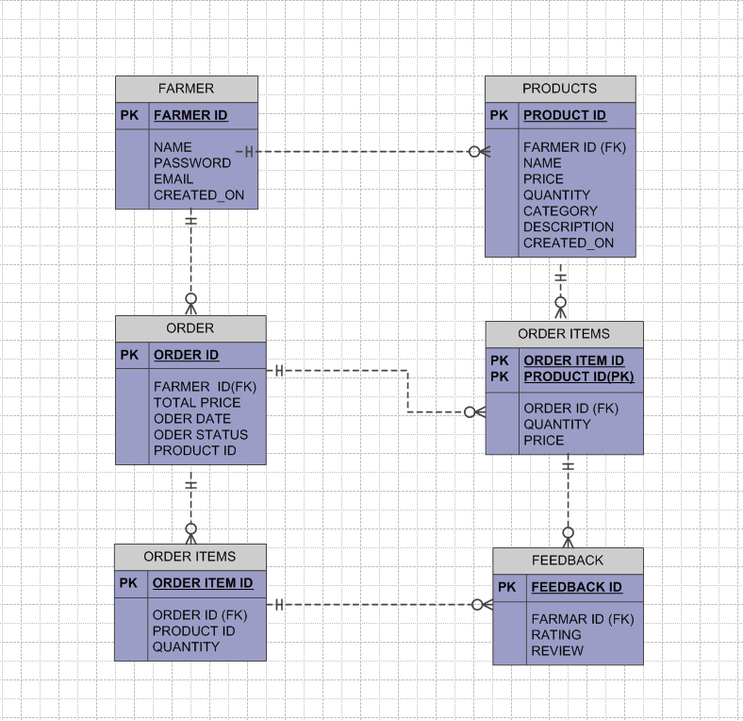
P ID

QUESTION 7 –
- WHAT IS DATA FLOW DIAGRAM ? DRAW A DATA FLOW DIAGRAM

THE DATA FLOW DIAGRAM IS A VISUAL REPRESENTATION THAT SHOW THE CLEAR PICTURE ABOUT HOW DATA MOVES THROUGH A SYSTEM OR PROCESS USING SYMBOLS LIKE ARROWS , RECTANGLES ,CIRCLES AND TEXT LABLES TO DEPICT DATA FLOW AND TRANSFORMATION
SOME OF THE KEY ELEMENTS ARE –
PROCESSES(CIRCLES OR RECTANGLES)-
IT REPRESENT ACTIONS OR TRANSFORMATIONS THAT DATA UNDER GOES .
DATA FLOWS( ARROWS)
IT SHOWS THE MOVEMENT OF DATA BETWEEN PROCESSES ,INPUTS ,OUTPUTS AND STORES
DATA STORES(RECTANGLES WITH OPEN SIDES)
IT REPRESENT PLACES WHERE DATA IS STORED SUCH AS DATA BASES OR FILES
EXTERNAL ENTITIES(RECTANGLES)
IT REPRESENT SOURCES OR DESTINATIONS OF DATA OUT SIDE THE SYSTEM WHICH IS BEING MODEL.
TEXT LABELS
USED TO DESCRIBE THE DATA,PROCESSES AND STORES

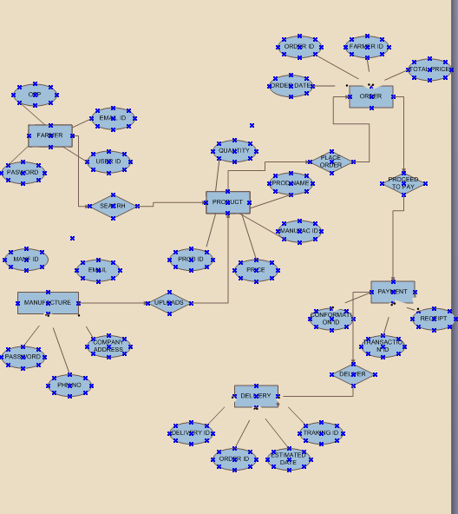

QUESTION 8 –
HOW TO HANDLE CHANGE REQUEST IN THE PROJECT –
A change request is a formal proposal for an alternation to a product system or project often which is initiated by the client or team member and requiring a structured process for evaluation and approval.
DEFINATION
A change request is a formal document that outlines a proposed modification to a project ,system and product.
PURPOSE
IT serves as a mechanism to mange the changes during a projects life cycle and ensuring that any alteration are documented assed for impact and it is approved before implementation
KEY ELEMENTS-
PROJECT NAME-IT clearly identifies the project to which the change request applies
REQUEST NUMBER- An identification for the change request
REQUESTER – The individual or a team who initiating the change request
DESCRIPTION FOR CHANGE- A Detailed explanation for the proposed change
REASON FOR CHANGE -Justification for why change is been needed
IMPACT OF THE CHANGE -Assessment of the potential effects of the change on the project scope ,schedule, budget and quality.
PROPOSED ACTION- the specification or actions required to implement the change
BUSINESS PRIORITY- The importance of the change is been related to the over all project goal.

CHANGE REQUEST PROCESS
COLLECT INFORMATIOM -
Gathering the all necessary documentation and information related to the proposed change .
EVALUATE IMPACT –
Asses the potential impact by the change request in the project.
PRIORITIZE
Determines the priority of the change request based on the importance and urgency and by this verifiy the impact assessment and seeing the risk analysis.
APPROVE or REJECT
Review and either approve or rejects the change request
PLAN IMPLEMENTATION
If the approval is done then plans the implementationof the change
TYPES OF THE CHANGE REQUEST.
-STANDARD CHANGES
Pre-authorized , low-risk changes that follow a well known procedure
-EMERGENCY CHANGES
Changes that must be implement immediately to resolve a major incident
-NORMAL CHANGES
All other change which is not standard changes and emergency changes are the normal changes .

QUESTION 9
CHANGE REQUEST V/S AN ENHANCEMENT
Both the change request and the enhancement involve in the modification some difference we have is enhancements are improving the existing functionality or features and in change request are broader proposal for altering the project ,product or system ,potentially including the enhancements new features or fixes.

ENHANCEMENT
- Focus -
It improves existing functionality and make it more efficient and powerful.
- Purpose –
It improves efficiency and capability of the project (or) system.
- Example- as our project is online agriculture store farmers want to sell the crops in this app so this app is usefull for buying and selling transactions

- Nature-
Often considered nice to have improvements, not necessarily critical for project’s core functionality.
CHANGE REQUEST
- Focus –
Any modification to a project, product, system, including enhancement , new features or fixtures.
- Purpose-
To address change in requirements, scope, or deliverables.
- Example- A change request might involve in adding new report of software application changing the way a button is positioned or fixing a bug that prevent a specific function from working correctly
- Nature –
Can be critical for project’s success as they address changes in requirements or address defects.
- Process-
Change request typically go through a formal process of review, approval and implementation.

AS THE PROJECT IS IN PROCESS,BEN AND KEVIN HAVE CONTACTED YOU. THE REASON IS TO INFORM YOU THAT THEY WANT FARMERS TO SELL THEIR CROP YIELDS THROUGH THIS APPLICATION i.e. FARMERS SHOULD BE ABLE TO ADD THEIR CROP YIELDS OR PRODUCTS AND DISPLAY TO GENERAL PUBLIC AND SHOULD BE ABLE TO SELL THEM . THEY ALSO WANT TO INTRODUCE AUCTION SYSTEM FOR THEIR CROP YIELD AS A BA, WHAT WILL BE YOUR REPONSE? THIS IS CHANGE REQUEST OR ENHANCEMENT??

Yes both these statements are enhancements.

ENHANCEMENT
- Purpose –
It improves efficiency and capability of the project (or) system.
- Origin-
Can come from users, customers, or internal teams.
- Examples-
1)Adding new feature to a website.
2) improve performance of software application.
- Process-
Enhancement request are typically reviewed and prioritized by development
team.
- Impact-
Enhancement can improve user satisfaction, increase product value and enhance the overall user experience.

QUESTIO 10 – Estimations 6 marks come up with estimations – how many man hours required?
To estimations the man hours required for an online agriculture store , we need to consider various stages of software development life cycle (SDLC) from planning to deployment . as we are In online agriculture store project ,it should be gather requirement from the rural areas as it should be user friendly to the user in rural area .

Man hours are the required efforts of the resources to complete a project as there are three typws of projects
- Small projects upto 500 hours
- Medium project upto 1000 hours
- Large project upto 1500 hours
As it has 18 months of the duration this is an large project
PHASE | JUSTIFICATION | ESTIMATED MAN HOURS
REQUIREMENT GATHERING | AS WE SHOULD CONDUCT THE ELICITATION TECHNIQUES AND GATHER THE REQUIREMENTS FROM THE STAKE HOLDERS | 140-160 HOURS
UI / UX DESIGN | WE SHOULD DO THE WORK FRAMES , PROTOTYPINGS AND REPONSIVE DESIGNS | 150-180 HOURS
CODE / TESTING | WRITING CODE DESIGN AND TESTING IN SYSTEM MOBILES | 140-160 HOURS
PAYMENT INTEGRATION | UPI , CARDS , RAZORPAY , PAYTM ETC.ALL PAYMENT INTIGRATION | 80-90 HOURS

QUESTION 11
UAT- 6MARKS PROJECT HAS FINALLY COMPLETED ALL STAGES i.e. DESIGN, DEVELOPMENT, TESTING ETC. NOW , IT IS ROLE OF A BUSINESS ANALYST TO CONTACT THE CLIENT FOR TESTING OF FINAL PRODUCT AND HAVE TO SUCESSFULLY COMPLETE IT. HOW ARE YOU GOING TO HANDLE THIS SITUATION? AND ONCE IT IS DONE, WHAT WILL BE THE PROCESS TO CLOSE THE PROJECT? EXPLAIN UAT ACCEPTANCE PROJECT?
User acceptance testing (UAT) is a crucial phase in software development where real users test software to ensure it meets the needs and expectations in real world scenarios.
PURPOSE-
- EARLY ISSUE DETECTION –
UAT helps identify potential issues and discrepancies before software is released.
- REDUCE POST-RELEASE ISSUES-
It can reduce the issues that arise after the software is released.
KEY STEPS –
- PLANNING –
Determine the scope of UAT and select representative group of end-users or stakeholders to participate. Develop a plan that analyses the objectives, test cases and outcomes of the project.
- TEST CASE DEVELOPMENT-
Create test cases based on user requirements and business needs and prioritize them based their importance and impact on user experience.
- EXECUTION AND REPORTING-
Conduct UAT and execute the created text cases . record the defects identified during UAT and prioritize the defects based on their severity and impact on user experience.
- DEFECT RESOLUTION AND RE-TESTING
Address and fix the defects identified and and retest the software to ensure the defects are solved.
- SIGN- OFF AND RELEASE-
After all the defects are solved obtain signoff from the users or stakeholders to proceed and release the software.
BENEFITS-
- UAT Improves the software quality .
- As we identify the issues before releasing the software , it saves time and cost of the user.

After successful User Acceptance Testing (UAT) , project closure involves obtaining signing off, documenting test results, addressing remaining issues and preparing for final release
CLOSURE PROCESS AFTER UAT-
- OBTAINING SIGN-OFF –
- Document tester approval:
The most important step after UAT is to document the tester’s approval signifying that system the system meets all the requirements of users and is ready to release.
- sign off methods-
Consider using email approvals or physical signature.
- Communicate next steps :
Explain next steps of the project to testers to address any concerns.
- DOCUMENT TEST RESULTS AND FINALISE REPORTS-
- Create report :
Group all the reports including defect reports bug verification.
- Sign-off on the report :
Ensure that all the stakeholders sign-off on the report ,confirming that all test are conducted and issues are addressed.
- ADDRESSING ISSUES AND PREPARE FOR RELEASE -
- Prioritize and resolve bugs:
Resolve the high priority defects identified during UAT.
- User training and documentation:
Arrange for user training and ensure that all the required documents are finalized and available.
- Prepare for post release support:
Plan for post release support that includes feedback.
- PROJECT CLOSURE-
- Finalize project documents :
Ensure that all the documents related to project like test plans, test cases, and final reports are accessible.
- RELEASE THE PRODUCT :
Deploy the product to production along with the finalised release plan.

QUESTION12 – PROJECT CLOSURE DOCUMENT- 6 MARKS
EXPLAIN PROJECT CLOSURE DOCUMENT
A project closure document is a formal document that summarises the final
outcome of a project and documents the lesson learned for future project.
- PURPOSE-
- Formal project completion:
It officially signals the end of project.
- Performance evaluation:
It provides the review of the project and helps to improve in future projects.
- Stakeholder communication:
It communicates the final project result and lessons learned to stakeholders.

- Resource release:
It facilitates the release of project resources and transition of project deliverables to the operation team.
- Lessons learned:
It captures key insights and best practices from the project that can help in improvement for future project.
- Contract closure:
It ensures whether all the agreements related to project are properly closed.

- KEY ELEMENTS-
- Project goals and objectives:
It provides a summary of initial goals of the project and helps to verify whether they were achieved.
- Deliverables and acceptance
A list of final deliverables and conformation of client acceptance
- Outstanding issues:
A list of any outstanding issues or tasks that need to be addressed after project closure.
- Stakeholder feedback:
It includes feedback the stakeholders involved in project.

- Resource release:
A plan for releasing project resources and transferring ownership of deliverables.
- Financial reconciliation:
It gives confirmation that all project related financial obligations have been met.
- Contract closure:
It ensures whether all the agreements related to project are properly closed.

s.no | Points to include | details | Reference link
1 | Did the client sign- off UAT testing | yes | Businesscase.docx
2 | Date of sign off | 20th June 2025
3 | Name of resource
4 | Objectives of project
5 | User friendly | Achieved
6 | Customer satisfaction | ROI in 6 months
7 | More categories | Achieved
8 | Functionality to worked on
9 | Secure payment processing | Achieved
10 | Categories | Achieved
11 | Infrastructure
12 | Software installed | Achieved
13 | Laptops purchased | Achieved
14 | Funding
15 | Amount approval | 2 crore | Financialbreakdown.docx
16 | Amount used | 1.4 lakhs
17 | Overall project info
18 | Escalations | 50
19 | Customer satisfaction | high
20 | Value to the company
21 | Positive/negative |  | 90% company gained edge over others, trained employees, increased clients, new project in pipeline

