**Capstone Project 1- Part II**

**Online Agriculture Store**

**Mr. Henry,** after being successful as a businessman and has become one of the wealthiest persons in the city. Now, **Mr. Henry wants to help others to fulfil their dreams**. One day, Mr. Henry went to meet his childhood friends **Peter, Kevin and Ben**. They live in a remote village and do farming. Mr. Henry asked his friends if they are facing any difficulties in their day-to-day work. **Peter told Mr. Henry that he is facing difficulties in procuring fertilizers** which are very important for farm. **Kevin said that he is also facing the same problem in-case of buying seeds for farming certain crops.**

**Ben raised his concern on lack of pesticides** which could help in greatly reducing pests in crops. After listening to all his friends’ problems, Mr. Henry thought that this is a crucial problem faced not only by his friends but also **by so many other farmers.** So, Mr. Henry **decided to make an online agriculture product store** to facilitate remote area farmers to buy agriculture products. Through this Online Web / mobile Application, Farmers and Companies (Fertilizers, seeds and pesticides manufacturing Companies) can communicate directly with each other.

**The main purpose to build this online store is to facilitate farmers to buy seeds, pesticides, and fertilizers from anywhere through internet connectivity**. Since new users are involved, Application should be user friendly**. This new application should be able to accept the product (fertilizers, seeds, pesticides) details from the manufacturers and should be able to display them to the Farmers**. Farmers will browse through these products and select the products what they need and request to buy them and deliver them to farmers location.

**Mr Henry has given this project through his Company SOONY**. In SOONY Company, **Mr Pandu is Financial Head and Mr Dooku is Project Coordinator. Mr. Henry, Mr Pandu, and Mr Dooku formed one Committee and gave this project to APT IT SOLUTIONS company for Budget 2 Crores INR and 18 months Duration under CSR initiative.** Peter, Kevin and Ben are helping the Committee and can be considered as Stakeholders share requirements for the Project.

**Mr Karthik is the Delivery Head in APT IT SOLUTIONS** company and he reached out to Mr Henry through his connects and bagged this project. APT IT SOLUTIONS company have Talent pool Available for this Project. **Mr Vandanam is project Manager, Ms. Juhi is Senior Java Developer, Mr Tayson, Ms Lucie, Mr Tucker, Mr Bravo are Java Developers. Network Admin is Mr Mike and DB Admin is John. Mr Jason and Ms Alekya are the Tester. And you joined this team as a BA.**

**Question 1 – Audits - 5 Marks**

**4 Quarterly Audits are planned Q1 , Q2, Q3, Q4 for this Project What is your**

**knowledge on how these Audits will happen for a BA ?**

As a Business Analyst (BA), your role in audits will primarily involve ensuring that business requirements, project documentation, and compliance measures align with project goals and organizational standards. Here's how the **four quarterly audits (Q1, Q2, Q3, Q4)** will likely happen and what your involvement will be:

|  |  |
| --- | --- |
| Stage | Quarter 1 Audit Report  Requirement Gathering |
| Completed | 10 Weeks (Week 1 to Week 10) |
| Checklist | BRD Document |
|  | Elicitation Report |
|  | Duplicate requirement Report |
|  | Grouping of functionalities and Client Signoff |
|  | Email communication to CC, BCC |
|  |  |

|  |  |
| --- | --- |
| Stage | Quarter 2 Audit Report  Requirement Analysis |
| Completed | 7 Weeks (Week 16 to Week 23) |
| Checklist | UML Diagram |
|  | Business to Functional Requirement mapping |
|  | Client Signoff Documents |
|  | RTM document version control |
|  | Email communication to CC, BCC |
|  |  |

|  |  |
| --- | --- |
| Stage | Quarter 3 Audit Report  Design |
| Completed | 7 Weeks (Week 30- to Week 37) |
| Checklist | Utilization of Tools |
|  | Documented evidence on client communication |
|  | Stakeholder MOM |
|  | Email communication to CC, BCC |
|  |  |
|  |  |

|  |  |
| --- | --- |
| Stage | Quarter 4 Audit Report  Development |
| Completed | 7 Weeks (Week 30- to Week 37) |
| Checklist | JAD session report |
|  | End user Manual preparation document |
|  | BA and Developer MOM |
|  | Email communication to CC, BCC |
|  |  |

|  |  |
| --- | --- |
| Stage | Quarter 4 Audit Report  Testing |
| Completed | 20 Weeks (Week 58- to Week 78) |
| Checklist | Test case summery |
|  | Training report to end user |
|  | Lesson learnt document |
|  | Email communication to CC, BCC |
|  |  |

**Question 2 – BA Approach Strategy**

**Before the Project is going to Kick Start, The Committee asked Mr Karthik to submit BA Approach**

**Strategy. Write BA Approach strategy (As a business analyst, what are the steps that you would need to follow to complete a project –**

1. **What Elicitation Techniques to apply.**
2. **How to do Stakeholder Analysis**
3. **What documents to Write**
4. **RACI/ILS, What Documents to Write.**
5. **What process to follow to Sign off on the Documents,**
6. **How to take Approvals from the Client**
7. **What Communication Channels to establish n implement.**
8. **How to Handle Change Requests**
9. **How to update the progress of the project to the Stakeholders**
10. **How to take signoff on the UAT- Client Project Acceptance Form)**
11. **What Elicitation Techniques to apply.**

We have many elicitation techniques to apply that used to gather the requirements

Some of them are:- Brainstorming, Document Analysis, Focus groups, observation etc..

1. **How to do Stakeholder Analysis**

Stakeholder analysis can be done by RACI Matrix. It involves identifying stakeholders and defining their roles and responsibilities within project.

1. **What documents to write**

BRD, FRD, use case documentation, Test case documents etc.

1. **What process to follow to Sign off on the Documents**

Signoff to be taken on SRS as it is a primary and important document. Sign off can be taken by using email confirmation from client.

1. **How to take approval from the client?**

Establish the formal meeting with the clients to keep them informed and get continuous feedback.

1. **What communication channel to establish and implement**

Regular meetings, weekly status meetings, bi-weekly sprint reviews and monthly stakeholder updates.

1. **How to handle change request**

Change request form, Do impact Analysis, Approval process documentation.

1. **How to update the progress of the project to the stakeholders.**

Weekly status report, Monthly review meetings.

1. **How to take signoff on UAT- client project acceptance form**

UAT preparation, Conduct UAT, Fix issues, Acceptance form, Final review meeting, obtain signoff.

**Technical Team have assembled to discuss on the Project approach and have finalised to follow 3-tier**

**architecture for this project.**

**Question 3 – 3-Tier Architecture - 5 Marks**

**Explain and illustrate 3-tier architecture?**

**A 3-tier architecture typically consists of:**

1. **Application Layer (Frontend)** –

* This is the topmost layer where users interact with the system.
* It Handles user interface components such as screen, pages
* It includes web-based, mobile, or desktop interfaces that send user requests to the business logic layer.
* E.g. – E-commerce website
* Technologies: **React, Angular, Vue.js, HTML, CSS, JavaScript**

1. **Business Logic Layer (Backend)** –

* Middle layer of the Architecture
* Acts as an intermediatory in between the presentation layer and the database layer.
* This layer contains the core logic of the application.
* E.g. Printer and the payment Gateways.
* Technologies: **Java (Spring Boot), .NET, Python, Node.js**

1. **Data Layer (Database) – Database management and queries.**

* Bottommost layer of the architecture
* Responsible for storing and retrieving data
* E.g. MySQL, Oracle Database.

*My role as a BA will involve ensuring requirements align with this architecture, facilitating communication between stakeholders and developers, and supporting UAT. Do you need help documenting this decision or defining roles within the architecture?*

***3 Tier Architecture***

3Tier Architecture

Client computers

DB Server

Application Server

Database Tier

Business logic Tier

Client Tier

**Question 4 – BA Approach Strategy for Framing Questions**

**Business Analyst should keep What points in his/her mind before he frames a Question to ask to**

**the Stakeholder.**

**(5W 1H – SMART – RACI – 3 Tier Architecture – Use Cases, Use case Specs, Activity**

**Diagrams, Models, Page designs)**

1. **5W1H:** Is a useful tool for gathering the information and understanding a situation by answering questions about who, what, when, where, why and how.
2. **The SMART** technique can help in creating questions.

(Specific, Measurable, Attainable, Relevant and Time Bound)

1. **RACI Charts** help define and clarify roles and responsibilities within a team by outlining who is responsible, accountable, consulted & Informed.
2. UML: Unified modelling language is a standard way of diagramming and modelling software system to aid in design , development and communication between team members

**1. 5W1H Framework (Who, What, When, Where, Why, How)**

This technique ensures comprehensive requirement gathering.

|  |  |
| --- | --- |
| **Question Type** | **Purpose** |
| **Who** | Identifies the users, stakeholders, and responsible parties. |
| **What** | Defines the requirements, features, and functionalities. |
| **When** | Determines project timelines, milestones, and deadlines. |
| **Where** | Identifies where the system will be used (desktop, mobile, remote areas). |
| **why** | Justifies the need for specific requirements. |
| **How** | Understands the implementation and workflow. |

**2. SMART Criteria (Specific, Measurable, Achievable, Relevant, Time-bound)**

**All requirements should be SMART to ensure clarity and feasibility.**

* Specific – Clearly defined requirements.
* Measurable – Requirements should have quantifiable success criteria.
* Achievable – Ensure feasibility with available resources.
* Relevant – Align with business objectives.
* Time-bound – Have a well-defined deadline.

1. **RACI Matrix (Responsible, Accountable, Consulted, Informed)**

Understanding roles and responsibilities helps in directing questions to the right stakeholder**.**

|  |  |
| --- | --- |
| **Role** | **Responsibility** |
| **Responsible** | The person executing the task (e.g., Developers, BA). |
| **Accountable** | The decision-maker (e.g., Project Manager, Sponsor). |
| **Consulted** | Experts providing input (e.g., SMEs, Architects). |
| **Informed** | Stakeholders who need updates (e.g., End-users, Clients). |
|  |  |

**4. 3-Tier Architecture Consideration**

**Questions should align with each layer of the architecture:**

* Application Layer: User experience, navigation, interface requirements.
* Business Logic Layer: Functional requirements, rules, and workflows.
* Data Layer: Data storage, retrieval, security, and integration**.**

**5. Use Cases, Use Case Specifications, Activity Diagrams, Models, Page Designs**

**A BA should structure questions around system behaviour and interaction:**

* **Use Cases –** Define actor-system interactions (e.g., "How should a farmer place an order?").
* **Use Case Specifications** – Detailed steps and alternate flows.
* **Activity Diagrams** – Process flow representation.
* **Models –** Data flow, system architecture, and ER diagrams.
* **Page Designs** – UI/UX considerations.

*Before framing questions, a BA should analyse all these aspects to ensure precise, well-structured, and relevant discussions with stakeholders****.***

**Question 5 – Elicitation Techniques**

***As a Business Analyst, What Elicitation Techniques you are aware of? ( BDRFOWJIPQU***

*As a Business Analyst (BA),* ***elicitation techniques*** *are used to gather requirements effectively from stakeholders. The acronym* ***BDRFOWJIPQU*** *represents various elicitation techniques, which are explained below:*

|  |  |  |
| --- | --- | --- |
| Acronym | Elicitation Technique | Explanation |
| B | Brainstorming | A group discussion to generate creative ideas and solutions. Useful for identifying risks, features, and enhancements. |
| D | Document Analysis | Reviewing existing documents (BRD, user manuals, reports) to gather requirements. |
| R | Research | Conducting market analysis, competitor benchmarking, and domain research to identify best practices. |
| F | Focus Groups | Engaging a group of stakeholders to discuss requirements and expectations collaboratively. |
| O | Observation | Watching end-users perform tasks in their environment to identify hidden or unspoken requirements. |
| w | Workshops | Interactive sessions where multiple stakeholders define requirements together, often using JAD (Joint Application Development). |
| J | JAD (Joint Application Development) | A structured workshop involving users, developers, and analysts to quickly define requirements. |
| I | Interviews | One-on-one discussions with stakeholders to gather detailed insights and requirements. |
| P | prototyping | Creating wireframes or mock-ups to validate and refine requirements before full development. |
| Q | Questionnaires & Surveys | Using structured forms to collect responses from a large audience efficiently. |
| U | Use case & senarios | Creating real-world user interaction scenarios to define system behaviour. |

**Question 6 – This project Elicitation Techniques - 5 Marks**

**Which Elicitation Techniques can be used in this Project and Justify your selection of Elicitation Techniques?**

* **Prototyping**
* **Use case Specs**
* **Document Analysis**
* **Brainstorming**

For the Online Agriculture Product Store project, the following elicitation techniques are suitable:

|  |  |
| --- | --- |
| Elicitation | Justification |
| **Prototyping** | Since the application is **new**, creating wireframes/prototype and mock-ups will help **visualize the user interface** and refine requirements based on stakeholder feedback. Farmers and manufacturers can provide input on UI/UX, making the application more user-friendly. |
| **Use case specs** | The project involves multiple user interactions (farmers, manufacturers, delivery services). **Use case specifications** will define **how users interact with the system**, ensuring clarity on different system behaviours and business rules. |
| **Document Analysis** | Reviewing **existing agriculture product sales records, competitor platforms, and relevant legal policies** will help in defining key features like payment processes, order tracking, and delivery mechanisms. |
| **Brainstorming** | Since multiple stakeholders (Mr. Henry, Peter, Kevin, Ben, and the technical team) are involved, **brainstorming sessions** will help generate ideas for feature enhancements, payment methods, and delivery logistics. It also helps in identifying risks and challenges early in the project. |

A combination of **Prototyping, Use Case Specs, Document Analysis, and Brainstorming** will ensure **thorough and effective requirement gathering** for this project. This structured approach will help define a **user-friendly, efficient, and scalable** system for farmers and manufacturers.

A **BA should ideally use multiple elicitation techniques**, but if only one can be chosen, it depends on the project's needs. **Prototyping or Use Case Specifications** would be the most impactful for this project since they help in structuring requirements effectively.

**Question 7 – 10 Business Requirements- 10 Marks**

**Identify Business Requirements (which includes Stakeholder Requirements)**

**Make suitable Assumptions and identify at least 10 Business Requirements.**

**Question 8 –Assumptions- 5 Marks**

**List your assumptions**

**(I have covered the assumptions in the table as follows)**

**Business Requirements Document (BRD)**

Project Name: Online Agriculture Product Store  
Client: SOONY Company  
Key Stakeholders: Mr. Henry, Peter, Kevin, Ben  
Business Analyst: Rashmi

|  |  |  |  |
| --- | --- | --- | --- |
| **ID** | **Requirement** | **Stakeholder** | **Assumption** |
| **BR-01** | The system should allow new users (farmers & manufacturers) to register using their email ID and a secure password. | Mr. Henry | Users will verify their email during registration |
| **BR-02** | The system should have a login feature for all users (farmers & manufacturers). | MR. Henry | Only registered users can access certain features like buying products. |
| **BR-03** | The system should provide a product catalogue for fertilizers, seeds, and pesticides that users can browse. | Kevin | The catalogue will be categorized for easy navigation. |
| **BR-04** | A search option should be available to allow farmers to search for products easily. | Kevin | A search option should be available to allow farmers to search for products easily. |
| **BR-05** | Farmers should be able to add products to a "buy later" list before making a purchase. | Ben | The list will be saved in the user account |
| **BR-06** | The system should support multiple payment options, including Cash-on-Delivery (COD), Credit/Debit Cards, and UPI. | Ben | Secure payment gateway will be required |
| **BR-07** | After placing an order, the system should send an email confirmation with order details. | Kevin | The email will contain product details, order number, and expected delivery time. |
| **BR=09** | A delivery tracking feature should be available so that farmers can track their orders. | Mr. Henry | A manufacturer login portal will be required. |
| **BR-09** | Manufacturers should be able to upload product details (fertilizers, seeds, pesticides), including pricing and stock availability. | Mr Henry | A manufacturer login portal will be required. |
| **BR-10** | The system should have an **easy-to-use interface** suitable for farmers with minimal technical knowledge. | Peter | The UI/UX will focus on **simplicity and accessibility.** |

**These 10 business requirements ensure that the Online Agriculture Product Store provides a user-friendly experience, secure transactions, and efficient order management.**

**Question 9 – This project Requirements Priority - 8 Marks.**

**Give Priority 1 to 10 numbers (1 being low priority – 10 being high priority ) to these Requirements after discussions with the stakeholders.**

|  |  |  |  |  |
| --- | --- | --- | --- | --- |
| **ID** | **Requirement** | **Stakeholder** | **justification** | **Priority** |
| **BR-01** | The system should allow new users (farmers & manufacturers) to register using their email ID and a secure password. | Mr. Henry | User registration is essential for accessing the platform and making transactions. | 10 |
| **BR-02** | The system should have a login feature for all users (farmers & manufacturers). | MR. Henry | Logging in is necessary for personalized access and order management. | 10 |
| **BR-03** | The system should provide a product catalogue for fertilizers, seeds, and pesticides that users can browse. | Kevin | The catalog is critical for product discovery and selection. | 9 |
| **BR-04** | A search option should be available to allow farmers to search for products easily. | Kevin | Enhances usability, making product discovery more efficient. | 8 |
| **BR-05** | Farmers should be able to add products to a "buy later" list before making a purchase. | Ben | A useful feature but not critical for system functionality. | 5 |
| **BR-06** | The system should support multiple payment options, including Cash-on-Delivery (COD), Credit/Debit Cards, and UPI. | Ben | Essential for smooth transactions and user convenience. | 9 |
| **BR-07** | After placing an order, the system should send an email confirmation with order details. | Kevin | Important for user trust and order tracking, but not a blocker for purchase. | 7 |
| **BR=09** | A delivery tracking feature should be available so that farmers can track their orders. | Mr. Henry | Useful but not immediately required for placing an order. | 6 |
| **BR-09** | Manufacturers should be able to upload product details (fertilizers, seeds, pesticides), including pricing and stock availability. | Mr Henry | Ensures updated product listings and availability. | 9 |
| **BR-10** | The system should have an **easy-to-use interface** suitable for farmers with minimal technical knowledge. | Peter | Critical for adoption and usability by farmers. | 10 |

* **High-priority (8-10): User registration, login, catalog, payments, and UI/UX design.**
* **Medium-priority (5-7): Order confirmation emails, delivery tracking, and search functionality.**
* **Low-priority (1-4): Features like the "buy later" list that enhance usability but do not impact core functionality.**

**Once the requirements are finalized, as a business analyst, one of the major roles is to act as a liaison between the client and the project team. To gather the requirements correctly from the client side and then to deliver those requirements to the project team in a way they understand. To make the project team understand the requirements, you need to convert those requirements into UML diagrams and screen mock-ups.**

**Question 10 – Use Case Diagram - 10 Marks**

**Draw use case diagram**

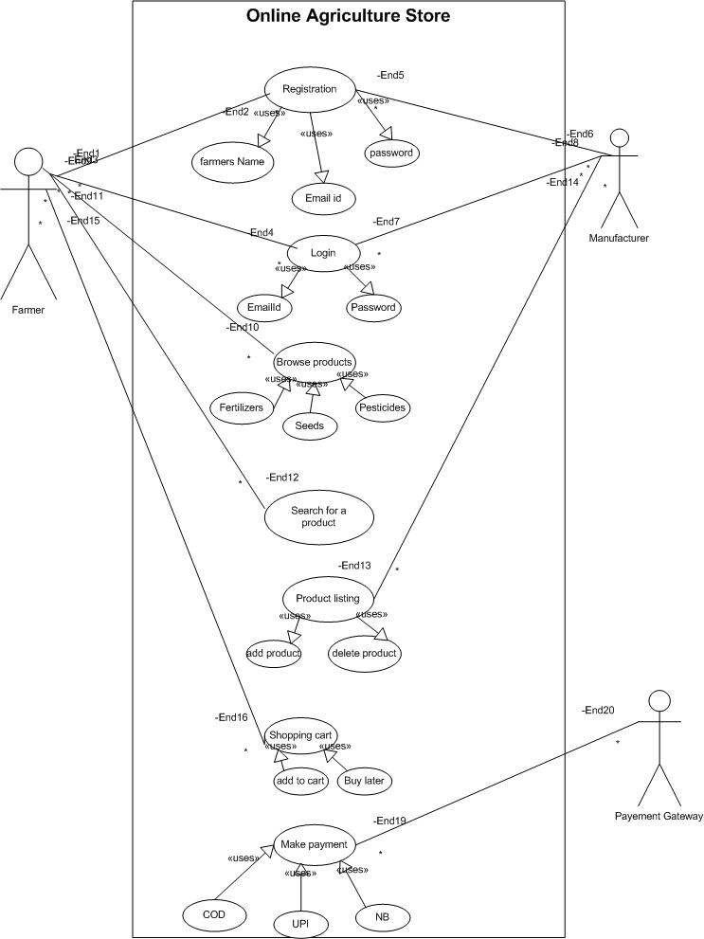

**Continue…**

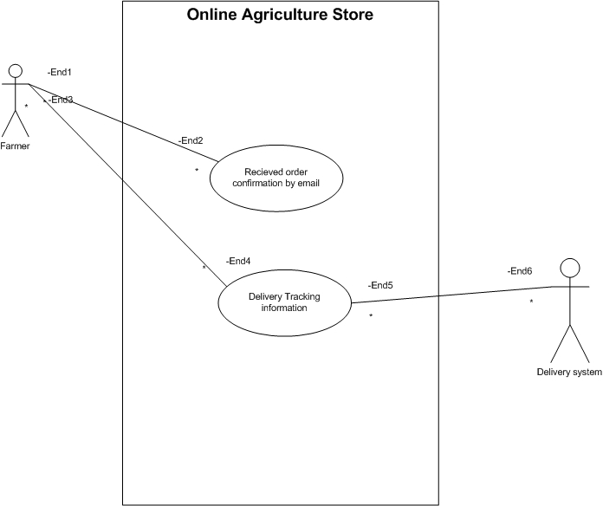

**Use case diagram**

**Question 11 – (minimum 5) Use Case Specs - 15 Marks**

**Prepare use case specs for all use cases.**

**Use case specification document which provides a detailed description of a use case, outlining how users (actors) will interact with the system to achieve a specific goal.**

1. **Use Case I: User Registration.**

|  |  |
| --- | --- |
| **Use case Id** | **UC-01** |
| **Use case name** | User Registration |
| **Actors** | Farmer and Manufacturer |
| **Precondition** | User must have a valid email ID and internet access |
| **Description** | Allows a new user (Farmer or Manufacturer) to create an account |
| **Trigger** | User clicks on “Register” |
| **Flow of the event**  **(Alternative)** | * User selects "Register" option * System prompts user to enter email, password, and role (Farmer/Manufacturer) * User enters details and submits * System validates input and creates account * Confirmation email is sent | |
| **Exceptional Flow** | * If email is already registered → System displays error message * If password is weak → System suggests a stronger password |

1. **Use Case II: User Login**

|  |  |
| --- | --- |
| **Use case Id** | **UC-02** |
| **Use case name** | User Login |
| **Actors** | Farmer and Manufacturer |
| **Precondition** | User must have an existing account |
| **Description** | Allows a user to log in to the system |
| **Trigger** | User clicks on "Login" |
| **Flow of the event**  **(Alternative)** | * User enters email and password * System verifies credentials * If valid, user is granted access * If invalid, an error message is shown |
| **Exceptional Flow** | * If the user forgets the password → User can reset password via email * User is logged in and redirected to the dashboard | |

**3. Use Case III: Browse and Search Products**

|  |  |
| --- | --- |
| **Use case Id** | **UC-03** |
| **Use case name** | Browse and search product |
| **Actors** | Farmer |
| **Precondition** | User must be logged in |
| **Description** | Farmers can browse product categories or search for specific products |
| **Trigger** | User selects the product catalog or enters a search query |
| **Flow of the event**  **(Alternative)** | * User opens the product catalog * User browses available categories- Fertilizers, seeds , pesticides * User enters the keyword in the search bar * System displays matching products |
| **Exceptional Flow** | * If no matching products are found- system shows “no result found” message * User can vies product details and add items to the cart. |

1. **Use Case IV: Place Order**

|  |  |
| --- | --- |
| **Use case Id** | **UC-04** |
| **Use case name** | Place Order |
| **Actors** | Farmer |
| **Precondition** | User must be logged in and have items in the cart |
| **Description** | Farmers can place an order for selected products |
| **Trigger** | User clicks on "Place Order" |
| **Flow of the event**  **(Alternative)** | * User reviews the cart * User selects the delivery address * User chooses a payment method (COD, UPI, Credit/Debit Card) * System processes payment and confirms the order * Confirmation email is sent | |
| **Exceptional Flow** | * If payment fails → System prompts user to retry * Order is placed and ready for shipment |

1. **Use Case v: Track Order**

|  |  |
| --- | --- |
| **Use case Id** | **UC-05** |
| **Use case name** | Track Order |
| **Actors** | Farmer |
| **Precondition** | User must have placed an order |
| **Description** | Farmers can track the delivery status of their order |
| **Trigger** | User clicks on "Track Order" |
| **Flow of the event**  **(Alternative)** | * User navigates to "My Orders" * User selects an order * System retrieves order tracking details * System displays order status (Processing, Shipped, Out for Delivery, Delivered) |
| **Exceptional Flow** | * If tracking information is unavailable → System shows "Tracking not available yet" * User gets the latest order status |

**Question 12 – (minimum 5) Activity Diagrams - 15 Marks**

**Activity diagrams**

An activity diagram is a type of diagram in UML That visually represents the flow of the activities within a system

Activity diagrams visually represent the workflow of different processes in the **Online Agriculture Product Store**. Below are five key activity diagrams:

1. **User Registration & Login**
2. **Product Browsing & Searching**
3. **Adding Products to Cart & Checkout**
4. **Payment Process**
5. **Order Tracking**

**---------------------------------------------------------------------------------------------------------**

1. **User Registration & Login**

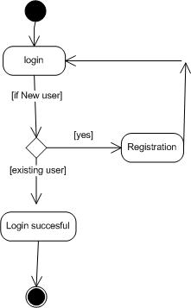 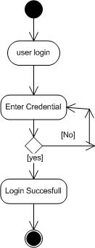

1. **Product browsing and searching**

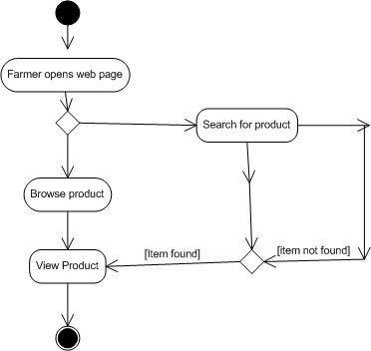

1. **Adding Products to Cart & Checkout**

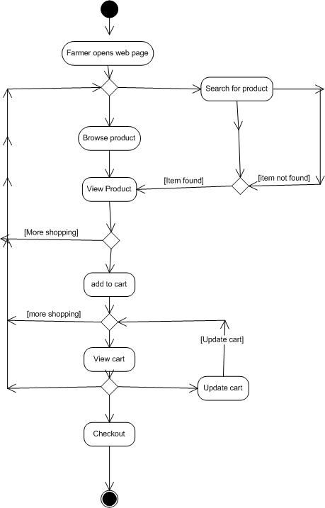

1. **Payment Process**

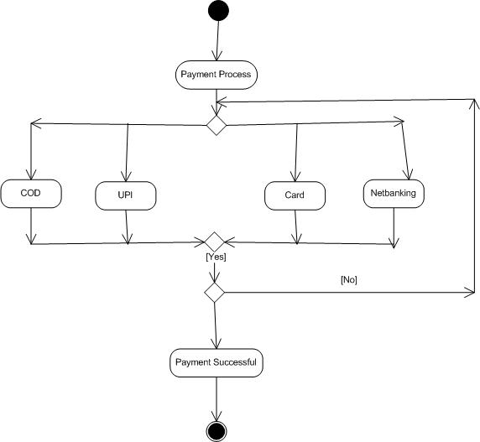

1. **Order Tracking**

