**Waterfall Model Documents - Part -2/2**

**Document 6- Please prepare a use case diagram, activity diagram and a use case specification document.**

**Use Case Diagram**



**Activity Diagram**

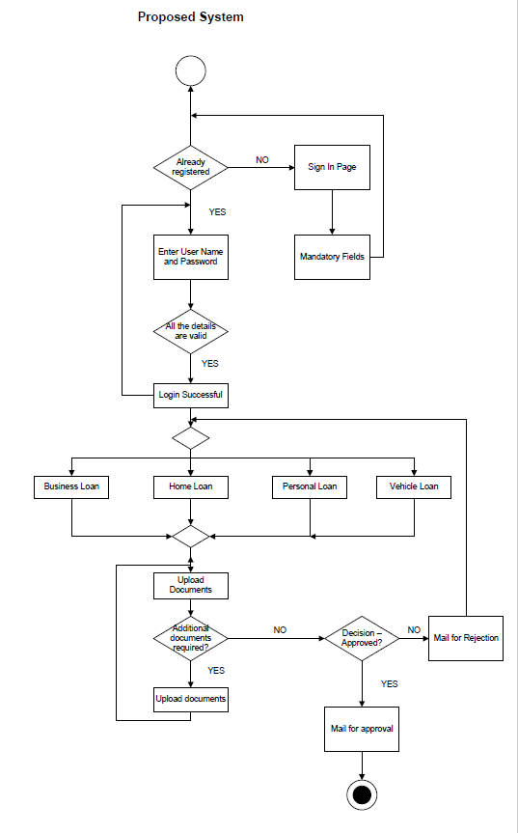

**Use Case Specification Document**

|  |  |
| --- | --- |
| **USE CASE ID** | UCD001 |
| **USE CASE NAME** | REGISTRATION |
| **PRIMARY ACTORS** | Customers |
| **SECONDARY ACTORS** | Database Admin |
| **BRIEF DESCRIPTION** | This use case describes how users will register to use the app/web page |
| **PRE-CONDITION** | Users are not registered previously |
| **POST CONDITION** | Successful login page |
| **BASIC FLOW** | Username and Password are entered correctly, mobile number and email entered correctly, click on submit, successful login page appears |
| **ALTERNATIVE FLOW** | Password is wrong, Username is wrong, error page appears |
| **EXCEPTIONAL FLOW** | Forgot username, forgot password, reset page appears |
| **FREQUENCY** | High |
| **ASSUMPTIONS** | There is internet connectivity, users have basic mobile knowledge |

|  |  |
| --- | --- |
| **USE CASE ID** | UCD002 |
| **USE CASE NAME** | LOGIN |
| **PRIMARY ACTORS** | Customers |
| **SECONDARY ACTORS** | Database Admin |
| **BRIEF DESCRIPTION** | This use case describes how users will login to use the app/web page |
| **PRE-CONDITION** | Customers are already registered |
| **POST CONDITION** | Successful login page |
| **BASIC FLOW** | Username and Password are entered correctly, click on submit, successful login page appears |
| **ALTERNATIVE FLOW** | Password is wrong, Username is wrong, error page appears |
| **EXCEPTIONAL FLOW** | Forgot username, forgot password, reset page appears |
| **FREQUENCY** | High |
| **ASSUMPTIONS** | There is internet connectivity, users have basic mobile knowledge |

|  |  |
| --- | --- |
| **USE CASE ID** | UCD003 |
| **USE CASE NAME** | SEARCH LOANS |
| **PRIMARY ACTORS** | Customers |
| **SECONDARY ACTORS** | Database Admin |
| **BRIEF DESCRIPTION** | This use case describes how users will choose the loan type from home loan, business loan, personal loan and vehicle loan |
| **PRE-CONDITION** | Users should select any one type of loan |
| **POST CONDITION** | Loan application page appears |
| **BASIC FLOW** | Click on the loan type, fill all the details of application form, save and proceed option appears |
| **ALTERNATIVE FLOW** | Any field left blank |
| **EXCEPTIONAL FLOW** | If any information is not in the prescribed format, system displays error message |
| **FREQUENCY** | High |
| **ASSUMPTIONS** | Users have all the required documents and information in pdf or jpeg format |

**Document 7- Screens and pages**

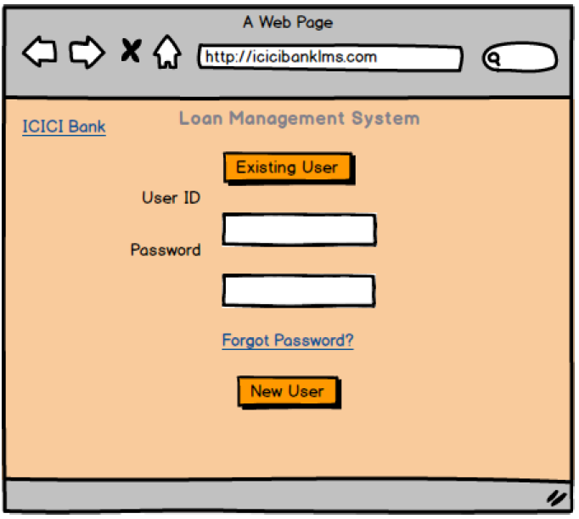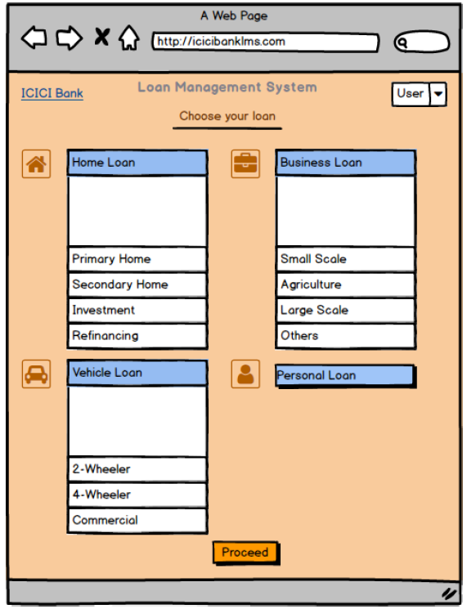

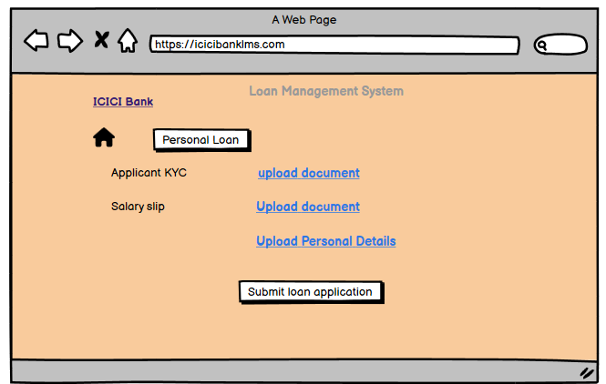

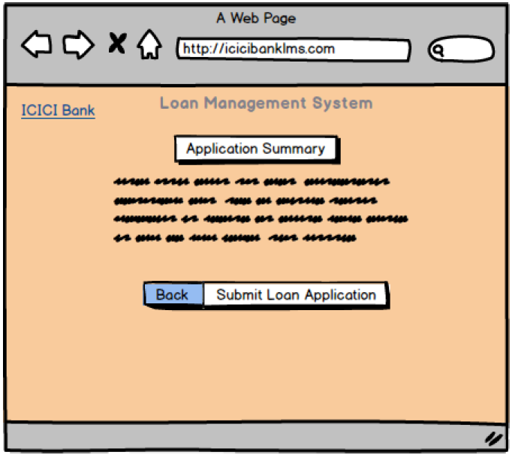

**Document 8- Tools-Visio and Axure**

Throughout the project, I leveraged Visio and Axure to create visual representations and interactive prototypes of the LMS enhancement system, enhancing both the design and development phases.

In MS **Visio**, I utilized its powerful diagramming tools to create detailed flowcharts, activity diagrams, and use case diagrams. The intuitive drag-and-drop interface allowed me to map out workflows such as Loan Searching, Applying for new loan and loan application status tracking in a clear, structured manner.

Visio's ability to connect various shapes and objects helped me maintain a consistent, organized visual structure, ensuring that stakeholders could easily understand the system's processes. Additionally, its integration with Microsoft tools made collaboration seamless, especially when incorporating feedback from team members or during meetings with the client.

On the other hand, I used **Axure** for creating interactive wireframes and high-fidelity prototypes that showcased the user interface (UI) and user experience (UX) of the enhanced LMS system. Axure's robust functionality allowed me to simulate dynamic interactions, such as, Loan Searching, Applying for new loan, loan application form, helping stakeholders visualize the actual user experience. The ability to add conditional logic and interactions made the prototype highly interactive, providing a realistic representation of how users would navigate the system. This was especially useful during user testing sessions, where real-time feedback could be gathered to iterate on design improvements.

Together, these tools not only enhanced collaboration among the project team and stakeholders but also provided a clear roadmap for developers and testers to follow. By leveraging Visio and Axure effectively, we were able to bridge the gap between business requirements and technical implementation, ensuring the project stayed on track and met its objectives.

**Document 9- BA experience**

**My experience as BA in following phases:**

**Requirement gathering:**

* We Identified the Stakeholders and gathered the requirement by doing Document Analysis and conducting Observation session with the employees and Interview session with the stakeholders to get more information about the Project.
* Once requirements were gathered, requirement sorting was done and we removed
* the duplicate and repeated requirements then validated the requirement using FURPS.
* Once the required requirements were validated, we prioritized the requirements according to the stakeholder needs using MoSCoW technique.

**Requirement Analysis:**

* In this phase we prepared UML diagram and Activity diagram.
  + Use case specifications was prepared with the help of Use Case diagram and we conducted meeting with the stakeholders to get information on the Use Case Specification.
  + BRD document was prepared by me and the same was shared with the Stakeholders for approval.
  + Functional specification Document and Non function document was merged and SRS document was prepared and was sent to client for sign off.
  + Once we got sign off on the SRS document, we prepared the RTM.

**Design:**

* In this phase we regularly provided update to the client about the progress of the project.
* Using the use case specification, I also prepared test cases for Testing.
* Training session was organized for the employees and end users.
* I also updated the RTM as per the designing of the requirements.

**Development:**

I worked closely with the development team to ensure that the application was developed according to the requirements gathered

* JAD session was conducted to clear the technical team doubts.
* We made sure that there are no technical doubts so that there is no problem while coding.
* Client was updated regularly about the Project progress.

**Testing:**

* Test cases were prepared using the Use Case Diagram.
* Training sessions were conducted for employees and end users and the manual was shared.
* We prepared client and the end user for UAT.
* Weekly meetings were conducted and sign off was taken from the client after the UAT.

**Deployment:**

* RTM along with Project Closure document was shared with the Client and Project Manager
* The project went Go Live and for few days, latency system ad proposed system was working simultaneously.