Question 1 – Functional Requirements:

Functional requirements define the specific behaviours, features, or functionalities of a system. They focus on what the system should do to fulfil user needs.

|  |  |  |
| --- | --- | --- |
| Req ID | Req name | Req Discription |
| FR001 | User Registration | Farmers and manufacturers can register with email and password |
| FR002 | User Login | Registered users can log in to access their accounts |
| FR003 | Product Catalog display | Farmers can browse fertilizers, seeds, and pesticides |
| FR004 | Seach Functionality | Farmers can search specific products using keywords |
| FR005 | Product upload | Manufacturers can upload and update product details |
| FR006 | Add to cart | Farmers can add products to a cart or buy-later list |
| FR007 | Payment option | Multiple payment option (COD, UPI, credit/debit cards) |
| FR008 | Order confirmation | Email notification are sent to users for order confirmation |
| FR009 | Delivery tracking | Users can track the status and location of their orders |
| FR010 | Support system | A contact or helpdesk feature for resolving issues |

Non functional requirements specify the quality attributes, performance, or constraints of a system. They focus on how the system should behave or operate.

|  |  |  |
| --- | --- | --- |
| Req ID | Req name | Req Discription |
| NFR001 | System performance | Each page should load within 2 seconds |
| NFR002 | Scalability | System should handle up to 10000 simultaneous users |
| NFR003 | Availability | Application must have 99.9% uptime |
| NFR004 | Security | the application must protect sensitive data by using secure authentication to prevent unauthorized access and data breaches |
| NFR005 | Accessibility | The system must comply with WCAG 2.1 for accessibility |
| NFR006 | Compatibility | The application should work on web and mobile application |
| NFR007 | Usability | The interface should be user-friendly for tech-savvy and non-tech-savvy users |
| NFR008 | Maintainability | The codebase should be modular and easy to update |
| NFR009 | Localization | The application should support multiple regional languages |
| NFR010 | Audit logs | All users actions should be logged for tracking |

Question 2–Minimum 5 page designs

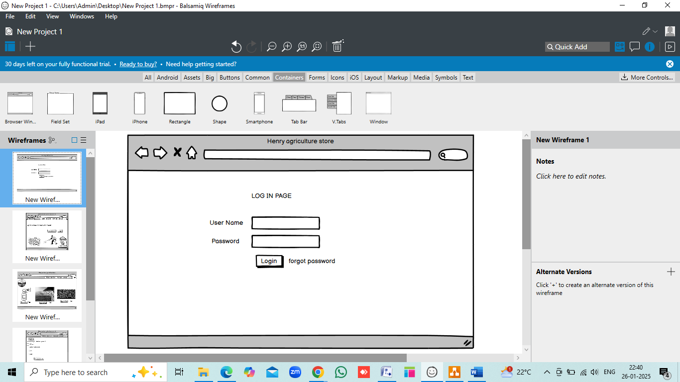

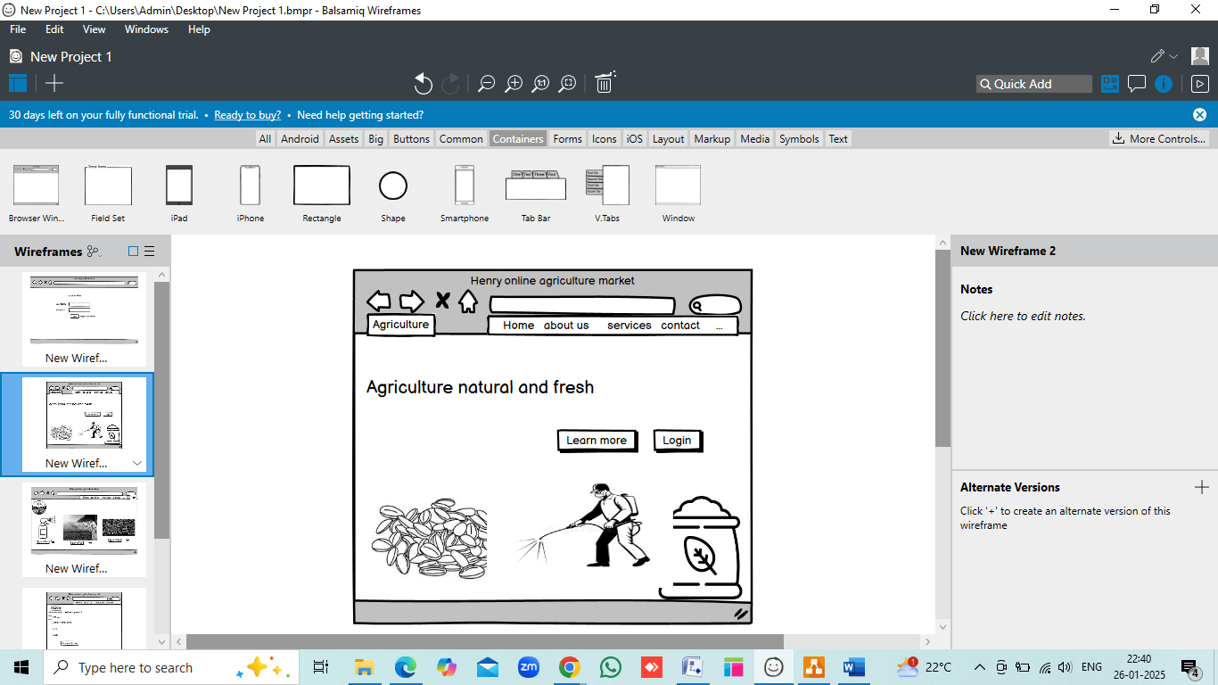

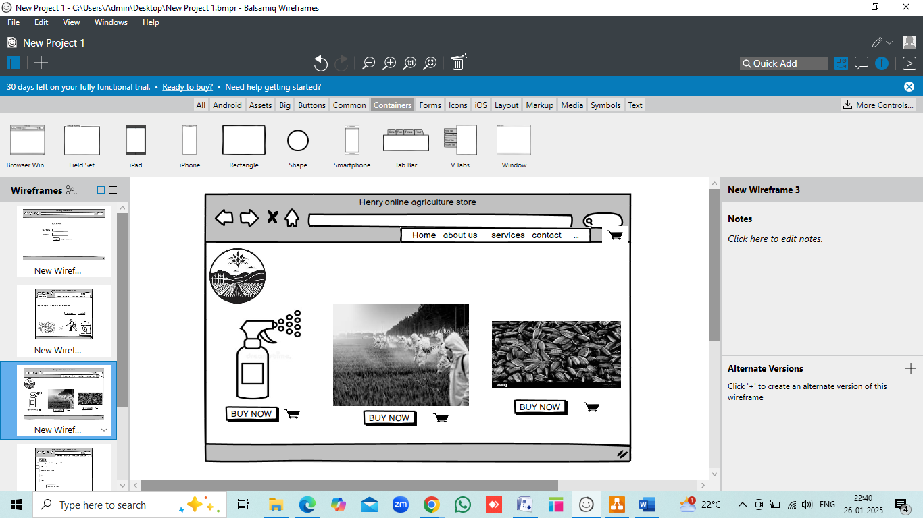

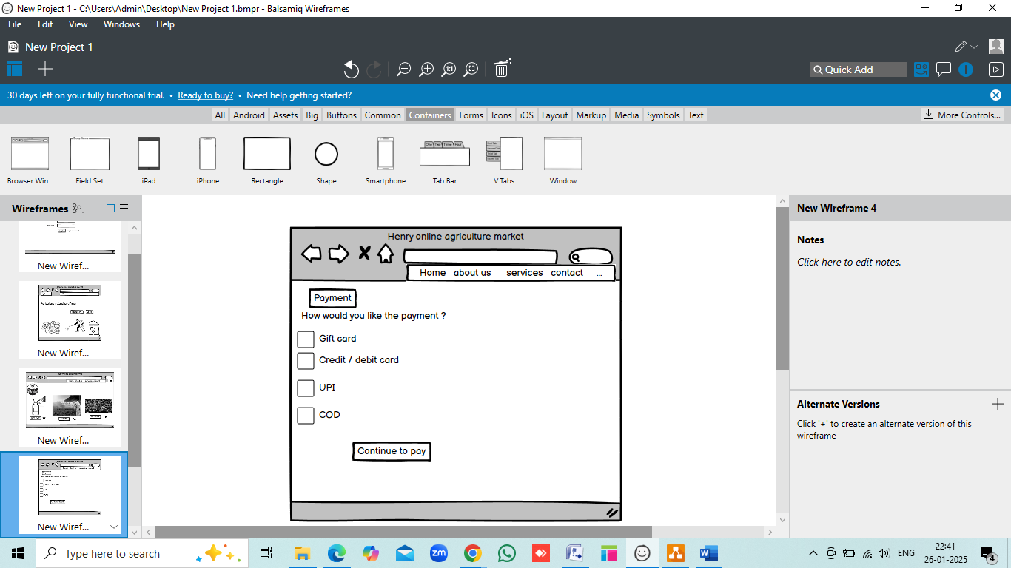

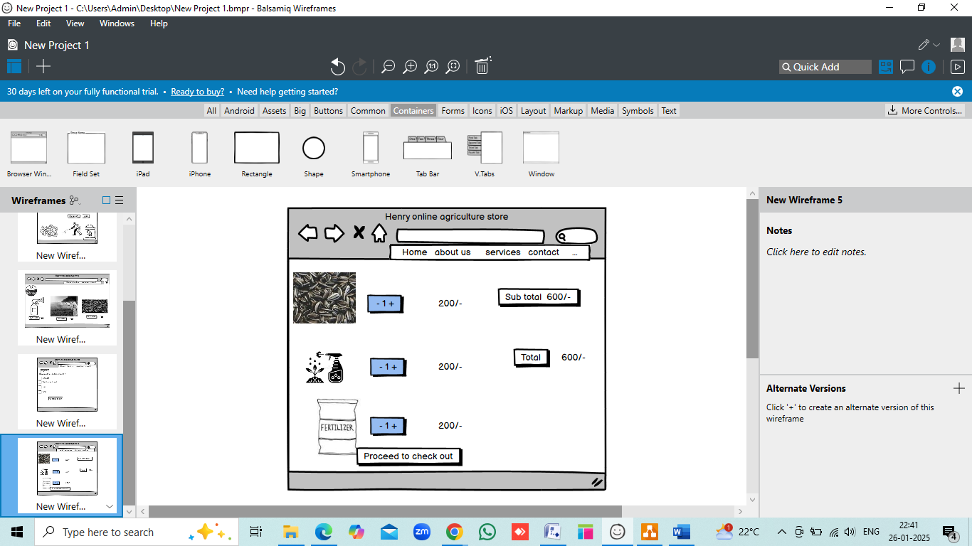

Question 3 – Tools (Visio, Balsamiq):

Visio

Visio, developed by Microsoft, is a powerful diagramming and vector graphics application primarily used for creating professional flowcharts, network diagrams, organizational charts, floor plans, and other visual representations of processes and systems

Feature: Extensive library of shapes and templates for various industries. Integration with Microsoft Office tools, enabling collaboration and easy sharing. Drag-and-drop functionality for ease of use. Supports complex diagrams like UML, ERD, and process maps. Cloud support via Microsoft 365 for real-time collaboration.

Advantages:

User-friendly interface for non-designers.

Helps streamline processes and visualize complex data.

Supports exporting in multiple formats (PDF, images, etc.).

Use Cases:

Creating workflow diagrams in business analysis.

Network diagrams for IT professionals.

Floor plans for architecture projects.

Balsamiq:

Balsamiq is a rapid wireframing tool designed for user interface (UI) and user experience (UX) design. It helps teams prototype and communicate software design ideas effectively.

Feature: Simple, sketch-style interface to focus on functionality over design.

Pre-built UI components (buttons, forms, menus, etc.).

Collaboration tools for team feedback.Supports linking between wireframes to simulate navigation.

Advantages:

Intuitive and easy to learn, even for non-designers.

Encourages brainstorming and idea generation.

Low-fidelity approach avoids distractions from visual details.

Use Cases:

Designing prototypes for websites and mobile apps.

Presenting UI ideas to stakeholders.

Planning the structure of software interfaces.

Question 4 – RTM

RTM is a tool used to track the progress of each requirement throughout the project lifecycle. It helps ensure that all the requirements are addressed by linking them to the corresponding development, testing, and design phases. The matrix provides a clear overview of status of functional and nonfunctional requirement allowing project teams to minitor the completion of task like coding, design, unit testing, system testing and UAT.

|  |  |  |  |  |  |  |  |  |  |
| --- | --- | --- | --- | --- | --- | --- | --- | --- | --- |
| Req ID | Req Name | Req Description | Design | Code | Unit testing | Component testing | System testing | SIT | UAT |
| FR0001 | Farmer Registration | Farmers should be able to register with the application | Complete | Incomplete | Incomplete | Incomplete | Incomplete | Incomplete | Incomplete |
| FR0002 | Farmer Search for Products | Farmers should be able to search for available products in fertilizers, seeds, pesticides | Complete | Incomplete | Incomplete | Incomplete | Incomplete | Incomplete | Incomplete |
| FR0003 | Product details | The platform should allow farmer to view detailed information about each product including price, discription, and usage instructions | Complete | Incomplete | Incomplete | Incomplete | Incomplete | Incomplete | Incomplete |
| FR0004 | Order History | The system should allow to view the order history | Complete | incomplete | incomplete | incomplete | incomplete | incomplete | incomplete |
| NFR0101 | Page Loading Time | Each Page should load within 2 seconds time | Complete | incomplete | incomplete | incomplete | incomplete | incomplete | incomplete |
| NFR0102 | WCAG 2.1 | The system must meet Web Content Accessibility Guidelines WCAG 2.1. | Complete | incomplete | incomplete | incomplete | incomplete | incomplete | incomplete |
| NFR0103 | Backupand recover | The plat must have back up and recover system in place to prevent data loss | Complete | Income  plete | Income  plete | Income  plete | Income  plete | Income  plete | Income  plete |
| NFR0104 | Mobile responsiveness | The application should be fully functionable and responsive across mobile | Complete | Incomplete | Incomplete | Incomplete | Incomplete | Incomplete | Incomplete |

Question 5 – 10 Test Case Documents

|  |  |  |  |
| --- | --- | --- | --- |
| Test case id | TC001 | Test case name | Verify user Login process |
| Project ID | P001 | Project Name | Online agriculture product store for Henry's initiative |
| PM ID | PM001 | PM Name | Mr Vandanam |
| Teststrategy ID | TS001 | Tester ID | T001 |
| Test plan ID | TP001 | Tester Name | ABC |
| Test schedule ID | TSCH002 | Date of Test | 24-01-2024 |

|  |  |  |  |  |  |
| --- | --- | --- | --- | --- | --- |
| Scenario | Verify user Login process |  |  |  |  |
| Link to that page |  | [www.henryagriculture.com](http://www.henryagriculture.com/) |  |  |  |
| Input Data | Username : testuser1 | Valid password: testpassword1 | Login Buttonclick | Browsertype | device |
| Expected Behavior | User name should be authenticated successfully | pass word should be authonticated successfully | clicking th button should triggered login action | The login process should work in google chrome | The login should work on desktop environment |
| Actual behavior | User name was successfully authenticated | pass word was successfully authenticated | Login button successfully triggered the login process | Login worked fine in google chrome | The login worked on desktop with no issues |
| comments | User name format was correct and entered as expected | The password met the security requirement | The login button was clicked after entering valid credentials | Browser compatability was tested with the latest version of chrome | The test was performed on a window 10 desktop |
| results | Pass | Pass | Pass | Pass | Pass |

|  |  |  |  |
| --- | --- | --- | --- |
| Test case id | TC002 | Test case name | Verify invalid login attempt |
| Project ID | P001 | Project Name | Online agriculture product store for Henry's initiative |
| PM ID | PM001 | PM Name | Mr Vandanam |
| Teststrategy ID | TS002 | Tester ID | T002 |
| Test plan ID | TP002 | Tester Name | DEF |
| Test schedule ID | TSCH002 | Date of Test | 24-01-2024 |

|  |  |  |  |  |  |
| --- | --- | --- | --- | --- | --- |
| Scenario | Verify invalid login attempt |  |  |  |  |
| Link to that page | [www.henryagriculture.com](http://www.henryagriculture.com/) |  |  |  |  |
| Input Data | User name : wrong user name | Password: wrong password | Login Button click | Browser google chrome | Device Desktop |
| Expected Behavior | The user name should not be recognised | The password should be rejected | Login button should fail with invalid credential | Login failure should happen in chrome | The login failure should be consistent on desktop |
| Actual behaviour | The user name was not recognised | Password was rejected due to invalid credential | Login button failed to authonticate the user | The login failed in google chrome | The login failed on desktop |
| comments | This was invalid user name attempt | The system handled invalid credential correctly | The login button worked as expected with incorrect details | The browser was tested as expected | Device compatibility wastested with no issued |
| Results | Pass | Pass | Pass | Pass | Pass |

|  |  |  |  |
| --- | --- | --- | --- |
| Test case id | TC003 | Test case name | Verify login with empty field |
| Project ID | P001 | Project Name | Online agriculture product store for Henry's initiative |
| PM ID | PM001 | PM Name | Mr Vandanam |
| Teststrategy ID | TS003 | Tester ID | T003 |
| Test plan ID | TP003 | Tester Name | GHI |
| Test schedule ID | TSCH003 | Date of Test | 24-01-2024 |

|  |  |  |  |  |  |
| --- | --- | --- | --- | --- | --- |
| Scenario | Verify login with empty field |  |  |  |  |
| Link to that page |  | [www.henryonlineagriculture.com](http://www.henryonlineagriculture.com/) |  |  |  |
| Input | Username: Empty | Password : empty | Login click button | Browser google chrome | Device: desktop |
| Expected behaviour | System should prompt for user name | System should prompt for a password | Clicking the button should not proceed the data | Behavior should be consistent across browsers | Behavior should be consistent across devices |
| Actual behavior | The System prompted ‘’enter user name’’ | The system prompted ‘’enter password’’ | Login button was disabled due to empty field | Behavior was consistent in google chrome | Behavior was consistent on desktop |
| Comment | Empty user name should trigger a prompt for user to enter data | Empty password should trigger a prompt user to enter data | The button remained in active when fields were empty | No browser related issued observed | No device specific issues observed |
| Result | Pass | Pass | Pass | Pass | Pass |

|  |  |  |  |  |  |  |
| --- | --- | --- | --- | --- | --- | --- |
| Test case id | TC004 | Test case name | Verify password visibility toggle | | | |
| Project ID | P001 | Project Name | Online agriculture product store for Henry's initiative | | | |
| PM ID | PM001 | PM Name | Mr Vandanam | | | |
| Teststrategy ID | TS004 | Tester ID | T004 | | | |
| Test plan ID | TP004 | Tester Name | GHI | | | |
| Test schedule ID | TSCH004 | Date of Test | 24-01-2024 | | | |
| Scenario | Verify password visibility toggle |  |  |  |  |
| Link to that page | [www.henryonlineagriculture.com](http://www.henryonlineagriculture.com/) |  |  |  |  |
| Input Data | User name : testuser1 | Password: testpassword1 | Click on password | Click on hide password | Device desktop |
| Expected Behavior | Username should remain visble | Password should be hidden by default | Password should be visible by clicking | Password should be hidden again | Visibility behavior should be consistent across device |
| Actual Behavior | Username remained visible after entering | Password was hidden as expected | Clicking the show password icon revealed the password | Clicking the hide password icon masked the password | The visibility toggle worked as expected |
| comments | No issue with visibility of username | The password wasmasked by default | Toggle worked correctly to reveal password | Toggle feature was functional | No issued found with the feature on the desktop |
| results | Pass | Pass | Pass | Pass | Pass |

|  |  |  |  |
| --- | --- | --- | --- |
| Test case id | TC005 | Test case name | Verify forget password link |
| Project ID | P001 | Project Name | Online agriculture product store for Henry's initiative |
| PM ID | PM001 | PM Name | Mr Vandanam |
| Teststrategy ID | TS005 | Tester ID | T005 |
| Test plan ID | TP005 | Tester Name | JKL |
| Test schedule ID | TSCH005 | Date of Test | 24-01-2024 |

|  |  |  |  |  |  |
| --- | --- | --- | --- | --- | --- |
| Scenario | Verify forget password link |  |  |  |  |
| Link to that page |  | [www.henryonlineagriculture.com](http://www.henryonlineagriculture.com/) |  |  |  |
| Input | Click forgot password | Enter email | Click reset link | Enter new password | Device desktop |
| Expected behavior | Should navigate to password reset page | Should prompt a password reset email | Reset link should open a password change page | The system should accept a new password | Process should be consistent across device |
| Actual behavior | Cliecking forgot password navigated to the reset page | System should send a password reset email | Clicking the reset link opened the password changepage | System accepted and confirmed the new password | The processwasconsistent on desktp |
| Comments | Forgot password link navigated to the correct page | Email was received within few minutes | The reset link functionality was correct | Password was updated and confirmed | No device specific issues observed |
| results | Pass | Pass | Pass | Pass | Pass |

|  |  |  |  |
| --- | --- | --- | --- |
| Test case id | TC006 | Test case name | Verify user logout process |
| Project ID | P001 | Project Name | Online agriculture product store for Henry's initiative |
| PM ID | PM001 | PM Name | Mr Vandanam |
| Teststrategy ID | TS006 | Tester ID | T006 |
| Test plan ID | TP006 | Tester Name | mno |
| Test schedule ID | TSCH006 | Date of Test | 24-01-2024 |

|  |  |  |  |  |  |
| --- | --- | --- | --- | --- | --- |
| Scenario | Verify user logout process |  |  |  |  |
| Link to that page | [www.henryonlineagriculture.com](http://www.henryonlineagriculture.com/) |  |  |  |  |
| Input | Click logout button | After logout | Login after logout | Session persistence | Device desktop |
| Expected | User should be logged out | User should be redirected to the login page | User should be able to login again after logging out | The session should be terminated after logout | Logout process should work across device |
| Actual behavior | Clicking the logout button succesfully logged the user out | The system redirected the login page after logout | User successfully logged in again after logged out | Session was terminated after logout user had to login again | Logout worked consistently on desktop |
| Comments | Logout functionality worked as expected | Logout followed by redirection worked | No issues with logging in again | Proper session termination afterlogout | No issued found on desktp |
| results | Pass | Pass | Pass | Pass | Pass |

|  |  |  |  |
| --- | --- | --- | --- |
| X`Test case id | TC007 | Test case name | Verify user dashboard content |
| Project ID | P001 | Project Name | Online agriculture product store for Henry's initiative |
| PM ID | PM001 | PM Name | Mr Vandanam |
| Teststrategy ID | TS007 | Tester ID | T007 |
| Test plan ID | TP007 | Tester Name | pqr |
| Test schedule ID | TSCH007 | Date of Test | 24-01-2024 |

|  |  |  |  |  |  |
| --- | --- | --- | --- | --- | --- |
| Scenario | Verify user dashboard content |  |  |  |  |
| Link to that page | [www.henryonlineagriculture.com](http://www.henryonlineagriculture.com/) |  |  |  |  |
| Input Data | User name | Login status | Device desktop | Browser google chrome | Content display |
| Expected Behavior | User should see the correct dashboard content | User should be logged in accessing the dashboard | Dashboard should be functional on desktop | Dashboard should load correctly on google chrome | Recent orders and suggestions should appear |
| Actual Behavior | The dashboard displayed the correct content | User was logged and could access the dashboard | Dashboard worked fine on desktop | The dashboard loaded successfully on google chrome | Recent orders was accurate and displayed as expected |
| comments | Dashboard loaded as expected | User login was confirmed before accessing dashboard | Dashboard and compatibility tested on desktop | No browswe specific issues observed | All content was accurate and displayed as expected |
| results | Pass | Pas | Pass | Pass | pass |

|  |  |  |  |  |  |  |  |
| --- | --- | --- | --- | --- | --- | --- | --- |
| Test case id | TC008 | Test case name | | Verify error message for incorrect user name | | | |
| Project ID | P001 | Project Name | | Online agriculture product store for Henry's initiative | | | |
| PM ID | PM001 | PM Name | | Mr Vandanam | | | |
| Teststrategy ID | TS008 | Tester ID | | T008 | | | |
| Test plan ID | TP008 | Tester Name | | stu | | | |
| Test schedule ID | TSCH008 | Date of Test | | 24-01-2024 | | | |
| Scenario | Verify error message for incorrect user name |  |  | |  |  |
| Link to that page | [www.henryonlineagriculture.com](http://www.henryonlineagriculture.com/) |  |  | |  |  |
| Input Data | User name | Password | Login button | | Error msg | Device desktop |
| Expected Behavior | System should display an error msg | System should display an error msg | System should not allowlogin with incorrect credentials | | Error msg should be clear | Error msg should display consistently |
| Actual Behavior | Error msg ‘’ incorrect username or password’’ was displayed | Error msg ‘’ incorrect username or password’’ was displayed | Login was not allowed due to incorrect credentials | | The error msg was clear | The error msg was displayed clearly on window |
| comments | Error msg was triggered for invalid username | The error msg was triggered for incorrect password | The system prevented login with incorrect credential | | Error msg was appropriated and user friendly | Error msg functionality was tested successfully |
| results | Pass | Pass | Pass | | Pass | pass |

|  |  |  |  |  |  |  |  |
| --- | --- | --- | --- | --- | --- | --- | --- |
| Test case id | TC009 | Test case name | | Verify account locked after multiple failed login attempts | | | |
| Project ID | P001 | Project Name | | Online agriculture product store for Henry's initiative | | | |
| PM ID | PM001 | PM Name | | Mr Vandanam | | | |
| Teststrategy ID | TS009 | Tester ID | | T009 | | | |
| Test plan ID | TP009 | Tester Name | | vwx | | | |
| Test schedule ID | TSCH009 | Date of Test | | 24-01-2024 | | | |
| Scenario | Verify account locked after multiple failed login attemos |  |  | |  |  |
| Link to that page | [www.henryonlineagriculture.com](http://www.henryonlineagriculture.com/) |  |  | |  |  |
| Input Data | User name | Password | Login button | | Error msg | Device desktop |
| Expected Behavior | Account should lock after 5 failed login attempts | Account should remain locked for 30 min after 5 failed login attempts | Button should not allow login after account lock | | An error msg should be shown for locked account | Lock behavior should be consistent across device |
| Actual Behavior | Account was locked after 5 failed login | The account was locked for 30min after 5 failed login | Login was not possible after account lock | | The error msg ‘’account locked’’ try again later was shown | Lock behavior was consistent on desktop |
| comments | Account lock functionality worked correctly after multiple failed attempts | Lock time was correct after failed attempts | The system did not allow login attempts after lock | | Error msg was clear and informed the user of the account lock | Locking worked as expected on the desktop |
| results | Pass | Pass | Pass | | Pass | pass |

|  |  |  |  |
| --- | --- | --- | --- |
| Test case id | TC010 | Test case name | Verify user profile update |
| Project ID | P001 | Project Name | Online agriculture product store for Henry's initiative |
| PM ID | PM001 | PM Name | Mr Vandanam |
| Teststrategy ID | TS010 | Tester ID | T010 |
| Test plan ID | TP010 | Tester Name | vwx |
| Test schedule ID | TSCH010 | Date of Test | 24-01-2024 |

|  |  |  |  |  |  |
| --- | --- | --- | --- | --- | --- |
| Scenario |  | Verify user profile update |  |  |  |
| Link to that page | [www.henryonlineagriculture.com](http://www.henryonlineagriculture.com/) |  |  |  |  |
| Input Data | User name | Profiledata: [newemail@gmail.com](mailto:newemail@gmail.com) | Profile data newphonenumber: 1234567890 | Profile data change pwd | Profile data change address |
| Expected Behavior | User should be able to update their profile | Updated email should be saved | New phone number should be saved | New password should replace old one | Address should be updated in the system |
| Actual Behavior | User successfully updated their profile info | New email was saved successfully | New phone number saved successfully | New password succesfully set | Address updated in system correctly |
| comment | Profile update successful | Email update functionality worked as expected | Phone number update functionality worked as expected | Password update functionality worked as expected | Address change functionality worked as expected |
| Results | Pass | Pass | Pass | Pass | pass |

Question 6 – DB Design:

DB Schema is a blue print that outlines the structure of a database, including its tables, fields, relationships, constraints, and other characteristics

An Entity Relationship diagram is visual representation of the relationship between entities in a database. It depicts the entities, attributes and relationship between them.

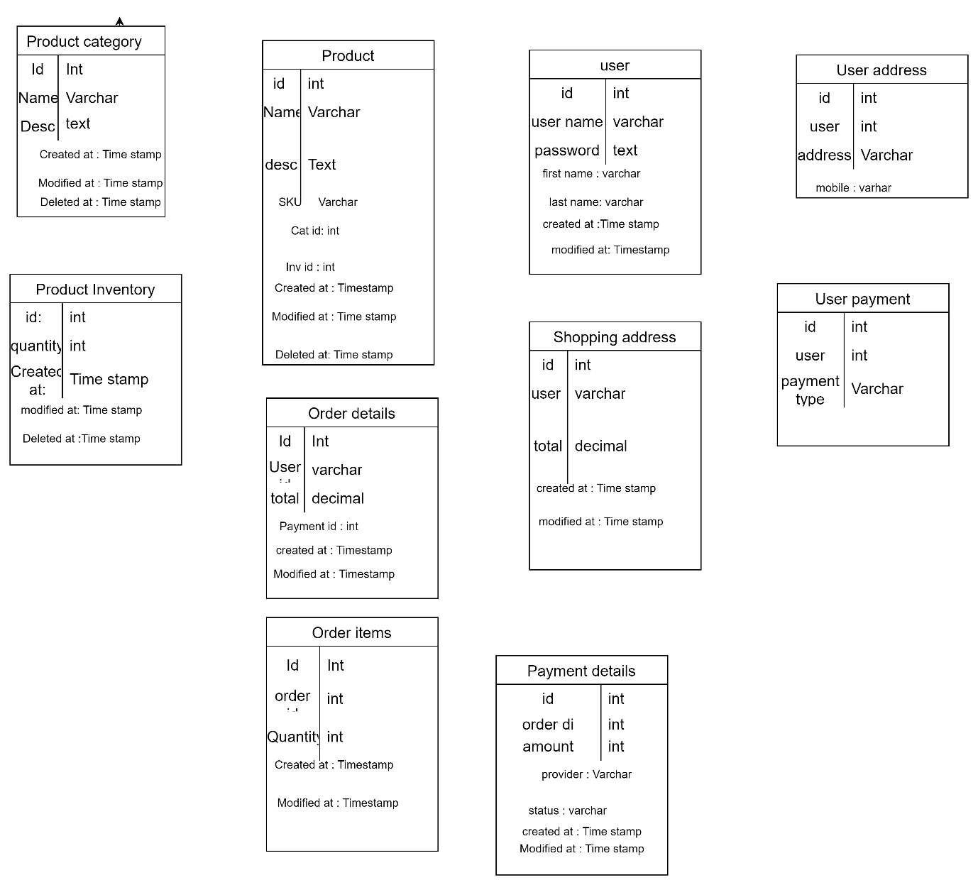



Question 7 – Data Flow Diagram:

A Data Flow Diagram (DFD) is a graphical representation that shows how data flows within a system and how it is processed by different components. It includes processes, data stores, data flows, and external entities to illustrate the movement and transformation of data.

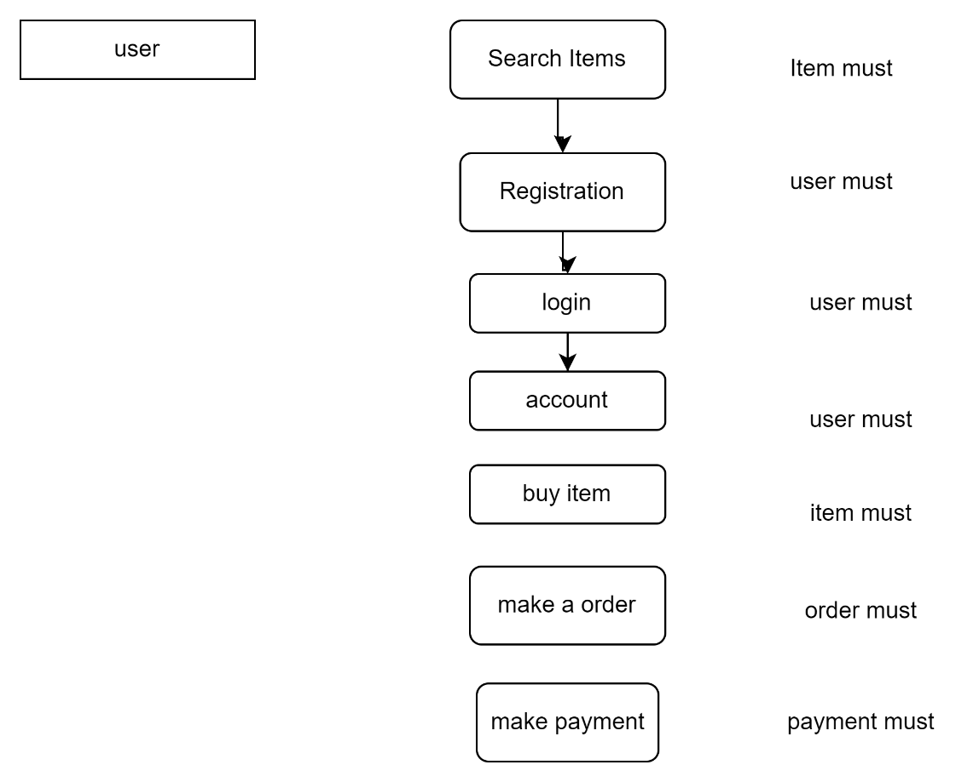

Question 8 – Change Request –

A change request is a formal proposal to modify any aspect of a project. This could involve changes in scope, schedule, cost, resources, or even quality. A change request is typically initiated when there is a need to update the project due to external factors, new requirements, or issues that arise during the project’s execution.

In a change request, the project team provides a detailed description of the proposed change, the reasons for it, its potential impact on the project, and how it will be addressed. The request is reviewed by stakeholders to determine if the change is necessary and how it will affect the overall project. If approved, the change is implemented and integrated into the project plan

To handle the change request regarding the government taxation structure in Henry's case study, follow these steps:

1. **Impact Assessment**: Analyze the effect of the new taxation structure on the existing system, including product pricing, billing, and any existing tax-related processes. Collaborate with stakeholders to understand the extent of the change.
2. **Update Requirements**: Modify the system requirements to reflect the new tax structure. This includes adjusting the tax rates, categories, and applying them to relevant products or services on the platform.
3. **Stakeholder Communication**: Notify all relevant stakeholders (e.g., project managers, developers, testers) about the change and its implications. Ensure clarity on what needs to be updated in the system.
4. **System Design & Implementation**: Work with the development team to design the changes needed in the application, including tax calculations, invoicing, and reports. Ensure that the system can dynamically apply the updated tax rates.
5. **Testing**: Test the updated system for compliance with the new taxation structure. Ensure that the changes don't interfere with other system functionalities.
6. **Documentation**: Update system documentation to reflect the new tax structure and any related processes or calculations.
7. **Deployment & Monitoring**: After implementing the changes, deploy them to the production environment and monitor the system for any issues related to the new tax structure.

Handling the change request involves careful assessment of the impact, collaboration with stakeholders, and implementation of necessary changes to ensure compliance with the new taxation structure. It’s essential to thoroughly test the system and ensure proper documentation, while closely monitoring the deployment to ensure smooth functionality and compliance.

Question 9 – Change Request Vs an Enhancement:

This request would be considered an enhancement rather than a change request.

Enhancement refers to adding new features or improving the existing functionality of the system. In this case, the request to allow farmers to sell their crop yields, add products, and introduce an auction system is a new feature that was not part of the original project scope but adds value to the application.

Change Request, on the other hand, would typically be used for adjustments or modifications to the existing features or scope due to unforeseen circumstances, such as changes in regulations or market conditions.

So, as a BA, the response would be

The request from Ben and Kevin to allow farmers to add their crop yields, display products to the public, and introduce an auction system is considered an enhancement to the current project. It introduces new features that expand the application’s functionality beyond the initial scope. These enhancements will require further discussion, including gathering detailed requirements, assessing technical feasibility, evaluating the impact on timeline and costs, and obtaining approval from stakeholders before proceeding.

Question 10 – Estimations:

For Henry's project, which is part of a larger initiative with an 18-month duration, the work required to implement the new features is classified as a medium-sized project. The estimated man-hours for these changes would be between 50-1000 man-hours, and the development phase for these features is expected to take around 2 to 4 months within the overall project timeline.

Question 11 – UAT :

Planning: The BA coordinates with the client to prepare for UAT by setting clear timelines, resources, and expectations for feedback.

Designing: The BA ensures the system design aligns with client requirements and supports efficient UAT testing.

UAT Testers: The client or end users perform the testing, with the BA acting as a liaison and ensuring proper access and support.

Bug Fixing: The BA tracks any bugs reported during UAT and ensures the development team fixes them promptly.

Signoff: Once all issues are resolved, the BA obtains formal sign-off from the client, indicating acceptance of the product and completing the project.

The BA ensures a smooth transition from UAT to project closure by carefully managing the planning, design, testing, and bug-fixing processes. With clear communication and effective issue resolution, the project is successfully completed, and the client provides final sign-off, marking the official closure of the project.

Question 12 – Project Closure Document:

Project closure documents are crucial for formally completing a project and ensuring all deliverables are met. They include the Project Closure Report, which summarizes the entire project and confirms all objectives were achieved, and the Final Deliverables, which list the completed work handed over to the client. The Client Sign-Off document signifies the client's formal approval of the work, while the Financial Closure Report provides a financial summary, ensuring the project stayed within budget. Lastly, the Post-Implementation Support Plan outlines the ongoing support and maintenance for the client, ensuring continued satisfaction after the project's completion.