Online Agriculture Product Store

Prepared by: Venkatesh Dhanana Contact No: 8247813228

**Question 1:** Write 20 Functional & Non Functional Requirements?

**Functional requirements** define the specific behaviours, functions or operations of a system. They describe what the system should do, outlining the necessary tasks, actions, or activities it must perform to achieve its objectives.

|  |  |  |
| --- | --- | --- |
| **Req ID** | **Req name** | **Req Description** |
| FR001 | User Registration & Login | The system should allow farmers and manufacturers to register and log in using their Email/User name and Password. |
| FR002 | Product Catalogue Management | Manufacturers should be able to add, update and delete product listings for fertilizers, seeds and pesticides. |
| FR003 | Product Search & Filters | Farmers should be able to search for products by name, category and manufacturer and filter results based on price and availability |
| FR004 | Add Products to Cart or Wish List | Farmers should be able to add products to a shopping cart or to a Wish list before making a purchase. |
| FR005 | Order Placement & Payment Processing | Farmers should be able to place orders and complete payments using multiple payment methods (COD, Credit/Debit Card, UPI). |
| FR006 | Order Confirmation & Notifications | The system should send email notifications for order confirmation, dispatch and delivery status updates. |
| FR007 | Delivery Tracking | Farmers should be able to track their orders in real-time using a tracking feature. |
| FR008 | User Role Management | The system should have different access levels for farmers, manufacturers and administrators. |
| FR009 | Order History & Reordering | Farmers should be able to view their past orders and reorder previously purchased products. |
| FR010 | Customer Support & Queries | The system should provide a help center or chat support for users to resolve queries related to orders or product information. |

**Non Functional Requirements** will describe the qualities and attributes of the system, focusing on how the system performs rather than specific behaviour or functions.

|  |  |  |
| --- | --- | --- |
| **Req ID** | **Req name** | **Req Description** |
| NFR001 | Performance | The system should handle at least 10,000 concurrent users without performance degradation. |
| NFR002 | Scalability | The application should be scalable to accommodate an increasing number of users and products over time. |
| NFR003 | Availability | The system should have 99.9% uptime to ensure continuous access for farmers and manufacturers. |
| NFR004 | Security | All user data and transactions should be encrypted for secure communication. |
| NFR005 | Usability | The application should have a simple and intuitive user interface that requires minimal training. |
| NFR006 | Compatibility | The platform should work seamlessly on mobile devices, tablets and desktops. |
| NFR007 | Multi-Language Support | The system should support multiple regional languages for farmers in different areas. |
| NFR008 | Regulatory Compliance | The system should comply with Indian e-commerce and data protection laws. |
| NFR009 | Backup & Disaster Recovery | Automated daily backups should be taken to prevent data loss in case of a system failure. |
| NFR010 | Response Time | The system should respond to user actions (search, login, add to cart) within 2 seconds under normal load conditions. |

**Question 2:** Prepare 5 Wireframes?

1. **Login Page** - A simple form for User Login.

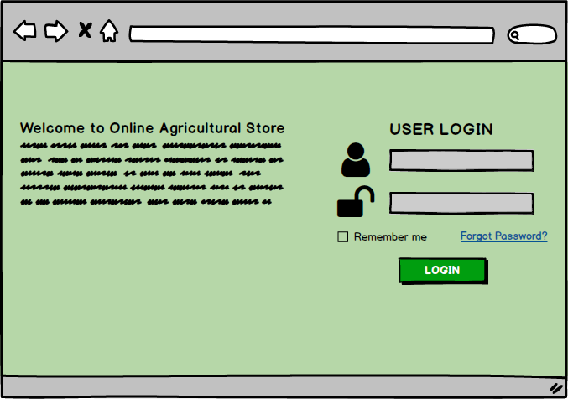

2. **Registration** **Page** – A form to register into the system

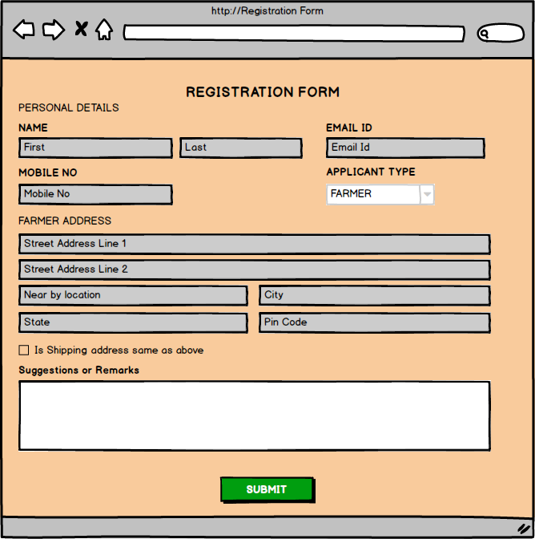

3. **Homepage (Product Catalogue)** - Displays available products with search and filter options.

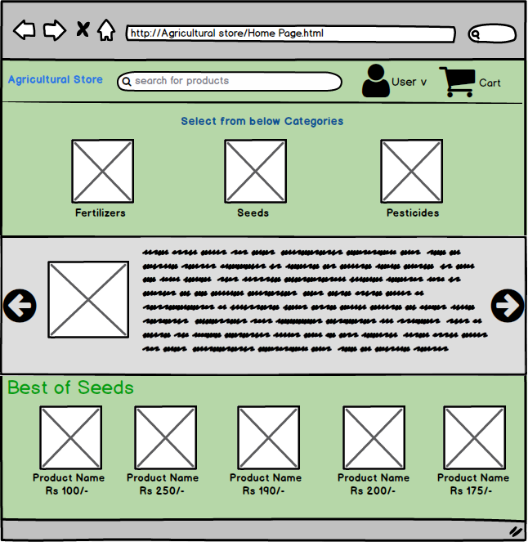

4. **Product Details Page** - Shows product descriptions, price and purchase options.

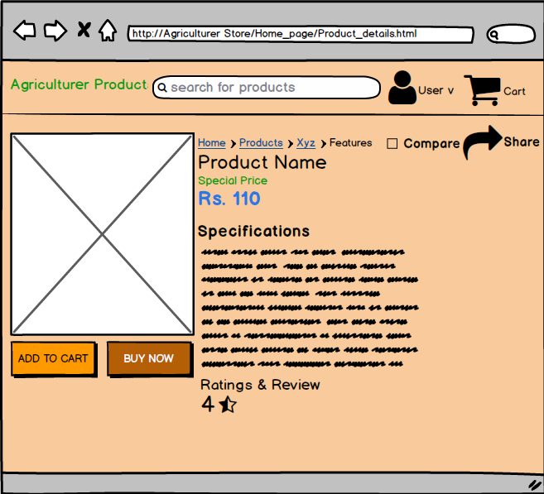

5. **Shopping Cart & Checkout Page** - Displays selected items and payment options.

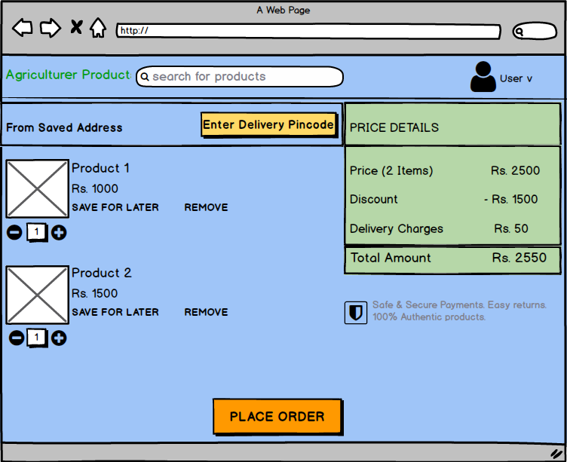

**Question 3:** Make a note of the Tools, which you are using for above concepts?

**Microsoft Visio** is a diagramming and vector graphic application used to create UML Diagrams, flowcharts and other visual representations of complex information.

In this project, it helps in designing **use case diagrams and activity diagrams.** Visio offers **drag-and-drop shapes, templates and collaboration features,** making it ideal for visualizing business processes and system workflows.

**Balsamiq** is a wire framing tool used to create mock-ups and low-fidelity prototypes of user interfaces. It helps designers and business analysts quickly sketch **user interfaces (UI) for web and mobile apps.**

In this project, Balsamiq is useful for designing **simple, user-friendly wireframes** to visualize screens like the login page, product catalogue and checkout process.

**Axure** is amore advances prototyping tool used to create high-fidelity, interactive wire frames and prototypes for web and mobile application with dynamic elements like buttons, animations and conditional logic.

In this project, Axure is useful for building **clickable prototypes** of the agriculture product store, improving user experience before actual development begins.

**Question 4:** Prepare RTM

It’s a document to track requirements throughout the project lifecycle, ensuring that they are met and that no requirements are missed.

|  |  |  |  |  |  |  |  |  |
| --- | --- | --- | --- | --- | --- | --- | --- | --- |
| **Req ID** | **Business Requirement Description** | **FR ID** | **Test Case ID** | **Design** | **Development** | **Unit Testing** | **Testing** | **UAT** |
| BR001 | Farmers should be able to search for available products in fertilizers, seeds, and pesticides. | FR003 | TC001 | Completed | Completed | Completed | Completed | Pending |
| BR002 | Manufacturers should be able to upload and display their products in the application. | FR002 | TC003 | Completed | Completed | Pending | Pending | Pending |
| BR003 | Users should have login/signup functionality. | FR001 | TC002 | Completed | Completed | Pending | Pending | Pending |
| BR004 | Farmers should be able to add products to a cart or Wish list. | FR004 | TC004 | Completed | Completed | Completed | Completed | Pending |
| BR005 | The system should support multiple payment methods (COD, Credit/Debit, UPI). | FR005 | TC005 | Completed | Pending | Pending | Pending | Pending |
| BR006 | Farmers should receive order confirmation and delivery updates via email. | FR006 | TC006 | Completed | Completed | Completed | Completed | Pending |
| BR007 | The application should provide a delivery tracking feature for farmers. | FR007 | TC007 | Pending | Pending | Pending | Pending | Pending |
| BR008 | The platform should be mobile-friendly and work across devices. | NFR006 | Common | Completed | Pending | Pending | Pending | Pending |
| BR009 | Farmers should be able to filter products based on price, brand and type. | FR003 | TC001 | Completed | Completed | Completed | Completed | Pending |
| BR010 | Application should support multiple regional languages so that rural farmers can access the application with ease. | NFR007 | Common | Completed | Pending | Pending | Pending | Pending |

**Question 5:** Prepare 10 Test Case Documents.

Each test case ensures the system meets the specified business and functional requirements. I'll structure them properly.

|  |  |  |  |
| --- | --- | --- | --- |
| **Test case ID** | TC001 | **Test case Name** | Search of Products |
| **Project ID** | OAP001 | **Project Name** | Online Agricultural Application |
| **PM ID** | 6978 | **PM Name** | COEPD |
| **Test Strategy ID** | TS001 | **Tester ID** | 1245 |
| **Test Plan ID** | TP001 | **Tester Name** | Venkatesh D |
| **Test Schedule ID** | TSD01 | **Date of Test** | 21-03-2025 |
| **Scenario ID** | BR001 | | |
| **Test Case Description** | Verify search of products using search bar. | | |
| **Input Data** | Enter any product name | | |
| **Expected Behaviour** | User need to navigate to search bar, enter any product name and click on **search** button, system need to show the product details if available else need to show popup as "Product not available, please search with another name" | | |
| **Actual Behaviour** | User need to navigate to search bar, enter any product name and click on **search** button, system need to show the product details if available else need to show popup as "Product not available, please search with another name" | | |
| **Comments** | Search bar is working fine. | | |
| **Expected Result** | Relevant products should be displayed. | | |
| **Result (Pass/Fail)** | Pass | | |

|  |  |  |  |
| --- | --- | --- | --- |
| **Test case ID** | TC002 | **Test case Name** | Manufacturer Login |
| **Project ID** | OAP001 | **Project Name** | Online Agricultural Application |
| **PM ID** | 6978 | **PM Name** | COEPD |
| **Test Strategy ID** | TS002 | **Tester ID** | 1245 |
| **Test Plan ID** | TP002 | **Tester Name** | Venkatesh D |
| **Test Schedule ID** | TSD02 | **Date of Test** | 21-03-2025 |
| **Scenario ID** | BR003 | | |
| **Test Case Description** | System should allow Manufacturer to login | | |
| **Input Data** | Enter Manufacturer username & Password | | |
| **Expected Behaviour** | 1. User need to enter his/her username and password and click on Login button. After login, system need to navigate to Home page of Manufacturer 2. IF Credentials are wrong, system need to through an alert “Invalid Username and password”. | | |
| **Actual Behaviour** | 1. Once user entering Username and Password and clicking on Login button, system validating credentials and allowing to access the application.  2. If Credentials are entered wrong, System is throwing an alert as “Invalid Username and password”. | | |
| **Comments** | Manufacturer Login is working fine | | |
| **Expected Result** | Manufacturer should login in to the system without any errors | | |
| **Result (Pass/Fail)** | Pass | | |

|  |  |  |  |
| --- | --- | --- | --- |
| **Test case ID** | TC003 | **Test case Name** | Upload of products |
| **Project ID** | OAP001 | **Project Name** | Online Agricultural Application |
| **PM ID** | 6978 | **PM Name** | COEPD |
| **Test Strategy ID** | TS003 | **Tester ID** | 1245 |
| **Test Plan ID** | TP003 | **Tester Name** | Venkatesh D |
| **Test Schedule ID** | TSD01 | **Date of Test** | 21-03-2025 |
| **Scenario ID** | BR002 | | |
| **Test Case Description** | Verify Manufacturer can upload their products. | | |
| **Input Data** | Provide Product name, Product specifications, Images, price details and click on ADD button. | | |
| **Expected Behaviour** | 1. Manufacturer need to navigate to Add Products screen. 2. Need to add Product name, specifications, images (in all formats) & price details. 3. Once submitted, product need to be displayed in catalogue with all the given details. | | |
| **Actual Behaviour** | 1. Manufacturer navigating to Add product screen with login.  2. User can add product details along with images but image format is accepting only PNG format. 3. After submitting product details are visible in catalogue but image is displaying very small. | | |
| **Comments** | 1. Image format can be PNG, JPEG and GIF 2. In Catalogue image need to be displayed properly with min 5*5 inch size in HD format | | |
| **Expected Result** | Product should be listed in the catalogue. | | |
| **Result (Pass/Fail)** | Fail | | |

|  |  |  |  |
| --- | --- | --- | --- |
| **Test case ID** | TC004 | **Test case Name** | Adding Products to Cart. |
| **Project ID** | OAP001 | **Project Name** | Online Agricultural Application |
| **PM ID** | 6978 | **PM Name** | COEPD |
| **Test Strategy ID** | TS004 | **Tester ID** | 1245 |
| **Test Plan ID** | TP004 | **Tester Name** | Venkatesh D |
| **Test Schedule ID** | TSD004 | **Date of Test** | 21-03-2025 |
| **Scenario ID** | BR004 | | |
| **Test Case Description** | Verify adding products to the cart. | | |
| **Input Data** | Select Product from catalogue  Enter Quantity of product Click on Add to Cart. | | |
| **Expected Behaviour** | 1. User can select one or more products and need to click on Add to Cart. 2. In Add to Cart screen, user can add new product or Delete the added product or Edit the added product. 3. If click on ADD button, need to navigate to products screen. 4. Total products with individual quantity should be placed order at once. | | |
| **Actual Behaviour** | 1. User can select one or more products and click on Add to Cart. 2. In Add to Cart screen, user is able to add new product and Edit the existing product in cart but unable to Delete the product from cart. 3. Once click on Add button, application navigating to Home page 4. Order is placed for all the products available in cart. | | |
| **Comments** | 1. Deleting of product from cart is not working 2. If click on Add button, application need to navigate to Products search screen. | | |
| **Expected Result** | Product should be added to the cart. | | |
| **Result (Pass/Fail)** | Fail | | |

|  |  |  |  |
| --- | --- | --- | --- |
| **Test case ID** | TC005 | **Test case Name** | UPI Payment Gateway |
| **Project ID** | OAP001 | **Project Name** | Online Agricultural Application |
| **PM ID** | 6978 | **PM Name** | COEPD |
| **Test Strategy ID** | TS005 | **Tester ID** | 1245 |
| **Test Plan ID** | TP005 | **Tester Name** | Venkatesh D |
| **Test Schedule ID** | TSD005 | **Date of Test** | 21-03-2025 |
| **Scenario ID** | BR005 | | |
| **Test Case Description** | Verify UPI payment gateway functionality. | | |
| **Input Data** | Select any one Payment mode If UPI is Selected, then enter valid UPI Number | | |
| **Expected Behaviour** | Case 1: 1. User should add the products to cart and click on “Place Order”. 2. Available Payment modes need to display to user like, UPI, Debt/Credit/card, Wallets or Cash On Delivery. 3. User need to select any one payment mode. 4. User need to enter UPI no and click on pay. 5. Application need to navigate to user UPI application for collecting payment. 6. Once payment done from user UPI application, need to redirect to Online Agricultural App. and Payment Success message need to display along with Order confirmation. | | |
| **Actual Behaviour** | Case 1: 1. User added the products to cart and click on “Place Order”. 2. Payment modes are displayed to user like, UPI, Debt/Credit/card, Wallets or Cash On Delivery. 3. User selects UPI payment mode. 4. User enters UPI no and click on pay. 5. Application verified the UPI no and navigated to user UPI application for collecting payment. 6. User pays the amount and redirects to Online Agricultural App. and Payment Success message displayed along with Order confirmation through SMS. | | |
| **Comments** | Payment functionality is working fine. | | |
| **Expected Result** | Payment should be successful, and order confirmed. | | |
| **Result (Pass/Fail)** | Pass | | |

|  |  |  |  |
| --- | --- | --- | --- |
| **Test case ID** | TC006 | **Test case Name** | Email Confirmation of Order placed |
| **Project ID** | OAP001 | **Project Name** | Online Agricultural Application |
| **PM ID** | 6978 | **PM Name** | COEPD |
| **Test Strategy ID** | TS006 | **Tester ID** | 1245 |
| **Test Plan ID** | TP006 | **Tester Name** | Venkatesh D |
| **Test Schedule ID** | TSD006 | **Date of Test** | 21-03-2025 |
| **Scenario ID** | BR006 | | |
| **Test Case Description** | Verify email confirmation after order placement. | | |
| **Input Data** | Order need to placed successfully Email need be in given format | | |
| **Expected Behaviour** | Once the order is placed, email need to send to user email id in the given format | | |
| **Actual Behaviour** | After order confirmation, email is sending to user but there are some changes in format. 1. Signature is not displaying completely at the bottom right corner. 2. Row spaces are not equal for all the lies in body of the email. | | |
| **Comments** | Need to display message exactly as per the given format | | |
| **Expected Result** | Order confirmation email should be received. | | |
| **Result (Pass/Fail)** | Partially Pass | | |

|  |  |  |  |
| --- | --- | --- | --- |
| **Test case ID** | TC007 | **Test case Name** | Order Tracking |
| **Project ID** | OAP001 | **Project Name** | Online Agricultural Application |
| **PM ID** | 6978 | **PM Name** | COEPD |
| **Test Strategy ID** | TS007 | **Tester ID** | 1245 |
| **Test Plan ID** | TP007 | **Tester Name** | Venkatesh D |
| **Test Schedule ID** | TSD007 | **Date of Test** | 21-03-2025 |
| **Scenario ID** | BR007 | | |
| **Test Case Description** | Verify order tracking system. | | |
| **Input Data** | User should have a valid Order ID | | |
| **Expected Behaviour** | User should navigate to Order Tracking page User need to enter Order ID, system validated the ID and displays the current order status If Order is not valid, need to show alert as “Enter valid Order ID” | | |
| **Actual Behaviour** | When user enters the valid Order ID, system validated the ID and displays the current order status If user enter invalid Order ID system is not showing any alert to re-enter the Order ID | | |
| **Comments** | Need to show alerts if invalid order Id is entered | | |
| **Expected Result** | Order status should be displayed. | | |
| **Result (Pass/Fail)** | Fail | | |

|  |  |  |  |
| --- | --- | --- | --- |
| **Test case ID** | TC008 | **Test case Name** | Product Filtering |
| **Project ID** | OAP001 | **Project Name** | Online Agricultural Application |
| **PM ID** | 6978 | **PM Name** | COEPD |
| **Test Strategy ID** | TS008 | **Tester ID** | 1245 |
| **Test Plan ID** | TP008 | **Tester Name** | Venkatesh D |
| **Test Schedule ID** | TSD008 | **Date of Test** | 21-03-2025 |
| **Scenario ID** | BR009 | | |
| **Test Case Description** | Verify product filtering options. | | |
| **Input Data** | Apply some filters like Price, availability, category | | |
| **Expected Behaviour** | User need to click on filter icon and select some filer option like Price, Availability, category and more. Once the User selects the filter option, products need to be displayed as per the filter given If user selects Price as filer, user can give price range in that filter criteria to get the products as per his choice | | |
| **Actual Behaviour** | User able to select the filter option of his choice and getting the products accordingly If selected Price as filter option, products are coming from lowest to high price, but there is no option to give min and max price filtration | | |
| **Comments** | In Price filter, minimum and maximum price option should be available | | |
| **Expected Result** | Products should be filtered accordingly. | | |
| **Result (Pass/Fail)** | Pass | | |

|  |  |  |  |
| --- | --- | --- | --- |
| **Test case ID** | TC009 | **Test case Name** | Farmer Login |
| **Project ID** | OAP001 | **Project Name** | Online Agricultural Application |
| **PM ID** | 6978 | **PM Name** | COEPD |
| **Test Strategy ID** | TS009 | **Tester ID** | 1245 |
| **Test Plan ID** | TP009 | **Tester Name** | Venkatesh D |
| **Test Schedule ID** | TSD09 | **Date of Test** | 21-03-2025 |
| **Scenario ID** | BR003 | | |
| **Test Case Description** | System should allow Farmer to login for product shopping | | |
| **Input Data** | Enter Farmer username & Password | | |
| **Expected Behaviour** | 1. User need to enter his/her username and password and click on Login button. After login, system need to navigate to Home page of farmer where products are displayed 2. If Credentials are wrong, system need to through an alert “Invalid Username and password”. | | |
| **Actual Behaviour** | 1. Once user entering Username and Password and clicking on Login button, system validating credentials and allowing to access the application.  2. If Credentials are entered wrong, System is throwing an alert as “Invalid Username and password”. | | |
| **Comments** | Farmer Login is working fine | | |
| **Expected Result** | Manufacturer should login in to the system without any errors | | |
| **Result (Pass/Fail)** | Pass | | |

|  |  |  |  |
| --- | --- | --- | --- |
| **Test case ID** | TC010 | **Test case Name** | Card Payment Gateway |
| **Project ID** | OAP001 | **Project Name** | Online Agricultural Application |
| **PM ID** | 6978 | **PM Name** | COEPD |
| **Test Strategy ID** | TS010 | **Tester ID** | 1245 |
| **Test Plan ID** | TP010 | **Tester Name** | Venkatesh D |
| **Test Schedule ID** | TSD010 | **Date of Test** | 21-03-2025 |
| **Scenario ID** | BR005 | | |
| **Test Case Description** | Verify Debit/Credit card payment gateway functionality. | | |
| **Input Data** | Select any one Payment mode If Debit/Credit Card selected, then enter Card no, expiry date, Card holder name and CVV no. | | |
| **Expected Behaviour** | Case 2: 1. User need to enter card details - card no, expiry date, Holder name and CVV No. and click on pay. 2. Application validates the card details from payment gateway server and if valid OTP will be shared to registered mobile No. 3. Once the OTP is entered system validates the OTP and payment will be collected.  4. Application displays Payment Success message and also displays Order confirmation message. | | |
| **Actual Behaviour** | Case 2: 1. User Enters the card details - card no, expiry date, Holder name and CVV No. and click on pay. 2. Application validates the card details from payment gateway server and OTP is shared to registered mobile No. 3. Once the OTP is entered system validates the OTP and payment is collected.  4. After payment confirmation, application displayed “Payment Success” message and also displayed “Order confirmation” message. | | |
| **Comments** | Payment functionality is working fine. | | |
| **Expected Result** | Payment should be successful, and order confirmed. | | |
| **Result (Pass/Fail)** | Pass | | |

**Question 6:** Draw database schema and ER diagram?

**DB Schema** is a blueprint that outlines the structure of a database, including its tables, fields, relationship and other characteristics.

1. User Table   
2. Product Table -   
3. Order Table  
4. OrderDetails table  
5. Payment table  
6. Deliveries Table

An **Entity Relationship diagram (ERD)** is a visual representation of the relationship between entities in a database. It depicts the entities (tables), attributes (properties of fields) and relationship between them.

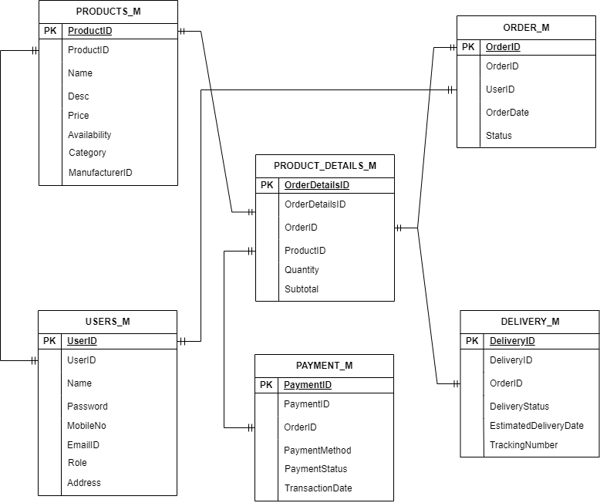

**Question 7: What is a Data Flow Diagram (DFD)?**

A Data Flow Diagram (DFD) is a graphical representation of the flow of data within a system. It visually maps input, processing, storage and output of data, showing how information moves between entities, processes and data stores.

Draw a data flow diagram to represent the in-flow and out-flow of data when a Farmer is placing an order for the product

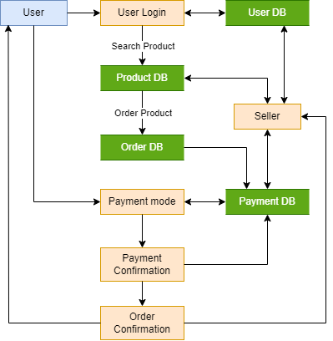

**Question 8:** Due to change in the Government Taxation structure. We should change the Tax structure. How do you handle change requests in a project?

Handling **Change Requests** in a project is crucial to ensure smooth implementation without affecting project scope, budget and timelines. Here’s how I would handle the **change in the Government Taxation structure** in our **online agriculture product store project.**

**Step-by-Step Approach to Handling Change Requests**

**1. Identify & Document the Change Request**

* The Finance Team or relevant authority formally submits a Change Request (CR) regarding the tax structure update.
* Document details such as reason for change, affected modules and urgency in a Change Request Form.

Example:

* Requester: Financial Head (Mr. Pandu)
* Change: Update tax calculation formula
* Reason: Compliance with new government taxation rules

**2. Analyse the Impact of the Change**

Assess how the change affects the current system:

* Product Pricing Calculation: Does tax apply before/after discounts?
* Order & Payment Module: Does tax impact total payable amount?
* Database Changes: Do we need new tax fields?

Discuss with the Project Manager (Mr. Vandanam), Finance Team (Mr. Pandu), and Developers (Ms. Juhi & team) to evaluate technical feasibility.

**3. Prioritize & Approve the Change**

* If the impact is significant, schedule a Change Control Board (CCB) meeting (Key stakeholders: Mr. Henry, Mr. Pandu, Mr. Dooku, and Development Team).
* Categorize change priority: High (urgent compliance), Medium (important but flexible), Low (future updates).
* If approved, update the Requirement Traceability Matrix (RTM) and project scope.

**4. Plan & Implement the Change**

Assign tasks to developers (Ms. Juhi & team) and DB admin (Mr. John).

What to Update:

* Product price calculation logic
* Tax details in invoices

Test the new tax structure to ensure compliance and conduct User Acceptance Testing (UAT) with the Finance team.

**5. Deploy & Communicate the Change**

* Deploy changes in a staging environment before production.
* Train farmers, manufacturers and finance users on the updated tax rules.
* Update User Manuals & Documents to reflect tax structure changes.

**Question 9:** As the project is in process, Ben and Kevin have contacted you. The reason is to inform you that they want the Farmers to sell their crop yields through this application i.e. Farmers should be able to add their crop yields or products and display to general public and should be able to sell them. They also want to introduce Auction system for their Crop yields. **As a BA, what will be your response? Is this a change request or an enhancement?**

As this is major change in the application, my response will be like:

**Acknowledge the Request**: I would thank Ben and Kevin for their valuable input and inform them that their request needs to be evaluated in terms of feasibility, scope, budget, and timeline impact.

**Clarify Requirements**:

* Should all farmers be allowed to sell their crops or will there be approval criteria?
* How will pricing work (fixed price or auction-based bidding)?

**Impact Analysis**:

* This change impacts database design, UI, payment processing and order fulfilment.
* It may require additional modules for listing crops, buyer registrations and auction management.
* It will increase project complexity and cost.

**Is this a Change Request or an Enhancement?**

This request is a Change Request (CR) rather than a simple enhancement.

**Scope Expansion**: The original system was designed for farmers to buy products (fertilizers, seeds, pesticides). Now, it needs to support selling as well.

**New Functional Modules**: The auction system introduces a completely new feature requiring extra development efforts.

**Budget & Timeline Impact:** This change will extend the project timeline and may exceed the allocated budget.

**Next Steps**:

* Document the Change Request (CR) with detailed requirements.
* Discuss with Key Stakeholders (Mr. Henry, Mr. Pandu, Mr. Dooku) to assess feasibility.
* Conduct Impact Analysis to determine cost, development time and required resources.
* Obtain Approval from the Change Control Board (CCB).
* Plan Implementation if approved, with updated timelines and testing strategy.

**Question 10**: Come up with estimations – How many Man hours required?

Since this is a major change request impacting multiple areas of the project (database, UI, business logic, payment system, order fulfilment, etc.), we will use the **Work Breakdown Structure (WBS) and Function Point Estimation** approach to calculate the estimated effort in man-hours.

**Identifying the Work Breakdown Structure (WBS)**

**Phase 1:** Requirement Analysis & Design

|  |  |  |
| --- | --- | --- |
| **Task** | **Resource(s) Involved** | **Estimated Hours** |
| Requirement gathering & documentation | Business Analyst (BA) | 16 |
| Stakeholder meetings & approvals | BA, Project Manager | 10 |
| System impact analysis | BA, Architect, PM | 12 |
| UI/UX design for seller & auction module | UI/UX Designer | 24 |
| Database schema updates & design | Database Admin (DBA) | 16 |
| API design for product listing & bidding | Backend Developer | 20 |
| **Subtotal (Phase 1)** |  | **98 hours** |

**Phase 2**: Development

|  |  |  |
| --- | --- | --- |
| **Task** | **Resource(s) Involved** | **Estimated Hours** |
| Develop product listing module for farmers | Java Developers | 40 |
| Implement auction system | Java Developers | 50 |
| Modify order processing & payment | Java Developers | 30 |
| Implement notifications & email alerts (bids, sales, etc.) | Java Developers | 20 |
| Update UI for farmers & buyers | Frontend Developers | 30 |
| Database modifications for crop products & auctions | DBA | 20 |
| API development & integration | Backend Developer | 40 |
| **Subtotal (Phase 2)** |  | **230 hours** |

**Phase 3:** Testing & Deployment

|  |  |  |
| --- | --- | --- |
| **Task** | **Resource(s) Involved** | **Estimated Hours** |
| Unit testing | Developers | 30 |
| Integration testing | Testers | 40 |
| User Acceptance Testing (UAT) | BA, Testers, Stakeholders | 24 |
| Bug fixing & retesting | Developers, Testers | 30 |
| Performance & security testing | Testers | 20 |
| Deployment & post-go-live monitoring | DevOps, DBA | 16 |
| **Subtotal (Phase 3)** |  | **160 hours** |

**Final Man-Hours Estimation**

|  |  |
| --- | --- |
| **Phase** | **Estimated Hours** |
| Requirement Analysis & Design | **98 hours** |
| Development | **230 hours** |
| Testing & Deployment | **160 hours** |
| **Total Estimated Effort** | **488 hours** |

**Estimated Timeline & Resources Needed**

* Total Estimated Effort: 488 man-hours
* Estimated Duration: 2 – 2.5 months with parallel execution
* Ideal Team Size: 4-5 developers, 2 testers, 1 BA, 1 UI/UX, 1 DBA

**Question 11:** Explain UAT Acceptance process

**Step 1: Plan & Schedule UAT**

* Contact the client representatives (Mr. Henry, Mr. Pandu, and Mr. Dooku) and schedule a UAT session.
* Prepare a UAT Test Plan that includes:
  + Scope of testing (what will be tested)
  + Roles & responsibilities (who will perform tests)
  + Test environment details (staging server, login credentials)
  + Testing timeline (planned start and end dates)
  + Acceptance criteria (what defines success)

**Step 2: Prepare UAT Test Cases & Scripts**

* Share detailed UAT test cases with the client (covering all functionalities).
* Ensure real business scenarios are covered (e.g., Farmers placing orders, Manufacturers listing products, Auction processes).
* Provide UAT guidelines and training for the client team.

**Step 3: Execute UAT & Gather Feedback**

* Conduct UAT Kick-off Meeting with stakeholders.
* Provide clients with access to the staging environment.
* Guide them through each test case and track their inputs.
* Record any defects or feedback in a UAT log.
* If major issues arise, coordinate with the development team for fixes.

**Step 4: Obtain UAT Sign-Off**

* Once all tests pass and feedback is addressed, obtain formal UAT sign-off from the client.
* The UAT Acceptance Document should include:
  + List of tested features
  + Final approval statement
  + Client’s confirmation that the system meets their expectations

**Question 12:** What is Project Closure Document and its Process?

A **Project Closure Document** is a formal report prepared at the end of a project to confirm its successful completion. It provides a **summary of the project, evaluates its success and documents lessons learned**. The closure document serves as an **official record** and ensures that all contractual obligations have been met before releasing project resources.

Once UAT is successfully completed, follow these steps for a structured project closure:

**Step 1: Deploy the Final Product**

* Move the application from staging to production.
* Conduct final system checks before go-live.

**Step 2: Client Training & Handover**

* Conduct training sessions for farmers, manufacturers, and administrators.
* Provide user manuals & documentation.

**Step 3: Transition to Support Team**

* Ensure all project deliverables are handed over to the client & support team.
* Set up a post-go-live support period (e.g., 2-4 weeks for issue resolution).

**Step 4: Conduct a Project Review & Closure Meeting**

Hold a final review meeting with the project team and key stakeholders.

Discussion points:

* Lessons learned
* Successes and challenges
* Future enhancements

**Step 5: Obtain Final Sign-Off & Closure Report**

Prepare a Project Closure Report, including:

* Project summary
* Objectives achieved
* UAT completion
* Final deployment confirmation

Obtain final sign-off from Mr. Henry and other stakeholders.

**Step 6:** Release Project Resources

* Officially release the project team from responsibilities.

**Key Components of a Project Closure Document**

1. Project Summary

* Project Name: Online Agriculture Product Store
* Project Sponsor: Mr. Henry (SOONY Company)
* Project Budget: 2 Crores INR
* Project Duration: 18 months
* Project Goal: To create an online platform for farmers to buy and sell agricultural products

2. Objectives & Deliverables Achieved

* Online platform with user-friendly UI for farmers and manufacturers.
* Features like product catalogue, search, payment gateway and order tracking.
* New feature: Farmers can list and auction their crop yields.
* Successful User Acceptance Testing (UAT) sign-off from the client.

3. Performance Evaluation

* Was the project delivered on time?
* Was it completed within budget?
* Were all client requirements met?
* Any major issues faced & how were they resolved?

4. Lessons Learned

What went well?

* Effective stakeholder collaboration.
* Strong requirement gathering & change management.
* Smooth UAT execution with quick fixes.

Challenges faced?

* Government taxation changes required quick adaptation.
* Introduction of farmer-to-public sales & auction system mid-project.

5. Handover & Support Transition

* Live System URL: [Production Server Link]
* User Manuals & Training Materials: Attached
* Support Team Contact: [Support Email & Helpdesk]
* Post-Go-Live Support Duration: 2 months

6. Final Client Sign-Off

* Client Representative Name: Mr. Henry
* Approval Signature: _______________________
* Date: [Final Sign-Off Date]