**Question 1**

**Answer:**

**Goal**: Facilitate remote farmers in purchasing agricultural products (fertilizers, seeds, and pesticides) online & become farmer’s centric company.

Inputs:

* Product details from the manufacturers like fertilizers, seeds, pesticides.
* Farmer requirements like product selection and delivery location.

Resources:

* Manufacturers (suppliers of products).
* Farmers (end-users).
* IT infrastructure (servers, databases, and networking).
* Development team (PM, BA, developers, testers,

Activities:

* Manufacturers upload product details.
* Farmers will browse these products and select the products what they

need and request to buy them and place orders.

* Payments are processed online.
* Products are shipped to farmer locations through logistic partner.

Outputs:

* Delivery of agricultural products at farmers location.

Value:

* Farmers gain easy access to essential products.
* Facilitate farmers to buy seeds, pesticides, and fertilizers from anywhere.
* Reduces logistical challenges and intermediaries.

**Question 2: SWOT Analysis**

**Answer:**

**Strengths**:

* Access to a wide range of products.
* Strong promoter Background, experienced Talented Employees
* Companies experience in handling such projects.

**Weaknesses**:

* Dependence on internet connectivity in rural areas.
* Regulatory compliance

**Opportunities**:

* Potential expansion into other agricultural products/services.
* Expansion in new markets, trending digital transformation in industries
* Increasing dependencies on online markets.

**Threats**:

* Competition from similar platforms.
* Data security risks and cyber threats.
* Technology changes

**Question 3: Feasibility Study**

**Answer:**

**Hardware Requirements**:

1. Servers: Server is required for application development and for

database storage and its location

2. Network infrastructure: Network infrastructure for secure communication between

the online store and customers, suppliers.

3. Devices: Devices on which it will be used like computers or mobiles

**Software Requirements**:

1. Operating System: Different operating system user will operate on their devices like for computers windows or Mac for mobiles Android or iOS. Accordingly online application will be developed.

2. A suitable e-commerce platform that supports agricultural products and provides

features like product listings, shopping cart, payment gateways, and inventory

management.

3. security measures to protect customer data, to ensure secure online transactions.

**Trained Resources**: Skilled Java developers, testers, and system admins.

**Budget**: INR 2 crores allocated.

1. Application Development Costs: Estimate the costs associated with website development, example-software licenses, server infrastructure cost, and employee cost

2. After development application maintenance cost.

**Time Frame**: 18 months for project completion.

Application Development Timeline: timeline for website development, testing, and

deployment.

**Question 4: Gap Analysis**

**Answer:**

**AS-IS Process**:

* Farmers struggle to procure fertilizers, seeds, and pesticides.
* Dependence on physical stores and intermediaries.
* Manufacturing Companies also facing difficulties in communicating, selling their products.

**TO-BE Process**:

* Online platform enables direct purchase from manufacturers.
* Reduced dependency on intermediaries and increased transparency.

**Gaps**:

* Lack of an existing digital platform.
* Inadequate digital literacy among farmers.
* There is a gap in terms of order placement, payment processing, order

tracking, and delivery management which will be fulfilled by technology

**Question 5: Risk Analysis**

**Answer:**

**BA Risks**:

* Stakeholder risk: There may be Lack of interest by stakeholder.
* Inadequate planning: there may be project start in hurry leads to risk.
* Market demand of product: A lack of demand for agricultural products online, leading to low sales.
* Competition: Other online agricultural stores may make it difficult to attract customers and gain market share.
* Supplier risk: Suppliers Dependency for timely delivery.
* Adoption of online purchase: Customers may be hesitant to adopt online platforms at early stage.

**Project Risks**:

* Technology Risks: Inadequate technology infrastructure may lead to project slower.
* Budget overruns.
* Delays due to lack of technical expertise.
* Low user adoption due to lack of training.

**Mitigation Strategies**:

* Regular requirement validation sessions.
* Proper resource allocation and training.
* Conduct workshops for farmers.

**Question 6: Stakeholder Analysis (RACI Matrix)**

**Answer:**

| **Stakeholder** | **Responsible** | **Accountable** | **Consulted** | **Informed** |
| --- | --- | --- | --- | --- |
| Mr. Henry |  | X | X |  |
| Mr. Karthik | X |  | X |  |
| Mr. Vedant | X |  |  | X |
| Mr. Pandu |  |  | X | X |
| Mr. Dooku |  |  | X | X |
| Farmers |  |  | X |  |
| Manufacturers |  |  | X |  |
| Development Team | X |  |  |  |

**Question 7 – Business Case Document**

**Answer:**

Summary: The online agriculture product store is a proposed solution to the difficulties

faced by farmers in buying fertilizers, seeds and pesticides. Both parties can communicate

directly with each other. The proposed project has an estimated budget of 2 crores INR and

a duration of 18 months.

Problem Statement: Farmers faces difficulties in procuring agriculture products such as

fertilizers, seeds and pesticides. which result in a decrease in crop yield.

Solution: The proposed solution is to create an online agriculture product store that will

make the buying and selling process easier to both. Agriculture store will be accessible

through internet connectivity and will be user-friendly.

Business Requirements:

Product catalogue: The ability to list products such as fertilizers,

seeds and pesticides with detailed information. Farmers must be able to place orders for

products they need through the platform, & delivery partners must have the ability to

arrange for delivery of the products to the farmers.

Benefits: Increased access to all agriculture products also Improved efficiency which reduces

the time and effort needed to purchase products which leads to increased crop yields.

Increased access to agriculture products: Farmers will have access to a wider range of

products through the platform, increasing their options for procurement.

Improved efficiency: The procurement process will become more efficient, reducing the

time and effort needed to purchase products.

Increased income: Improved access to essential agriculture products will result in increased

crop yields, leading to an increase in income for the farmers.

Costs and Funding:

The estimated budget for the project is 2 crores INR.

Project Schedule:

The project is expected to take 18 months to complete. Key milestones include project

initiation, requirements gathering, development, testing and deployment.

**Question 8 – Four SDLC Methodologies**

**Answer:**

There are many Project Development Approach. Mr Karthik explained to Mr. Henry

about SDLC. And four methodologies like Sequential Iterative Evolutionary and Agile. Which

are explained below.

Four SDLC Methodology

1. Sequential -: This is the most common SDLC models, it is also referred to as a linear-

sequential life cycle model. each phase must be completed in its entirety before the

next phase can begin. This method is best suited for projects with well-defined

requirements, low risk, and predictable outcomes.

2. Iterative -: This methodology involves developing the software in iterations, where

each iteration builds upon the previous one. There are Four Project Life cycle Phases

namely Inception, Elaboration, Construction, Transition. This method is best suited

for projects with complex requirements and high risk.

3. Evolutionary -: This methodology involves developing a basic version of the software

and then incrementally improving it. The spiral model gives more emphases placed

on risk analysis. The spiral model has four phases: Planning, Risk Analysis,

Engineering and Evaluation. This method is best suited for projects with rapidly

changing requirements and high risk.

4. Agile -: This methodology is based on an iterative and incremental approach, and

involves close collaboration between the development team and stakeholders. Agile

methodology Satisfy the customer through early and continuous delivery of valuable

software. This method is best suited for projects with rapidly changing requirements,

high risk, and complex environments.

**Question 9 – Waterfall RUP Spiral and Scrum Models**

**Answer:**

1. Waterfall: This model is a sequential approach where each phase of development

must be completed before moving on to the next phase. At the end of each phase

review of a project taken to ensure project on right direction. Phases of Waterfall

Model - Requirements gathering, Requirements Analysis, Design, Development,

Testing. It is best suited for projects with well-defined requirements and clear project

goals.

2. RUP: This model is a unified and iterative approach that uses a set of best practices

for software development. It is based on a set of building blocks, namely Roles (who),

Work Products (what), Tasks (how). There are Four Project Life cycle Phases namely

Inception, Elaboration, Construction, Transition. This method is best suited for

projects with complex requirements and high risk.

3. Spiral: This model is a combination of both the sequential and iterative approaches,

where each iteration builds upon the previous one. model gives more emphases

placed on risk analysis. The spiral model has four phases: Planning, Risk Analysis,

Engineering and Evaluation. In planning phase, requirements are gathered and risk is

assessed. A prototype is produced at the end of the risk analysis phase. Software is

produced in the engineering phase, along with testing at the end of the phase.

evaluation phase allows the customer to evaluate the output of the project. It is

costly model to use. It is best suited for high-risk projects with uncertain

requirements.

4. Scrum: This model is an agile approach that emphasizes teamwork, collaboration,

and adaptability. This model is currently used in many companies. Project is divided

into product backlog, from it is sub divided in to sprints. Sprints consist of specific set

of user-stories & each sprints duration is 2 weeks max. scrum team consist of scrum

Manager responsible for monitor the performance of the team within the sprint,

Product owner who responsible for how the product has to be, there are developers,

testers & business analyst. After completion of each sprint meeting is done called

Sprint Retrospective Meeting, the meeting is dedicated to discussing what went well

and what could be improved in the next sprint.

When the APT IT SOLUTIONS company got the project to make this online agriculture

product store, there is a difference of opinion between a couple of SMEs and the project

team regarding which methodology would be more suitable for this project. SMEs are

stressing on using the V model and the project team is leaning more onto the side of

waterfall model. As a business analyst, which methodology do you think would be better for

this project?

Answer: - As a business analyst, waterfall model is better in this project. As it develops

software in a linear way. Also, it is not high-risk project where testing continuously to be

done. The cost of Waterfall model is low. Hence, we prefer waterfall model.

**Question 10 – Waterfall Vs V-Model**

**Answer:**

Waterfall Model:

* The Waterfall Model is a sequential development process. It consists of 6 stages –
* Requirement gathering, Requirement analysis, Design, Development, Testing and
* Deployment.
* Each phase must be completed in its entirety before the next phase can begin.
* The cost of Waterfall model is low.
* Waterfall model is not Flexible.
* Waterfall model is a continuous process.
* However, this model is not suggested for bigger or high-risk projects as changes can’t
* be incorporated in between.

V-Model

* V-Model is a type of SDLC model where the process executes sequentially in a V-
* shape. It is also known as the Verification and Validation model
* The development of each step is directly associated with the testing phase. The next

phase starts only after completion of the previous phase i.e., for each development

activity.

* V-model is expensive & Little flexible.
* V-model is a simultaneous process where for each development activity, there is a testing activity corresponding to it.
* The V-Model offers a methodical way to manage testing activities and reduce risks.

**Question 11 – Justify your choice**

**Answer:**

Waterfall model is an easy to understand and simple model. The complete process is divided into several phases. One phase should be completed to reach the next phase. The first phase is requirement gathering and analysis.

The requirements are then documented. It is called the Software Requirement Specification (SRS). The next is the system design phase.

It is to design the entire software architecture. Next phase is the implementation phase. It is to start coding the small units.

These units are combined to form the complete system and tested in the integration and testing phase. After the testing is completed, the software is distributed to the market. The activities such as maintenance of the software and adding new features come under deployment and maintenance. This model is appropriate for small projects and when the requirements are very clear.

**Question 12 – Gantt Chart**

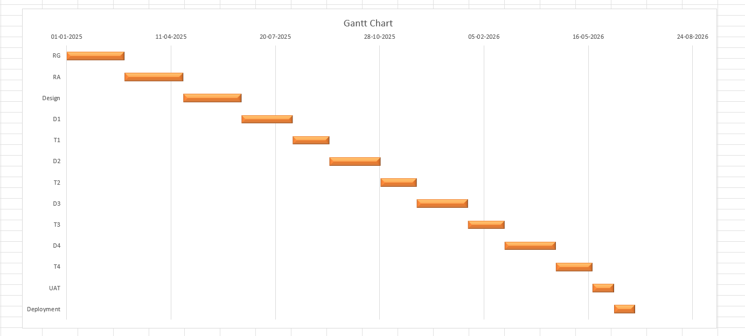

**Question 13 – Fixed Bid Vs Billing**

**Answer:**

Fixed Bid Model:

* A method of project delivery where the price for the project is agreed upon and

fixed.

* In this model, the scope of the project is defined and agreed upon by the client and

the vendor

* The vendor is responsible for delivering the project within the agreed-upon budget

and timeline.

* The vendor bears the risk of any cost over runs or schedule delays.

Billing Model:

* The Billing Model is a method of project delivery where the client is charged based

on the actual time and resources used on the project.

* In this model, the scope of the project is not fixed.
* The client is charged based on the actual time and resources spent on the project

and any changes to the scope of the project are accommodated through changes to

the budget and timeline.

* This model allows for greater flexibility in the project.

**Q14 Timesheets of a BA in various stages of SDLC**

