Q1) Identify Business Process Model for Online Agriculture Store – (Goal, Inputs, Resources, Outputs, Activities, Value created to the end Customer)

To define the Business Process Model for the Online Agriculture Store:

**1. Goal:**

The primary goal of the **Online Agriculture Store** is to enable farmers in remote areas to easily purchase agricultural products (fertilizers, seeds, and pesticides) through an online platform, overcoming the challenges of accessing these products in rural areas.

**2. Inputs:**

* **Farmer Needs**: Information about the products that farmers need (fertilizers, seeds, pesticides).
* **Product Information from Manufacturers**: Details of the products (seeds, fertilizers, pesticides) including pricing, quantity, and descriptions.
* **Internet Access**: Internet connectivity to access the online store.
* **Order Requests**: Farmers' requests to buy the products.
* **Payment Methods**: Different modes of payment for purchasing products (credit card, debit card, online payment gateways, etc.).

**3. Resources:**

* **Online Platform**: The website or mobile application that facilitates transactions and interaction between farmers and manufacturers.
* **Database**: Stores information about products, farmer accounts, order history, payments, and delivery information.
* **Logistics/Delivery System**: Partners with delivery services to ship products to farmers' locations.
* **Customer Support**: Assistance to help farmers with any issues related to product selection, ordering, or delivery.
* **Marketing Materials**: Promoting the platform to farmers and agricultural product manufacturers.

**4. Outputs:**

* **Product Purchases**: Completed orders of fertilizers, seeds, and pesticides.
* **Delivery of Products**: The ordered products are delivered to the farmers' location.
* **Transaction History**: A record of all orders made, including the product details, quantities, and payment.
* **Farmer Feedback**: Feedback about the product quality and user experience on the platform.

**5. Activities:**

* **Product Listing**: Manufacturers submit product details (seeds, fertilizers, pesticides) to the online store, including prices, descriptions, and availability.
* **Product Browsing**: Farmers browse the available products through the platform.
* **Product Selection**: Farmers select the products they want to purchase.
* **Order Placement**: Farmers place an order by adding selected products to the cart and proceeding with the checkout process.
* **Payment Processing**: The system processes the payment using available payment methods.
* **Order Confirmation**: Once payment is confirmed, the order is processed for delivery.
* **Delivery Coordination**: The logistics team coordinates the delivery of the products to the farmer’s location.
* **Customer Support**: Addressing any issues farmers may have regarding their orders, delivery, or products.

**6. Value Created to the End Customer:** (Here farmers and all related are the customers)

* **Convenience**: Farmers can order agricultural products from the comfort of their homes, avoiding travel and time constraints.
* **Access to Variety**: Farmers can access a wide variety of seeds, fertilizers, and pesticides from different manufacturers.
* **Time and Cost Efficiency**: By purchasing online, farmers save time and costs associated with traveling to buy these products.
* **Product Quality Assurance**: The online platform can offer a review system where farmers can assess product quality based on previous buyer feedback.
* **Product Availability**: The platform ensures the availability of the necessary agricultural products year-round.
* **Delivery to Remote Areas**: Farmers in remote locations get the products delivered directly to their farms, addressing logistical challenges.

Q2) Mr Karthik is doing SWOT analysis before he accepts this project. What Aspects he Should consider as Strengths, as Weaknesses, as Opportunity and as Threats.

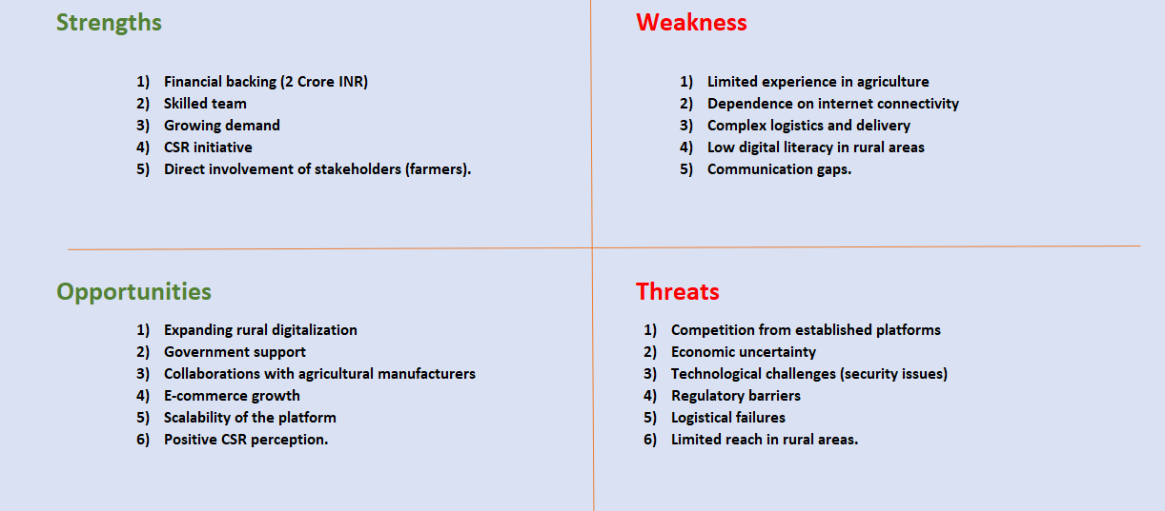…

Q3) Mr Karthik is trying to do feasibility study on doing this project in Technology (Java), Please help him with points (HW SW Trained Resources Budget Time frame) to consider in feasibility Study.

Feasibility Study for the Online Agriculture Store project using Java technology, Mr. Karthik should evaluate several key factors, dividing the feasibility analysis in the three parts: Hardware, Software, Trained Resources and also Budget, Time Frame helping us make better go or no-go decisions.

**1. Hardware Requirements:**

* **Server Infrastructure**:
  + **Web Servers**: To host the online platform, Java-based web applications
  + **Database Servers**: Using database with SQL for storing product information, user data, order history, etc.
  + **Storage**: Sufficient disk space for data storage, backups, and any media files (e.g., images of products, documentation).
  + **Backup Systems**: For critical data like orders, user details, and product information.
  + Network infrastructure to support real-time data transfer, connectivity & manage traffic with ease.

**2. Software Requirements:**

* **Operating System**:
  + Choose a robust and scalable operating system for hosting the Java-based platform like Windows or Linux or IOS etc.
* **Java Frameworks & Libraries**:
  + Backend.
  + Database Management.
  + Create robust web applications.
  + Web pages and interactive UI.
* **Development Tools**:
* **Testing Tools**:
* **Security**:
  + Encryption for secure transactions.
  + Authentication and authorization of users.
  + Firewalls and other cybersecurity measures to protect sensitive data.

**3. Trained Resources:**

* **Java Developers**
* **Frontend Developers**
* **Database Administrators (DBAs)**
* **DevOps Engineer**
* **Tester**
* **Technical Support Team**

**4. Budget:**

* **Initial Development Costs**:
  + Software Licenses
  + Hardware Infrastructure
  + Development Tools
* **Operational Costs**:
  + Salaries
  + Cloud Services
  + Marketing
  + Maintenance & Support

**5. Time Frame:**

| **Phase** | **Time Allocation** | **Time (Months)** |
| --- | --- | --- |
| Requirements | 10% | 2 months |
| Design | 25% | 4.5 months |
| Development | 40% | 7 months |
| Testing | 20% | 4 months |
| Implementation | 5% | 1 month |

Q4) Mr Karthik must submit Gap Analysis to Mr Henry to convince to initiate this project. What points (compare AS-IS existing process with TO-BE future Process) to showcase in the GAP Analysis

To help Mr. Karthik convince Mr. Henry to initiate the project, a Gap Analysis can be presented by comparing the AS-IS (Current Process) with the TO-BE (Future Process). This will highlight the improvements and benefits that the new Online Agriculture Product Store can bring. Below are key points that should be covered in the Gap Analysis:

**1. AS-IS (Current Process):**

* **Product Procurement**:
  + Farmers like Peter, Kevin, and Ben struggle to procure fertilizers, seeds, and pesticides due to lack of accessibility.
  + Dependency on local vendors, middlemen who may not have the required products in stock at times is high.
  + Limited availability of products for farmers in remote areas, creating gaps in supply.
* **Communication**:
  + Farmers must physically visit local shops to inquire about product availability, pricing, and quality.
  + Lack of direct communication between farmers and manufacturers, which means farmers cannot directly access product information.
* **Transaction Process**:
  + Manual payment methods (cash or local banking), which can lead to delays and errors in payment processing.
  + Limited product selection: Farmers can only access products that local vendors have, and they may not have access to new or high-quality products.
  + Order Tracking is mostly non-existent or inefficient.
* **Time and Efficiency**:
  + Time-consuming is high & Limited options for product.
* **User Experience**:
  + Farmers lack digital literacy and Limited awareness about different products

**2. TO-BE (Future Process with Online Agriculture Product Store):**

* **Product Procurement**:
  + Farmers can easily access a wide variety of products through the online platform.
  + Direct access to products from reliable manufacturers.
  + Centralized marketplace for agricultural products, ensuring consistent supply.
* **Communication**:
  + Direct communication between farmers and product manufacturers.
  + The platform will provide real-time product information.
  + Feedback and reviews from other farmers and manufacturers can be shared directly through the platform.
* **Transaction Process**:
  + Secure online payments, Order confirmation and tracking.
* **Time and Efficiency**:
  + Time savings
  + Faster order fulfilment
  + No need to visit multiple locations
* **User Experience**:
  + User-friendly interface designed to cater to the digital literacy level of farmers, including easy navigation and clear product listings.
  + The platform will provide a personalized experience, showing product recommendations based on farming needs.
  + Mobile-friendly platform to ensure farmers can access the store from their mobile devices even in remote areas.
  + Educational resources such as guides and tutorials will be available to help farmers understand how to use the platform and select the right products.

Q5) List down different risk factors that may be involved (BA Risks And process/Project Risks)

**1. BA (Business Analyst) Risks:**

**a. Missing Important Information**

* The Business Analyst might miss some key details or get the requirements wrong, leading to a product that doesn’t meet the needs of the users.

**b. Misunderstanding Between Stakeholders**

* Different stakeholders might want different things, which could lead to confusion and changes in the project.

**c. Unclear Project Goals**

* If the project’s goals aren’t well-defined, the team might get confused, and the project might get delayed or go over budget.

**d. Not Validating Requirements**

* The Business Analyst might not check the requirements with stakeholders enough, leading to mistakes in the final product.

**e. Changing Requirements**

* Stakeholders might change their minds after work has already started, leading to delays and extra costs.

**f. Not Considering User Experience**

* If the platform is too complicated for farmers to use, they may not adopt it.

**2. Process/Project Risks:**

**a. Going Over Budget**

* The project could cost more than the ₹2 Crores budget if things don’t go as planned.

**b. Delays in Timeline**

* The project might not be finished within the 18-month deadline.

**c. Team Availability Issues**

* Team members might not be available due to personal or work reasons, causing delays.

**d. Not Enough Testing**

* The platform might have bugs or issues if it’s not tested properly.

**e. Technical Problems**

* There could be unexpected problems with the technology being used, like compatibility issues or system crashes.

**f. Security Risks**

* The platform might face security issues like data breaches or hacking.

**g. Problems with Integrating Other Systems**

* If the platform needs to work with other systems (like payment systems or delivery services), it might not integrate smoothly.

**h. Low User Adoption**

* Farmers might not use the platform because they don’t understand how to use it or don’t trust it.

**i. Legal or Compliance Issues**

* There might be legal problems if the platform doesn’t meet local rules and regulations.

**j. Stakeholder Engagement Problems**

* If the stakeholders (like farmers or manufacturers) are not involved enough, the project might not meet their needs.

**k. External Problems**

* External factors like political changes, natural disasters, or economic changes could impact the project.

Q6) Perform stakeholder analysis (RACI Matrix) to find out the key stakeholders who can take Decisions and Who are the influencers

| **Role/Profession** | **Project Scope & Objectives** | **Budget Allocation** | **Product Features** | **Platform Design** | **Technology & Development** | **Testing & Quality Assurance** | **Launch Decision** | **Post-Launch Support** |
| --- | --- | --- | --- | --- | --- | --- | --- | --- |
| **Sponsor** | A | I | A | A | I | I | A | I |
| **Financial Head** | C | A | C | C | C | C | I | I |
| **Project Coordinator** | A | I | C | C | I | I | C | C |
| **Farmers** | C | I | C | C | I | I | I | I |
| **Delivery Head** | C | I | C | I | A | I | I | I |
| **Project Manager** | A | I | A | A | A | I | I | I |
| **Senior Java Developer** | C | I | C | A | R | I | I | I |
| **Java Developers** | I | I | C | R | R | I | I | I |
| **Network Admin** | I | I | I | I | C | I | I | A |
| **DB Admin** | I | I | I | I | C | I | I | A |
| **Testers** | I | I | I | I | I | R | I | I |

Q7) Help Mr Karthik to prepare a business case document

**1. Project Initiation: Why is this project initiated?**

This project is initiated to address the critical challenges faced by farmers in remote areas who struggle to procure essential agricultural products such as fertilizers, seeds, and pesticides. These farmers often lack direct access to vendors and face significant logistical barriers to purchasing quality products. The goal is to build an online platform that will provide farmers with an easy way to purchase agricultural products directly from manufacturers, improving productivity and supporting the agricultural community.

The initiative also aligns with the Corporate Social Responsibility (CSR) goals of the sponsoring company and addresses a social need by leveraging technology to empower farmers.

**2. Current Problems: What are the current problems?**

* **Limited Access to Agricultural Products:** Farmers in remote areas are unable to easily access fertilizers, seeds, and pesticides due to the absence of nearby suppliers or local markets.
* **High Costs and Unreliable Supply Chains:** The supply chain for agricultural products in these areas is fragmented, leading to high prices, delays, and inconsistent product availability.
* **Limited Technology Adoption:** Many farmers lack access to modern agricultural technologies, and are not well-versed in how to leverage the internet to make purchases.
* **Inefficient Communication:** There is no central platform for manufacturers and farmers to communicate directly, causing inefficiencies in transactions.

**3. Problem Solved with the Project: How many problems could be solved?**

The proposed solution will address several key issues:

* **Improved Access to Agricultural Products:** Farmers will be able to browse and order fertilizers, seeds, and pesticides directly through the platform, making it easier to procure essential products.
* **Lower Costs and Streamlined Supply Chain:** By connecting farmers directly with manufacturers, the platform eliminates middlemen, potentially lowering costs and improving supply chain efficiency.
* **Increased Technology Access:** Farmers will be able to access technology through the platform, allowing them to make informed purchasing decisions and track orders online.
* **Direct Communication Channels:** Manufacturers can directly interact with farmers, leading to better product offerings and more tailored solutions.
* **Scalability:** The platform will be scalable, allowing it to be expanded to other areas and serve a broader audience of farmers in the future.

This solution has the potential to solve multiple problems simultaneously, including access, cost efficiency, technology adoption, and communication.

**4. Resources Required: What are the resources required?**

* **Human Resources:**
  + **Development Team:** Developers (Java, Senior Java Developer, Database Admin, Network Admin) to build the platform.
  + **Project Manager:** Oversee development, manage timelines, and ensure project delivery.
  + **Testers:** To ensure quality assurance and proper functionality of the platform.
  + **Financial Experts:** To manage the budget and ensure financial accountability.
* **Technology Resources:**
  + **Web and Mobile Development Tools:** To create the platform that is user-friendly and accessible.
  + **Cloud Infrastructure:** For hosting and storing data securely.
  + **Database Management System:** For managing user data, product inventory, and transaction records.
  + **Payment Integration:** For processing online transactions securely.
* **Financial Resources:**
  + The project has a budget of **2 Crores INR**, which will be allocated to development, infrastructure, marketing, and support.

**5. Organizational Change: How much organizational change is required to adopt this technology?**

The organizational change required to adopt this technology will be moderate but significant. The company will need to:

* **Adopt New Technologies:** IT staff and project management will need to become familiar with the specific technologies used in the development and operation of the platform.
* **Train Farmers:** Since the target audience (farmers) may have limited experience with online platforms, there will be a need for outreach programs, tutorials, and customer support to help them adopt the technology.
* **Supplier Integration:** Manufacturers will need to be onboarded and taught how to upload products and manage their inventory on the platform. The company will need to provide support to manufacturers to facilitate this integration.
* **Internal Processes:** New processes will be implemented for order handling, customer service, and payment reconciliation, requiring coordination across multiple departments.

**6. Time Frame to Recover ROI (Return on Investment):**

The time frame to recover ROI will depend on the adoption rate and market reach. Based on the project's scope and the target market (farmers and manufacturers), we anticipate the following:

* **Year 1:** Focus on platform development, farmer education, and initial adoption.
  + The ROI in the first year will likely be low as the platform is being established and users are being onboarded.
* **Year 2:** As the platform gains traction and more farmers start using the service, the ROI should improve.
  + The increase in product sales, along with the reduced cost of procurement for farmers, will contribute to a return.
* **Year 3 and beyond:** At this stage, we expect significant growth as the platform scales, leading to a more rapid recovery of the investment and profitability.
  + **Estimated ROI Recovery Time:** Approximately **2 to 3 years**.

**7. Identifying Stakeholders: How to identify stakeholders?**

Stakeholders for this project can be identified based on their direct or indirect involvement in the project's success. Here's how they can be categorized:

* **Primary Stakeholders:**
  + **Farmers (End Users):** They are the primary users of the platform who need the product offerings (fertilizers, seeds, pesticides).
  + **Manufacturers:** Suppliers of agricultural products who will list their products on the platform.
* **Secondary Stakeholders:**
  + **Project Team (APT IT Solutions):** Includes project managers, developers, testers, and infrastructure staff responsible for building and maintaining the platform.
  + **Mr. Henry and the CSR Committee:** The project sponsors who are driving the initiative as part of their corporate social responsibility.
* **Tertiary Stakeholders:**
  + **Government Agencies:** Potentially involved in the regulation and oversight of agricultural products.
  + **Local NGOs or Farmers' Associations:** May help with outreach and training for farmers to use the platform.

Q8) The Committee of Mr. Henry , Mr Pandu , and Mr Dooku and Mr Karthik are having a discussion on Project Development Approach. Mr Karthik explained to Mr. Henry about SDLC. And four methodologies like Sequential Iterative Evolutionary and Agile. Please share your thoughts and clarity on Methodologies.

SDLC (Software Development Life Cycle): The Software Development Life Cycle (SDLC) is a structured approach to software development that consists of several phases, including planning, design, development, testing, and deployment. The purpose of SDLC is to ensure that the software meets the required standards, is delivered on time, and meets the business needs of the project.

The Four Methodologies: Mr. Karthik explained four key methodologies: Sequential, Iterative, Evolutionary, and Agile. Let’s discuss each one in the context of the online agriculture product store project.

1. **Sequential Methodology:** The Sequential or Waterfall methodology is the traditional, linear approach to software development. In this approach, each phase of the development process must be completed before moving on to the next phase. Product is available at the end of very process. The phases typically include Requirement Gathering, Design, Development, Testing, and Deployment. The online agriculture product store involves multiple stakeholders (farmers, manufacturers, etc.) and may require frequent updates or changes based on user feedback, the Waterfall method might not be the best fit for this project.
2. **Iterative Methodology**: The Iterative approach involves breaking the project into smaller, manageable portions which are called as iterations. After completing one iteration, feedback is gathered, and the product is improved in the next iteration. In this approach, each cycle results in a functional version of the product that can be tested and evaluated. The Iterative approach could work well for this project, because when one portion is completed it can be tested and shown to the clients feedback will be taken any suggestions can lead to improvement and any part which might not seem useful can be taken directly from the stakeholders which can prove to be very crucial and can save time & resources.
3. **Evolutionary Methodology:** The Evolutionary approach is similar to the iterative method but emphasizes continuous improvement and adaptation over time. Evolutionary development may involve creating a prototype and then taking feedback and continuously improve based on market demands.

Similar to the iterative approach the evolutionary approach can also be useful considering the needs and demands of farmers and manufacturers and developing a prototype or initial working version and we can keep on refining on that based on feedbacks.

1. **Agile Methodology:** The Agile methodology is an iterative and incremental approach to software development, focused on delivering small, functional versions of the product in short, time-boxed cycles called sprints. Agile emphasizes flexibility, collaboration, and delivering value to the customer at every stage of the development process.

As there is involvement of multiple user groups in this and the communication must be thorough both on manufactures, middleman side as well as the farmers side Agile can be very suitable to adapt as SDLC methodology as it offers continuous feedback and improvements based on real time data from stakeholders

Helping the platform to be more user centric.

Q9) When the APT IT SOLUTIONS company got the project to make this online agriculture product store, there is a difference of opinion between a couple of SMEs and the project team regarding which methodology would be more suitable for this project. SMEs are stressing on using the V model and the project team is leaning more onto the side of waterfall model. As a business analyst, which methodology do you think would be better for this project?

As a **Business Analyst**, the decision on which methodology to adopt for the **Online Agriculture Product Store** project should consider the following factors:

1. **Changing Requirements**: The project involves multiple stakeholders (farmers, manufacturers) whose needs may evolve during development.
2. **Stakeholder Feedback**: The platform should be continuously improved based on user feedback and needs, requiring a flexible and adaptable methodology.
3. **Time and Budget Constraints**: While the project has a set budget and timeline, the ability to iterate and deliver incremental improvements is essential for success.

Considering these factors, Scrum (an Agile framework) would be the most suitable methodology. Scrum's flexibility, iterative approach, and focus on stakeholder feedback will allow the development team to adapt to changing requirements and deliver incremental value throughout the project. Additionally, Scrum ensures that the platform will continuously evolve based on user input, which is critical for ensuring that the product meets the evolving needs of farmers and manufacturers in the agricultural sector.

Q10) Write down the differences between waterfall model and V model.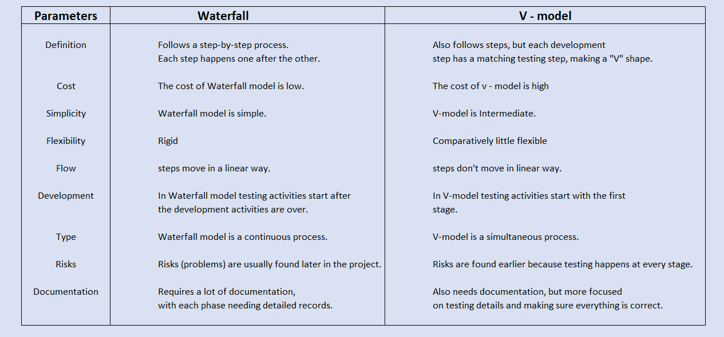

Q11) As a BA, state your reason for choosing one model for this project.

As a Business Analyst from the given two models to select the best one I would recommend using the V-Model for the Online Agriculture Product Store project. Here's why:

**1.Feedback and Testing:**

The **V-Model** integrates testing with every development phase. This is important because we can check the platform's features early and make sure it meets the needs of farmers and manufacturers. This will help catch problems early and avoid bigger issues later on.

**2. Quality Control:**

The **V-Model** ensures that each part of the project is tested alongside development. This helps in identifying risks and fixing them right away, which is important for ensuring the platform is reliable and works well for users.

**3. Flexibility:**

While the V-Model provides a clear, step-by-step approach like Waterfall, it allows for testing and adjustments along the way. This means we can make sure the platform aligns with user needs as we develop it, which is crucial when working with evolving requirements.

**4. Change Management:**

The V-Model makes it easier to manage changes and feedback during development. Since testing happens throughout the process, any adjustments needed based on feedback from farmers or manufacturers can be made without disrupting the whole project.

Q12) The Committee of Mr. Henry, Mr Pandu, and Mr Dooku discussed with Mr Karthik and finalised on the V Model approach (RG, RA, Design, D1, T1, D2, T2, D3, T3, D4, T4 and UAT) Mr Vandanam is mapped as a PM to this project. He studies this Project and Prepares a Gantt chart with V Model (RG, RA, Design, D1, T1, D2, T2, D3, T3, D4, T4 and UAT) as development process and the Resources are PM, BA, Java Developers, testers, DB Admin, NW Admin.

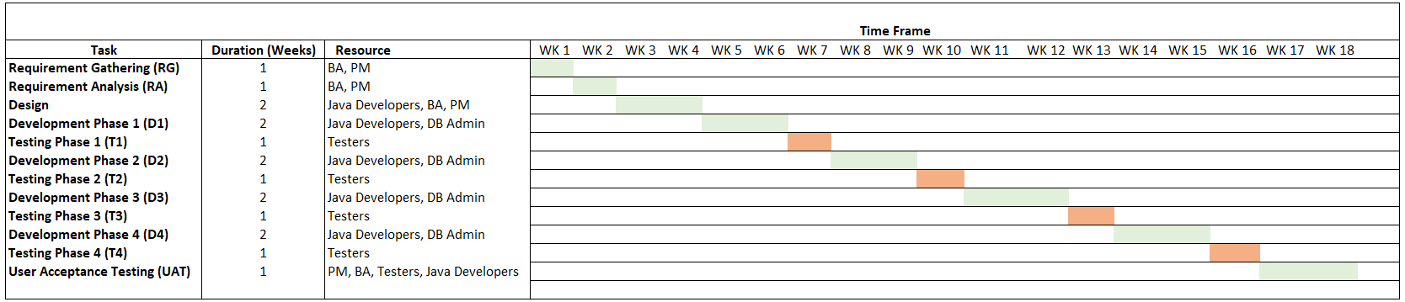Zoom to see

Q13) Explain the difference between Fixed Bid and Billing projects

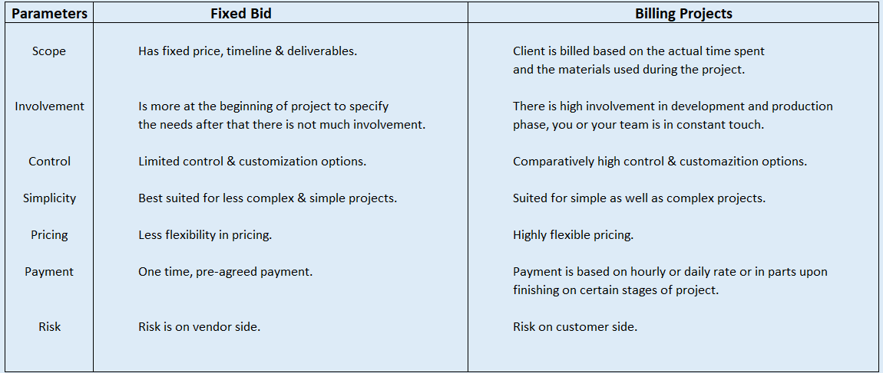

Q 14) Preparer Timesheets of a BA in various stages of SDLC

➢ Design Timesheet of a BA

➢ Development Timesheet of a BA

➢ Testing Timesheet of a BA

➢ UAT Timesheet of a BA

➢ Deployment n Implementation Timesheet of a BA

1. Design Phase Timesheet of a BA

**Timesheet Example:**

| **Date** | **Activity** | **Time Spent (hrs)** |
| --- | --- | --- |
| 01/03/2025 | Requirement gathering with stakeholders | 4 hrs |
| 02/03/2025 | Reviewing wireframes and UI/UX designs | 3 hrs |
| 03/03/2025 | Creating user stories and functional specs | 5 hrs |
| 04/03/2025 | Conducting workshops with development team | 3 hrs |
| 05/03/2025 | Preparing business process flow diagrams | 2 hrs |
| **Total** |  | **17 hrs** |

1. Development Phase Timesheet of a BA

**Timesheet Example:**

| **Date** | **Activity** | **Time Spent (hrs)** |
| --- | --- | --- |
| 06/03/2025 | Reviewing technical specifications | 4 hrs |
| 07/03/2025 | Assisting development with requirement clarifications | 3 hrs |
| 08/03/2025 | Participating in sprint planning meetings | 3 hrs |
| 09/03/2025 | Reviewing user stories and design documents | 4 hrs |
| 10/03/2025 | Continuous coordination with developers | 2 hrs |
| **Total** |  | **16 hrs** |

1. Testing Phase Timesheet of a BA

**Timesheet Example:**

| **Date** | **Activity** | **Time Spent (hrs)** |
| --- | --- | --- |
| **11/03/2025** | **Reviewing test cases and scenarios** | **3 hrs** |
| **12/03/2025** | **Coordinating with testers on business scenarios** | **4 hrs** |
| **13/03/2025** | **Assisting in UAT preparation** | **4 hrs** |
| **14/03/2025** | **Verifying traceability of requirements** | **2 hrs** |
| **15/03/2025** | **Supporting defect triage meetings** | **3 hrs** |
| **Total** |  | **16 hrs** |

1. User Acceptance Testing (UAT) Phase Timesheet of a BA

| **Date** | **Activity** | **Time Spent (hrs)** |
| --- | --- | --- |
| **16/03/2025** | **Preparing UAT test plan and cases** | **3 hrs** |
| **17/03/2025** | **Assisting business users with UAT execution** | **5 hrs** |
| **18/03/2025** | **Capturing feedback from business users** | **4 hrs** |
| **19/03/2025** | **Managing and prioritizing UAT defects/issues** | **4 hrs** |
| **20/03/2025** | **Verifying UAT completion and obtaining sign-off** | **3 hrs** |
| **Total** |  | **19 hrs** |

**Timesheet Example:**

1. Deployment & Implementation Phase Timesheet of a BA

| **Date** | **Activity** | **Time Spent (hrs)** |
| --- | --- | --- |
| **21/03/2025** | **Supporting deployment team with requirements clarification** | **3 hrs** |
| **22/03/2025** | **Assisting with end-user training** | **4 hrs** |
| **23/03/2025** | **Supporting business stakeholders during rollout** | **3 hrs** |
| **24/03/2025** | **Monitoring post-deployment phase** | **4 hrs** |
| **25/03/2025** | **Documenting lessons learned and support plans** | **2 hrs** |
| **Total** |  | **16 hrs** |

**Timesheet Example:**

**Summary of Timesheets:**

| **Phase** | **Total Hours** |
| --- | --- |
| **Design Phase** | 17 hrs |
| **Development Phase** | 16 hrs |
| **Testing Phase** | 16 hrs |
| **UAT Phase** | 19 hrs |
| **Deployment Phase** | 16 hrs |
| **Overall Total** | **84 hrs** |