COEPD – Traditional Development

Capstone Project1 – Part -2

**DINESH KULKARNI**

Online Agriculture Products Store

**Question 1** – Audits - 5 Marks

4 Quarterly Audits are planned Q1, Q2, Q3, Q4 for this Project What is your knowledge on how these Audits will happen for a BA?

***Answer***

**Audit: -**Audit refers to systematic examination and assessment of various aspects of the project to ensure compliance with established guidelines, standards, procedures, and objectives

**Types of Audits**

1.Security Audit: -Evaluating the security measures such as unauthorized use of application

2.Compliance Audit: -Verify that project adheres to legal and regulatory requirements

3.Performanvce Audit: -Assessing and effectiveness of the system and process

4.Risk Management Audit: -Reviewing the risk management strategy and practices to identify potential risk

5.Internal Audit: -It is independent, objective evaluation conducted by organizational audit team to assess effectiveness, efficiency, security, compliance, and performance.

6.External Audit: -It is independent valuation conducted by third party organization to assess project compliance, security, efficiency, and overall effectiveness.

|  |  |
| --- | --- |
| **Quarter** | **Activity considering BA for Audit** |
| Q1 | Initial compliance and requirement review  1.Ensure business and functional requirements aligned with compliance standard  2.Validate user workflow, payment flow meets business objective  3.Document regulatory requirement  4.Audit business process document and Business requirement document |
| Q2 | System and process validation  1.Assist audit team to evaluate system performance  2.Validate system integration as per requirement  3.Show process flow diagram how orders flow through system  4.Checking timesheets of BA, mailing formats if any standardised method to follow |
| Q3 | Customer experience and data integrity  1.Ensure customer feedback, complaints are analysed and mapped to improvement  2.Review data security and access management  3.Fraud prevention measures and data privacy maintain |
| Q4 | End review  1.Track any previous audit recommendations implemented  2.Identy the gaps and prepare report  3.Work with project team to ensure proper tacking and implementation |

**Question 2** – BA Approach Strategy - 6 Marks

Before the Project is going to Kick Start, The Committee asked Mr Karthik to submit BA Approach

Strategy

Write BA Approach strategy (As a business analyst, what are the steps that you would need to

follow to complete a project – What Elicitation Techniques to apply, how to do Stakeholder Analysis

RACI/ILS, What Documents to Write, what process to follow to Sign off on the Documents, how to

take Approvals from the Client, What Communication Channels to establish n implement, how to

Handle Change Requests, how to update the progress of the project to the Stakeholders, how to

take signoff on the UAT- Client Project Acceptance Form)

Your Team

Project Manager - Mr Vandanam Senior

Java Developer - Ms. Juhi

Java Developers - Mr Teyson, Ms Lucie, Mr Tucker, Mr Bravo

Network Admin - Mr Mike

DB Admin - Mr John.

Testers - Mr Jason and Ms Alekya

BA - You

Technical Team have assembled to discuss on the Project approach and have finalised to follow 3-tier

architecture for this project

***Answer***

BA approach strategy: - It refers to a structured method a BA follow to analyze, document and manage business requirements while ensuring successful project delivery. It defines how BA will engage stakeholders, gather and validate requirements and ensure alignment between business stakeholders and project team for business solution.

It indicates what are the steps need to follow to complete the project. It also gives the roadmap of the project.

**Steps**

1. What Elicitation Techniques to apply?

Elicitation technique is the process use by BA to gather the requirement from stakeholders to understand business need, project requirement and system expectation.

Chose right elicitation techniques

Workshops: -for collaborative discussions

Interviews: -For in-depth insights from key stakeholder

Survey / Questionnaire: -For collection of large-scale feedback

Observation: -To understand real world user behaviour

2. How to do Stakeholder Analysis?

RACI/ILS: -We identify the stakeholder in project and use RACI matrix technique to analyse the stakeholders

|  |  |  |  |  |
| --- | --- | --- | --- | --- |
| Stakeholder/Activity | Project Plan | BRD | Design Report | Test cases |
| Project Manager | R | A | I | I |
| BA | C | R | A | A |
| Developer | I | I | R | I |
| Tester | I | I | I | R |
| Admin | I | I | I | I |

Also, ILS (Interest, Legitimacy and Power, Support) Method to use for stakeholder analysis

Interest: -Stakeholder’s level of interest

Legitimacy: -Stakeholder’s validity and involvement in decision making

Power: -Ability to influence the decision in the project

Support: -Who are stakeholders supporting the project

3.What Documents to Write?

High level business needs to accomplish project objective or scope-Business requirement document (BRD)

Specific requirement of stakeholder-User requirement document (URD)

Solution requirement document (SRS)

Functional requirement document-Requirement which gives solution to business (FRD)

Non-functional requirement document-Supplementary support document (SSD)

Transition requirement document- Additional design document (ADD)

4. What process to follow to Sign off on the Documents?

Review the documents to ensure they are correct, complete, and feasible

Prepare signature for those who are signing authority list down all stakeholders

Authenticate and execute signature for respective stakeholders

Distribute copy of sign document to all the stakeholders also mailed to all

File and store the document, this may involve physical or digital storage of document.

5. How to take Approvals from the Client?

Getting approval from client is crucial to ensure alignment on requirement, deliverables, and project progress. Firstly, identify what needs approval, determine approval criteria and expectation from client, identify approving stakeholder, prepare clear and concise document, Present the information to the client either by meeting, walkthrough, presentation and address the questions raised by client. Gather feedback and make necessary changes, ensure all stakeholders are aligned, and obtain formal approval by mail or document signature or approval system.

6. What Communication Channels to establish and implement?

Email is the most formal means of communication channel use for escalation, approvals, and formal update. Project management tool like JIRA, Trello. Enterprise communication channel Microsoft teams, Webex, Zoom, Google meet also by meeting minutes and documentation.

7. How to Handle Change Requests?

Handling change request effectively is key responsibility of BA.

1.Identify and capture change request

Changes can come from clients, stakeholder, regulatory updates, internal teams, Ensure the change request is documented properly, also note down requester details, business justification, description of change.

2.Analyse and Evaluate the Impact

Assess the impact on scope, project budget, timeline, resources, Analyse the risk by feasibility and risk analysis.

3.Obtain approval and prioritisation

Formal sign off document and analyse its priority on project implementation

4.Documentation

Update all project document (BRD, FSD, User story)

5.Implement and communicate the change

Work with project team to implement the change, ensure changes meets business requirements

6.Analyses the impact and closure

Collect feedback from user, monitor the changes and track the project progress

8. How to update the progress of the project to the Stakeholders?

1.Identify stakeholder expectation: -Determine who needs update (Client, Sponsor, Manager), Understand preferred frequency (Daily, Weekly, Monthly), choose right format (email, meeting, dashboard).

2.Select right communication channel (Email, dashboard, meetings, Tools)

3.Prepare clear and concise progress report (Project summary, Key millstone, upcoming task, Timelines)

4.Conduct regular meetings: -Sprint review, Monthly progress meeting, Issue resolution calls

5.Use visual aids and gather feedback: - (Gantt chart, Burndown chart, Dashboard) and ask stakeholder whether their expectations meet or not.

9. How to take signoff on the UAT- Client Project Acceptance Form?

1.Prepare UAT sign off form which contains details like project name, client details, scope of UAT, Test plan, Test execution and its result, Feedback, acceptance statement.

2.Conduct final UAT review with client: -Organise UAT review meeting, address open issues, pending defects or minor enhancement

3.Obtailn formal approval and sign off: -Request formal sign off via mail or other means from client

4.Store and record sign off form: -Save the sign off form and proceed for go live planning.

**Question 3** – 3-Tier Architecture - 5 Marks

Explain and illustrate 3-tier architecture?

***Answer***

3-tier architecture is a software architecture pattern that organizes applications into three logical layers.

Screens, Pages, Validations on page, company specific logic, functionality

Application layer/ Presentation / client Frontend

All re-usable components, frequently changing components, Governing body rules and regulations, compliances examples printer, payment gateways, mail services rules for Banks, IRDA rules for insurance

Business Logic layer Backend

Database component connecting to database

Database layer Database

Application layer: -This is UI where user interacts with system, Technology use is HTML, CSS, JAVASCRIPT, ReactJS, AngularJS.

Business layer: -The middle layer that process business rules, logic, and workflows, it connects UI to database, Technology use is JAVA, .NET, C, C#, PHP, Python

Database layer: -Stores and retrieves data, technology use is ORACLE, MySQL, POSTGRES, CASSANDRA, DB2, MongoDB

Advantage of 3 tier architecture

1.Scalability: -Each layer can be scaled independently

2.Security: -Data is protected by restricting direct access

3.Maintainibility: -Changes in one layer do not affect another layer

4.Reusablity: -Business logic can be reuse across multiple applications

**Question 4** – BA Approach Strategy for Framing Questions – 10 Marks

Business Analyst should keep What points in his/her mind before he frames a Question to ask to

the Stakeholder

(5W 1H – SMART – RACI – 3 Tier Architecture – Use Cases, Use case Specs, Activity

Diagrams, Models, Page designs)

***Answer***

Before framing a question for stakeholder, a Business Analyst must ensure the questions are clear, relevant, and aligned with project objectives.

1.5W-1H: -It is considered as a tool of BA. Questions like who, what, where, when, why and how to gather complete, consistent, and precise requirement.

Example: -

1.Who are the users and impacted stakeholders?

2.What are the key business needs?

3.Where will be the system use?

4.When should be the requirement implemented?

5.Why is this requirement being important?

6.How should be the system behave?

2.SMART: - A well-formed requirement should comply with

S-Specific

M-Measurable

A-Attainable

R-Realistic

T-Traceable / Time bound

Every requirement should be clearly defined what needs to be achieved? Can it be tracked or quantify? Is it realistic with available resources? Does it align with business goal? what is the deadline or timeline?

3.RACI Matrix: -BA must clarify who is responsible, Accountable, Consulted and Informed for each requirement

R-Responsible-Executes the task

A-Accountable-Final decision maker

C-Consulted-provides input and expertise

I-Informed-Needs updates but no decision maker

4. 3 Tier Architecture

Presentation layer: -UX/UI-What should user interface looks like?

Business logic layer: -What rules should be implemented?

Data layer: -What data needs to store and retrieve?

5.Use cases and Use case specification: -It defines user interaction with system

6.Activity diagrams and process models: -Activity diagram maps step by step flow of process

Models help to visualise the business workflow

7.Page designs and wireframes: -Wireframes and mock-ups helps to visualise how system should look and function, it also helps stake holders understand navigation, layouts, and content placement.

**Question 5** – Elicitation Techniques - 6 Marks

As a Business Analyst, What Elicitation Techniques you are aware of? (BDRFOWJIPQU)

***Answer***

Requirement elicitation is the process of gathering, identifying, and understanding business needs from stakeholders, users, and subject matter experts SME.

Business Analyst must use different technique depending upon the project type, stakeholder availability, and complexity of requirement.

**1.B(Brainstorming): -**A creative group discussion to generate innovative ideas, encourage stakeholders to think beyond obvious solution. Identifying multiple solutions for a problem but it can lead to too many ideas without any prioritisation.

Prepare for Brainstorming-Develop clear and concise area of interest, determine time limit to generate idea, decide who will be included in the session and their role.

Conduct brainstorming session-Share new ideas without any discussion, record all ideas, encourage participate to share ideas, do not limit the number of ideas.

Wrap up brainstorming-Once the time limit has been reached discuss the ideas, create the list of ideas, rate the ideas, and distribute the final list of ideas to appropriate parties.

**2.D(Document Analysis): -**Reviewing existing document like SOP, business rules, business charter, old requirement document, user manuals. It helps to understand current process. It is use for existing system or if any compliance requirement. But it may contain outdated information.

Document analysis is one of the compulsory elicitation techniques for any project.

**3.R(Reverse Engineering): -**In situation where the software for an existing system has little or outdated documentation and it is necessary to understand what the system actually does reverse engineering is an elicitation technique that can extract implemented requirements from software code.

There are two general categories of reverse engineering

Black box reverse engineering-The system / product is studied without examining its internal structure

White box reverse engineering-The inner working of the system / product is studied.

**4.F(Focus group): -**A guided discussion with selected end users and customers, it helps to gather opinions, preferences, and feedback it typically has 6 to 12 attendees. It is best for validating the concept or feature before development. It can be bias if participant is not diverse. Homogeneous -Individuals with similar characteristics. Differing perspective will not be shared. Possible solution conducts separate sessions for different homogeneous group. Heterogeneous-Individuals with diverse background perspective. Cautions individual may self-censor if not comfortable with other background resulting in lower quality of data collected.

**5.O(Observation): -**BA observe or shadow end users as they perform task in their daily workflow. It helps to understand real world challenges they face. Best suited to understand user manual process the main disadvantage is that user may act differently when being observed.

**6.W(Workshop): -**A collaborative session involves multiple stakeholders, helps in aligning different view point and resolving conflict. It is best for Agile project and cross functional teams and large system. The main disadvantage is scheduling is the challenge.

**7.J(Joint Application Development-JAD): -**It is extended, facilitated workshop, it involves collaboration between stakeholders and system analyst to identify needs or requirements in a concentrated and focus effort. This technique allows for the simultaneous gathering and consolidating of large amount of information. It also provides high quality information in short time. Discrepancies are resolved immediately with the aid of the facilitator. This technique provides a forum to explore multiple points of view regarding a topic. The main dis advantage is that it requires planning and execution along with stakeholder commitment. It required trained and experienced personnel for facilitation and record. The JAD team should consist of mixture of skilled individuals.

JAD process steps

1.Define session-Purpose, scope, objectives of JAD session, Selecting JAD team, Invite them

2.Research Product-Become more familiar with product or service, gather preliminary information

3.Prepare-any visual aids, Agenda, meeting room, recorder

4.Conduct Session-Follow agenda to gather and document the project needs and requirements, it is important to ensure all participants are given equal treatment.

5.Draft and document-Prepare the formal document, The information obtain through JAD session is analysed, refine and final document is given to stake holder for review and validation.

**8.I(Interview): -**Structure or unstructured discussion with stakeholder, helps to gather deep insights, opinions, and expectations. It is best for senior executive, SME, and project sponsors but it is time consuming and depend upon availability of stakeholder.

**9.P(Prototype): -**Creating mock-ups, wireframes, and prototypes of system, helps to visualise the final product before development. It is best for UX / UI development, early-stage feedback, reducing mis understanding. It is time consuming and it requires tools.

**10.Q(Questionnaire): -** collect feedback from multiple stakeholders using structure questions, helps when stakeholders are in different location or hard to reach. It is best suited for large user groups and market research. But this type of technique may get less response. Can be slow to create questionnaire.

**Question 6** – This project Elicitation Techniques - 5 Marks

Which Elicitation Techniques can be used in this Project and Justify your selection of Elicitation Techniques?

Prototyping

Use case Specs

Document Analysis

Brainstorming

Fertilizers, seeds, pesticides details from the manufacturers and should be able to display them to the

Farmers. To gather the business requirements from the client, you went to SOONY and met Mr. Henry. When Mr. Henry was asked about the project and what are they expecting from the project, Mr. Henry stated that he is expecting to have a login for all its users (fertilizers, seeds, pesticides manufacturers and Farmers), a product catalog of fertilizers, seeds, pesticides, a search option to search for products, payment process, and delivery tracking.

After doing the stakeholder analysis, you have found out that Peter, Kevin, Ben are the key stakeholders and

you have scheduled an appointment to meet them. After meeting with them and trying to gather the

stakeholder requirements, Kevin said that, a Farmer should be able to browse through the products catalog

once they visit the website and need to have a search option so that they can search for any product they

need. Peter said that, if a farmer wants to buy any product or add them to buy-later list, they need to login

first using their email id and password. If it is a new user, then they can create a new account by submitting

their email ID and creating a secure password. Ben added saying that, Farmers needs to have an easy-to-use payment gateway which should include cash-on-delivery (COD), Credit/Debit card and UPI options so that the user’s experience should be better. Kevin mentioned that, a user gets an email confirmation regarding their order status. A delivery tracker to track the whereabouts of their order.

Identify Business Requirements (which includes Stakeholder Requirements)

BR001 – Farmers should be able to search for available products in fertilizers, seeds, pesticides

BR002 – Manufacturers should be able to upload and display their products in the application

***Answer***

Here USE case specification technique for requirement gathering. The use case specification is powerful method in requirement gathering and elicitation, The focus of this diagram will be on ‘How external Interfaces’ (End users, support system, special databases, internet connectivity to third party) will be interacting with proposed IT system. This interaction will be initiating distinct business function called USE case and shown with elliptical symbol. following are the steps

1.Identifying Actors: -Begin by identifying all the actors or stakeholders involved in the system. Actors are entities that interact with the system to achieve specific goal.

2.Defining use cases: -A use case represents the specific interaction between an actor (user) and the system to accomplish goal. Each use case typically describes a sequence of actions or steps the actor performs and how the system responds.

3.Use case description: -For each identified use case a detailed description is created This includes following

Name and Identifier: -A unique name and identifier for the use case

Description: -A brief overview of what the use case accomplishes

Actors: -The actors and users involve in use case

Preconditions: -Condition that must be true before the use case can start

Flow of events: -A step by step description of the action taken by the actor and the system response. This includes primary and alternative flow.

Post conditions: -The state of the system after the use case completed successfully.

**Following is the benefit of use case diagram**

1.Clarity-Provides a clear understanding of system functionality from the user’s perspective

2.Scope Definition- Helps in defining the boundaries and scope of the system

3.Requirement Validation-Validate requirements against real world scenarios.

4.Communiacation tool- Serves as communication tool between stake holder and project team.

Business requirement: -High level business needs to accomplish project objectives or scope.

Stakeholder requirement: -It is called specific requirement associated with specific stakeholder.

Business requirement which includes stake holder requirement

|  |  |
| --- | --- |
| BR001 | Farmers should be able to search for available products in fertilizers, seeds, pesticides |
| BR002 | Manufacturers should be able to upload and display their products in the application |
| BR003 | The system should provide login functionality for all users (Fertilizers, seed, pesticides manufacturer, farmers) |
| BR004 | New user should be able to register using mail id and create secure password |
| BR005 | Farmers should be able to browse the product catalog without logging in |
| BR006 | The system should maintain catalog of fertilizers, seed, and pesticides from various manufacturer |
| BR007 | The catalog should have search functionality to allow user to find the product |
| BR008 | Farmers should be able to add the product to cart |
| BR009 | The system should allow farmer to review the order and modify before check out |
| BR010 | The system should provide an easy-to-use payment gateway |
| BR011 | User should receive email confirmation for their order |
| BR012 | Delivery tracking system allows users to track the purchase order |
| SK013 | Farmers should be able to browse the product catalog and search option |
| SK014 | User should receive email notification regarding their order status |
| SK015 | A delivery tracker should be available |
| SK016 | Farmers need to log in before purchasing the items |
| SK017 | New user should be able to registered using their mail id and password |
| SK018 | The system should have all the payment options COD / cards / UPI for payment |

**Question 7** – 10 Business Requirements- 10 Marks

Make suitable Assumptions and identify at least 10 Business Requirements.

**Answer**

|  |  |  |
| --- | --- | --- |
| **ID** | **Requirement** | **Assumptions** |
| BR001 | Farmers should be able to search for available products in fertilizers, seeds, pesticides | Search features allow farmers product search by name, category and brand, Search is possible for partial keyword, filter by price, brand, and type. |
| BR002 | Manufacturers should be able to upload and display their products in the application | Manufacturer must register and log in |
| BR003 | The system should provide login functionality for all users (Fertilizers, seed, pesticides manufacturer, farmers) | System must support different user role, User must register with credentials, user must have valid username and password, |
| BR004 | New user should be able to register using mail id and create secure password | User must open the app, User must provide detail like name, addresses, mobile number for registration. |
| BR005 | Farmers should be able to browse the product catalog without logging in | Farmers should have internet connection and browser, Farmers should open the app for browse the product, all products are visible to farmers. |
| BR006 | The system should maintain catalog of fertilizers, seed, and pesticides from various manufacturer | Products must add in the system which can visible in search option |
| BR007 | The catalog should have search functionality to allow user to find the product | Products must be added in the application and user can search |
| BR008 | Farmers should be able to add the product to cart | Application should accept the products in catalog |
| BR009 | The system should allow farmer to review the order and modify before check out | Products must be added in the cart |
| BR010 | The system should provide an easy-to-use payment gateway | Required product must be added in the cart and Payment option is visible to user |
| BR011 | User should receive email confirmation for their order | Farmer must confirm the order |
| BR012 | Delivery tracking system allows users to track the purchase order | Farmer must purchase the product and order must be shipped |
| SK013 | Farmers should be able to browse the product catalog and search option | Manufacturer must add the product in its catalog |
| SK014 | User should receive email notification regarding their order status | User must place the order |
| SK015 | A delivery tracker should be available | Order should be confirmed and in dispatch state |
| SK016 | Farmers need to log in before purchasing the items | Farmers must register the app with valid details and approve by admin |
| SK017 | New user should be able to registered using their mail id and password | User must have internet connection and he can browse the app and open the app for search |
| SK018 | The system should have all the payment options COD / cards / UPI for payment | User must add the product in the cart and ready for purchase |

**Question 8** –Assumptions- 5 Marks

List your assumptions

***Answer***

To ensure clarity and completeness following assumptions are made regarding the requirements

1.User should have different roles (Farmers, manufactures and admin)

2.User should have active internet connection

3.User must open the app and search the product

4.User must have valid email id and valid password

5.User should have corrected mobile number so that he can get OTP for registration

6.Password recovery mechanism must be available for user

7.Product catalog must have image, descriptions, and other details

8.The search functionality will support keywords, phrases, and auto search option

9.Payment security should be maintained through secure payment gateway and interface

10.Refund should be given for failed payment process

11.Admin should have dashboard to view the details of orders

12.Automated tracking ID should be generated for purchasing the product.

13.Order status must contain the estimated delivery date and time

**Question 9** – This project Requirements Priority - 8 Marks

Give Priority 1 to 10 numbers (1 being low priority – 10 being high priority) to these Requirements

after discussions with the stakeholders Req ID Req Name Req Description Priority

BR001 Farmer Search for Products Farmers should be able to search for available products in fertilizers, seeds, pesticides 8

BR002 Manufacturers upload their Products Manufacturers should be able to upload and display their products in the application 8

Once the requirements are finalized, as a business analyst, one of the major roles is to act as a

liaison between the client and the project team. To gather the requirements correctly from the

client side and then to deliver those requirements to the project team in a way they understand.

To make the project team understand the requirements, you need to convert those requirements

into UML diagrams and screen mock-ups.

***Answer***

|  |  |  |  |
| --- | --- | --- | --- |
| **Req ID** | **Req Name** | **Requirement Description** | **Priority** |
| BR001 | Farmers search for product | Farmers should be able to search for available products in fertilizers, seeds, pesticides | 8 |
| BR002 | Manufacture uploads their product | Manufacturers should be able to upload and display their products in the application | 8 |
| BR003 | User login | The system should provide login functionality for all users (Fertilizers, seed, pesticides manufacturer, farmers) | 10 |
| BR004 | User Registration | New user should be able to register using mail id and create secure password | 10 |
| BR005 | Product search globally | Farmers should be able to browse the product catalog without logging in | 7 |
| BR006 | Maintain catalog of products | The system should maintain catalog of fertilizers, seed, and pesticides from various manufacturer | 7 |
| BR007 | Catalog search for user | The catalog should have search functionality to allow user to find the product | 8 |
| BR008 | Adding the product | Farmers should be able to add the product to cart | 10 |
| BR009 | Review the order | The system should allow farmer to review the order and modify before check out | 7 |
| BR010 | Payment option | The system should provide an easy-to-use payment gateway | 10 |
| BR011 | Email confirmation | User should receive email confirmation for their order | 5 |
| BR012 | Delivery Tacking | Delivery tracking system allows users to track the purchase order | 5 |
| SK013 | Searching the product | Farmers should be able to browse the product catalog and search option | 8 |
| SK014 | Email confirmation | User should receive email notification regarding their order status | 5 |
| SK015 | Delivery tracking | A delivery tracker should be available | 5 |
| SK016 | User login | Farmers need to log in before purchasing the items | 10 |
| SK017 | User registration | New user should be able to registered using their mail id and password | 10 |
| SK018 | Payment options | The system should have all the payment options COD / cards / UPI for payment | 8 |

**Unified modelling Language UML: -**The industry standard language for specifying, visualizing, constructing, and documenting software system. It simplifies software design and communication about design.

Dynamic diagrams model time and static diagram do not model time

**In static there are 5 diagrams**

1.Use case

2.Class

3.Component

4.Package

5.Deployment

**In dynamic there are 4 diagrams**

1.Sequence

2.Activity

3.State chart

4.Collabration

**Question 10** – Use Case Diagram - 10 Marks

Draw use case diagram

***Answer***

Use case diagram or UCD-This is high level diagram and mother of all diagrams. The focus of this diagram will be on how external interfaces will be interacting with proposed IT system. This interaction will be initiating distinct business function called use cases and is shown with and ellipse symbol.

**The UCD have only 4 major elements**

1.The Actors: -That the system you are describing interacts with Primary and secondary

2.The System itself: -the rectangular box

3.The Use cases: -Services that the system knows how to perform (Essential and supporting)

And the lines that represents relationships between these three elements. (Generalization, Association)

The system in UCD represents the system which includes the entire Architecture, Screens, Business Logic, and Databases.

**Steps to draw use case diagram from case study**

1.We model only functional requirement in use case diagram and we do not model technical information and labels in use case diagram which includes

Name of system (Laptop, Desktop, Workstations)

Architecture (2 tier, 3 tier, client server)

Database name (DB2, MySQL)

Networks (LAN, WAN, Internet)

Brand Names (HP, Lenovo)

Technology Name (JAVA, .NET)

Differentiate information against Actions

Write all sequence of actions

Try to find out which actor is performing the above action

Try to identify essentials use cases and supporting use cases

Try to identify some modules with respect to functionality and usage

Try to draw relationship appropriately between the identified Actors and use cases

**Here Use case showing interaction between Farmers, Manufacturers and System. The diagram includes key functionalities like**

1.User registration and Login

2.Product catalog management

3.Product search and browsing

4.Cart and check out process

5.Payment processing

6.Order confirmation and tracking

**Rework: -Primary actors: -Initiate interaction with system to achieve goal here in our case FARMERS are primary actors**

**Secondary actors: -These are assistance to primary actors to achieve their goal in our case MANUFACTURERS are secondary actors**

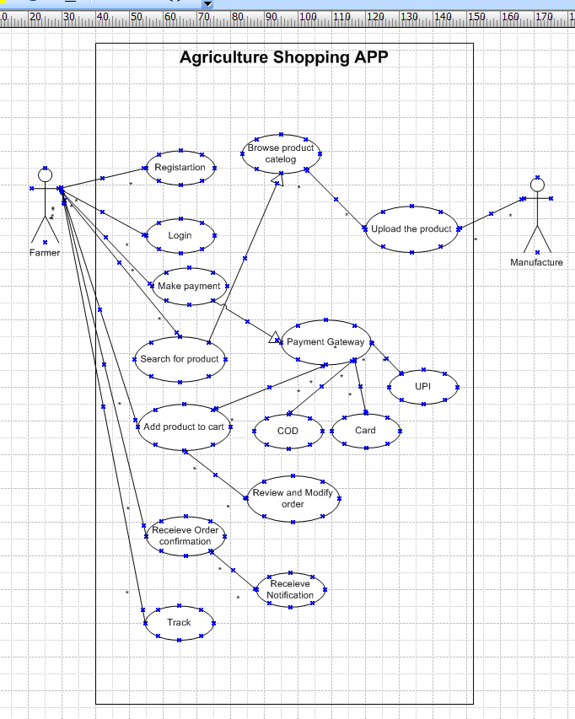

**Question 11** – (minimum 5) Use Case Specs - 15 Marks

Prepare use case specs for all use cases

***Answer***

Every use case will have its own use case description or use case specification.

**Sample use case specification has following**

Use case name

Use case description

Actors (Primary and Secondary)

Basic flow

Alternative flow

Exceptional flow

Pre-condition

Post condition

Assumptions

Constraints

Dependencies Input and Outputs

Business rules

Miscellaneous information

**Use case specification for online agriculture product shopping application**

1.Brief Description: -This use case describes how farmers purchase the agriculture products from online shopping app and along with manufacturer add the products to its inventory.

2.Actors

Farmers

Manufactures

3.Preconditions

There is active internet connection

Online shopping app is accessible to farmers

Products are available in inventory for search and purchase

4.Basic flow of event

**1. Use case for User registration**

Actors: -Farmers and Manufactures

Description: - Allow new user to register an account

Precondition: -User must have valid email id

Steps: -

1.User clicks on register

2.Enter email id and Create password

3.Submit registration form

4.System verify the details and create an account

5.User receives confirmation email

Post condition: -User is registered and can log in

**2. Use case for User Login**

Actors: -Farmers and Manufactures

Description: -Allow user to log in

Precondition: -User must be registered

Steps: -

1.User enter email id and password

2.System verify credentials

3.If correct use is log in

4.If incorrect error message is display

Post condition: -User is logged in to the system

**3. Use case Browse product catalog**

Actor: - Farmer

Description: -Allow farmer to view product

Pre-condition: -Farmer must open the app

Steps: -

1.User visit the home page

2.Select the category

3.View product details

Post condition: -User can see product listing

**4. Use case Product search**

Actor: -Farmer

Description: -Enables farmer to search specific product

Pre conditions: -System must have products in catalog

Steps: -

1.User enters keyword in search bar

2.System displays matching product

3.User filter the search product

Post condition: -User finds desired product

**5. Use case Add to cart**

Actor: -Farmer

Description: -Allow farmeres to add product in shopping cart

Pre-condition: -User must be logged in

Steps: -

1.User selects the product

2.Clicks on add to cart

3.System updated the cart

Post condition: -Product is added to cart

**6. Use case Check out and Payment**

Actors: - Farmer

Description: -Enables the user to complete the purchase

Pre-condition: -User must have product in the cart and must be logged in application

Steps: -

1.User review the cart

2.Select payment method COD, Card, UPI

3.Confirms the order

4.System process the payment

Post conditions: -Order is placed successfully

**7. Use case Order confirmation and email notification**

Actor: -System

Description: -Send email confirmation after order is placed

Pre conditions: - Order must be placed successfully

Steps: -

1.System generated order ID

2.Send confirmation mail

Post condition: -User receives order confirmation mail

**8. Use case Delivery tracking**

Actor: -Farmer

Description: -Allow user to track order delivery status

Pre-condition: -Order must be shipped

Steps: -

1.User logs in

2.Navigate to my orders

3.Clicke on track order

4.System shows real time tracking updates.

Post conditions: -User can track their order

**9. Use case Manufacture product management**

Actor: -Manufacture

Description: -Allow manufacture to upload, update and manage their product

Pre-conditions: - Manufacture must be registered and log in

Steps: -

1.Manufacture must be log in

2.Navigate to manage product

3.Add new product with details like price, name, and quantity

4.Update or remove existing product

Post conditions: -Products are update din catalog

**Question 12** – (minimum 5) Activity Diagrams - 15 Marks

Activity diagrams

***Answer***

**REWORK: - Show GUARD Conditions on Arrow**

**Use Branch and Merge Join in diagram for different payment option**

Activity diagram is a type of UML diagram that visually represents workflows and processes in a system. BA use activity diagram to understand business process, analyse requirement, communicate with stakeholder, identify risk and improvement.

Activity diagram are one of the five diagrams in the UML for modelling the dynamic aspects of the system. An activity diagram is essentially a flowchart showing flow of control from activity to activity. Speaks of all the activities which are happening in the system through system perspective but not actor perspective.

An activity diagram is drawn to model how the system should function to achieve business logic, business functionality and business objectives.

Activity diagrams are typically used for business process modelling, for modelling the logic captured by a single use case or usage scenarios or for modelling the detailed logic of a business rule.

Activity diagram is UML behaviour diagram which shows flow of control or object flow with emphasis on the sequence and conditions of the flow. The action coordinated by activity models can be initiated because other actions finish executing, because objects and data become available or because some events external to the flow occur.

Activity diagram is basically flow chart to represent the flow from one activity to another activity. The activity can be described as an operation of the system.so the control flow is drawn from one operation to another.

Activity diagram consists of following

1.Activities

2.Flows

3.Decision box (Guard condition)

Guard conditions: -It is Boolean expression that control the flow of activity. It is written in square bracket and placed above the path between action and decisions. The transition only occurs if the guard condition evaluates to true.

4.Branch and merge: This is OR condition

5.Fork and join: -This is AND condition example ATM cash withdrawal success multiple action need to finished.

1. Activity diagram for User registration and Login

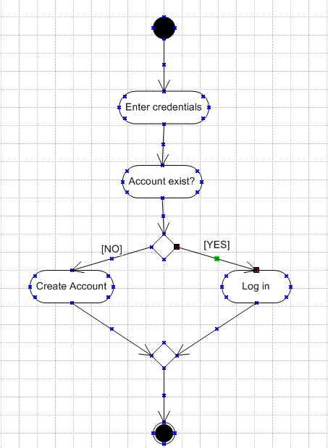

2.Activity diagram for browse the product

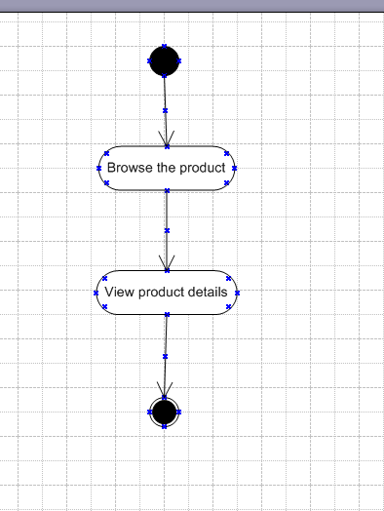

3.Activity diagram for adding the product to cart

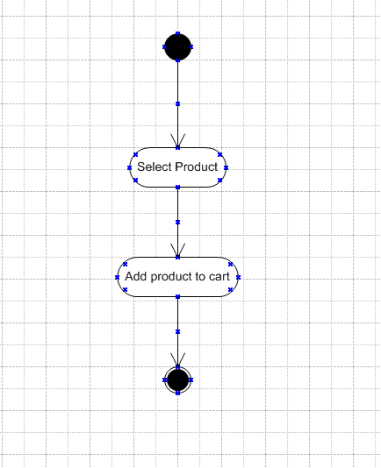

4.Activity Diagram for check out and payment processing

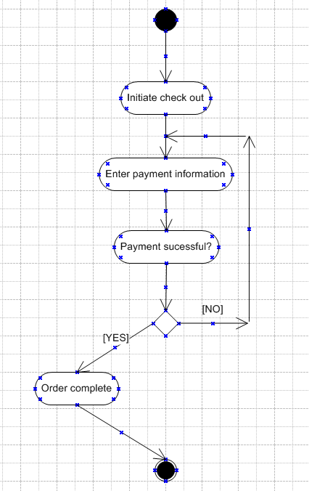

5. Activity diagram for Order Confirmation & Delivery Tracking

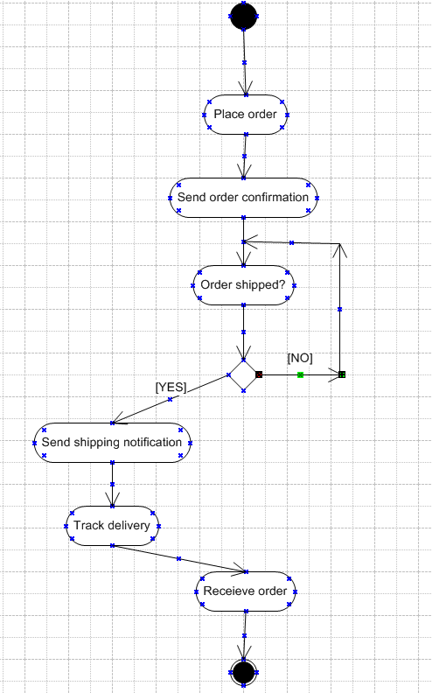

Complete diagram for combined use cases

