**Agile Project BA Implementation - Product vision Product Backlog Sprints n deliverables**

**AGILE DOCUMENTS**

**Definition of Done (DoD) Document**

**Project:** Tata.com Website Enhancement  
**Prepared by:** Business Analyst Team  
**Date:** [25/03/2025]

**1. Introduction**

As per the Agile Extension to the BABOK® Guide v2, the Definition of Done (DoD) is a technique where the team agrees on and prominently displays a list of criteria that must be met before a backlog item is considered done. It ensures the team creates a well-defined, unambiguous, measurable, agreed-upon, and shared DoD among all team members.

The best form of DoD representation is a checklist of activities that demonstrates the agreed value and quality of a user story. The DoD applies to different levels of project work, including user stories, sprints, and releases.

**2. Purpose and Scope**

The DoD aims to:

* Establish a shared understanding of what constitutes a completed task.
* Ensure deliverables meet customer and quality requirements.
* Minimize technical debt by enforcing thoroughness and consistency.

This document applies to all development, testing, and deployment activities related to the **Tata.com website enhancement project**.

**3. Definition of Done Checklist**

For a task to be considered done, it must meet the following criteria:

**Development Criteria:**

* **Produced code for presumed functionalities** → Ensures that the required features and functionalities are implemented in the code.
* **Assumptions of User Story met** → Confirms that all stated and implied assumptions for the user story are satisfied.
* **Project builds without errors** → Ensures the build is error-free and stable.
* **Unit tests written and passing** → Confirms that unit tests are in place and successfully executed.
* **Refactoring completed** → Ensures that the code has been cleaned and optimized for better performance and readability.
* **Peer Code Review performed** → Verifies that the code has been reviewed by a peer for quality and consistency.
* **Any configuration or build changes documented** → Ensures that configuration or build modifications are properly recorded.
* **Code follows coding standards and guidelines** → Ensures that the code complies with established coding practices.
* **Project deployed on the test environment identical to the production platform** → Confirms that the deployment environment accurately mimics production.

**Testing Criteria:**

* **QA performed & issues resolved** → Confirms that quality assurance testing has been conducted and any identified issues have been addressed.
* **Tests on devices/browsers listed in the project assumptions passed** → Ensures the feature works correctly across the specified devices and browsers.
* **Feature is tested against acceptance criteria** → Verifies that the feature meets the predefined acceptance standards.
* **Regression testing performed** → Ensures that new changes do not break existing functionality.
* **Performance and security tests passed** → Confirms that the code meets performance and security benchmarks.
* **No blocking or critical defects remain unresolved** → Ensures that no critical defects are left unresolved.
* **Test cases executed and validated successfully** → Verifies that all test cases have been run and passed.

**Acceptance Criteria:**

* **Feature ok-ed by UX designer** → Confirms that the UX team has reviewed and approved the design and functionality.
* **Feature ok-ed by Product Owner** → Ensures the Product Owner has signed off on the feature, confirming it meets business needs.
* **Feature demonstrates the agreed value and quality of the user story** → Confirms that the delivered feature provides the intended value.
* **Meets business requirements and delivers expected value** → Ensures the solution aligns with business objectives.
* **User acceptance testing (UAT) completed** → Verifies that end-users have tested the functionality and approved it.

**Documentation & Compliance:**

* **Documentation updated →** Ensures that all related documentation is revised to reflect the changes.
* **Any configuration or build changes documented →** Confirms that any modifications to configurations or builds are properly recorded.
* **Release notes created and shared →** Ensures that relevant release information is documented and communicated.
* **Deployment instructions documented →** Provides clear deployment guidelines.
* **User manuals or guides updated (if applicable) →** Ensures that user-facing documentation reflects the latest changes.
* **Compliance with regulatory and security guidelines ensured →** Verifies adherence to necessary standards.
* **Version control and changelog updated →** Confirms that version history and logs are properly maintained.

**4. Levels of DoD**

The DoD applies to the following levels in the project:

* **User Story Level:** Ensures individual stories meet customer expectations and technical quality.
* **Sprint Level:** Ensures all user stories within a sprint meet the DoD criteria.
* **Release Level:** Ensures the entire release meets the DoD, including deployment and documentation.

**5. Acceptance Criteria Example**

For the **Tata.com website enhancement project**, the acceptance criteria for a feature (e.g., job posting functionality) may include:

* **User Story:** As a user, I want to view job postings on the Tata.com website so that I can apply for relevant positions.
* **Acceptance Criteria:**
  + Users can filter job postings by location, category, and company.
  + Job postings display accurate information (title, description, location).
  + Application form is functional and error-free.
  + Page loads within 3 seconds.
  + Works on Chrome, Firefox, and Safari.

**6. Review and Approval**

The DoD will be reviewed and approved by the following stakeholders:

* **Product Owner:** [Amith Goyal]
* **Scrum Master:** [Sushil Kumar]
* **Development Team:** [Ankit Sharma,Prabhu Shetty,Charan Nayak,Harish Tonde,Rahul Thokle]
* **QA Team:** [Rekha Nair]

**7. Version Control and Updates**

This document will be reviewed periodically and updated based on project needs, team feedback, and process improvements.

**Version:** 1.0  
**Last Updated:** [Insert Date]

2- Product Vision

|  |  |
| --- | --- |
| **Scrum Project** | |
| **Name:** | **Tata.com Website Enhancement Project** |
| **Venue:** | Tata Digital Office / Virtual Meeting (Zoom or Teams) |
| **Date:** | 21st March 2025 |
| **Start time:** | 21st March 2025 |
| **End time:** | 21st sep 2025 |
| **Duration:** | 6 months |
| **Client:** | Tata Group |
| **Stakeholder list:** | Business Analyst : Nilesh Bhambure |
| Product Owner: Amith Goyal |
| Developers :Ankit Sharma |
| Testers : Rekha Nair |
| Designers:Ankita Puri |
| Marketing Team:Ajay Wagh, Kiran More |
| Tata.com End Users: Pooja Desai,Mayank Desai |

|  |  |
| --- | --- |
| **Scrum Team** | |
| **Scrum Master:** | Sushil Kumar |
| **Product owner:** | Amith Goyal |
| **Scrum Developer 1:** | Ankit Sharma |
| **Scrum Developer 2:** | Prabhu Shetty |
| **Scrum Developer 3:** | Charan Nayak |
| **Scrum Developer 4:** | Harish Tonde |
| **Scrum Developer 5:** | Rahul Thokle |

|  |  |  |  |
| --- | --- | --- | --- |
| **Target group** | **Needs** | **Product** | **Value** |
| **Which market segment does the product address?** | **What problem does the product solve?** | **What product is it?** | **How is the product going to benefit the company?** |
| **Who are the target users and customers?** | **Which benefit does it provide?** | **What makes it desirable and special?** | **What are the business goals?** |
|  |  | **Is it feasible to develop the product?** | **What is the business model?** |
| - **Market Segment:** Tata Group employees, job seekers, customers, and stakeholders. | - Simplifies the **job application process** with intuitive navigation. | - **Enhanced website features**, including improved UX/UI, dark mode, and faster navigation. | - **Benefits:** Increases website traffic and improves **user retention**. |
| - **Target Users:** Potential employees, customers exploring Tata products, and business partners. | - Enhances **content discoverability** with better categorization and search filters. | - **Special Features:** Integration of dynamic content, video highlights, and a seamless job application process. | - **Business Goals:** Attracts more talent and strengthens Tata’s digital presence. |
|  | - Improves **user engagement** with interactive product showcases. | - Feasibility: Yes, the website enhancements are achievable with Agile development. | - **Business Model:** Improved **user experience** leads to higher engagement and more job applications, driving business growth. |

**Dodument 3 User Stories**



Ajile PO experience

|  |  |
| --- | --- |
| **Responsibility Area** | **Details** |
| Vision | The Product Owner leverages domain/industry experience to shape a product vision that aligns with the market need. |
| Market Analysis | • Analyse market need/demand |
| • Evaluate the availability of similar products in the market |
| Enterprise Analysis | • Conduct due diligence on the market opportunity to validate the product’s feasibility |
| Product Vision & Roadmap | • Develop a product vision informed by market and need analysis |
| • Create a high-level product roadmap detailing key features and timeline |
| Managing Product Features | • Manage stakeholder expectations |
|  | • Prioritize epics, user stories, and features based on criticality and ROI |
| Managing Product Backlog | • Prioritize and continuously re-prioritize user stories |
| • Plan epics and adjust priorities based on evolving stakeholder needs |
| Managing Iteration Progress | • Review sprint progress regularly |
| • Reprioritize sprints and epics as needed |
| • Conduct sprint retrospectives in collaboration with the Business Analyst |
| Sprint Meetings Learned | • Handle sprint planning meetings |
| • Conduct daily scrum meetings |
| • Lead sprint review and retrospective meetings |
| • Execute backlog refinement meetings |
| User Story Creation | • Create user stories incorporating key details: |
| - Story No |
| - Tasks |
| - Priority |
| - Acceptance criteria |
| - Business Value (BV) & Customer Priority (CP) |
| Scrum Liaison Role | • Act as the communication bridge between business stakeholders and Scrum teams |
| • Keep all areas of the business informed on project progress |
| Vision to Execution | • Translate the product vision into operational features |
| • Break down product features into actionable product backlog items for the Scrum team |

**Document 5: Product and sprint backlog and product and sprint burndown chart**

**1. Product Backlog**

* It is a prioritized list of all features, enhancements, bug fixes, and technical tasks needed for the product.
* Managed by the **Product Owner** and continuously refined.
* Items in the Product Backlog are not assigned to a specific sprint until selected for development.
* Covers the entire project and evolves over time based on customer feedback and market changes.

**2. Sprint Backlog**

* A subset of the Product Backlog that consists of tasks committed for a specific sprint (typically 1–4 weeks).
* Created by the **Development Team** during Sprint Planning.
* Contains user stories and technical tasks required to meet the Sprint Goal.
* The team works on these items during the sprint, and changes are minimized once the sprint begins.

**Key Differences**

| **Feature** | **Product Backlog** | **Sprint Backlog** |
| --- | --- | --- |
| Scope | Entire product | Specific sprint |
| Owner | Product Owner | Development Team |
| Priority | Continuously updated | Fixed for the sprint |
| Changes Allowed | Yes, anytime | Limited once sprint starts |
| Contains | Features, enhancements, bugs, technical tasks | Selected backlog items + breakdown into tasks |

Product backlog:



Sprint Backlog:



Product Burnup report

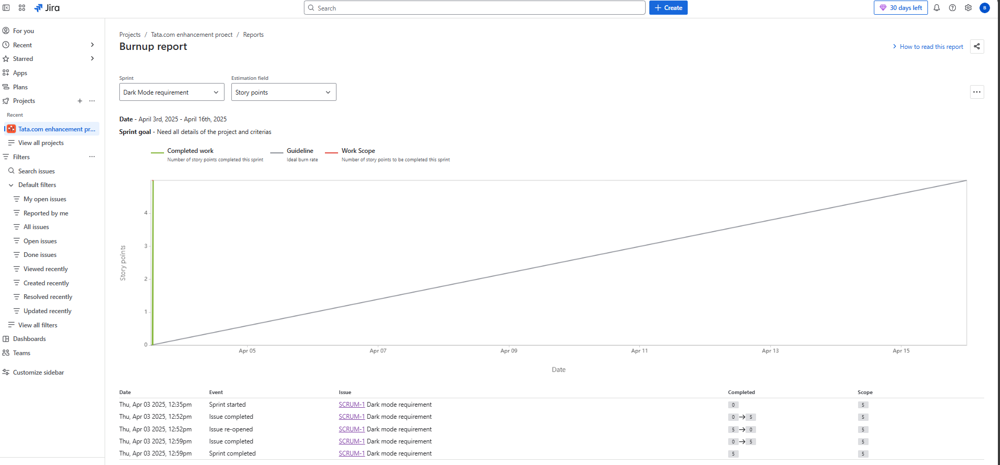

Sprint Burndown Report

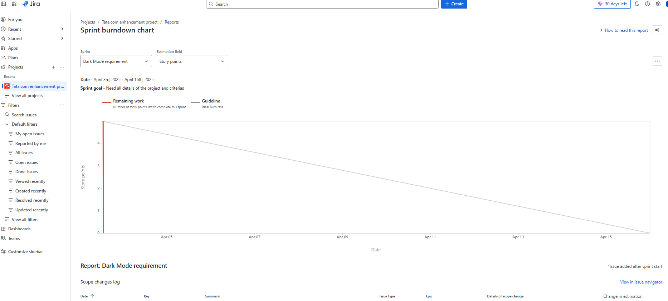

**Sprint Planning Meeting**



**Agenda Topics**



**Agenda Topics**



**Other Information**



**Meeting Type 2: Sprint Review Meeting**



**Sprint Review Details**



**Meeting Type 3: Sprint retrospective meeting**



**Agenda**



**4: Daily Stand-up Meeting**

