**Online Agriculture Products Store**

1. **Functional Requirements**

|  |  |  |  |
| --- | --- | --- | --- |
| **Req ID** | **Req Name** | **Req Description** | **Priority** |
| FR0001 | Farmer Registration | Farmer should be able to register with the application | 9 |
| FR0002 | Farmer Search for Products | Farmer should be able to search for available products in  fertilizers, seeds, pesticides | 8 |
| FR0003 | No matching Product | Farmer should be notified if the searched product not found | 5 |
| FR0004 | Product Selection | Farmer should be able to select the product | 7 |
| FR0005 | Out of Stock | Farmer should be notified, if the product is out of stock | 7 |
| FR0006 | Filter | Farmer should be able to filter and select the product as per  Brands and Price | 7 |
| FR0007 | Similar products | Farmer should be able to select similar products, if the searched  product is out of stock | 6 |
| FR0008 | Bought together | Once the product is finalized, farmer should be suggested with  related products as a package with the price | 6 |
| FR0009 | Add to Cart | Farmer should be able to Add the product to the Cart for  purchase | 8 |
| FR0010 | Wishlist | Farmer should have an option to Add the product into Wishlist | 6 |
| FR0011 | Save it Later | Farmer should be able to see the option for Save it Later, to  purchase later | 7 |
| FR0012 | Delivery Address | Farmer should be able to select the Delivery address to deliver  the product | 8 |
| FR0013 | Payment options | Once the delivery address is selected, Application should show the Payment options to the Farmer for purchasing the product. | 8 |
| FR0014 | Payment Confirmation | Farmer should receive the Payment confirmation email and SMS | 10 |
| FR0015 | Order Confirmation | Farmer should receive the Order confirmation email and SMS | 9 |
| FR0016 | Expected Delivery date | Farmer should also see the Expected Delivery date of the  product. | 9 |
| FR0017 | Track Delivery | Farmer should have the option to Track the delivery on the  application | 8 |
| FR0018 | Cancel/Return/Replacement | Farmer should be able to Cancel/Return/Replacement the  product | 9 |
| FR0019 | Return Pick up | Farmer should be given Pick up date and time for cancel/return | 7 |
| FR0020 | Return Confirmation | Farmer should receive SMS and Email confirmation for  cancellation/return | 7 |
| **Req ID** | **Req Name** | **Req Description** | **Priority** |
| NFR001 | Page Loading Time | Each Page should load within 2 seconds time | 9 |

|  |  |  |  |
| --- | --- | --- | --- |
| NFR002 | Technical  supported system | Application can be used on any OS (Android/IOS) | 9 |
| NFR003 | Time limit for OTP | OTP time limit should be given maximum of 5 minutes for Login  and Registration process | 4 |
| NFR004 | Logout System | If the page is not accessed for more for 5 minutes, the page  should log out automatically. | 4 |
| NFR005 | Stock Availability | Stock availability should be updated on a real time basis | 8 |
| NFR006 | SMS & Mail  confirmation | Automated Email and SMS notification should be sent to Users | 8 |
| NFR007 | Back up | All data should get backup automatically | 9 |
| NFR008 | Connectivity | System should be connected with Internet | 10 |
| NFR009 | Stock alerts | Seller should receive Stock alert notifications when Stock is  reduced, every week. | 8 |
| NFR010 | Net Banking | Bank account should be active in nature for smooth payment  process | 9 |
| NFR011 | Check Stock | Once the Product is sold, the stock of the product should be  reduced. | 7 |
| NFR012 | Email Address | Email Address should be an active to receive Email notifications | 3 |
| NFR013 | Taxation system | All products should be included with additional Tax | 8 |
| NFR014 | Password | User should receive Password change alert every 30 day | 5 |

1. **Minimum 5-page designs – Wireframes and Prototype**

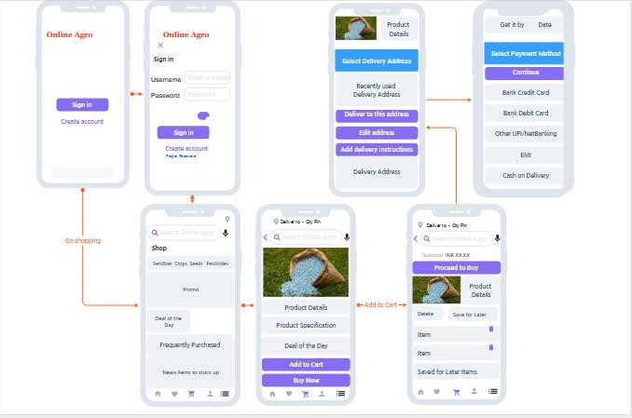

1. **Tools (Visio, Balsamiq)**

* **Microsoft Office Visio**

Microsoft Visio is a diagramming and vector graphics application and is part of the Microsoft Office family. It is used to create diagram types such as Flowcharts, Org Charts, Floor Plans, Network Diagrams, UML Diagrams, Mind maps and more. It is also commonly used for scenarios such as Process Mapping and Visual Collaboration. The latest version of Visio also has data visualization that allows users to create diagrams from Excel data and also embed Visio diagrams in Power BI dashboards.

**Microsoft Office Visio** is a tool that eases the process of making complex diagrams. Especially for business purposes. It can help in the making of presentations, floor plans, org charts, etc. Listed below are some uses of Visio:

Followings things can draw BA by using MS Office Visio.

* + **Flowchart**: A flowchart helps to show the steps in sequential order. These are steps that need to be taken to complete a certain process. It is effective in conveying information. Thus, it can be used in various other fields too
  + **Organization Chart**: An org chart displays the roles and reporting relationships in a business organization. It can be used in also any other organization. It depicts the names and positions of employees in a company. In short, we can say it shows the structure of an organization.
  + **Floor Plan**: A floor plan is the structure of a room or a floor. Architects use floor plans to place doors, windows, and other objects. Visio also offers a floor plan template.
  + **Business Process Modelling Notation**: BPMN is a flowchart method of displaying all the processes in a business that is to be taken. In other words, it helps in give a clear understanding of the processes in a particular business through visual representation.
* **Balsamiq**

Balsamiq Mock-ups is an effective tool for presenting the software requirements in the form of wireframes. This helps the software development team to visualize how the software project will look like in the very early stages of development. This is a small tutorial where we will cover all the basic steps needed to start with Balsamiq Mock-ups.

1. **RTM**

|  |  |  |  |  |  |  |  |  |  |  |  |  |  |
| --- | --- | --- | --- | --- | --- | --- | --- | --- | --- | --- | --- | --- | --- |
| **Req ID** |  | **Req Name** | **Req Description** | **Design** | **D1** | **T1** | **D2** | **T2** | **D3** | **T3** | **D4** | **T4** | **UAT** |
| FR0001 | BR001 | Farmer Registration | Farmer should be able to register with the application | Y | Y | Y | Y | Y | Y | Y | Y | Y | N |
| FR0002 | BR002 | Farmer Search for Products | Farmer should be able to search for available products in fertilizers, seeds, pesticides | Y | Y | Y | Y | Y | Y | Y | Y | Y | N |
| FR0003 | BR003 | No matching Product | Farmer should be notified if the searched product not found | Y | Y | Y | Y | Y | Y | Y | N | N | N |
| FR0004 | BR004 | Product Selection | Farmer should be able to select the product | Y | Y | Y | Y | Y | Y | N | N | N | N |
| FR0005 | BR005 | Out of Stock | Farmer should be notified, if the product is out of stock | Y | Y | Y | N | N | N | N | N | N | N |
| FR0006 | BR006 | Filter | Farmer should be able to filter and select the product as per Brands and Price | Y | Y | Y | N | N | N | N | N | N | N |
| FR0007 | BR007 | Similar products | Farmer should be able to select similar products, if the searched product is out of stock | Y | Y | Y | N | N | N | N | N | N | N |
| FR0008 | BR008 | Bought together | Once the product is finalized, farmer should be suggested with related products as a package with the price | Y | Y | Y | Y | Y | N | N | N | N | N |
| FR0009 | BR009 | Add to Cart | Farmer should be able to Add the product to the Cart for purchase | Y | Y | Y | Y | N | N | N | N | N | N |
| FR0010 | BR010 | Wishlist | Farmer should have an option to Add the product into Wishlist | Y | Y | Y | N | N | N | N | N | N | N |
| FR0011 | BR011 | Save it Later | Farmer should be able to see the option for Save it Later, to purchase later | Y | Y | Y | N | N | N | N | N | N | N |
| FR0012 | BR012 | Delivery Address | Farmer should be able to select the Delivery address to deliver the product | Y | Y | Y | N | N | N | N | N | N | N |
| FR0013 | BR013 | Payment options | Once the delivery address is selected, Application should show the Payment options to the Farmer for purchasing the product. | Y | Y | Y | N | N | N | N | N | N | N |
| FR0014 | BR014 | Payment Confirmation | Farmer should receive the Payment confirmation email and SMS | Y | Y | Y | Y | Y | N | N | N | N | N |
| FR0015 | BR015 | Order Confirmation | Farmer should receive the Order confirmation email and SMS | Y | Y | Y | N | N | N | N | N | N | N |
| FR0016 | BR016 | Expected Delivery date | Farmer should also see the Expected Delivery date of the product. | Y | Y | Y | N | N | N | N | N | N | N |
| FR0017 | BR017 | Track Delivery | Farmer should have the option to Track the delivery on the application | Y | Y | Y | N | N | N | N | N | N | N |
| FR0018 | BR018 | Cancel/Return/Replacement | Farmer should be able to Cancel/Return/Replacement the product | Y | Y | Y | Y | Y | N | N | N | N | N |
| FR0019 | BR019 | Return Pick up | Farmer should be given Pick up date and time for cancel/return | Y | Y | Y | N | N | N | N | N | N | N |
| FR0020 | BR020 | Return Confirmation | Farmer should receive SMS and Email confirmation for cancellation/return | Y | Y | Y | N | N | N | N | N | N | N |

|  |  |  |  |  |  |  |  |  |  |  |  |  |
| --- | --- | --- | --- | --- | --- | --- | --- | --- | --- | --- | --- | --- |
| **Req ID** | **Req Name** | **Req Description** | **Design** | **D1** | **T1** | **D2** | **T2** | **D3** | **T3** | **D4** | **T4** | **UAT** |
| NFR001 | Page Loading Time | Each Page should load within 2 seconds time | Y | Y | Y | Y | Y | Y | Y | Y | Y | N |
| NFR002 | Technical supported  system | Application can be used on any OS (Android/IOS) | Y | Y | Y | Y | Y | N | N | N | N | N |
| NFR003 | Time limit for OTP | OTP time limit should be given maximum of 5 minutes for Login and Registration  process | Y | Y | Y | N | N | N | N | N | N | N |
| NFR004 | Logout System | If the page is not accessed for more for 5 minutes, the page should log out  automatically. | Y | Y | Y | N | N | N | N | N | N | N |
| NFR005 | Stock Availability | Stock availability should be updated on a real time basis | Y | Y | Y | N | N | N | N | N | N | N |
| NFR006 | SMS & Mail confirmation | Automated Email and SMS notification should be sent to Users | Y | Y | Y | Y | Y | N | N | N | N | N |
| NFR007 | Back up | All data should get backup automatically | Y | Y | Y | Y | N | N | N | N | N | N |
| NFR008 | Connectivity | System should be connected with Internet | Y | Y | Y | Y | Y | N | N | N | N | N |
| NFR009 | Stock alerts | Seller should receive Stock alert notifications when Stock is reduced, every week. | Y | Y | Y | N | N | N | N | N | N | N |
| NFR010 | Net Banking | Bank account should be active in nature for smooth payment process | Y | Y | Y | N | N | N | N | N | N | N |
| NFR011 | Check Stock | Once the Product is sold, the stock of the product should be reduced. | Y | Y | Y | Y | Y | N | N | N | N | N |
| NFR012 | Email Address | Email Address should be an active to receive Email notifications | Y | Y | Y | N | N | N | N | N | N | N |

|  |  |  |  |  |  |  |  |  |  |  |  |  |
| --- | --- | --- | --- | --- | --- | --- | --- | --- | --- | --- | --- | --- |
| NFR013 | Taxation system | All products should be included with additional Tax | Y | Y | Y | N | N | N | N | N | N | N |
| NFR014 | Password | User should receive Password change alert every 30 day | Y | Y | Y | N | N | N | N | N | N | N |

1. **10 Test Case Documents**
2. **Test Case for User Login details**

|  |  |  |  |  |  |  |  |
| --- | --- | --- | --- | --- | --- | --- | --- |
| **Project Name:** | **Online Agriculture product**  **store** | **Test Designed by:** | **Kumaran Dharmalingam** |  | | | |
| **Module Name:** | **Login with User details** | **Test Designed**  **date:** | **13th Feb 2025** |
| **Release**  **Version:** |  | **Test**  **Executed by:** | **Kumaran Dharmalingam** |
|  |  | **Test Execution**  **date:** | **13th Feb 2025** |
|  |  | | | | | | |
| **Pre-condition** | **User need a valid User name and Password**  **for Login to the Online store** | | |  | | | |
| **Dependencies:** | **User should have an active internet** | | |
| **Test Priority** |  | | |
|  |  | | | | | | |
| **Test Scenario** | **Test Case** | **Test Steps** | **Test Data** | **Expected**  **Result** | **Post-**  **condition** | **Actual Result** | **Status** |
| Verify the login of Online agriculture product store | Entered valid Username and valid Password | Enter  Username | <valid  Username> | Successful Login | Home Page | Successfully Logged in | Pass |
| Enter  Password | <valid  password> |
| Click Login  button |  |
| Verify the login of Online agriculture product store | Entered valid Username and Invalid Password | Enter  Username | <valid  Username> | The Username or Pwd is not correct.  Please enter correct Username or  Pwd | Invalid Username or Password | Pop up banner shows "Invalid Password" | Fail |
| Enter  Password | <invalid  password> |
| Click Login button |  |

|  |  |  |  |  |  |  |  |
| --- | --- | --- | --- | --- | --- | --- | --- |
| Verify the login of Online agriculture product store | Entered Invalid Username and valid Password | Enter  Username | <invalid  Username> | The Username or Pwd is not correct.  Please enter correct Username or  Pwd | Invalid Username or Password | Pop up banner shows "Invalid Password" | Fail |
| Enter  Password | <valid  password> |
| Click Login button |  |
| Verify the login of Online agriculture product store | Entered Invalid Username and Invalid Password | Enter  Username | <invalid  Username> | The Username or Pwd is not correct.  Please enter correct Username or  Pwd | Invalid Username or Password | Pop up banner shows "Invalid User details" | Fail |
| Enter  Password | <invalid  password> |
| Click Login button |  |

1. **Test Cases for Cash on Delivery/Pay on Delivery**

|  |  |  |  |  |  |  |  |
| --- | --- | --- | --- | --- | --- | --- | --- |
| **Project Name:** | **Online Agriculture product**  **store** | **Test Designed by:** | **Kumaran Dharmalingam** |  | | | |
| **Module Name:** | **Cash On Delivery/Pay on Delivery** | **Test Designed date:** | **13th Feb 2025** |
| **Release**  **Version:** |  | **Test Executed by:** | **Kumaran Dharmalingam** |
|  |  | **Test Execution**  **date:** | **13th Feb 2025** |
|  |  | | | | | | |
| **Pre-condition** | **User should have a Bank account for any Payment Gateway to select** | | |  | | | |
| **Dependencies:** | **User should have an active internet** | | |
| **Test Priority** |  | | |
|  |  | | | | | | |
| **Test Scenario** | **Test Case** | **Test Steps** | **Test Data** | **Expected Result** | **Post- condition** | **Actual Result** | **Status** |
| Verify the availability of COD | Select COD payment gateway | COD | <Cash, UPI, Cards also accepted> | Order Placed | Home Page | Order Placed | Pass |
| Verify the availability of COD | COD Not Available | COD Not available | <COD available on Selected Items> | Choose another payment method | Payment Page | COD Not Available | Fail |

1. **Test Cases for Debit card**

|  |  |  |  |  |  |  |  |
| --- | --- | --- | --- | --- | --- | --- | --- |
| **Project Name:** | **Online Agriculture product store** | **Test Designed by:** | **Kumaran Dharmalingam** |  | | | |
| **Module**  **Name:** | **Using Debit Card** | **Test Designed**  **date:** | **13th Feb 2025** |
| **Release**  **Version:** |  | **Test Executed**  **by:** | **Kumaran Dharmalingam** |
|  |  | **Test Execution**  **date:** | **13th Feb 2025** |
|  |  | | | | | | |
| **Pre-condition** | **User should have a Debit card and Bank account for this**  **Payment Method** | | |  | | | |
| **Dependencies:** | **User should have an active internet** | | |
| **Test Priority** |  | | |
|  |  | | | | | | |
| **Test Scenario** | **Test Case** | **Test Steps** | **Test Data** | **Expected Result** | **Post- condition** | **Actual Result** | **Status** |
| Verifying the selection of Debit card as Payment Method | Entered Card Details and OTP correctly | Enter Card  Number | <valid card  number> | Payment Successful | Order Page | Order Placed Successfully | Pass |
| Enter Expiry  Date | <valid expiry> |
| Enter CVV |  |
| Enter OTP | <valid OTP> |
| Verifying the selection of Debit card as Payment Method | Entered Card number correctly, but Incorrect Expiry date | Enter Card  Number | <valid card  number> | Enter Correct Expiry date | Incorrect Expiry Date | Enter correct Expiry date | Fail |
| Enter Expiry  Date | <Incorrect Expiry  Date> |
| Enter CVV |  |
| Enter OTP |  |
| Verifying the selection of Debit card as Payment Method | Entered Card details correctly, but incorrect OTP | Enter Card  Number | <valid card  number> | Enter correct OTP | Incorrect OTP  entered | Enter correct OTP | Fail |
| Enter Expiry  Date | <valid expiry> |
| Enter CVV |  |
| Enter OTP | <Incorrect OTP> |

1. **Test Cases for Credit card**

|  |  |  |  |  |  |  |  |
| --- | --- | --- | --- | --- | --- | --- | --- |
| **Project Name:** | **Online Agriculture product store** | **Test Designed by:** | **Kumaran Dharmalingam** |  | | | |
| **Module Name:** | **Using Credit card** | **Test Designed**  **date:** | **13th Feb 2025** |
| **Release**  **Version:** |  | **Test Executed**  **by:** | **Kumaran Dharmalingam** |
|  |  | **Test Execution**  **date:** | **13th Feb 2025** |
|  |  | | | | | | |
| **Pre-condition** | **User should have a Credit card and Bank account for this**  **Payment Method** | | |  | | | |
| **Dependencies:** | **User should have an active internet** | | |
| **Test Priority** |  | | |
|  |  | | | | | | |
| **Test Scenario** | **Test Case** | **Test Steps** | **Test Data** | **Expected**  **Result** | **Post-**  **condition** | **Actual**  **Result** | **Status** |

|  |  |  |  |  |  |  |  |
| --- | --- | --- | --- | --- | --- | --- | --- |
| Verifying the selection of Credit card as Payment Method | Entered Card Details and OTP correctly | Enter Card  Number | <valid card  number> | Payment Successful | Order Page | Order Placed Successfully | Pass |
| Enter Expiry  Date | <valid expiry> |
| Enter CVV |  |
| Enter OTP | <valid OTP> |
| Verifying the selection of Credit card as Payment Method | Entered Card number correctly, but Incorrect Expiry date | Enter Card  Number | <valid card  number> | Enter correct Expiry date | Incorrect Expiry Date | Enter correct Expiry date | Fail |
| Enter Expiry  Date | <Incorrect Expiry  Date> |
| Enter CVV |  |
| Enter OTP |  |
| Verifying the selection of Credit card as Payment Method | Entered Card details correctly, but incorrect OTP | Enter Card  Number | <valid card  number> | Enter correct OTP | Incorrect OTP  entered | Enter correct OTP | Fail |
| Enter Expiry  Date | <valid expiry> |
| Enter CVV |  |
| Enter OTP | <Incorrect OTP> |

1. **Test Cases for Product Availability for selected address**

|  |  |  |  |  |  |  |  |
| --- | --- | --- | --- | --- | --- | --- | --- |
| **Project Name:** | **Online Agriculture**  **product store** | **Test Designed by:** | **Kumaran Dharmalingam** |  | | | |
| **Module Name:** | **Product Availability for selected**  **address** | **Test Designed date:** | **13th Feb 2025** |
| **Release Version:** |  | **Test Executed by:** | **Kumaran Dharmalingam** |
|  |  | **Test Execution date:** | **13th Feb 2025** |
|  |  | | | | | | |
| **Pre-condition** | **User should have a valid Postal address with postal code** | | |  | | | |
| **Dependencies:** | **User should have an active internet** | | |
| **Test Priority** |  | | |
|  |  | | | | | | |
| **Test Scenario** | **Test Case** | **Test Steps** | **Test Data** | **Expected Result** | **Post- condition** | **Actual Result** | **Status** |
| Verify the product delivery on the selected Postal  code | Entered valid Postal code to check the Delivery | Enter Postal Code | <Postal Code available> | Product is available to this Postal code | Product Page | Page accepts the Postal code for product  selection | Pass |

|  |  |  |  |  |  |  |  |
| --- | --- | --- | --- | --- | --- | --- | --- |
| Verify the product delivery on the selected Postal code | Entered incorrect Postal code to check the Delivery | Enter Postal Code | <Currently Out of Stock> | Product is not available in this postal code | Product Page | Pop up banner shows "Currently Out of Stock for this Postal  code" | Fail |

1. **Test Cases for Product Availability for selected address**

|  |  |  |  |  |  |  |  |
| --- | --- | --- | --- | --- | --- | --- | --- |
| **Project Name:** | **Online Agriculture product store** | **Test Designed by:** | **Kumaran Dharmalingam** |  | | | |
| **Module Name:** | **Product Cancellation/Re turn** | **Test Designed date:** | **13th Feb 2025** |
| **Release Version:** |  | **Test Executed by:** | **Kumaran Dharmalingam** |
|  |  | **Test Execution**  **date:** | **13th Feb 2025** |
|  |  | | | | | | |
| **Pre-condition** | **User should have valid Order processed** | | |  | | | |
| **Dependencies:** | **User should have an active internet** | | |
| **Test Priority** |  | | |
|  |  | | | | | | |
| **Test Scenario** | **Test Case** | **Test Steps** | **Test Data** | **Expected Result** | **Post- condition** | **Actual Result** | **Stat us** |
| Testing the product cancellation/Ret urn | Select the Product for cancellation/Ret urn within the Return period | Select Cancel/Ret urn | <Cancel/Ret urn selected> | Product cancellation/ret urn successful | Product Cancellation on page | Product cancellation/return successful | Pass |
| Enter Cancel/Ret urn Reason | <Cancel Reason Selected> |
| Select Pick up address | <Pick up address selected> |
| Testing the product cancellation/Ret urn | Select the Product for cancellation/Ret urn out of cancellation/ Return period | Select Cancel/Ret urn | <Cancellation n Not available> | Product is not available for cancellation as its out of cancellation period | Order Page | Pop up banner shows "Cancellation/Return not available" | Fail |

1. **Test Cases for Shopping Cart**

|  |  |  |  |
| --- | --- | --- | --- |
| **Project Name:** | **Online Agriculture product store** | **Test Designed**  **by:** | **Kumaran Dharmalingam** |

|  |  |  |  |  |  |  |  |
| --- | --- | --- | --- | --- | --- | --- | --- |
| **Module Name:** | **Shopping Cart** | **Test Designed**  **date:** | **13th Feb 2025** |  | | | |
| **Release Version:** |  | **Test**  **Executed by:** | **Kumaran Dharmalingam** |
|  |  | **Test Execution**  **date:** | **13th Feb 2025** |
|  |  | | | | | | |
| **Pre-condition** | **User should be a Registered customer** | | |  | | | |
| **Dependencies:** | **User should have an active internet** | | |
| **Test Priority** |  | | |
|  |  | | | | | | |
| **Test Scenario** | **Test Case** | **Test Steps** | **Test Data** | **Expected**  **Result** | **Post-**  **condition** | **Actual**  **Result** | **Status** |
| Test that all items are added into the cart | Selected Items are added in Cart successfully | Select Add to Cart | <Item Added to Cart> | Selected Items in Cart | Items in Cart page | Items added to cart  successfully | Pass |
| Test that the user is able to increase/decrease quantity from the cart | Item Quantity is increased/decreased successfully | Select Item Quantity | <Item Quantity selected> | Item Quantity is selected and added to cart | Items in Cart page | Items added to cart successfully | Pass |
| Select Add to Cart | <Item Added to Cart> |

1. **Test Cases for Applying Coupon code.**

|  |  |  |  |  |  |  |  |
| --- | --- | --- | --- | --- | --- | --- | --- |
| **Project Name:** | **Online**  **Agriculture product store** | **Test Designed by:** | **Kumaran Dharmalingam** |  | | | |
| **Module Name:** | **Applying Coupons** | **Test Designed**  **date:** | **13th Feb 2025** |
| **Release**  **Version:** |  | **Test**  **Executed by:** | **Kumaran Dharmalingam** |
|  |  | **Test Execution**  **date:** | **13th Feb 2025** |
|  |  | | | | | | |
| **Pre-condition** | **User should be a Registered customer** | | |  | | | |
| **Dependencies:** | **User should have an active internet** | | |
| **Test Priority** |  | | |
|  |  | | | | | | |
| **Test Scenario** | **Test Case** | **Test Steps** | **Test Data** | **Expected**  **Result** | **Post-**  **condition** | **Actual**  **Result** | **Status** |
| Test that User should be able to add coupons | Entering the correct Coupon code in Checkout page | Apply Coupon code | <coupon code accepted> | Coupon code accepted and Price adjusted accordingly | Checkout page | Banner show "Coupon code  applied" | Pass |

|  |  |  |  |  |  |  |  |
| --- | --- | --- | --- | --- | --- | --- | --- |
| Test that User should be able to add coupons | Entering the incorrect Coupon code in Checkout page | Apply Coupon code | <Coupon code already used> | Coupon code not accepted. | Checkout page | Banner shows " Coupon code already used. Enter  new coupon code | Fail |

1. **Test Cases for Seller Adding Product within Limit**

|  |  |  |  |  |  |  |  |
| --- | --- | --- | --- | --- | --- | --- | --- |
| **Project Name:** | **Online Agriculture**  **product store** | **Test Designed by:** | **Kumaran Dharmalingam** |  | | | |
| **Module Name:** | **Seller Adding**  **Product** | **Test Designed**  **date:** | **13th Feb 2025** |
| **Release**  **Version:** |  | **Test Executed**  **by:** | **Kumaran Dharmalingam** |
|  |  | **Test Execution**  **date:** | **13th Feb 2025** |
|  |  | | | | | | |
| **Pre-condition** | **Seller should be a registered seller** | | |  | | | |
| **Dependencies:** | **User should have an active internet** | | |
| **Test Priority** |  | | |
|  |  | | | | | | |
| **Test Scenario** | **Test Case** | **Test Steps** | **Test Data** | **Expected**  **Result** | **Post-**  **condition** | **Actual**  **Result** | **Status** |
| Test the maximum product adding limit | Seller adding product within limit | Upload Product Image | <Product Image uploaded> | Product added Successfully | Home Page | Banner shows " Product added Successfully" | Pass |
| Enter Product Name | <Product Name updated> |
| Update Product Price | <Product Price updated> |
| Test the maximum product adding limit | Seller adding product over the limit | Upload Product Image | <Product Image uploaded> | Duplicate Product already available | Home Page | Banner shows " Product already available. Upload New Product" | Fail |
| Enter Product Name | <Duplicate Product  available> |
| Update  Product Price |  |

1. **Test Cases for Product Search**

|  |  |  |  |
| --- | --- | --- | --- |
| **Project Name:** | **Online Agriculture**  **product store** | **Test Designed by:** | **Kumaran Dharmalingam** |
| **Module**  **Name:** | **Searching**  **Product** | **Test Designed**  **date:** | **13th Feb 2025** |
| **Release**  **Version:** |  | **Test Executed**  **by:** | **Kumaran Dharmalingam** |
|  |  | **Test Execution**  **date:** | **13th Feb 2025** |
|  |  | | |

|  |  |  |  |  |  |  |  |
| --- | --- | --- | --- | --- | --- | --- | --- |
| **Pre-condition** | **User should have Online application installed** | | |  | | | |
| **Dependencies:** | **User should have an active internet** | | |
| **Test Priority** |  | | |
|  |  | | | | | | |
| **Test Scenario** | **Test Case** | **Test Steps** | **Test Data** | **Expected**  **Result** | **Post-**  **condition** | **Actual**  **Result** | **Status** |
| Test if the user is able to Search the Product | Enter the name of the Product user want to Search | Enter Product name | <Product lists up per search> | Product Lists up successfully | Product Search page | Banner shows " Searched Item  Listed" | Pass |
| Test if the user is able to Search the Product | Enter the name of the Product user want to Search which is not available | Enter Product name | <Product Searched Not Available> | Product searched Not successful | Product Search page | Banner shows " Searched Item Not Available" | Fail |

1. **DB Design & ER Diagram**
   1. **DB Diagram**

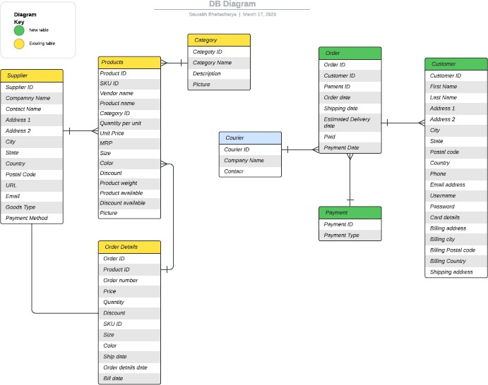

* **ER Diagram**

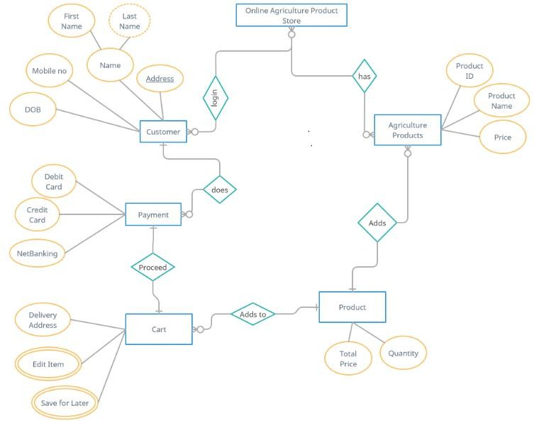

1. **Data Flow Diagram**

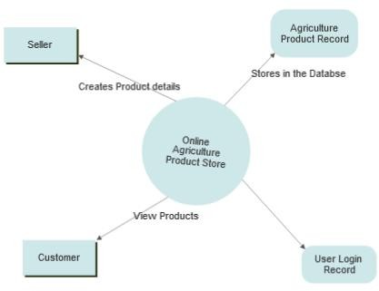

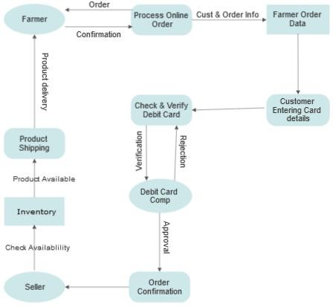

1. **Change Request**

What is a **Change request** - Change requests are when a stakeholder, either a client or an internal team or department, requests a change to the processes or deliverables that had already been decided upon in the project scope.

However, in this scenario, this change request has come up due to change in the Govt. Taxation structure. As a BA, I would analyse the request and clarify the stakeholders exactly what the request is asking us to do in the Online Agriculture Product Store. In a normal scenario, as a BA, I would first do the Feasibility Test, to check, how feasible it is to change the current ongoing project with the new change request.

However, in this case, Feasibility study is not required, as it’s a Govt structure which needs to be updated and followed. Therefore, I will follow the below steps to change the project as per the client’s requirements.

* Document the Change request.
* Look for any Supporting materials to help in adding this Change.
* Need to assess, whether the Change is an Inside or Outside scope. As it’s an outside scope, the Budget and time will get impacted.
* BA and PM should ensure whether the change is a minor or a major change. Policy changes by Govt is a major change request and we need to ensure that the change should be done according to the Govt. instruction.
* Fill the Change request Form and get the approval from the Project Manager.
* We also need to ensure that our Team understands the priority of this change request.
* We also need to discuss the change with Change Control Board who will recommend the necessary change on the Project.
* Once this change is approved, the project deliverables will need to be updated. This can include plans and schedules, business process documents, and the requirements documents.
* Once these updates have been made, the project manager can communicate the new course of action to everyone who will be impacted. Now you can delegate the necessary tasks to the people in charge of implementing these new changes.

1. **Change Request Vs an Enhancement**

The request from Ben and Kevin is an **Enhancement** request, as they want to add another feature in the Online store, which will also help the Farmers to sell the yields directly in the online store, apart from buying products. Hence my response would a positive response to them.

Therefore, as a BA, I should analyse the request and provide a project plan, requirement, design, a testing plans for this request. I must prepare an enhancement request form and decide how much manpower and manhours required for this enhancement request.

1. **Estimations - Manhours required.**

**Manhours Required** = Total hours working per day x Total number of members x Total numbers of days worked over the specific period.

Number of Working Hours a day = 8 hours Number of Resources = 12

Time period provided = 18 months = 547 days = 78 weeks (Including Weekends and Public Holidays)

Assuming Weekends = 156 Assuming Public Holidays = 10 Total = 166

547-166 = 381 working days

Hence, Estimated Manhours = 8 hours * 12 resources * 381 days = 36,576 hours required.

1. **UAT**

User Acceptance Testing (UAT) is a phase in the software development life cycle where the users of the Online Agriculture Product Store participate in validating that if meets their needs.

As a BA, I will verify all the validations prior to design the UAT Test cases, which will cover the functionality of the product, System environment, any possible defects which could arise and how to deal with these defects.

Steps for UAT

* **Analysis of Business Requirements**: One of the most important activities in the UAT is to identify and develop test scenarios. These test scenarios are derived from the following documents:
  1. Business Use Cases
  2. Process Flow Diagrams
  3. Business Requirements Document (BRD)
  4. System Requirements Specification (SRS)
* **Creation of UAT Plan**: The UAT test plan outlines the strategy that will be used to verify and ensure an application meets its business requirements. It documents entry and exit criteria for UAT, Test scenarios and test cases approach and timelines of testing.
* **Identify Test Scenarios and Test Cases**: Identify the test scenarios with respect to high-level business process and create test cases with clear test steps. Test Cases should sufficiently cover most of the UAT scenarios. Business Use cases are input for creating the test cases.
* **Preparation of Test Data**: It is best advised to use live data for UAT. Data should be scrambled for privacy and security reasons. Tester should be familiar with the database flow.
* **Run and record the results**: Execute test cases and report bugs if any. Re-test bugs once fixed. Test Management tools can be used for execution.
* **Confirm Business Objectives met**: Business Analysts or UAT Testers needs to send a sign off mail after the UAT testing. After sign-off, the product is good to go for production. Deliverables for UAT testing are Test Plan, UAT Scenarios and Test Cases, Test Results and Defect Log.

1. **Project Closure Document**

Project Closure

Online Agriculture Product Store

Version: 1.0

**Revision Date: MM/DD/YYYY**

*Submit the document to the Project Sponsor, Business Owner, and PPMO/PMO Division Director; and archive this closure document with the project artifacts once completed.*

|  |  |  |  |
| --- | --- | --- | --- |
| **Approver Name** | **Title/Role** | **Signature** | **Date** |
| Peter and Ben | Project Stakeholder * | Ok | xx/xx/xxxx |
| Mr. Henry | Exec Sponsor (AVP or Exec. Dir) * | Ok | xx/xx/xxxx |
| Mr. Pandu | Financial Head | Ok | xx/xx/xxxx |
| Mr. Vandanam | Project Manager | Ok | xx/xx/xxxx |
| Mr. Kartik | Delivery head | Ok | xx/xx/xxxx |
| Mr. Dooku | Project Coordinator | Ok | xx/xx/xxxx |

\**By authorizing this Project Closure, the Project Stakeholder(s), and Executive Sponsor agree to all terms within this document*.

**Revision History**

*Identify document changes.*

|  |  |  |  |
| --- | --- | --- | --- |
| **Version** | **Date** | **Name** | **Description** |
| 1.0 | xx/xx/xxxx | Mr. Henry | Ok to process |

**Section 1. General Information**

|  |  |
| --- | --- |
| **Project Activity** | **Date** |
| Project Start | 09th Feb 2025 |
| Project Closure* | 03rd Aug 2026 |

*\* Date of Project Closure refers to the project finish date, meaning all project tasks have been completed*

**Section 2. Business Objectives**

*As identified in section 2.2 of the Business Case.*

|  |  |  |  |
| --- | --- | --- | --- |
| **Business Case Ref #** | **Business Objectives** | **Met/Not Met** | **Comments** |
| BI0001 | Farmer should be able to buy and sell  agricultural product online. | Yes | Ok |

**Section 3. Customer Expectation Management**

|  |  |  |  |
| --- | --- | --- | --- |
| **Item** | **Question** | **Description** | **Comments** |
| 1 | Were all expected benefits and business outcomes realized? | Yes | Ok |
| 2 | Were all expected performance standards satisfied? | Yes | Ok |

**Section 4. Outstanding Actions Items and Issues**

|  |  |
| --- | --- |
| **Action Item** | **Transition and/or Resolution** |
|  |  |

**Section 5. Project Office Checklist**

|  |  |  |
| --- | --- | --- |
| **Deliverable** | **Description** | |
| Risk Assessment completed and posted on suitable shared storage. | 🗸Yes | No |
| Business Case completed and posted on suitable shared storage. | 🗸Yes | No |
| Project Charter completed and posted on suitable shared storage. | 🗸Yes | No |
| Meeting Notes completed and posted on suitable shared storage. | 🗸Yes | No |
| Additional project documentation and artifacts posted on suitable shared storage, including Requirements Template, Project Change Requests, Milestone Timeline, Work Breakdown Structure, etc. | 🗸Yes | No |
| Lessons Learned documented. | 🗸Yes | No |
| Project folder moved completed projects on suitable shared storage. | 🗸Yes | No |
| Support Handover Document completed and archived. | 🗸Yes | No |
| **Comments**  Ok to process. Application running properly. | | |