**PREP 3-1**

Q1. Draw a Use Case Diagram

A Use Case Diagram for a customer making a payment by Card, Wallet, Cash, or Net Banking should include the following actors and use cases:

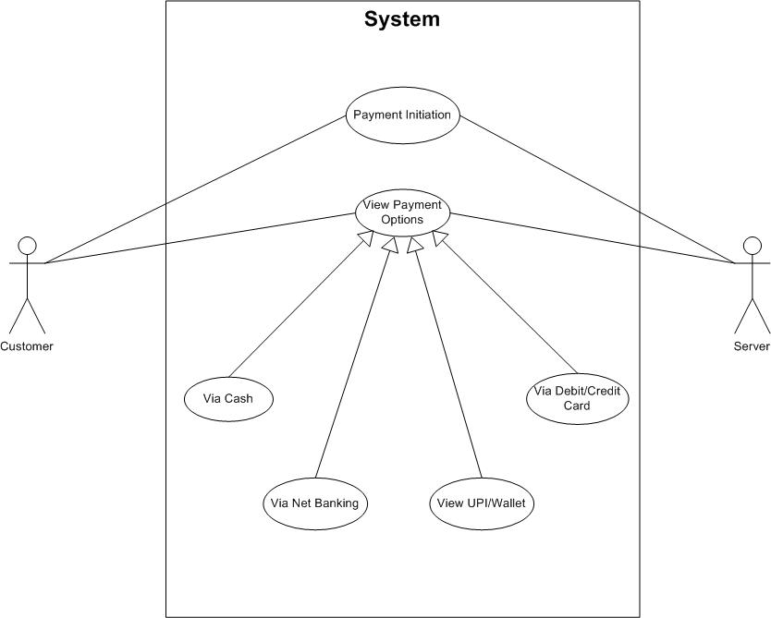

Q2. Derive Boundary Classes, Controller Classes, Entity Classes

Boundary Classes- Used to handle interactions between the systems and external actors: **a boundary represents a user interface screen or some kind of input-output device:** use cases become boundary class:

* PaymentUI
* CardPaymentUI
* WalletPaymentUI
* CashPaymentUI
* NetBankingPaymentUI

Controller Classes- Acts as an intermediate between boundary and entity classes: **a controller is defined as what controls the work that's done as well as when and how that work is done so you might think of a controller as an overseer that decides for example how the system should handle a user's request:** use case relationship where there is no third party involved becomes controller class

* PaymentController
* CardPaymentController
* WalletPaymentController
* CashPaymentController
* NetBankingPaymentController

Entity Classes- Represents the core data and business logic of the application: **an entity is some persistent element that is something that gets stored typically in a file so an entity in a sequence diagram is typically implemented as a table or an element in a database**: all the actors become entity class

* Customer
* Payment
* CardDetails
* WalletDetails
* BankDetails
* Transaction

Q3. Place These Classes on a Three-Tier Architecture

Presentation Tier:

* PaymentUI
* CardPaymentUI
* WalletPaymentUI
* CashPaymentUI
* NetBankingPaymentUI

Business Logic Tier:

* PaymentController
* CardPaymentController
* WalletPaymentController
* CashPaymentController
* NetBankingPaymentController

Data Access Tier:

* Customer
* Payment
* CardDetails
* WalletDetails
* BankDetails
* Transaction

Q4. Explain Domain Model for Customer Making Payment through Net Banking

A domain model is a conceptual representation that defines the structure, relationships, and behaviors of entities within a specific problem domain. Following is the domain model for a customer making a payment through Net Banking including entities and their relationships. **Visual representation of the relation between different component tables and entities**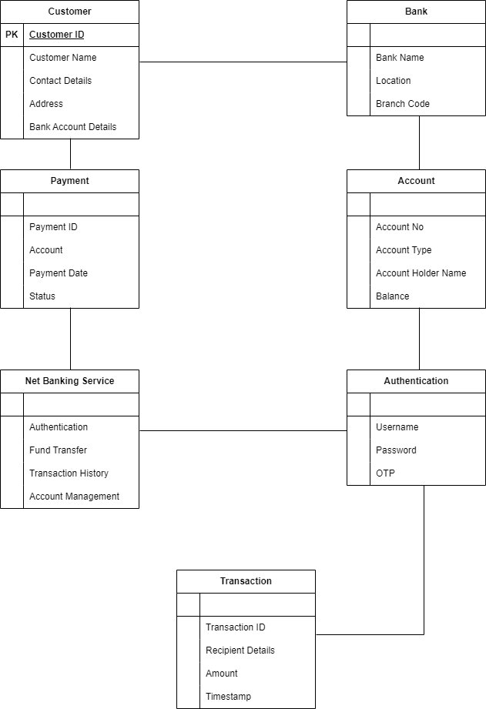

Q5. Draw a Sequence Diagram for Payment Done by Customer Net Banking

A sequence diagram is a type of interaction diagram used in software engineering and systems design to illustrate how processes operate with one another and in what order, following is a diagram representing the same:

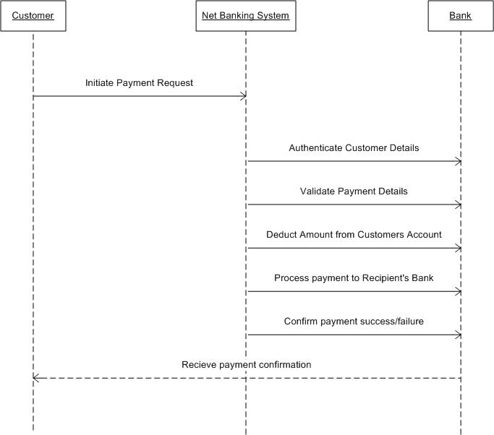

Q6. Explain the Conceptual Model for this Case

A conceptual model for the payment process done by a customer using net banking is a high-level representation of a system that helps in understanding, visualising, and communicating the essential aspects of a domain.

It provides a clear and simplified view of the domain, making it easier to understand.

Key elements of a Conceptual Model:

1. Entities: Customer, Product, Order & Payment
2. Attributes: CustomerID, Name, Email, Phone Number
3. Relationship: For example, a customer places an order.

Q7. What is MVC Architecture? Explain MVC Rules to Derive Classes from Use Case Diagram and Guidelines to Place Classes in 3-Tier Architecture

Model–view–controller (MVC) is a software design pattern commonly used for developing user interfaces that divide the related program logic into three interconnected elements. These elements are the internal representations of information (the model), the interface (the view) that presents information to and accepts it from the user, and the controller software linking the two.

It is an architecture or a software design pattern that makes creating huge applications easy. It does not belong to a specific programming language or framework, however, it is a concept that you can use in creating any kind of application or software in any programming language.

* Model: The central component of the pattern. It is the application's dynamic data structure, independent of the user interface. It directly manages the data, logic, and rules of the application. The model works directly with the database. It does not have to deal with user interface or data processing. In day-to-day scenarios, we will simply use the model to fetch, insert, update, and delete data from your database. For example, imagine we are creating a task management application that will simply allow users to organize tasks based on date and time. It means that we will have users and tasks to manage in our database. In the language of MVC, User and Task are models in our application.
* View: View is the User Interface on which our customer/user can perform some actions. It contains HTML, CSS, JS, XML, or any other markup language that we can use to create a beautiful user interface. It also contains code to show the data that it receives from our application. View means any representation of information such as a chart, diagram, or table. Multiple views of the same information are possible, such as a bar chart for management and a tabular view for accountants. The only two things that a View has to do are to show data to the customer/user on the User Interface and to respond to the events.

For example, what to do when a user clicks on the Update or Delete button? The answer is, that the user should be redirected to the Update form or the delete confirmation popup.

* Controller: The controller is the part in which we process the data after we get a request from View and before updating anything in our database with our Model. Accepts input and converts it to commands for the model or view.
* MVC Architecture Rules:

1. Combination of One Actor and an use case results in one Boundary class.
2. Combination of Two Actors and an use case results in two Boundary classes.
3. Combination of Three Actors and an use case results in Three Boundary classes and so on.

Note: only one primary actor is to be considered with a use case.

1. Use case will result in a controller class
2. Each Actor will result in one entity class

Q8. Explain BA Contributions in Project (Waterfall Model – All Stages) – 8 Marks

| Stages | Activities | Artifacts & Resources |
| --- | --- | --- |
| Pre Project | Enterprise Analysis - SWOT Analysis, GAP Analysis, Root Cause Analysis, Decision Analysis, Strategy Analysis, Enterprise  Architectural Frameworks, Project Scope and Business case writing, Risk Analysis | Business Case,  SOW(Statement of Work),  PO(Purchase Order) |
| Sr. BA, Business Architects, Presale consultants |
| Planning, Estimation & Assessment  Project Kick-Off(Big Picture Plan) | 1. Understand Assumptions and constraints along with business rules and business goals 2. Plan packages for Big Projects 3. Understand the project plan from PM 4. BA conducts stakeholder analysis 5. Plan BA approach strategy (Requirement gathering techniques, communication, requirement management, documents to follow, tools to use, change request handling methodology) for this project |  |
| PM, Sr. BA |
| Requirement Gathering | 1. Stakeholder identification and document 2. Client gives BRD, or BA prepares BRD by interacting with the Client- Brainstorming, Document Analysis, Reverse Engineering, Interviews, workshops, Focus Groups, Observation, and Questionnaires. 3. Prototyping can be used by BA to make the Client give more specific requirements 4. Sort the gathered requirements (avoiding duplicate requirements, grouping into similar functionality or into modules) 5. Prioritize requirements- MoSCoW 6. Validate Requirements- FURPS | BRD (Business Requirement Document) |
| BA, PM |
| Requirement Analysis | 1. Draw UML Diagrams (Use Case and Activity Diagrams) 2. Prepare Functional requirements from Business requirements 3. All Architects come up with Technical Requirements (SSD) 4. SRS will have Functional Requirements and Technical Requirements 5. Take Sign-Off on SRS from the Client. SRS is the first legally binding document between the Business and the Technical team. 6. BA prepares RTM from SRS before the Design phase starts. (BA is the owner of RTM) 7. BA traces how the requirements are dealt in each phase of the development life cycle from Design to UAT. | Functional Requirement Specification,  SSD (Supplementary Support Document),  SRS (Software Requirement Specification),  RTM (Requirement Traceability Matrix) |
| BA, PM, Solution Architect, DB Architect, NW Architect |
| Design | 1. From the Use Case Diagram, the Test Manager or BA will prepare Test Cases. 2. Communicate with the Client on the Design and Solution Documents (Update status to Client and make them understand how the solution would look like to prepare them to drive UAT) 3. BA will initiate the preparation of the end-user manuals 4. Update RTM 5. From Use Case Diagrams, the Solution Architect recommends the Architecture of the IT Solution. 6. DB Architect uses Persistence Classes (Entry Classes) and comes up with the ER Diagrams or DB Schema. 7. GUI Designer will look into Transient Classes (Boundary Classes) and design all possible Screens for the IT Solution | Solution Document,  Design Document  -HDD  -ADD |
| BA, PM, Solution Architect, DB Architect, NW Architect, GUI Designer, Test Manager |
| Coding | 1. BA organizes JAD Sessions 2. BA clarifies queries of the Technical Team during Coding 3. Developers refer to Diagrams and Transient(Controller Classes) of BA and code their unit. 4. Update end-user manuals 5. Update RTM 6. Conduct regular Status meetings with the Technical team and the Client and turn the Client for participation in UAT | LDD-CDD Application |
| Development Team, BA, PM |
| Testing | 1. BA prepares Test Cases from the Use Cases or assists the Test Manager in doing so 2. BA Performs high-level testing 3. BA prepares Client for UAT 4. Test Data is requested by BA from the Client 5. Update end-user manual 6. Update RTM 7. Take Sign-Offs from Client on Client Project Acceptance form | Test Concerning Documents Application with less errors |
| Testing Team, BA, PM, Client |
| Deployment & Implementation | 1. Forward RTM to the Client or the PM which should be attached to the Project Closure Document 2. Coordinate to complete and share end-user manuals 3. Plan and organize Training Sessions for end users 4. Prepare lessons learned from this project (to take precautions for the coming project) |  |

Q9. What is Conflict Management? Explain Using Thomas-Kilmann Technique

Conflict management is the approach and strategies designed towards achieving a positive outcome and resolution amongst the parties involved in matters relating to conflicts. These strategies and approaches are dependent on the type of conflict that exist in the organizations or institutions involved. It could be a systematic or unordered method that is task-specific, research-oriented, and requires proper attention. Conflict management is the process of limiting the negative aspects of conflict while increasing the positive aspects of conflict. Conflict management aims to enhance learning and group outcomes, including effectiveness or performance in an organizational setting.

It's human to deal with conflict by defaulting to what's comfortable. According to Thomas and Kilmann, most people take one of two approaches to conflict management, assertiveness or cooperativeness. From these approaches come five modes or styles of conflict management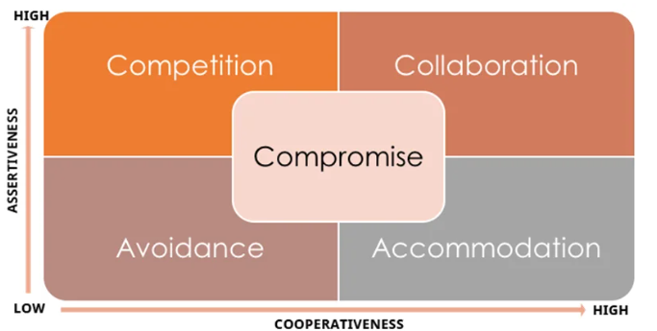

* Accommodating:

An accommodating mode of conflict management tends to be high in cooperation but low in assertiveness. When you use this style, you resolve the disagreement by sacrificing your own needs and desires for those of the other party. This kind of conflict management requires that the parties involved accept the views of one another. Both or one is ready to give the other party/side what is needed, for instance, in a business environment where employees are required to dress formally throughout the working days of the week. An employee can approach the organization to allow the wearing of casuals on Fridays. This can cause conflicts between the company and the employee because that may be a core organizational principle. However the company can apply an accommodation strategy by allowing the employees to wear casuals on Fridays. People are happy and feel among when this strategy is employed

* Avoiding:

When avoiding, you try to bypass a conflict. This style of managing conflicts is low in assertiveness and cooperativeness. Avoidance is unproductive for handling most disputes because it may leave the other party feeling like you don't care. Also, if left unresolved, some conflicts become much more troublesome.

* Compromising:

Compromising demands moderate assertiveness and cooperation from all parties involved. With this type of resolution, everyone gets something they want or need. This style of managing conflict works well when time is limited. Because of time constraints, compromising isn't always as creative as collaborating, and some parties may come away less satisfied than others. Most businesses would include this strategy to resolve a dispute when parties observe that there is a risk at the end, as any of them could lose something of value in matters that caused the conflict. Contract negotiation, customer service, and big investors are aspects you will see businesses compromising their standard to work with the other party.

* Collaborating:

A collaborating conflict management style demands a high-level of cooperation from all parties involved. Individuals in a dispute come together to find a respectful resolution that benefits everyone. Collaborating works best if you have plenty of time and are on the same power level as the other parties involved. If not, you may be better off choosing another style.

* Competing:

This type of conflict management strategy often involves individuals who are assertive and have the will power to fight till they achieve their goal and the other losing. For instance, a company might hold on to this competitive strategy by conflicting and holding on until they win on issues that will damage the organization's reputation based on an employee trying to defraud the company.

Q10. List Down the Reasons for Project Failure

There are no guarantees that starting a project will ensure that it’s delivered successfully. There are many ways a project can fail. To avoid failure, it’s important to understand failure and know the signs that your project is in danger. Project failure can be delivering a project after its deadline, over its budget, or not meeting its quality expectations. It could also be not delivering the project for any number of reasons. However, if the project fails, the client or stakeholder won’t get a return on their investment.

Reasons for Project Failures:

* Poor Planning:

Insufficient planning can lead to unrealistic timelines, inadequate resource allocation, and overlooked dependencies. For example, launching a software product without a detailed development and testing schedule can cause missed deadlines and budget overruns, resulting in project failure.

* Unclear Objectives and Requirements:

When project goals and requirements are vague or poorly communicated, team members may work towards different objectives, causing misalignment and confusion. For instance, developing a new app without clear specifications can result in features that don't meet user needs, leading to project failure.

* Inadequate Risk Management:

Failing to identify and mitigate potential risks means the project can be derailed by unforeseen issues. For example, not planning for potential supplier delays in a construction project can cause significant delays and increased costs, ultimately halting the project.

* Poor Communication:

Effective communication is essential for coordination and clarity. Poor communication leads to misunderstandings, errors, and a lack of cohesion among team members. For instance, if a marketing team isn't kept in the loop about product changes, their campaigns may become irrelevant, impacting project success.

* Scope Creep:

Uncontrolled additions of new features or requirements without proper change management can stretch resources thin and disrupt the project timeline. For example, continually adding new features to a software development project without adjusting the schedule or budget can lead to delays and increased costs, overwhelming the team.

* Lack of Stakeholder Engagement:

Engaging stakeholders ensures that their needs and expectations are understood and met. Without their involvement, the project may miss critical requirements and face resistance. Also, when stakeholders don't put sufficient time and effort into giving inputs or clarifying doubts, it can hinder project progress. For example, not involving key users in the development of a new software system can result in a product that doesn't meet their needs, causing project failure.

* Resource Constraints:

Adequate resources are crucial for project success. Constraints in time, budget, or personnel can impede progress and reduce the quality of work. For instance, attempting to develop a complex mobile application with a small, inexperienced team can lead to missed milestones and project failure.

* Technical Challenges:

Projects involving new or complex technologies may encounter significant technical issues. For example, implementing an advanced AI system without sufficient expertise can lead to persistent technical difficulties, increasing costs and delaying progress, ultimately resulting in project failure.

Q11. List the Challenges Faced in Projects for BA

Following are the challenges faced by a BA during a project:

* Unclear or Changing Requirements:

BAs struggle with vague or frequently changing requirements, causing confusion and misalignment among team members. This leads to increased workload, rework, and delays, jeopardizing project success. For example, a client requests a simple reporting tool but later adds advanced analytics, causing the team to repeatedly revise the project scope and timeline, leading to rework and delays.

* Managing Stakeholder Expectations:

Balancing diverse stakeholder expectations is challenging, as different priorities can cause conflicts. Effective communication, negotiation, and stakeholder engagement are crucial. Ensuring a shared understanding of goals and limitations is vital. For example, the marketing team wants user-friendly features, while finance prioritizes cost savings, leading to misaligned project goals and difficulties in meeting everyone’s needs.

* Scope Creep and Scope Management:

Uncontrolled scope changes (scope creep) significantly impact project timelines and budgets. BAs must implement strict change management to control scope and evaluate new requirements' impact. For example, during a website redesign, stakeholders continuously add features like additional payment gateways without extending deadlines or budgets, overwhelming the team and delaying the project.

* Time and Resource Management:

Effective time and resource management keeps projects on track and within budget. Challenges arise with limited resources, unexpected issues, or conflicting priorities. BAs must monitor progress and adjust plans. For example, a software development project faces delays due to an insufficient number of developers or unexpected technical issues like bugs that require more time to resolve.

* Quality Assurance and Testing:

Ensuring final deliverables meet quality standards and user requirements involves thorough testing and validation. Challenges include coordinating testing activities and managing defects. BAs must work closely with QA teams. For example, failing to properly test the checkout process in an e-commerce platform can result in a non-functional payment system, leading to lost sales and customer dissatisfaction.

* Documentation and Knowledge Management:

Creating and maintaining comprehensive documentation for all project aspects is essential for clarity and continuity. Challenges include ensuring accuracy and managing versions. Poor documentation leads to misunderstandings and errors. For example, a BA needs to document all functional requirements, user stories, and design specifications for a new CRM system, ensuring they are up-to-date and accessible.

* Technology Constraints:

BAs face challenges with technology limitations and integration issues, affecting feasibility and development efforts. Managing these constraints involves planning, risk assessment, and communication. For example, implementing a new ERP system is constrained by existing legacy systems that are not easily compatible, requiring additional resources and time to develop custom integration solutions or migrate data.

Q12. Write About Document Naming Standards

Establishing electronic file-naming standards will:

Improve access to documents and make sure that the right documents are available at the right time to support the daily business operations of each unit; facilitate more effective collaborative work between employees; and ensure that electronic files are easy to locate for records retention purposes. All documents will be named using some standards like:

[ProjectID ][Document Type]V[X]D[Y].ext

Q13. What Are the Do’s and Don’ts of a Business Analyst

Being a successful business analyst requires a combination of technical skills, communication skills, and a deep understanding of the business.

* Do's of BA:

1. Understand the business:

To be an effective business analyst, you need to have a deep understanding of the business you're working in. This means understanding its goals, objectives, and operations. By understanding the business, you'll be able to identify the right data to analyse and provide insights that are relevant to the organization.

1. Listen carefully:

As a business analyst, you'll be working with different stakeholders in the organization, including business leaders, developers, and project managers. It's important to listen carefully to their needs, concerns, and feedback. This will help you understand their requirements and provide solutions that meet their needs.

1. Be data-driven:

As a business analyst, you'll be working with a lot of data. It's important to be data-driven in your approach, which means using data to support your recommendations and decisions. This will help you provide insights that are based on facts and evidence rather than opinions.

1. Communicate clearly:

To be an effective business analyst, you need to be able to communicate clearly and concisely. This means presenting data in a way that is easy to understand and using clear and jargon-free language. This will help you to ensure that your recommendations are understood and acted upon.

1. Be adaptable:

The business environment is constantly changing, and as a business analyst, you need to be adaptable. This means being able to adjust your approach and methods as needed to meet changing business needs.

* **Don'ts of BA:**

1. Never say NO to the client.
2. There is NO word called “By Default”
3. Never imagine anything in terms of GUI.
4. Question the existence/ question everything in the world. Eg: what the client gives is not always correct
5. Consult an SME for clarifications in Requirements. Every problem of the Client is unique. No two problems of different clients are the same. Maybe the approach, technology, place of use, and local laws may vary making them different.
6. Make assumptions: As a business analyst, it's important to avoid making assumptions. Assumptions can lead to incorrect conclusions and recommendations that don't meet the needs of the organization. Instead, focus on gathering and analyzing data to support your recommendations.
7. Ignore feedback: Feedback is important in any business environment, and as a business analyst, you need to be open to feedback from stakeholders. Ignoring feedback can lead to missed opportunities and solutions that don't meet the needs of the organization.
8. Use jargon: Using technical jargon can be confusing for stakeholders who may not be familiar with the terminology. Avoid using jargon and instead, focus on communicating in a language that is easy to understand.
9. Overcomplicate things: As a business analyst, it's important to keep things simple. Overcomplicating things can make it difficult for stakeholders to understand your recommendations and may lead to too complex or difficult-to-implement solutions.
10. Work in isolation: Business analysis is a collaborative effort, and as a business analyst, you need to work with different stakeholders in the organization. Avoid working in isolation and instead collaborate with others to ensure that your recommendations meet the needs of the organization.

Q14. Write the Difference Between Packages and Sub-systems

|  | Packages | Subsystems |
| --- | --- | --- |
| Definition | Collection of components that are not reusable in nature | Collection of components that are reusable in nature |
| Granularity | Smaller and more focused in scope | Larger and encompasses multiple packages or modules |
| Dependency Management | Manage dependencies at a class/component level | Manage dependencies at a higher level, defining boundaries and interfaces between different parts of the system. |
| Example: | Application development companies work on packages. | Product development companies work on sub-systems. |

Q15. What is Camel-Casing and Explain Where It Will Be Used

Camel Casing is a naming convention used in computer programming and is characterized by removing spaces between words and capitalizing the first letter of each word except for the first word. The name “camel casing” is derived from the appearance of the resulting string, which resembles the humps of the camel. By using camel casing, developers can create meaningful and readable names that are easier to understand and follow the coding standards. It promotes consistency within the codebase and improves collaboration among the team members.

Example: camelCasingExample

Q16. Illustrate Development Server and What Are the Accesses Does Business Analyst Have?

Development Server:

A development server refers to a dedicated environment or server that is used during the software development process. It provides a platform for developers and testers to build, test, and debug applications before they are deployed to a production environment. The development server typically replicates the target production environment to ensure compatibility and accurate testing.

BA Accesses:

- Read-only access to requirements and design documents.

- Limited access to test environments.

- Access to project management tools and collaboration platforms.

Q17. What is Data Mapping?

Data mapping is the process of establishing a relationship or connection between data elements in two or more different data sources or data formats. It involves defining how data from one source corresponds to or transforms into data from another source. Data mapping is commonly used in data interpretation, data migration, and data transformation processes.

The purpose of data mapping is to ensure that data can be accurately and effectively transferred, converted, or transformed between different systems, databases, or formats. It involves identifying the source data elements and determining their corresponding target data elements. This is especially important when you are moving data between different systems or databases to ensure that the data stays consistent and accurate.

Q18. What is API? Explain How You Would Use API Integration in the Case of Your Application

API (Application Programming Interface):

An API is a set of rules and protocols that allow different software applications to communicate with each other. It defines the methods and data formats that applications can use to request and exchange information.

Using API Integration:

1. Establish API Communication: Set up API communication between your application and the other application to exchange data.
2. Data formatting: When sending date data from your application to the other application, convert the date from the dd-mm-yyyy format to the mm-dd-yyyy format. This can be achieved by extracting the day, month, and year components from the date and rearranging them according to the target format.
3. Data Parsing: When receiving the date from the other application, parse the mm-dd-yyyy formatted date into your application’s dd-mm-yyyy format. Again, you will need to extract the day, month, and year components and rearrange them accordingly.
4. Data Validation: Perform data validation and ensure that the converted date remains valid after the format conversion. Check for edge cases, such as invalid dates or date ranges that might be affected by the format conversion, and handle them appropriately.

**PREP 3-2**

Q1. What is the difference between Brainstorming and JAD Sessions? 3 Marks

|  | Brainstorming | JAD Sessions |
| --- | --- | --- |
| Purpose and focus | Generating a wide range of  ideas and solutions | Analyzing and documenting detailed requirements for a software application or  system. |
| Facilitation and  Structure | Open and free-flowing with  minimal facilitation | Structured and facilitated by a trained facilitator, following predefined activities and  techniques |
| Participants | Typically includes a diverse group of individuals from various backgrounds | Involves key stakeholders such as users, developers, and business analysts |
| Duration | Usually short, ranging from a few minutes to a few hours | Often extended sessions, ranging from several hours to multiple days |
| Output | A list of creative ideas or potential solutions | Detailed documentation of requirements, use cases, and functional specifications |
| Decision-Making | Decisions are not made during the session; ideas are later evaluated | Decisions are made collaboratively during the session, aiming for consensus |

Q2. Why Document Analysis is one of the compulsory techniques we use in a Project? Justify – 3 Marks

Document analysis is a crucial technique used in project management and requirements-gathering processes because it equips the project team with a comprehensive understanding of the project's existing conditions, provides a reliable reference for ongoing work, and helps identify potential risks and issues. These aspects are fundamental to the successful planning, execution, and completion of any project.

Below are three reasons why document analysis is considered a compulsory technique:

* Understanding Existing Documentation:

Document analysis involves reviewing project-related documentation such as business plans, charters, reports, and communications. This review provides insights into the project's context, objectives, and constraints. It helps project managers identify completed tasks and information gaps, and avoid duplicating efforts, ensuring informed decisions and realistic goals.

* Establishing Baseline and Reference:

Document analysis helps establish a project baseline by providing clear references for current processes, systems, and requirements. This baseline is essential for measuring progress and evaluating changes. It ensures consistency, aligns with organizational goals, and validates new requirements against existing ones, maintaining project integrity and achieving desired outcomes.

* Identifying Risks and Issues:

A thorough examination of existing documents allows early identification of potential risks and issues. Historical data, past project challenges, and lessons learned provide foresight into potential pitfalls. Understanding previous problems and resolutions enables proactive risk mitigation, contributing to smoother project execution and reducing the likelihood of significant issues.

Q3. In Which Context we will use Reverse Engineering? - 3 Marks

Reverse engineering is commonly used in various contexts to understand and analyze existing systems, products, or technologies, providing critical insights and ensuring system integrity. Here are five key contexts where reverse engineering is employed:

1. Software Development and Maintenance:

* Understand code and structure of legacy systems for maintenance, upgrades, or integration.
* Identify system operations, fix bugs, and add features without original documentation.
* Ensure compatibility between old and new systems for smooth data exchange and interoperability.

1. Product Analysis and Competitor Research:

* Dissect competitors' products to gain insights into features, design, and functionalities.
* Reveal technological strengths and weaknesses to aid innovation and product improvement.
* Identify potential intellectual property infringements for enforcing rights and legal actions.

1. Security Analysis:

* Analyze software and hardware for security vulnerabilities
* Understand internal workings to identify and fix potential security flaws.
* Protect against cyber threats and ensure robust security measures.

1. Education and Training:

* Serve as a valuable educational tool for students and professionals.
* Provide practical insights into design and implementation principles by deconstructing systems.
* Enhance problem-solving and technical skills.

1. Compliance and Verification:

* Ensure products comply with industry standards and regulations.
* Analyze design and functionality to verify legal and safety compliance.
* Certify products and avoid legal issues related to non-compliance.

Q4. What is the difference between Brainstorming and Focus Groups? - 3 Marks

|  | Brainstorming | Focus Group |
| --- | --- | --- |
| Purpose | Generating a wide range of ideas and solutions | Obtaining indepth insights, opinions, and  feedback |
| Structure | Open-ended and unstructured | Guided and structured |
| Participants | Usually consists of team members or individuals with diverse expertise | Typically involves target audience or relevant stakeholders |
| Outcome | Generates a broad array of ideas, often without immediate evaluation | Provides detailed understanding and evaluative feedback on specific topics |
| Facilitation | Facilitator encourages free-flowing ideas and creative thinking | Moderator leads the discussion, ensuring all topics are covered |
| Interaction | Encourages spontaneous and interactive idea generation among participants | Focused discussion, often with participants responding to specific questions or prompts |

Q5. Observation Technique – Explain both Active and Passive approaches - 3 Marks

Observation techniques are essential in research, usability testing, and requirements gathering to collect data by directly observing individuals, processes, or systems. The two main approaches are:

Active Observation:

In active observation, the observer takes an interactive role with the participants or the environment. This includes engaging with participants, asking questions, and guiding the observation process. The observer might participate in the activities being observed to gain a deeper understanding. This approach helps in obtaining detailed insights and immediate clarifications, making it suitable for complex or dynamic environments.

Passive Observation:

In passive observation, the observer adopts a non-intrusive stance. They simply observe and record behaviors, activities, or events without direct interaction or influence. This approach minimizes the observer's impact on the environment, ensuring that the behaviors and activities observed are as natural as possible. Passive observation is ideal for studies where interference could alter the authenticity of the data, such as in natural settings or routine operations.

Q6. How do you conduct the Requirements Workshop- 3 Marks

Conducting a requirements workshop involves facilitating a collaborative session with stakeholders to elicit, analyze, and document requirements for a project. Here are the key steps:

1. Plan and Prepare:

* Define Objectives: Clearly outline the goals and outcomes expected from the workshop.
* Logistics: Arrange the necessary resources, such as meeting space, equipment, and materials.
* Pre-Workshop Research: Gather relevant background information and any preliminary data needed for the discussion.

2. Identify Participants:

* Stakeholder Selection: Identify and invite key stakeholders, including project sponsors, users, developers, and any other relevant parties.
* Roles and Responsibilities: Define the roles of participants, such as facilitator, scribe, and subject matter experts.

3. Create an Agenda:

* Structured Plan: Develop a detailed agenda outlining the topics to be covered, time allocation for each topic, and any activities or exercises.
* Focus Areas: Include time for introductions, setting expectations, brainstorming sessions, prioritization of requirements, and wrap-up.

4. Facilitate the Workshop:

* Engagement: Use facilitation techniques to encourage participation and ensure all voices are heard.
* Documentation: Capture discussions, decisions, and requirements accurately, often using tools like whiteboards, sticky notes, or software applications.
* Conflict Resolution: Manage conflicts and ensure the group stays focused on the objectives.

5. Post-Workshop Activities:

* Review and Validate: Summarize the collected requirements and circulate them among participants for review and validation.
* Follow-Up: Schedule follow-up meetings if necessary to address any unresolved issues or gather additional information.
* Documentation: Finalize the documentation of requirements and ensure it is shared with all relevant stakeholders.

Q7. In which context, Interview Tec hnique can be conducted by a BA? How many approaches are there in conducting Interviews? (Structured – Unstructured) Explain them. Explain the difference between Open Ended Questions and Closed-ended Questions –6Marks

A Business Analyst (BA) conducts interviews primarily in the context of gathering requirements, understanding stakeholders' needs, or conducting research for a project. Interviews are a crucial tool in business analysis for collecting information, clarifying requirements, eliciting feedback, and gaining insights from stakeholders.

### Approaches to Conducting Interviews

1. Structured Interviews:

* Description: In a structured interview, the interviewer follows a predetermined set of questions in a standardized manner.
* Purpose: This approach ensures consistency and comparability of responses across different participants.
* Application: Structured interviews are useful when specific information is needed from each participant or when the BA needs to gather data that can be easily quantified and compared.

2. Unstructured Interviews:

* Description: An unstructured interview is more flexible and open-ended, allowing the interviewer to explore topics in-depth based on the participant's responses.
* Purpose: This approach is beneficial for gaining a deep understanding of the participant's perspectives and uncovering new insights that may not emerge from a structured format.
* Application: Unstructured interviews are ideal for exploratory research and when the BA seeks to understand complex issues or experiences in detail.

| Differences | Open-Ended Questions | Closed-Ended Questions |
| --- | --- | --- |
| Format | Require narrative, descriptive responses | Offer predefined response options |
| Response Type | Participants have the freedom to provide their answers | Participants chose from the given response options |
| Information Obtained | Provide qualitative, detailed information | Provide quantitative, standardized information |

Q8. Questionnaire Technique – Where we will use? Give one example - 6 Marks

The questionnaire technique is widely employed in research and data collection to efficiently gather information from a large number of participants in a structured manner. This method involves presenting a series of questions to respondents, who then provide their answers either by selecting from given options or by providing their own responses.

Usage:

* Purpose: Questionnaires are used to collect standardized information, making it easy to analyze and compare data across a large group of respondents.
* Application: This technique is particularly useful when the objective is to gather quantitative data that can be statistically analyzed.

Example: Market Research: Companies frequently use questionnaires to collect data about consumer preferences, opinions, and purchasing behavior. For instance, a company might distribute a questionnaire to understand which product features are most important to their customers, aiding in product development and marketing strategies.

Q9. How to Sort the Requirements – Where we will use? Give one example - 5 Marks

Sorting requirements is a crucial step in the requirements engineering process. This involves organizing and prioritizing the gathered requirements based on their importance, relevance, and feasibility. This helps in identifying the most critical and high-priority requirements for the development or implementation of a product or system.

Usage:

* Purpose: To ensure that the most important and feasible requirements are addressed first, facilitating efficient project planning and execution.
* Application: This technique is used in various fields to manage and streamline the requirements, ensuring a focus on high-impact areas.

Example:

* Software Development: In building a software application, numerous requirements are identified from stakeholders, users, and project teams. Sorting these requirements helps prioritize features and functionalities that are critical to the project's success, ensuring that essential aspects are developed first and align with project goals.

Q10. Prioritise the Requirements – –Where we will use? Give one example - 5 Marks

Prioritizing requirements is an essential step in the requirements engineering process. This involves ranking or ordering the identified requirements based on their relative importance and urgency. This process guides the development team's efforts, resource allocation, and decision-making during product or system development.

Usage:

* Purpose: To ensure that the most critical and urgent requirements are addressed first, optimizing the use of resources and enhancing project outcomes.
* Application: This technique is used in various project management and development methodologies to focus on high-impact tasks.

Example:

* Project Management (Agile Methodologies): In agile methodologies like Scrum, prioritizing requirements is a key practice. The product backlog is a prioritized list of requirements, often referred to as user stories. This helps the Scrum team focus on delivering the most valuable features first, ensuring that the project meets stakeholder needs effectively.

Q11. Weekly status reporting – How we will drive? 5 Marks

To effectively drive weekly status reporting, follow these steps:

1. Define Reporting Requirements: Clearly specify what information needs to be reported.
2. Set Reporting Frequency and Deadline: Establish a consistent schedule, such as every Friday by noon.
3. Standardize Reporting Format: Use a uniform template to ensure consistency and ease of review.
4. Communicate Expectations: Inform all team members about the reporting process and expectations.
5. Provide Guidance and Support: Offer training or resources to help team members complete their reports accurately.
6. Remind and Follow Up: Send reminders before the deadline and follow up with those who miss it.
7. Review and Consolidate Reports: Collect individual reports and compile them into a comprehensive summary.
8. Share and Discuss the Reports: Distribute the compiled report to relevant stakeholders and hold meetings to discuss the findings.
9. Act on the Findings: Use the insights gained from the reports to make informed decisions and address any issues.

Q12. Meeting Minutes Document – prepare one Sample -5 Marks

| MOM Template | |
| --- | --- |
| Date |  |
| Time |  |
| Location |  |
| Attendees | ABC BDC EFG |
| Agenda | Item 1 Item 2  Item 3  Item 4 |
| Discussion Summary | Item 1 Discussion  Summary of the Item |
| Action Items |  |
| Next Meeting | |
| Date |  |
| Time |  |
| Location |  |
| Agenda |  |

Q13. Change Tracker – Document - – prepare one Sample -4 Marks

| Change Tracker Document |
| --- |
| Version: [Insert Version Number] |
| Date: [Insert Date] |
| Change Details |
| Change Request Number |
| Requested By |
| Date Requested |
| Change Description |
| Change Assessment |
| Impact Analysis |
| Risk Analysis |
| Feasibility Analysis |
| Effort Estimate |
| Approval Status |
| Approval Date |
| Implementation Details |
| Developer/Implementer |
| Start Date |
| End Date |
| Test Coverage |
| Test Results |
| Deployment Plan |
| Rollback Plan |
| Rollback Procedure |
| Rollback Test Plan |
| Rollback Date |
| Rollback Results |
| Documentation Update |
| Document Affected |
| Update Description |
| Update Date |
| Updated By |
| Approvals |
| Approver 1 |
| Approver 2 |
| Approver 3 |
| Approver Date |
| References |
| Related Documents |
| Supporting Materials |

Q14. Difference between Traditional Development Model and Agile Development Models –8 Marks

| Waterfall | Agile (Scrum) |
| --- | --- |
| Feasiblity evaluation takes a long phase and is done in advance to avoid reworking in the next project phase | Feasibility test takes a shorter while considerably. Clients are engaged in the earty project phase to get the buy-in and refine the needs in the long run. |
| Project planning is done at the beginning of the and is not open to any changes later on. | The plan is not given the foremost prionty and is done during sprint planning. Modifications are welcome except during an active sprint. |
| Project progress gets monitored according to the plan | The developrnent gets tallied in each sprint. |
| Only the project managers communicate and carry out gogress review meetings weekly/monthly. | Communication is frequent, face-to-face, and clients also participate throughout the project. |
| Roles are not interchangeable once distributed among project team members. | You can switch roles quickly, and the team can work in cycles. |
| Documentation gets a lot of emphases and that is pretty comprehensive. | There's a need to file requirements, build designs, and write test plan to promote working software delivery. |

Q15. Explain Brainstorming Technique – Where to use? 5 Marks

Brainstorming is a creative problem-solving technique that involves generating a large number of ideas or solutions through group discussion and collaboration. The key principles of brainstorming include:

1. Encouraging Free Expression: Participants are encouraged to freely express their thoughts, ideas, and suggestions without fear of criticism or judgment.
2. Building on Ideas: Group members build on each other's ideas to enhance and refine them.
3. Quantity Over Quality: The initial goal is to generate as many ideas as possible, focusing on quantity rather than quality.
4. Defer Judgment: Evaluation and criticism of ideas are deferred until the brainstorming session is complete to foster a safe and open environment.

Here are some common scenarios where brainstorming is useful:

* Idea Generation
* Project Planning
* Problem-solving
* Team Building
* Innovation and Product Development
* Strategic Planning

Case study ( Q16 – Q20 → 33 Marks)

TTS Company is a multinational Company giving services on Software development in the BFSI Vertical. They have multiple products available. They have Research and Development Wing, which continuously try to improve the Quality of the products and innovation is their USP, this is helping TTS Company to be in Top 10 List. TTS Company came up one initiative to help their Employees with Loans based on their eligibility. To support this cause, they proposed the development of Employees Loan Management System.

The Employees Loan Management System will help an organization to manage a loan for its employees online in an efficient way. Employees can request loans, which will be reviewed by the HR and Accounts departments and then loans will be approved or rejected. In case, the loan is rejected, the employee will be informed of the reason for loan rejection.

However, in the case of loan approval, Loan approval terms and conditions, the loan repayment schedule will be provided to the employee. If the employee will agree with the loan offer, terms and condition, and repayment schedule, the loan will be granted to the employee and automatic deduction from employee salary will be made.

Q16. What reports Accounts Departments will generate (minimum 5 reports) – 10 Marks

* Financial Statements: The accounts department prepares and provides financial statements, including balance sheets, income statements, and cash flow statements. These statements give an overview of the borrower's financial position, profitability, and ability to generate cash flow.
* Company reserve loan Report: This report will help understand the reserve amount.
* Credit Report: The accounts department may obtain a credit report on the borrower from a credit bureau. This report provides information on the borrower's credit history, including their repayment track record, outstanding loans, and credit score.
* Collateral Evaluation: If the loan requires collateral, the accounts department may be involved in evaluating the value and marketability of the proposed collateral. Cash Flow Projections: The accounts department prepares cash flow projections based on the borrower's financial data.
* Debt-to-Income Ratio Analysis: The accounts department calculates the borrower's debt-to-income ratio, which compares the borrower's total debt obligations to their income

Q17. What is the structure of the message/mail communicated from the HR department to the employee in case the Loan is rejected? – 5 Marks

Subject: Notification of Loan Rejection

Dear Hema,

I hope this message finds you well. We regret to inform you that, after careful consideration and evaluation of your loan application, the company’s loan approval committee has decided to reject your request.

We understand this news may be disappointing. Please know that this decision was made following a thorough assessment of various factors and in alignment with the company’s lending policies and financial guidelines.

While we are unable to disclose specific reasons for the rejection, we encourage you to review your financial situation and explore alternative options that may better suit your current circumstances. Our HR department is available to provide guidance and support should you need assistance in exploring other avenues for financial assistance.

It's important to note that this decision does not reflect your value as an employee, nor will it impact your employment status or benefits with the company. We remain committed to your professional growth and well-being as part of our team.

Should you have any questions or require further clarification, please do not hesitate to contact the HR department. We are here to assist you.

Thank you for your understanding and cooperation.

Best regards,

HR Department

ABC Company

Q18. What is the structure of the message/mail communicated from the HR department to the employee in case the Loan is approved? – 5 Marks

Subject: Loan Approval Notification

Dear Hema,

We are delighted to inform you that your loan application has been approved by the company’s loan approval committee. Congratulations on this successful outcome!

After a thorough review of your application, which included considerations of your financial standing, employment history, and eligibility criteria for the loan program, we are confident that this loan will support you in achieving your financial goals.

Here are the details of your approved loan:

* Loan Amount: Rs 1,500,000
* Loan Term: 10 years
* Interest Rate: 7.5% per annum
* Repayment Schedule: Yearly installments of Rs 150,000

Please take the time to carefully review the loan agreement and associated terms. If you have any questions or need further clarification, please do not hesitate to contact the HR Department. We are here to provide support and guidance throughout the loan process.

We kindly remind you of your responsibility to fulfill the loan repayment obligations as per the agreed-upon terms. Timely and consistent repayment will not only help you achieve your financial objectives but also demonstrate your reliability and strengthen your creditworthiness.

Your prompt attention to the loan agreement and adherence to the repayment schedule are greatly appreciated. Should you encounter any challenges during the repayment period or require assistance, please feel free to approach the HR Department for support.

Once again, congratulations on your loan approval. We wish you every success in reaching your financial aspirations.

Best Regards,

HR Department

ABC Company

Q19. Design a sample report on the loan applications Received by the accounts department – 8 Marks





**Loans Applications Report** Date: DD/MM/YYYY

| Loan Application ID | Applicant Name | Loan Amount | Status |
| --- | --- | --- | --- |
| PL01 | Hema | 100000 | Approved |
| HL01 | Jaya | 500000 | Pending |
| EL01 | Sushma | 1500000 | Rejected |

Notes:

* Approved applications have met the loan approval criteria and are eligible for loan disbursement.
* Rejected applications do not meet the loan approval criteria and have been declined.
* Pending applications are currently under review and a decision will be communicated soon.
* For any inquiries or further information, please contact the Accounts Department.

Q20. Which reporting Tools we will use for generating reports? – 5 Marks

The choice of reporting tool depends on factors such as the nature of data, reporting requirements, user skill level, budget, and integration capabilities. Here are some popular reporting tools commonly used:

1. Microsoft Excel:

* Description: Widely used spreadsheet software with powerful data analysis and reporting capabilities.
* Features: Pivot tables, charts, data filtering, and complex formulas.
* Use Case: Suitable for detailed data analysis and ad-hoc reporting.

1. Tableau:

* Description: Leading data visualization and reporting tool that enables users to create interactive and visually appealing reports and dashboards.
* Features: Drag-and-drop interface, real-time data analytics, and extensive visualization options.
* Use Case: Ideal for creating sophisticated, interactive visual reports and dashboards.

1. Power BI:

* Description: Business intelligence tool developed by Microsoft that allows users to connect, transform, and visualize data from different sources.
* Features: Data modeling, interactive dashboards, AI-powered insights, and integration with various data sources.
* Use Case: Best for comprehensive data analysis and reporting across multiple data sources with real-time updates.