**Assignment- 1**

1. Please make a BRD which can be presented to the client along with complete development and resource plan.

**Business Requirements Document (BRD)**

**1. Introduction**

**1.1 Purpose**

The purpose of this document is to define the business requirements for developing an Inventory Management & Delivery Optimization System for a company that manufactures ice cream and milk products. The system aims to:

* Optimize inventory management across multiple warehouses.
* Ensure the quickest delivery of products to customers.

**1.2 Scope**

This system will provide real-time inventory tracking and automate order processing to enable efficient stock management and timely delivery.

**1.3 Stakeholders**

* **Business Owners:** Oversee and fund the project.
* **Supply Chain Managers**: Manage inventory and logistics.
* **Warehouse Managers:** Ensure stock levels are maintained.
* **Delivery Teams:** Fulfil customer orders.
* **IT & Development Team:** Build and maintain the system.

2. **Business Objectives**

* Reduce inventory wastage by implementing real-time tracking.
* Optimize warehouse storage based on demand and seasonality.
* Enhance order fulfilment efficiency through route optimization.
* Improve customer satisfaction with fast delivery and accurate order tracking.

3. **Functional Requirements**

3.1 **Inventory Management**

* Real-time inventory tracking at all warehouses.
* Automatic reordering when stock is low.
* Expiry date management for dairy products.
* AI-based demand forecasting to prevent overstocking or understocking.

3.2 **Order Processing & Delivery Optimization**

* Customer order portal (web & mobile).
* Automated order assignment to the nearest warehouse.
* Delivery route optimization for fastest fulfilment.
* GPS tracking for real-time order tracking.

3.3 **Reporting & Analytics**

* Inventory reports for warehouse managers.
* Sales and demand trend analysis.
* Delivery performance metrics.

**4. Non-Functional Requirements**

* **Scalability**: Handle high order volumes during peak seasons.
* **Security**: Role-based access control for different stakeholders.
* **Performance:** Order processing should be completed within 5 seconds.
* **Availability:** 99.9% uptime to ensure business continuity.

**5. Development & Resource Plan**

5.1 **Development Approach**

* Agile methodology with weekly sprints.
* MVP (Minimum Viable Product) in 4 months, full-scale system in 8 months.

5.2 **Resource Planning**

|  |  |  |
| --- | --- | --- |
| Role | Responsibility | No of resources |
| Business Analyst | * Requirement Gathering * BRD Document * UAT | 1 |
| Project Manager | * Project Execution & Delivery | 1 |
| UI/ UX Designer | * Frontend Design | 1 |
| Backend Developer | * API & Database Development | 2 |
| Frontend Developer | * UI Development | 2 |
| QA Tester | * System Testing | 1 |
| DevOps Engineer | * Deployment & Monitoring | 1 |

**6. Risks & Mitigation**

|  |  |
| --- | --- |
| **Risks** | **Mitigation Strategy** |
| System Downtime | Implement Failover Servers |
| Delay in Delivery | Implement alternative delivery routes |
| Inventory Mismatch | Implement barcode/ RFID Based Tracking |

1. **Prepare Process flow Diagram.**

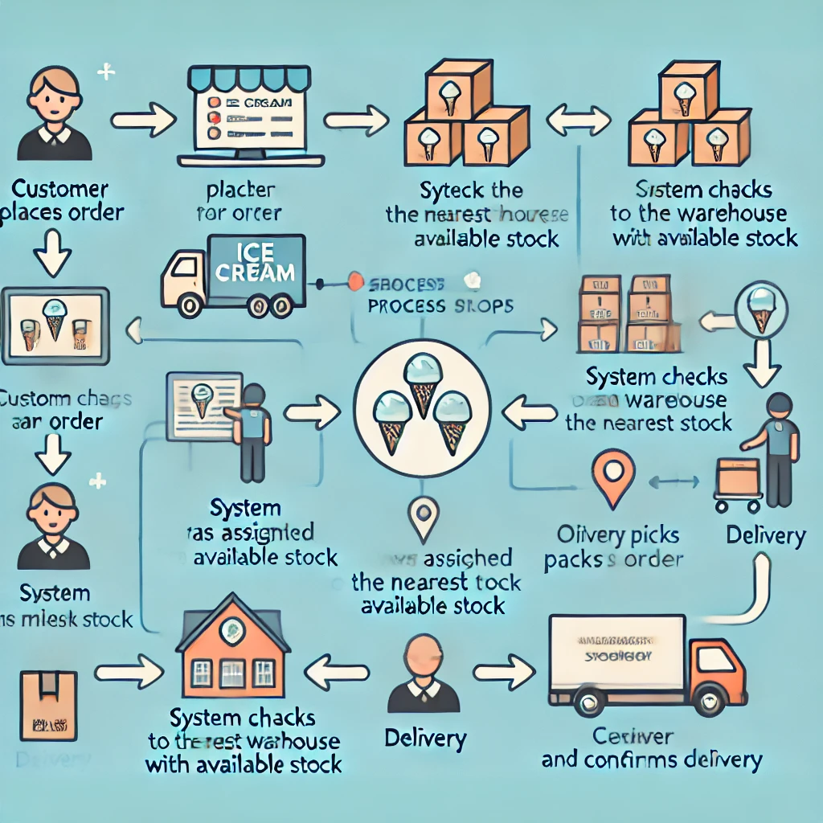

**Breakdown of the Process Flow Diagram step by step:**

1**. Customer Places an Order**

The process begins when a customer places an order through the website or mobile app.

The system captures the order details, including product type, quantity, and delivery location.

**2. System Checks Warehouse Stock Availability**

* The software automatically checks the nearest warehouse based on the customer’s location.
* If stock is available, the order proceeds to fulfilment.
* If stock is unavailable at the nearest warehouse, the system checks alternative warehouses.

**3. Order Assignment to Warehouse**

* Once the nearest warehouse with stock is identified, the system assigns the order.
* A notification is sent to the warehouse team to begin processing.

**4. Warehouse Team Picks and Packs the Order**

* Warehouse workers pick the ordered items from inventory.
* The items are packed securely, considering product sensitivity (e.g., refrigerated transport for ice cream).
* A barcode or RFID is assigned to the package for tracking.

**5. Delivery Route Optimization**

* The system calculates the fastest delivery route using AI-based route optimization.
* Factors such as traffic conditions, distance, and delivery priority are considered.

**6. Dispatch for Delivery**

* The packed order is handed over to the delivery team.
* The delivery vehicle is assigned based on the optimal route.
* Real-time GPS tracking is enabled, allowing both the customer and business to monitor progress.

7. **Customer Receives the Order & Confirms Delivery**

* The order is delivered to the customer’s location.
* The customer confirms receipt through OTP or digital signature.
* The system updates the status to ‘Delivered’ and records the transaction for future reference.

This process ensures real-time inventory tracking, efficient warehouse management, and fast customer deliveries, aligning with the company’s business goals.

**ASSIGNMENT-2**

1. Write an Introduction letter to a client introducing yourself as a Business Analyst in charge of working with the client and his team to start the business understanding process.

**Subject: Introduction – Business Analyst for Your Project**

Dear Mr Anshul Jadhav,

I hope you are doing well. My name is Ravi Chhabriya, and I am the Business Analyst assigned to collaborate with you and your team on Ice- Cream and Milk product Project. I am excited to begin this journey with you to understand your business needs and ensure a smooth and efficient project execution.

As part of my role, I will be working closely with your team to:

* Gather and analyse business requirements.
* Understand your current processes and identify areas for improvement.
* Define project goals, scope, and key deliverables.
* Facilitate discussions to align business needs with technical solutions.

To kick things off, I would love to schedule an initial meeting where we can discuss your business objectives, challenges, and expectations. Please let me know a convenient time that works for you.

Looking forward to working with you and contributing to the success of this project.

Best regards,

Ravi Chhabriya

Business Analyst

+91-1234567890

Standard Chartered Bank

1. **Prepare a brief BRD and SRS For a project (Ticketing System)**

**Business Requirements Document (BRD)**

**1. Introduction**

* 1. **Project Overview**

The Ticketing System is designed to streamline the process of logging, tracking, and resolving customer issues efficiently. The system will allow users to raise support tickets, assign them to the appropriate support personnel, track progress, and provide timely resolution and also allow user to book the ticket online.

1.2 **Business Problem Statement**

Currently, issue tracking is done manually via emails or spreadsheets, leading to inefficiencies, delays, and lack of transparency in ticket resolution. The Ticketing System aims to provide an automated and structured approach to handling customer issues.

1.3 **Business Objectives**

* Enable users to raise and track tickets in real-time.
* Provide automated ticket assignment based on priority and category.
* Ensure timely resolution with Service Level Agreements (SLAs).
* Improve customer satisfaction through transparency and communication.
* Generate reports and insights on ticket trends and performance.

**2. Scope of the Project**

**2.1 In-Scope**

* User registration and authentication
* Ticket creation, assignment, and tracking
* Automated notifications and status updates
* Reporting and analytics

**2.2 Out-of-Scope**

* Integration with third-party CRM systems (for now)
* AI-based auto-resolution of tickets

3. **Stakeholders**

* Customers: Users who raise support tickets
* Support Agents: Handle and resolve tickets
* Managers: Monitor performance and generate reports
* Admin: Manage users, categories, and configurations

4. **Key Business Requirements**

|  |  |  |
| --- | --- | --- |
| **ID** | **Requirements** | **Priority** |
| BR1 | User should be able to create and track ticket online | High |
| BR2 | System should assign tickets bases on category and priority | High |
| BR3 | Uses should receive notification of ticket status update | Medium |
| BR4 | Support agent should be able to update and resolve ticket issues on a real time basis. | High |
| BR5 | Managers should be able to generate reports on ticket trends | Medium |

1. **Assumptions and Constraints**

* The system will be web-based.
* Users will require internet access.
* Initial launch will support only English language.

**Software Requirements Specification (SRS)**

1. **Introduction**

**1.1 Purpose**

The Ticketing System aims to provide an efficient way to log, manage, and resolve customer issues.

**1.2 Scope**

The system will allow users to raise tickets, track their progress, and receive updates. Support agents will manage and resolve tickets, while managers can generate reports.

**1.3 Intended Audience**

* Business Teams
* Developers
* Quality Analysts
* IT Support Teams

1.4 **Assumptions**

* The system will be hosted on a cloud platform.
* Users will access the system through a web portal.

B. **Goals and Objectives**

* Provide a centralized platform for ticket management.
* Improve response and resolution times.
* Enhance user experience through automated notifications.

(C) **Use Case Diagram for a ticketing system**

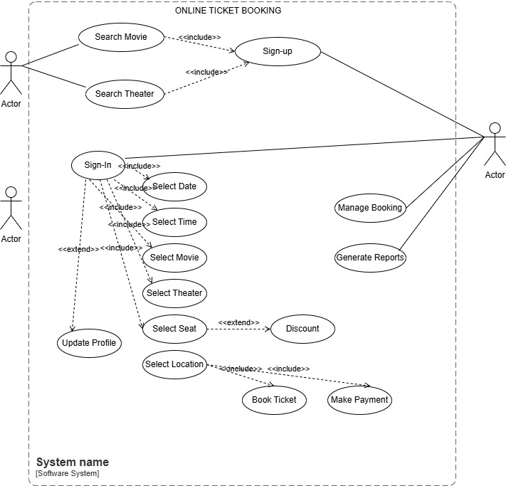

(D) . **Functional Requirements**

|  |  |  |
| --- | --- | --- |
| ID | Requirements | Priority |
| FR1 | Users should be able to register and login | High |
| FR2 | Users should be able to create and track the ticket online | High |
| FR3 | System should assign ticket automatically once booking is confirmed | High |
| FR4 | System agent should be able to update the ticket status | High |
| FR5 | Notification should be sent on status updated | Medium |
| FR7 | Notification should be sent on status updated | Medium |
| FR7 | Notification should be sent on status updated | Medium |
| FR8 | Notification should be sent on status updated | Medium |
| FR9 | Notification should be sent on status updated | Medium |
| FR10 | Notification should be sent on status updated | Medium |
| FR-11 | Notification should be sent on status updated | Medium |

(E) . **Non-Functional Requirements**

|  |  |  |
| --- | --- | --- |
| **ID** | **Requirements** | **Priority** |
| NFR1 | The system should be available 99.9% of the time | High |
| NFR2 | The response time of the system should be under 3 Seconds | High |
| NFR3 | Date should be encrypted during transmission | High |
| NFR4 | System should support to 10,000 users at a time | Medium |

1. **Make an ERD of Creating a support ticket/ ticketing life cycle.**

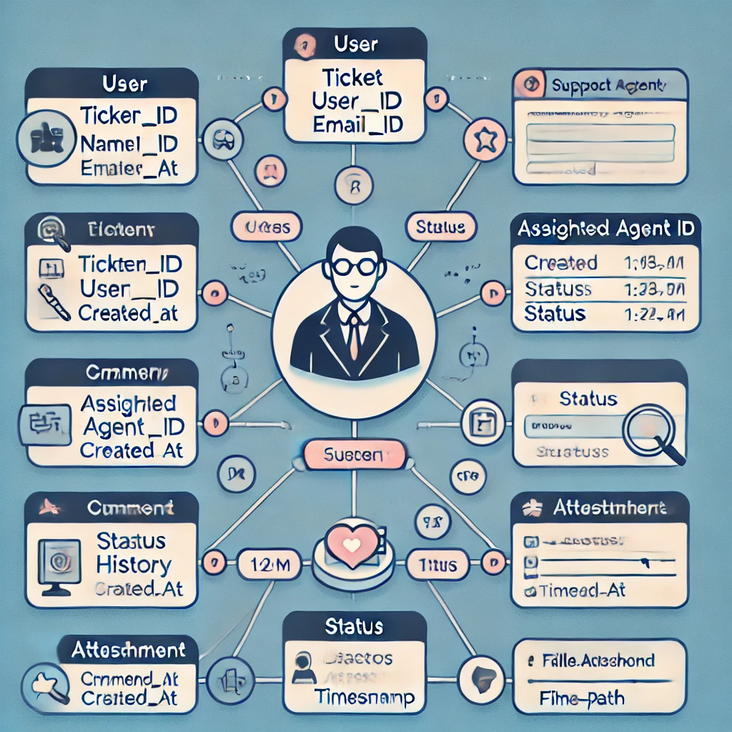

1. **User story of a shopping from ecommerce (Amazon)**

|  |  |  |  |
| --- | --- | --- | --- |
| **User story No: 1- Registration** |  | | **Priority: High** |
| **Value statement:**  As a User  I want to register for an account,  So that I can purchase product online. | | | |
| **BV: 100** | | **CP: 2** | |
| **Acceptance criteria:**   * I am the new and first-time user. * When I enter my details like name, number, email id my accounts get created successfully. * If the email id and mobile number is already registered it should display an error message. | | | |

|  |  |  |  |
| --- | --- | --- | --- |
| **User story No: 2- User Login** |  | | **Priority: High** |
| **Value statement:**  As a User  I want to login to my account.  So that I can access my account and see all the details. | | | |
| **BV: 500** | | **CP: 2** | |
| **Acceptance criteria:**   * I should be a registered user while login to my account. * When I entered valid credentials then only my account should get logged in. * If I entered incorrect details an error message should be displayed,. | | | |

|  |  |  |  |
| --- | --- | --- | --- |
| **User story No: 3- Password Reset** |  | | **Priority: High** |
| **Value statement:**  As a User  I want to reset the password if I forgot it,  So that I can access my account again. | | | |
| **BV: 100** | | **CP: 2** | |
| **Acceptance criteria:**   * When I enter my email id, I should get a password reset link. * When I click on reset password link, I should get an option to reset my password. * I should be able to reset my password through mobile app or through web application. | | | |

|  |  |  |  |
| --- | --- | --- | --- |
| **User story No: 4- Browse product** |  | | **Priority: High** |
| **Value statement:**  As a User  I want to browse different product categories,  So that I can Explore different products. | | | |
| **BV: 200** | | **CP: 1** | |
| **Acceptance criteria:**   * I should see all the relevant information while search for a different product. * I should get all the categories and Sub- categories while searching for a product. * I should get a search option by key words. | | | |

|  |  |  |  |
| --- | --- | --- | --- |
| **User story No: 5- Search product.** |  | | **Priority: High** |
| **Value statement:**  As a User  I want to get an option to search for a product,  So that I can find it quickly. | | | |
| **BV: 100** | | **CP: 2** | |
| **Acceptance criteria:**   * I should get a search bar option to search for a product. * When I hit the search button, I should get all relevant product details. * I should also get an option for the substitute of a product if my product is not available in the stock. | | | |

|  |  |  |  |
| --- | --- | --- | --- |
| **User story No: 6- Sort product** |  | | **Priority: High** |
| **Value statement:**  As a User  I want to filter and sort the product,  So that I can refine my search. | | | |
| **BV: 100** | | **CP: 2** | |
| **Acceptance criteria:**   * I should get an option of all the relevant product as per my filters. * I should get an option according to price, brand and ratings when I apply for this filter. | | | |

|  |  |  |  |
| --- | --- | --- | --- |
| **User story No: 7- Product Details & review.** |  | | **Priority: High** |
| **Value statement:**  As a User  I want to see the details product information,  So that I can take the decision accordingly. | | | |
| **BV: 100** | | **CP: 2** | |
| **Acceptance criteria:**   * I should see the product image, price, and availability of a product. * I should see the review and ratings of the product. | | | |

|  |  |  |  |
| --- | --- | --- | --- |
| **User story No: 8- Product Review.** |  | | **Priority: High** |
| **Value statement:**  As a User  I want to see all the reviews of the product,  So that I can understand the feedback of the customers. | | | |
| **BV: 100** | | **CP: 2** | |
| **Acceptance criteria:**   * When I click on a particular product, I can see the reviews of the product. * When I click on a particular product, I can see the ratings of the product. * I should also get an option to review my product after purchasing. | | | |

|  |  |  |  |
| --- | --- | --- | --- |
| **User story No: 9- Write a review.** |  | | **Priority: High** |
| **Value statement:**  As a User  I want to get an option to write my review,  So that I can share my feedback. | | | |
| **BV: 100** | | **CP: 2** | |
| **Acceptance criteria:**   * Given that I have purchased a product. * I should get an option to submit my review, so that it can added to the product page. | | | |

|  |  |  |  |
| --- | --- | --- | --- |
| **User story No: 10- Add to cart.** |  | | **Priority: High** |
| **Value statement:**  As a User  I want to add a product to the cart,  So that I can purchase it later. | | | |
| **BV: 100** | | **CP: 2** | |
| **Acceptance criteria:**   * When I click on add to cart button product should be added to my cart successfully. * I should get an option to add more product to my cart as per my requirements. | | | |

|  |  |  |  |
| --- | --- | --- | --- |
| **User story No: 11- -View Cart** |  | | **Priority: High** |
| **Value statement:**  As a User  I want to view my cart,  So that I can see my selection before making a purchase. | | | |
| **BV: 100** | | **CP: 2** | |
| **Acceptance criteria:**   * I should get an option to view my cart. * When I see my cart I should see the items, price, and their quantity. * I should also get an option of total price of the cart. | | | |

|  |  |  |  |
| --- | --- | --- | --- |
| **User story No: 12 Remove cart.** |  | | **Priority: High** |
| **Value statement:**  As a User  I want to remove product from my cart,  So that I can modify my order. | | | |
| **BV: 100** | | **CP: 2** | |
| **Acceptance criteria:**   * When I click on a delete button in my cart item should be deleted from my cart. * I should get an option to add or delete product from my cart as per my requirements. | | | |

|  |  |  |  |
| --- | --- | --- | --- |
| **User story No: 13- Save to Wishlist** |  | | **Priority: High** |
| **Value statement:**  As a User  I want to save the product to my Wishlist,  So that I can purchase it later. | | | |
| **BV: 100** | | **CP: 2** | |
| **Acceptance criteria:**   * When I click on a particular product, I should get an option to add the product to my Wishlist. * Once the product is added to my Wishlist we should modify our order as per requirements. | | | |

|  |  |  |  |
| --- | --- | --- | --- |
| **User story No: 14-Payment.** |  | | **Priority: High** |
| **Value statement:**  As a User  I want to process to checkout,  So that I can complete my purchase. | | | |
| **BV: 100** | | **CP: 2** | |
| **Acceptance criteria:**   * When I processed to checkout then I should direct to the payment page. * I should get an option to pay the amount through multiple payment options. | | | |

|  |  |  |  |
| --- | --- | --- | --- |
| **User story No: 15- Apply coupons.** |  | | **Priority: High** |
| **Value statement:**  As a User  I want to apply a discount coupon,  So that I can get a lower price of the product. | | | |
| **BV: 100** | | **CP: 2** | |
| **Acceptance criteria:**   * Coupon code should be valid. * Coupon code be applied on overall amount at the time of billing | | | |

|  |  |  |  |
| --- | --- | --- | --- |
| **User story No: 16- Payment Method.** |  | | **Priority: High** |
| **Value statement:**  As a User  I want to choose a payment method,  So that I can complete the transaction. | | | |
| **BV: 100** | | **CP: 2** | |
| **Acceptance criteria:**   * I should get multiple payment option at the time of checkout. * I should get UPI, Credit card, Debit card and other options at the time of payment. * I should get an COD option available with a minimum spend of RS 1000 and Above. | | | |

|  |  |  |  |
| --- | --- | --- | --- |
| **User story No: 17- View order Summary.** |  | | **Priority: High** |
| **Value statement:**  As a User  I want to review my order before making the payment,  So that I can verify my details.. | | | |
| **BV: 100** | | **CP: 2** | |
| **Acceptance criteria:**   * At the time of checkout, I should see all my order summary. * I should see all the details like quantity, price, and shipping details. | | | |

|  |  |  |  |
| --- | --- | --- | --- |
| **User story No: 18- Order Confirmation email.** |  | | **Priority: High** |
| **Value statement:**  As a User  I want to receive an order confirmation email,  So that I can have a proof of my order.. | | | |
| **BV: 100** | | **CP: 2** | |
| **Acceptance criteria:**   * When my order is placed and successful, I should receive a confirmation email. * I should receive an email with the confirmation of the product. | | | |

|  |  |  |  |
| --- | --- | --- | --- |
| **User story No: 19- track order status.** |  | | **Priority: High** |
| **Value statement:**  As a User  I can track my order,  So that I can know when my product is arriving. | | | |
| **BV: 100** | | **CP: 2** | |
| **Acceptance criteria:**   * Once order is shipped, I can get the tracking details. * I can see the tracking details on my home page. * Also, I should receive my tracking details on my email id and my contact number. | | | |

|  |  |  |  |
| --- | --- | --- | --- |
| **User story No: 20- Cancel Order.** |  | | **Priority: High** |
| **Value statement:**  As a User  I should have an option to cancel my order,  So that I can get a refund of my order. | | | |
| **BV: 100** | | **CP: 2** | |
| **Acceptance criteria:**   * Order should be cancelled before the order is shipped. * After order is shipped the cancellation should have a charge of 50%. * The amount should be refunded to the original payment option. | | | |

|  |  |  |  |
| --- | --- | --- | --- |
| **User story No: 21- Return & refund.** |  | | **Priority: High** |
| **Value statement:**  As a User  I want to return or replace a product.  So that I can get the money back or the replacement of the product. | | | |
| **BV: 100** | | **CP: 2** | |
| **Acceptance criteria:**   * When my order is received, I should be able to initiate a return process. * If the order is return, I should get a refund my the money in my original payment method. | | | |

|  |  |  |  |
| --- | --- | --- | --- |
| **User story No: 22- Social Medial Login.** |  | | **Priority: High** |
| **Value statement:**  As a User  I want to login to google/ FB account,  So that I don’t want to create a separate account. | | | |
| **BV: 100** | | **CP: 2** | |
| **Acceptance criteria:**   * Given that I should choose google login when authenticate is successful then I should login to the system. * When I deny the permission, I should see the error message. | | | |

|  |  |  |  |
| --- | --- | --- | --- |
| **User story No: 23- Two Factor authentication.** |  | | **Priority: High** |
| **Value statement:**  As a User  I want to enable two factor authentication,  So that my account is more secure. | | | |
| **BV: 100** | | **CP: 2** | |
| **Acceptance criteria:**   * When I enable this feature, I should receive a verification code. * Given that I entered the correct verification code so that it can login successful. * When I enter the incorrect verification code it should give an error message. | | | |

|  |  |  |  |
| --- | --- | --- | --- |
| **User story No: 24- Select Delivery Address** |  | | **Priority: High** |
| **Value statement:**  As a User  I want to select the address for the delivery location,  So that I can get my order on the right place. | | | |
| **BV: 100** | | **CP: 2** | |
| **Acceptance criteria:**   * I should get an option to select the delivery address. * I should get an option to update the address if required. * I should get an option to edit or delete the address if it is required. | | | |

|  |  |  |  |
| --- | --- | --- | --- |
| **User story No: 25- Payment Failure** |  | | **Priority: High** |
| **Value statement:**  As a User  I want to know that the payment is successful or not,  So that I can purchase accordingly. | | | |
| **BV: 100** | | **CP: 2** | |
| **Acceptance criteria:**   * If my payment is successful, I should get an notification for the payment successful. * If my payment is failed, I should get an error message. * I should also get an option for the different payment option if transaction is failed. | | | |

|  |  |  |  |
| --- | --- | --- | --- |
| **User story No: 26- Gift card** |  | | **Priority: High** |
| **Value statement:**  As a User  I want to purchase a gift card to use it for my orders,  So that I can make payments using my gift card. | | | |
| **BV: 100** | | **CP: 2** | |
| **Acceptance criteria:**   * The gift card code should be a valid code. * At the time of payment, the gift card option should be enable to make a payment. | | | |

|  |  |  |  |
| --- | --- | --- | --- |
| **User story No: 27- Gift card balance** |  | | **Priority: High** |
| **Value statement:**  As a User  I want to see the balance on my gift card,  So that I can make my purchase accordingly. | | | |
| **BV: 100** | | **CP: 2** | |
| **Acceptance criteria:**   * At the time of check out gift card balance should be visible. * I should get an option to add the balance in my gift card. | | | |

|  |  |  |  |
| --- | --- | --- | --- |
| **User story No: 28- Seller Dashboard.** |  | | **Priority: High** |
| **Value statement:**  As a Seller  I want to add, update, track my products,  So that I can manage my sales efficiently. | | | |
| **BV: 100** | | **CP: 2** | |
| **Acceptance criteria:**   * As a seller I should have an all the information about my sales. * As a seller I should have an option to update the product as per the requirements. | | | |

|  |  |  |  |
| --- | --- | --- | --- |
| **User story No: 29- Two Factor authentication.** |  | | **Priority: High** |
| **Value statement:**  As a Seller  I should have an option to update product price and stock,  So that I can manage my inventory. | | | |
| **BV: 100** | | **CP: 2** | |
| **Acceptance criteria:**   * When seller update the product details it should reflect on the home page. * The change should be reflected on a real time basis. | | | |