Nurturing Process - Capstone Project1 – Part -2/3 V2D2- August 2024

Capstone Project1 – Part -2/3 – 100 Marks - Pass 60 %

12 Questions

Online Agriculture Products Store

Mr. Henry, after being successful as a businessman and has become one of the wealthiest persons in the city. Now, Mr. Henry wants to help others to fulfil their dreams. One day, Mr. Henry went to meet his childhood friends Peter, Kevin and Ben. They live in a remote village and do farming. Mr. Henry asked his friends if they are facing any difficulties in their day-to-day work. Peter told Mr. Henry that he is facing difficulties in procuring fertilizers which are very important for farm. Kevin said that he is also facing the same problem in-case of buying seeds for farming certain crops. Ben raised his concern on lack of pesticides which could help in greatly reducing pests in crops. After listening to all his friends’ problems, Mr. Henry thought that this is a crucial problem faced not only by his friends but also by so many other farmers. So, Mr. Henry decided to make an online agriculture product store to facilitate remote area farmers to buy agriculture products. Through this Online Web / mobile Application, Farmers and Companies (Fertilizers, seeds and pesticides manufacturing Companies) can communicate directly with each other. The main purpose to build this online store is to facilitate farmers to buy seeds, pesticides, and fertilizers from anywhere through internet connectivity. Since new users are involved, Application should be user friendly. This new application should be able to accept the product (fertilizers, seeds, pesticides) details from the manufacturers and should be able to display them to the Farmers. Farmers will browse through these products and select the products what they need and request to buy them and deliver them to farmers location. Mr. Henry has given this project through his Company SOONY. In SOONY Company, Mr Pandu is Financial Head and Mr Dooku is Project Coordinator. Mr. Henry , Mr Pandu , and Mr Dooku formed one Committee and gave this project to APT IT SOLUTIONS company for Budget 2 Crores INR and 18 months Duration under CSR initiative. Peter, Kevin and Ben are helping the Committee and can be considered as Stakeholders share requirements for the Project. Mr Karthik is the Delivery Head in APT IT SOLUTIONS company and he reached out to Mr Henry through his connects and Bagged this project. APT IT SOLUTIONS company have Talent pool Available for this Project. Mr Vandanam is project Manager, Ms. Juhi is Senior Java Developer, Mr Teyson, Ms Lucie, Mr Tucker, Mr Bravo are Java Developers. Network Admin is Mr Mike and DB Admin is John. Mr Jason and Ms Alekya are the Tester. And you joined this team as a BA.

Question 1 – Audits - 5 Marks

4 Quarterly Audits are planned Q1 , Q2, Q3, Q4 for this Project What is your knowledge on how these Audits will happen for a BA?

Answer: Quarterly audit checks play a crucial role in assessing a company’s operational efficiency and the integrity of its accounting processes. By regularly reviewing financial statements and operational practices, these audits help ensure that a company adheres to its established rules and regulations.

As a Business Analyst, I would be involved in the quarterly audits for the Online Agriculture Products Store project in a support role. During these audits, I would provide relevant information and documentation related to the project requirements, design, development, testing, The purpose of these audits is to assess the progress of the project, ensure that it is on track to meet the goals and timeline, and identify any potential risks or issues that need to be addressed.

|  |  |  |
| --- | --- | --- |
| **Audit Plans for BA** | | |
| BA  Quarter  Quarter | Activity | BA to Assist in Audit Process |
| Q1 | Requirements Gathering | Provide, collect and document stakeholder requirements documents like BRD, FRD etc |
|  | Stakeholder Analysis | Identify and analyze stakeholders' needs and expectations. |
|  | Feasibility Study | Assess technical and financial feasibility of proposed solutions with the Auditor |
|  | Business Requirements Document (BRD) | Review a comprehensive BRD for stakeholder sign-off. |
| Q2 | Requirements Validation | Review requirements with stakeholders for accuracy. |
|  | Impact Analysis | Review impact of changes on project scope and timelines. |
|  | Risk Assessment | Review risks documents related to the requirements. |
| Q3 | Solution Design | We have to design a solution |
| Q4 | Prototype Development | Prototype development is the process of creating a preliminary version of a product to test its design and functionality |
|  | Code Development | Code development is the process of creating and maintaining code to build software |
| Q5 | Unit Testing | Testing units is done |
|  | Integrated Testing | Integrated Testing is a software testing method that verifies how different parts of a program work together Testing multiple module is done |
|  | Security Testing | Testing security features is done |
|  | System Testing | Testing the system as a whole is done |
|  | UAT | User Acceptance testing is performed |

Question 2 – BA Approach Strategy - 6 Marks

Before the Project is going to Kick Start, The Committee asked Mr Karthik to submit BA Approach

Strategy

Write BA Approach strategy (As a business analyst, what are the steps that you would need to

follow to complete a project – What Elicitation Techniques to apply, how to do Stakeholder Analysis

RACI/ILS, What Documents to Write, What process to follow to Sign off on the Documents, How to

take Approvals from the Client, What Communication Channels to establish n implement, How to

Handle Change Requests, How to update the progress of the project to the Stakeholders, How to

take signoff on the UAT- Client Project Acceptance Form )

Your Team

Project Manager - Mr Vandanam Senior

Java Developer - Ms. Juhi

Java Developers - Mr Teyson, Ms Lucie, Mr Tucker, Mr Bravo

Network Admin - Mr Mike

DB Admin - Mr John.

Testers - Mr Jason and Ms Alekya

BA - You

Technical Team have assembled to discuss on the Project approach and have finalised to follow 3-tier architecture for this project.

Answer: A business analysis (BA) approach is a strategy that outlines the activities, resources, and time needed to conduct a business analysis. It helps guide actions to achieve project goals

The following steps will be implemented to ensure effective communication and collaboration with stakeholders throughout the project:

A. Elicitation Techniques

To gather requirements effectively, we will employ the following elicitation techniques:

1. Brainstorming: We will conduct sessions where participants can share their ideas

openly, fostering creativity without criticism. The goal is to generate a diverse range

of ideas quickly.

2. Interviews: One-on-one interviews will be conducted with each stakeholder to

capture detailed requirements essential for project completion.

3. Workshops/Focused groups: Focused workshops will bring together key stakeholders

and subject matter experts (SMEs) for collaborative planning, analysis, design,

scoping, and requirements elicitation. These sessions will also facilitate discussions

on new features and help reach consensus on critical topics.

4. Surveys/Questionnaires: Surveys will be distributed to stakeholders and SMEs,

containing a mix of open and closed-ended questions to gather insights on desired

products, work practices, and behavioural attitudes

A.) Elicitation Techniques: To gather requirements effectively, we will employ the following elicitation techniques:

1. Brainstorming: We will conduct sessions where participants can share their ideas openly, fostering creativity without criticism. The goal is to generate a diverse range of ideas quickly.

2. Interviews: One-on-one interviews will be conducted with each stakeholder to capture detailed requirements essential for project completion.

3. Workshops/Focused groups: Focused workshops will bring together key stakeholders and subject matter experts (SMEs) for collaborative planning, analysis, design, scoping, and requirements elicitation. These sessions will also facilitate discussions on new features and help reach consensus on critical topics.

4. Surveys/Questionnaires: Surveys will be distributed to stakeholders and SMEs, containing a mix of open and closed-ended questions to gather insights on desired products, work practices, and behavioural attitudes

B.) Stakeholder Analysis: Stakeholder analysis involves identifying and analysing those impacted by the project changes.

a) Identifying Stakeholders:

* Internal Stakeholders:

i) Project Manager: Mr. Vandanam

ii) Senior Java Developer: Ms. Juhi

iii) Java Developers: Mr. Teyson, Ms. Lucie, Mr. Tucker, Mr. Bravo

iv) Network Admin: Mr. Mike

v) DB Admin: Mr. John

vi) Testers: Mr. Jason, Ms. Alekya

vii) Business Analyst: Mr. Ashay

* External Stakeholders:

i) Project Sponsor: Mr. Henry

ii) Financial Head: Mr. Pandu

iii) Project Coordinator: Mr. Dooku

* Key Stakeholders: Peter, Kevin, Ben

C.) Documentation

Key documents to be created include:

* Project Vision Document
* Project Feasibility Study document
* Business Analysis Plan
* Stakeholder Analysis (RACI)
* Business approach strategy
* Business Requirements Document (BRD)
* Functional Requirements Specification (FRS)
* System Requirements Specification (SRS)

D.) Document Sign-Off:

I will obtain sign-off via email and physical signatures from the relevant stakeholders:

•Project Vision Document: Email to Project Sponsor, CC Financial Head, Project

Coordinator, and Project Manager.

•Project Feasibility Study document & Business Analysis Plan: Email it to Project

head for approval and sign-off

•Business Requirements Document: Email and physical sign-off from Project Sponsor.

•FRS/SRS: Email to Project Sponsor, CC Financial Head, Project Coordinator, and

Project Manager for sign-off.

I will obtain sign-off via email and physical signatures from the relevant stakeholders:

* Project Vision Document: Email to Project Sponsor, CC Financial Head, Project Coordinator, and Project Manager.
* Project Feasibility Study document & Business Analysis Plan: Email it to Project head for approval and sign-off
* Business Requirements Document: Email and physical sign-off from Project Sponsor.
* FRS/SRS: Email to Project Sponsor, CC Financial Head, Project Coordinator, and Project Manager for sign-off.

E.) Approval Process:

I will contact respective stakeholders to discuss approvals and follow up with detailed emails and highlight it in regular meetings outlining the necessary information for each document.

F. Communication Channels:

I will establish the following communication channels:

* Face-to-Face: Preferred for requirement gathering and interviews.
* Video Conferencing: Used for remote stakeholders.
* Phone Calls: For scheduling meetings and approvals.
* Emails: For arranging meetings and confirmations.

G.) Handling Change Requests:

To effectively manage change requests, I will:

1. Understand the scope of the change.

2. Assess the feasibility of incorporating the change.

3. Secure necessary approvals on cost and time

4. Communicate and implement the change with the help of the other active stakeholders.

H.) Project Progress Updates:

Regular updates will be provided to stakeholders, including the project manager and technical team, through:

* Status reports
* Dashboards reports
* Meetings

1. User Acceptance Testing (UAT) Sign-Off:

A clear process for UAT will be defined, allowing clients to test the system and provide feedback. Upon project completion, I will prepare a brief report for stakeholders and executives summarizing adherence to the project plan, any risks or issues encountered, and an overall assessment of the project's success by Conduct User Acceptance Testing (UAT) to validate the project's deliverables. Obtain sign-off from the client on the UAT results and the Project Acceptance Form. Ensure that the project meets the client's expectations and requirements

Question 3 – 3-Tier Architecture - 5 Marks

Explain and illustrate 3-tier architecture?

Answer: Three-tier architecture is a software architecture that consists of three layers: Application layer, business logic layer, and database layer.

* Application Layer: The application layer is the top layer of the architecture and is responsible for presenting the user interface to the end-users. It is also known as the user interface layer or the client layer. This layer handles the interaction between the user and the system.
* Business Logic Layer: The application layer is the middle layer of the architecture and contains the business logic of the system. It is also known as the logic layer or the server layer. This layer manages the application logic, data validation, and data processing. It communicates with the application layer and the database layer.
* Data Layer: The database layer is the bottom layer of the architecture and is responsible for managing the data storage and retrieval. It is also known as the data layer or the server layer. This layer is responsible for storing and retrieving data from a database management system (DBMS). The database layer provides an interface for the application layer to access and manipulate data.

Question 4 – BA Approach Strategy for Framing Questions – 10 Marks

Business Analyst should keep What points in his/her mind before he frames a Question to ask to

the Stakeholder

( 5W 1H – SMART – RACI – 3 Tier Architecture – Use Cases, Use case Specs, Activity

Diagrams, Models, Page designs)

Answer: 5W 1H-

* Who is the Client?
* Who are the users?
* What is the organization structure?
* What is the approval process in the company?
* Who will benefit from this project?
* Where will the product be deployed?
* How much is the Budget?
* What is the Project and what are the objectives?
* What is the Timeline for the project?
* Why are the clients developing this product?
* What is the current process farmers are adopting for purchase of fertilizers, Seeds, Pesticides?
* What after opening of the URL what things are shown on the First page?
* How manufacture can be able to upload the new products into application?
* What things we should keep in Filter when farmer search product such as price, brand, delivery time and category etc.
* When the application can be used?
* How many users can use the application at a time?
* What things are most suitable for user to log in the application by email or mobile number?
* Where the provision for the guest user to be provided for using the application?

SMART:

Ensure that questions are Specific, Measurable, Achievable, Relevant, and Time- bound.To effectively clarify requirements and gather actionable information, it's essential to frame questions that are Specific, Measurable, Achievable, Relevant, and Time-bound (SMART).Confirming that each requirement meets the SMART criteria before acceptance for development will enhance project clarity and focus.

1. Specific: Ensure each question addresses a clear element of the project.

2. Measurable: Formulate questions that can be quantified and counted.

3. Action-Oriented: Craft questions that encourage the creation of new or enhanced features.

4. Relevant: Identify which features are most important to the customer

5. Time-bound: Establish a timeline to help prioritize requirements. We can ensure that the questions we ask lead to clear, actionable, and measurable responses that support the overall project goals.

RACI Matrix:

The RACI Matrix is an essential tool for clarifying roles and responsibilities within a project, fostering accountability and collaboration among team members. It categorizes participants as follows:

* Responsible: These are the individuals who carry out the tasks needed to achieve project objectives. They are directly accountable for executing the work or making decisions. This group typically includes project team members such as project managers, business analysts, and developers.
* Accountable: This person is ultimately responsible for the overall success of the task. They ensure that the work is completed accurately and meets the necessary standards. The accountable individual holds the final decision-making authority.
* Consulted: These stakeholders provide valuable feedback and insights throughout the project. Their input is sought through two-way communication, helping to guide decisions and enhance project outcomes.
* Informed: This group consists of individuals who need to be kept updated on project progress. While they do not participate in decision-making or provide feedback, it is important to keep them informed about developments and outcomes.

3-Tier Architecture: The 3-Tier Architecture is a structured framework that separates an application in 3 layers

* Application Layer:

1. What specific user interfaces (UIs) need to be developed?
2. What functionalities should the UI provide to the end-users?
3. Are there any company-specific branding or design requirements for the presentation layer?
4. What types of input validation are necessary to ensure data integrity?
5. How will user feedback be collected and incorporated into the design?

* Business Logic Layer:

1. What core business rules and logic need to be implemented?
2. Are there existing reusable components that can be integrated into this layer?
3. What compliance and regulatory requirements must be considered?
4. How frequently do the business processes change, and how should the architecture accommodate these changes?
5. Who will be responsible for maintaining and updating the business logic?

* Data Layer:

1. What types of data will be stored, and what is the expected volume?
2. What database management system (DBMS) will be used, and why?
3. What operations (insert, update, delete) will be required on the data?
4. What security measures need to be in place to protect the data?
5. How will data backup and recovery be handled?

Use Cases: This is a high-level diagram and mother of all diagrams. The focus of this diagram will be on “how external Interfaces” (End Users, support Systems, Special Databases and internet connectivity to third party) will be interacting with the proposed IT System.

* What type of product we will deliver?
* Where is the location we will deliver the application?
* When should be the process be completed?
* Who all are responsible for doing this?
* Why this product will be used?
* How will we deliver this project?

Use Case Specifications: A use case specification is a detailed description of how a system functions for a specific use case.

* Who are the Primary and Secondary actors?
* What are the Actor Goals?
* What are the main Tasks or functions that are performed by the Actor?
* What information does the actor desire from the system?

Activity Diagrams: An activity diagram is a type of Unified Modelling Language (UML) flowchart that shows the flow from one activity to another in a system or process.

Activity diagrams are visual representations that depict a sequence of actions or the flow of control within a system, like data flow diagrams. Essentially, they serve as flowcharts that illustrate the progression from one activity to another, with each activity representing an operation within the system.

Purpose of Activity Diagrams:

Illustrate Activity Flow: They provide a clear depiction of how activities are interconnected within the system.

Detail Sequence of Activities: Activity diagrams describe the order in which actions occur, facilitating understanding of the overall process.

Show Parallel and Concurrent Flows: These diagrams can also represent parallel, branched, and concurrent flows, capturing the complexity of system interactions.

Types of Models:

Conceptual Model: A high-level representation of the system's structure and behaviour.

Data Model: Focuses on the organization and relationships of data elements within the system.

Physical Model: Details the physical implementation of the system, including hardware and software specifications.

By considering these aspects, you can formulate well-structured questions that gather the necessary information for developing effective activity diagrams.

Page Designs: Creating mock-ups and wireframes of the application's user interface is essential for gaining insights into user needs and preferences. These visual representations help to:

Clarify Layout and Functionality: Mock-ups and wireframes provide a clear structure for the application, allowing stakeholders to visualize how users will interact with different elements.

Enhance User Experience: By illustrating design concepts, these tools enable designers to identify potential usability issues early in the development process.

Facilitate Feedback: Sharing these designs with users and stakeholders invites valuable feedback, ensuring that the final product aligns with user expectations and requirements.

Question 5 – Elicitation Techniques - 6 Marks

As a Business Analyst, What Elicitation Techniques you are aware of? ( BDRFOWJIPQU)

Answer: As a Business Analyst, employing various elicitation techniques is crucial for gathering requirements and insights from stakeholders. Here are some commonly used techniques:

1. Brainstorming: This collaborative technique encourages open and creative thinking among stakeholders to generate ideas and identify potential solutions or requirements. The spontaneous generation of ideas, often in a larger group of people with a white board or some capture mechanism. Brainstorming can be very fun. It’s a way to think outside the box and to get people thinking about ideas and solutions that might not come to mind in a more formal elicitation session.

2. Document Analysis: Reviewing existing documentation—such as business plans, process flows, and user manuals—helps extract relevant information and identify gaps or areas for improvement. With the document analysis elicitation there will be a need to identify which materials are suitable and relevant for analysis, studying the material, taking note of relevant information, and listing follow-up questions for the stakeholders and finally, reviewing notes with stakeholders, organising requirements, and seeking answers to follow-up questions.

3. Reverse Engineering: Also called back engineering, is the process of extracting knowledge or design information from anything man-made and re-producing it based on the extracted information. Often involves disassembling something to analyze its component. Majorly used in migration projects. The BA can conduct a complete breakdown of an existing product to elicit requirements for the product development. By performing reverse engineering, he can reduce the finished product into its underlying process, components, and attributes.

4. Focus Groups: Bringing together a selected group of stakeholders encourages interaction and the exchange of ideas, providing valuable insights on specific topics of interest. Focus group discussion is frequently used as a qualitative approach to gain an in-depth understanding of issues. The method aims to obtain data from a purposely selected group of individuals rather than from a statistically representative sample of a broader population.

5. Observation: Actively observing stakeholders in their work environment helps gain a deeper understanding of their needs, challenges, and workflows. Observation requires a business analyst to go and look at the work – for example, observing the business processes in scope of the project. The elicitation technique observation is an effective means of understanding how a user does their job by assessing their work environment. This technique can be used to understand requirements and provide context to the requirements

6. Requirements Workshops: Facilitated sessions with stakeholders enable collaborative discussions to gather requirements, clarify doubts, resolve conflicts, and ensure alignment among participants. The business analyst may work with a group of stakeholders to develop a model or develop a prototype. At the end of that workshop, the business analyst may have a deliverable or a work product, as opposed to meeting notes capturing an understanding

7. JAD: Joint Application Development has higher customer satisfaction and lower error percentage as user is directly involved in the development process. Joint Application Development (JAD) is a process used to collect business requirements while developing new information systems for a company. The JAD process may also include approaches for enhancing user participation, expediting development and improving the quality of specifications. The intention of a JAD session is to pool in subject matter expert’s/Business analyst or IT specialist to bring out solutions.

8. Interviews: The interview is one of the main elicitation techniques used by business analysts. Sometimes, the business analyst may use the elicitation technique interview to elicit information from a person (or a group of people) in an informal or formal setting by asking questions and documenting the responses. Interviews involve asking questions, listening to the answers, and asking follow-up questions. Interviews can be done one-on-one, but they can also be done in a small group setting if you’re careful to get all the perspectives out.

9. Prototyping: Creating visual representations or interactive models of proposed solutions facilitates feedback, validates requirements, and enhances stakeholder understanding. Prototyping to be very valuable is by creating a potential graphical interface that could be used to solve a problem and demonstrating that to the business users and getting their feedback.

10. Questionnaires and Surveys: Distributing structured questionnaires or surveys allows for the collection of quantitative and qualitative data from stakeholders on specific topics or requirements. The survey elicitation technique is the preferred elicitation technique when faced with many stakeholders or when stakeholders are geographically dispersed, and you need to gather the same information from them. Surveys can also be used to gather requirements anonymously. Survey and questionnaires are used to gather information from many people who answer a specific question.

11. Use Cases: Describing interactions between users and the system illustrates how the system should behave and what actions it should support.

Document Analysis: Reviewing existing documentation—such as business plans,

process flows, and user manuals—helps extract relevant information and identify

gaps or areas for improvement.

3. Requirements Workshops: Facilitated sessions with stakeholders enable collaborative

discussions to gather requirements, clarify doubts, resolve conflicts, and ensure

alignment among participants.

4. Interviews: Conducting one-on-one or group discussions allows for detailed

information gathering, helping to understand stakeholder perspectives and uncover

specific requirements.Document Analysis: Reviewing existing documentation—such as business plans,process flows, and user manuals—helps extract relevant information and identifygaps or areas for improvement.3. Requirements Workshops: Facilitated sessions with stakeholders enable collaborativediscussions to gather requirements, clarify doubts, resolve conflicts, and ensurealignment among participants.4. Interviews: Conducting one-on-one or group discussions allows for detailedinformation gathering, helping to understand stakeholder perspectives and uncoverspecific requirements.

Question 6 – This project Elicitation Techniques - 5 Marks

Which Elicitation Techniques can be used in this Project and Justify your selection of Elicitation Techniques?

Prototyping

Use case Specs

Document Analysis

Brainstorming

Fertilizers, seeds, pesticides details from the manufacturers and should be able to display them to the Farmers.

To gather the business requirements from the client, you went to SOONY and met Mr. Henry. When Mr. Henry was asked about the project and what are they expecting from the project, Mr. Henry stated that he is expecting to have a login for all its users (fertilizers, seeds, pesticides manufacturers and Farmers), a product catalogue of fertilizers, seeds, pesticides, a search option to search for products, payment process, and delivery tracking.

After doing the stakeholder analysis, you have found out that Peter, Kevin, Ben are the key stakeholders and you have scheduled an appointment to meet them. After meeting with them and trying to gather the stakeholder requirements, Kevin said that, a Farmer should be able to browse through the products catalogue once they visit the website and need to have a search option so that they can search for any product they need. Peter said that, if a farmer wants to buy any product or add them to buy-later list, they need to login first using their email id and password. If it is a new user, then they can create a new account by submitting their email ID and creating a secure password. Ben added saying that, Farmers needs to have an easy-to-use payment gateway which should include cash-on-delivery (COD), Credit/Debit card and UPI options so that the user’s experience should be better. Kevin mentioned that, a user gets an email confirmation regarding their order status. A delivery tracker to track the whereabouts of their order.

Identify Business Requirements (which includes Stakeholder Requirements)

BR001 – Farmers should be able to search for available products in fertilizers, seeds, pesticides

BR002 – Manufacturers should be able to upload and display their products in the application

Answer:

Prototyping: The prototyping technique can be used to create a working model of the application's user interface, which can be used to gather feedback from stakeholders and ensure that the requirements are being met. This technique can be particularly useful for gathering requirements related to the user interface and user experience.

Use Case Specifications: Use case specifications can be used to capture the functional requirements of the system, by defining the various use cases that the system will need to support. This technique can be used to gather requirements related to the interactions between users and the system, as well as the various system functions and features.

Document Analysis: Document analysis can be used to review existing documents such as project charters, business requirements documents, and other relevant documents to gather requirements. This technique can be used to gather requirements related to existing business processes and system functionalities.

Brainstorming: Brainstorming can be used to generate new ideas and requirements for the system by bringing together stakeholders to discuss the project. This technique can be used to gather requirements related to new features or functionalities that have not yet been considered.

Question 7 – 10 Business Requirements- 10 Marks

Make suitable Assumptions and identify at least 10 Business Requirements.

Answer:

|  |  |
| --- | --- |
| **Req ID** | **Requirement Description** |
| BR001 | Easy Sign-Up: All users, including manufacturers and farmers, should be able to sign up easily on the system. |
| BR002 | Secure Login: Users must be able to log in by submitting their email ID and password. |
| BR003 | Product Search: Farmers should be able to search for available products, including fertilizers, seeds, and pesticides |
| BR004 | Product Catalogues Browsing: Farmers should have the ability to browse through product catalogues upon visiting the website |
| BR005 | Instant Purchase Option: A "Buy Now" option should be available for farmers who wish to purchase products immediately |
| BR006 | Order Tracking: Farmers should be able to track their orders once they are placed. |
| BR007 | Product Upload: Manufacturers should have the capability to upload and display their products on the platform |
| BR008 | Cancellation and Returns: Farmers should be able to cancel or return products if they are not satisfied. |
| BR009 | Address Management: Upon logging into the portal, users should be able to update their address details to ensure deliveries are made to the correct location. |
| BR010 | Mobile Optimization: The online store should be optimized for mobile devices, allowing farmers to access and use the platform seamlessly on smartphones and tablets. |
| BR011 | Wishlist Feature: Farmers should have the option to save products for later or create a Wishlist for future purchases. |
| BR012 | Data Security: The platform must ensure the security of farmers' personal information, including payment details, by implementing robust security measures and encryption protocols. |
| BR013 | User-Friendly Payment Gateway: An easy-to-use payment gateway should be available, offering options such as cash on delivery (COD), credit/debit cards, and UPI to enhance the user experience |
| BR014 | Order Confirmation: Farmers should receive email confirmations regarding their order status |

Question 8 –Assumptions- 5 Marks

List your assumptions

Answer: Assumptions are given below:

The project is a web-based application accessible through desktop and mobile devices.

2. The product catalog will contain only details of fertilizers, seeds, and pesticides.

3. The application will not store any financial information of the users.

4. The delivery of the products will be outsourced to a third-party logistics company.

5. The application will not have any social media integration

1. The project is a web-based application accessible through desktop and mobile devices.

2. The product catalogue will contain only details of fertilizers, seeds, and pesticides.

3. The application will not store any financial information of the users.

4. The delivery of the products will be outsourced to a third-party logistics company.

5. The application will not have any social media integration

Question 9 – This project Requirements Priority - 8 Marks

Give Priority 1 to 10 numbers (1 being low priority – 10 being high priority) to these Requirements

after discussions with the stakeholders

|  |  |  |  |
| --- | --- | --- | --- |
| **Req ID** | **Req Name** | **Req Description** | **Priority** |
| BR001 | Farmer Search for Products | Farmers should be able to search for available products in fertilizers, seeds, pesticides | 8 |
| BR002 | Manufacturers upload their Products | Manufacturers should be able to upload and display their products in the application | 8 |

Once the requirements are finalized, as a business analyst, one of the major roles is to act as a

liaison between the client and the project team. To gather the requirements correctly from the

client side and then to deliver those requirements to the project team in a way they understand.

To make the project team understand the requirements, you need to convert those requirements

into UML diagrams and screen mock-ups.

Answer:

|  |  |  |  |
| --- | --- | --- | --- |
| **Req ID** | **Req Name** | **Req Description** | **Priority** |
| BR001 | Easy Sign-Up | All users, including manufacturers and farmers, should be able to sign up easily on the system. | 1 |
| BR002 | Secure Login | Users must be able to log in by submitting their email ID and password. | 2 |
| BR003 | Product Search | Farmers should be able to search for available products, including fertilizers, seeds, and pesticides | 3 |
| BR004 | Product Catalogues Browsing | Farmers should have the ability to browse through product catalogues upon visiting the website | 4 |
| BR005 | Instant Purchase Option | A "Buy Now" option should be available for farmers who wish to purchase products immediately | 5 |
| BR006 | Order Tracking | Farmers should be able to track their orders once they are placed. | 5 |
| BR007 | Product Upload | Manufacturers should have the capability to upload and display their products on the platform | 6 |
| BR008 | Cancellation and Returns | Farmers should be able to cancel or return products if they are not satisfied. | 6 |
| BR009 | Address Management | Upon logging into the portal, users should be able to update their address details to ensure deliveries are made to the correct location. | 7 |
| BR010 | Mobile Optimization | The online store should be optimized for mobile devices, allowing farmers to access and use the platform seamlessly on smartphones and tablets. | 7 |
| BR011 | Wishlist Feature | Farmers should have the option to save products for later or create a Wishlist for future purchases. | 8 |
| BR012 | Data Security | The platform must ensure the security of farmers' personal information, including payment details, by implementing robust security measures and encryption protocols. | 8 |
| BR013 | User-Friendly Payment Gateway | An easy-to-use payment gateway should be available, offering options such as cash on delivery (COD), credit/debit cards, and UPI to enhance the user experience | 9 |
| BR014 | Order Confirmation | Farmers should receive email confirmations regarding their order status | 10 |

Question 10 – Use Case Diagram - 10 Marks

Draw use case diagram

Answer:

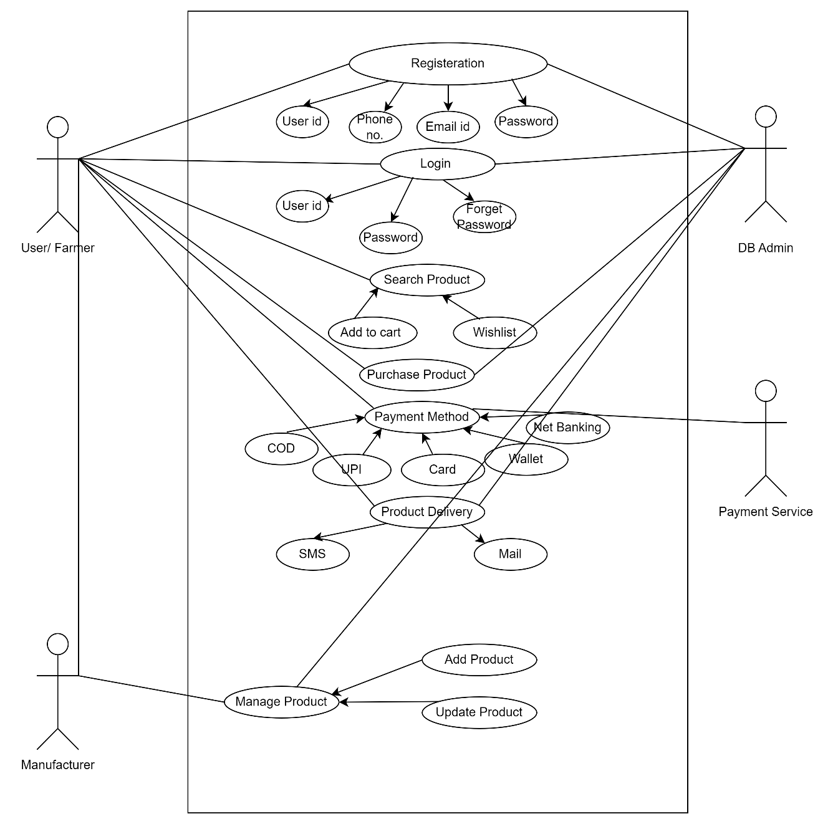

Question 11 – (minimum 5) Use Case Specs - 15 Marks

Prepare use case specs for all use cases.

|  |  |
| --- | --- |
| Use Case Specification | Details |
| Use Case ID | 1 |
| Use Case Name | User Buying Fertilizer from Online Agriculture Product Store |
| Brief Description | This Use Case explains how a Farmer uses the Online Agriculture Product Store to buy Fertilizers |
| Actors | 1. Farmers  2. Database/Admin |
| Pre-Conditions | • There should be an active Internet connection.  • Farmer should have Laptop/Mobile |
| Basic Flow | 1. User logs in.  2. User validation is performed.  3. Customer searches for the Agriculture Product.  4. Application displays multiple products.  5. User selects the product and adds it to cart.  6. User selects the Delivery location.  7. User selects the Payment mode.  8. Order placed; user receives an SMS for order confirmation.  9. Use case ends successfully. |
| Alternate Flow | Invalid User: If user validation fails, app displays: "User validation not completed successfully”. “Use case ends with failure condition”.  Product Out of Stock: If selected product is out of stock, app displays: Product out of stock. Select from similar products available.  Product Out of Stock for Selected Location: If product not available for selected location, app displays: Product out of stock for selected location. Please try after few days / Try selecting from similar products.  No Response from Payment Server: If server disconnects or no response during payment. Use Case Ends. |
| Post Condition | Successful Completion: User bought the fertilizer successfully.  Failure Condition: User couldn’t purchase due to technical/financial reasons |
| Supplemental Requirements | The price of all agriculture products should be as per government policy. The application shall keep a usage detail of all complete and incomplete transactions. |

|  |  |
| --- | --- |
| Use Case Specification | Details |
| Use Case ID | 2 |
| Use Case Name | User Registering in the Application |
| Brief Description | This Use Case describes how a user registers in an Online Agriculture Store. |
| Actors | 1. Farmers  2. Database/Admin |
| Pre-Conditions | There should be an active Internet connection.  Farmer should have a Laptop/Mobile.  User must have an active Email address.  User must have an active mobile number |
| Basic Flow | User initiates registration by entering personal details: Name, Address, Mobile number, and Email ID.  Application offers to send OTP to mobile for verification.  User requests OTP to be sent.  User enters received OTP.  Application confirms OTP verification.  User validation is performed.  Application confirms successful user creation.  Use case ends |
| Alternate Flow | Invalid OTP: If the incorrect OTP is entered, the app displays: Please enter the correct OTP.  Mobile Number Already Used: If the entered mobile number is already registered, the app displays: Mobile number is already in use. Please enter a different mobile number.  Email Address Already Used: If the entered email is already registered, the app displays: Email address is already in use. Please enter a different email address.  User ID Not Available: If the User ID is already taken, the app displays: User ID already used. Please enter another User ID.  Server Issue: If the server is down, the app displays: Server busy. Please try again later. |
| Post Condition | Successful Completion: User ID has been successfully created. Details are updated in the log accordingly. |
| Supplemental Requirements | The application shall maintain a log, including date and time, of all complete and incomplete transactions. |

|  |  |
| --- | --- |
| Use Case Specification | Details |
| Use Case ID | 3 |
| Use Case Name | User Making Payment for the Order Placed |
| Brief Description | This use case describes how the user goes through the payment process after product selection. |
| Actors | 1. Farmers  2. Database/Admin  3. Bank |
| Pre-Conditions | There should be an active Internet connection.  Farmer should have a Laptop/Mobile.  User should have an active Bank account.  User should have an active mobile number to receive the Bank OTP |
| Basic Flow | User initiates registration by entering personal details: Name, Address, Mobile number, and Email ID.  Application offers to send OTP to mobile for verification.  User requests OTP to be sent.  User enters received OTP.  Application confirms OTP verification.  User validation is performed.  Application confirms successful user creation.  Use case ends. |
| Alternate Flow | Incorrect Card Details: If the user enters incorrect card details, the user receives an SMS from the bank about payment failure. Display message: Payment not completed.  Incorrect OTP: If the user enters incorrect OTP, display message: Payment declined. Incorrect OTP entered.  Insufficient Funds: Payment is declined due to insufficient funds. Display message: Payment declined. User receives SMS from the bank confirming payment declined due to insufficient funds.  Server Busy: If payment doesn’t complete due to server issues, display message: Payment not completed. Server busy. Please try again. |
| Post Condition | Successful Completion: Payment is completed, and the order is placed successfully. |
| Supplemental Requirements | The application shall maintain a log, including date and time, of all complete and incomplete transactions. |

|  |  |
| --- | --- |
| Use Case Specification | Details |
| Use Case ID | 4 |
| Use Case Name | Seller Adding and Updating Products in the Portal |
| Brief Description | This use case describes how a Seller/Manufacturer adds or updates products on the portal. |
| Actors | 1. Seller / Manufacturer  2. Database/Admin |
| Pre-Conditions | There should be an active Internet connection.  Seller should have a Laptop/Mobile. |
| Basic Flow | Use case begins when the Seller wants to add or update any new agricultural product at the Agricultural Product store.  Seller selects the Sale option before login.  User validation is performed.  Application displays different product selling alternatives; the Seller selects the Agricultural product option.  Seller chooses product categories.  Seller enters product details: Product Name, Type, Price, Offers, and Approximate Delivery date.  Application confirms the new product details have been updated successfully.  Seller receives a receipt by SMS or email.  Use case ends. |
| Alternate Flow | Region-wise product price display: If the Seller tries to update the price according to the region, the application throws an error. Display message: Price not matching as per the region. Please enter the correct price.  Incorrect product categories: If the Seller selects the wrong product category, display message: Incorrect Product category. Please select the correct category. |
| Post Condition | Successful Completion: The product has been successfully updated |
| Supplemental Requirements | The application shall maintain a log, including date and time, of all complete and incomplete transactions with the admin. |

|  |  |
| --- | --- |
| Use Case Specification | Details |
| Use Case ID | 5 |
| Use Case Name | User tracking the delivery |
| Brief Description | This use case describes how a user tracks the delivery of the product |
| Actors | 1. Farmer  2. Database/Admin |
| Pre-Conditions | There should be an active Internet connection.  Seller should have a Laptop/Mobile.  User has placed the confirmed order |
| Basic Flow | Use case begins when the user wants to track agricultural product at the agricultural product store.  User validation is performed.  Application displays multiple confirmed orders that have already been placed.  User selects the order/product for tracking.  Application confirms that the product identity.  User receives the product tracking details: status of product shipment and delivery dates.  Use case ends. |
| Alternate Flow | If the user attempts to track the recently placed order the application displays the message: Product shipment is in progress, tracking details will be available post ready for shipment. |
| Post Condition | The product is arriving as per delivery schedule or expecting a delay. Talk to customer care |
| Supplemental Requirements | The application shall maintain a log, including date and time, of all deliverables. |

Question 12 – (minimum 5) Activity Diagrams - 15 Marks

Activity diagrams

Answer:

1. Login Page

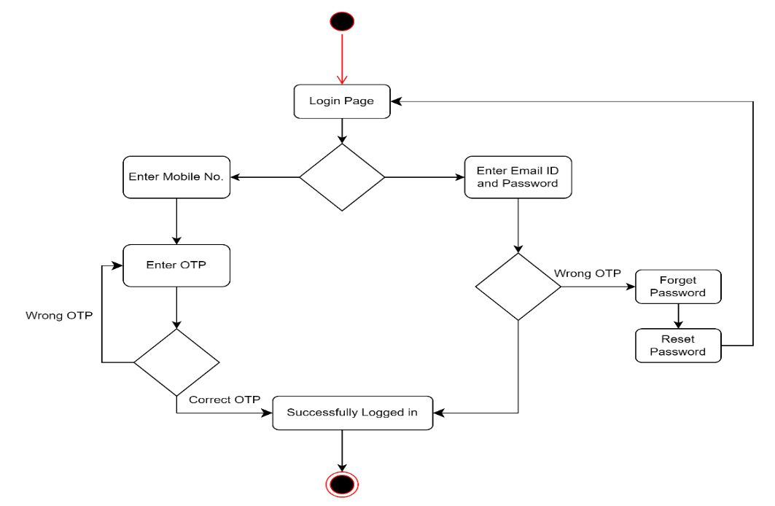

1. Sign Up Page

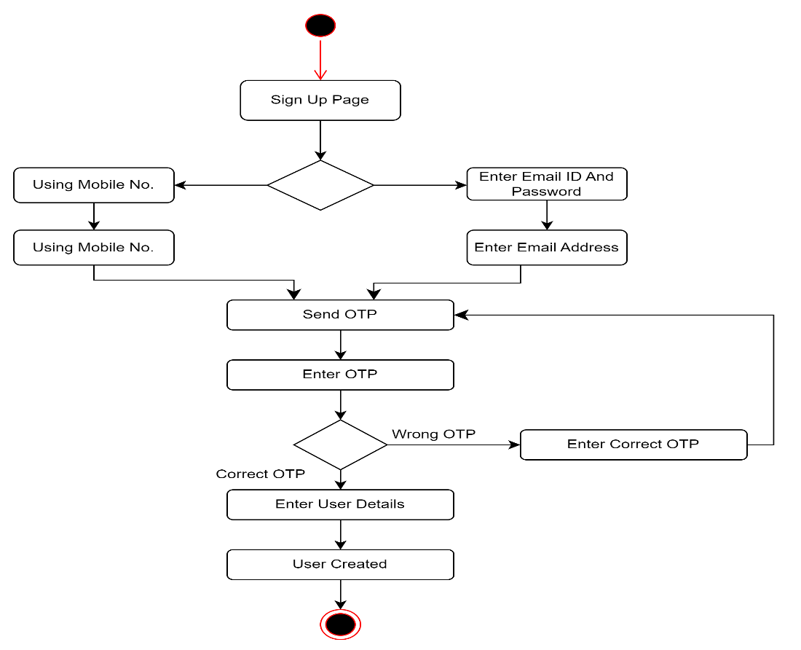

1. Buying Fertilizer

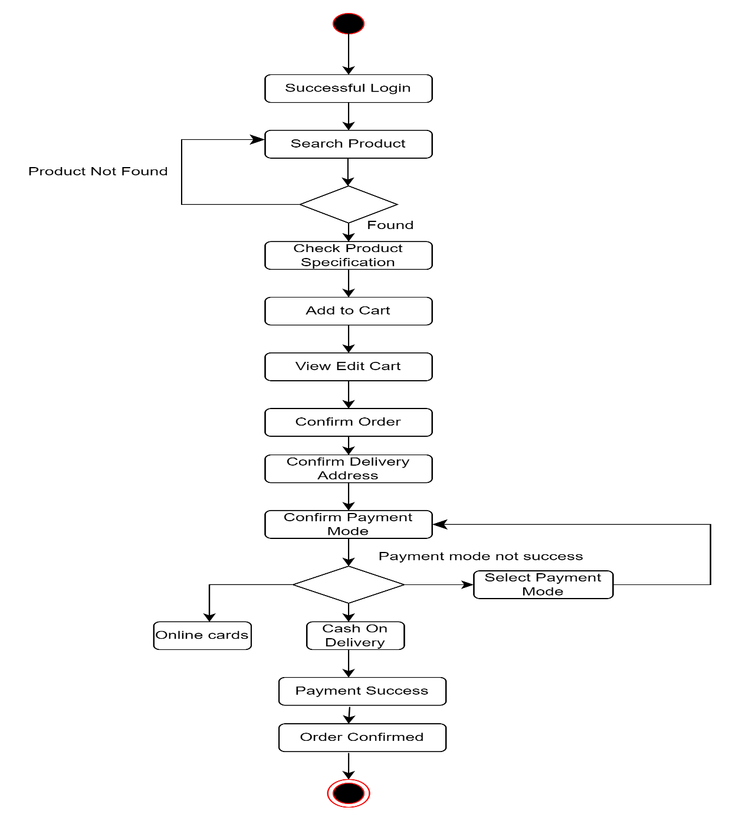

1. Order Cancellation

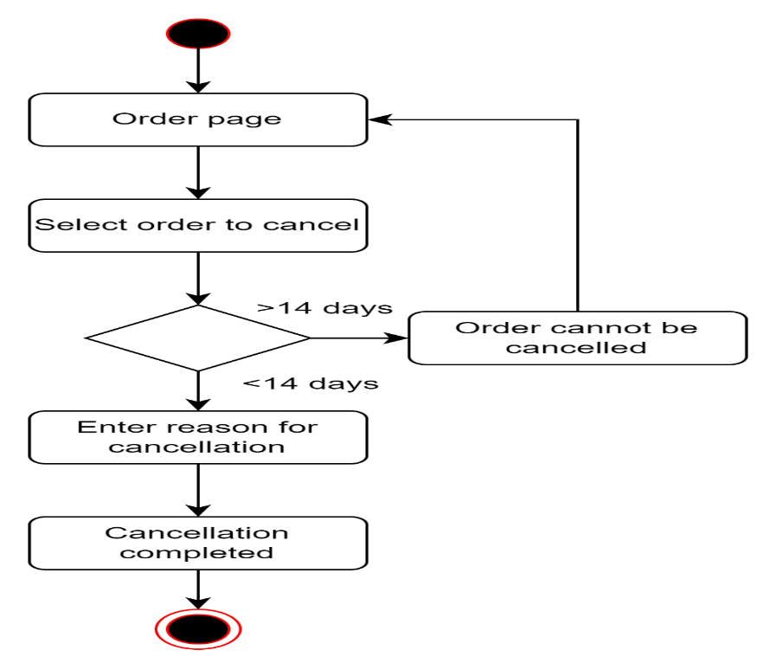

1. Adding and Updating Product

