**Question 1 – Audits**

**Quarter 1:**

|  |  |
| --- | --- |
| **Stage** | **Quarter 1 – Audit Report (Requirement gathering phase)** |
| **Completed** | 10 weeks (Week 1 to Week 10) |
| **Checklist** | BRD Template |
| Elicitation results report |
| Duplicate requirement report |
| Grouping of functionalities/features - Client signoff |
| Email communication – To, cc, bcc |

**Quarter 2:**

|  |  |
| --- | --- |
| **Stage** | **Quarter 2 – Audit Report (Requirement analysis phase)** |
| **Completed** | 7 weeks (Week 16 to Week 23) |
| **Checklist** | UML Diagrams |
| Business to functional requirement mapping |
| Client signoff – Document |
| RTM document version control |
| Email communication – To, cc, bcc |

**Quarter 3:**

|  |  |
| --- | --- |
| **Stage** | **Quarter 3 – Audit Report (Design phase)** |
| **Completed** | 7 weeks (Week 30 to Week 37) |
| **Checklist** | Utilization of tools |
| Documentation evidence on client communication |
| Stakeholder MOM |
| JAD Session Report |
| Email communication – To, cc, bcc |

**Quarter 4:**

|  |  |
| --- | --- |
| **Stage** | **Quarter 4- Audit Report (Development Phase)** |
| **Completed** | 20 Weeks (Week 43 to Week 63) |
| **Checklist** | JAD Session report |
| End User Manual Preparation Report |
| BA and Developer MoM |
| Email Communication – To, cc, bcc |

**Quarter 5:**

|  |  |
| --- | --- |
| **Stage** | **Quarter 5 – Audit Report (Testing phase)** |
| **Completed** | 20 weeks (Week 58 to Week 78) |
| **Checklist** | Test case summary |
| Training report to end users |
| Lesson learnt document |
| Email communication – To, cc, bcc |
| End user manual preparation document |

**Question 2 – BA Approach Strategy**

1. **What Elicitation Techniques to apply?**

**Answer:** As permy understanding, we can use the below elicitation techniques:

* **Workshops –** It is a structured meeting where stakeholders and subject matter experts work together to define and establish requirements for a project. We can gather farmers and manufacturers to bridge gaps in understanding the flow of information.
* **Surveys/Questionnaires –** It is a method to gather all the information from multiple stakeholders in a system development process. We can use this to collect data from a group of farmers and manufacturers about their requirements and preferences.
* **Brainstorming –** It is a technique used to generate ideas, solutions, and requirements for a project. In this process, all the questions and challenges are introduced and participants are asked to propose as many ideas and solutions as possible.

1. **How to do Stakeholder Analysis RACI/ILS?**

**Answer –** The RACI matrix can help clarify roles and responsibilities and ensure that stakeholder needs are addressed in the project – Responsible, Accountable, Consulted and Informed.

* Responsible: The individuals performing the task.
* Accountable: The individual ultimately answerable for the task.
* Consulted: Stakeholders whose opinions are sought.
* Informed: Stakeholders kept up to date on progress.

1. **What Documents to Write?**

**Answer –** We can write the below documents:

* **Initiation Document -** These documents are created during the initial phase of the project to define objectives, scope, and stakeholders.
* **Business Requirement Document -** A high-level document that outlines the business needs and goals of a project. It's created at the beginning of a project and serves as the foundation for all other deliverables.
* **Functional Requirement Document -** A detailed document that outlines how to fulfil the business needs of a project. It's created after the BRD and breaks down the business requirements into technical specifications.
* **Non-Functional Requirements –** It is to identify the requirements related to performance, security, and usability.
* **Use Case Document -** A document that describes how a user interacts with a system or product.
* **Test Case Documentation -** A document that includes test strategies, test cases, bugs, and execution reports. It helps to ensure that all requirements are met and to minimize the time and cost of software development.
* **Risk Management Plan –** This document identifies the potential risk of the project.

1. **What process to follow to Sign off on the Documents?**

**Answer –**A project sign-off is a formal process that acknowledges the completion of a project and the delivery of its deliverables. Here are the steps to follow the sign-off process:

* Preparing sign-off document.
* Organizing a sign-off meeting.
* Presenting sign-off document.
* Discussing feedback.
* Asking for sign-off via email
* Documenting approvals.
* Communicating sign-off to all stakeholders.

1. **How to take Approvals from the Client?**

**Answer –** Establish a formal meeting with the client to keep them informed and get continuous feedback.

Once the feedback is received, we can send a formal email to ask for an approval to sign-off the project. After the approval is received, we can forward it to all the stakeholders and document it.

1. **What Communication Channels to establish and implement?**

**Answer –** We can establish the communication channels through the below modes:

* Face to face meeting
* Email communication.
* Telephonic communication.
* Online messaging and calling platforms.

1. **How to Handle Change Requests?**

**Answer –** To handle the change request we can follow the below steps:

* Receiving the change request in “change request form”
* Acknowledge the change request
* Analysing the change request
* Approve or reject the change request
* Communicating the change request
* Implementing the change request
* Document the status of change

1. **How to update the progress of the project to the Stakeholders?**

**Answer –** Wecan organize weekly or daily meeting and can keep theprogress document ready to present it in this meeting. Apart from this, we can also organize a monthly review meeting to track the progress of the project and discuss the upcoming steps/strategies.

1. **How to take signoff on the UAT- Client Project Acceptance Form?**

**Answer -** The User Acceptance Testing (UAT) and Client Project Acceptance Form are critical for ensuring that the delivered project meets the client’s expectations. Here are the steps to take sign-off on the UAT:

* Preparing UAT form.
* Conduct a UAT process.
* Recording all the feedbacks.
* Fixing the issues.
* Preparing acceptance form.
* Review the final form with the client.
* Obtain the formal approval.
* Document the signed form.
* Communicate sign-off to all the stakeholders.

**Question 3 – 3-Tier Architecture**

Three-tier architecture is a software application architecture that organizes applications into three logical tiers - Presentation Layer, Application Layer, and Data Layer.

This separation improves scalability, maintainability, and flexibility.

1. **Client/Presentation tier** - This is the user interface that communicates with the other two tiers.
2. **Business Logic Layer-** The middle tier that handles the application's core processing, business rules, and calculations. This layer processes user requests, applies business logic, and communicates with the data layer to retrieve or store data.
3. **Database Tier –** It manages the storage, retrieval, and manipulation of the application's data. It handles database operations such as creating, reading, updating, and deleting records.



**3-Tier Architecture**

**Client Tier**

**Business Logic Layer**

**Database Tier**

**Question 4 – BA Approach Strategy for Framing Questions**

Business Analyst should keep What points in his/her mind before he frames a Question to ask to the Stakeholder (5W1H–SMART–RACI–3TierArchitecture– Use Cases, Use case Specs, Activity Diagrams, Models, Page designs)

1. **5W1H Framework –** This framework helps analyze the project by addressing the below questions.

|  |  |
| --- | --- |
| **Question** | **Answer** |
| Who? | Farmers, manufacturers, delivery teams, SOONY Company, and APT IT Solutions are stakeholders. |
| What? | An online platform for farmers to purchase agricultural products like fertilizers, seeds, and pesticides. |
| When? | Over 18 months with a budget of 2 Crores INR. |
| Where? | Remote areas where farmers face difficulties procuring agricultural products. |
| Why? | To simplify access to essential products, reducing logistical challenges for farmers. |
| How? | Through a web/mobile application that connects farmers and manufacturers directly. |

1. **SMART Goals -** Specific, Measurable, Achievable, Relevant, and Time-bound goals for the project.

|  |  |
| --- | --- |
| **Criteria** | **Details** |
| Specific | Develop a platform for farmers to browse, purchase, and receive agricultural products. |
| Measurable | Ensure at least 90% of farmers can place orders successfully during UAT. |
| Achievable | Use existing technology stacks and skilled personnel within the budget and timeframe. |
| Relevant | Aligns with CSR goals of SOONY Company and addresses farmers' challenges. |
| Time-bound | Deliver the solution within 18 months. |

1. **RACI Matrix –**

* Responsible: The individuals performing the task.
* Accountable: The individual ultimately answerable for the task.
* Consulted: Stakeholders whose opinions are sought.
* Informed: Stakeholders kept up to date on progress.

1. **3 Tier Architecture:** Three-tier architecture is a software application architecture that organizes applications into three logical tiers - Presentation Layer, Application Layer, and Data Layer
2. **Client/Presentation Layer –**

* How would be the application first page?
* How the filter option would work for different products listed in the application?
* How would the sensitive information will be protected?
* Will the store be available on both web and mobile platforms for farmers?

1. **Business Logic Layer –**

* How would the system work after farmers places any order?
* How would the products will be listed with “In stock” and “out of stock”?
* How would the system confirm once the order is placed?

1. **Database Layer –**

* What type of details does the data store?
* How does the database store the user information?
* How will the database manage the availability of the products?
* How would the database manage the payment options?

1. **Use Case –** It refers to a description of how a farmer ad manufacturer interacts with the system to achieve a specific goal.
2. **Use Case specs -** It provide a detailed description of the functional behaviour of a system from a user’s perspective.
3. **Activity Diagram –** Itis a type of UML (Unified Modelling Language) diagram that visually represents the workflow of a system or process. For Mr. Henry’s Online Agriculture Products Store case study, an activity diagram would illustrate how farmers interact with the system to browse, select, and purchase agricultural products, and how the system processes these actions.
4. **Page Design –** After therequirements gathering and requirement analysis process, we can start the page design along with the software designing process.

**Question 5 – Elicitation Techniques**

**Here are the elicitation techniques - BDRFOWJIPQU:**

1. **B - Brainstorming**: Brainstorming is a collaborative technique where a group of stakeholders (including the project team, users, and clients) come together to generate a wide range of ideas, solutions, or requirements in a short amount of time. The goal is to come up with as many ideas as possible without criticism.
2. **D - Document Analysis**: Document analysis involves reviewing existing documents, such as business process maps, policies, standards, and reports, to extract relevant requirements and information. This technique is useful for understanding current systems, regulations, or workflows that impact the project.
3. **R - Reverse Engineering**: Reverse engineering is the process of analyzing and deconstructing a system, product, or component to understand its structure, functionality, and operation. The goal of reverse engineering is to extract knowledge or design information from the existing product without prior access to the original design documents or source code.
4. **F - Focus Groups**: Focus groups are small groups of stakeholders, typically end users, gathered together to discuss their needs, expectations, and pain points regarding the system or process in question.
5. **O - Observations (Job Shadowing)**: Observation involves watching users perform their work in their natural environment.
6. **W - Workshops (Facilitated Sessions)**: Workshops involve structured and collaborative sessions where stakeholders, including users and domain experts, work together to define business processes, identify problems, and generate solutions. They encourage interaction and direct involvement in the requirements gathering process.
7. **J - Joint Application Development (JAD)**: JAD is a highly structured, facilitated session where business users, IT staff, and other stakeholders come together to discuss and define system requirements.
8. **I - Interviews**: Interviews are one-on-one discussions with stakeholders to gather detailed insights about their needs, problems, and expectations. Interviews can be structured (with predefined questions) or unstructured (more open-ended to allow for in-depth exploration).
9. **P - Prototyping**: Prototyping involves building an early, simplified version of a system (or part of a system) that stakeholders can interact with. Feedback from stakeholders is used to refine the prototype, and this iterative process helps clarify and define requirements.
10. **Q - Questionnaires/Surveys**: Questionnaires or surveys are written tools used to collect information from a large group of stakeholders. These can be used to gather quantitative data or opinions about needs, priorities, and current challenges in a more scalable way.
11. **U - Use Cases**: Use cases describe how users will interact with a system to achieve a specific goal. Creating use cases with stakeholders helps to define functional requirements in a structured way by detailing system actions, user interactions, and expected outcomes.

**Question 6 – This project Elicitation Techniques**

Which Elicitation Techniques can be used in this Project and Justify your selection of Elicitation Techniques?

**Answer -** Together, these techniques can provide a comprehensive and adaptable approach to gathering requirements for complex systems or projects. Each has its strengths depending on the stage of the project and the nature of the requirements.

* **Prototyping -** Prototyping involves creating a working model (prototype) of the system early in the project. This prototype is continuously refined based on user feedback, allowing stakeholders to interact with the system and clarify their needs.
* **Use case Specs -** Use cases describe how users will interact with a system to achieve a specific goal. Creating use cases with stakeholders helps to define functional requirements in a structured way by detailing system actions, user interactions, and expected outcomes.
* **Document Analysis -** Document analysis involves reviewing existing documents, such as business process maps, policies, standards, and reports, to extract relevant requirements and information. This technique is useful for understanding current systems, regulations, or workflows that impact the project.
* **Brainstorming -** Brainstorming is a collaborative technique where a group of stakeholders (including the project team, users, and clients) come together to generate a wide range of ideas, solutions, or requirements in a short amount of time. The goal is to come up with as many ideas as possible without criticism.

**Question 7 – 10 Business Requirements**

Identify Business Requirements (which includes Stakeholder Requirements)

BR001 – Farmers should be able to search for available products in fertilizers, seeds, pesticides

BR002 – Manufacturers should be able to upload and display their products in the application

|  |  |  |
| --- | --- | --- |
| **Req ID** | **Requirement Name** | **Description** |
| BR001 | Accessibility | If the application would be accessible via both desktop and mobile. |
| BR002 | Ease of use | The application should be easy to use for all the farmers and manufacturers. |
| BR003 | Language | The application should have multiple language as per the user’s convenience. |
| BR004 | Search and Filter | The users should be able to search all the available options and add a filter to it. |
| BR005 | Data logging | The manufacturers should be able to upload all the details with respective bifurcation |
| BR006 | System Update | The application should update the details about the availability of the products real time. |
| BR007 | Privacy | The application should be able to protect all the personal data uploaded by the users. |
| BR008 | Tracking | The application should support the method to track the order and provide the delivery date/day update. |
| BR009 | Support and Feedback | There should be a system to provide pre-sales and post-sales support to users for the effectiveness of the application. |
| BR010 | Notification and Alert | The application should be able to send the notification and important updates such as system errors, approval requests, or order status change. |

**Question 8 – Assumptions**

**List your assumptions:**

1. The stakeholders would have all the idea around the business requirements before the first stage of the project.
2. The stakeholders would attend all the meetings on time as per the decided schedule.
3. All the users would have the basic knowledge to use the application.
4. All the necessary data would be available for the technical team to use and prepare the designing and development stage.
5. The common resources like - mobile devices and internet connection would be available for the users.
6. The application would be developed within the given timeframe and decided budget.
7. There would be no un-ethical work involved while working on this project.
8. All the third-party stakeholders would co-ordinate properly at each stage of the project.
9. The logistics and delivery will be done seamlessly in all the locations of the users.
10. The overall users of the application would increase with time.

**Question 9 – This project Requirements Priority**

**Give Priority 1 to 10 numbers (1 being low priority– 10 being high priority) to these Requirements after discussions with the stakeholders**

Answer – With the help of the MoSCoW [(Must-Have, Should-Have, Could-Have and Won’t-Have (this time)] technique we can prioritize the list of top 10 business requirements.

|  |  |  |  |
| --- | --- | --- | --- |
| **Req ID** | **Req Name** | **Req Description** | **Priority** |
| BR001 | Accessibility | Application should be accessible via both desktop and mobile. | 1 |
| BR002 | Ease of use | The application must be easy to use for all the farmers and manufacturers. | 2 |
| BR003 | Language | The application should have multiple language as per the user’s convenience. | 3 |
| BR004 | Search and Filter | The users should be able to search all the available options and add a filter to it. | 4 |
| BR005 | Data logging | The manufacturers should be able to upload all the details with respective bifurcation | 7 |
| BR006 | System Update | The application should update the details about the availability of the products real time. | 6 |
| BR007 | Privacy | The application should be able to protect all the personal data uploaded by the users. | 5 |
| BR008 | Tracking | The application should support the method to track the order and provide the delivery date/day update. | 8 |
| BR009 | Support and Feedback | There should be a system to provide pre-sales and post-sales support to users for the effectiveness of the application. | 10 |
| BR010 | Notification and Alert | The application should be able to send the notification and important updates such as system errors, approval requests, or order status change. | 9 |

**Question 10 – Use CaseDiagram**

The use case diagram is a type of UML diagram which is used to represent the functional requirements of a system and the interactions between the system and its external actors. For Mr. Henry’s project, we can consider Manufacturers, Farmers and Delivery partner as actors.

In the below use case diagrams the main use cases can be for registration by manufacturers/farmers, login by manufacturer, farmers/users, search option subsections, payment methods available and order confirmation status via email/text message.

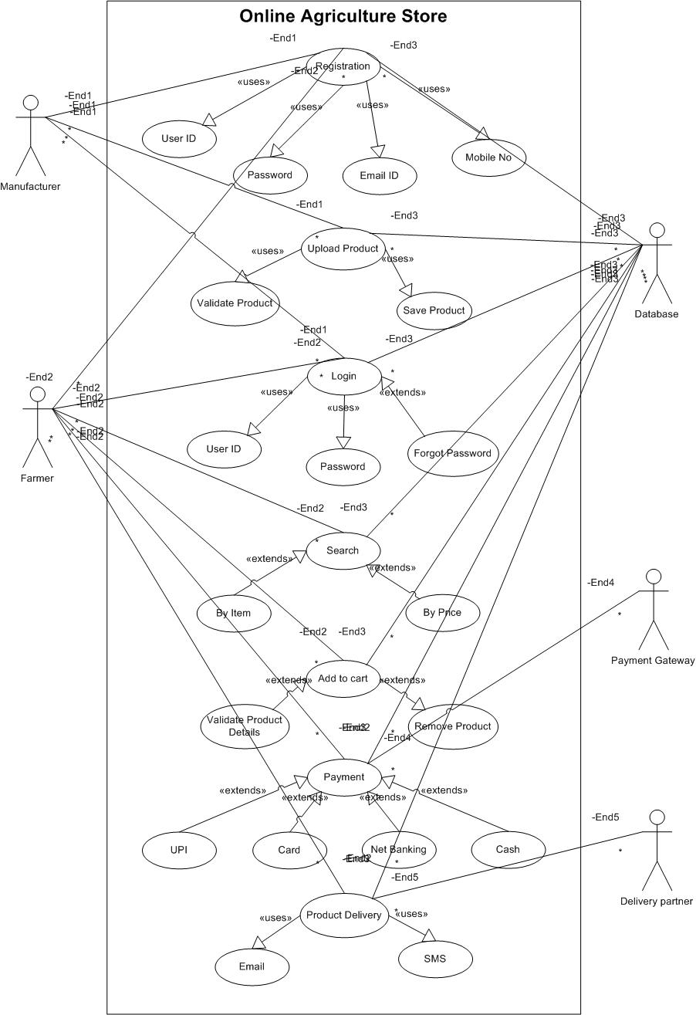

**Question 11– (minimum 5) Use Case Specs**

1. **Use Case Document for “Login” to the online agriculture store.**

|  |  |  |  |
| --- | --- | --- | --- |
| Use Case ID | UC001 | | |
| Use Case Name | User Login | | |
| Created By | Mr. Daniel | Last Updated By | April 1st, 2025 |
| Data Created | January 31st, 2025 | Last Revision Date | April 15th, 2025 |
| Actor | Farmer, Manufacturer, Admin | | |
| Description | This use case describes how the user can login. | | |
| Pre-condition | 1. The user must have the internet connectivity. 2. The users must have a registered account to login to the application. | | |
| Post condition | 1. The user successfully logged in and re-directed to the dashboard of the application. | | |
| Normal Flow | 1. The user navigates to the login page of the online agriculture store. 2. The login page asks for the user name/phone number/email address and password. 3. The user enters the credentials and clicks on the login button. 4. The system verifies the credentials and redirects the user to the dashboard. | | |
| Alternative Flow | 1. In case the user fails to login successfully, the system will show an error message for “invalid credentials”. 2. The system will then provide an option for “Forgot user ID/Password”. 3. The user is asked to re-enter their credentials. | | |
| Exceptions | 1. If the user forgets their password. 2. If the internet connectivity is not working. 3. If the application is facing some technical issue. | | |
| Frequency of Use | High | | |
| Assumptions | 1. It is assumed that the user has registered on the application. 2. It is assumed that the user knows the credentials correctly. | | |

1. **Use Case Document for “Searching Products” on the online agriculture store.**

|  |  |  |  |
| --- | --- | --- | --- |
| Use Case ID | UC002 | | |
| Use Case Name | Search Products | | |
| Created By | Mr. Daniel | Last Updated By | April 1st, 2025 |
| Data Created | January 31st, 2025 | Last Revision Date | April 15th, 2025 |
| Actor | Farmer | | |
| Description | This use case describes how the farmers would search for products. | | |
| Pre-condition | 1. The user must be logged in to the application. 2. The application must have the data uploaded by the manufacturers. | | |
| Post condition | 1. The farmer was able to search for the desired product. | | |
| Normal Flow | 1. The user clicked on the search bar on the dashboard of the application. 2. The user enters a keyword like “seed” and click on the search button. 3. The application would show the complete list of similar/related products. 4. User can click on any product to see complete details and specifications of the product including product name, quantity in option, price, other specifications and manufacturer/seller details. 5. Along with the list of products, the application would show a filter option to sort the list as per brand, price, variety, quantity etc. | | |
| Alternative Flow | 1. In case no product match with the keyword searched, the application would redirect to a page that will show “no product found”. 2. The user can try and search with different keyword. | | |
| Exceptions | 1. If the internet connectivity is not working. 2. If the application is facing some technical issue. | | |
| Frequency of Use | High | | |
| Assumptions | 1. The product database matches with the keyword searched by the user. 2. The user has knowledge to use the search option and applying filter to the searched list of products. | | |

1. **Use Case Document for “Adding products in the cart” on the online agriculture store.**

|  |  |  |  |
| --- | --- | --- | --- |
| Use Case ID | UC003 | | |
| Use Case Name | Add product in the cart | | |
| Created By | Mr. Daniel | Last Updated By | April 1st, 2025 |
| Data Created | January 31st, 2025 | Last Revision Date | April 15th, 2025 |
| Actor | Farmer | | |
| Description | This use case describes how the farmers would add the product in the cart. | | |
| Pre-condition | 1. The user must be logged in to the application. 2. The application must have the details of the products in the system’s inventory. 3. The user has already reached to the desired product through the search option. | | |
| Post condition | 1. The farmer has successfully added the product in the cart. | | |
| Normal Flow | 1. The user searches for the desired product on the search option. 2. The application shows a list of all the similar/related products. 3. The user selects the product they want to purchase. 4. The system displays complete details and specifications of the product including product name, quantity in option, price, other specifications and manufacturer/seller details. 5. The user clicks on the “add to cart” button. 6. The product gets added to the cart with the details – product name, price and quantity. 7. The system displays the message that product is added to the cart. | | |
| Alternative Flow | 1. In case the user wants to change the product after adding a product to the cart. 2. The user wants to change the quantity selected for the product. | | |
| Exceptions | 1. If the product is out of stock. 2. If the application is facing some technical issue. | | |
| Frequency of Use | High | | |
| Assumptions | 1. The user has knowledge to add the product to the cart. 2. The product details are up to date and the application is showing the “in stock” and “out of stock” products properly. | | |

1. **Use Case Document for “Making Payment” on the online agriculture store.**

|  |  |  |  |
| --- | --- | --- | --- |
| Use Case ID | UC004 | | |
| Use Case Name | Making payment | | |
| Created By | Mr. Daniel | Last Updated By | April 1st, 2025 |
| Data Created | January 31st, 2025 | Last Revision Date | April 15th, 2025 |
| Actor | Farmer | | |
| Description | This use case describes how the farmers would make payment for the products available in the cart. | | |
| Pre-condition | 1. The user must be logged in to the application. 2. The user must have added some products to the cart. 3. The application should have secure option to make the payment. | | |
| Post condition | 1. The farmer has successfully made the payment for the products. | | |
| Normal Flow | 1. The user searched and added the products to the cart to checkout. 2. The system displays the total amount to be paid for all the products added to the cart. 3. The user clicks on the option “proceed to pay”. 4. The application shows different methods to make the payment as :  * UPI * Credit Card * Debit Card * Wallet * Cash on Delivery * Net Banking  1. The user selects an option and click on the pay now button. 2. The system processes the payment through the payment gateway. 3. The payment gateway confirms the transaction and sends a response to the system. 4. The system displays a confirmation message: "Payment Successful! Your order has been placed." 5. The user receives an order confirmation with a receipt via email/SMS. | | |
| Alternative Flow | 1. In case the user wants to change the payment method, the application would show an option to go back to the previous page. 2. In case the user wants to add any discount available on the product. | | |
| Exceptions | 1. If the payment fails after clicking on the pay now through the desired gateway of the payment, the application would ask to “retry to make the payment after few minutes”. 2. In case the payment is interrupted due to any bank or technical issue. 3. In case the sufficient balance is not available in the chosen payment method. | | |
| Frequency of Use | High | | |
| Assumptions | 1. The user has knowledge to use different payment methods. 2. The user would have sufficient amount in their bank account to make the required payment. | | |

1. **Use Case Document for “Product Delivery” from the order received by manufacturers through online agriculture store.**

|  |  |  |  |
| --- | --- | --- | --- |
| Use Case ID | UC005 | | |
| Use Case Name | Product delivery | | |
| Created By | Mr. Daniel | Last Updated By | November 1st, 2025 |
| Data Created | January 31st, 2025 | Last Revision Date | November 15th, 2025 |
| Actor | Farmers, manufacturers and delivery partner. | | |
| Description | This use case describes the process of delivering purchased products to the user’s designated address after an order has been placed successfully in the system. | | |
| Pre-condition | 1. The user has successfully placed an order and completed the payment process. 2. A valid delivery address is provided during the checkout process. 3. Products are available in stock and ready for dispatch. | | |
| Post condition | 1. Products are delivered successfully to the customer’s specified address, and the order status is updated to "Delivered." | | |
| Normal Flow | 1. After the order is placed and payment is confirmed, the system generates a unique order ID. 2. The system assigns the order to the logistics/delivery partner. 3. The logistics team receives the order details, including the delivery address and product information. 4. The warehouse staff prepares the products for shipment, including secure packaging and labeling. 5. The delivery partner collects the package and updates the system with the shipment status. 6. The system sends a notification to the user with the shipment tracking details. 7. The delivery partner delivers the product to the user’s specified address. 8. Upon successful delivery, the system updates the order status to "Delivered" and notifies the user. | | |
| Alternative Flow | 1. In case the user wants to change the address of the product delivery. 2. In case the delivery is delayed due to some reasons. | | |
| Exceptions | 1. If the delivery fails due to incorrect address or user unavailability, the system notifies the user and provides options for rescheduling or cancellation. 2. In case the user receives any damaged/missing products after the delivery of the product, the user reports the issue to customer support and the system initiates a replacement or refund process as per the return policy. | | |
| Frequency of Use | High | | |
| Assumptions | 1. The customer provides an accurate delivery address and contact details. 2. The delivery partner provides timely delivery services. 3. The products are dispatched within the given timeline at the time of order placing. | | |

**Question 12 – (minimum 5) Activity Diagrams**

1. **Activity Diagram: User Login**

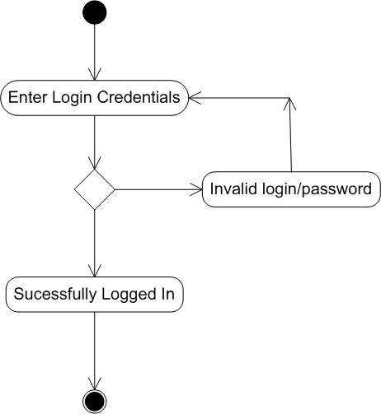

1. **Activity Diagram – Search Product**

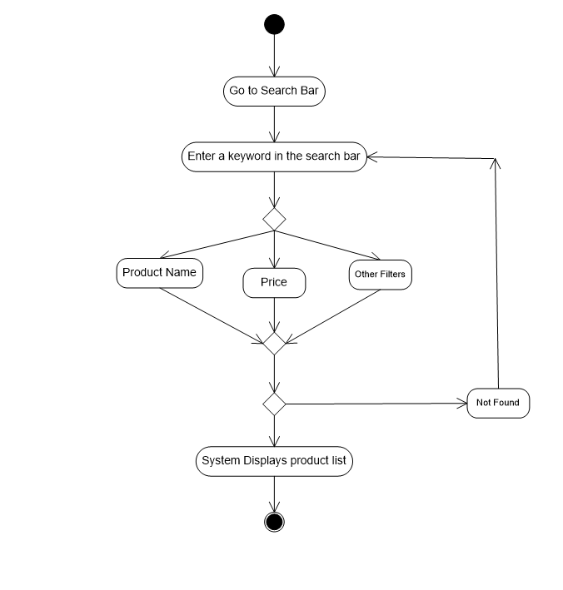

1. **Activity Diagram: Add product to cart**

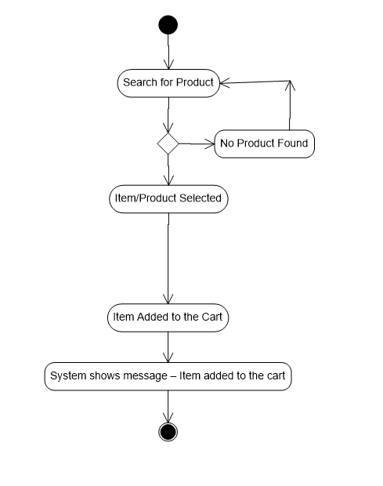

1. **Activity Diagram: Make payment for the product added in the cart**

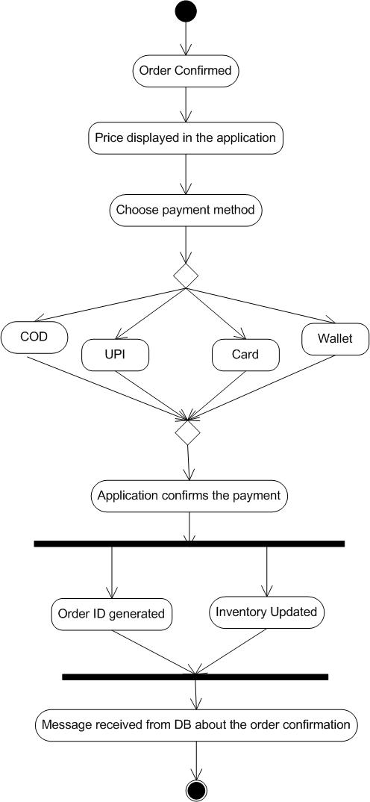

1. **Activity Diagram – Delivery partner delivers the order**

