**Question 1- Identify minimum 20 functional requirement.**

**Ans-**

|  |  |  |  |
| --- | --- | --- | --- |
| REQ ID | REQ NAME | REQ DESCRIPTION | PRIORITY |
| FR0001 | Farmer Registration | armers should be able to register with the application. | 8 |
| FR0002 | Farmer Search for Products | Farmer should be able to search for available products in fertilizers, seeds, pesticides | 9 |
| FR0003 | Printer print the package slip | When an order is fulfilled, the local printer shall print a packing slip | 8 |
| FR0004 | Adding the product to the cart | Farmer should be able to add to cart once they select the product | 6 |
| FR0005 | Product tracking | Farmers should able must to track the ordered item | 7 |
| FR0006 | New user email verification | For a new customer he  has should do the email verification for the doing login | 6 |
| FR0007 | Payment option for the customer | The farmers should  have the payment options either UPI cod or through cards | 5 |
| FR0008 | After Cancellation refund option | After cancellation is  initiated the refund to  be followed. | 6 |
| FR0009 | Manufacture tracking facility | When item is in the payment the OTP is send to registered mobile number. | 7 |
| FR0010 | OTP initiation for payment | When item is in the payment the OTP is send to registered mobile number. | 8 |
| FR0011 | Address update option | the farmer should be able to update his address every time of checkouts. | 9 |
| FR0012 | Return Policy | Availability of product return policy option /Cancelation of product in the application | 5 |
| NFR0013 | Page Loading Time | Each Page should load  within 2 seconds time | 6 |
| NFR0014 | Payment receipt | The farmer should get the receipt with in a hour of order. | 7 |
| NFR0015 | Page timeout | After 15minute of activity the page will  logout | 7 |
| NFR0016 | Fascinating Home page | The home page should not contain much information and should look good. | 7 |
| NFR0017 | Quick Payment option | Payment options should be quick and  fast | 8 |
| FR0018 | Review option | After every order customers should be able to give review. | 8 |
| NFR0019 | Security of data | Information of farmers could should not be shared | 8 |
| NFR0020 | WCAG 2.1. | The system must meet Web Content Accessibility Guidelines WCAG 2.1 | 9 |

**Question 2–Minimum 5 pages designs**

**Ans-**

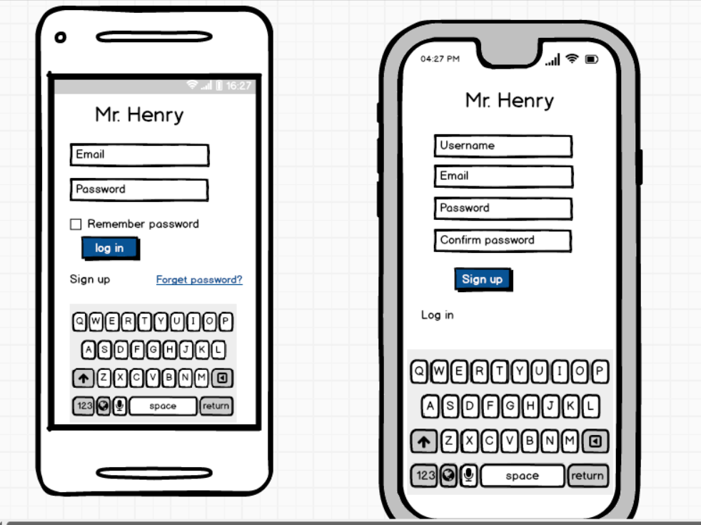

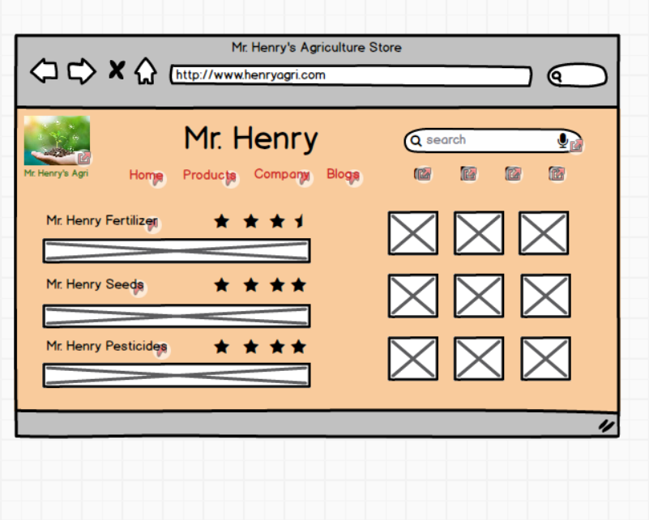

**/**

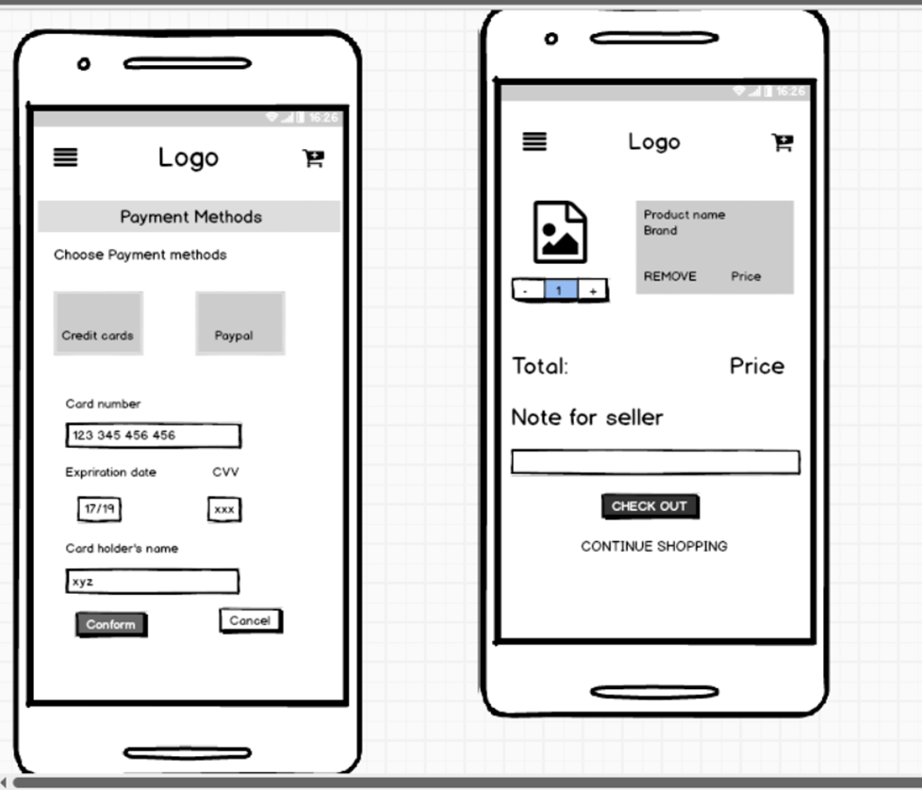

**Question 3 – Tools (Visio, Balsamiq)**

**Microsoft Visio-**

**Microsoft Visio** is a diagramming and [vector graphics](https://en.wikipedia.org/wiki/Vector_graphics) application and is part of the [Microsoft](https://en.wikipedia.org/wiki/Microsoft_Office)

[Office](https://en.wikipedia.org/wiki/Microsoft_Office) family. It is used to create diagram types such as [Flowcharts,](https://en.wikipedia.org/wiki/Flowcharts) [Org Charts,](https://en.wikipedia.org/wiki/Organizational_chart) [Floor Plans,](https://en.wikipedia.org/wiki/Floor_Plans) [Network Diagrams,](https://en.wikipedia.org/wiki/Network_diagram) [UML Diagrams,](https://en.wikipedia.org/wiki/UML) [Mind maps](https://en.wikipedia.org/wiki/Mind_maps) and more. It is also commonly used for scenarios such as [Process Mapping](https://en.wikipedia.org/wiki/Process_Mapping) and Visual Collaboration. The latest version of Visio also has [data visualization](https://en.wikipedia.org/wiki/Data_visualization) that allows users to create diagrams from Excel data and also embed Visio diagrams in [Power BI](https://en.wikipedia.org/wiki/Power_BI) dashboards.

**Microsoft Office Visio** is a tool that eases the process of making complex diagrams. Especially for business purposes. It can help in the making of presentations, floor plans, org charts, etc. Listed below are some uses of Visio:

Followings things can draw BA by using MS Office Visio

1. **Flowchart**: A flowchart is helps to show the steps in sequential order. These are steps that

need to be taken to complete a certain process. It is effective in conveying information. Thus, it can

be used in various other fields too.

1. **Organization Chart:** An org chart displays the roles and reporting relationships in a business organization. It can be used in also any other organization. It depicts the names and positions of

employees in a company. In short, we can say it shows the structure of an organization.

1. **Floor Plan**: A floor plan is the structure of a room or a floor. Architects use floor plans to

place doors, windows, and other objects. Visio also offers a floor plan template.

1. **Business Process Modelling Notation**: BPMN is a flowchart method of displaying all the

processes in a business that is to be taken. In other words, it is helps in give a clear understanding of

the processes in a particular business through visual representation.

**Balsamiq**-

Balsamiq Mockups is an effective tool for presenting the software requirements in the form of wireframes. This helps the software development team to visualize how the software project will look like in the very early stages of development. This is a small tutorial where we will cover all the basic steps needed to start with Balsamiq Mockups.

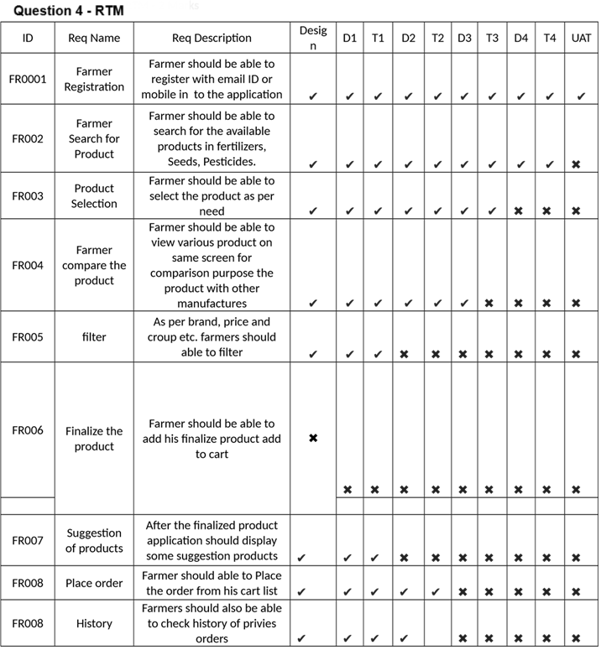

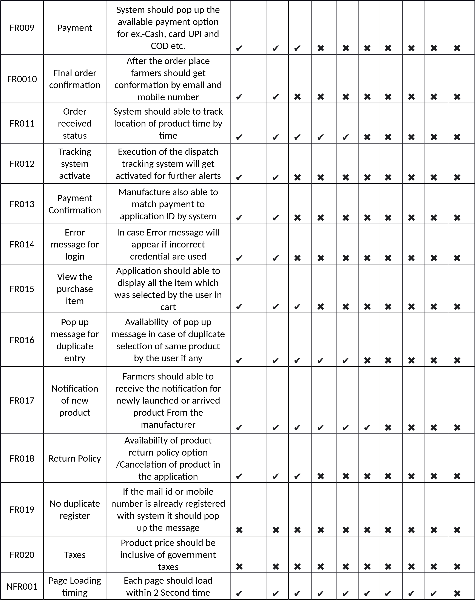

**Que. 5. 10 Test case documents.**

**Ans-**

1.

|  |  |  |  |
| --- | --- | --- | --- |
| Test Case ID | PQ9437 | Test Case Name | login |
| Project ID | 1234 | Project Name | Farmers website |
| PMID | 786 | PM Name | Mr. Vandanam |
| Test strategy ID | PQ9437 | Tester ID |  |
| Test plan ID | PQ9437 | Tester name |  |
| Test schedule ID | PQ9437 | Date of test |  |

|  |
| --- |
| Scenario: website for online shopping of farm products, in that we have login we have 4inputs 3compulsory 1 optional and after that results are being shown |
| Link to that page |

|  |  |  |  |  |  |
| --- | --- | --- | --- | --- | --- |
|  | Set 1 |  |  |  |  |
| Input data | 1.Userid  2.password  3.capcha  4.otp |  |  |  |  |

|  |  |  |  |  |  |
| --- | --- | --- | --- | --- | --- |
|  |  |  |  |  |  |
| Expected behavior | Home page /error page  pops up |  |  |  |  |
| Actual behavior | Home page /error page  pops up |  |  |  |  |
| comments | Test was good |  |  |  |  |
| Pass/fail | Pass |  |  |  |  |

2.

|  |  |  |  |
| --- | --- | --- | --- |
| Test Case ID | PQ9437 | Test Case Name | New user |
| Project ID | 1234 | Project Name | Farmers website |
| PMID | 786 | PM Name | Mr. Vandanam |
| Test strategy ID | PQ9437 | Tester ID |  |
| Test plan ID | PQ9437 | Tester name |  |
| Test schedule ID | PQ9437 | Date of test |  |

|  |
| --- |
| Scenario: website for online shopping of farm products, in that we have new user we have 1 4compulsory 1 optional and after that results are being shown |
| Link to that page |

|  |  |  |  |  |  |
| --- | --- | --- | --- | --- | --- |
|  |  |  |  |  |  |
| Input data | 1.User name  2.set password  3. mail  4.capcha  5. mobile OTP |  |  |  |  |
| Expected behavior | Registered  done and  home page  shows |  |  |  |  |
| Actual behavior | Home page comes |  |  |  |  |
| comments | Test was good |  |  |  |  |
| Pass/fail | Pass |  |  |  |  |

3.

|  |  |  |  |
| --- | --- | --- | --- |
| Test Case ID | PQ9437 | Test Case Name | Online purchasing |
| Project ID | 1234 | Project Name | Farmers website |
| PMID | 786 | PM Name | Mr. Vandanam |
| Test strategy ID | PQ9437 | Tester ID |  |
| Test plan ID | PQ9437 | Tester name |  |
| Test schedule ID | PQ9437 | Date of test |  |

|  |
| --- |
| Scenario: website for online shopping of farm products, in that we perform online purchasing we have 1 1compulsory 1 optional and after that results are being shown |
| Link to that page |

|  |  |  |  |  |  |
| --- | --- | --- | --- | --- | --- |
|  |  |  |  |  |  |
| Input data | 1.Product name  2.filters |  |  |  |  |
| Expected behavior | Product option |  |  |  |  |
| Actual behavior | Different  product pops |  |  |  |  |
| comments | Test was good |  |  |  |  |
| Pass/fail | Pass |  |  |  |  |

4.

|  |  |  |  |
| --- | --- | --- | --- |
| Test Case ID | PQ9437 | Test Case Name | Product availability |
| Project ID | 1234 | Project Name | Farmers website |
| PMID | 786 | PM Name | Mr. Vandanam |
| Test strategy ID | PQ9437 | Tester ID |  |
| Test plan ID | PQ9437 | Tester name |  |
| Test schedule ID | PQ9437 | Date of test |  |

|  |
| --- |
| Scenario: website for online shopping of farm products, in that we should have product available in which we have 3 inputs 3 compulsory and after that results are being shown |
| Link to that page |

|  |  |  |  |  |  |
| --- | --- | --- | --- | --- | --- |
|  |  |  |  |  |  |
| Input data | 1.Manufacturing code  2.capcha  3. password |  |  |  |  |
| Expected behavior | stock  information |  |  |  |  |
| Actual behavior | Same as  expected |  |  |  |  |
| comments | Test was good |  |  |  |  |
| Pass/fail | Pass |  |  |  |  |

5.

|  |  |  |  |
| --- | --- | --- | --- |
| Test Case ID | PQ9437 | Test Case Name | Payment gateway |
| Project ID | 1234 | Project Name | Farmers website |
| PM ID | 786 | PM Name | Mr. Vandanam |
| Test strategy ID | PQ9437 | Tester ID |  |
| Test plan ID | PQ9437 | Tester name |  |
| Test schedule ID | PQ9437 | Date of test |  |

|  |
| --- |
| Scenario: website for online shopping of farm products, in that we should have payment gateway in which we have 4 inputs 4 compulsory and after that results are being shown |
| Link to that page |

|  |  |  |  |  |  |
| --- | --- | --- | --- | --- | --- |
|  |  |  |  |  |  |
| Input data | 1.Expiry  2.cvv  3. OTP  4. name |  |  |  |  |
| Expected behavior | Transaction  page |  |  |  |  |
| Actual behavior | Same as  expected |  |  |  |  |
| comments | Test was good |  |  |  |  |
| Pass/fail | Pass |  |  |  |  |

6.

|  |  |  |  |
| --- | --- | --- | --- |
| Test Case ID | PQ9437 | Test Case Name | Browse product |
| Project ID | 1234 | Project Name | Farmers website |
| PM ID | 786 | PM Name | Mr. Vandanam |
| Test strategy ID | PQ9437 | Tester ID |  |
| Test plan ID | PQ9437 | Tester name |  |
| Test schedule ID | PQ9437 | Date of test |  |

|  |
| --- |
| Scenario: website for online shopping of farm products, in that we should have browse product in which we have 4 inputs 4 compulsory and after that results are being shown |
| Link to that page |

|  |  |  |  |  |  |
| --- | --- | --- | --- | --- | --- |
|  |  |  |  |  |  |
| Input data | 1.category  2.size  3.availability  4.price range |  |  |  |  |
| Expected behavior | Different  product  options |  |  |  |  |
| Actual behavior | Same as  expected |  |  |  |  |
| comments | Test was good |  |  |  |  |
| Pass/fail | Pass |  |  |  |  |

7.

|  |  |  |  |
| --- | --- | --- | --- |
| Test Case ID | PQ9437 | Test Case Name | Experience rating |
| Project ID | 1234 | Project Name | Farmers website |
| PM ID | 786 | PM Name | Mr. Vandanam |
| Test strategy ID | PQ9437 | Tester ID |  |
| Test plan ID | PQ9437 | Tester name |  |
| Test schedule ID | PQ9437 | Date of test |  |

|  |
| --- |
| Scenario: website for online shopping of farm products, in that we should have browse product in which we have 4 inputs 3 compulsory and after that results are being shown |
| Link to that page |

|  |  |  |  |  |  |
| --- | --- | --- | --- | --- | --- |
|  |  |  |  |  |  |
| Input data | 1.experience  2.name 3.phone number |  |  |  |  |
| Expected behavior | Review done |  |  |  |  |
| Actual behavior | Same as  expected |  |  |  |  |
| comments | Test was good |  |  |  |  |
| Pass/fail | Pass |  |  |  |  |

8.

|  |  |  |  |
| --- | --- | --- | --- |
| Test Case ID | PQ9437 | Test Case Name | Product cancel |
| Project ID | 1234 | Project Name | Farmers website |
| PM ID | 786 | PM Name | Mr. Vandanam |
| Test strategy ID | PQ9437 | Tester ID |  |
| Test plan ID | PQ9437 | Tester name |  |
| Test schedule ID | PQ9437 | Date of test |  |

|  |
| --- |
| Scenario: website for online shopping of farm products, in that we should have product cancel in which we have 2 inputs and click ok and after that results are being shown |
| Link to that page |

|  |  |  |  |  |  |
| --- | --- | --- | --- | --- | --- |
|  |  |  |  |  |  |
| Input data | Order id Captcha |  |  |  |  |
| Expected behavior | Order cancellation page |  |  |  |  |
| Actual behavior | Yes Same as  expected |  |  |  |  |
| comments | Test was good |  |  |  |  |
| Pass/fail | Pass |  |  |  |  |

9.

|  |  |  |  |
| --- | --- | --- | --- |
| Test Case ID | PQ9437 | Test Case Name | Helpline |
| Project ID | 1234 | Project Name | Farmers website |
| PM ID | 786 | PM Name | Mr. Vandanam |
| Test strategy ID | PQ9437 | Tester ID |  |
| Test plan ID | PQ9437 | Tester name |  |
| Test schedule ID | PQ9437 | Date of test |  |

|  |
| --- |
| Scenario: website for online shopping of farm products, in that we have helpline option in which we have 4 inputs and click ok and after that results are being shown |
| Link to that page |

|  |  |  |  |  |  |
| --- | --- | --- | --- | --- | --- |
|  |  |  |  |  |  |
| Input data | Name  Number  Query |  |  |  |  |
| Expected behavior | Call person calls you |  |  |  |  |
| Actual behavior | Same as  expected |  |  |  |  |
| comments | Test was good |  |  |  |  |
| Pass/fail | Pass |  |  |  |  |

10.

|  |  |  |  |
| --- | --- | --- | --- |
| Test Case ID | PQ9437 | Test Case Name | Download Payment Receipt |
| Project ID | 1234 | Project Name | Farmers website |
| PM ID | 786 | PM Name | Mr. Vandanam |
| Test strategy ID | PQ9437 | Tester ID |  |
| Test plan ID | PQ9437 | Tester name |  |
| Test schedule ID | PQ9437 | Date of test |  |

|  |
| --- |
| Scenario: website for online shopping of farm products, in that we have payment receipt option in which we have 3 inputs and click ok and after that results are being shown |
| Link to that page |

|  |  |  |  |  |  |
| --- | --- | --- | --- | --- | --- |
|  |  |  |  |  |  |
| Input data | Order id captcha password |  |  |  |  |
| Expected behavior | Shows Payment receipt |  |  |  |  |
| Actual behavior | Same as  expected |  |  |  |  |
| comments | Test was good |  |  |  |  |
| Pass/fail | Pass |  |  |  |  |

**Question 6- DB Design**

**Ans- Database Schema Diagram for online agricultural Product Store**

|  |
| --- |
| Products |
| ID  Name  Price  Weight Descriptions Image Category Stock |

|  |
| --- |
| Option |
| ID  Option Name |

|  |
| --- |
| Product option |
| ID  Option ID  Product ID |

|  |
| --- |
| Product Categories |
| ID  Product ID  Category ID |

|  |
| --- |
| Categories |
| ID  Name  Description |

|  |
| --- |
| Orders |
| ID  Customer ID  Amount ID  Shipping Address Order Address Order Email  Order Date  Order Status |

|  |
| --- |
| Customers |
| ID  Email ID  Password  Full Name  Billing Address District  Mobile Number |

|  |
| --- |
| Order details |
| ID  Order ID  Product ID  Price  Quantity |



Belons to

**Question 7- Data flow Diagram**

**Ans-**

According to Wikipedia.org a data flow diagram is a way of representing a flow of data through a process or a system. The DFD also provides Information about the outputs and inputs of each entity and the process itself. A data-flow diagram has no control flow there are no decision rules and no loops.

**Context level DFD- 0**

**level**

Creates Products Details

Stores into database

Views Products

Agricultural product records

Seller

Online agriculture

product store

User

User Login Records

order

Customer and order Information

acknowledgement

D1 Farmer

Database

Debit card Number and

And order Amount

Approval or

rejection

Confirmation

And delivery date

Order Information

Product type and amount

Farmer

1

. Online Process

order

2

. Cyber Check verify

Debit Card

Debit Card

Company

3

. Shipping ship order

D2 Inventory

**Question 8- Change Request-**

Definition of a “Change”

For the purposes of this document, a Change is defined as the addition, modification, or removal of a configuration item (CI), service, or service component, and/or its associated elements.

When as a I receives a request of change from the client Due to change in government taxation structure, I will analyses the request and clarifies exactly what the request is asking me to do in that agriculture product store. I will perform some activities to improvise and change the project as per the Clients Requirement.

They are:

1.Feasibilty Study

Basically, this is the first step I am as Business Analyst does whenever come across the Change Requests. This Feasibility Study helps me in answering the possible question like “Are we supposed to proceed with the proposed project change requirements?”. If yes, he will go accept the change request and goes to the Impact Analysis.

This change has occurred due to change in governments taxation structure change as BA we need to change privies taxation structure change.

When a change is requested, as a Business Analyst I should follow the following steps. In simple terms,

1. Firstly, I need to documents the change requests.
2. BA identifies whether the change in the ongoing project is really worth it or not.

The taxation structure change by government is priority to consider point according to that I need to develop documents and into on-going sprint.

1. Project Manager should approve the change requests. If yes, the project will move furtherly. As a BA I will Take Approval from PM and PO on Email and forward this mail to all team and done this change on priority Bases.
2. Business Analyst along with the Project Manager ensure whether the change is a minor or a major change.

If the policy change by government the it is major change request according to the government instruction, we need to make change with a given time.

1. If the new requirement is a major change, they make sure that it should not impact the delivery date of the project or any changes in the project scope.
2. Also try to help the other stakeholders to understand the importance of change requests which helps to reduce the negative impact of the project.

**Change Request Form**

**(Change in the Government Taxation structure)**

**1.) SUBMITTER - GENERAL INFORMATION**

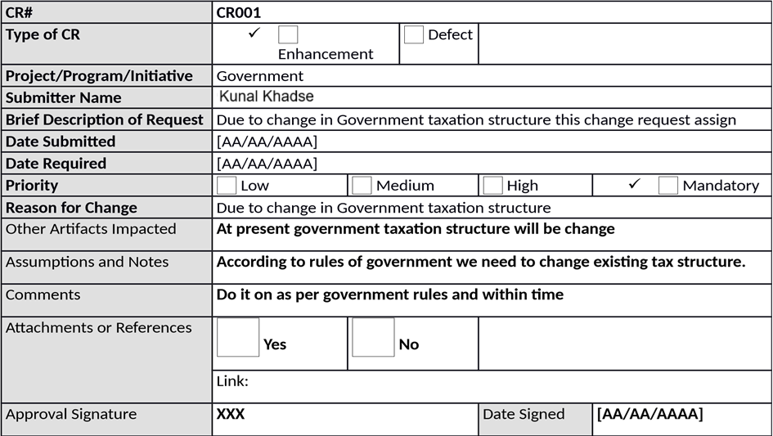

2.)

PROJECT MANAGER - INITIAL ANALYSIS

Hour Impact

**[30**

**hrs**

**]**

**For all team it will take minimum 60 hrs**

Duration Impact

**[3**

**dys**

**]**

**For all team we finished this job within three days**

Schedule Impact

**[**

**XXX**

**]**

**[**

**AA/AA/AAAA] To [AA/AA/AAAA**

**]**

Cost Impact

$80/Hr.

**This will cost around**

$2400

Comments

**Kindly approve**

Recommendations

**From project sponsor**

Approval Signature

**XXX**

Date Signed

**[**

**AA/AA/AAAA**

**]**

3.) CHANGE CONTROL BOARD - DECISION

**Decision**

✓

**Approved**

**Approved**

**with Conditions**

**Rejected**

**More**

**Info**

**Decision Date**

**[[**

**AA/AA/AAAA**

**]**

**Decision Explanation**

**Due to change in rules of government we need to change existing tax**

**structure.**

**Conditions**

**This change will be utilizing when this government utilize this new taxation**

**structure.**

Approval Signature

**XXX**

Date

Signed

**[**

**AA/AA/AAAA**

**]**

**Question 9- Change Request Vs an Enhancement**

According to my understanding change Request mean in any IT project we can change all process or we add new process or system instance of old remove. Enhancement is a part of change request. For example, we provide only service through web and we are not available at application services and we lunch new application at android platform that change request

Enhancement mean add something new in existing process or system for example if farmer can process payment by only UPI and Debit card and now we add new feature farmer can pay payment by credit card and online banking.

According to IBM.com A change request is a proposal from a stakeholder in the software development process to change something in a product or in a product process.

According to IBM.com Common change requests include defects and requests for product enhancements or new features

As the project is in process, Ben and Kevin have contacted you. The reason is to inform you that they want the Farmers to sell their crop yields through this application i.e. Farmers should be able to add their crop yields or products and display to general public and should be able to sell them. They also want to introduce Auction system for their Crop yields. As a BA, what will be your response?

As BA I will check introduce new link in online product store Buy and sale product from farmers. And in that add auction link also farmers can able to sale their agricultural product to other farmers by location wise we are already into delivery service of small amount of agricultural product is sale by farmer then can choose delivery service through application also

**Question 10- Estimations** -

* PM -$130/Hr,

PM work every Month 60 Hr

For Entire Project He work 1080 Hr

Total work Cost $64800

* Sol Architect – $55/Hr,

Sol Architect work every Month 80 Hr

For Entire Project He work 1440 Hr

Total Work cost $115200

* Programmers – $50/Hr

Programmers work every Month 90 Hr

For Entire Project He work 1620 Hr

Total work cost $145800

* Sr. Programmers – $80/Hr

Sr. Programmers work every Month 85 Hr

For Entire Project he works 1530 Hr Total Work cost $122400

* Network Engineer – $80/Hr NE work every Month 65 Hr

For Entire Project He work 1170 Hr

Total Work cost $93600

* DBA - $80/Hr

DBA work every Month 70Hr

For Entire Project He work 1260 Hr

Total Work Cost $88200

* BA- $60/Hr

BA work every Month 90 Hr

For Entire Project He work 1620 Hr

Total Work Cost $145800

Total man-hours Required for project = 9720 Hr

Total Cost for the Project = $775,800

**Question 11- UAT-**

The Business Analyst role is all about ensuring that online agricultural product store project delivers the value the business needs and expects. Actively participating in planning for and running User Acceptance Testing is an important way for the BA to ensure that value is indeed delivered.

Following why I handle the situation

I understand the functionality the system is supposed to deliver and as such, have the knowledge needed to validate the system (confirm whether the solution meets business needs or not). The fact that a system has been built to specification does not make it automatically acceptable. UAT helps stakeholders to determine whether the system can be put to use in real-life business scenarios or not.

Steps in UAT

Analyze Requirements –Requirements should be analyzed and documented properly before conducting a UAT session. Even the users agreed with the Software Requirement Specification, there will be change requests after going through a UAT. That’s where the users get the real look and feel of the system.

Identify major Test scenarios and Prepare the UAT Plan – UA Test plan is the document that outline to identify test cases which validate the deliverables.

Create UAT test cases - Test Cases are the steps to the user to guide the system in testing. It’s important to write the proper test cases to conduct a good UA Test. User cases which identified in requirements elicitation can be used to write the UA test cases.

Run the Test – To run the UAT test cases, testers should be the real world end users of the business.

Record the results – When conducting a proper UAT scenario, it need to be documented the progress and Issues in a defect log. Defects need to be documented to evaluate and fix.

Confirm the Business objectives are met – If the requirement hasn’t met the product will send to further development. If there any change requests from users, they will be hand over to the development.

UAT Documents Created by Business analyst

UAT plan

UAT Test cases

Defect Log (after conducting the UAT)

Challenges when conducting a UAT session

UAT environment installation and proceeding. In some cases, it’s difficult to allocate time from end users and their environment as not to distract the business process

Problems can be arising when the test plan is not completed properly. UAT plan is one important document that needs to be organized and accurate to conduct the UA Test.

Users with low business process knowledge and lack of training. When selecting testers, select end users with a good business knowledge.

I hope this article will help Business analysts and those who want to learn about UAT. Your reviews are mostly welcome)

**Question 12- Project Closer Document-**

The project closure doc prepaid the main purpose document of to make note of what went wrong the correct approach adopted deposit vive and negatives during the project. Varies initiatives taken by the team issues face by the members and solution obtaining in short this document is existing of all positives negatives of the project which helps to avoid same mistake in future project it also helps to improve performance of the team member in future. In short closure report is a tool for management to access success of the project and its team members

**Project Closure**

Online Agriculture Product Store

Version: 1.0

Revision Date: MM/DD/YYYY

*Submit the document to the Project Sponsor, Business Owner, and PPMO/PMO Division Director; and archive this closure document with the project artifacts once completed.*

**Approver**

**Name**

**Title / Role**

**Signature**

**Date**

Peter and Ben

Project Stakeholder*

ok

Xx/xx/xxxx

Mr. Henry

Exec Sponsor (AVP or Exec.

Dir)*

ok

Xx/xx/xxxx

Mr. Pandu

Financial Head

ok

Xx/xx/xxxx

Mr. Vandanam

Project Manager

ok

Xx/xx/xxxx

Mr. Kartik

Delivery head

ok

Xx/xx/xxxx

Mr. Dooku

Project Coordinator

ok

Xx/xx/xxxx

*By authorizing this Project Closure, the Project Champion, Project Stakeholder(s), and Executive Sponsor agree to all terms within this document.

**Revision History**

*Identify document changes.*

**Version**

**Date**

**Name**

**Description**

1.0

Xx/xx/xxxx

Mr. Henry

Ok to process

Section 1. General Information

***Project Activity***

**Date**

Project Start

[01/01/2025]

Project Closure

1

[31/07/2026]

**Section 2. Business Deliverables**

*As identified in section 2.2 of the Business Case.*

**Business**

**Case Ref**

**ID**

**Business Objective**

**Met/Not**

**Met**

**Comments**

BI0001

Farmer should able to buy and send

agricultural product by online

Yes

Ok

*In addition to the project specific goals and objectives identified by the project champion/project stakeholders, University of Houston-Clear Lake requires business solutions uphold the integrity of the university by complying with

**Section 3. Customer Expectation Management**

**Item**

**Question**

**Description**

1

Were all expected benefits and business outcomes realized?

Yes

2

Were all expected performance standards satisfied?

Yes

1 Date of Project Closure refers to the project finish date, meaning all project tasks have been completed.

**Item**

**Question**

**Description**

**Comments**

**ok**

**Section 4. Outstanding Action Item and Issues**

***Action Item and/or Issue***

***Transition and/or Resolution***

**Section 5. Project Office Checklist**

***Deliverable***

***Description***

Risk Assessment completed and posted on suitable shared storage.

✓

Yes

No

Business Case completed and posted on suitable shared storage.

✓

Yes

No

Project Charter completed and posted on suitable shared storage.

✓

Yes

No

Meeting Notes completed and posted on suitable shared storage.

✓

Yes

No

Additional project documentation and artifacts posted on suitable shared

storage, including Requirements Template, Project Change Requests,

Milestone Timeline, Work Breakdown Structure, etc.

✓

Yes

No

Lessons Learned documented.

✓

Yes

No

Project folder moved

*completed-projects*

on suitable shared storage.

✓

Yes

No

***Deliverable***

***Description***

Support Handover Document completed, archived, and provided to UCT

Support Center and Student Assistance Center.

✓

Yes

No

**Comments**

Ok to process application running properly.