Online Agriculture Products Store

Mr. Henry, after being successful as a businessman and has become one of the wealthiest persons in the city. Now, Mr. Henry wants to help others to fulfil their dreams. One day, Mr. Henry went to meet his childhood friends Peter, Kevin and Ben. They live in a remote village and do farming. Mr. Henry asked his friends if they are facing any difficulties in their day-to-day work. Peter told Mr. Henry that he is facing difficulties in procuring fertilizers which are very important for farm. Kevin said that he is also facing the same problem in-case of buying seeds for farming certain crops. Ben raised his concern on lack of pesticides which could help in greatly reducing pests in crops.

After listening to all his friends’ problems, Mr. Henry thought that this is a crucial problem faced not only by his friends but also by so many other farmers. So, Mr. Henry decided to make an online agriculture product store to facilitate remote area farmers to buy agriculture products. Through this Online Web / mobile Application, Farmers and Companies (Fertilizers, seeds and pesticides manufacturing Companies) can communicate directly with each other.

The main purpose to build this online store is to facilitate farmers to buy seeds, pesticides, and fertilizers from anywhere through internet connectivity. Since new users are involved, Application should be user friendly.

This new application should be able to accept the product (fertilizers, seeds, pesticides) details from the manufacturers and should be able to display them to the Farmers. Farmers will browse through these products and select the products what they need and request to buy them and deliver them to farmers location.

Mr. Henry has given this project through his Company SOONY. In SOONY Company, Mr Pandu is Financial Head and Mr Dooku is Project Coordinator. Mr. Henry , Mr Pandu , and Mr Dooku formed one Committee and gave this project to APT IT SOLUTIONS company for Budget 2 Crores INR and 18 months Duration under CSR initiative. Peter, Kevin and Ben are helping the Committee and can be considered as Stakeholders share requirements for the Project.

Mr Karthik is the Delivery Head in APT IT SOLUTIONS company and he reached out to Mr Henry through his connects and Bagged this project. APT IT SOLUTIONS company have Talent pool Available for this Project. Mr Vandanam is project Manager, Ms. Juhi is Senior Java Developer, Mr Teyson, Ms Lucie, Mr Tucker, Mr Bravo are Java Developers. Network Admin is Mr Mike and DB Admin is John. Mr Jason and Ms Alekya are the Tester. And you joined this team as a BA.

**Decode the case study**:

1. **Project Idea** – Develop an online agriculture product store to facilitate buy and sell of farming products (like fertilizers, seeds, pesticides etc) between manufacturers and farmers.
2. **Current needs** – The remote area farmers should be able to buy the required agriculture products online using this application and get it delivered to their location.
3. **Overview of the project** – Develop Online Web / mobile Application, where manufactures can post all information for their farming products and farmers can see this information and buy the product online.
4. **Current problems** – Being in remote place, farmers are facing difficulties in buying the required farming products.
5. **Know the team** -

SOONY Business Team:

* Mr Henry - Project Head, Committee member
* Mr Pandu - Financial Head, Committee member
* Mr Dooku - Project Coordinator, Committee member
* Peter, Kevin and Ben - Users of the application

APT IT Solutions Technical Team:

* Mr Karthik - Delivery Head
* Mr Vandanam - Project Manager
* Ms Juhi - Senior Java Developer
* Mr Teyson, Ms Lucie, Mr Tucker, Mr Bravo - Java Developers
* Mr Mike - Network Admin
* Mr John - DB Admin
* Mr Jason and Ms Alekya - Tester
* Mr Uday - Business Analyst

**Question and Answers:**

**Question 1** **– BPM**: Identify Business Process Model for Online Agriculture Store.

BPM helps us to understand the application from system point of view. BPM is collection of activities that are required to get desired output from specific input.

* **Goal** – To bridge the gap between buyers and sellers of Agriculture products.
* **Inputs** – Farmers requirements, Agriculture product data, Sanctioned Budget, Available timeline (Estimates).
* **Resources** – Hardware, Software, Office space, Network, Payment gateways, Product Delivery mechanism, Application Development team
* **Outputs** –
  + Online agriculture product store
  + Increase in Sales of Agriculture products,
* **Activities** –
  + Understand the requirements of end user (i.e. Farmers) from this online store
  + Develop an application that will address all the requirements, those are agreed between all the stakeholders
  + Set up payment gateways
  + Setup product delivery mechanism.
  + Collect and upload Agriculture product data from all the suppliers
  + Educate farmers on how to use the application
* **Value created to the end Customer** –
  + Farmers can see/buy the products from any supplier …even if it is geographically placed very far from his location
  + Farmers can compare the same product being supplied from multiple suppliers for things like cost, features etc.
  + Easy way of buying the products for Farmers

**Question 2** **– SWOT Analysis**:

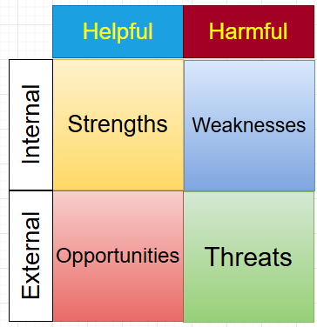

SWOT analysis is a model that is used to understand the factors that can affect/influence the project.

* **Strength**:
  + Mr. Henry is a successful businessman and knows how to execute the projects.
  + Mr. Henry has the end users ready who can give the requirements and can also start using the end product.
  + We know the “Pain points” of the users i.e. difficulties they face during their day-to-day farming work
  + With direct communication between buyer and supplier of the product (no middleman), the cost of product will be less compared to physical store cost.
  + Farmers are not restricted to buy the products near to their geographical area
  + APT IT SOLUTIONS company has the required Talent pool available to develop this project
* **Weakness**:
  + Farmers are not familiar with using the application for buying the agricultural products
* **Opportunity**:
  + With the ease for buying the agricultural products, more and more farmers will start using the product
  + New market will be opened up for the suppliers …along with existing vendor market
  + The reach of suppliers to the Farmers will be widen, resulting increase in sales/revenue of suppliers
* **Threat**:
  + Weak internet connection in remote areas for farmers to use the product on web/mobile
  + If farmers find it difficult to use the product, then they may go away from it
  + Timely delivery of ordered products in remote areas.
  + The project is fix bid where budget and timeline are already fixed. So requirements and scope of the project needs to be defined clearly at the start of the project. Any changes in requirements may result in scope crip.

**Question 3 – Feasibility study**

Feasibility study is an analysis done to determine if the project can be done within defined constraints like Technology, Resources, Budget and Time.

* **Technology**:
  + Online Web / Mobile Application
  + Java application
  + Payment gateway and security
* **Hardware**
  + Server to host the application
  + Network connectivity
  + Backup mechanism
  + Product delivery infrastructure
* **Software**
  + Database to store the agriculture product data
  + Payment gateway
  + Product Delivery and Tracking
* **Resources**
  + Business team
  + Project Management team
  + Project Development team
  + Testing team
  + DB Admin
  + Network Admin
  + Product delivery team
* **Budget**
  + Fixed - 2 Crores INR
* **Time frame**
  + Fixed – 18 months

**Question 4 – Gap Analysis**

Gap Analysis is comparison of current state and desired state of the situation. It helps to understand where we are currently, what issues we are facing and where we want to be.

* **Current State (AS-IS):**
  + Farmers are purchasing their day-to-day agricultural products from the nearby stores, where they need to physically go to purchase the products.
  + Farmers from remote villages finds it difficult to purchase the product, as there are no shops nearby them.
  + Farmers can purchase only the products those are available in local shops. So, there is constrain for Variety, Cost and Supplier etc.
  + The reach of agricultural product suppliers is limited within their vendor’s geographical areas.
  + The final cost of product = Supplier cost + Vendor commission
* **Desired State (TO-BE):**
  + Develop online agriculture product store that will bring Farmers and Suppliers on same platform.
  + Farmers can purchase the required products online from home and there is no need to physically go to nearby shop.
  + Farmers can get delivery of their product at doorstep …even in remote areas.
  + Farmers can choose the required products from different suppliers, of different cost and quality.
  + The reach of agricultural product suppliers gets widen and can reach directly to the farmers …. irrespective of their geographical location.
  + Farmers can purchase the product at lesser cost as there is no vendor commission included.
  + Increase in sales and revenue of supplier.

**Question 5 – Risk Analysis**

Risk is an uncertain event or condition that can have impact on project’s cost, timeline, scope or quality of work. Risk is threat to the project.

Risk analysis is process of identifying and listing all the possible risks that project can have.

* **Internal Risks:**
  + Farmers may find using the application difficult and may go away from it
  + Allocated budget or timeline may not be sufficient
* **External Risks:**
  + Competition from other online Agriculture product stores
  + Network connectivity in remote areas
  + Dependency on payment gateways to receive the payment
  + Dependency on suppliers to provide their product details
* **BA Risks:**
  + Incomplete requirements
  + Lack of Domain knowledge to understand the requirements
* **Project based Risk:** 
  + Change in requirements
  + Change in development team, Holidays, Leaves, Resignations
  + Less Stakeholder Involvement during project life cycle

**Question 6 – Stakeholder Analysis (RACI Matrix)**

Stakeholder analysis is done using RACI matrix method. In this, we divide all the stakeholders into four main categories i.e. Responsible, Accountable, Consulted and Informed. This analysis helps BA to understand things like who are the decision makers in the team, who are the main impactors to the project, who can act as SME in the project etc.

|  |  |  |
| --- | --- | --- |
| **Online Agriculture Products Store** | | |
| **R/A/C/I** | **Name of Person** | **Designation** |
| Responsible | Mr Vandanam | Project Manager |
| Ms. Juhi, Mr Teyson, Mr Bravo and Mr Tucker | Java Developers |
| Mr Jason and Ms Alekya | Testers |
| Accountable | Mr Pandu | Financial Head |
| Mr Dooku | Project Coordinator |
| Mr Karthik | Project Delivery Head |
| Consulted | Mr. Peter, Kevin and Ben | Users |
| Mr Mike | Network Admin |
| Mr. John | DB Admin |
| Informed | Mr. Henry | Sponsor and project head |

**Question 7 – Business Case Document**

Business case document gives overview of the project. It covers things like why project is needed, what resources are required, what is timeline for ROI etc.

**Online Agriculture Products Store** – This project is to develop an online agriculture product store to facilitate remote area farmers to buy agriculture products. It will also help to bring both manufacturers and buyers on the same platform by eliminating need of vendors.

* Why is this project initiated?

Currently the remote area farmers are facing lots of problems while buying their day-to-day agriculture products. So, this project is initiated to facilitate those remote area farmers to buy the needed agriculture products.

* What are the current problems?
  + Farmers are facing difficulties in procuring fertilizers which are very important for farm.
  + They also face issues while buying seeds for farming certain crops.
  + Lack of pesticides which could help in greatly reducing pests in crops.
* With this project, how many problems could be solved?

With the new project, an online agriculture product store will be developed to facilitate remote area farmers to buy agriculture products. Through this Online Web / mobile Application, Farmers and Companies (Fertilizers, seeds and pesticides manufacturing Companies) can communicate directly with each other. This will solve majority of the current problems of farmers.

* What are the resources required?
  + Team to develop the online agriculture product store
  + Hardware and Software resources
  + Office space
  + Network
  + Payment gateways
  + Product Delivery mechanism
* How much organizational change in required to adopt this technology?
  + Farmers needs to be educated on how to use the online agriculture product store to buy the required farming products.
* What is the time frame to recover ROI?
  + Not mentioned in the given business case.

* How to identify stakeholders?
  + Using RACI matrix

**Question 8 – Four SDLC Methodologies**

Any software project can be developed using any of below 4 methodologies:

1. Sequential:

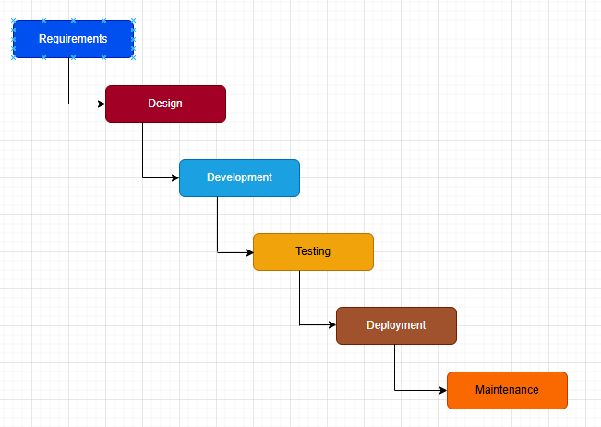

* + This is most commonly used methodology
  + It has got below phases. Each phase must be complete fully before starting next phase
    - Requirement Gathering
    - Requirement Analysis
    - Design
    - Development
    - Testing
    - Deployment and Implementation – Moving and running the code in production.
  + Disadvantages:
    - Client will see the developed product only at the end of entire project life cycle.
    - Once the work is started, changes in requirements cannot be accommodated easily.

1. Iterative:

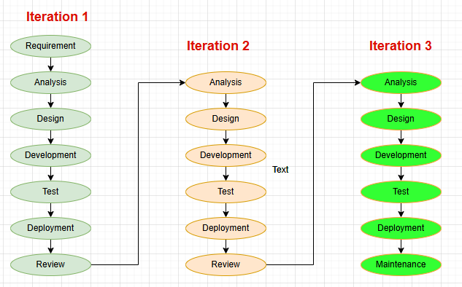

* + Main building blocks are:
    - Roles (who)
    - Work Products (what)
    - Task (how)
  + In each iteration, tasks are categorized into:
    - Requirements
    - Analysis
    - Design
    - Development
    - Test
    - Deployment
  + There are four project life cycle phases:
    - Inception – Agreement between customer and team on what to build
    - Elaboration – Agreement within team on architecture and design to build the requirement
    - Construction – Develop the application/system as per requirement
    - Transition – Delivery of the developed product and get customer acceptance

1. Evolutionary:

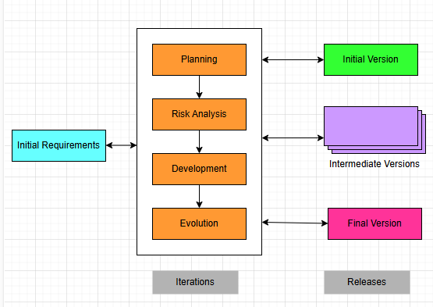

* + More emphasis is on ‘Risk Analysis’
  + It has got 4 phases:
    - Planning
    - Risk Analysis
    - Engineering (Development)
    - Evolution
  + Software project repeatedly passes through the above 4 pashes
  + Advantages:
    - High amount of risk analysis
    - Good for large and mission-critical projects
  + Disadvantages:
    - Costly model to use
    - Project success highly dependent on risk analysis
    - Not suitable for small projects

1. Agile:

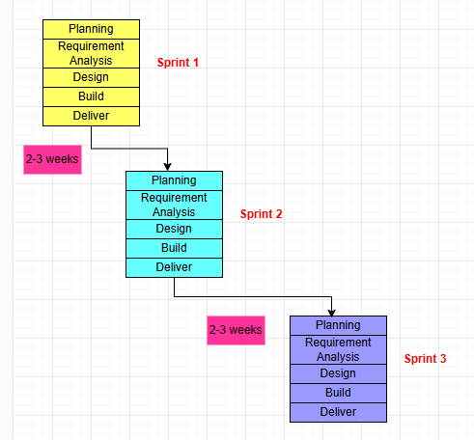

* + Suitable for faster delivery projects
  + Self-Organised teams
  + Four values:
    - Individuals and interactions over process and tools
    - Working software over comprehensive documentation
    - Customer collaboration over contract negotiations
    - Respond to change over following a plan
  + Twelve principles:
    1. Satisfy customer by early and continuous delivery of valuable software
    2. Requirement changes are welcome at any point of time
    3. Deliver working piece of software within each agreed time limit
    4. Business people and developers need to work together throughout the project
    5. Motivate team by giving them the required environment and support
    6. Communication using face-to-face conversation
    7. Working software is primary measure of progress
    8. Maintain constant pace of project execution
    9. Attention to technical excellence and good design
    10. Best architecture, design, requirement comes Self-Organised teams
    11. At regular intervals, team discuss on how to become more effective and then adjust the next plans accordingly.

**Question 9 –** **Waterfall, RUP, Spiral and Scrum Models**

The main difference between Methodology and Model is that …. methodology is set of rules/guidelines to follow …and using those rules/guidelines model is created.

1. **Waterfall**:

* The waterfall model is useful in situations where the project requirements are well-defined, and the project goals are clear.
* It is often used for large-scale projects with long timelines, where there is little room for error and the project stakeholders need to have a high level of confidence in the outcome.
* The Waterfall Model has six phases. This model considers that one phase can be started after the completion of the previous phase. That is the output of one phase will be the input to the next phase. Thus, the development process can be considered as a sequential flow in the waterfall. Here the phases do not overlap with each other.
* The Waterfall Model has six phases which are:
  + **Requirements**: The first phase involves gathering requirements from stakeholders and analysing them to understand the scope and objectives of the project.
  + **Design**: Once the requirements are understood, the design phase begins. This involves creating a detailed design document that outlines the software architecture, user interface, and system components.
  + **Development**: The Development phase include implementation involves coding the software based on the design specifications. This phase also includes unit testing to ensure that each component of the software is working as expected.
  + **Testing**: In the testing phase, the software is tested as a whole to ensure that it meets the requirements and is free from defects.
  + **Deployment**: Once the software has been tested and approved, it is deployed to the production environment.
  + **Maintenance**: The final phase of the Waterfall Model is maintenance, which involves fixing any issues that arise after the software has been deployed and ensuring that it continues to meet the requirements over time.

1. **Spiral Model**:

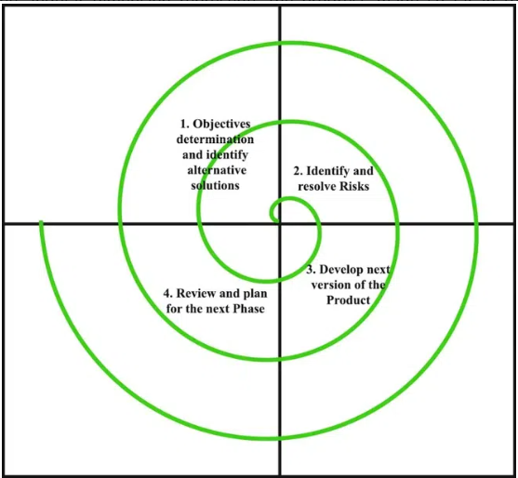

The Spiral Model is a Software Development Life Cycle (SDLC) model that provides a systematic and iterative approach to software development. In its diagrammatic representation, looks like a spiral with many loops. The exact number of loops of the spiral is unknown and can vary from project to project. Each loop of the spiral is called a phase of the software development process.

**Phases of the Spiral Model**:

* Objectives Defined: In first phase of the spiral model, we clarify what the project aims to achieve, including functional and non-functional requirements.
* Risk Analysis: In the risk analysis phase, the risks associated with the project are identified and evaluated.
* Engineering: In the engineering phase, the software is developed based on the requirements gathered in the previous iteration.
* Evaluation: In the evaluation phase, the software is evaluated to determine if it meets the customer’s requirements and if it is of high quality.
* Planning: The next iteration of the spiral begins with a new planning phase, based on the results of the evaluation.

1. **RUP model**:

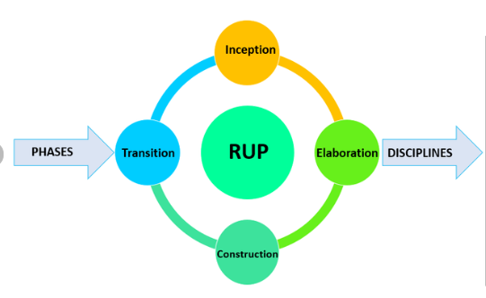

Rational Unified Process (RUP) is a framework for software engineering processes. RUP is an Iterative and incremental approach to improving problem knowledge through consecutive revisions. RUP is a software development process for object-oriented models. It is also known as the Unified Process Model.

Phases of RUP - There is a total of five phases of the life cycle of RUP:

* Inception
* Elaboration
* Construction
* Transition
* Production

1. **Scrum**:

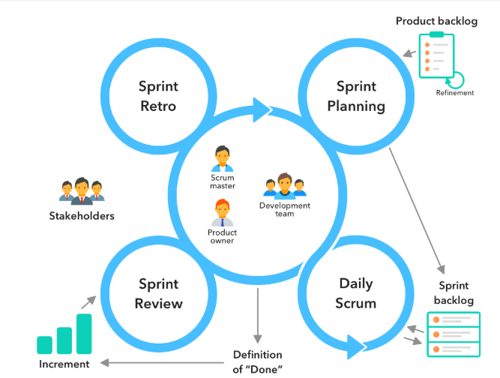

* Scrum is a management framework that teams use to self-organize and work towards a common goal.
* Scrum practices allow teams to self-manage, learn from experience, and adapt to change.
* The essence of Scrum is a self-organizing team delivering customer value in a time-boxed period called a Sprint. Scrum defines artifacts, roles, and events associated with each Sprint.
* **Scrum artifacts:**
  + Product Backlog
    - The Product Backlog is a dynamic list of features, requirements, enhancements, and fixes that must be completed for project success.
    - It is essentially the team’s to-do list, which is constantly revisited and reprioritized to adapt to market changes.
    - The product owner maintains and updates the list, removing irrelevant items or adding new requests from customers
  + Sprint Backlog:
    - The Sprint Backlog is the list of items to be completed by the development team in the current Sprint cycle.
    - Before each Sprint, the team chooses which items it will work on from the Product Backlog.
    - A Sprint Backlog is flexible and can evolve during a Sprint.
  + Increment:
    - The Increment is a step towards a goal or vision.
    - It is the usable end product from a Sprint.
    - Teams can adopt different methods to define and demonstrate their Sprint Goals.
* **Scrum roles**:
  + Product Owner:
    - The Product Owner focuses on ensuring the development team delivers the most value to the business.
    - They understand and prioritize the changing needs of end users and customers.
    - Give the team clear guidance on which features to deliver next.
    - Bridge the gap between what the business wants and what the team understands.
  + Scrum master:
    - Scrum masters are the champions for Scrum within their teams.
    - They are accountable for the Scrum Team’s effectiveness.
    - They coach teams, Product Owners, and the business to improve its Scrum processes and optimize delivery.
    - They are also responsible for:
      * Schedule the resources needed for each Sprint.
      * Facilitate other Sprint events and team meetings.
      * Facilitate any team training when adopting new technologies.
      * Communicate with external groups to solve any challenges the team might be facing as a whole.
  + Scrum development team:
    - The Scrum Team consists of testers, designers, UX specialists, Ops engineers, and developers.
    - Team members have different skill sets and cross-train each other, so no one person becomes a bottleneck in delivering work.
    - Team Work collaboratively to ensure a successful Sprint completion.
    - Drive the planning and estimating for how much work they can complete for each Sprint.
* **Scrum events**:
  + Sprint Planning - In this event, the team estimates the work to be completed in the next Sprint.
  + Sprint - A Sprint is the actual time period when the Scrum Team works together to finish an Increment. Two weeks is the typical length for a Sprint but can vary depending on the needs of the project and the team.
  + Daily Scrum or stand-up - A Daily Scrum is a short meeting in which team members check in and plan for the day. They report on work completed and voice any challenges in meeting Sprint Goals.
  + Sprint Review - At the end of the Sprint, the team gets together for an informal session to review the work completed and showcase it to stakeholders.
  + Sprint Retrospective - The team comes together to document and discuss what worked and what did not work during the Sprint. Ideas generated are used to improve future Sprints.

**Question 10 – Waterfall Vs V-Model:**

| **Aspect** | **Waterfall model** | **V-model** |
| --- | --- | --- |
| **Cost** | The cost of Waterfall model is low. | V-model is expensive. |
| **Simplicity** | Simplicity of Waterfall model is simple. | Simplicity of V-model is Intermediate. |
| **Flexibility** | Flexibility of Waterfall model is Rigid. | Flexibility of V-model is Little flexible. |
| **Phases** | There is no way to return to the earlier phase. | There is no such constraint in V-model. |
| **Linear Movement of Steps** | Waterfall model’s steps move in a linear way. | V-model’s steps don’t move in linear way. |
| **Testing Activities Start** | In Waterfall model testing activities start after the development activities are over. | In V-model testing activities start with the first stage. |
| **Success Guarantee** | Guarantee of success through Waterfall model is low. | Guarantee of success through V-model is high. |
| **Process** | Waterfall model is a continuous process. | V-model is a simultaneous process. |
| **Defects** | Software made using Waterfall model, the number of defects are less in comparison of software made using V-model. | Software made using V-model, the number of defects are greater in comparison of software made using Waterfall model. |
| **Customer Involvement** | Less customer involvement. | More customer involvement as compared to waterfall model. |
| **Testing during Development** | It is not possible to test a software during its development. | There is possibility to test a software during its development. |
| **Identification of Defects** | Identification of defects is done in the testing phase. | Identification of defects can be done from the beginning. |
| **Debugging** | Debugging is done after the last phase. | Debugging can be done in between phases. |
| **Usage** | Waterfall model is less used now-a-days in software engineering. | V-model is widely used in software engineering. |

**Question 11 – Justify your choice**

As a BA, for this project, I would like to use Agile (Scrum) model for below reasons:

* Requirements are not detail enough given in case study.
* Customer involvement is needed more and throughout the project life cycle.
* As requirements are not detail enough, they are likely to get changed frequently. Agile is suitable for changing requirements project.

**Question 12 – Gantt Chart**

A Gantt chart is a type of bar chart that illustrates a project schedule. This chart lists the resources involved on the vertical axis, and time intervals on the horizontal axis. The width of the horizontal bars in the graph shows the duration for which each resource is going to be involved in the project. Usually, PM prepare this.

|  |  |  |  |  |  |  |  |  |
| --- | --- | --- | --- | --- | --- | --- | --- | --- |
| **Resources** | **Week 1** | **Week 10** | **Week 20** | **Week 30** | **Week 40** | **Week 50** | **Week 60** | **Week 72** |
| **Project Manager** |  |  |  |  |  |  |  |  |
|  |  |  |  |  |  |  |  |  |
| **Business Analyst** |  |  |  |  |  |  |  |  |
|  |  |  |  |  |  |  |  |  |
| **Java Developers** |  |  |  |  |  |  |  |  |
|  |  |  |  |  |  |  |  |  |
| **Testers** |  |  |  |  |  |  |  |  |
|  |  |  |  |  |  |  |  |  |
| **DB Admin** |  |  |  |  |  |  |  |  |
|  |  |  |  |  |  |  |  |  |
| **Network Admin** |  |  |  |  |  |  |  |  |
|  |  |  |  |  |  |  |  |  |

**Question 13 – Fixed Bid Vs Billing**

Fixed-bid pricing and Billing (i.e. time and material T&M) pricing are two common pricing models used for projects by the customers.

**Fixed Bid:**

Fixed-bid pricing is a model where the price of a project is fixed upfront based on the scope of the project. The payment is either made in full upon completion of the project or split by milestones to add critical checkpoints in larger projects. Here Customer is not interested in how many resources are working on the project and for how much time.

This model has several advantages. Firstly, it provides a clear understanding of the cost and budget for the project from the start, which helps in better planning and allocation of resources. Secondly, it reduces the risk of cost overruns as the price is fixed, and the project team is bound to complete the project within the budget.

The main disadvantage of this model is that the requirements need to be well defined and fixed at very initial stage of the project. Once the project starts, no changes are accepted in the requirements. Another disadvantage is that, for any reason, if project results into cost overruns, then that extra cost has to be consumed by the development company.

**Billing (Time and Material T&M):**

T&M pricing is a model where the client pays for the time and resources used by the project team to develop the project, along with any other expenses incurred during the project. Here weekly timesheets are submitted to client… mentioning which resources worked and for how much time in that week. Based on the timesheet submitted, the payment is done by Client.

This model has some advantages, such as flexibility in project scope and the ability to adjust the budget as the project progresses. So, as the project progresses, the scope/requirement of the project can be changed. Also, based on the budget, the number of resources working on the project can be increased or decreased. As per changes made in scope or team composition, the project completion date gets changed.

The disadvantage of this model is that the client has to monitor and worry both about the timeline and the cost, which can create additional stress and uncertainty. It can encourage the project team to drag out the work and artificially increase the time needed, in order to get paid more. This can result in unnecessary delays and increased costs for the client.

**Question 14 – Preparer Timesheets of a BA in various stages of SDLC**:

Design Timesheet of a BA:

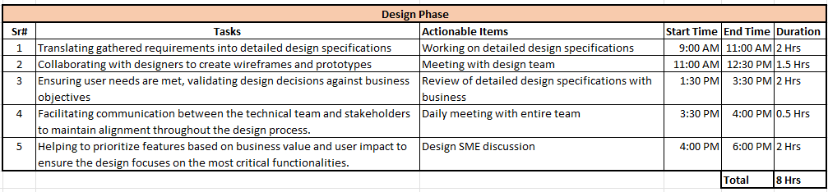

Development Timesheet of a BA:

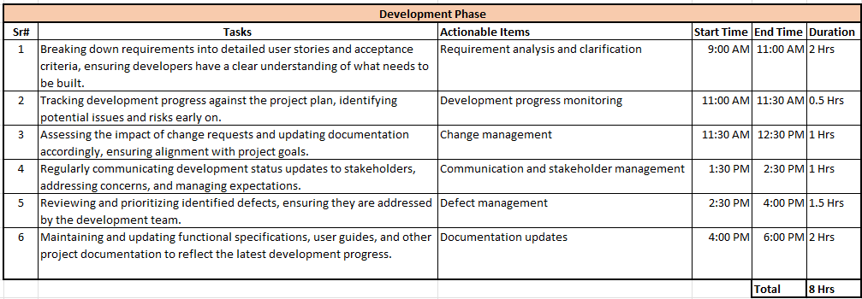

Testing Timesheet of a BA:

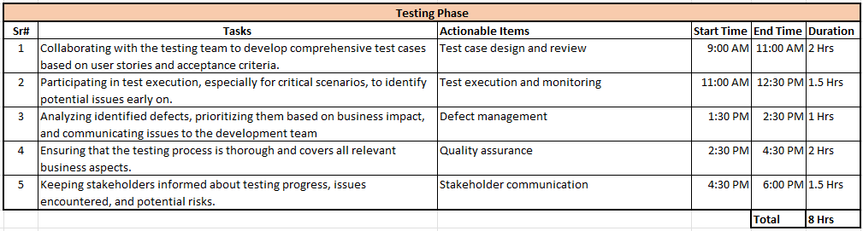

UAT Timesheet of a BA:

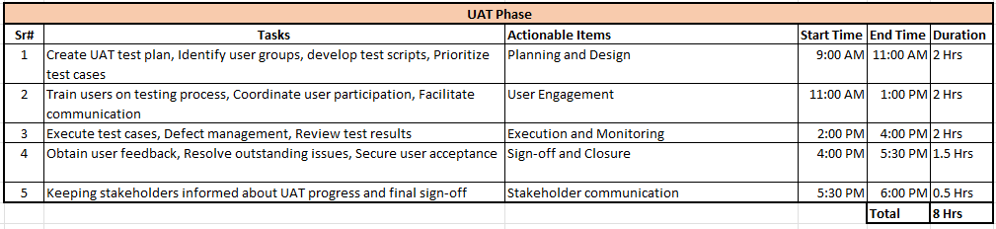

Deployment n Implementation Timesheet of a BA

