**Question 1 - Write Agile Manifesto – 8 Marks  
  
  
 Agile**

* Agile is light weight and can be implemented where faster delivery is required.
* Agile no documentation is required.
* Customer retention since no documentation.
* Agile does not support scalability and extendibility.

**Four Main values of agile**

* Individuals and interactions over processed and tools.
* Working software over comprehensive documentation.
* Customer collaboration over contract negotiation.
* Responding to change over following a plan.  
    
    
  **Twelve principles of Agile Software**1. Satisfy the customer through early and continuous delivery of valuable software.  
  2. Welcome changing requirements, even late in development. Agile processes harness change for the customer’s competitive advantage.  
  3. Deliver working software frequently, from a couple of weeks to a couple of months, with a preference to the shorter timescale.  
  4. Business people and developers must work together daily throughout the project.  
  5. Build projects around the motivated individuals. Give them the environment and support they need and trust them to get the job done.  
  6. The most efficient and effective method of conveying information to and within a development team is face to face conversation.  
  7. Working software is primary measure of progress.  
  8. Agile processes promote sustainable development. The Sponsors, developers, and users should be able to maintain constant pace indefinitely.  
  9. Continuous attention to technical excellence and good design enhances agility.  
  10. Simplicity the art of maximizing the amount of work not done is essential.  
    
  11. The best architectures, requirements and designs emerge from self organizing teams.  
  12. At regular intervals, the team reflects on how to become more effective, then tunes and adjusts its behavior accordingly.  
    
    
    
    
  **Question 2 - User Stories- Acceptance Criteria-BV-CP – 40 Marks**  
    
  Sprint 1  
    
  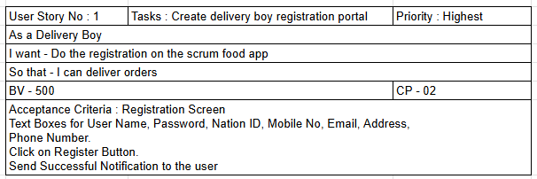  
    
  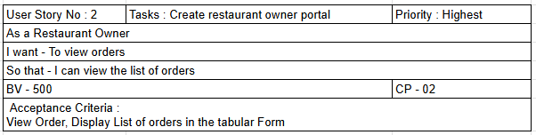  
    
  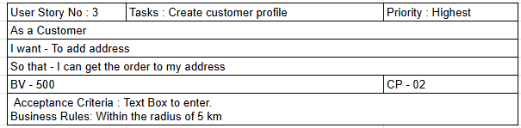  
    
  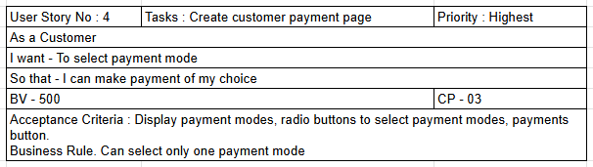  
    
  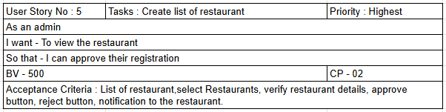  
    
  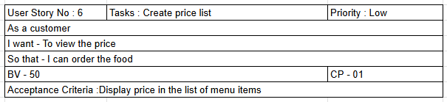

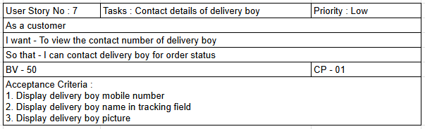  
  
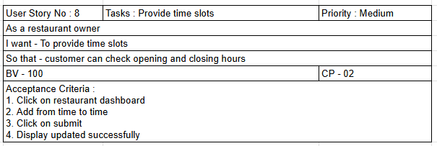

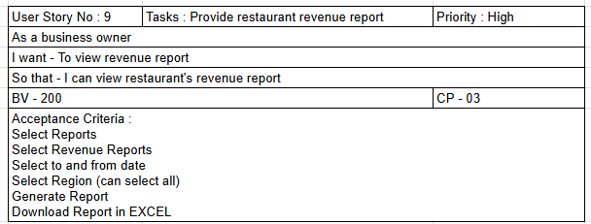  
  
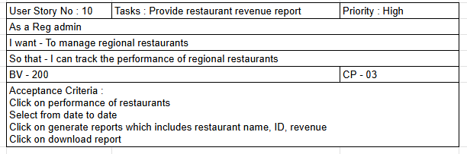  
  
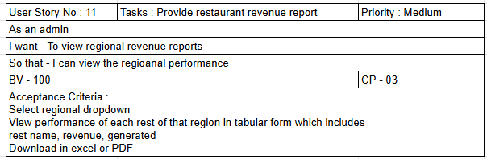  
  
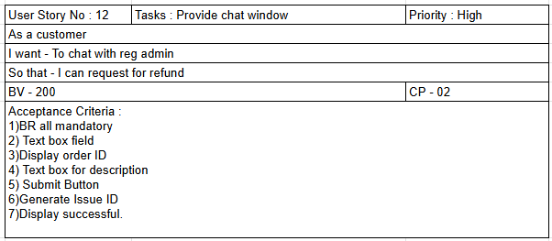  
  
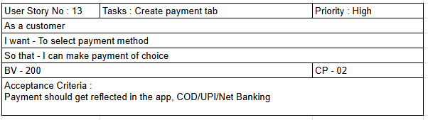  
  
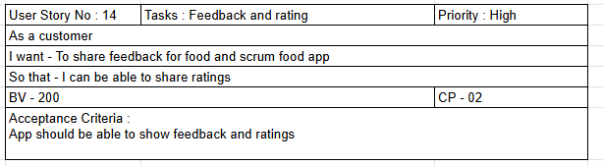  
  
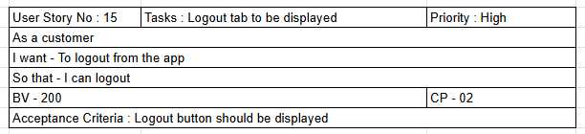

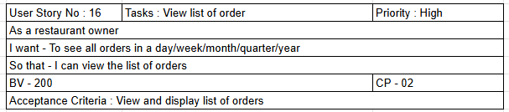

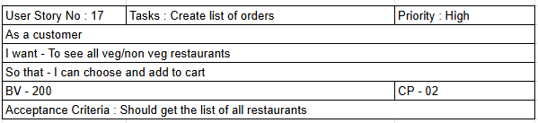

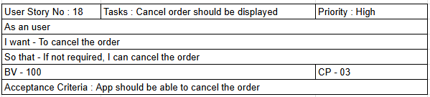  
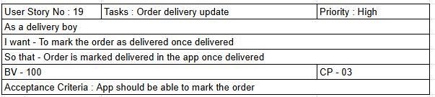  
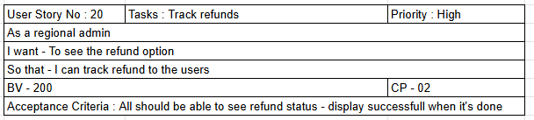

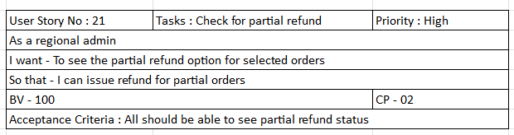  
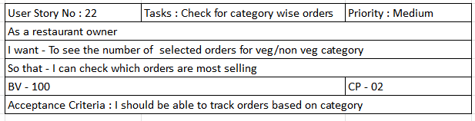  
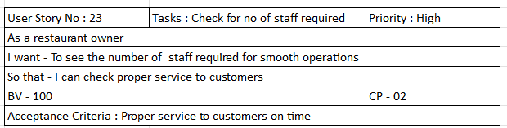

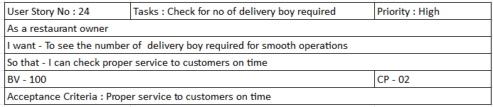  
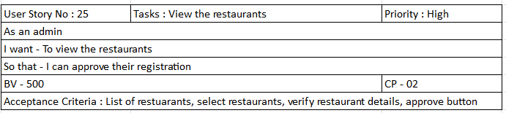  
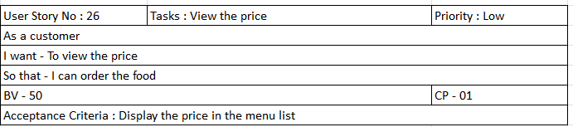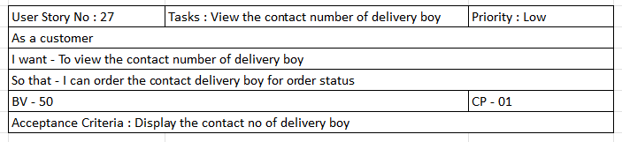  
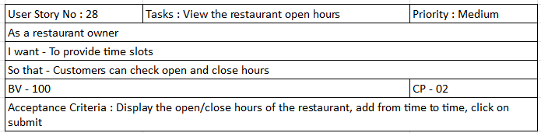  
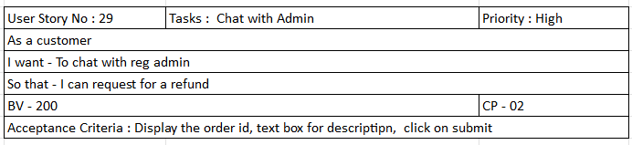  
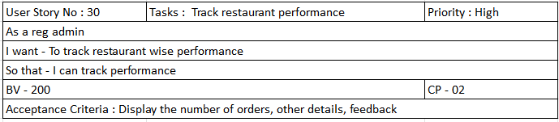  
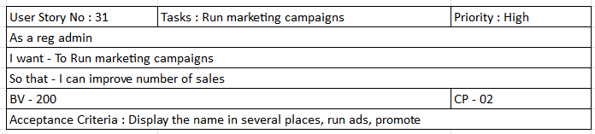  
  
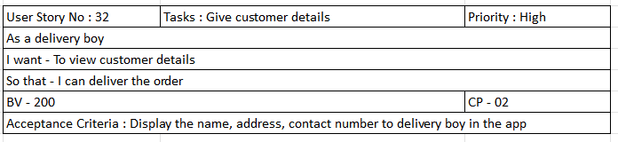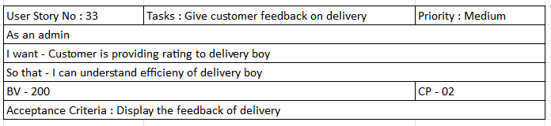  
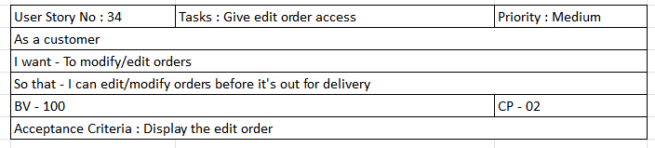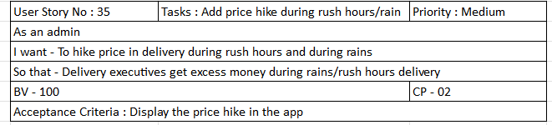  
  
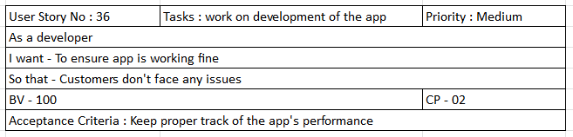  
  
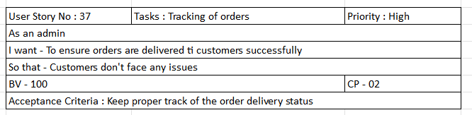

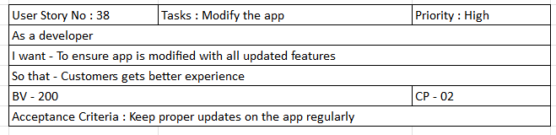  
  
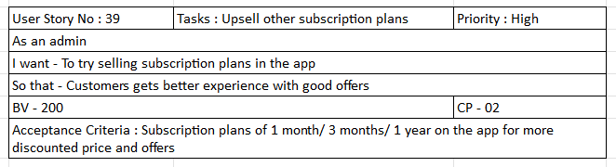  
  
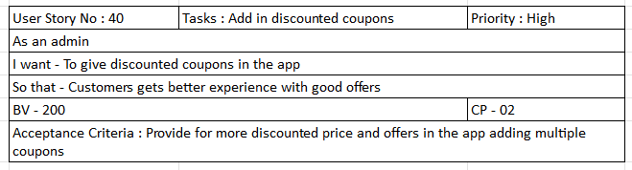  
  
  
  
  
  
  
  
**Question 3 - What is epic? Write 2 epics – 5 Marks**Epics are larger user stories that can be broken down into smaller manageable stories before the start of a sprint. An epic is a significant piece of work that will strategically add value to your product and business.  
  
1. Login – Customer should be able to login with Email ID and password  
2. Order history – Customer should be able to locate the current orders and previous orders.  
3. Search and filter – Customers should be able to search and filters all the available food option using key word.  
4. Design delivery map – As a part of the order status, users would like to view the location and arrival time for their food.  
  
  
**Question 4 - What is the difference between BV and CP – 2 Marks**\*\*Business value is the vision where in product owner uses to order the product backlog. It can be derived by lowering costs, increasing revenue, growing customer satisfaction, reducing risk or enhancing capability.  
  
**Business value is what delivered to end customer and how they have received it. Feedback from customer is good measure to know the value delivered.   
  
**Story Points is the rough estimation of user stories, will be given by the development and QA team in the form of planning poker or Fibonacci series.  
  
**Story points/velocity help development team to plan their work and have better delivery predictability.   
  
**Story points are an important part of user story mapping, and most agile teams use them when planning their work out each sprint.  
  
  
   
  
**Question 5 – Explain about Sprint– 5 Marks**  
Sprint Understanding

What is sprint Duration: 2 Weeks - Your sprint Value _________2 Weeks__________(Sprint are limited to one calendar month/do days or less)

Scrum is a subunit of Sprint.

What is scrum Duration: 1 day – Your scrum Value_____1 day____  
  
 PBI: Product Backlog Item – Contains list of all the user stories and Epic created by Product owner.   
  
  
Task: Unit of Work done by 1 Developer in 1 Scrum – During sprint palling meeting – So in every user story will be divided into sub task and will be allotted/picked up by the developers in that sprint.  
  
WIP: Work In Progress – The feature that are in the production process/phase but not yet the finished product. WIP therefore refers to all the task that are at various stages of the production process.   
  
Sprint Backlog – List of omitted user stories by dev and QA team for that particular sprint will be added in the sprint backlog.  
  
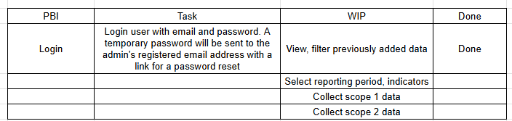  
  
  
  
  
  
**Question 6 – Explain Product backlog and sprint back log– 5 Marks**A product backlog is a prioritized list of work for the development team that is derived from the roadmap and its requirements. The most important items are shown at the top of the product backlog so the team knows what to deliver first.  
  
Sprint back log – is the subset of product backlog A sprint backlog is the set of items that a cross-functional product team selects from its product backlog to work on during the upcoming sprint. Typically the team will agree on these items during its sprint planning session. In fact, the sprint backlog represents the primary output of sprint planning.  
  
**Question 7 –** **What is impediments log? Write 2 impediments – 5 Marks**An Agile impediment log is used to record, track and resolve a list of obstacles, challenges that delay the team's performance.  
An Impediment is anything that keeps the Team from getting work done and that slows Velocity.  
  
Ex- sick team member, a missing resource, lack of management support Business or customer issues; unresolved dependencies  
  
Organizational Impediments – issues that are dependent on others to solve. These issues include but are not limited to:   
  
** Slow Internet  
** Issues with obtaining input from other teams or divisions  
** Lack of training  
  
  
  
  
  
  
  
  
  
  
**Question 8 – Explain Velocity of the Team – 1 Marks**Velocity is a measure of the amount of work a Team can tackle during a single Sprint and is the key metric in Scrum. Velocity is calculated at the end of the Sprint by totaling the Points for all fully completed User Stories. Estimated time for this course: 5 minutes.  
  
Actual velocity is calculated by dividing the total Story Points completed by the team by the number of Sprints. For instance, if the Scrum Team has finished a total of 80 points over 4 Sprints then the actual velocity of the team would be 20 points.  
  
ff0/4 = 20  
  
  
  
**Question 9 –**  **Draw Sprint Burn Charts n Product Burn Down Charts– 3 Marks**A product burn down chart shows how much work remains for the entire project, whereas a sprint burn down chart shows how much work remains in a specific iteration.  
  
A sprint burn down chart includes:  
** X-axis- The horizontal axis of the graph represents the remaining amount of time to complete the project usually depicted in days. Sprints  
** Y-axis- The vertical axis of the graph represents the effort needed to complete the project. Story Pt  
** Actual work line - This represents the actual number of tasks remaining. It might be straight in some cases; however, it often changes due to unforeseen issues in the projector an increase in the number of tasks.  
  
  
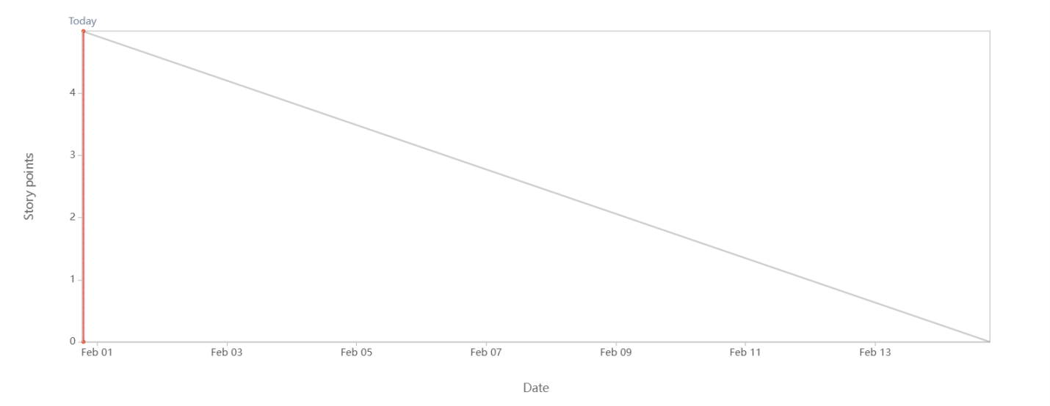  
  
  
  
  
**Question 10 –** **Explain about Product Grooming – 2 Marks**Grooming is an open discussion between the development team and product owner. The user stories are discussed to help the team gain a better understanding of the functionality that is needed to fulfill a story. This includes design considerations, integrations, and expected user interactions.  
Product Backlog grooming is a regular session where backlog items are discussed, reviewed, and prioritized by product managers, product owners, and the rest of the team. The primary goal of backlog grooming is to keep the backlog up-to-date and ensure that backlog items are prepared for upcoming sprints.  
  
 **Question 11 – Explain the roles of Scrum Master and Product Owner – 3 Marks**A Scrum Master popularly known as a coach, motivator and leader of an Agile team. The role of a Scrum Master is to educate the team on Agile processes and help team members follow Scrum practices religiously. Facilitation scrum event as and when it is required.  
  
The Scrum Master collaborates both with the Product Owner (PO) who focuses on building the right product, and the development team that focuses on building the product right. A Scrum Master’s job is essentially to help everyone understand and imbibe Scrum values, principles, and practices and get the best product out to the customer.  
  
The Product Owner takes the lead in many aspects of a product’s development. As a member of the Scrum Team, the Product Owner provides clarity to the team about a product’s vision and goal. All work is derived and prioritized based on the Product Goal in order to deliver value to all stakeholders including those within their organization and all users both inside and out. Product Owners identify measure and maximize value throughout the entire product's lifecycle.  
  
**Defining the vision  
**Prioritizing the product backlog  
**Taking an overview of development stages  
**Handling communications  
**Knowing what the client needs  
**Evaluating progress  
  
  
  
  
 **Question 12 –** **Explain all Meetings Conducted in Scrum Project – 8 Marks**\*\* Sprint planning meeting- Before your team begins a Scrum sprint; you need to know where you're going. The team defines the sprint goal and creates a sprint backlog which outlines the specific tasks required to complete the selected backlog items.   
  
** Daily standup meeting – This short daily meeting typically last 15 minutes, involves the development team. Each team member shares their progress since the last stand up, discusses any impediments or challenges they are facing and communicates their plan for the day. The focus is on transparency, co ordination and identifying the potential roadblocks.   
  
** Sprint review meeting – At the end of each sprint, the sprint review meeting takes place. The development team presents the work completed during the sprint to the stakeholders, including the product owners and users. The team demonstrates the features implemented and gathers feedback. The purpose is to assess progress, gather input and determine potential adjustments to the product backlog.   
  
** Sprint retrospective meeting – Immediately following the sprint review, the sprint retrospective meeting occurs. It is a dedicated session to the scrum team to reflect on the sprint, identify what went well and areas of improvement and discuss potential adjustments to their progress. The focus is on continuous learning, adaptation and enhancing team effectiveness.  
  
  
**Question 13 –** **Explain Sprint Size and Scrum Size– 2 Marks**Sprint Size- Sprints are the soul of Scrum methodology within Agile Project Management. A Sprint is a time-boxed event of weeks in which your Scrum team focuses only on a sprint goal. The goal is typically a product increment or iteration, often an updated, improved version of your product or software. Normally a sprint happens for two weeks.  
  
Scrum Size- The optimum size for the scrum team is around 10 members with varying skill sets and large enough to accomplish the tasks comfortably and share, communicate, and collaborate effectively. A Scrum team will have 1 Scrum Master, 1Product Owner and 8 to 10 Scrum Developers.  
  
  
 **Question 14 –** **Explain DOR and DOD – 2 Marks**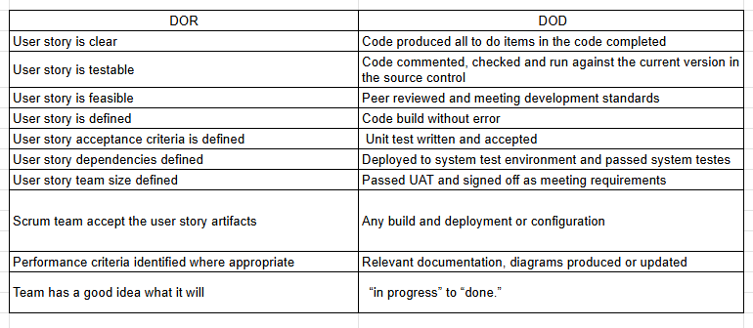  
  
  
**Question 15 –** **Explain Prioritization Techniques and MVP – 3 Marks**  
Prioritization Techniques -  
  
MOSCOW” Technique: Must should could would  
100 Dollars Test  
Top 10 requirements = Numerical Assignment-Mandatory, very important, rather important, not important; does not matter.  
“FURPS” Technique  
this technique is used to validate must requirement.  
F-Functionality  
U-Usability  
R-Reliability  
P-Performance  
S-Supportability (Extendable, Testable & Enhance-able)  
  
A minimum viable product (MVP) is the release of a new product (or a major new feature) that is used to validate customer needs and demands prior to developing a more fully featured product. To reduce development time and effort, an MVP includes only the minimum capabilities required to be a viable customer solution.   
  
A minimum viable product is a version of a product with just enough features to be usable by early customers who can then provide feedback for future product development. A focus on releasing an MVP means that developers potentially avoid lengthy and unnecessary work.   
  
  
  
**Question 16 –** **Difference between Business Analyst and Product Owner – 3 Marks**Product Owner role  
  
In many organizations, the Product Owner also has a Product Manager title and is responsible for making decisions about the product, for managing the product’s strategic roadmap and for communicating that roadmap. If there are cross-product impacts, then coordination of feature prioritization with other product POs is necessary - because certainly those in the C-suite are going to want to see a consolidated view of all product priorities.  
  
  
Business Analyst roleSimilar to the PO, the BA plays a critical role in working with the scrum team to execute the product vision by defining needs and recommend solutions that deliver value. The BA goes a bit deeper by breaking down high level product features into user stories, with the appropriate amount of detail. This may result in other BA artifacts –some of the most common examples I’ve experienced are capabilities gap analysis and process flow diagrams. **Question 17 –** **Prepare a sample Resume of 3yrs exp Product Owner – 3 Marks**  
**Sourav Banerjee**

sourav.banerjee301996@gmail.com

+91 8250443132

**Objective**

Motivated and forward-thinking product owner with 5+ years of experience in a Dynamic Sales environment. Eager to support team with leadership and guidance over a wide range of product development efforts. In previous roles reduced the delivery time by 20% and was able to coordinate 95% of product completion in line with the company roadmap.

**Work Experience**

**Agile Product Owner**

ABC Company, Bangalore

2021–Present

* Acted as liaison between business, sales and IT teams to refine the product and incorporate features based on market demands.
* Partnered with IT and product leadership to drive and manage the solution development process and ensure the product team understands the direction and vision.
* Collaborated with teams to discover and deliver the best solution to the market presented by the product team lead and the business.
* Created and maintained the solution vision, roadmap, and backlog of work through the project's life cycle.
* Translated features into user stories within the team’s backlog while managing, ranking, and prioritizing this backlog to reflect stakeholder’s requirements.

**Key achievement:**

* Effectively negotiated sprint goals with the team, which resulted in slashing delivery time by 20% in a single quarter.

**Scrum Product Owner**

XYZ Company, Bangalore

2019–2021

* Collaborated with stakeholders to understand business problem statements and convert them into user stories.
* Articulated product vision and user stories in a way clearly understandable to development teams.
* Managed backlog of user stories for 2 products simultaneously.
* Established user story acceptance criteria and refined stories with Scrum teams.
* Created Sprint Release Plans with input from development teams.
* Applied Agile methods and processes to promote a disciplined and transparent project management process.

**Key achievement:**

* Planned and estimated 2-week sprints in a realistic yet time-efficient manner that allowed the teams to deliver 97% of the MVP according to the company roadmap.

**Education**

B.Tech Computer Science

SRM University, Chennai

2019

**Key Skills**

* Conceptual skills
* User-centered design processes
* Design quality standards
* Service and product design methodologies
* Agile and Scrum
* Conducting design sprints
* User validation
* Analytical skills
* Collaboration and teamwork
* Communication

**Certifications**

* Certified Product Owner @ABC

**Languages**

* English
* Bengali
* Hindi

**Interests**

* Photography
* Cricket