**Assignment 1:**

1. **Prepare BRD**

**Business Requirements Document (BRD)**

**Project Title:** Inventory Management and Quick Delivery System  
**Version:** 1.0  
**Date:** 22/01/2025

**1. Executive Summary** The client operates manufacturing plants and warehouses across the country, producing ice cream and milk products. The goal of this project is to develop a robust software solution to achieve two key objectives:

1. Efficiently manage inventory across manufacturing and warehouse locations.
2. Ensure the quickest possible delivery of products to customers. This project aims to streamline operations, reduce delivery times, minimize inventory wastage, and enhance customer satisfaction.

**2. Business Objectives**

* **Optimize Inventory Management:**
  + Real-time inventory tracking.
  + Automated restocking alerts.
  + Enhanced visibility of stock levels across locations.
* **Ensure Quickest Delivery:**
  + Dynamic route optimization for deliveries.
  + Predictive analytics for demand forecasting and planning.

**3. Scope of the Project**

* **In-Scope:**
  + Manufacturing plant inventory tracking.
  + Warehouse stock management.
  + Customer order tracking and delivery scheduling.
  + Reporting dashboards.
  + Integration with existing ERP and logistics systems.
* **Out-of-Scope:**
  + Customer-facing e-commerce platform.
  + Manufacturing process automation.

**4. Stakeholders**

* **Internal:**
  + Operations Manager
  + Logistics Team
  + IT Department
* **External:**
  + Software Development Vendor
  + Logistics Providers
  + End Customers

**5. Requirements**

* **Functional Requirements:**
  + Inventory Tracking: Real-time updates on stock levels.
  + Order Management: Automated order assignment to warehouses.
  + Delivery Scheduling: Route optimization and dispatch notifications.
  + Reporting: Inventory reports, delivery performance metrics.
* **Non-Functional Requirements:**
  + Scalability to support future growth.
  + High system availability (99.9% uptime).

**6. Success Criteria**

* Reduction in inventory wastage by 20% within the first six months.
* Average delivery time reduced by 15%.
* Achieve 95% accuracy in stock level predictions.
* Increased customer satisfaction resulting in revenue growth

**7. Assumptions and Constraints**

* Assumes availability of accurate historical data for demand forecasting.
* Compliance with regional regulations for food product delivery.

**8. Development and Resource Plan**

* **Development Plan:**
  + **Phase 1:** Requirement Gathering and Analysis (2 weeks)
  + **Phase 2:** System Design (2 weeks)
  + **Phase 3:** Development (6 weeks)
  + **Phase 4:** Testing (4 weeks)
  + **Phase 5:** Deployment and Training (2 weeks)
* **Methodology:** Agile with bi-weekly sprints.
* **Resource Plan:**
  + **Business Analyst:** 1 (Full-time, 6 months)
  + **Project Manager:** 1 (Part-time, 6 months)
  + **Developers:** 4 (Full-time, 3 months)
  + **QA Engineers:** 2 (Full-time, 2 months)
  + **UI/UX Designer:** 1 (Part-time, 1 month)
  + **IT Support:** 1 (Part-time, ongoing)

**9. Risks and Dependencies**

* **Risks:**
  + Resistance to adoption of new system.
  + Data migration issues from legacy systems.
* **Dependencies:**
  + Availability of current inventory and delivery data.
  + Timely feedback from stakeholders during sprints.

**10. Appendices**

* Glossary
* Stakeholder RACI Chart

**Prepared by:** Nirvikar Naik  
**Role:** Business Analyst  
**Contact Information:** [nirvikarnaik@gmail.com](mailto:nirvikarnaik@gmail.com)

1. **Use Case Diagram**



**Use Case Specifications:**

**1. Use Case: Place Order**

|  |  |
| --- | --- |
| **Use Case ID** | **UC001** |
| **Use Case Name** | Place Order |
| **Actor(s)** | Customer (Primary) |
| **Description** | A customer places an order for ice cream or milk products through the system. |
| **Preconditions** | - The customer is logged into the system. |
| - Products and inventory details are updated. |
| **Flow of Events** | 1. Customer selects products and quantity. |
| 2. System verifies stock availability. |
| 3. Customer provides delivery address and preferred time slot. |
| 4. System generates an order summary. |
| 5. Customer confirms the order. |
| 6. Order details are saved, and confirmation is sent to the customer. |
| **Alternate Flow** | If the product is out of stock, the system notifies the customer and suggests alternatives. |
| **Postconditions** | - Order is successfully placed. |
| - Inventory is updated. |
| **Exceptions** | - Invalid payment method. |
| - System downtime. |

**2. Use Case: Track Inventory**

|  |  |
| --- | --- |
| **Use Case ID** | **UC002** |
| **Use Case Name** | Track Inventory |
| **Actor(s)** | Warehouse Manager (Primary) |
| **Description** | The warehouse manager monitors inventory levels in real-time. |
| **Preconditions** | - The system is operational. |
| - User has appropriate access rights. |
| **Flow of Events** | 1. Warehouse Manager logs into the system. |
| 2. Selects a specific warehouse or product category. |
| 3. System displays current stock levels, reorder alerts, and expiration dates. |
| 4. Manager updates stock levels if required. |
| **Alternate Flow** | The system automatically alerts for low stock levels. |
| **Postconditions** | - Accurate inventory status is displayed. |
| - Updates are reflected in real-time. |
| **Exceptions** | - Connectivity issues with the inventory database. |

**3. Use Case: Schedule Delivery**

|  |  |
| --- | --- |
| **Use Case ID** | **UC003** |
| **Use Case Name** | Schedule Delivery |
| **Actor(s)** | Logistics Team (Primary) |
| **Description** | The logistics team schedules deliveries based on orders and optimizes delivery routes. |
| **Preconditions** | - Order is placed and ready for dispatch. |
| - Delivery personnel and vehicles are available. |
| **Flow of Events** | 1. Logistics team accesses pending orders in the system. |
| 2. System suggests optimized delivery routes. |
| 3. Delivery slots are scheduled based on customer preferences. |
| 4. Team assigns orders to drivers. |
| 5. Dispatch is confirmed in the system. |
| **Alternate Flow** | If no vehicles are available, the system sends an alert to the team. |
| **Postconditions** | - Delivery schedule is finalized. |
| - Notifications sent to customers. |
| **Exceptions** | - Unexpected vehicle breakdown. |
| - System fails to generate optimized routes. |

**4. Use Case: Dispatch Order**

|  |  |
| --- | --- |
| **Use Case ID** | **UC004** |
| **Use Case Name** | Dispatch Order |
| **Actor(s)** | Warehouse Manager (Primary) |
| **Description** | Orders are prepared for dispatch and handed over to the delivery team. |
| **Preconditions** | - The order is scheduled for delivery. |
| - Inventory is updated for the dispatched items. |
| **Flow of Events** | 1. Warehouse Manager prints the order dispatch list. |
| 2. Items are packed and labelled. |
| 3. Dispatch confirmation is updated in the system. |
| 4. Items are handed over to the delivery team. |
| **Alternate Flow** | If items are damaged or missing, dispatch is delayed. |
| **Postconditions** | - Order is marked as dispatched. |
| - Tracking information is sent to the customer. |
| **Exceptions** | - Missing products in inventory. |

**5. Use Case: Generate Reports**

|  |  |
| --- | --- |
| **Use Case ID** | **UC005** |
| **Use Case Name** | Generate Reports |
| **Actor(s)** | System Administrator (Secondary) |
| **Description** | Generate periodic reports on inventory, order fulfilment, and delivery efficiency. |
| **Preconditions** | - System data is up-to-date. |
| - User has admin privileges. |
| **Flow of Events** | 1. Administrator selects the type of report (inventory, delivery, sales). |
| 2. Defines the date range and report parameters. |
| 3. System compiles data and generates the report. |
| 4. Administrator downloads or shares the report. |
| **Alternate Flow** | If data is incomplete, the system flags it and allows a partial report generation. |
| **Postconditions** | - Report is successfully generated. |
| - Data insights are available for analysis. |
| **Exceptions** | - Data inconsistency or corruption. |

**Assignment 2**

1. Write an introduction letter to a client introducing yourself as a business analyst in charge of working with the client and his team to start the business understanding process

Dear Mr. Sandeep Bhopatkar,

**Subject: Introduction as Your Dedicated Business Analyst**

I hope this message finds you well. My name is Nirvikar Naik, and I am a Business Analyst at ICICI Bank Ltd. I am delighted to introduce myself as your dedicated point of contact for the upcoming project focused on Inventory Management and Quick Delivery System.

My role in this collaboration is to work closely with you and your team to understand your business objectives, identify key challenges, and translate them into actionable requirements that align with your vision. With a comprehensive understanding of the end-to-end project lifecycle, I will ensure that we prioritize clear communication, efficient processes, and the delivery of high-quality solutions tailored to your needs.

**How I Can Support You:**

* **Requirements Gathering:** Conduct detailed discussions to understand your current workflows, pain points, and desired outcomes.
* **Stakeholder Collaboration:** Facilitate seamless communication between your team and our technical experts.
* **Documentation:** Prepare structured documentation such as Business Requirements Documents (BRDs), System Requirements Specifications (SRS), and process diagrams to maintain clarity and alignment.
* **Solution Design:** Work with the development team to ensure the proposed solution is practical, scalable, and meets your expectations.
* **Continuous Engagement:** Provide regular updates, address queries, and adapt to any evolving requirements to ensure the project remains on track.

I look forward to scheduling an initial meeting to discuss your vision, priorities, and key expectations for the project. In the meantime, please feel free to reach out to me via email at nirvikarnaik@gmail.com or call me directly at +91 7774078756.

Thank you for entrusting us with this exciting opportunity. I am confident that, together, we can achieve remarkable results.

Warm regards,

**Nirvikar Naik**  
Business Analyst  
ICICI Bank Ltd  
nirvikarnaik@gmail.com | 7774078756

1. Prepare a brief BRD and SRS for a project- Horoscope or Ticketing system or online store

**Business Requirements Document (BRD)**

**Project Title**: Online Ticketing System

**Introduction**

This project aims to develop an Online Ticketing System that allows users to book tickets for events or movies conveniently through a web-based platform. The system will enhance customer experience by providing a seamless booking process, secure payments, and real-time updates on ticket availability.

**Business Goals and Objectives**

* Goals:
  + Streamline the ticket booking process.
  + Reduce manual efforts for booking and ticket management.
  + Increase customer satisfaction by offering a user-friendly platform.
* Objectives:
  + Provide an intuitive interface for users to search for events/movies options.
  + Enable secure and multiple payment options.
  + Deliver automated notifications and confirmations.

**Scope**

* In-Scope:
  + User registration and profile management.
  + Ticket search and booking functionalities.
  + Secure online payment processing.
  + Real-time seat availability updates.
  + Email/SMS notifications for bookings and cancellations.
* Out-of-Scope:
  + Offline ticket booking.

**Stakeholders**

* Customers (end-users)
* Event organizers
* Admin and support team
* Payment gateway providers

**Assumptions**

* All users will have internet access.
* Payment gateways will be integrated and operational.
* Seat availability data will be updated in real-time.

**High-Level Requirements**

1. User Registration: Users can create and manage their profiles.
2. Search Functionality: Users can search for tickets based on criteria like date, category, or location.
3. Booking Process: Users can select seats, confirm bookings, and make payments.
4. Notifications: Users receive booking confirmations and reminders.
5. Admin Panel: Admins can manage events, monitor bookings, and generate reports.

**Risks and Dependencies**

* Risk: Downtime of payment gateway providers.
* Dependency: Timely updates from event organizers.

**Success Criteria**

* 95% user satisfaction rating within the first 6 months.
* Minimum system downtime (<1%) after deployment.

**System Requirements Specification (SRS)**

Project Title: Online Ticketing System

**Introduction**

The Online Ticketing System will provide a robust platform for users to book tickets, ensuring security, scalability, and user-friendly operations.

Functional Requirements

1. User Registration and Login:
   * Users must register with an email and password.
   * Password recovery functionality must be available.
2. Ticket Search:
   * Users can filter events by category, date, location, and price range.
   * The system displays event details, available seats, and pricing.
3. Booking and Payments:
   * Users can select preferred seats and confirm their booking.
   * Payment methods include credit/debit cards, UPI, and wallets.
4. Notifications:
   * Email and SMS confirmations for successful bookings.
   * Notifications for changes or cancellations.
5. Admin Functions:
   * Manage event data (add/edit/delete events).
   * View and resolve customer complaints.
   * Generate sales and activity reports.

Non-Functional Requirements

* Performance: The system should handle 1,000 concurrent users.
* Usability: The interface should adhere to accessibility standards.
* Security: Payment data must be encrypted.
* Scalability: The system should accommodate growing user demand.

System Architecture

1. Frontend:
   * Built using React or Angular for a responsive design.
2. Backend:
   * Node.js/Java with a RESTful API.
3. Database:
   * MySQL for managing user, booking, and event data.
4. Payment Gateway:
   * Integration with Visa, Paytm, Mastercard
5. Hosting:
   * Cloud-based hosting (AWS or Azure).

Assumptions and Constraints

* Assumption: Users will provide valid information during registration.
* Constraint: The system must support multi-language capabilities.

Acceptance Criteria

* Users can complete a booking within 3 minutes.
* The system provides real-time seat updates.
* Admin can generate a daily sales report within 2 minutes.

1. Make an ERD of creating a support ticket/Ticketing life cycle

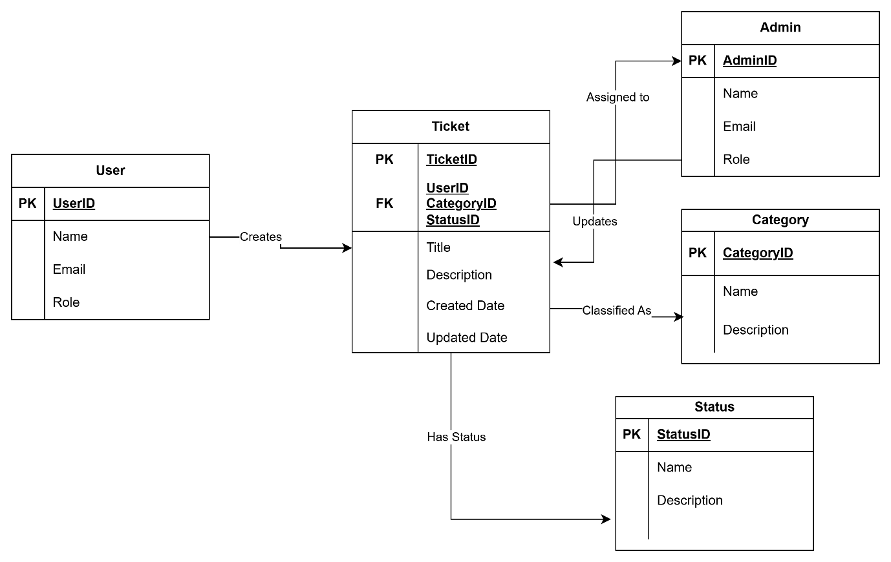

1. User story of shopping from ecommerce

**As a Customer:**

1. I want to create an account using my email address so that I can save my preferences and order history.
2. I want to log in using my email and password so that I can access my account securely.
3. I want to browse products by category so that I can find items of interest easily.
4. I want to search for products by keyword so that I can find specific items quickly.
5. I want to view detailed product descriptions so that I can make informed purchasing decisions.
6. I want to filter products by price, brand, and ratings so that I can narrow down my choices.
7. I want to sort products by price, popularity, and reviews so that I can identify the best options.
8. I want to add products to my cart so that I can review and purchase them later.
9. I want to view my cart so that I can see all selected products and their total cost.
10. I want to update the quantity of items in my cart so that I can adjust my order before checkout.
11. I want to remove items from my cart so that I can change my purchase decisions.
12. I want to save items to a wishlist so that I can consider them for future purchases.
13. I want to apply discount codes or coupons at checkout so that I can save money.
14. I want to choose a shipping method so that I can receive my products at my convenience.
15. I want to enter a delivery address so that my order is shipped to the correct location.
16. I want to pay securely using multiple payment options so that I can complete my purchase.
17. I want to receive an order confirmation email so that I know my purchase was successful.
18. I want to track my order so that I can know its status and expected delivery date.
19. I want to return a product so that I can get a refund or replacement if it doesn’t meet my expectations.
20. I want to review my past orders so that I can reorder items easily.

**As an Admin:**

21. I want to add new products to the catalog so that customers can view and purchase them.

22. I want to update product details so that information is always accurate.

23. I want to remove discontinued products from the catalog so that customers do not order unavailable items.

24. I want to manage inventory levels so that stock availability is accurately reflected.

25. I want to process and approve returns so that customers can receive refunds or replacements.

26. I want to manage user accounts so that I can address any account-related issues.

27. I want to generate sales reports so that I can monitor business performance.

28. I want to manage promotional offers and discounts so that customers are encouraged to shop.

29. I want to approve product reviews so that only appropriate content is displayed.

30. I want to analyze customer behavior data so that I can improve the shopping experience.

**As a Vendor:**

31. I want to list my products on the platform so that I can sell them to customers.

32. I want to manage my product inventory so that my listings are accurate.

33. I want to view sales reports for my products so that I can track performance.

34. I want to handle customer inquiries about my products so that I can provide good service.

35. I want to manage product pricing so that I can remain competitive.

**As a System Admin:**

36. I want to validate user input during account creation so that invalid data is not stored.

37. I want to recommend products based on browsing history so that customers find relevant items.

38. I want to send automated notifications for order updates so that customers stay informed.

39. I want to process payments securely so that customer data remains safe.

40. I want to prevent duplicate orders so that customers are not charged multiple times for the same purchase.