**Question 1** – write Agile Manifesto

**Answer-** The Agile Manifesto is a foundational document for Agile software development, emphasizing flexibility, collaboration, and responsiveness to change. It is based on four key values and twelve principles

Four main values are-

1. Individuals and interactions over processes and tools.
2. Working software over comprehensive documentation.
3. Customer collaboration over contract negotiation.
4. Responding to change over following a plan.

While there is value in the items on the right, we value the items on the left more.

Agile principles are-

1. Make the customer happy by delivering something useful quickly and often.
2. Be okay with changing plans, even if it's late in the project.
3. Show progress by delivering small working parts of the product regularly.
4. Work together every day with customers and team members.
5. Trust your team and give them the support they need.
6. Talk face-to-face whenever possible—it’s the best way to communicate.
7. Focus on delivering useful, working products—that’s what really matters.
8. Work at a steady pace that the team can keep up with over time.
9. Do your best work by focusing on quality and good design.
10. Keep things simple and don’t waste time doing things that aren’t needed.
11. Teams work best when they are independent and self-organized.
12. Regularly look back, learn from your mistakes, and improve how you work.

**Question 2**- Write minimum 40 User stories and their Acceptance Criteria along with their BV and CP

**Answer-** A user story is a short, simple description of a feature or requirement, written from the perspective of the end user or customer. It captures who the user is, what they want to accomplish, and why it matters, here are some user stories –

|  |  |  |  |
| --- | --- | --- | --- |
| User story N0: 1 | | Task: 01 | Priority: High |
| **As a Customer,** I want to register and create an  account,  so that I can log in and use the Scrum Food app. | | | |
| BV: 100 | CP: 02 | | |
| Acceptance Criteria:  Click on Register button.  Enter valid name, email, phone number, and password.  Click on Submit to successfully create an account | | | |

|  |  |  |  |
| --- | --- | --- | --- |
| User story N0: 02 | Task: 01 | Priority: High | |
| **As a Customer,** I want to log in using my credentials,  so that I can access my account securely. | | | |
| BV: 100 | | | CP: 02 |
| Acceptance Criteria:  Enter a valid email and password.  Click on Login to access the account.  Display an error message for invalid credentials. | | | |

|  |  |  |  |
| --- | --- | --- | --- |
| User story N0: 03 | Task: 01 | Priority: Medium | |
| **As a Customer,** I want to search for restaurants,  so that I can view nearby options for ordering food. | | | |
| BV: 200 | | | CP: 03 |
| Acceptance Criteria:  Enter a keyword or use location-based search.  Display results based on proximity, ratings, and availability.  Filter restaurants by cuisine type, ratings, or delivery time. | | | |

|  |  |  |  |
| --- | --- | --- | --- |
| User story N0: 04 | Task: 01 | Priority: Medium | |
| **As a Customer,** I want to view a restaurant’s menu,  so that I can choose the items I want to order. | | | |
| BV: 150 | | | CP: 02 |
| Acceptance Criteria:  Click on a restaurant to view its menu.  Display items with descriptions, prices, and availability.  Allow sorting and filtering by category or price. | | | |

|  |  |  |  |
| --- | --- | --- | --- |
| User story N0: 05 | Task: 02 | Priority: High | |
| **As a Customer,** I want to place an order,  so that I can get food delivered to my location. | | | |
| BV: 300 | | | CP: 05 |
| Acceptance Criteria:  Select items from the menu and add them to the cart.  Review the cart for quantity and pricing.  Confirm the delivery address and payment method.  Receive an order confirmation notification. | | | |

|  |  |  |  |
| --- | --- | --- | --- |
| User story N0: 06 | Task: 02 | Priority: High | |
| **As a Customer,** I want to track my order status,  so that I can know when it will be delivered. | | | |
| BV: 250 | | | CP: 03 |
| Acceptance Criteria:  Click on the Track Order option.  Display the current status (e.g., Preparing, Out for Delivery, Delivered).  Update status in real-time | | | |

|  |  |  |  |
| --- | --- | --- | --- |
| User story N0: 07 | Task: 03 | Priority: High | |
| **As a Customer,** I want to cancel an order,  so that I can stop the delivery if needed. | | | |
| BV: 150 | | | CP: 03 |
| Acceptance Criteria:  Click on the **Cancel Order** option before the order is out for delivery.  Confirm cancellation with a prompt.  Receive a notification for successful cancellation | | | |

|  |  |  |  |
| --- | --- | --- | --- |
| User story N0: 08 | Task: 01 | Priority: Medium | |
| **As a Customer,** I want to leave feedback and ratings for an order,  so that I can share my experience. | | | |
| BV: 200 | | | CP: 03 |
| Acceptance Criteria:  Click on Feedback after the order is delivered.  Provide ratings (1-5 stars) and write comments.  Submit the feedback successfully. | | | |

|  |  |  |  |
| --- | --- | --- | --- |
| User story N0: 09 | Task: 01 | Priority: High | |
| **As a Delivery Boy,** I want to register and create an account,  so that I can access delivery features. | | | |
| BV: 100 | | | CP: 02 |
| Acceptance Criteria:  Enter valid name, email, phone number, and vehicle details  Click on Submit to register successfully. | | | |

|  |  |  |  |
| --- | --- | --- | --- |
| User story N0: 10 | Task: 01 | Priority: High | |
| **As a Delivery Boy,** I want to log in using my credentials,  so that I can access my delivery dashboard. | | | |
| BV: 100 | | | CP: 02 |
| Acceptance Criteria:  Enter a valid email and password.  Click on Login to access the dashboard.  Display an error message for invalid credentials. | | | |

|  |  |  |  |
| --- | --- | --- | --- |
| User story N0: 11 | Task: 01 | Priority: High | |
| **As a Delivery Boy,** I want to view available delivery orders,  so that I can choose and accept orders to deliver. | | | |
| BV: 150 | | | CP: 03 |
| Acceptance Criteria:  Login to the application.  Navigate to the Orders section.  Select an order from the available list and accept it. | | | |

|  |  |  |  |
| --- | --- | --- | --- |
| User story N0: 12 | Task: 01 | Priority: Medium | |
| **As a Delivery Boy,** I want to update the delivery status,  so that customers and restaurants are informed about progress. | | | |
| BV: 200 | | | CP: 03 |
| Acceptance Criteria:  Click on the Start Delivery button after accepting an order.  Mark as Order Picked Up when food is collected.  Mark as Delivered after successful delivery to the customer. | | | |

|  |  |  |  |
| --- | --- | --- | --- |
| User story N0: 13 | Task: 01 | Priority: High | |
| **As a Delivery Boy,** I want to view my delivery history and revenue,  so that I can track my performance and earnings. | | | |
| BV: 250 | | | CP: 04 |
| Acceptance Criteria:  Click on the Delivery History section  View a list of completed deliveries with revenue details.  Filter history by date range | | | |

|  |  |  |  |
| --- | --- | --- | --- |
| User story N0: 14 | Task: 01 | Priority: High | |
| **As a Restaurant,** I want to register and create an account,  so that I can list my restaurant on the Scrum Food platform. | | | |
| BV: 200 | | | CP: 03 |
| Acceptance Criteria:  Enter valid restaurant details (name, address, contact info)  Submit required documents for verification.  Successfully register and receive a confirmation notification. | | | |

|  |  |  |  |
| --- | --- | --- | --- |
| User story N0: 15 | Task: 01 | Priority: High | |
| **As a Restaurant,** I want to view customer orders,  so that I can prepare them for delivery. | | | |
| BV: 250 | | | CP: 04 |
| Acceptance Criteria:  Login to the platform.  Navigate to the Orders section.  View details like item names, quantities, and customer details | | | |

|  |  |  |  |
| --- | --- | --- | --- |
| User story N0: 16 | Task: 02 | Priority: Medium | |
| **As a Restaurant,** I want to update order preparation status,  so that delivery boys know when to pick up the food | | | |
| BV: 200 | | | CP: 03 |
| Acceptance Criteria:  Mark orders as Preparing, Ready for Pickup, or Delayed  Notify the assigned delivery boy automatically | | | |

|  |  |  |  |
| --- | --- | --- | --- |
| User story N0: 17 | Task: 02 | Priority: High | |
| **As a Restaurant,** I want to track the revenue generated,  so that I can monitor my performance on the platform. | | | |
| BV: 300 | | | CP: 03 |
| Acceptance Criteria:  Click on the Revenue section.  Select a time range to filter revenue reports.  View and download the revenue data in Excel format. | | | |

|  |  |  |  |
| --- | --- | --- | --- |
| User story N0: 18 | Task: 02 | Priority: Low | |
| **As a Restaurant,** I want to manage my menu items,  so that I can update or remove items as needed. | | | |
| BV: 200 | | | CP: 03 |
| Acceptance Criteria:  Navigate to the Menu Management section.  Add, edit, or remove items from the menu.  Save changes and reflect them in real-time. | | | |

|  |  |  |  |
| --- | --- | --- | --- |
| User story N0: 19 | Task: 02 | Priority: LOW | |
| **As a Restaurant,** I want to respond to customer feedback,  so that I can address concerns and improve services. | | | |
| BV: 150 | | | CP: 03 |
| Acceptance Criteria:  view customer feedback in the Feedback section.  Respond to comments where necessary.  Resolve flagged issues promptly. | | | |

|  |  |  |  |
| --- | --- | --- | --- |
| User story N0: 20 | Task: 02 | Priority: MEDUIM | |
| **As a Restaurant,** I want to raise issues or support requests,  so that I can resolve operational challenges. | | | |
| BV: 100 | | | CP: 02 |
| Acceptance Criteria:  Navigate to the Support section.  Submit a detailed description of the issue.  Receive a ticket number for tracking resolution | | | |

|  |  |  |  |
| --- | --- | --- | --- |
| User story N0: 21 | Task: 02 | Priority: High | |
| **As a Regional Admin,** I want to log in securely,  so that I can manage regional operations. | | | |
| BV: 100 | | | CP: 02 |
| Acceptance Criteria:  Enter valid credentials to log in.  Redirect to the dashboard after a successful login.  Display error messages for invalid credentials. | | | |

|  |  |  |  |
| --- | --- | --- | --- |
| User story N0: 22 | Task: 02 | Priority: High | |
| **As a Regional Admin,** I want to manage regional delivery boys,  so that I can ensure timely food delivery. | | | |
| BV: 300 | | | CP: 04 |
| Acceptance Criteria:  Add, edit, or deactivate delivery boy accounts.  View delivery boy performance and feedback.  Update account statuses as needed. | | | |

|  |  |  |  |
| --- | --- | --- | --- |
| User story N0: 23 | Task: 02 | Priority: MEDUIM | |
| **As a Regional Admin,** I want to view regional restaurant performance, so that I can monitor their contributions. | | | |
| BV: 200 | | | CP: 03 |
| Acceptance Criteria:  Navigate to the Restaurant Performance section.  View key metrics like orders completed and revenue generated.  Filter data by date range or restaurant name. | | | |

|  |  |  |  |
| --- | --- | --- | --- |
| User story N0: 24 | Task: 02 | Priority: MEDUIM | |
| **As a Regional Admin,** I want to resolve customer issues,  so that I can improve customer satisfaction. | | | |
| BV: 250 | | | CP: 04 |
| Acceptance Criteria:  Access the Customer Issues section.  View detailed issue descriptions and track resolution progress.  Mark issues as resolved once addressed. | | | |

|  |  |  |  |
| --- | --- | --- | --- |
| User story N0: 25 | Task: 02 | Priority: HIGH | |
| **As a Regional Admin,** I want to generate revenue reports for my region, so that I can analyze financial performance. | | | |
| BV: 300 | | | CP: 05 |
| Acceptance Criteria:  Include revenue details for restaurants and delivery boys.  Download reports in PDF or Excel formats. | | | |

|  |  |  |  |
| --- | --- | --- | --- |
| User story N0: 26 | Task: 02 | Priority: HIGH | |
| **As a Regional Admin,** I want to monitor refunds issued,  so that I can ensure proper accountability. | | | |
| BV: 200 | | | CP: 03 |
| Acceptance Criteria:  View refund requests from customers.  Approve or reject refund requests based on validation.  Track approved refunds in the Refund History section. | | | |

|  |  |  |  |
| --- | --- | --- | --- |
| User story N0: 27 | Task: 02 | Priority: Medium | |
| **As a Regional Admin,** I want to oversee regional revenue distribution, so that restaurants and delivery boys are paid fairly. | | | |
| BV: 250 | | | CP: 04 |
| Acceptance Criteria:  Access the Revenue Distribution section.  View earnings for restaurants and delivery boys.  Generate payment schedules for timely disbursements. | | | |

|  |  |  |  |
| --- | --- | --- | --- |
| User story N0: 28 | Task: 02 | Priority: Medium | |
| **As a Regional Admin,** I want to manage customer feedback for my region,  so that I can improve service quality. | | | |
| BV: 200 | | | CP: 03 |
| Acceptance Criteria:  Access the Customer Feedback section.  View and categorize feedback by type (positive, negative, neutral)  Take corrective actions based on critical feedback | | | |

|  |  |  |  |
| --- | --- | --- | --- |
| User story N0: 29 | Task: 02 | Priority: Medium | |
| **As an Admin,** I want to manage regional admins,  so that I can oversee all regional operations. | | | |
| BV: 300 | | | CP: 05 |
| Acceptance Criteria:  Add or remove regional admin accounts.  Edit access permissions for regional admins  View performance metrics for each regional admin. | | | |

|  |  |  |  |
| --- | --- | --- | --- |
| User story N0: 30 | Task: 02 | Priority: Medium | |
| **As an Admin,** I want to approve or reject restaurant registration requests,  so that only verified businesses are listed. | | | |
| BV: 200 | | | CP: 03 |
| Acceptance Criteria:  Access the Registration Requests section.  Review submitted documents and details.  Approve or reject requests with reasoning. | | | |

|  |  |  |  |
| --- | --- | --- | --- |
| User story N0: 31 | Task: 02 | Priority: Medium | |
| **As an Admin,** I want to manage customer feedback platform-wide,  so that I can maintain service standards. | | | |
| BV: 250 | | | CP: 04 |
| Acceptance Criteria:  View feedback from all regions.  Escalate unresolved feedback to the respective regional admin  Track the resolution of critical feedback | | | |

|  |  |  |  |
| --- | --- | --- | --- |
| User story N0: 32 | Task: 02 | Priority: Medium | |
| **As an Admin,** I want to resolve escalated issues from regional admins, so that I can address complex problems effectively. | | | |
| BV: 300 | | | CP: 05 |
| Acceptance Criteria:  Access the Escalated Issues section  Assign issues to specialized support teams if necessary  Monitor issue resolution and close resolved tickets. | | | |

|  |  |  |  |
| --- | --- | --- | --- |
| User story N0: 33 | Task: 02 | Priority: Low | |
| **As an Admin,** I want to track overall revenue performance,  so that I can present data to stakeholders. | | | |
| BV: 400 | | | CP: 05 |
| Acceptance Criteria:  Generate detailed revenue reports by region and platform-wide.  Include graphical analysis of trends over time.  Export reports in multiple formats (PDF, Excel, CSV). | | | |

|  |  |  |  |
| --- | --- | --- | --- |
| User story N0: 34 | Task: 02 | Priority: Low | |
| **As an Admin,** I want to manage refund policies,  so that I can ensure fair practices across the platform. | | | |
| BV: 150 | | | CP: 03 |
| Acceptance Criteria:  Access the Refund Policy Management section  Update policy terms and conditions.  Notify all stakeholders of policy changes. | | | |

|  |  |  |  |
| --- | --- | --- | --- |
| User story N0: 35 | Task: 02 | Priority: Medium | |
| **As an Admin,** I want to track and resolve payment disputes,  so that financial inconsistencies are minimizeD. | | | |
| BV: 250 | | | CP: 04 |
| Acceptance Criteria:  View and categorize disputes by region and type.  Resolve disputes in collaboration with regional admins.  Record resolved disputes in the Dispute History section. | | | |

|  |  |  |  |
| --- | --- | --- | --- |
| User story N0: 36 | Task: 02 | Priority: Medium | |
| **As a Business Owner,** I want to view detailed reports of platform performance,  so that I can assess business growth | | | |
| BV: 400 | | | CP: 05 |
| Acceptance Criteria:  Access the Business Reports section.  Generate reports on revenue, orders, and feedback trends.  Download reports for presentations and meetings. | | | |

|  |  |  |  |
| --- | --- | --- | --- |
| User story N0: 37 | Task: 02 | Priority: High | |
| **As a Business Owner,** I want to update payments for restaurants and delivery boys,  so that timely compensation is ensured | | | |
| BV: 300 | | | CP: 04 |
| Acceptance Criteria:  Access the Payment Management section.  View pending payments for restaurants and delivery boys.  Approve and release payments after verification. | | | |

|  |  |  |  |
| --- | --- | --- | --- |
| User story N0: 38 | Task: 02 | Priority: High | |
| **As a Business Owner,** I want to resolve escalated payment issues,  so that operational efficiency is maintained. | | | |
| BV: 200 | | | CP: 03 |
| Acceptance Criteria:  Access the Escalated Payment Issues section.  View details of escalated issues, including transaction IDs, amounts, and reasons for escalation.  Contact the relevant regional admin or support team for resolution.  Generate a report of resolved and pending payment issues. | | | |

|  |  |  |  |
| --- | --- | --- | --- |
| User story N0: 39 | Task: 02 | Priority: Medium | |
| **As a Business OWNER,** I want to analyze platform-wide customer behavior, so that I can make data-driven strategic decisions. | | | |
| BV: 350 | | | CP: 05 |
| Acceptance Criteria:  Access the Customer Insights section view aggregated data on customer orders, preferences, and feedback trends.  Download analytics reports in various formats (PDF, Excel).  Identify top-performing areas and areas for improvement. | | | |

|  |  |  |  |
| --- | --- | --- | --- |
| User story N0: 40 | Task: 02 | Priority: Medium | |
| **As a Business OWNER,** i want to set business goals for revenue and performance, so that all stakeholders work towards achieving targets. | | | |
| BV: 300 | | | CP: 04 |
| Acceptance Criteria:  Navigate to the Business Goals section.  Define measurable goals for revenue, customer satisfaction, and order volume  Monitor progress through periodic updates and performance dashboards. | | | |

**Question 3**– What is epic? Write 2 epics

**Answer-**

An epic is a big task or feature in a project that takes a lot of work and time to complete. It’s like a large goal that is broken down into smaller, easier tasks (called user stories) so that the team can work on them step by step.

Here are two sample epics, and under one of them, I've broken down five user stories with their Business Value (BV) and Complexity Points (CP).

**Epic 1**: Enable customers to purchase products online.

|  |  |  |  |
| --- | --- | --- | --- |
| User story N0: 01 | Task: 02 | Priority: Medium | |
| **As a user**, I want to browse a catalog of agricultural products,  so that I can view available items. | | | |
| BV: 08 | | | CP: 05 |
|  | | | |
| User story N0: 02 | Task: 02 | Priority: Medium | |
| **As a user**, I want to add products to my cart,  so that I can review my selected items before checkout. | | | |
| BV: 10 | | | CP: 06 |

|  |  |  |  |
| --- | --- | --- | --- |
| User story N0: 03 | Task: 02 | Priority: Medium | |
| **As a user**, I want to make payments securely,  so that I can complete my purchase. | | | |
| BV: 10 | | | CP: 07 |

|  |  |  |  |
| --- | --- | --- | --- |
| User story N0: 04 | Task: 02 | Priority: Medium | |
| **As a user**, I want to view my order summary before payment,  so that I can confirm my details. | | | |
| BV: 07 | | | CP: 04 |

**Epic 2**: Allow customers to leave reviews on products.

|  |  |  |  |
| --- | --- | --- | --- |
| User story N0: 01 | Task: 02 | Priority: Medium | |
| **As a user**, I want to submit a review with a star rating and comments,  so that I can share my opinion about a product. | | | |
| BV: 09 | | | CP: 05 |

|  |  |  |  |
| --- | --- | --- | --- |
| User story N0: 02 | Task: 02 | Priority: Medium | |
| **As a user**, I want to see reviews and ratings on a product page,  so that I can make informed decisions about the product. | | | |
| BV: 08 | | | CP: 06 |

|  |  |  |  |
| --- | --- | --- | --- |
| User story N0: 03 | Task: 02 | Priority: Medium | |
| **As an admin**, I want to moderate reviews before they are published,  so that inappropriate content does not appear on the website. | | | |
| BV: 07 | | | CP: 08 |

|  |  |  |  |
| --- | --- | --- | --- |
| User story N0: 04 | Task: 02 | Priority: Medium | |
| **As a user**, I want to sort and filter reviews (e.g., by highest rating or most recent),  so that I can find relevant feedback quickly. | | | |
| BV: 06 | | | CP: 04 |

**Question 4-** What is the difference between BV and CP

**Answer-** The terms BV (Business Value) and CP (Complexity Points) are related to prioritizing and estimating items in a Product Backlog (which contains your User Stories),and Business value represents the importance or value a User Story brings to the business. It is usually assigned by stakeholders or the Product Owner and it Helps prioritize backlog items based on the potential impact on the business.

Whereas complexity points (CP) represent the estimated effort or complexity of completing a User Story. This is determined by the development team it helps assess how difficult or time-consuming a backlog item is to implement.

In the product backlog-

User Stories go into the Product Backlog, where they are assessed based on BV and CP, for example- User Story: "As a farmer, I want to browse available seeds by category, so I can choose the best one."

**BV:** High (Critical for the core functionality of the store)

**CP:** Medium (Requires database filtering and UI updates)

**Question 5-** –Explain about Sprint

**Answer-** A Sprint is a short time (1 to 4 weeks) where a team works together to finish specific tasks or features for a product. They start by planning what to do, work on it during the Sprint, and at the end, they show what they’ve completed. After that, they discuss what went well and what can be improved before starting the next Sprint. It’s like breaking big work into small chunks and completing them step by step.

Characteristics of a Sprint-

1. Timeboxed: Each Sprint has a fixed duration (e.g., 2 weeks). Once it starts, the duration cannot be changed.
2. Goal-Oriented: Every Sprint has a Sprint Goal, which defines what the team aims to achieve by the end of the Sprint.
3. Incremental Delivery: At the end of each Sprint, the team delivers a potentially shippable product increment that adds value to the product.

What happens in a sprint?

1. Sprint planning (before the sprint starts)
2. Daily scrum meetings (During the sprints)
3. Development work
4. Sprint review meeting (End of the sprint)
5. Sprint retrospective (after the sprint)

**Question 6**– Explain Product backlog and sprint back log

**Answer**-

Product backlog is the complete list of everything that needs to be done for the product, It includes all features, fixes, and ideas for the product.

Sprint backlog is the smaller list of tasks taken from the Product Backlog that the team plans to finish in one Sprint (1-4 weeks), It’s like the "to-do list" for just that Sprint. The Product Backlog is the complete list of everything that needs to be done for the product, including features, fixes, and improvements.

It is like the master to-do list for the entire project and is managed by the Product Owner. On the other hand, the Sprint Backlog is a smaller list of tasks selected from the Product Backlog that the team plans to complete during a single Sprint (1 to 4 weeks). While the Product Backlog covers the big picture for the whole project, the Sprint Backlog focuses on what the team will work on during the current Sprint.

Product Backlog:

1. This is a big list of everything that needs to be done for the product.
2. It includes all features, fixes, improvements, and tasks, written as User Stories.
3. Managed by the Product Owner, it’s a high-level view of the entire project and can be updated as new ideas or requirements come up.

Sprint Backlog:

1. This is a smaller list of tasks taken from the Product Backlog that the team plans to complete in a single Sprint.
2. It is created during Sprint Planning and focuses only on the tasks for that Sprint.
3. The team works on this list until the Sprint ends.

The Product Backlog is the big list for the whole project, while the Sprint Backlog is a smaller list for the current Sprint only.

**Question 7 –** What is impediments log? write 2 impediments?

**Answer-**

An Impediments Log is a record that tracks any obstacles or issues called impediments that prevent the team from progressing with their work. The Scrum Master is responsible for helping to remove or resolve these impediments so the team can continue working smoothly.

The Impediments Log is a tool used by Agile teams to keep track of obstacles or challenges that are hindering their ability to complete tasks or deliver features.

The purpose of the log is to help the team identify and address issues as soon as they arise. When an impediment is identified, it’s added to the log, and the Scrum Master takes responsibility for removing or resolving it as quickly as possible.

The log helps ensure that blockers are not ignored, and the team can stay focused on delivering value without unnecessary delays. It can be reviewed during daily stand-ups or Sprint Retrospectives to see which issues are still unresolved and how they can be tackled.

Implement Log

|  |
| --- |
| All challenges faced by the team will be logged in this impediments log   1. *Lack of Resources*: The team doesn’t have access to the necessary software tools for Foods Delivery Application, slowing down the work. 2. *Unclear Requirements***:** The team is unable to proceed with a User Story because the requirements are not well-defined or the stakeholder is unavailable to clarify questions. 3. *Team Member Availability****:***A key team member is on vacation or has personal issues, and their absence causes a delay in the completion of a task. |

**Question 8-** Explain Velocity of the Team

**Answer-** Velocity is calculated by a scrum master, it measures how much work a team can complete in a Sprint. It is typically measured by the number of Story Points or Complexity Points (CP) the team finishes during a Sprint. It helps predict how much work the team can handle in future Sprints based on past performance, the combination of how much teams completes the work is called velocity

For example, if a team completes 30 Story Points or CP in one Sprint, their velocity for that Sprint is 30**.**

This refers to how many Complexity Points (CP) the team was able to complete during the Sprint. CP is a way of estimating the difficulty or effort required to complete a task or User Story.

For example, if the team planned to complete 40 CP in a Sprint but finished 35 CP, they covered 35 CP in that Sprint. The velocity is then 35 CP for that Sprint.

So, Velocity is the average of how many CP the team typically completes, and the CP covered is the specific amount of work completed in the current Sprint

**Question 9**- Draw Sprint Burn Charts and Product Burn Down Charts

**Answer-** A Sprint Burn Chart is used to track the progress of work within a specific sprint. It shows how much work remains to be done during that sprint**,** On the other hand, a Product Burn Down Chart looks at the entire project or product over multiple sprints. It tracks how much work is left in the overall product backlog

Product Burndown chart-

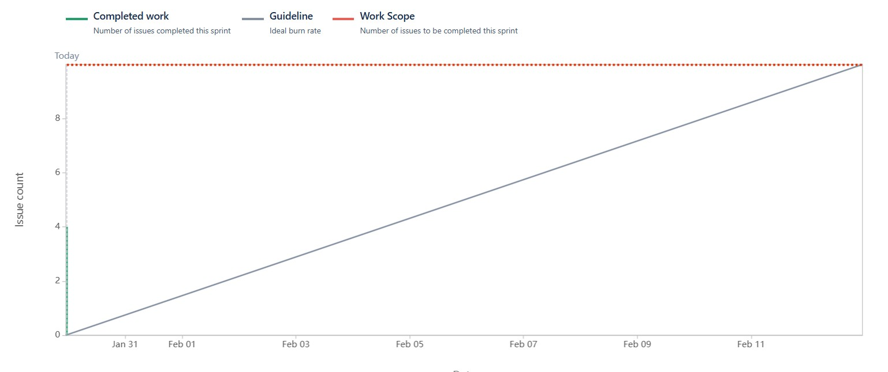

Sprint burndown chart-

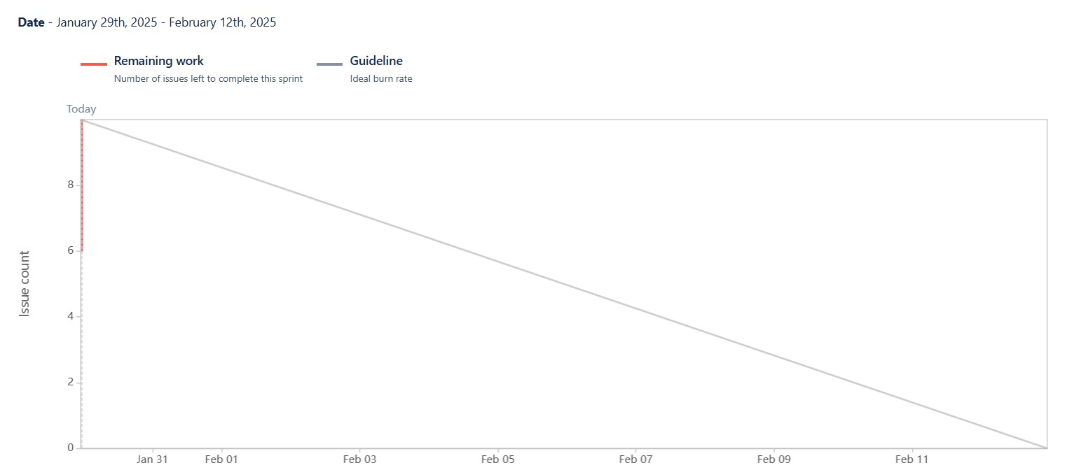

**Question 10** – Explain about Product Grooming.

**Answer**- Product Grooming is the process of regularly reviewing and organizing the list of tasks (backlog) for a product to make sure it’s up to date, prioritized, and ready for upcoming work. It involves clarifying what needs to be done, estimating how much effort it’ll take, and removing any unnecessary items.

Product Insights for Improvement are ideas or feedback that help make the product better. This can come from things like user feedback, how people are using the product, tracking important data, and learning from past work. These insights guide the team in making improvements, adding new features, or fixing issues to make the product more valuable.

**Question 11** – Explain the roles of Scrum Master and Product Owner.

**Answer-** The Scrum Master acts as a facilitator for the Scrum team, ensuring that the Scrum framework is being followed correctly. They help organize and lead Scrum events like daily standups, sprint planning, and retrospectives. Additionally, they remove any obstacles or blockers that may hinder the team’s progress, ensuring that the team can work efficiently and focus on delivering value**,**

whereas the Product Owner is responsible for managing the product backlog, which includes creating, organizing, and prioritizing the list of tasks and features to be worked on. They gather input from stakeholders, customers, and the market to define product requirements and ensure that the team is building the right product. The Product Owner also ensures that the development team is focused on high-priority items that will deliver the most value to the business and users.

Scrum Master-

The Scrum Master is like a coach for the team. They help the team follow Scrum practices, remove obstacles, and ensure smooth communication and collaboration.

1. Facilitating Scrum Events: The Scrum Master ensures that Scrum events like the Daily Standup, Sprint Planning, Sprint Review, and Sprint Retrospective are happening and run smoothly.
2. Removing Obstacles: They help identify and remove any roadblocks or issues that might prevent the team from being productive, such as technical challenges or communication problems.
3. Supporting the Team’s Growth: The Scrum Master helps the team improve their processes, build self-organizing capabilities, and continuously grow in their Agile practices.

Product Owner-

The Product Owner is responsible for defining and managing the product backlog, ensuring the team works on the most valuable tasks that align with business goals.

1. Managing the Product Backlog: The Product Owner creates, organizes, and prioritizes the product backlog, making sure the most important tasks are ready for the team to work on in the upcoming sprints.
2. Defining Product Requirements: They gather input from stakeholders, customers, and the market to define the features, user stories, and requirements that will bring value to the product.

**Question 12** – Explain all Meetings Conducted in Scrum Project

**Answer**-

In a Scrum project, several key meetings (also called ceremonies) are conducted to ensure transparency, collaboration, and continuous improvement. These meetings help the Scrum Team (Product Owner, Scrum Master, and Developers) to plan, execute, and deliver high-quality increments effectively.

It help the team stay organized, communicate effectively, and improve continuously. These meetings involve the Product Owner, Scrum Master, and Developers, ensuring that work is well-planned, progress is tracked, feedback is gathered, and improvements are made.

The five scrum meetings are-

1. Sprint Planning- The main purpose of this meeting is Plan work for the upcoming Sprint,

***When*-** it is conducted at the beginning of each sprint

***Who Attend*s**- Product Owner, Scrum Master, and Developers attend this meeting,

***Agenda***-the Product Owner presents high-priority items from the Product Backlog,

the Developers discuss and select items to work on, forming the Sprint Backlog, The team defines a Sprint Goal and estimates tasks.

1. Daily Scrum (Stand-up)- The main purpose of this meeting is Synchronize team progress and identify blockers,

***When***- it conducted everyday (15 Timebox)

***Who***- it is attended by Developers (Scrum Master and Product Owner may join but don’t micromanage)

***Agenda***- the main agenda is the developers will answer 3 questions, what they did yesterday, what they will do today and is there any blockers?

1. Sprint Review- The Main purpose of this meeting is to Showcase completed work to stakeholders and get feedback

***When***- it conducted in end of each sprint

***Who***- Scrum Team and Stakeholders attend the meeting

***Agenda***- Developers demonstrate completed work, Stakeholders provide feedback on the increment, Discussions on potential improvements for future Sprints.

1. Sprint Retrospective- the purpose of this meeting is to inspect and improve team process,

***When-*** it is conducted After the Sprint Review, before the next Sprint Planning

***Who-*** the scrum team attend this meeting

***Agenda***- What went well? What didn’t go well? What can be improved?

1. Backlog Refinement (Grooming)- The purpose of this to Prepare and prioritize backlog items for future Sprints,

***When-*** Ongoing (not an official Scrum event but highly recommended)

***Who-***Product Owner, Scrum Master, and Developers attend this meeting.

***Agenda-*** Clarifying requirements, splitting large user stories into smaller ones, Estimating and prioritizing backlog items.

**Question 13**- Explain Sprint Size and Scrum Size.

**Answer-**

Sprint Size refers to the duration of a Sprint and the amount of work a team can complete within that time. In Scrum, a Sprint typically lasts between one to four weeks, with two weeks being the most common. The team determines how much work they can take on based on their capacity and past performance. The goal is to deliver a usable product increment by the end of each Sprint while maintaining a steady and sustainable pace.

Scrum Size, on the other hand, refers to the number of people in a Scrum Team. A well-balanced Scrum Team usually consists of five to eleven members, including the Product Owner, Scrum Master, and Developers. Having the right team size ensures effective collaboration, smooth communication, and efficient work distribution. If the team is too small, it may struggle to complete work on time, whereas a very large team can lead to coordination challenges.

Both Sprint Size and Scrum Size are important factors in ensuring a successful Scrum project. The Sprint Size helps define the pace of development, while the Scrum Size impacts teamwork and overall efficiency. Finding the right balance in both is essential for delivering high-quality products consistently.

**Question 14**- Explain DOR and DOD.

**Answer**-

In Scrum, Definition of Ready (DOR) and Definition of Done (DoD) ensure clarity and consistency in the development process, DOR refers to the criteria a Product Backlog Item (PBI) must meet before the team can start working on it. It ensures that tasks are well-defined, clear, and actionable. A user story is considered "Ready" if it has a clear description, acceptance criteria, dependencies resolved, and is small enough to be completed within a Sprint. This helps the team avoid misunderstandings and delays during development.

whereas DOD defines the conditions that must be met for a task or user story to be considered fully completed. It includes aspects like coding, code review, testing, integration, documentation, and deployment readiness. A task is "Done" only when it meets all the quality standards set by the team, ensuring that the increment is potentially shippable and meets business requirements.

**Question 15**- Explain Prioritization Techniques and MVP

**Answer-**

In Scrum, prioritization helps the Product Owner decide which features or tasks should be developed first to maximize value. Several techniques are used to rank backlog items based on their impact, urgency, and feasibility.

Prioritization Techniques-

*Moscow Method*- Categorizes items into Must Have, Should Have, Could Have, and Won’t Have to clarify importance.

*Kano Model*- Classifies features into Basic Needs, Performance Needs, and Delighters based on customer satisfaction.

*$100 Technique-* it is also called 100-Point Method is a prioritization technique used in Agile and Business Analysis. It helps teams or stakeholders decide which features or requirements are most important by distributing a limited budget (100 points or dollars) among different options

MVP- Minimal viable product-

It is the smallest version of a product that delivers enough value to attract early users and gather feedback. Instead of building a full-featured product upfront, an MVP focuses on essential functionalities to test assumptions and validate ideas with minimal effort.

**Question 16-** Difference between Business Analyst n Product Owner.

**Answer**-

Difference Between Business Analyst (BA) and Product Owner (PO) A **Business Analyst (BA)** focuses on analyzing business needs, gathering requirements, and ensuring alignment with business goals. They act as a bridge between stakeholders and the development team, refining and documenting requirements but do not make final product decisions. Their main responsibility is to provide insights through Business Requirement Documents (BRD), functional specifications, and user stories. They work in both Agile and non-Agile environments across various industries like IT, finance, and healthcare.

A **Product Owner (PO)**, on the other hand, owns the product vision, defines priorities, and manages the product backlog. They represent the customer, make key product decisions, and ensure that development aligns with business objectives. Unlike a BA, the PO has full authority over backlog prioritization and directly influences product delivery. Their primary focus is on delivering product value in an Agile environment, working closely with stakeholders and the Scrum Team.

**Question 17 - Prepare a sample Resume of 3yrs exp Product Owner.**

**Answer-**

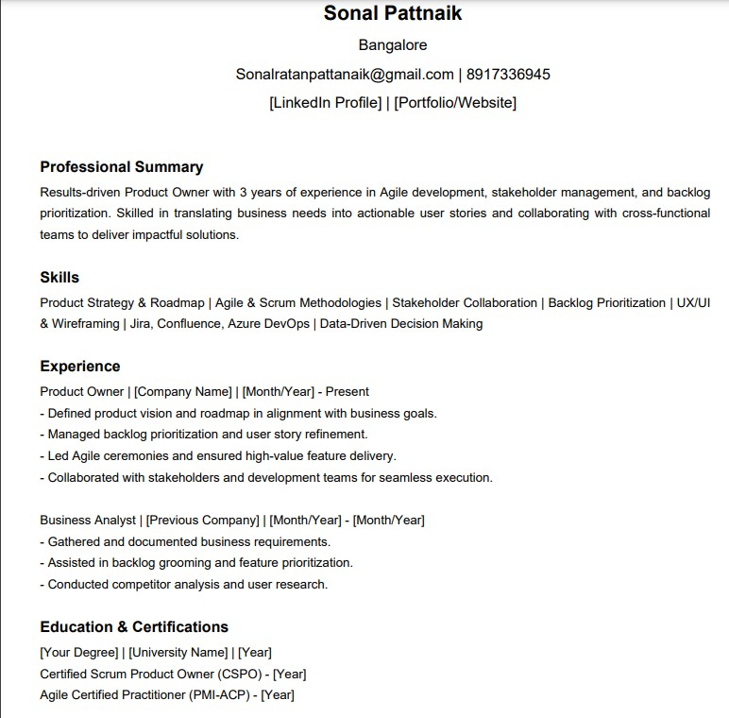

**Projects & Achievements** - Successfully launched [Project Name], resulting in [impact, e.g., 20% increase in engagement]. - Improved backlog prioritization, reducing feature delivery time by [X]%. - Implemented a new workflow that optimized team efficiency

**Tools & Technologies**-Jira | Confluence | Azure DevOps | SQL | Figma | Power BI

**Languages**- English, Hindi

**References**- Available upon request