# Capstone Part 3/3

**Q. Functional Requirements:**

|  |  |  |  |
| --- | --- | --- | --- |
| **ID** | **Requirement** | **Description** | **Priority** |
| FR001 | Farmer Registration | Farmers should have the ability to register with the application | 9 |
| FR002 | Farmers search for products | Farmers should have the ability to search product fertilizers, seeds and pesticides | 9 |
| FR003 | Manufacturer registration | Manufacturer should have the ability to register with the application | 8 |
| FR004 | Manufacturer product listing | Manufacturer should have the ability to list their products in the catalogue | 8 |
| FR005 | Product details display | Application should display detailed information about each product which includes description, specifications and the pricing | 7 |
| FR006 | Filter | Farmers should be able to filter and select the product as per brands and price | 6 |
| FR007 | Add to Cart | Users should be able to add products to their shopping cart for purchase | 9 |
| FR008 | Cart management | Users should be able to view and manage their cart including addition or removal of products | 8 |
| FR009 | Wishlist management | Users should be able to manage their wish list or buy-later list which includes addition or removal of products | 10 |
| FR010 | Payment gateways | Application should integrate with multiple payment gateways to facilitate secure and convenient transactions. | 6 |
| FR011 | Order placement | Users should be able to place orders for selected products, specifying quantity and delivery address | 9 |
| FR012 | Order confirmation | User should receive an order confirmation with details such as order number, products, quantities, total amount and estimated delivery date. | 7 |
| FR013 | Order tracking | User should be able to track the status and location of the orders in real-time | 6 |
| FR014 | Order history | Users should have the ability to check their past placed orders and all the transactions. | 7 |
| FR015 | Customer support | Users should have the access to customer service either by live chats, emails, phone calls for assistance to their orders or inquiry. | 8 |
| FR016 | User ratings and reviews | User should be able to provide ratings and reviews about the product | 7 |
| FR017 | Product recommendation | The application should show product recommendation based on the customers previous order | 7 |
| FR018 | Social sharing | Users should have the option to share products on the social media | 7 |
| FR019 | Secure transactions | Platform should have the necessary firewalls in terms of doing the payment. | 9 |
| FR020 | Product filtering | Users should have the ability to filter the products by the price range, brand or product | 8 |

|  |  |  |  |
| --- | --- | --- | --- |
| **Non-functional Requirements** | | | |
| **ID** | **Requirement** | **Description** | **Priority** |
| NFR001 | Page loading time | Each page should load within 2 sec time | 10 |
| NFR002 | Technical support system | Application can be used in any OS/Android | 6 |
| NFR003 | Time limit for OTP | OTP time limit should be given maximum of 5 minutes for login and registration process. | 10 |
| NFR004 | Logout System | If the page is not accessed for more than 5 min then the page should logout automatically | 7 |
| NFR005 | Stock Availability | Stock availability should be updated on real time basis | 8 |
| NFR006 | SMS & Mail confirmation | Automated email and SMS notification should be sent to the users | 6 |
| NFR007 | Backup | All the data should be backed up automatically | 7 |
| NFR008 | Connectivity | System should always be connected with the internet | 8 |
| NFR009 | Stock Alerts | Seller should receive stock alert notification when stock is reduced every week. | 6 |
| NFR010 | Net Banking | Bank account should be active in nature for smooth banking process. | 8 |
| NFR011 | Check store | Once the product is sold, the stock of the product should be reduced. | 7 |
| NFR012 | Email address | Email address should be active in order to receive the email notification. | 5 |
| NFR013 | Taxation system | All the products should be included with additional tax. | 8 |
| NFR014 | Password | User should receive the password change alert for every 30 days. | 4 |
| NFR015 | Payment receipt | Payment receipt should be generated. | 5 |

**Q. Wire frame and Prototype  
A.**

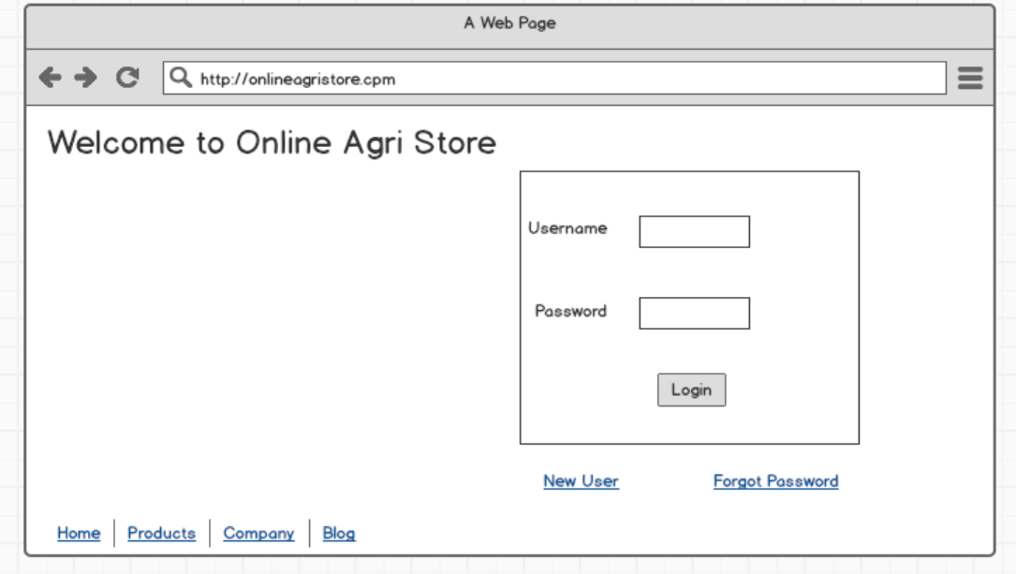

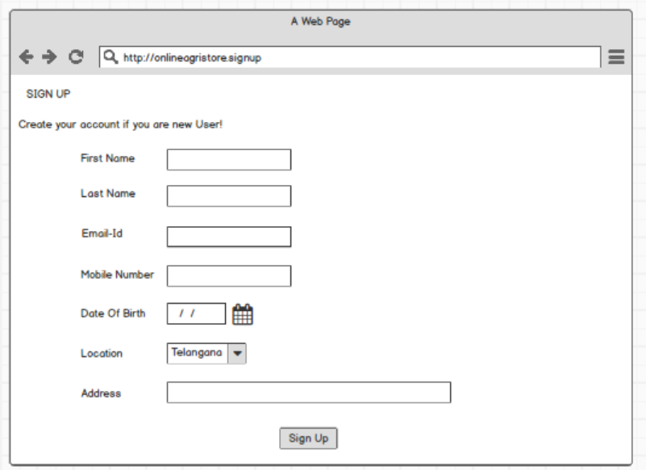

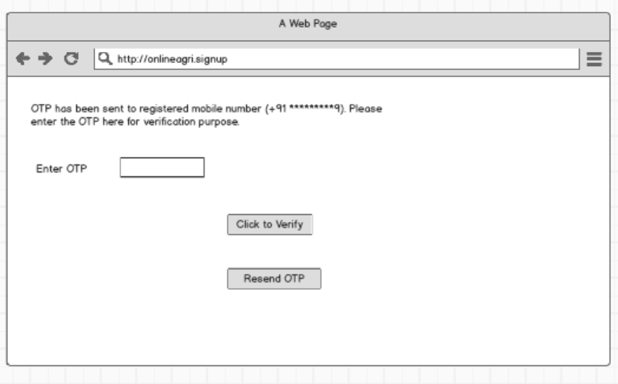

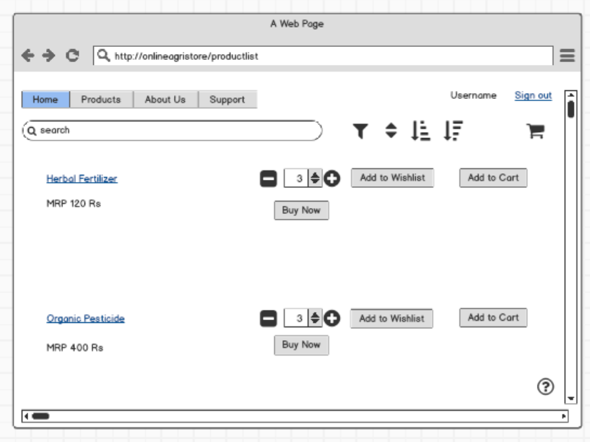

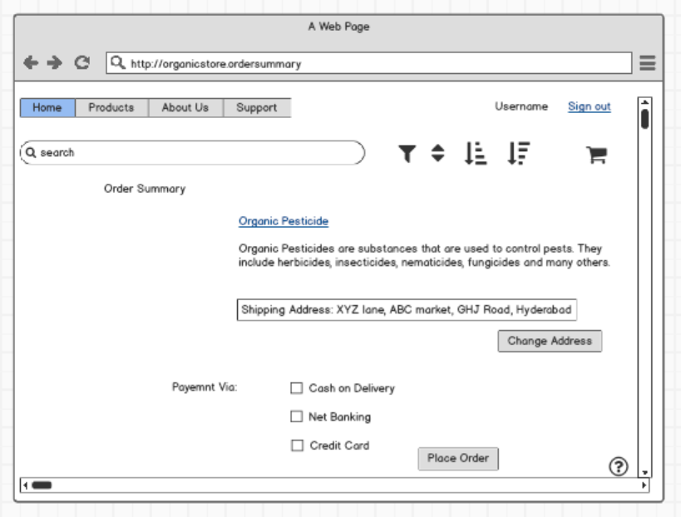

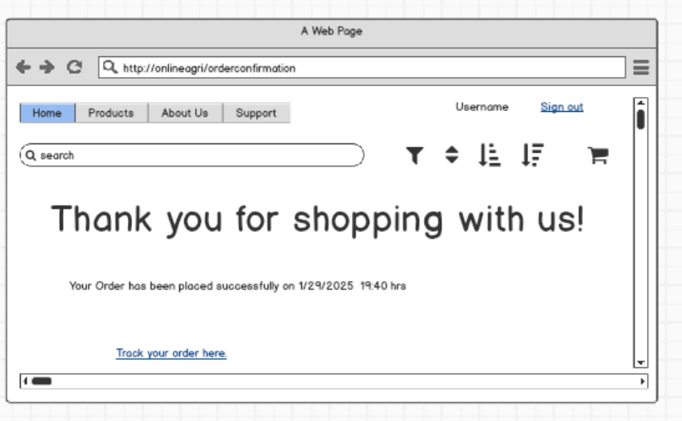

**Q. Tools (Visio, Balsamiq)**

**MS Viso:** Microsoft Visio is a powerful diagramming tool used to create a variety of visual representations, including flowcharts, organizational charts, and network diagrams. It allows users to easily design and communicate complex ideas, processes, and systems. Visio is commonly used in business, engineering, and IT for planning, analysis, and documentation.

Microsoft Visio has a variety of uses across different fields, including:

1. **Flowcharts and Process Mapping**: Used to design flowcharts that visually represent processes, workflows, or decision-making paths.
2. **Organizational Charts**: Helps create diagrams that show hierarchical structures within organizations or teams.
3. **Network Diagrams**: Allows the design of IT infrastructure layouts, including network connections, hardware, and server structures.
4. **Floor Plans**: Used to design layouts for office spaces, buildings, or event venues.
5. **Data Visualizations**: Helps in illustrating data relationships, data flow diagrams, and Entity-Relationship (ER) diagrams for system designs.
6. **Business Models**: Useful for mapping out business processes, value streams, and customer journeys.
7. **UML Diagrams**: Supports the creation of Unified Modeling Language diagrams for software development and system design.

**Balsamiq:** Balsamiq is a wireframing tool designed to help users quickly create low-fidelity prototypes and mockups of websites, apps, and software interfaces. Its simple drag-and-drop interface makes it easy to sketch out ideas without getting bogged down in design details, allowing teams to focus on functionality and user experience. Balsamiq is commonly used by designers, product managers, and business analysts to visualize and communicate design concepts in the early stages of development.

**Q. RTM**

**Ans:**

|  |  |  |  |  |  |  |  |  |  |  |  |  |
| --- | --- | --- | --- | --- | --- | --- | --- | --- | --- | --- | --- | --- |
| **ID** | **Requirement** | **Description** | Design | D1 | T1 | D2 | T2 | D3 | T3 | D4 | T4 | UAT |
| FR001 | Farmer Registration | Farmers should have the ability to register with the application | Y | Y | Y | Y | Y | Y | Y | Y | Y | N |
| FR002 | Farmers search for products | Farmers should have the ability to search product fertilizers, seeds and pesticides | Y | Y | Y | Y | Y | Y | Y | Y | Y | N |
| FR003 | No matching product | Farmers should be notified if the searched product not found | Y | Y | Y | Y | Y | Y | Y | N | N | N |
| FR004 | Product Selection | Farmers should be able to select the product | Y | Y | Y | Y | Y | Y | N | N | N | N |
| FR005 | Out of Stock | Farmer should be notified, if the product is out of stock | Y | Y | Y | N | N | N | N | N | N | N |
| FR006 | Filter | Farmers should be able to filter and select the product as per brands and price | Y | Y | Y | N | N | N | N | N | N | N |
| FR007 | Similar products | Farmer should be able to select similar products, if the searched product is out of stock | Y | Y | Y | N | N | N | N | N | N | N |
| FR008 | Bought together | Once the product is finalized, famer should be suggested with related products as a package with the price | Y | Y | Y | Y | Y | N | N | N | N | N |
| FR009 | Add to Cart | Farmer should be able to add the product to the cart for purchase | Y | Y | Y | Y | N | N | N | N | N | N |
| FR010 | Whishlist | Farmer should have an option to add the product to whishlist | Y | Y | Y | N | N | N | N | N | N | N |
| FR011 | Save it later | Farmer should be able to see the option for save it later, to purchase later. | Y | Y | Y | N | N | N | N | N | N | N |
| FR012 | Delivery Address | Farmer should be able to select the delivery address to deliver the product | Y | Y | Y | N | N | N | N | N | N | N |
| FR013 | Payment options | Once the delivery address is selected, application should show the payment options to the farmer for purchasing the product. | Y | Y | Y | N | N | N | N | N | N | N |
| FR014 | Payment confirmation | Farmer should receive the payment confirmation email and SMS | Y | Y | Y | Y | Y | N | N | N | N | N |
| FR015 | Order Confirmation | Farmer should receive the order confirmation email and SMS. | Y | Y | Y | N | N | N | N | N | N | N |
| FR016 | Expected Delivery date | Farmers should also see the expected delivery date of the product. | Y | Y | Y | N | N | N | N | N | N | N |
| FR017 | Track delivery | Farmer should have the option to track the delivery on the application | Y | Y | Y | N | N | N | N | N | N | N |
| FR018 | Cancel/ Return/ Replacement | Farmers should be able to cancel/return/replace the product | Y | Y | Y | Y | Y | N | N | N | N | N |
| FR019 | Return Pickup | Farmer should be given pickup date and time for cancel/return. | Y | Y | Y | N | N | N | N | N | N | N |
| FR020 | Return Confirmation | Farmer should receive SMS and Email confirmation for cancellation/return. | Y | Y | Y | N | N | N | N | N | N | N |

|  |  |  |  |  |  |  |  |  |  |  |  |  |
| --- | --- | --- | --- | --- | --- | --- | --- | --- | --- | --- | --- | --- |
| **ID** | **Requirement** | **Description** | Design | D1 | T1 | D2 | T2 | D3 | T3 | D4 | T4 | UAT |
| NFR001 | Page loading time | Each page should load within 2 sec time | Y | Y | Y | Y | Y | Y | Y | Y | Y | N |
| NFR002 | Technical support system | Application can be used in any OS/Android | Y | Y | Y | Y | Y | N | N | N | N | N |
| NFR003 | Time limit for OTP | OTP time limit should be given maximum of 5 minutes for login and registration process. | Y | Y | Y | N | N | N | N | N | N | N |
| NFR004 | Logout System | If the page is not accessed for more than 5 min then the page should logout automatically | Y | Y | Y | N | N | N | N | N | N | N |
| NFR005 | Stock Availability | Stock availability should be updated on real time basis | Y | Y | Y | N | N | N | N | N | N | N |
| NFR006 | SMS & Mail confirmation | Automated email and SMS notification should be sent to the users | Y | Y | Y | Y | Y | N | N | N | N | N |
| NFR007 | Backup | All the data should be backed up automatically | Y | Y | Y | Y | N | N | N | N | N | N |
| NFR008 | Connectivity | System should always be connected with the internet | Y | Y | Y | Y | Y | N | N | N | N | N |
| NFR009 | Stock Alerts | Seller should receive stock alert notification when stock is reduced every week. | Y | Y | Y | N | N | N | N | N | N | N |
| NFR010 | Net Banking | Bank account should be active in nature for smooth banking process. | Y | Y | Y | N | N | N | N | N | N | N |
| NFR011 | Check store | Once the product is sold, the stock of the product should be reduced. | Y | Y | Y | Y | Y | N | N | N | N | N |
| NFR012 | Email address | Email address should be active in order to receive the email notification. | Y | Y | Y | N | N | N | N | N | N | N |
| NFR013 | Taxation system | All the products should be included with additional tax. | Y | Y | Y | N | N | N | N | N | N | N |
| NFR014 | Password | User should receive the password change alert for every 30 days. | Y | Y | Y | N | N | N | N | N | N | N |

**Q. Test Case Documents**

|  |  |  |  |  |  |  |  |
| --- | --- | --- | --- | --- | --- | --- | --- |
| **Test Case for User login details** | | | | | | | |
| **Pre-condition** | User need to have a valid username and password for login into the application. | | | | | | |
| **Dependencies** | User should have active internet connection | | | | | | |
|  |  |  |  |  |  |  |  |
| **Test Scenario** | **Test Case** | **Test Steps** | **Test Data** | **Expected Result** | **Post-condition** | **Actual result** | **Status** |
| Verify the login credentials which are entered by the user | Enter valid username and password | Enter Username | <Valid Username> | Successful login | Home Page | Successfully logged in | Pass |
| Enter Password | <valid password> |
| Click login button |  |
| Verify the login of online agriculture product store | Entered invalid username and valid password | Enter Username | <Invalid Username> | The Username and password is not correct. Please enter correct username and password | Invalid Username or Password | Pop up banner shows ‘Invalid Password’ | Fail |
| Enter Password | <Valid Password> |
| Click login button |  |
| Verify the login of online agriculture product store | Entered valid username and invalid password | Enter Username | <Valid Username> | The Username and password is not correct. Please enter correct username and password | Invalid Username or Password | Pop up banner shows ‘Invalid Password’ | Fail |
| Enter Password | <Invalid password> |
| Click login button |  |
| Verify the login of online agriculture product store | Entered invalid username and invalid password | Enter Username | <Invalid Username> | The Username and password is not correct. Please enter correct username and password | Invalid Username or Password | Pop up banner shows ‘Invalid Password’ | Fail |
| Enter Password | <Invalid Password> |
| Click login button |  |

|  |  |  |  |  |  |  |  |  |
| --- | --- | --- | --- | --- | --- | --- | --- | --- |
| **Test Case for Cash on Delivery/Pay on Delivery** | | | | | | | | |
| **Pre-condition** | | User should have an active bank account for any payment gateway to be selected. | | | | | | |
| **Dependencies** | | User should have active internet connection | | | | | | |
| **Test Scenario** | **Test Case** | | **Test Steps** | **Test Data** | **Expected Result** | **Post-condition** | **Actual result** | **Status** |
| Verify the availability of COD | Select the COD payment gateway | | COD | <Cash, UPI, Cards are accepted> | Order Placed | Home Page | Order Placed | Pass |
| Verify the availability of COD | COD not available | | COD not available | <COD not available on selected product> | Choose another payment method | Payment page | COD not available | Fail |

|  |  |  |  |  |  |  |  |  |
| --- | --- | --- | --- | --- | --- | --- | --- | --- |
| **Test Case for Debit Card** | | | | | | | | |
| **Pre-condition** | | User should have an active debit card holding bank account for any payment gateway to be selected. | | | | | | |
| **Dependencies** | | User should have active internet connection | | | | | | |
| **Test Scenario** | **Test Case** | | **Test Steps** | **Test Data** | **Expected Result** | **Post-condition** | **Actual result** | **Status** |
| Verifying the selection of Debit card as Payment method | Entered Card details and OTP correctly | | Enter Card Number | <Valid Card Number> | Payment Successful | Order Page | Order Placed Successfully | Pass |
| Enter Expiry Date | <Valid Expiry> |
| Enter CVV |  |
| Enter OTP | <Valid OTP> |
| Verifying the selection of Debit card as Payment method | Entered Card Number correctly but Incorrect Expiry date | | Enter Card Number | <Valid Card Number> | Enter Correct Expiry Date | Incorrect Expiry Date | Enter Correct Expiry Date | Fail |
| Enter Expiry Date | <Incorrect Expiry Date> |
| Enter CVV |  |
| Enter OTP |  |
| Verifying the selection of Debit card as Payment method | Entered Card Details correctly but incorrect OTP | | Enter Card Number | <Valid Card Number> | Enter correct OTP | Incorrect OTP entered | Enter correct OTP | Fail |
| Enter Expiry Date | <Valid Expiry> |
| Enter CVV |  |
| Enter OTP | <Invalid OTP> |

|  |  |  |  |  |  |  |  |  |
| --- | --- | --- | --- | --- | --- | --- | --- | --- |
| **Test Case for Credit Card** | | | | | | | | |
| **Pre-condition** | | User should have an active credit card holding bank account for any payment gateway to be selected. | | | | | | |
| **Dependencies** | | User should have active internet connection | | | | | | |
| **Test Scenario** | **Test Case** | | **Test Steps** | **Test Data** | **Expected Result** | **Post-condition** | **Actual result** | **Status** |
| Verifying the selection of Credit card as Payment method | Entered Card details and OTP correctly | | Enter Card Number | <Valid Card Number> | Payment Successful | Order Page | Order Placed Successfully | Pass |
|  |  | | Enter Expiry Date | <Valid Expiry> |  |  |  |  |
|  |  | | Enter CVV |  |  |  |  |  |
|  |  | | Enter OTP | <Valid OTP> |  |  |  |  |
| Verifying the selection of Credit card as Payment method | Entered Card Number correctly but Incorrect Expiry date | | Enter Card Number | <Valid Card Number> | Enter Correct Expiry Date | Incorrect Expiry Date | Enter Correct Expiry Date | Fail |
| Enter Expiry Date | <Incorrect Expiry Date> |
| Enter CVV |  |
| Enter OTP |  |
| Verifying the selection of Credit card as Payment method | Entered Card Details correctly but incorrect OTP | | Enter Card Number | <Valid Card Number> | Enter correct OTP | Incorrect OTP entered | Enter correct OTP | Fail |
| Enter Expiry Date | <Valid Expiry> |
| Enter CVV |  |
| Enter OTP | <Invalid OTP> |

|  |  |  |  |  |  |  |  |  |
| --- | --- | --- | --- | --- | --- | --- | --- | --- |
| **Test Case for Product Cancellation for selected address** | | | | | | | | |
| **Pre-condition** | | User should have valid order processed. | | | | | | |
| **Dependencies** | | User should have active internet connection | | | | | | |
|  | |  | | | | | | |
| **Test Scenario** | **Test Case** | | **Test Steps** | **Test Data** | **Expected Result** | **Post-condition** | **Actual result** | **Status** |
| Testing the product cancellation/Return | Select the product for cancellation/Return within the return period | | Select Cancel/Return | <Cancel/Return selected> | Product Cancellation/Return successful | Product Cancellation page | Product Cancellation/return successful | Pass |
| Enter Cancel/Return reason | <Cancel Reason Selected> |
| Select Pickup Address | <Pickup Address selected> |
| Testing the product cancellation/Return | Select the product for cancellation/return out of cancellation/Return period | | Select Cancel/Return | <Cancellation Not available> | Product is not available for cancellation as it is out of cancellation period | Order Page | Pop up banner shows “Cancellation/Return not available” | Fail |

|  |  |  |  |  |  |  |  |  |
| --- | --- | --- | --- | --- | --- | --- | --- | --- |
| **Test Case for Applying Coupon Code** | | | | | | | | |
| **Pre-condition** | | User should be a registered customer | | | | | | |
| **Dependencies** | | User should have active internet connection | | | | | | |
|  | |  | | | | | | |
| **Test Scenario** | **Test Case** | | **Test Steps** | **Test Data** | **Expected Result** | **Post-condition** | **Actual result** | **Status** |
| Test that user should be able to add coupons | Entering the correct coupon code in checkout page | | Apply coupon code | <coupon code accepted> | Coupon code accepted and price adjusted accordingly | Checkout Page | Banner show “Coupon Code Applied” | Pass |
| Test that user should be able to add coupons | Entering the incorrect coupon code in checkout page | | Apply coupon code | <Coupon code already exists/Incorrect coupon code> | Coupon code not accepted | Checkout page | Banner shows “Coupon code already used. Enter new coupons code” | Fail |

|  |  |  |  |  |  |  |  |  |
| --- | --- | --- | --- | --- | --- | --- | --- | --- |
| **Test Case for Seller Adding Product within limit** | | | | | | | | |
| **Pre-condition** | | Seller should be a registered seller | | | | | | |
| **Dependencies** | | User should have active internet connection | | | | | | |
|  | |  | | | | | | |
| **Test Scenario** | **Test Case** | | **Test Steps** | **Test Data** | **Expected Result** | **Post-condition** | **Actual result** | **Status** |
| Test the maximum product adding limit | Seller adding product within limit | | Upload Product Image | <Product Image uploaded> | Product added successfully | Home Page | Banner shoes “Product added successfully” | Pass |
| Enter Product Name | <Product Name updated> |
| Update Product Price | <Product price updated> |
| Test the maximum product adding limit | Seller adding product over the limit | | Upload Product Image | <Product Image uploaded> | Duplicate Product already available | Home page | Banner shows “Product already available. Upload New Product” | Fail |
| Enter Product Name | <Duplicate Product available> |
| Update Product Price |  |

|  |  |  |  |  |  |  |  |  |
| --- | --- | --- | --- | --- | --- | --- | --- | --- |
| **Test Case for Product Search** | | | | | | | | |
| **Pre-condition** | | User should have online application installed | | | | | | |
| **Dependencies** | | User should have active internet connection | | | | | | |
|  | |  | | | | | | |
| **Test Scenario** | **Test Case** | | **Test Steps** | **Test Data** | **Expected Result** | **Post-condition** | **Actual result** | **Status** |
| Test if the user is able to search the product | Enter the name of the product user want to search | | Enter Product name | <Product lists up per search> | Product lists up successfully | Product search page | Banner shows “searched item listed” | Pass |
| Test if the user is able to Search the product | Enter the name of the product user want to available | | Enter Product name | <Product searched not available> | Product searched not successful | Product search page | Banner shows “Searched item not available” | Fail |

**Q. Data Base Design:**

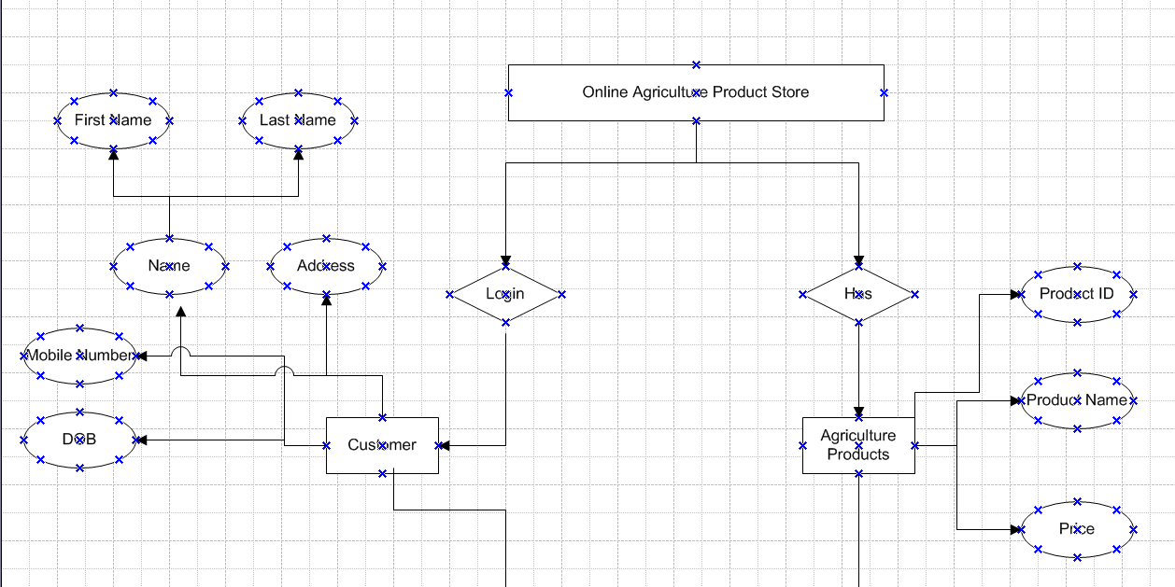

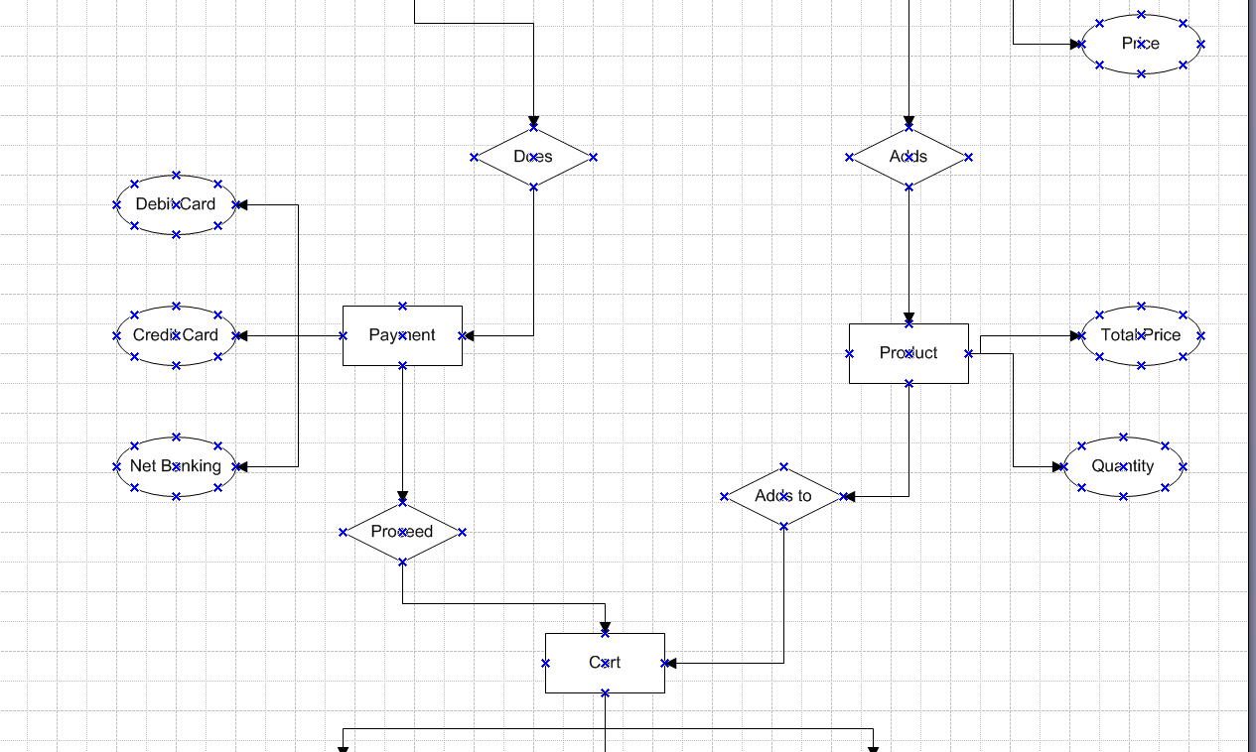

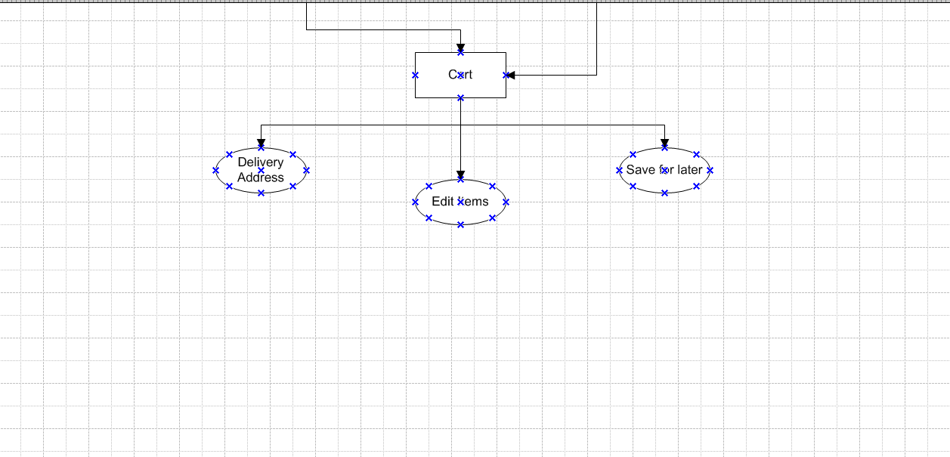

**Q. Data Flow Diagram:**

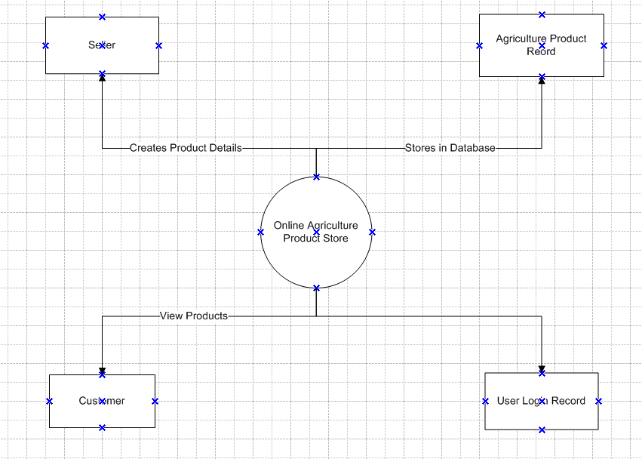

**Q. Change Request**

**A.** Change request refers to a formal proposal or request for altering or modifying an existing project or system. It is a process initiated when there's a need to make adjustments to the scope, deliverables, features, or other aspects of a project, based on new requirements, issues, or feedback.

As a BA, I would analyze the request and clarify the stakeholders exactly what the request is asking us to do in the Online Agriculture Product Store. I would first do the feasibility test to check how feasible is to change the current ongoing project with the new change request.

In this case, feasibility study is not required because it the government structure which needs to be updated and followed. Hence, I will follow the below mentioned steps:

* Document the change request
* Look for supporting materials to help in adding this change
* Need to assess, whether the change is inside or outside scope. As this is outside scope, the time and budget will get impacted
* BA and PM should ensure whether the change is minor or major change. Policy changes by govt is a major change request and we need to ensure that the change should be done according to the govt rules.
* Fill in the change request form and get the approval from the project manager.
* We also need to ensure that or team understands the priority of the change request.
* We also need to discuss this change with the change control board who will recommend the necessary changes in the project.
* Once this change is approved, the project deliverables will need to be updated. This includes BRD, Business process documents and all other necessary documents.
* Once these updates are done then the project manager can communicate the new course of action to everyone who will be impacted. Now I can delegate the necessary tasks to the people in charge of implementing these new charges.

**Q. Change request Vs Enhancements**

**A.** The request from Ben and Kevin is an enhancement request, as they want to add another feature in the online store, which will also help the farmers to sell their yields directly, apart from buying products. Hence my response would be positive.   
  
As a BA I should analyze the request and provide a project plan, requirement, design and testing plans for this request. I must prepare an enhancement request form and decide how much manpower and manhours required for this enhancement request.

**Q. Estimations**

**A.** Manhours required = Total number of working hours per day * Total number of members * Total number of days worked over specific period.  
  
Number of Working hours per day = 8hrs   
Number of resources = 12  
Time period provided = 18 months = 547 days = 78 weeks (which includes weekoffs and public holidays)   
Weekends (Assumption) = 156  
Public holidays (Assumptions) = 10   
Total = 166  
547-166 = 381 Working daysSo, Estimated Manhours = 8 hrs* 12 resources* 381 days = 36,576 hrs required.

**Q. UAT   
A.** UAT (User Acceptance Testing) is the final phase of the software testing process, where the end users or business stakeholders test the software to verify that it meets the business requirements and works as intended in real-world scenarios. The goal of UAT is to ensure that the product is ready for deployment and that it satisfies the needs of the users.

Steps for UAT:

**Planning**: Define objectives, create test plan, and set criteria.  
**Environment Setup**: Ensure the testing environment mirrors production.  
**Test Case Development**: Create test cases based on business scenarios.  
**Testing**: Execute the test cases, log results, and report defects.  
**Defect Management**: Triage and fix defects, followed by retesting.  
**Sign-off**: Review and gain approval from stakeholders.  
**Post-UAT**: Deploy to production and provide necessary training.

**Q. Project Closure Document  
A.**

|  |  |  |  |
| --- | --- | --- | --- |
| **Project Closure  Online Agriculture Product Store** | | | |
| Revision Date: MM/DD/YYYY | | Version 1.0 | |
| **Approver Name** | **Title/Role** | **Signature** | **Date** |
| Peter and Ben | Stakeholders | Ok | xx/xx/xxxx |
| Mr. Henry | Sponsor | Ok | xx/xx/xxxx |
| Mr. Pandu | Financial Head | Ok | xx/xx/xxxx |
| Mr. Vandanam | Project Manager | Ok | xx/xx/xxxx |
| Mr. Kartik | Deliver head | Ok | xx/xx/xxxx |
| Mr. Dooku | Project Coordinator | Ok | xx/xx/xxxx |

Note: By signing this document, the stakeholders, sponsors agree with all the terms in this document.

Revision history

Identify the document changes

|  |  |  |  |
| --- | --- | --- | --- |
| Version | Date | Name | Description |
| 1.0 | xx/xx/xxxx | Mr. Henry | Ok to process |

Section 1: General Information

|  |  |
| --- | --- |
| **Project Activity** | **Date** |
| Project Start | 13th Feb 2023 |
| Project Closure | 14th April 2024 |

Section 2: Business Objectives

|  |  |  |  |
| --- | --- | --- | --- |
| **Business Case Ref#** | **Business Objectives** | **Met/Not Met** | **Comments** |
| BC001 | Farmers should able to buy and sell agriculture products online | Yes | Ok |

Section 3: Customer Expectation Management

|  |  |  |  |
| --- | --- | --- | --- |
| **Item** | **Question** | **Description** | **Comment** |
| 1 | Were all expected benefits and business outcomes realized? | Yes | Ok |
| 2 | Were all expected performance standards satisfied? | Yes | Ok |

Section 4: Outstanding Action Items and Issues

|  |  |
| --- | --- |
| **Action Item** | **Transition or Resolution** |
|  |  |

Section 5: Project Office Checklist (Tick any one)

|  |  |
| --- | --- |
| **Deliverable** | **Description** |
| Risk Assessment completed and posted on suitable shared storage | Yes/No |
| Business Case completed and posted on suitable shared storage | Yes/No |
| Project Charter completed and posted on suitable shared storage | Yes/No |
| Meeting Notes completed and posted on suitable shared storage | Yes/No |
| Additional project documentation and artifacts posted on suitable shared storage, including requirements template, Project change requests, Milestone Timeline, WBS etc | Yes/No |
| Lessons learned document | Yes/No |
| Project folder moved completed projects on suitable shared storage | Yes/No |
| Support Handover document completed and archived | Yes/No |
| Comments: Ok to process, Application running properly | |