A company is having manufacturing plants and warehouses in various parts of the country. They manufacture ice-cream and milk products. They want to build software to achieve two goals.

• Manage the inventory

• Quickest delivery to the customers Business Requirements Document (BRD)

**Assignment 1:**

1. Please make a BRD which can be presented to the client along with complete development and resource plan.

**Project Title: Integrated Software for Inventory Management and Delivery Optimization**

**Document Version:** Version 1.0

**1. Executive Summary**

The client, a manufacturer of ice cream and milk products, operates multiple manufacturing plants and warehouses across the country. To address challenges in inventory management and delivery efficiency, the company seeks a software solution that ensures real-time inventory visibility and optimizes delivery operations for quicker customer service. This document outlines the business requirements, development plan, and resource allocation for this project.

**2. Business Objectives**

**Primary Goals:**

1. **Efficient Inventory Management:**
   * Enable real-time tracking of inventory levels at all manufacturing plants and warehouses.
   * Automate alerts for low stock and replenishment requirements.
2. **Quickest Customer Delivery:**
   * Implement route optimization for fast and cost-effective deliveries.
   * Track and monitor delivery progress to ensure timely fulfillment.

**Key Benefits:**

* Reduction in inventory holding costs.
* Minimized delays in delivery, enhancing customer satisfaction.
* Improved operational efficiency and resource utilization.

**3. Project Scope**

**In-Scope:**

* Development of a centralized inventory management system.
* Integration of delivery optimization software.
* User interfaces for warehouse staff, delivery drivers, and administrators.
* Reporting and analytics for inventory and delivery performance.

**Out-of-Scope:**

* Financial accounting integration.
* Direct manufacturing process automation.

**4. Functional Requirements**

**Inventory Management:**

* Real-time visibility of inventory at all locations.
* Automated replenishment alerts based on predefined thresholds.
* Batch tracking for perishable items (e.g., expiration dates).
* Inventory transfer functionality between warehouses.

**Delivery Optimization:**

* Route optimization algorithm for quickest delivery.
* Integration with GPS systems for real-time navigation.
* Dynamic reassignment of delivery tasks based on traffic or delays.
* Customer notification system for delivery updates.

**Reporting:**

* Inventory status reports by location.
* Delivery performance metrics (on-time delivery, delays).
* Low-stock and replenishment trend analysis.

**5. Non-functional Requirements**

* **Availability:** 99.9% system uptime.
* **Scalability:** Handle up to 1 million transactions per day.
* **Security:** Compliance with industry standards for data protection.
* **Performance:** Ensure real-time updates with latency under 1 second.

**6. Assumptions and Constraints**

* Reliable internet connectivity at all plants and warehouses.
* Initial deployment for a single region before nationwide rollout.
* Integration with existing ERP systems is feasible.

**7. Development Plan**

**Methodology:**

Agile development with bi-weekly sprints.

**Phases:**

1. **Requirement Gathering and Analysis (2 weeks):**
   * Stakeholder interviews and workshops.
   * Finalize detailed requirements and workflow designs.
2. **Design (3 weeks):**
   * Create wireframes for user interfaces.
   * Develop system architecture.
3. **Development (12 weeks):**
   * Build inventory management modules.
   * Develop delivery optimization functionalities.
4. **Testing (4 weeks):**
   * Perform unit, integration, and user acceptance testing.
5. **Deployment and Training (2 weeks):**
   * Roll out software to pilot locations.
   * Conduct user training sessions.
6. **Post-deployment Support (4 weeks):**
   * Monitor performance and address issues.

**8. Resource Plan**

**Team Composition:**

* **Project Manager:** 1
* **Business Analysts:** 2
* **Developers:** 5
* **UI/UX Designers:** 2
* **Quality Assurance Engineers:** 3
* **System Administrator:** 1
* **Delivery Manager:** 1

**Tools and Technologies:**

* **Programming Languages:** Python, JavaScript
* **Database:** PostgreSQL
* **Frameworks:** Django/React
* **Delivery Optimization Tools:** Google Maps API, GIS libraries
* **Version Control:** GitHub
* **Project Management:** Jira, Confluence

**9. Risks and Mitigation**

|  |  |  |  |
| --- | --- | --- | --- |
| **Risk** | **Likelihood** | **Impact** | **Mitigation Strategy** |
| Delayed requirement finalization | Medium | High | Regular stakeholder meetings for clarifications. |
| Data migration challenges | High | Medium | Allocate dedicated resources for migration. |
| Resistance to change by users | Medium | Medium | Conduct training and change management sessions. |

**10. Approval and Next Steps**

We recommend proceeding with requirement gathering workshops as the next immediate step. Please review this document and provide your feedback or approval to initiate the project.

**Prepared by:** Sudhamayi Pandravada  
**Date:** 24/03/2024

**2. Prepare process flow diagram using your imagination.**

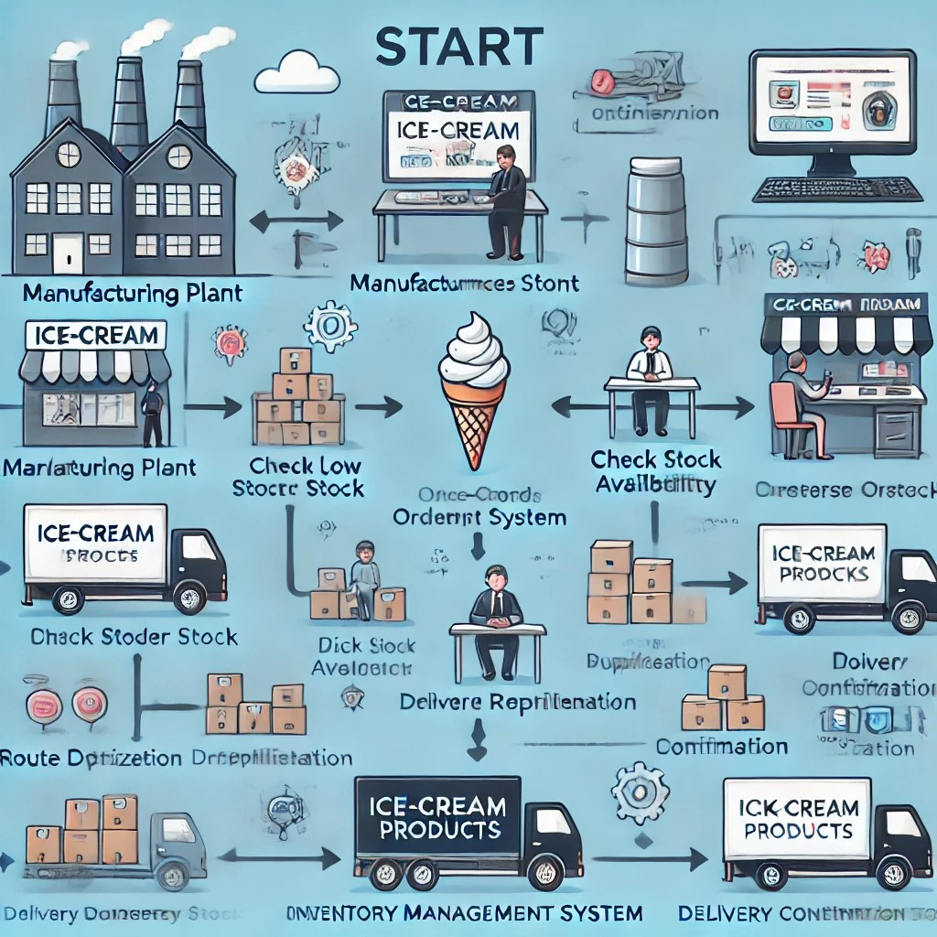

**Assignment 2:**

**1. Write an introduction letter to a client introducing yourself as a business analyst in charge of working with the client and his team to start the business understanding process.**

**Subject:** Introduction and Collaboration for Business Understanding Process

Dear Sashikanth,

I hope this email finds you well. My name is Sudhamayi, and I am pleased to introduce myself as the Business Analyst assigned to collaborate with you and your team. I will be working closely with you throughout the business understanding process to ensure a comprehensive and insightful approach tailored to your objectives.

My primary role is to understand your business needs, gather requirements, and facilitate discussions that align our strategies with your vision. Through structured workshops, stakeholder meetings, and data analysis, I aim to identify opportunities, challenges, and actionable solutions that will drive value for your organization.

I look forward to engaging with you and your team to gain a deeper understanding of your processes, goals, and expectations. Your insights and expertise will be invaluable in shaping the roadmap for success.

Please let me know a convenient time for an initial discussion so we can begin this journey together. In the meantime, feel free to reach out with any questions or information you would like to share.

Looking forward to working with you.

Best regards,  
Sudhamayi Pandravada  
Business Analyst- SK Info Tech

**2. Prepare a brief BRD and SRS for a project- Horoscope or Ticketing system or online store.**

**Business Requirements Document (BRD) and Software Requirements Specification (SRS)**

## **Project: Online Ticketing System**

### **Business Requirements Document (BRD)**

#### **1. Introduction**

#### The Online Ticketing System is designed to provide users with a seamless platform for booking and managing tickets for events, concerts, movies, and travel. The system aims to enhance user experience by offering real-time seat selection, secure payment options, and automated notifications.

#### **2. Business Objectives**

* Enable users to book tickets online with ease.
* Provide real-time availability of seats.
* Offer multiple payment options with secure transactions.
* Generate e-tickets and send notifications.
* Allow event organizers and vendors to manage ticket sales.

#### **3. Key Features**

* **User Registration & Authentication**: Users can create accounts, log in, and manage their bookings.
* **Event Listing & Search**: Users can browse, search, and filter events.
* **Seat Selection**: Interactive seat selection for venues.
* **Payment Gateway Integration**: Multiple payment options (credit card, PayPal, UPI, etc.).
* **E-Ticket Generation**: QR-code enabled e-tickets for verification.
* **Notifications & Reminders**: Email/SMS confirmations and reminders.
* **Admin Panel**: Event organizers can create and manage events, pricing, and availability.

#### **4. Stakeholders**

* Customers (End Users)
* Event Organizers
* Ticketing Platform Administrators
* Payment Gateway Providers

#### **5. Assumptions & Constraints**

* The system must support high traffic during peak booking periods.
* Secure transactions and compliance with payment regulations.
* Scalability to add new events and locations.

### **Software Requirements Specification (SRS)**

#### **1. Introduction**

This document outlines the functional and non-functional requirements of the Online Ticketing System.

#### **2. Functional Requirements**

* **User Management**:
  + Users can register, log in, and update profiles.
  + Password recovery via email.
* **Event Management**:
  + Event organizers can add, modify, or delete events.
  + Event details include date, time, venue, pricing, and availability.
* **Booking & Payments**:
  + Users can book tickets with seat selection.
  + Secure online payment processing.
* **Notifications**:
  + Booking confirmation emails and SMS notifications.
  + Event reminders before the scheduled time.
* **Admin Controls**:
  + Dashboard for sales and booking analytics.
  + Fraud prevention and refund processing.

#### **3. Non-Functional Requirements**

* **Performance**: System should handle up to 10,000 concurrent users.
* **Security**: Data encryption, PCI-DSS compliant payment transactions.
* **Usability**: Intuitive UI for ease of access.
* **Scalability**: Cloud-based infrastructure for expansion.

#### **4. System Architecture**

* **Frontend**: React.js / Angular for a dynamic user interface.
* **Backend**: Node.js / Django for handling requests.
* **Database**: MySQL / MongoDB for storing user and event data.
* **Payment Gateway**: Stripe / PayPal integration.
* **Hosting**: AWS / Azure for cloud hosting.

#### **5. Acceptance Criteria**

* Users can successfully book and pay for tickets.
* Event organizers can create and manage events.
* The system generates unique e-tickets with QR codes.
* Payment transactions are processed securely.
* The system provides real-time seat availability.

1. **Make an ERD of creating a support ticket/Ticketing life cycle.**

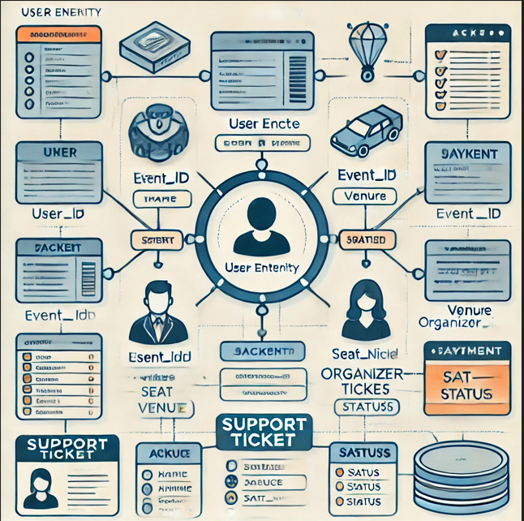

1. **User story of shopping from ecommerce.**

### **User Story: Online Shopping on an E-commerce Platform**

As a **customer**, I want to **browse and purchase products online**, so that I can **conveniently shop from anywhere**.

#### **Acceptance Criteria:**

1. Users can **browse products** by category or search by name.
2. Users can **view product details** including price, reviews, and availability.
3. Users can **add products to the cart** and modify quantities.
4. Users can **proceed to checkout**, choose a payment method, and complete the purchase.
5. Users receive an **order confirmation** via email or SMS.
6. Users can **track order status** from their account dashboard.
7. Users can **initiate a return or request support** for defective items.

#### **Example User Flow:**

1. **Login/Guest Checkout** → User signs in or continues as a guest.
2. **Search & Browse** → User searches for a product or browses categories.
3. **View Product Details** → User checks product specifications, reviews, and pricing.
4. **Add to Cart** → User adds products to the shopping cart.
5. **Checkout** → User selects delivery options and payment method.
6. **Order Confirmation** → System processes the order and sends confirmation.
7. **Delivery & Tracking** → User receives updates and tracks the package.
8. **Post-Purchase** → User reviews the product or requests support if needed.