WATERFALL DELIVERABLES
Document 1
Business case Document Template
In business Case Document Template there are set of questions such as

- Why is this project initiated?
The project has started because the existing CRM at ICICI Bank is mainly for reporting and does not support daily work. RMs waste time on manual tasks, BMs lack real-time performance views, and customer insights are missing. By adding AI, mobile access, and dashboards, the new CRM aims to save time, increase sales, and improve customer experience.
- What are the current problems?
The current CRM has major gaps: RMs waste time on manual entry, it is not integrated with other banking apps, lacks smart insights for customer engagement, and BMs cannot track real-time performance—making interactions more transactional than relationship-driven.
- With this project, how many problems could be solved?
- RMs save time by avoiding repeated data entry.
- All customer/sales/service data in one system.
- AI gives alerts for cross-sell, upsell, and churn risk.
- BMs get instant dashboards on branch/team performance.
- Bankers can approach customers with personalized offers, not just react.
- What are the resources required?
- Project Manager- to manage the complete project and monitor progress.
- Business Analyst- to gather requirements and bridge between business and technical teams.
- Developers- to make changes and enhancements in the CRM application.
- Testing Team- to test the system and ensure quality.

- How much organizational change is required to adopt this technology?
The organizational change required is moderate. Bankers (RMs/BMs) will need to adopt new ways of working with CRM, such as using mobile CRM, relying on AI insights, and reducing manual work. This will mainly need training, habit change, and management support. The bank’s overall structure will not change, only the way employees use CRM in daily tasks.
- Time- frame to recover ROI?
The time- frame to recover ROI for this CRM enhancement project is expected to be around 18–24 months. This is because benefits like improved sales conversion, higher cross-sell, faster service resolution, and better customer satisfaction will gradually increase revenue and efficiency after full adoption.
- How to identify Stakeholders?
We use RACI Matrix to identify stakeholders and their role in the project:
Responsible (R): Person who does the work (Business Analyst gathers requirements).
Accountable (A): Decision maker of the work Project Manager ensures delivery).
Consulted (C): who gives input/advice Compliance team for rules).
Informed (I): Gets updates (Senior Management).

Document-2

BA Strategy

AS a Business Analysis steps we use to complete our project is as follow

- Requirement Gathering – How we collect requirements (workshops, interviews, surveys, etc.).
- Documentation – What documents we will prepare (BRD, SRS, user stories, diagrams).
- Stakeholder Engagement – How we will work with stakeholders (meetings, approvals).
- Requirement Management – How we will track and manage requirements (RTM).
- Change Management – How we will handle requirement changes (review, approval, rejection).
- Analysis & Modeling – Techniques used to analyze (SWOT, Gap, process flows).
- Validation & Testing – How requirements will be checked/verified (UAT Testing).
- Communication – How updates will be shared (reports, presentations, dashboards, emails).

- As a BA we should do SWOT Analysis
SWOT
Strength: Bank already has a CRM system in place, so staff is familiar with basic usage.
Weakness: Current CRM is used mostly for reporting, not for daily productivity or customer engagement.
Opportunity: By adding AI insights and mobile CRM, bank can improve sales and customer satisfaction.
Threat: Employees may resist using the new system if they are not trained properly
Strength | Strong Market Recognition
Weakness | Staff Awareness for the Application is low
Opportunity | Expansion in Market
Threat | Very poor competitor

- Feasibility Study
Means checking whether the project is possible to execute or not with available resources, technology, budget, and time.
Resources: - CRM Application (CRMNEXT), Bank Staff, and IT Support
Hardware: - Secure Servers, Strong Network Connectivity
Software: - CRMNEXT Application with AI & Dashboard features
Team: - Business Analyst, Developers, Testers, Project Manager, Vendor Team
Budget: - Estimated Budget is ₹1.5 Crore (approx.)
Time: - Project completion timeline is 8–9 Months

- GAP Analysis
Gap Analysis means comparing the current state (AS-IS) with the desired future state (TO-BE) to find out what is missing and what needs to be improved.
AS-IS (Current State): Presently, the CRM system (CRMNEXT) is used mainly as a reporting tool. Security features are weak, customer interaction history is not fully visible, and personalized offers for each customer are not displayed.

TO-BE (Future State): The enhanced CRM will have stronger security features, complete customer interaction history (360° view), and display personalized offers and insights. This will help bankers engage better with customers and improve sales.

Gantt Chart
Resources | Week 1-5 | Week 6-15 | Week 16-25 | Week 26-35 | Week 36-45 | Week 46-52
Project Manager
Business Analysist
Java/CRM developers
Data Science Team
Tester
Network Engineer
CRM Vendor

- Risk Analysis
Risk Analysis means identifying possible risks in a project, checking how likely they are to happen, and understanding their impact on cost, time, or quality. The following are the risks which are involved in this project are as follows:-

- BA Risk: Incomplete requirements, lack of domain knowledge, wrong market understanding.
- Process Risk: Complicated steps for users, incomplete product details, inefficiency in workflows.
- Project Risk: Scope creep, budget overrun, delay in timeline, vendor dependency.
- User Adoption Risk: RMs/BMs may resist using new CRM → solved by training & gamification.
- Data Quality Risk: Wrong/missing data may reduce AI insights.

- RACI Matrix OR Stakeholder Analysis
The RACI chart identify the person to whom we have to contact once the changes take place in the document The Main role of RACI chart is to describe the role of Stakeholders in the production of BRD document RACI stands for
- Responsible (does the task)
- Accountable (final decision/ownership)
- Consulted (provides input)
- Informed (kept updated)

Elicitation Techniques we used to complete a Project
- Document Analysis :- A mandatory technique used in almost every project. I am applying it to understand the current state of the application by reviewing emails, meeting minutes, and existing documents to identify enhancements.
- Reverse Engineering :- This technique is important for migration or enhancements. I am using it to analyze the existing system and build an improved version of the application.
- Focus Groups :- Involve people with similar domain knowledge so they can share ideas and suggest improvements together.
- JAD Session :- Since the project is technical in nature, the technical team’s role is crucial for its success.
- Documents to Write for the Project
- BRD (Business Requirement Document): Explains business needs and objectives.
- FSD (Functional Specification Document): Explains how the system should function.
- FRD (Functional Requirement Document): Details specific functional requirements in depth.
- Use Case Document: Shows step-by-step interactions between user and system.

- What process to follow to sign off on the Document?
Sign-off will be taken on the SRS document, as it is the key document that captures all requirements. The client can provide sign-off through an official email approval or a signed copy of the document.
- How to take Approvals from the Client?
First, arrange a meeting with the client to share updates and take their feedback. After that, send a formal email with the final document, and once the client confirms, it is considered approved (sign-off).
- What Communication Channels to Establish and Implement?
The communication can be done through email updates, regular face-to-face meetings, telephonic discussion and messaging platforms like- Teams/ WhatsApp.

- How to handle a change request?
First, the request is received formally through a Change Request Form. Once received, the team acknowledges it and analyses its impact on the project in terms of time, cost, and scope. After the analysis, the change request is either approved or rejected based on discussions with the client and the project team to ensure smooth implementation without affecting overall project delivery.
- How to update progress of the project to the stakeholders?
Project progress can be shared through weekly status emails and monthly review meetings. These updates keep stakeholders informed about milestones achieved, challenges faced, and next steps of the project.

- How to take sign-off on UAT – Client Project Acceptance Form?
For our project, we will first prepare the UAT form and conduct testing with users. Any issues will be reviewed and fixed. Then the Client Project Acceptance form will be prepared and formal approval obtained. Finally, the signed form will be documented and shared with all stakeholders.

Document-3

Functional Specifications

Project Name | Enhancement in CRM NEXT OF ICICI Bank
Customer Name | ICICI Bank
Project Version | Version 1.0
Project Sponsor | Customer Experience (CX) Department or Retail Banking Business Team
Project Manager | ANJALI SINHA
Project Initiation Date | 20.08.2025

Functional Requirement Specifications

Req. ID | Req. Name | Description | Priority
FR0001 | Login | Secure login with SSO, MFA, biometrics; role-based access; works on desktop & mobile; session timeout and encryption. | 1
FR0002 | Display | Single customer view with products, balances, KYC flags, interactions, RM notes, tickets, and sentiment in one screen. | 2
FR0003 | Search |  | 3
  Smart search by CRN/Mobile/PAN/Name; shows results across systems; supports fuzzy match, nearby customers, and de-duplication.
FR0004 | Result | Results page will show AI suggestions, churn alerts, reminders (KYC/renewals), and one-click actions (leads, meetings, SRs) with SLA timers. | 4
FR0005 | Offers | AI-based personalized offers, cross-sell/upsell, easy consent, one-tap fulfilment, and automatic tracking for dashboards. | 5

Document-4

Requirement Traceability Matrix

Req. ID | Req. Name | Req. Description | Design | D1 | T1 | D2 | T2 | UAT
FR0001 | Login | User must be able to securely login | Completed | Completed | Completed | Completed | Completed | Completed
FR0002 | Search | System must search customer details by CRN, Mobile no., PAN with correct results. | Completed | Completed | Completed | Completed | Completed | Completed
FR0003 | Display | Once CRN entered, system should show 360° customer profile with all interactions. | Completed | Completed | Completed | Completed | Completed | Completed
FR0004 | Result | System should provide AI-driven insights, next best opportunity. | Completed | Completed | Completed | Completed | Completed | Completed
FR0005 | Offers | System should display pre-approved offers for the customer. | Completed | Completed | Completed | Completed | Completed | Completed

Document-5

BRD TEMPLATE

- Document Revisions

Date | Document Version | Document Changes
20/08/2025 | 1.0 | Enhancement in existing application and adding new features like AI insights, Mobile access of application, performance dashboards for BMS, better customer 360° view, faster service resolution, & improve NPS.

- Approvals

Role | Name | Title | Signature | Date
Project Sponser | Customer Experience Department |  |  | 1/20/2025
Business owner
Project Manager | ANJALI SINHA
System Architect | System Designers
Development Lead | Developers
User Experience Lead
Quality Lead | Developers
Content Lead

3. RACI Chart for this Document
The RACI Matrix is a project management tool that clearly defines and communicates the roles and responsibilities of different stakeholders for each task or deliverable in a project. The term RACI stands for Responsible, Accountable, Consulted, and Informed, and each of these represents a level of involvement in completing a task.
Codes Used in RACI Chart

Responsible Who is Responsible for creating the document
Accountant Accountable for Accuracy of this project
Support Provide Supporting Services in the production of this document
Consultant Provides Input
Informed Must be informed of any change

RACI CHART

TASK | Project Sponsor | Project Manager | Business Analyst | Developers/Testers | Client(RM/BM)
Req. Gathering | A | R | R/A | C | C
System Design | C | A | R | C | C
Implementation(  Development/integration) | C | A | C | R | C
Testing & quality verification | C | A | C | R/A | C
UAT & Client review | C | A | R | C | R/A
Maintenance & Updates | C | A | C | R | C
Final approval & Handover | A | R | C | C | C

4 .Introduction
4.1 Business Goal: Improve ICICI Bank’s CRM to give RMs and BMs smarter insights, simpler processes, and better customer engagement tools — boosting sales, branch productivity, and customer loyalty.

4.2 Business Objective
- Reduce manual work b to free bankers’ time for customers.
- Provide 360° customer view with product recommendations.
- Enable real-time dashboards for Branch Managers.
- Cut service request time for faster resolutions.
- Boost customer satisfaction (NPS) in one year.

4.3 Business Rules
- Only authorized users can log in securely
- Customer details fetched only with valid CRN.
- Personalized offers shown only if eligible.
4.4 Background
ICICI Bank’s CRM helps with customer details, leads, service requests, and reports, but it’s mainly used as a reporting tool rather than a daily working tool.
4.5 Project Objectives
This CRM enhancement project aims to reduce manual work, allowing bankers to focus more on customers, while giving them a 360° customer view with AI-driven product recommendations. It will also deliver real-time dashboards for Business Managers to track performance instantly and cut service request handling time, leading to faster resolutions. Overall, these improvements are expected to boost customer satisfaction (NPS) by 15% within a year.

  - Project scope:
4.6.1 In scope
- AI-driven insights suggest next best products and track customer sentiment.
- Unified RM workbench gives one screen for all sales and service tasks.
- Mobile CRM enables geo-tagging, offline updates, and nearby customer view.
- Real-time dashboards help BMs track performance and productivity.
- Automated compliance checks and lifecycle alerts ensure timely actions.
4.6.2 Out of scope
- Core banking system changes are not included.
- ATM, net banking, and UPI systems are out of scope.
- Third-party app integrations beyond CRM are excluded.
- Hardware upgrades or new infrastructure setup not covered.
- Employee HR/training systems are outside the project scope

5. Assumptions
Requirements which are not real which may happen comes under Assumptions There are many type of requirement such as functional non- functional in those requirement there are Assumption
Assumption 1- A user should correctly enter valid customer details in the system.
Assumption 2 - A user will provide complete details such as CRN, Mobile Number, PAN Number, etc.
Assumption 3- The system will automatically fetch and display details related to the entered customer.
Assumption 4- The user is assumed to have basic knowledge of online access (login, navigation, etc.).
Assumption 5- The user is assumed to have sufficient knowledge to use the CRM application effectively.
6. Constraints
These are the following constraints of the project:
- Budget – Limited funding allocated for CRM upgrade.
- Time – Project must be delivered within fixed timeline.
- Compliance – Must strictly follow RBI & ICICI policies.
- Integration – Dependent on existing core banking systems.
- Data Quality – CRM performance relies on clean, accurate data.
7.Risks
In every project there are different different as risk . Risk could affect the success and failure of the project. Risk Analysis is conducted to identify the risk as when we work on any project definitely risk factor is their. There are different types of risk depends upon the condition Such as Operational Risk , Reputational Risk , Technical , Legal , etc
- Teclnological Risks :- AI, mobile app, and compliance tools may not integrate well or need frequent updates.
- Skills Risk :- eam may lack expertise in AI, dashboards, or compliance automation.
- Political Risk :- If there is any political force connect to project then that affect the project
- Business Risks If project fails, money is wasted and competitors gain advantage.
- Requirement Risk Poorly defined requirements may lead to wrong features or gaps.
- Other Risk

- Internal Risk :- Server downtime, weak security, or poor usability.

- External Risk :- Cyberattacks, competitor pressure, or third-party software issues..
- BA Risk :- Improper requirement gathering or lack of domain knowledge.

- Process Risk:- Complicated steps or incomplete dashboards may reduce usability.

- Project Based Risk:- Scope creep, delays or budget overrun.

8. Business Process Overview
TO BE Proposed Recommendation and As is Legacy System

Business Process Flow Shows the complete process flow follows in this project

AS-IS (Current State)
- Multiple disconnected systems
- No complete customer view
- Manual tracking and compliance
- Delayed reporting

TO-BE (Future State with CRMNEXT)
- Unified platform with CRM Next
- Customer 360° view
- AI-driven insights
- Automated compliance
- Mobile CRM
- Real-time dashboards

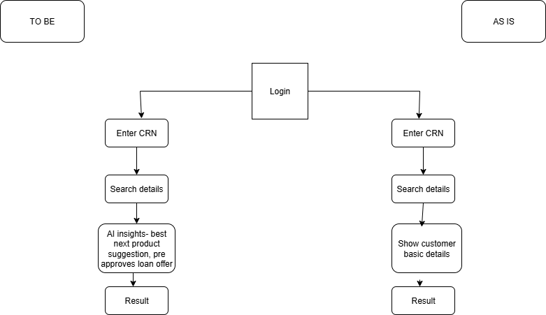

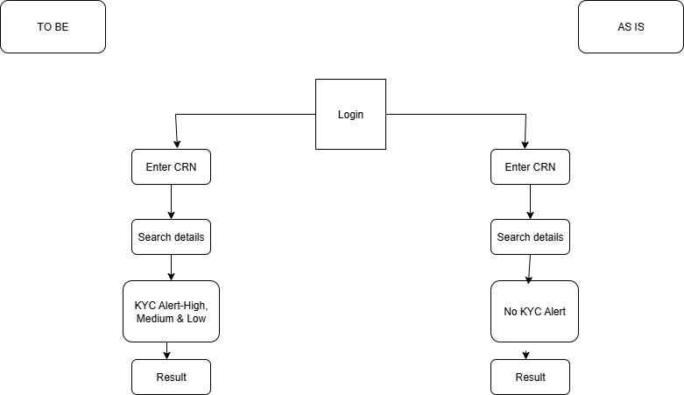

9. Business Requirement
ID | Requirement | Priority | Notes
BR01 | AI-driven insights to suggest next best product & track sentiment | High | Helps RMs cross-sell/upsell and improve customer focus
BR02 | Unified RM Workbench (single screen for sales & service) | High | No need to switch multiple systems
BR03 | Mobile CRM with geo-tagging & offline mode | Medium | Supports field bankers to work on-the-go
BR04 | Branch Manager dashboards with real-time performance | High | Enables monitoring of branch KPIs and team productivity
BR05 | Automated compliance & lifecycle triggers (KYC, renewals) | High | Ensures RBI/ICICI policies are always followed

10. Appendices
10.1 List of Acronyms
- CRM → Customer Relationship Management
- RM → Relationship Manager
- BM → Branch Manager
- KYC → Know Your Customer
- NPS → Net Promoter Score
10.2 Glossary of terms
  - Customer 360° View - a single unified profile showing all customer details, accounts, and interactions.
  - Geo-tagging - mapping customer locations to help bankers identify nearby clients.
  - Next Best Product - AI-based recommendation for the most suitable product to offer a customer.
  - Lifecycle Trigger - Automated alerts/events based on customer milestones (e.g., renewal, maturity).
  - Related Documents
  - Business Requirement Document (BRD)
  - Functional Requirement Specification (FRS)
  - RACI Matrix
  - Test Plan & UAT Sign-off Forms

