**Document 6- Please prepare a use case diagram, activity diagram and a use case specification document.**

**Answer :**

**Use Case diagram**

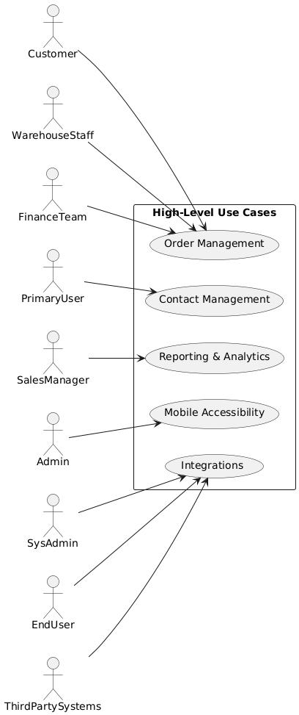

1. **Order management:**

**Key Features in the Diagram:**

1. **Actors:**
   * **Customer interacts with "Order Processing".**
   * **Warehouse Staff is responsible for "Inventory Management".**
   * **Finance Team oversees "Invoicing and Billing".**
2. **Includes:**
   * **Major use cases (Order Processing, Inventory Management, and Invoicing and Billing) include smaller use cases (Create Order, Track Inventory Levels, etc.).**
3. **Generalization:**
   * **Order Processing, Inventory Management, and Invoicing and Billing generalize their specific functionalities.**

**Activity Diagram:**

* **Explanation:**

1. **Start:** The activity diagram begins with the customer initiating an order.
2. **Create Order:** The system creates a new order record.
3. **Inventory Check:** The system checks if the required inventory is available.
   * **If available:** The system records the inventory usage and fulfills the order.
   * **If not available:** The order is backordered.
4. **Update Order Status:** The system updates the order status accordingly (e.g., "Pending," "Processed," "Shipped," "Delivered," "Backordered").
5. **Payment Processing:**
   * **If payment is received:** The system processes the payment and generates an invoice.
   * **If payment is not received:** The system sends an invoice to the customer.
6. **Ship Order:** The system initiates the order shipment process.
7. **Track Shipment:** The system tracks the shipment progress.
8. **Order Delivered:** The activity diagram ends with the order being delivered to the customer.

**Use Case Specification Document**

**1. Use Case Name:** Order Processing

**2. Use Case Description:** This use case describes the process of creating and fulfilling an order within the Order Management System. It covers activities such as order creation, inventory checks, payment processing, order fulfillment, and tracking.

**3. Actors**

* **Primary Actors:** Customer, Warehouse Staff
* **Secondary Actors:** Finance Team, Payment Gateway

**4. Basic Flow**

1. **Customer Initiates Order:** The customer selects products, adds them to the cart, and submits the order.
2. **System Validates Order:** The system validates the order details, including customer information, shipping address, and payment information.
3. **System Checks Inventory:** The system checks if the required inventory is available for all ordered products.
4. **System Creates Order:** The system creates a new order record in the database.
5. **System Updates Inventory:** The system updates the inventory levels to reflect the ordered items.
6. **System Notifies Customer:** The system sends an order confirmation email to the customer.
7. **System Initiates Payment Processing:** The system forwards the payment information to the Payment Gateway.
8. **Payment Gateway Processes Payment:** The Payment Gateway processes the payment and sends a confirmation to the system.
9. **System Generates Invoice:** The system generates an invoice for the order and sends it to the customer.
10. **System Initiates Order Fulfillment:** The system sends a request to the Warehouse Staff to fulfill the order.
11. **Warehouse Staff Fulfills Order:** The Warehouse Staff prepares the order for shipment.
12. **System Updates Order Status:** The system updates the order status to "Shipped."
13. **System Tracks Shipment:** The system tracks the shipment progress and updates the order status accordingly.
14. **Order Delivered:** The system updates the order status to "Delivered."

**5. Alternate Flows**

* **Inventory Not Available:**
  + If any of the ordered products are out of stock:
    - The system backorders the unavailable items.
    - The system notifies the customer about the backorder.
    - The system updates the order status to "Backordered."
* **Payment Failure:**
  + If the payment fails:
    - The system notifies the customer about the payment failure.
    - The system cancels the order.
    - The system updates the order status to "Cancelled."
* **Order Cancellation:**
  + If the customer cancels the order:
    - The system cancels the order.
    - The system updates the order status to "Cancelled."
    - The system refunds the payment if applicable.

**6. Exceptional Flows**

* **System Error:** If any unexpected error occurs during the order processing, the system logs the error and attempts to recover or notify the administrator.
* **Fraudulent Activity:** If the system detects any suspicious activity, it may flag the order for review and potentially block the transaction.

**7. Pre-Conditions**

* The system is operational and accessible to authorized users.
* The customer has an account with the system.
* Product information and pricing are available in the system.
* Inventory levels are accurately maintained.

**8. Post-Conditions**

* A new order is created in the system.
* Inventory is updated to reflect the order fulfillment.
* Payment is processed successfully.
* An invoice is generated and sent to the customer.
* The order is shipped and tracked.
* Order status is updated in the system.

**9. Assumptions**

* All actors have the necessary permissions and access rights to perform their roles.
* The system is always available and responsive.
* The network connectivity is stable and reliable.
* The payment gateway is integrated and functioning correctly.

**10. Constraints**

* Order processing must comply with all applicable laws and regulations.
* Order data must be stored securely and confidentially.
* The system must be able to handle a high volume of orders during peak periods.

**11. Dependencies**

* Integration with the inventory management system.
* Integration with the payment gateway.
* Integration with the shipping carrier.

**12. Inputs and Outputs**

* **Inputs:** Customer order details, payment information, shipping address, inventory levels.
* **Outputs:** Order confirmation, invoice, shipping notifications, order status updates.

**13. Business Rules**

* Orders must be approved before they can be processed.
* Orders cannot be shipped until payment is received.
* Backordered items must be shipped as soon as they become available.

**14. Miscellaneous Information**

* This document was created on [Date].
* This document may be subject to change.

1. **Contact management:**

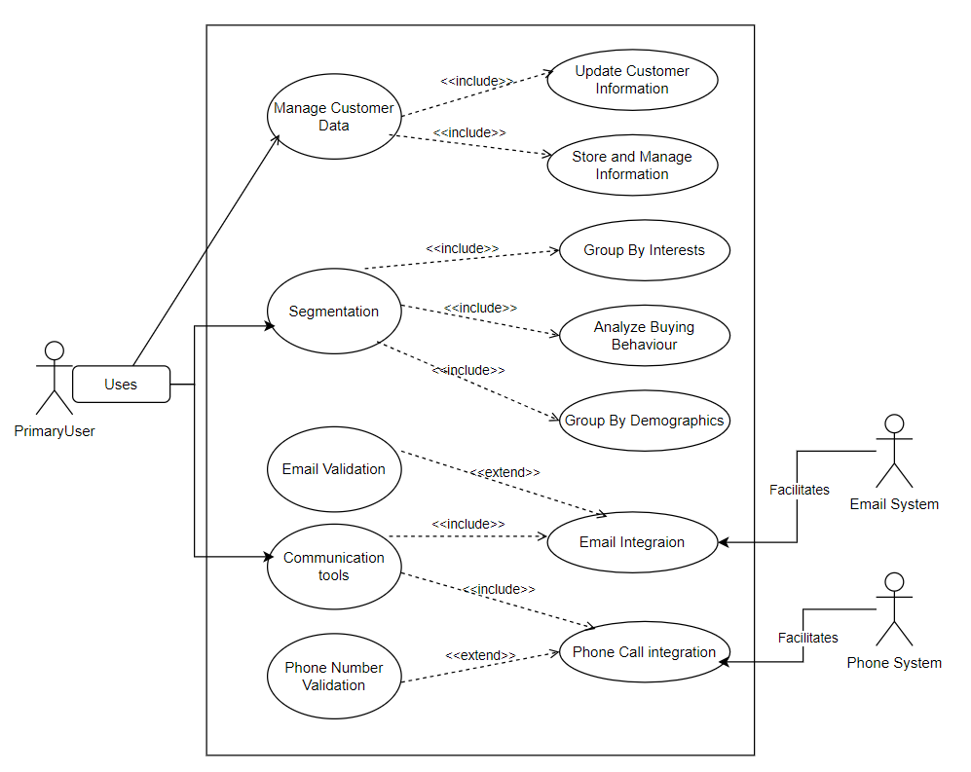

**Explanation of Elements:**

1. **Actors:**
   * **PrimaryUser: The main actor interacting with the system.**
   * **Email System and Phone System: Secondary actors supporting specific functionality.**
2. **Use Cases:**
   * **Manage Customer Data: Includes sub-use cases for storing and updating customer information.**
   * **Segmentation: Groups customers by different attributes with explicit sub-use cases.**
   * **Communication Tools: Integrates email and phone functionalities with extended validations.**
3. **Relationships:**
   * **<<include>>: Represents mandatory sub-use cases.**
   * **<<extend>>: Represents optional functionality like validation.**
4. **Associations:**
   * **Secondary actors (Email System, Phone System) interact with their respective use cases.**

**Activity Diagram:**

**Explanation:**

1. **Start:** The activity diagram begins with capturing contact information.
2. **Validate Contact Information:** The system validates the entered data for accuracy and completeness.
3. **Store and Manage Information:** If the information is valid, the system stores and manages the contact data.
4. **Segment Contacts (Optional):** If segmentation is required, the system groups contacts based on demographics, interests, and buying behavior.
5. **Communicate with Contacts (Optional):** If communication is required, the system determines the communication channel.
   * **Email Communication:** If email is chosen, the system validates the email address and integrates with the email system.
   * **Phone Communication:** If phone is chosen, the system validates the phone number and integrates with the phone system.

**Use Case Specification Document**

**1. Use Case Name:** Manage Contacts

**2. Use Case Description:** This use case describes the core functionalities for managing contacts within the system. It includes capturing, storing, updating, segmenting, and communicating with contacts.

**3. Actors**

* **Primary Actors:** Primary User (e.g., Marketing Manager, Sales Representative)
* **Secondary Actors:** Email System, Phone System

**4. Basic Flow**

1. **Capture Contact Information:** The Primary User enters or imports contact information (name, email, phone number, company, etc.).
2. **Validate Contact Information:** The system validates the entered data for accuracy and completeness.
3. **Store and Manage Information:** The system stores the validated contact information in the database.
4. **Segment Contacts (Optional):** The Primary User can segment contacts based on demographics, interests, or other criteria.
5. **Communicate with Contacts (Optional):** The Primary User can initiate communication with selected contact segments.
   * **Email Communication:** The system validates email addresses and integrates with the Email System to send emails.
   * **Phone Communication:** The system validates phone numbers and integrates with the Phone System for phone calls.

**5. Alternate Flows**

* **Invalid Contact Information:** If the entered contact information is invalid, the system displays an error message and prompts the user to correct the information.
* **Data Import Failure:** If the contact import process fails, the system displays an error message and provides options for troubleshooting.
* **Communication Failure:** If communication with the Email System or Phone System fails, the system logs the error and notifies the administrator.
* **Contact Segmentation Failure:** If the segmentation process fails due to data inconsistencies or other issues, the system displays an error message and provides suggestions for resolving the issue.

**6. Exceptional Flows**

* **Duplicate Contact Entry:** If a duplicate contact is detected, the system notifies the user and provides options for merging or updating the existing record.
* **Data Breach:** In case of a data breach, the system implements security measures to protect contact information and notifies relevant parties.

**7. Pre-Conditions**

* The system is operational and accessible to authorized users.
* The user has the necessary permissions to manage contacts.
* The Email System and Phone System (if applicable) are integrated and functioning correctly.

**8. Post-Conditions**

* Contact information is accurately stored in the system.
* Contacts are segmented according to defined criteria.
* Communication with contacts is successfully initiated.
* Audit logs are maintained for all contact management activities.

**9. Assumptions**

* All actors have the necessary permissions and access rights to perform their roles.
* The system is always available and responsive.
* The network connectivity is stable and reliable.

**10. Constraints**

* Contact data must be handled securely and confidentially in compliance with relevant data privacy regulations (e.g., GDPR, CCPA).
* The system must be able to handle a large volume of contacts and data.
* The system should provide features for data deduplication and contact enrichment.

**11. Dependencies**

* Integration with the Email System.
* Integration with the Phone System (if applicable).
* Integration with other relevant systems (e.g., CRM, marketing automation).

**12. Inputs and Outputs**

* **Inputs:** Contact information (name, email, phone number, company, etc.), segmentation criteria, communication messages.
* **Outputs:** Contact lists, segmentation reports, communication logs, error messages.

**13. Business Rules**

* Only authorized users can access and modify contact information.
* Contact data must be kept up-to-date and accurate.
* Communication with contacts must comply with relevant laws and regulations (e.g., CAN-SPAM Act, GDPR).

**14. Miscellaneous Information**

* This document was created on [Date].
* This document may be subject to change.

1. **Reporting and Analytics:**

**Key Features in the Diagram:**

1. **Actors:**
   * **Sales Manager monitors sales performance.**
   * **Business Analyst customizes reports.**
   * **Executive Team reviews dashboards.**
2. **Includes:**
   * **Core use cases like "Sales Performance Tracking" and "Customizable Reports" include detailed tasks like "Monitor Revenue" or "Export Data".**
3. **Generalization:**
   * **Each major use case (Sales Performance Tracking, Customizable Reports, Dashboard) generalizes smaller, specific tasks.**

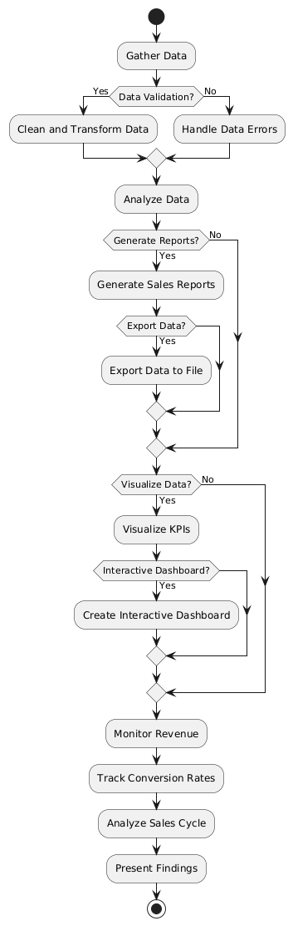

**Explanation:**

1. **Gather Data:** This is the initial step where data is collected from various sources.
2. **Data Validation:** The collected data is validated for accuracy and completeness.
3. **Clean and Transform Data:** If the data passes validation, it is cleaned and transformed into a suitable format for analysis.
4. **Handle Data Errors:** If data validation fails, appropriate actions are taken to handle the errors.
5. **Analyze Data:** The data is analyzed to identify trends, patterns, and insights.
6. **Generate Reports (Optional):** If reports are required, the system generates sales reports.
   * **Export Data (Optional):** If required, the generated reports can be exported to various file formats.
7. **Visualize Data (Optional):** If data visualization is required, the system visualizes key performance indicators (KPIs).
   * **Interactive Dashboard (Optional):** If an interactive dashboard is needed, the system creates a dynamic and interactive dashboard for data exploration.
8. **Monitor Revenue:** The system monitors revenue performance.
9. **Track Conversion Rates:** The system tracks conversion rates across different stages of the sales funnel.
10. **Analyze Sales Cycle:** The system analyzes the sales cycle to identify areas for improvement.
11. **Present Findings:** The analyzed data and insights are presented to the relevant stakeholders (Sales Manager, Business Analyst, Executive Team).

**Use Case Specification Document**

**1. Use Case Name:** Reporting and Analysis

**2. Use Case Description:** This use case describes the process of collecting, analyzing, and presenting data related to sales performance, revenue, and other key business metrics.

**3. Actors**

* **Primary Actors:** Sales Manager, Business Analyst, Executive Team
* **Secondary Actors:** (None specifically mentioned in the diagram)

**4. Basic Flow**

1. **Data Gathering:** The system gathers data from various sources (e.g., CRM, sales databases, financial systems).
2. **Data Validation:** The gathered data is validated for accuracy and completeness.
3. **Data Cleaning and Transformation:** The data is cleaned, transformed, and prepared for analysis (e.g., data cleansing, data aggregation, data enrichment).
4. **Data Analysis:** The system performs various analytical tasks such as trend analysis, sales forecasting, customer segmentation, and key performance indicator (KPI) calculation.
5. **Generate Sales Reports (Optional):** The system generates various sales reports based on user requirements and predefined templates.
6. **Export Data (Optional):** The user can export the generated reports or raw data to different file formats (e.g., CSV, Excel, PDF).
7. **Visualize KPIs (Optional):** The system visualizes key performance indicators using charts, graphs, and dashboards.
8. **Create Interactive Dashboard (Optional):** The system creates interactive dashboards that allow users to explore data, filter results, and gain deeper insights.
9. **Monitor Revenue:** The system continuously monitors revenue performance and identifies trends.
10. **Track Conversion Rates:** The system tracks conversion rates at different stages of the sales funnel.
11. **Analyze Sales Cycle:** The system analyzes the sales cycle to identify bottlenecks and areas for improvement.
12. **Present Findings:** The system presents the analysis results to the relevant stakeholders (e.g., Sales Manager, Business Analyst, Executive Team) through reports, dashboards, and presentations.

**5. Alternate Flows**

* **Data Quality Issues:** If the data quality is poor (e.g., missing values, inconsistencies), the system may trigger alerts or require manual intervention to correct the data.
* **Data Source Errors:** If there are issues with data sources (e.g., data feeds are interrupted, data is not available), the system may be unable to gather the required data.
* **Analysis Failures:** If the analysis algorithms fail to produce meaningful results, the system may require manual intervention or adjustments to the analysis parameters.
* **Report Generation Errors:** If there are errors during report generation, the system may display error messages or provide alternative options.

**6. Exceptional Flows**

* **System Errors:** If the system encounters unexpected errors during any stage of the process, it should log the error and attempt to recover gracefully.
* **Security Breaches:** If security breaches or unauthorized access occur, the system should take appropriate security measures to protect the data.

**7. Pre-Conditions**

* The system has access to all necessary data sources.
* The system is configured with the appropriate analysis settings and parameters.
* Users have the necessary permissions and access rights to perform the required actions.

**8. Post-Conditions**

* Sales data is analyzed and insights are generated.
* Reports and dashboards are generated and presented to stakeholders.
* Key performance indicators are tracked and monitored.
* The system provides valuable information to support business decisions.

**9. Assumptions**

* Data sources are reliable and provide accurate information.
* Users have the necessary skills and knowledge to interpret the analysis results.
* The system has sufficient processing power and storage capacity to handle the data analysis workload.

**10. Constraints**

* Data privacy and security regulations must be adhered to at all times.
* The system must be able to generate reports and visualizations in a timely manner.
* The system must be scalable to handle increasing data volumes and user demands.

**11. Dependencies**

* Integration with various data sources (e.g., CRM, ERP, databases).
* Access to data visualization tools and libraries.
* Availability of sufficient computing resources.

**12. Inputs and Outputs**

* **Inputs:** Raw data from various sources, user queries, analysis parameters.
* **Outputs:** Reports, dashboards, visualizations, alerts, notifications.

**13. Business Rules**

* Data analysis must be performed in accordance with established business rules and methodologies.
* Reports and dashboards must be accurate, timely, and easy to understand.
* User access to data and analysis results must be controlled based on their roles and responsibilities.

**14. Miscellaneous Information**

* This document was created on [Date].
* This document may be subject to change.

1. **Mobile Accessibility:**

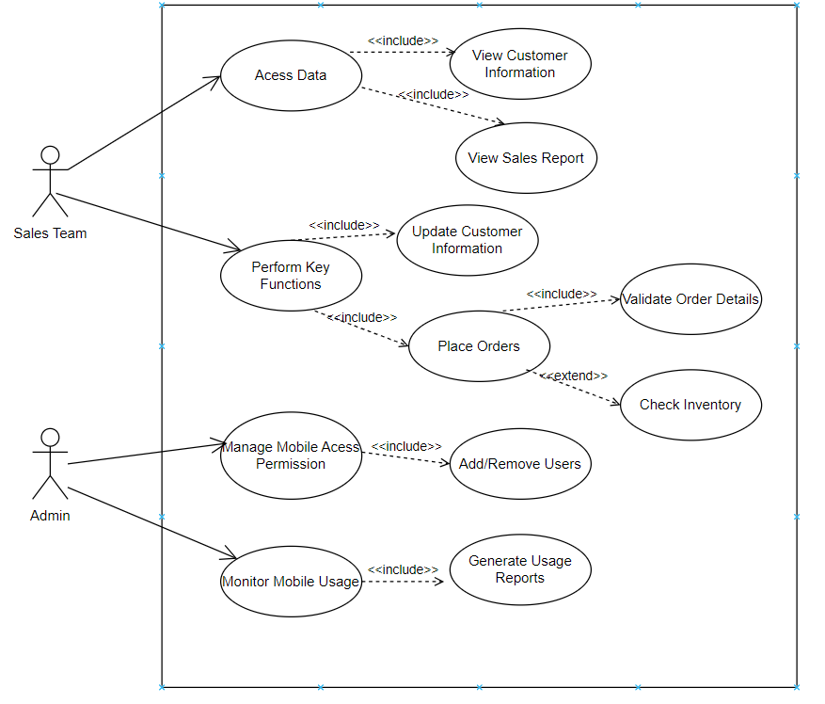

**Explanation:**

**Actors:**

* Sales Team: Represents users accessing the mobile features.
* Admin: Manages permissions and monitors usage.

**Use Cases:**

* Access Data: Includes viewing customer information and sales reports.
* Perform Key Functions: Includes updating customer information and placing orders.
* Place Orders: Extends to validate order details and check inventory.
* Admin Use Cases: Managing mobile access permissions and monitoring mobile usage.

**Relationships:**

* <<include>>: Indicates mandatory functionality that is part of a larger process.

<<extend>>: Indicates optional functionality that may occur under certain conditions.

**Explanation:**

**Start:** The activity diagram begins with the Sales Team accessing the system.

**Access Data:** This is a common activity included in several use cases. It represents the initial step of accessing the necessary data for each use case.

* + **View Customer Information:** If the Sales Team wants to view customer information, they access the relevant data.
  + **View Sales Report:** If the Sales Team wants to view sales reports, they access the necessary sales data.
  + **Update Customer Information:** If the Sales Team needs to update customer information, they access the existing customer data.
  + **Place Orders:** If the Sales Team needs to place orders, they access product information and customer details.
* **Validate Order Details:** If placing an order, the system validates the order details.
* **Check Inventory:** If placing an order, the system checks inventory availability.
* **Perform Key Functions:** This represents other key functions that might be performed by the Sales Team.
* **Manage Mobile Access Permission:** If the Admin wants to add or remove users, they manage the mobile access permissions.
* **Generate Usage Reports:** If the Admin wants to monitor mobile usage, the system generates usage reports.

**Use Case Specification Document**

**1. Use Case Name:** Mobile Accessibility

**2. Use Case Description:** This use case describes the functionalities related to mobile device access and usage within the system. It covers scenarios where users access the system through mobile devices, including user management, access control, and usage monitoring.

**3. Actors**

**Primary Actors:** Admin

**Secondary Actors:** Sales Team

**4. Basic Flow**

**Admin Manages Access:** The Admin accesses the system to manage user permissions and mobile access.

**Add/Remove Users:** The Admin adds or removes users from the system and assigns appropriate access permissions.

**Monitor Mobile Usage (Optional):** The Admin monitors mobile usage data, such as usage frequency, data consumption, and device types.

**Generate Usage Reports (Optional):** The system generates reports on mobile usage data for analysis and decision-making.

**5. Alternate Flows**

**Invalid User Credentials:** If the Admin provides invalid credentials, the system denies access and may display an error message.

**Permission Configuration Errors:** If errors occur while configuring user permissions, the system displays appropriate error messages and may provide assistance to the Admin.

**Data Collection Issues:** If there are issues with collecting mobile usage data, the system may display warnings or alerts to the Admin.

**6. Exceptional Flows**

**Unauthorized Access:** If unauthorized attempts to access or modify mobile access configurations occur, the system logs the event and may take appropriate security measures.

**System Errors:** If unexpected system errors occur during mobile access management or usage monitoring, the system logs the error and attempts to recover gracefully.

**7. Pre-Conditions**

The system is operational and accessible to authorized users.

The Admin has the necessary permissions to manage user access and mobile usage.

Mobile devices are properly configured and connected to the system.

**8. Post-Conditions**

User permissions are updated accurately in the system.

Mobile usage data is collected and stored securely.

Usage reports are generated and made available to the Admin.

**9. Assumptions**

All actors have the necessary permissions and access rights to perform their roles.

The system is always available and responsive.

The network connectivity is stable and reliable.

**10. Constraints**

Mobile access must be secured and protected from unauthorized access.

Mobile usage data must be collected and stored in compliance with relevant privacy regulations.

The system must be able to handle a high volume of mobile usage data.

**11. Dependencies**

Integration with the mobile device management (MDM) system (if applicable).

Access to relevant system logs and usage data.

**12. Inputs and Outputs**

**Inputs:** User information, access permissions, configuration settings.

**Outputs:** User access reports, mobile usage reports, error messages, alerts.

**13. Business Rules**

Only authorized users can manage mobile access permissions.

Mobile usage data must be collected and analyzed for system performance and improvement.

The system should provide mechanisms for controlling mobile access based on security policies and user roles.

**14. Miscellaneous Information**

This document was created on [Date].

This document may be subject to change.

1. **Integrations:**

**Explanation:**

**Actors:**

System Administrator (SysAdmin): Responsible for setting up and managing integrations.

End User: Uses the integrated features for daily operations.

Third-party Systems: Represents external applications like marketing tools, e-commerce platforms, and accounting software.

**Use Cases:**

Set Up Integrations: The primary task of connecting with external systems.

Access Integrated Features: Day-to-day usage of the integrated functionalities.

Connect to Marketing Automation Tools, E-commerce Platforms, and Accounting Software: Specific integrations.

Sync Campaign Data, Product Data, and Automate Billing: Sub-use cases for detailed integration processes.

**Relationships:**

<<include>>: Used to indicate mandatory features or sub-use cases.

<<extend>>: Indicates optional functionalities that add value to the core use cases.

Third-party Interactions:

Use of APIs for real-time data synchronization is represented.

**Activity Diagram**

**Explanation:**

1. **System Administrator Sets Up Integration:** This is the starting point of the integration process.
2. **Connect to Marketing Automation Tool:** If integration with a marketing automation tool is required, the system connects to the tool.
3. **Sync Campaign Data:** Data related to marketing campaigns is synchronized between the system and the marketing automation tool.
4. **Integrate with E-Commerce Platform:** If integration with an e-commerce platform is required, the system connects to the platform.
5. **Sync Product and Inventory Data:** Product and inventory data is synchronized between the system and the e-commerce platform.
6. **Sync with Accounting Software:** If integration with accounting software is required, the system connects to the accounting software.
7. **Automate Billing and Invoicing:** Billing and invoicing processes are automated through integration with the accounting software.
8. **Provide API Access:** The system provides API access for integration with third-party systems.
9. **Enable Real-Time Data Sync:** If real-time data synchronization is required, the system enables it.
10. **End User Accesses Integrated Features:** End users can now access the integrated features.
11. **Generate Integrated Reports:** The system can generate integrated reports based on data from multiple sources.
12. **Trigger Automated Workflows:** The system can trigger automated workflows based on events and data from integrated systems.

**Use Case Specification Document**

**1. Use Case Name:** System Integration

**2. Use Case Description:** This use case describes the process of integrating the system with various external applications and platforms, including marketing automation tools, e-commerce platforms, and accounting software. The integration enables seamless data exchange and automated workflows.

**3. Actors**

* **Primary Actor:** System Administrator

**4. Basic Flow**

1. **System Administrator Sets Up Integration:** The System Administrator initiates the integration process.
2. **Connect to Marketing Automation Tool (Optional):** The System Administrator configures the integration with the marketing automation tool.
3. **Sync Campaign Data (Optional):** The system synchronizes campaign data, such as contact lists, campaign schedules, and performance metrics, between the system and the marketing automation tool.
4. **Integrate with E-Commerce Platform (Optional):** The System Administrator configures the integration with the e-commerce platform.
5. **Sync Product and Inventory Data (Optional):** The system synchronizes product information, inventory levels, and order data between the system and the e-commerce platform.
6. **Sync with Accounting Software (Optional):** The System Administrator configures the integration with the accounting software.
7. **Automate Billing and Invoicing (Optional):** The system automates billing and invoicing processes by integrating with the accounting software.
8. **Provide API Access:** The system exposes APIs to enable integration with third-party systems.
9. **Enable Real-Time Data Sync (Optional):** The system enables real-time data synchronization between the system and integrated platforms.
10. **End User Accesses Integrated Features:** End-users can now utilize the features enabled by the integration, such as accessing customer data from the CRM, managing orders through the e-commerce platform, and viewing integrated reports.
11. **Generate Integrated Reports (Optional):** The system generates integrated reports that combine data from multiple sources, such as sales data from the e-commerce platform, marketing campaign performance from the marketing automation tool, and financial data from the accounting software.
12. **Trigger Automated Workflows (Optional):** The system triggers automated workflows based on events and data received from integrated platforms. For example, a new order placed in the e-commerce platform could automatically trigger an inventory update and a shipment notification.

**5. Alternate Flows**

* **Integration Setup Failure:** If the integration with any of the external platforms fails, the system displays error messages and guides the System Administrator through troubleshooting steps.
* **Data Synchronization Errors:** If data synchronization errors occur, the system logs the errors and attempts to resolve them automatically or notifies the System Administrator.
* **API Access Issues:** If third-party systems encounter issues accessing the system's APIs, the system logs the errors and provides information to the relevant parties.

**6. Exceptional Flows**

* **Security Breaches:** If security vulnerabilities are detected in the integration interfaces, the system takes immediate action to mitigate the risks and prevent unauthorized access.
* **Data Loss:** If data loss occurs during data synchronization, the system implements data recovery mechanisms and notifies the relevant parties.

**7. Pre-Conditions**

* The System Administrator has the necessary permissions to configure and manage system integrations.
* The external platforms are available and accessible for integration.
* Network connectivity is stable and reliable.

**8. Post-Conditions**

* The system is successfully integrated with the specified platforms.
* Data is synchronized between the system and the integrated platforms.
* Automated workflows are triggered as expected.
* Integrated reports are generated and available for analysis.

**9. Assumptions**

* The external platforms provide stable and reliable APIs for integration.
* Data formats and structures are compatible between the system and the integrated platforms.
* The System Administrator has the necessary technical expertise to configure and manage integrations.

**10. Constraints**

* Integration must comply with security and privacy regulations.
* Data synchronization must be performed efficiently and without disrupting system performance.
* The system must be able to handle potential integration errors and failures gracefully.

**11. Dependencies**

* Availability and stability of external platforms.
* Network connectivity between the system and external platforms.
* Technical expertise of the System Administrator.

**12. Inputs and Outputs**

* **Inputs:** Integration configuration settings, data from external platforms, user commands.
* **Outputs:** Integration status messages, error messages, synchronized data, reports, automated workflow triggers.

**13. Business Rules**

* Only authorized users can configure and manage system integrations.
* Data synchronization must be performed securely and efficiently.
* Integration with external platforms must be regularly monitored and maintained.

**14. Miscellaneous Information**

* This document was created on [Date].
* This document may be subject to change.

**Question : Document 7- Screens and pages**

**Answer:**

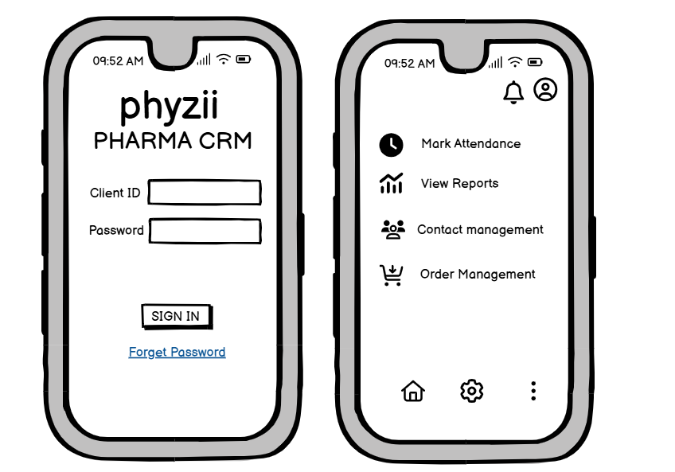

**Question : Document 8- Tools-Visio and Axure**

**Answer:**

During the project, I utilized **Visio** and **Axure** extensively to design and document the features related to Contact Management, Order Management, Report Analysis, Mobile Accessibility, and Integration. Visio was instrumental in creating clear and professional diagrams such as use case diagrams, process flows, and data flow diagrams. It allowed me to visually represent the workflows for contact segmentation, order processing, and reporting dashboards in a manner that was easy for stakeholders to understand. On the other hand, Axure provided a robust platform for prototyping and wireframing the mobile application interfaces. It was especially useful for demonstrating the layout of features like "Mark Attendance," "Manage Orders," and "View Sales Reports." Axure's interactive prototyping capabilities helped convey the user flow and functionality, ensuring clarity in user experience design. Together, these tools streamlined collaboration and communication, providing a seamless bridge between technical design and business requirements.

**Document 9- BA experience**

**Answer:**

1. **1. Requirement Gathering:**
   * To gather requirements for customer information storage, I collaborated with stakeholders to understand what specific data needed to be stored (contact details, company info, purchase history).
   * I validated requirements using the FURPS technique and worked closely with the technical team to design the database schema.
   * Prototyping was used to demonstrate the customer segmentation process.
   * Collected detailed information on order processing from stakeholders and identified business needs related to inventory and billing.
   * Worked closely with the inventory team to gather requirements for tracking inventory levels and ensuring real-time order fulfillment.
   * Gathered requirements for sales performance metrics such as revenue, conversion rates, and sales cycle length.
   * Collaborated with clients and stakeholders to define the need for customizable reports and interactive dashboards.
   * Identified core features (order management, reporting, and customer data) that would be critical for mobile access.
   * Worked with UX/UI designers to gather requirements for mobile accessibility, ensuring user-friendly functionality.
   * Collected requirements for integrating with external systems like marketing automation, e-commerce platforms, and accounting software.
   * Validated integration requirements using the FURPS technique, focusing on functionality and system dependencies.
2. **2. Requirement Analysis:**
   * Created UML diagrams, including use case diagrams to illustrate the customer data management processes.
   * Prepared SRS and BRS documents, ensuring all user requirements were captured.
   * Created flowcharts and process models to map the order management workflow, identifying key points of interaction between the customer, inventory system, and billing.
   * Developed visual representations of the reporting flow and dashboard layouts, gathering feedback from stakeholders.
   * Used activity diagrams to show how key performance indicators would be visualized.
   * Worked with the technical team to ensure that mobile compatibility was accounted for in the system’s design.
   * Created documentation detailing the integration points and ensured clear communication between teams for external system integration.
3. **3. Design:**
   * From use case diagrams, I helped develop test cases for verifying the accuracy and security of stored customer data.
   * Communicated design and solution documents to the client for feedback, incorporating their suggestions into the design.
   * Developed test cases from use case scenarios, ensuring that order fulfillment, inventory tracking, and invoicing were adequately tested.
   * Worked with the team to ensure these features were aligned with client expectations.
   * Designed low-fidelity mockups for the dashboard and customizable reports.
   * Validated design elements through client workshops, ensuring the dashboard layout met their needs.
   * Collaborated with designers to ensure mobile functionality was intuitive and user-friendly.
   * Created prototypes for mobile screens to demonstrate how features would appear on different devices.
   * Worked with the technical team to ensure that integration points were designed for smooth data flow between internal and external systems.
   * Conducted design reviews with stakeholders to confirm integration feasibility.
4. **4. Development:**
   * Coordinated with the development team to implement features for storing and retrieving customer data.
   * Ensured that the centralized database adhered to security protocols and data privacy standards.
   * Clarified requirements for order processing and inventory management during development.
   * Worked with the technical team to ensure that the system could handle real-time data and that order fulfillment worked seamlessly.
   * Worked with the development team to integrate sales performance tracking features and create real-time dashboards.
   * Facilitated communication between teams to ensure KPIs were displayed correctly.
   * Coordinated with the mobile development team to ensure the application was responsive and functional across multiple devices.
   * Ensured that features like order management and reporting were fully accessible on mobile.
   * Supported the technical team in integrating the system with external applications, ensuring smooth data exchange.
   * Managed integration issues and resolved conflicts between systems.
5. **5. Testing:**
   * Developed test cases for database retrieval and customer data processing.
   * Conducted system testing to ensure the accuracy and integrity of customer information.
   * Created test cases for order processing, inventory management, and billing features.
   * Performed high-level testing to ensure smooth order tracking and accurate invoicing.
   * Verified the functionality of sales performance metrics, ensuring reports generated correctly and KPIs were displayed accurately on the dashboard.
   * Performed testing for custom report generation based on user criteria.
   * Tested the mobile interface to ensure that all core features were accessible and functioned well across various devices.
   * Conducted user acceptance testing (UAT) for mobile users to gather feedback and adjust based on user needs.
   * Ensured that integrations with external systems like marketing automation and accounting software were functioning correctly.
   * Tested data flow across systems and ensured no data loss or discrepancies occurred.
6. **6. Deployment:**
   * Coordinated the delivery of the centralized database and ensured it was properly integrated into the live system.
   * Worked with the client to ensure smooth data migration and final data validation.
   * Finalized and deployed the order processing, inventory, and invoicing system to production.
   * Coordinated with stakeholders to ensure system go-live went smoothly.
   * Delivered the reporting and dashboard features and ensured they were working seamlessly.
   * Provided training materials and documentation to clients to help them understand how to use reports and dashboards.
   * Oversaw the deployment of the mobile application, ensuring all features were accessible and functional.
   * Ensured end-users had proper training on using the mobile version of the system.
   * Coordinated with external partners for the final integration and ensured that data syncing was working as expected.
   * Provided post-deployment support to resolve any integration issues.