Question 1 – Audits 4 Quarterly Audits are planned Q1 , Q2, Q3, Q4 for this Project What is your knowledge on how these Audits will happen for a BA ?

|  |  |
| --- | --- |
| Stage | Q1-Audit report requirement gathering phase |
| completed | 1-18 weeks |
| Checklist | BRD template |
|  | elicitation results report |
|  | Duplicate requirement report |
|  | Grouping of functionality/features-client signoff |
|  | Email communication- To,cc,bcc |

|  |  |
| --- | --- |
| Stage | Q2-Audit report requirement analysis phase |
| completed | 19-36 weeks |
| Checklist | UML diagrams |
|  | Business to functional requirements mapping |
|  | Client signoff-documents |
|  | RTM document version control |
|  | Email communication- To,cc,bcc |

|  |  |
| --- | --- |
| Stage | Q3-Audit report design |
| completed | 37-54 weeks |
| Checklist | Utilization of tools |
|  | Documented evidence on client communication |
|  | stakeholder MOM |
|  | Email communication- To,cc,bcc |

|  |  |
| --- | --- |
| Stage | Q4-Audit report development and testing phase |
| completed | 55-72 weeks |
| Checklist | JAD session and test case summary |
|  | end user manual preparation and training report to end users |
|  | BA and development MOM and Lessons learnt document |
|  | Email communication- To,cc,bcc |

Question 2 – BA Approach Strategy

What Elicitation Techniques to apply:

We have many elicitation techniques in this project we can apply to gather the necessary requirements they are interviews, surveys/questionnaires, worshops, observation, document analysis, prototyping, user stories.

How to do Stakeholder Analysis RACI/ILS:

Stakeholder analysis can be done by using RACI matrix which helps to clarify the roles and responsibility within a project. We can do this RACI matrix, assign roles accordingly.

What Documents to Write:

BRD, FRD, Use case Document, Stakeholder analysis document, RACI matrix, test plan etc

What process to follow to Sign off on the Documents:

To ensure proper signoff on the documents we need to get the relevant approval from the stakeholders. This process will confirm that all the parties will agree with the documentation.

Through a email confirmation it can be sign-off.

How to take Approvals from the Client:

To get the approval from the client need to prepare a document send the feedback request for the formal approval through the formal meeting and get the feedback from them.

What Communication Channels to establish n implement:

To ensure proper communication in the project need to establish below communication channel like email communication, instant msges in teams, meeting in teams or virtually (weekly or montly), docs sharing, feedback to channels, stakeholders’ updates etc.

How to Handle Change Requests:

Document the request, ass the impact, review and approve, implement the change, monitor and close.

How to update the progress of the project to the Stakeholder:

Prepare the report and publish it weekly and also while the montly meeting will be conducted same thing should be informed

How to take signoff on the UAT- Client Project Acceptance Form ):

Ensure completion of UAT that is UAT preparation, conduct UAT, fix issues acceptance form final review meeting take feed back, obtain sign off.

Question 3 – 3-Tier Architecture:

Application Layer:

This is the top layer that interacts with the user. It contains all the elements that allow users to interact with application. Its main responsibility is to handle inputs and display information.

Example: web page/mobile app

Business Logic Layer:

This is the middle layer of the architecture it handle core functionality and business logic of the application. It acts as a mediator between application layer and data layer

Example: payment gate way, printers.

Data base Layers:

This is bottom layer which is responsible for the data storage and management. It handles all database interactions.

Example: MySQL and oracle database

Question 4 – BA Approach Strategy for Framing Questions:

5W 1H (Who, what, where, when, why, how)

Who: identify all relevant stakeholders, including end users, managers, and external partners.

What: Specify the exact features, functions, and outcomes expected.

Where : Determine the physical or digital environment where the solutions will be deployed.

When: Understand the project timeline deadline and any time sensitive requirements

Why : Clarify the purpose behind each requirement to ensure it aligns with business goals.

How: explore the process or method by which the solution will be implemented.

SMART : (Specific, measurable, Achievable, Relevant, Time-bound)

Specific: Ensure each requirement is detailed and precise to avoid ambiguity.

Measurable: Define how success will be measured, such as performance matrics or KPIs

Achievable: Confirm that the goals are realistic given the resources and constraints

Relevant: Ensure each requirement directly supports the overall objectives of the project.

Time-bound: Set clear deadlines and milestones to track progress.

RACI:

Responsible: Identify the team members responsible for excuting tasks

Accountable: Determine who is ultimately accountable for the final output.

Consulted: List the individuals whose input is necessary for making informed decisions.

Informed: Ensure all stakeholders who need updates are kept in the loop.

3 Tier Architecture:

Application Layer: Focus on user interfaces, user experience and accessibility.

Business logic tier: Ask about the ruler, calculations and workflows the system must support,

Data tier: Explore data storage, data retrieval, and database requirements,

Use Cases:

Identify the different actors (users or systems) interacting with the system, define the goal of each use case and the preconditions required. Map out the normal flow and alternative flows of actions.

Use case specifications:

Detail the steps involved in each use case, including input and outputs Specify any exceptions or error conditions that need to be handled. Include business rules that apply to use case.

Activity Diagrams:

This is used to visualize the sequence of activities and decision points. Highlight the start and end points of each activity flow. Show the interactions b/w different components or actors.

Models:

Discuss data models to understand the structure of data entities and relationships. Explore process models to visualize the floe of activities and tasks. Consider object models to define the objects and their interactions in the systems.

Page designs:

Discuss layout, navigation, and content organization for each page. Ensure the design aligns with brand guidelines and user expectations. Consider accessibility standards to make the pages usable for all users.

Question 5 – Elicitation Techniques As a Business Analyst, What Elicitation Techniques you are aware of? ( **BDRFOWJIPQU**)

Brainstorming:

A group discussion to generate a wide variety of ideas and sollutions.

Document analysis:

Reviewing existing documents to gather information about current process and systems.

Requirement engineering:

it is a process of analysing and deconstructing an existing system, product, or software to understand its design, functionality, or components.

Focus groups:

Small group discussions with stakeholders to understand their needs and preferences.

Observations:

Watching other users in their natural environment to identify challenges and needs.

Workshops:

Collaborative sessions with stakeholders to define or refine requirements or solutions.

JAD:

Joint application development is structured workshops with stakeholders, developers, and SMEs to collaboratively design a system.

Interviews:

One on one or group meeting to gather detailed insights from stakeholders.

Prototyping:

Creating models or mock-uos of the system to get feedback from stakeholders.

Questionaries:

Distributing structured forms to gather quantitative or qualitative data from a large audience.

Use case spec:

It is detailed document that describes how a system should behave in various scenarios, outlining the interactions between users and the system to achieve goals.

Question 6 – This project Elicitation Techniques:

Prototyping:

Creating early version of the system to give stakeholders something tangible to review. It helps stakeholders like Mr Henry, peter, Kevin, and Ben visualize the product catalog, search functionality, and payment options. Feedback from them can refine the design and features.

Use case Spec:

Writing out detailed scenarios of how users ie farmers will interact with the system. This help define the step a user will follow, such as logging in, browsing products, or making payments. This ensures all functionality and user logins.

Document analysis:

Reviewing existing documents like product catalogs, regulations, and reports. This will help to understand the existing products from manufacturers and ensure that all relevant product details are included in the system.

Brainstorming:

Gathering a group of stake holders to generate and discuss ideas for the system. It encourages collaboration and helps discover additional features, such as different payment options and delivery tracking. It allows stakeholders to share their thoughts and ensure no requirements are missed.

If I had to select one then I will use prototyping:

Visual feedback: It allows stakeholders to see and interact with visual model of the system, making it easier for them to understand the features and provide clear, actionable feedback. We can refine the system iteratively based on stakeholder input, which helps in better aligning with their expectations.

Question 7 - 10 Business Requirements

BR001: User Registration and Login

Farmers, manufacturers and admins should be able to register and login to the platform using their email id and password. Ensure security and personalization for different users.

BR002: User catalog display

Manufacturers should be able to upload and display products such as fertilizers, seeds, and pesticides with details like price, description, and images. It will allow users to view and choose the products.

BR003 : Product search Functionality

Farmers should be able to search for specific products (fertilizers, seeds, pesticides) using keywords or product categories. It improves user experience by making product discovery easier.

BR004: Add to cart and buy later:

Farmers should be able to add products to their cart and save them for later purchase. It facilitates better shopping experience especially for farmers who may not make a purchase immediately.

BR005: Secure payment Gateway

The system should support multiple payment options like cash on delivery, credit/debit cards, and UPI to cater to different user preferences. It offers flexibility and convenience in payment options for farmers.

BR006: Email and notifications

After an order placed, the system should send an email confirmation to the farmer with order details and expected delivery. It provides transparency and keeps users informed about their orders.

BR007: Delivery tracking:

Farmers should be able to track the status of their order through a real time delivery tracking feature. It increases customer satisfaction by providing visibility into the order status.

BR008: Product reviews and ratings:

Farmers should be able to rate and review products after purchase to provide feedback for other users and improve product selection. It encourages trust and helps farmers make informed purchasing decisions.

BR009: User profile Management:

User ie farmers or manufacturers should be able to update their profiles, including contract information, order history, and payment preferences. It helps maintain up to date user information and improves personalization.

BR010: Admin dashboard:

Admins should have access to a dashboard to monitor user activity, manage product listings, track orders, and generate reports. It ensures smooth operations and allows the admin to manage the platform effectively.

Question 8 –Assumptions- List your assumptions:

1. User roles: the platform will support different user roles, including farmers, manufacturers and admins.
2. Internet access: users especially in rural areas, will have basic internet access to use the platform.
3. Simple UI/UX: The platform will have a user-friendly interface suitable for users with verifying digital literacy.
4. Product details: manufacturers will provide necessary product detail like price, description, and images.
5. Payment options: Multiple payment methods, including cash on delivery, credit/debit cards, and UPI, will be available for users.

Question 9 – This project Requirements Priority:

Based on the project here is the possible prioritization of the business requirements, with 1 being low priority and 10 being high priority:

|  |  |  |  |
| --- | --- | --- | --- |
| Req no | Req name | Req description | Priority |
| BR001 | Farmer search for products | Farmers should be able to search for available products in fertilizers, seeds, pesticides | 8 |
| BR002 | Manufacturers upload their products | Manufacturer should be able to upload and display their products in the application | 8 |
| BR003 | User Registration and login | Users should be able to register and login to access personalized features | 9 |
| BR004 | Add to cart and buy later | Farmers should be able to add products to their cart and save them for later purchase | 6 |
| BR005 | Secure payment Gateway | The system should support multiple payment options like cash on delivery, credit/debit cards, and UPI | 9 |
| BR006 | Email and notifications | system should send an email confirmation to the farmer with order details after purchase | 7 |
| BR007 | Delivery tracking | Farmers should be able to track the status of their order through a real time | 7 |
| BR008 | Product reviews and ratings | Farmers should be able to rate and review products after purchase | 5 |
| BR009 | User profile Management | User ie farmers or manufacturers should be able to update their profiles and view order history | 6 |
| BR010 | Admin dashboard | Admins should have a dashboard to manage user activities and product listing | 8 |

Justification of priority:

High priority (8 to 10):

Core functionalities like product search, product upload, user registration, and secure payment are crucial for the platform operation.

Medium priority (6-7): Features like email notifications, delivery tracking, cart management, and user profile management enhance user experience but are secondary to core functionalities.

Low Priority (5):

Product reviews add value but are not critical in the initial phase.

**This prioritization ensures that the fundamental requirements are addressed first, ensuring a functional and user-friendly platform.**

Question 10 – Use Case Diagram:

Note : I made this from draw io which is also saved in my system.

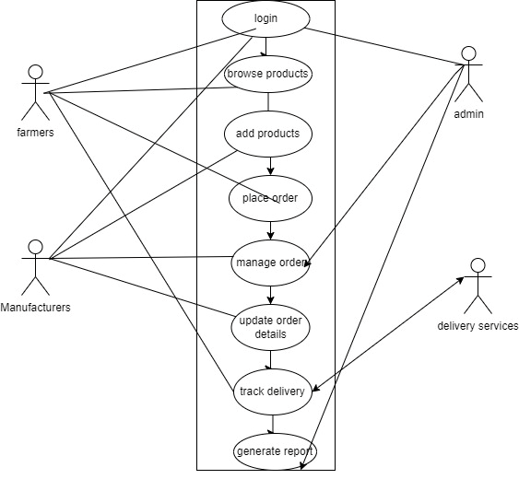

In the above diagram system boundary name is online agriculture market

Left side of the boundary we have the primary actors and right side we have secondary actors

Primary actors initiate some actions with the system, and secondary actors support the system with some information. Use cases are represented in oval shape, straight line that is drawn between actors and use case are relationships.

So here farmer who is primary actor can login, browse products, track the delivery and place orders.

Manufacturers can also login, add the product, manage order, update order details.

Secondary actor’s admin can login, manage orders, and generate report also. Delivery service can track the delivery and responsible for updating and tracking.

In this diagram relationships represent how the use cases and actors interact.

Association relations:

Farmers are associated with login, browse products, place order and track delivery.

Manufacturers are associated with login, add product, manage order and update order details.

Include relationships represents:

A mandatory step that must occur as part of a large use case

For example: place order includes login because farmer must login before placing the order

Track delivery includes place order because only placed orders can be tracked.

Extend relationships:

This is a optional conditional steps that extend a use case

Example: place order extends browse products.

The use case diagram for the online agriculture market clearly represents interactions between actors and the system. It effectively show cases how farmers, manufacturers, admin, and delivery services perform their roles through defined relationships like association, include and extend.

Question 11 – (minimum 5) Use Case Specs:

Use case specification is a detailed description of how a system will behave in response to specific user actions or interactions. It defines the interactions between a user and a system under consideration typically in the form of a use case. The goal is to capture functional requirements and describe how user will use the system to achieve specific goals.

|  |  |
| --- | --- |
| Component | Description |
| Use case ID | UC001 |
| Use case Name | Farmer purchase agricultural products |
| Created by | Vidyashree |
| Last created date | 22/01/2025 |
| Description | Use case describes the process by which a farmer can log into the online portal, browse agricultural products, and make a purchase |
| Norma flow/basic flow/happy flow | 1. Farmer log into the online platform 2. Farmer searches for seeds, pesticides, or fertilizers. 3. The system displays products with details. 4. Farmer select desired products and add them to cart 5. Farmer proceeds to checkout. 6. System prompts for payment details 7. Farmer enters payment info and confirms the order 8. System processes payment and confirms the order |
| Alternate flow | 1. If product is out of stock, the farmer is notified and given and option to wait for restocking or choose an alternative. 2. If the payment is declined, the farmer is prompted to re-enter payment details |
| Exceptions | 1. Farmer has no internet connection preventing the transaction from being completed. 2. Payment gateway error leads to retry or failure notification. |
| Frequency | Daily ( high volume of transactions expected during peak seasons like planting season) |
| Assumptions | 1. The farmer is registered and has access to the platform 2. The platform supports secure online transactions 3. The farmer has necessary internet connectivity for online shopping |

Question 12 – (minimum 5) Activity Diagrams:

Activity diagram 1: Browse products: This diagram represents the steps involved when farmer browses products in different categories.

* Start
* Login
* Select category (seeds, pesticides, fertilizers)
* View product list
* Select product
* Add to cart
* End
* 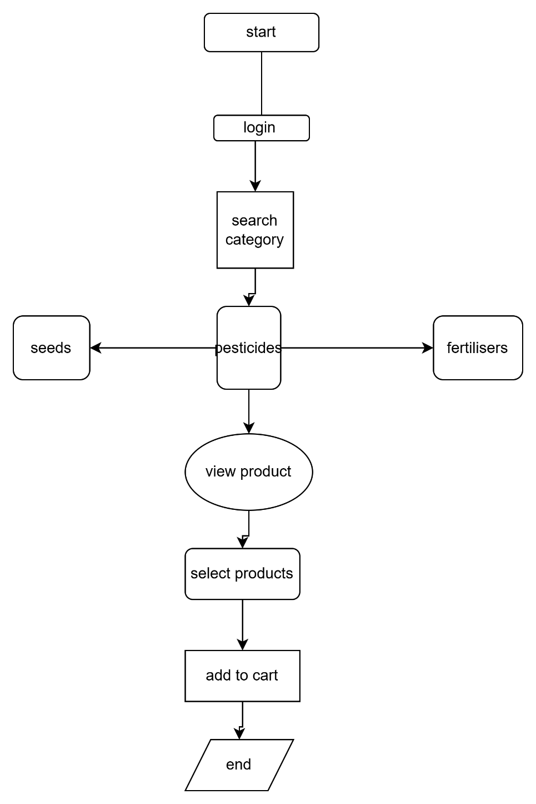

Activity diagram 2 Search for the products:

This diagram shows the step for searching products

* start
* Login
* Enter search query ( is query is valid or no)
* View search results
* Select products
* Proceed to check out
* End
* 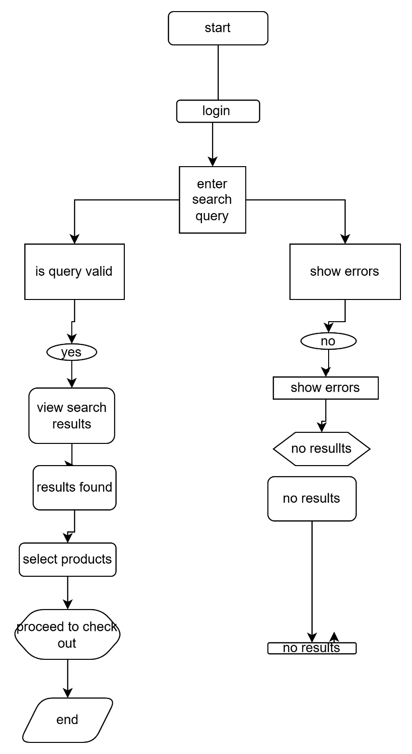

Activity diagram 3: place an order

This diagram shows the steps for placing an order after the products are added to the cart.

* Start
* Login to the portal
* Enter search query
* View results
* Select product
* Add to cart
* Proceed to checkout
* Enter shipping information
* Select payment method
* Confirm and place order
* end
* 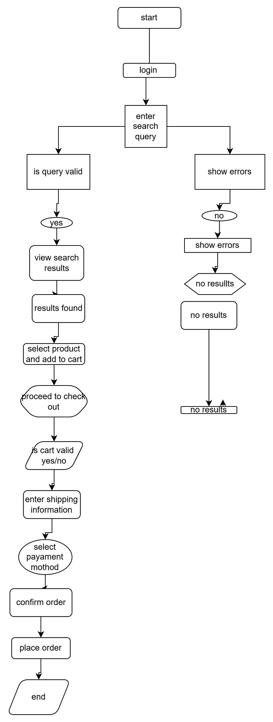

Activity diagram 4: Manage cart

This diagram shows how a user can add, remove or modify items in the cart

* Start
* Login
* View cart
* Modify item quantities
* Remove items
* Update cart
* End
* 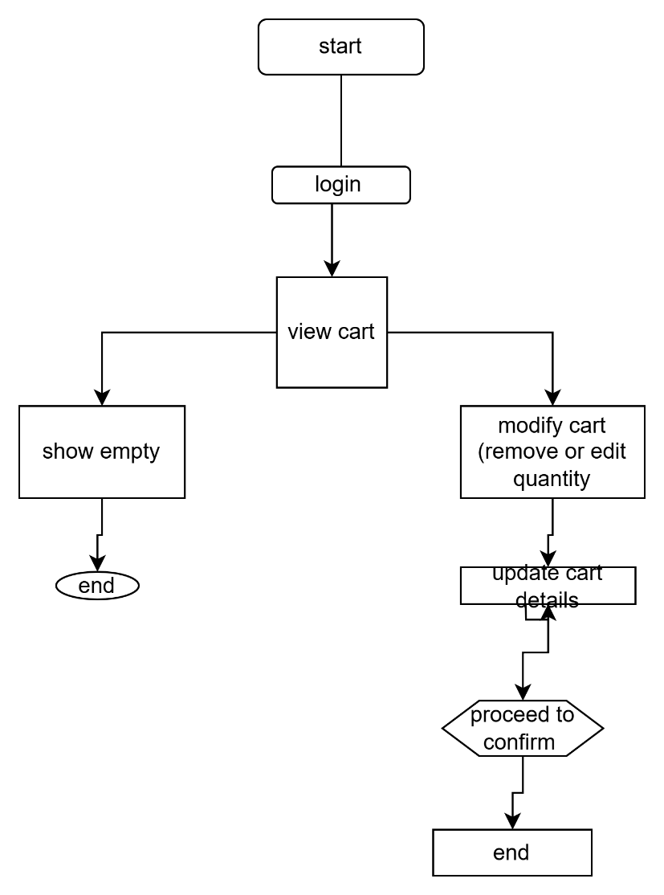

Activity diagram 5: Track order status:

This diagram tracks the status of an order that a farmer placed earlier

* Start
* Login
* Enter order number
* Check order status
* View status
* End

