Question 1: Identify minimum 10 functional and 10 non-functional requirements

Answer:

Functional requirements:  These requirements define the specific behaviour or functions of a system and how the system should work. It applies business logic as well.

|  |  |  |
| --- | --- | --- |
| **Req Id** | **Req Name** | **Description** |
| FR001 | User Registration and Login | Farmers and manufacturers must be able to register and log in using email ID and password. |
| FR002 | Product Catalogue Display | The system should display a categorized catalogue of fertilizers, seeds, and pesticides. |
| FR003 | Search Option | Farmers should be able to search for products using keywords |
| FR004 | Add to cart | Farmers should be able to add products to the cart |
| FR005 | Buy later option | Farmers should be able to save the products to a buy later list |
| FR006 | Order placement | Farmers should be able to place orders after logging in |
| FR007 | Payment Option | Farmers should be able to use different payment modes like COD/CC/DC/UPI |
| FR008 | Email alerts | Once order is placed, email should be sent to the user’s registered email |
| FR009 | Delivery Tracking | Farmers should be able to track their orders |
| FR10 | Manufacturer order approval | Manufacturers should be able to approve the orders placed by farmers and update tracking details |

Non-Functional requirements: These requirements define the qualities and constraints that the system should meet. The inclusion on integrated external peripherals along with the quality requirements like usability, performance, compatibility, reliability etc form the non-functional requirements

|  |  |  |
| --- | --- | --- |
| **Req Id** | **Req Name** | **Description** |
| NFR001 | Usability | The application must be easy to use for non-technical users, especially farmers in rural areas |
| NFR002 | Performance | The system should load product pages and search results in under 3 seconds. |
| NFR003 | Security | The application must ensure secure user authentication |
| NFR004 | Scalability | The system should support a growing number of users and products without performance degradation. |
| NFR005 | Compatibility | The app should be compatible with all the major browsers |
| NFR006 | Reliability | The system should be up and functional at least 99.5% of the time (excluding maintenance). |
| NFR007 | Maintainability | The system should have clean and well-documented code to facilitate updates and bug fixes |
| NFR008 | Multilingual Support | The application should support multiple Indian languages for broader reach |
| NFR009 | Accessibility | The application should be accessed by everyone |
| NFR10 | Data Backup | Daily data backups should be maintained |

Question 2: Make wireframes and prototypes

Answer:

Wireframes:

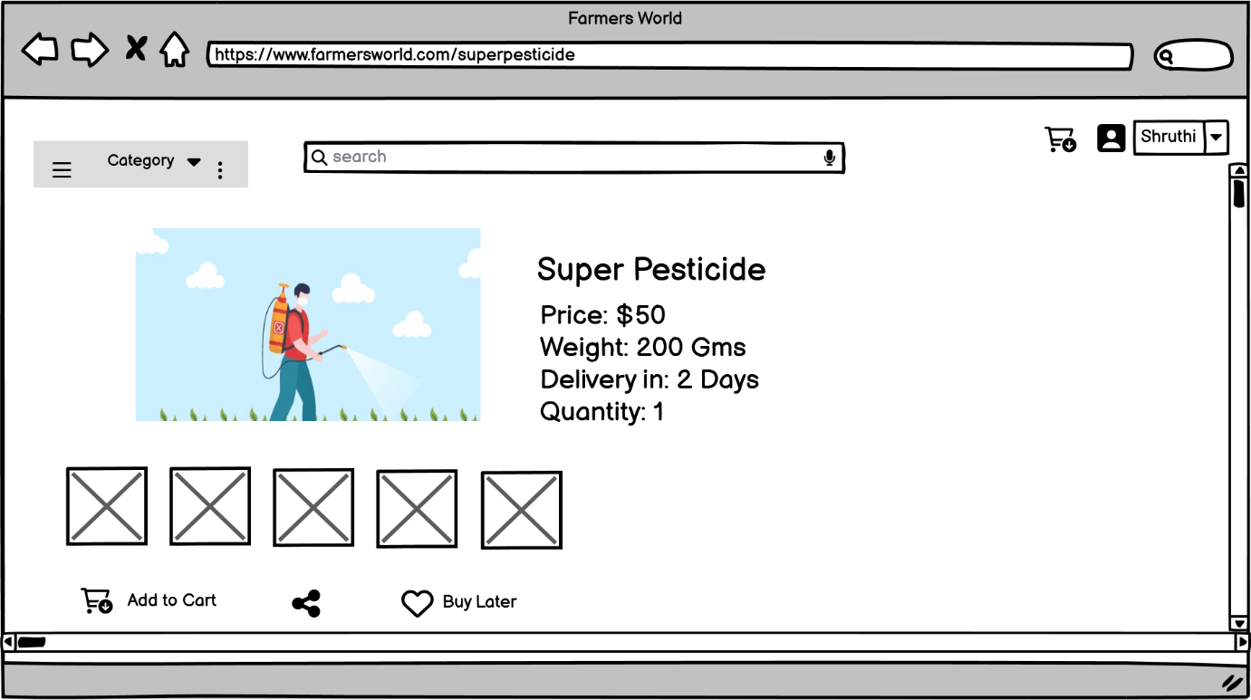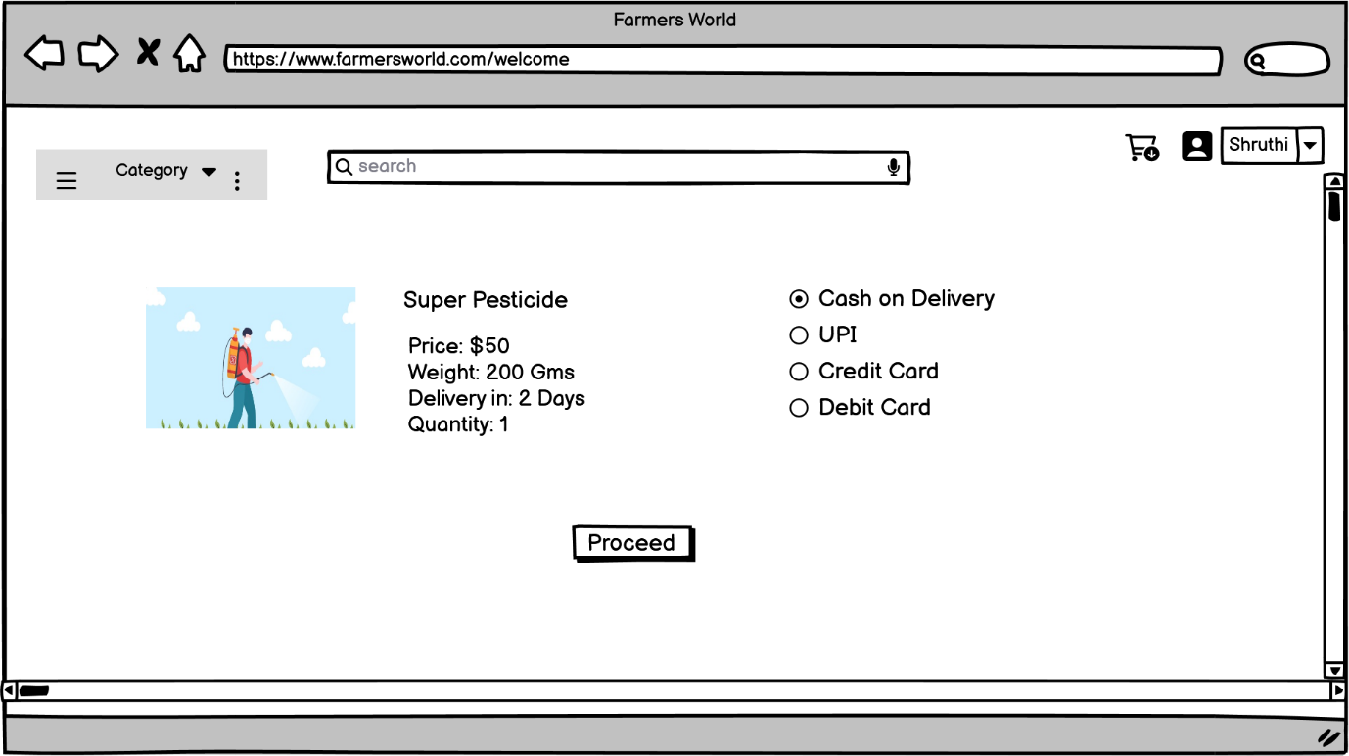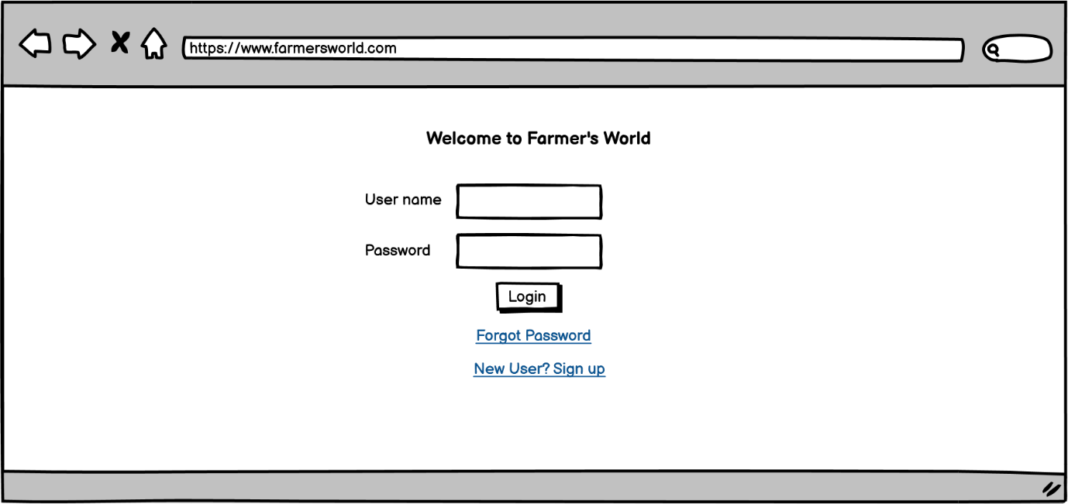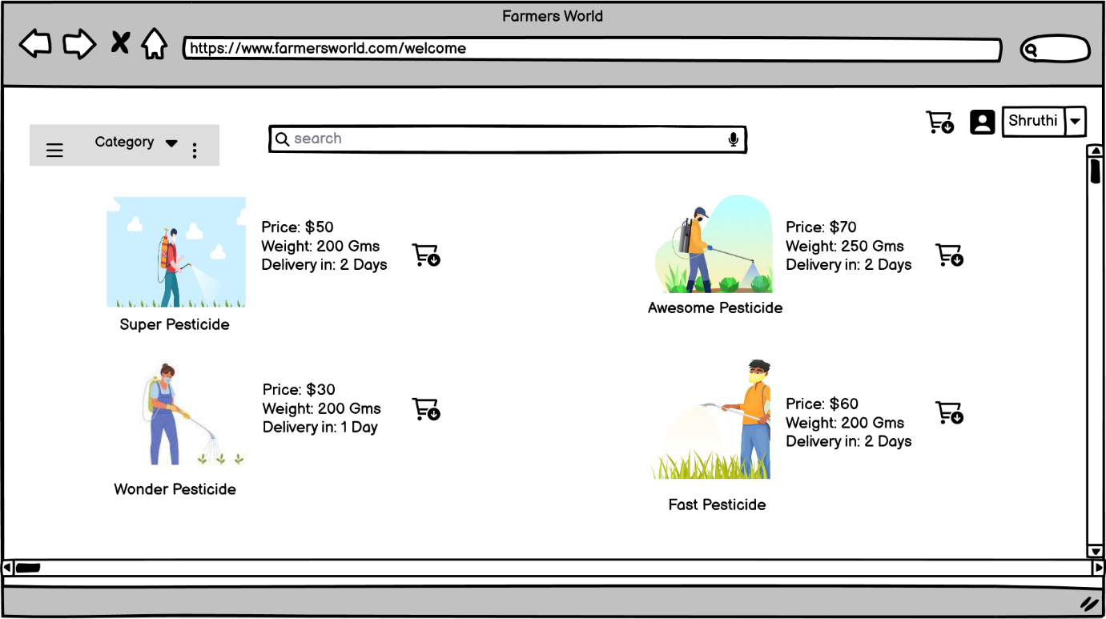

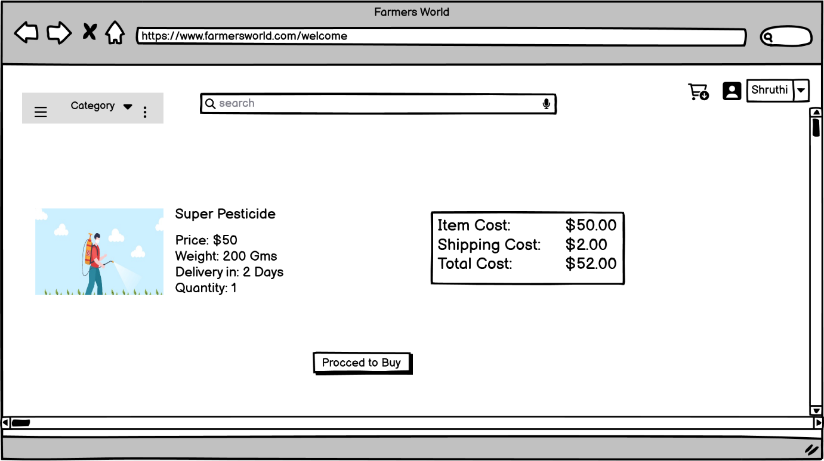

Prototype:

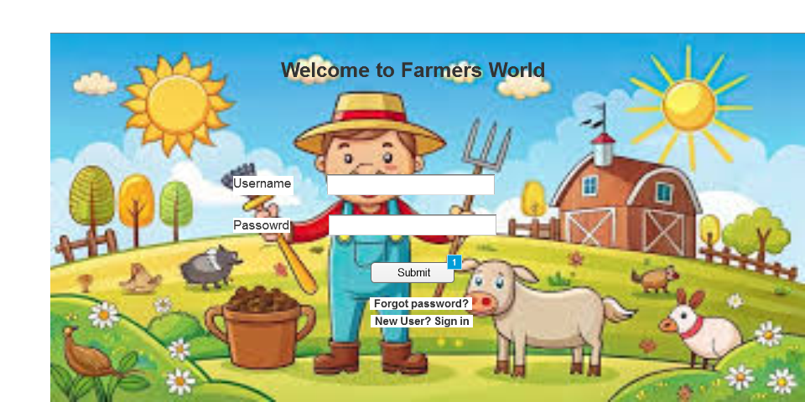

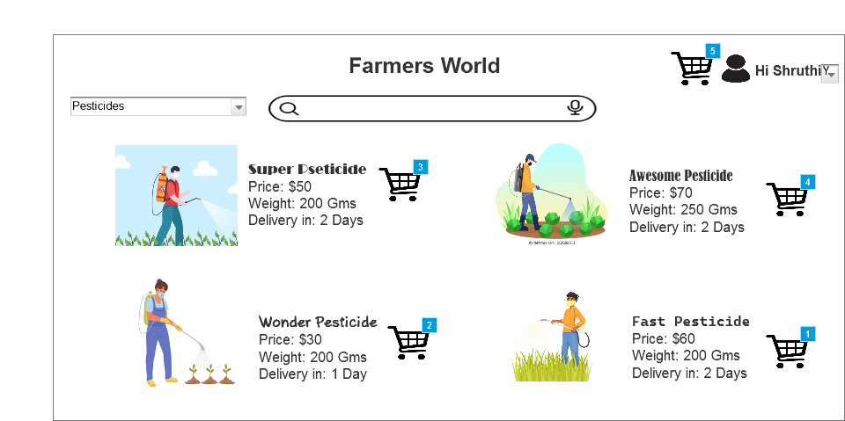

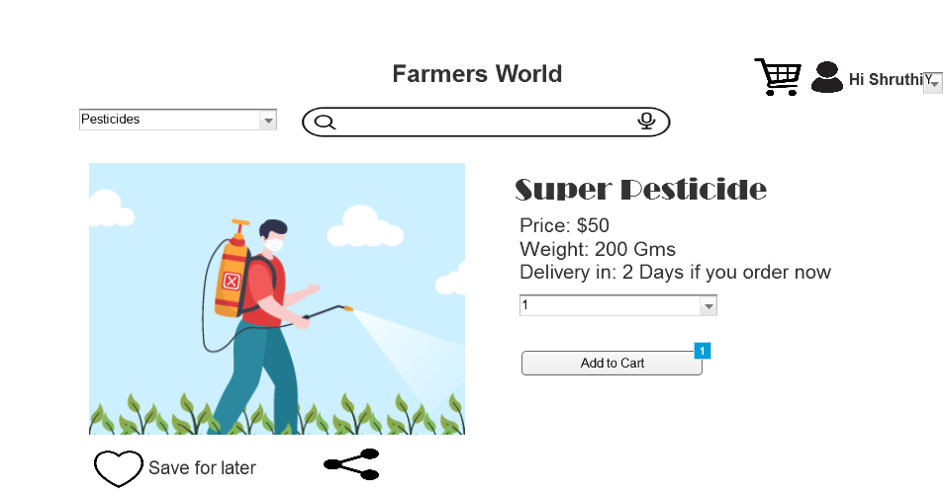

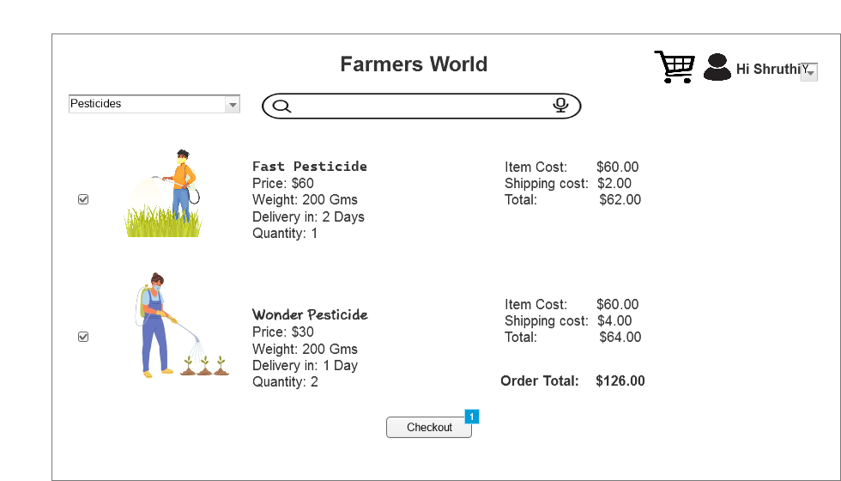

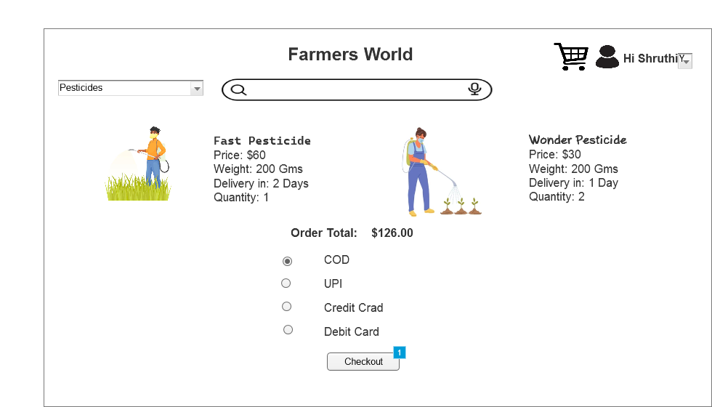

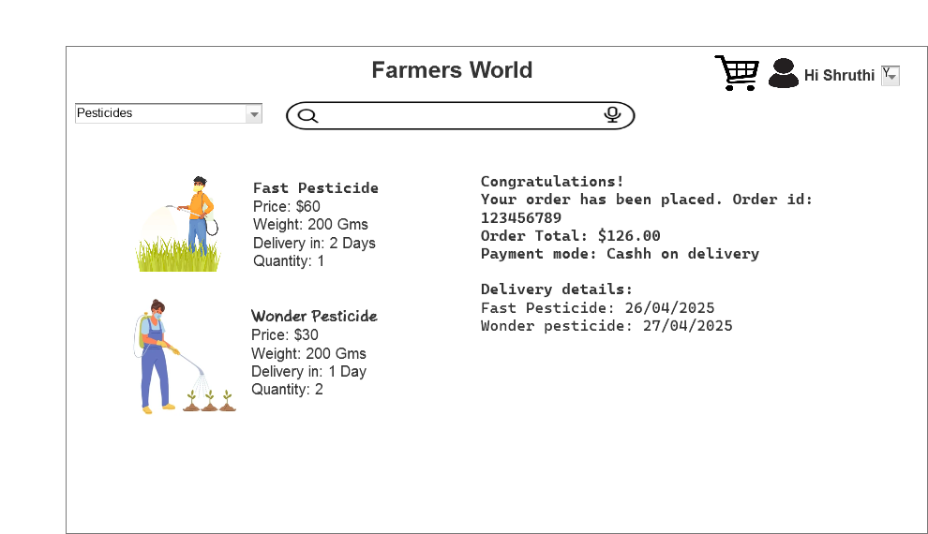

Question 3: Make a note of the Tools, which you are using for above concepts.

Answer:

As a Business Analyst we use 3 tools majorly which are MS Visio, Balsamiq and Axure rp. These are used to draw diagrams, wireframe and prototypes. Here’s the detailed explanation about each tool.

**MS Visio:**

**Microsoft Visio** is a **diagramming tool** developed by Microsoft that allows users to create a wide variety of **professional diagrams**, including:

* Flowcharts
* UML diagrams
* Process diagrams
* Use case diagrams
* Gantt charts etc.

You can create visual representations that help explain complex ideas or workflows clearly.

Through Visio, we can communicate ideas clearly to both technical and non-technical users. We can translate requirements into visuals for developers, testers, and clients. Document workflows and systems in a standardized and understandable format. Create Visuals for presentations, reports or stakeholder meetings.

**Balsamiq:**

**Balsamiq** is a **wireframing tool** designed to help sketch out user interfaces for web or mobile applications **quickly and simply**. It focuses on low-fidelity design, meaning your mockups look like hand-drawn sketches. They are great for brainstorming and discussing ideas.

We can easily drag and drop the pre-built elements like text bar, buttons, sliders, scroll bars etc., It only focuses on the structure and layout and not much detailed information and can help during early discussion with stakeholders on how the application may look. We can also export them as images or pdfs.

**Axure rp:**

**Axure RP (Rapid Prototyping)** is a **professional prototyping tool** that allows you to create high fidelity interactive prototypes. It helps us in not only how the application may look but mostly how it works.

We can use the tools on Axure rp like drop down menus, typable text boxes, etc which are more interactive and easier for the developers to understand and as well as for the stakeholders.

These closely mimic the real applications. It is not only used to see how the tool may look but also how it behaves.

Question 4: A business analyst’s key responsibilities are to keep track of the requirements and make sure that no requirement is missed.

|  |  |  |  |  |  |  |  |  |  |
| --- | --- | --- | --- | --- | --- | --- | --- | --- | --- |
| Re id | Req Name | Desc | Design | Code | UT | CT | ST | SIT | UAT |
| FR001 | User Registration and Login | Farmers and manufacturers must be able to register and log in using email ID and password. | Complete | C | C | C | C | C | C |
| FR002 | Product Catalogue Display | The system should display a categorized catalog of fertilizers, seeds, and pesticides. | Complete | C | C | C | C | C | C |
| FR003 | Search Option | Farmers should be able to search for products using keywords | Complete | C | C | C | C | C | C |
| FR004 | Add to cart | Farmers should be able to add products to the cart | Complete | C | C | C | C | C | C |
| FR005 | Buy later option | Farmers should be able to save the products to a buy later list | Complete | C | C | C | C | C | C |
| FR006 | Order placement | Farmers should be able to place orders after logging in | Complete | C | C | C | C | C | C |
| FR007 | Payment Option | Farmers should be able to use different payment modes like COD/CC/DC/UPI | Complete | C | I | I | I | I | I |
| FR008 | Email alerts | Once order is placed, email should be sent to the user’s registered email | Complete | C | C | C | I | I | I |
| FR009 | Delivery Tracking | Farmers should be able to track their orders | Complete | C | C | C | C | C | I |
| FR10 | Manufacturer order approval | Manufacturers should be able to approve the orders placed by farmers and update tracking details | Complete | C | C | C | C | I | I |
| NFR001 | Usability | The application must be easy to use for non-technical users, especially farmers in rural areas | Complete | I | I | I | I | I | I |
| NFR002 | Performance | The system should load product pages and search results in under 3 seconds. | Complete | C | C | C | C | C | I |
| NFR003 | Security | The application must ensure secure user authentication | Complete | C | C | I | I | I | I |
| NFR004 | Scalability | The system should support a growing number of users and products without performance degradation. | Complete | I | I | I | I | I | I |
| NFR005 | Compatibility | The app should be compatible with all the major browsers | Complete | C | C | C | I | I | I |
| NFR006 | Reliability | The system should be up and functional at least 99.5% of the time (excluding maintenance). | Incomplete | Incomplete | I | I | I | I | I |
| NFR007 | Maintainability | The system should have clean and well-documented code to facilitate updates and bug fixes | Incomplete | Incomplete | I | I | I | I | I |
| NFR008 | **Multilingual Support** | The application should support multiple Indian languages for broader reach | Incomplete | Incomplete | I | I |  | I | I |
| NFR009 | Accessibility | The application should be accessed by everyone | Incomplete | Incomplete | I | I | I | I | I |
| NFR10 | Data Backup | Daily data backups should be maintained | Incomplete | Incomplete | I | I | I | I | I |
|  |  |  |  |  |  |  |  |  |  |

Question 5: Prepare 10 Test Case Documents

Answer: Test

|  |  |  |  |  |  |  |  |  |  |  |
| --- | --- | --- | --- | --- | --- | --- | --- | --- | --- | --- |
| Test Case Id | FMT001 | | | Test Case Name | | | | User registration | | |
| Project Id | FM123 | | | Project name | | | | Famers World | | |
| PM ID | VM123 | | | PM Name | | | | Vandanam | | |
| Test Strategy ID | FWTS001 | | | Tester ID | | | | 007 | | |
| Test Plan ID | FWTS001 | | | Tester Name | | | | Alekya | | |
| Test Schedule ID | FWTS001 | | | Date of Test | | | | 25/03/2025 | | |
| Scenario | User registration should be done with registered unique id and password | | | | | | | | | |
| Link to that page |  | | | | | | | | | |
|  | Set 1 | Set 2 | | | | Set 3 | Set 4 | | | Set 5 |
| Input Data | Correct email id  Password  Click register | Incorrect email id  Password  Click register | | | | Incorrect email & wrong password format | Correct email & incorrect password format | | | Incorrect email id format and password |
| Expected Behaviour | Successful registration | Unsuccessful registration | | | | Unsuccessful registration | Unsuccessful registration | | | Unsuccessful registration |
| Actual Behaviour | Successful registration | Unsuccessful registration | | | | Unsuccessful registration | Unsuccessful registration | | | Unsuccessful registration |
| Comments | Tested | Tested | | | | Tested | Tested | | | Tested |
| Result (Pass/Fail) | Pass | Pass | | | | Pass | Pass | | | Pass |
| Test Case Id | | FMT002 | | | Test Case Name | | | | Product Catalog | | |
| Project Id | | FM123 | | | Project name | | | | Farmers World | | |
| PM ID | | VM123 | | | PM Name | | | | Vandanam | | |
| Test Strategy ID | | FWTS002 | | | Tester ID | | | | 007 | | |
| Test Plan ID | | FWTS002 | | | Tester Name | | | | Alekya | | |
| Test Schedule ID | | FWTS002 | | | Date of Test | | | | 28/03/2025 | | |
| Scenario | | The home screen should have product catalog with all the products | | | | | | | | | |
| Link to that page | |  | | | | | | | | | |
|  | | Set1 | | Set2 | | Set 3 | | Set 4 | | Set 5 | |
| Input Data | | Click on seeds from product catalog | Click on fertilizers from product catalog | | | | Click on pesticides from product catalog | Click on Farming accessories from product catalog | | | Click on brands from product catalog |
| Expected Behaviour | | Only seeds should be displayed | Only fertilizers should be displayed | | | | Only pesticides should be displayed | Only farming accessories should be displayed | | | All brands should be displayed |
| Actual Behaviour | | Only seeds should be displayed | Only fertilizers should be displayed | | | | Only pesticides should be displayed | Only farming accessories should be displayed | | | All brands should be displayed |
| Comments | | Tested | Tested | | | | Tested | Tested | | | Tested |
| Result (Pass/Fail) | | Pass | Pass | | | | Pass | Pass | | | Pass |

|  |  |  |  |  |  |  |  |
| --- | --- | --- | --- | --- | --- | --- | --- |
| Test Case Id | FMT003 | | Test Case Name | | | Search Product with keywords | |
| Project Id | FM123 | | Project name | | | Farmers World | |
| PM ID | VM123 | | PM Name | | | Vandanam | |
| Test Strategy ID | FWTS003 | | Tester ID | | | 007 | |
| Test Plan ID | FWTS003 | | Tester Name | | | Alekya | |
| Test Schedule ID | FWTS003 | | Date of Test | | | 30/03/2025 | |
| Scenario | Users should be able to search products with keyword | | | | | | |
| Link to that page |  | | | | | | |
|  | Set 1 | Set 2 | | Set 3 | Set 4 | | Set 5 |
| Input Data | Wow Pesticides | Super Fertilizers | | Cotton seeds | Wheat grains | | Lentil seed |
| Expected Behaviour | Pesticides from wow brand should be displayed | Fertilizers from super brand should be displayed | | All brands cotton seeds to be displayed | All brands wheat grains to be displayed | | All brands lentil seeds to be displayed |
| Actual Behaviour | Pesticides from wow brand are displayed | Fertilizers from super brand are displayed | | All brands cotton seeds are displayed | All brands cotton seeds are displayed | | All brands lentil seeds are be displayed |
| Comments | Tested | Tested | | Tested | Tested | | Tested |
| Result (Pass/Fail) | Pass | Pass | | Pass | Pass | | Pass |

|  |  |  |  |  |  |  |  |
| --- | --- | --- | --- | --- | --- | --- | --- |
| Test Case Id | FMT004 | | Test Case Name | | | Add to Cart | |
| Project Id | FMT123 | | Project name | | | Farmers World | |
| PM ID | VM123 | | PM Name | | | Vandanam | |
| Test Strategy ID | FWTS004 | | Tester ID | | | 009 | |
| Test Plan ID | FWTS004 | | Tester Name | | | Jason | |
| Test Schedule ID | FWTS004 | | Date of Test | | | 02/04/2025 | |
| Scenario | Customers should be able to add product to cart | | | | | | |
| Link to that page |  | | | | | | |
|  | Set 1 | Set 2 | | Set 3 | Set 4 | | Set 5 |
| Input Data | Click on product to add to cart | Click on add to cart option | | Click on category | Move cursor on product | | Click on cart icon next to product |
| Expected Behaviour | Should not add | Product added to cart | | Should not add product to cart | Should not add product to cart | | Should add product to cart |
| Actual Behaviour | Did not add | Product added to cart | | Did not add | Did not add | | Product added |
| Comments | Tested | Tested | | Tested | Tested | | Tested |
| Result (Pass/Fail) | Pass | Pass | | Pass | Pass | | Pass |

|  |  |  |  |  |  |  |  |
| --- | --- | --- | --- | --- | --- | --- | --- |
| Test Case Id | FMT005 | | Test Case Name | | | Buy Later Option | |
| Project Id | FMT123 | | Project name | | | Farmers World | |
| PM ID | VM123 | | PM Name | | | Vandanam | |
| Test Strategy ID | FWTS005 | | Tester ID | | | 009 | |
| Test Plan ID | FWTS005 | | Tester Name | | | Jason | |
| Test Schedule ID | FWTS005 | | Date of Test | | | 07/04/2025 | |
| Scenario | Customer should be able to add products to buy later list | | | | | | |
| Link to that page |  | | | | | | |
|  | Set 1 | Set 2 | | Set 3 | Set 4 | | Set 5 |
| Input Data | Click on buy later icon | Click on Buy later option under product | | Click on buy later icon | Move cursor on buy later option | | Buy later icon enable and diable |
| Expected Behaviour | Adds product to buy later list | Adds product to buy later list | | Should not add product to cart | Should not add product to cart | | Should be able to add and remove directly with icon |
| Actual Behaviour | Added | Added | | Did not add | Did not add | | Adding and removing with one click |
| Comments | Tested | Tested | | Tested | Tested | | Tested |
| Result (Pass/Fail) | Pass | Pass | | Pass | Pass | | Pass |

|  |  |  |  |  |  |  |  |
| --- | --- | --- | --- | --- | --- | --- | --- |
| Test Case Id | FMT006 | | Test Case Name | | | Order placement | |
| Project Id | FMT123 | | Project name | | | Farmers World | |
| PM ID | VM123 | | PM Name | | | Vandanam | |
| Test Strategy ID | FWTS006 | | Tester ID | | | 009 | |
| Test Plan ID | FWTS006 | | Tester Name | | | Jason | |
| Test Schedule ID | FWTS006 | | Date of Test | | | 10/04/2025 | |
| Scenario | Customer should be able to place order by clicking on place order option | | | | | | |
| Link to that page |  | | | | | | |
|  | Set 1 | Set 2 | | Set 3 | Set 4 | | Set 5 |
| Input Data | Click on place order option | Click on cart option | | Click on place order directly from product detail page | Click on buy later list | | Hover on place order option |
| Expected Behaviour | Page directed to payment page | Page should not be directed to payment | | Page directed to payment page | Page should not be directed to payment | | Page should not be directed to payment |
| Actual Behaviour | Page directed to payment page | Page not directed to payment | | Page directed to payment page | Page not directed to payment | | Page not directed to payment |
| Comments | Tested | Tested | | Tested | Tested | | Tested |
| Result (Pass/Fail) | Pass | Pass | | Pass | Pass | | Pass |

|  |  |  |  |  |  |  |  |
| --- | --- | --- | --- | --- | --- | --- | --- |
| Test Case Id | FMT007 | | Test Case Name | | | Payment option | |
| Project Id | FMT123 | | Project name | | | Farmers World | |
| PM ID | VM123 | | PM Name | | | Vandanam | |
| Test Strategy ID | FWTS007 | | Tester ID | | | 007 | |
| Test Plan ID | FWTS007 | | Tester Name | | | Alekya | |
| Test Schedule ID | FWTS007 | | Date of Test | | | 13/04/2025 | |
| Scenario |  | | | | | | |
| Link to that page |  | | | | | | |
|  | Set 1 | Set 2 | | Set 3 | Set 4 | | Set 5 |
| Input Data | Click on COD | Click on UPI | | Click on DC | Click on CC | | Click on proceed without choosing any option |
| Expected Behaviour | Order placed | Page directed to UPI app | | Load DC details page | Load CC details page | | Prompt user to choose payment option |
| Actual Behaviour | Order placed | Page directed to UPI app | | Loaded DC details page | Loaded CC details page | | Prompting user to choose payment option |
| Comments | Tested | Tested | | Tested | Tested | | Tested |
| Result (Pass/Fail) | Pass | Pass | | Pass | Pass | | Pass |

|  |  |  |  |  |  |  |  |
| --- | --- | --- | --- | --- | --- | --- | --- |
| Test Case Id | FMT008 | | Test Case Name | | | Email alert | |
| Project Id | FMT123 | | Project name | | | Farmers World | |
| PM ID | VM123 | | PM Name | | | Vandanam | |
| Test Strategy ID | FWTS008 | | Tester ID | | | 007 | |
| Test Plan ID | FWTS008 | | Tester Name | | | Alekya | |
| Test Schedule ID | FWTS008 | | Date of Test | | | 18/04/2025 | |
| Scenario | User should be able to receive an email alert after successful order placement | | | | | | |
| Link to that page |  | | | | | | |
|  | Set 1 | Set 2 | | Set 3 | Set 4 | | Set 5 |
| Input Data | Click on place order after COD | Click on place order after giving incorrect CC details | | Click on place order after giving incorrect DC details | Click on place order after giving incorrect UPI details | | Click on register after filling registration forms |
| Expected Behaviour | Order placed and email alert sent | Email alert with information on payment rejection | | Email alert with information on payment rejection | Email alert with information on payment rejection | | Receive email after entering registration details |
| Actual Behaviour | Email received by user | Email not received | | Email not received | Email not received | | Email received |
| Comments | Tested | Tested | | Tested | Tested | | Tested |
| Result (Pass/Fail) | Pass | Failed | | Failed | Failed | | Pass |

|  |  |  |  |  |  |  |  |
| --- | --- | --- | --- | --- | --- | --- | --- |
| Test Case Id | FMT009 | | Test Case Name | | | Delivery tracking | |
| Project Id | FMT123 | | Project name | | | Farmers World | |
| PM ID | VM123 | | PM Name | | | Vandanam | |
| Test Strategy ID | FWTS009 | | Tester ID | | | 009 | |
| Test Plan ID | FWTS009 | | Tester Name | | | Jason | |
| Test Schedule ID | FWTS009 | | Date of Test | | | 21/04/2025 | |
| Scenario | User should be able to track his order | | | | | | |
| Link to that page |  | | | | | | |
|  | Set 1 | Set 2 | | Set 3 | Set 4 | | Set 5 |
| Input Data | Click on track order from website | Click on track order through app | | Click on track order from email conf | Click on order id | | Click on product image from orders page |
| Expected Behaviour | Redirect to tracking info page | Redirect to tracking info page | | Redirect to tracking info page | Don’t redirect to tracking page | | Don’t redirect to tracking page |
| Actual Behaviour | Redirected | Redirected | | Redirected | Not redirecting | | Not redirecting |
| Comments | Tested | Tested | | Tested | Tested | | Tested |
| Result (Pass/Fail) | Pass | Pass | | Pass | Pass | | Pass |

|  |  |  |  |  |  |  |  |
| --- | --- | --- | --- | --- | --- | --- | --- |
| Test Case Id | FMT010 | | Test Case Name | | | Manufacturer product upload | |
| Project Id | FMT123 | | Project name | | | Farmers World | |
| PM ID | VM123 | | PM Name | | | Vandanam | |
| Test Strategy ID | FWTS010 | | Tester ID | | | 009 | |
| Test Plan ID | FWTS010 | | Tester Name | | | Jason | |
| Test Schedule ID | FWTS010 | | Date of Test | | | 25/04/2025 | |
| Scenario | Manufacturer should be able to upload his products on the website | | | | | | |
| Link to that page |  | | | | | | |
|  | Set 1 | Set 2 | | Set 3 | Set 4 | | Set 5 |
| Input Data | Click on add product from category page | Click on add product from home page | | Click on pesticide option | Click on seeds option | | Click on fertilizers option |
| Expected Behaviour | Give option to choose product and add | Give option to choose product and add | | Given option to add only pesticides | Given option to only add seeds | | Given option to add only fertilizers |
| Actual Behaviour | Given option to choose product and add | Given option to choose product and add | | Given | Given | | Given |
| Comments | Tested | Tested | | Tested | Tested | | Tested |
| Result (Pass/Fail) | Pass | Pass | | Pass | Pass | | Pass |

Question 6: After the requirements are thoroughly explained to the entire project team by business analyst, the Database architects have decided to do the database design and also to represent the in-flow and out-flow of data.

Draw database schema and ER diagram

Answer:

DB Schema: In a database all the data is stored in the form of tables and each table is given a name.

The columns are called as ‘Entities’ and the data inside the columns are called as ‘Data record’.

All the tables in the database along with their entities forms Database Schema

Product Table

|  |  |  |  |  |
| --- | --- | --- | --- | --- |
| Product ID | Product Name | Category | Price | Quantity |
| 123456 | Wow Pesticide | Pesticide | $60 | 1 |
| 123567 | Super pesticide | Pesticide | $60 | 1 |
| 123789 | Fast Pesticide | Pesticide | $50 | 1 |
| 123123 | Wheat grains | Seeds | $80 | 1 |
| 123896 | Manure magic | Fertilizer | $100 | 1 |
| 124567 | Cotton cure | Seeds | $200 | 1 |
| 127894 | Lets go fertilize | Fertilizer | $80 | 1 |

Customer Table

|  |  |  |  |  |
| --- | --- | --- | --- | --- |
| Customer ID | Customer Name | DOB | Contact # | Age |
| 0022233 | Ram | 12/12/2001 | 1234567890 | 15 |
| 2165121 | Shyam | 01/01/1993 | 0123456798 | 20 |
| 5561325 | Sudha | 08/15/1988 | 6545145441 | 18 |
| 8965369 | Madhu | 07/12/1999 | 5475210121 | 25 |
| 8484512 | Karthik | 08/08/1997 | 5478721000 | 33 |
| 4973263 | Karthika | 02/05/2000 | 8787454151 | 31 |
| 7976114 | Akhil | 08/05/2001 | 5845161610 | 25 |

Customer Product Table

|  |  |  |  |  |
| --- | --- | --- | --- | --- |
| Account No | Customer ID | Product ID | Sale Date | Quantity |
| 1548151 | 0022233 | 123456 | 01/01/2025 | 3 |
| 5165462 | 2165121 | 123567 | 08/05/2022 | 2 |
| 4197562 | 5561325 | 123789 | 04/05/2025 | 1 |
| 1548841 | 8965369 | 123123 | 05/05/2024 | 5 |
| 8795622 | 8484512 | 123896 | 08/08/2020 | 4 |
| 6487961 | 4973263 | 124567 | 06/04/2021 | 2 |
| 5796411 | 7976114 | 127894 | 09/08/2023 | 1 |

Transaction Table:

|  |  |  |  |  |
| --- | --- | --- | --- | --- |
| Transaction ID | Account No | Customer ID | Amt | Balance |
| 00004494 | 1548151 | 0022233 | $100 | $100 |
| 0000514941 | 5165462 | 2165121 | $80 | $50 |
| 6468451616 | 4197562 | 5561325 | $50 | $0 |
| 9795626112 | 1548841 | 8965369 | $200 | $0 |
| 0000044646 | 8795622 | 8484512 | $150 | $25 |
| 0000487956 | 6487961 | 4973263 | $110 | $35 |
| 0000587941 | 5796411 | 7976114 | $90 | $200 |

From the above details, all the **4 tables** **Product, Customer, Customer Production and Transaction** tables along with their **entities Product ID, Product Name, Category, Price, Quantity, Customer ID, Customer Name, DOB, Age, Phone #, Account No, Customer ID, Product ID, Sale Date, Transaction ID, Amt, Balance** together form the DB schema

ER diagram or Entity relation diagrams are a visual way of representing structure of a database. It shows how the tables, entities are related to each other.

Visual representation of ER diagram.

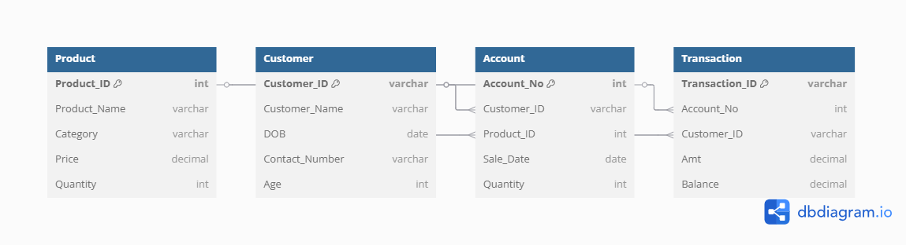

Question 7: What is a data flow diagram? Draw a data flow diagram to represent the in-flow and out-flow of data when a Farmer is placing an order for the product

Answer:

Data Flow diagram represents how the data flows through a system visually. It helps us understand how the data we input transforms into output results. It shows how the Processes, data, external factors flow.



Question 8: Due to change in the Government Taxation structure. we should change the Tax structure How do you handle change requests in a project?

Answer: Change request means whenever a change or an adjustment is required during the ongoing project for the features that were already created or agreed upon.

In this scenario, due to the change in government taxation structure, we should go ahead and comply to it and inculcate this in our project.

Steps to be followed:

* Document the change request with details like new tax details. date of change, legal documents to be needed)
* This information needs to be submitted by the Financial Head Mr.Pandu.

Once done, we need to go ahead and enter these details in the Change request log with the following information:

* Change id
* Description
* Requestor
* Priority
* Date
* Impacted items

Once done, we need to do the impact analysis involved due to this change.

* What would be impacted if this change is made? Payment, Invoices, Tax on the product
* What are the risks? - If delayed, it would lead to legal complications
* Timeline and efforts – as this is an emergency situation and involves legal decisions, this needs to be the top priority and we would need a tax advisor to help us with the calculations to be embedded in the code
* Dependencies with other features - this also depends on various tax factors like how it impacts the manufacturers and sellers

Once we analyse these, we need to inform this to the Change Control Board or Project Committee Mr. Henry, Mr. Pandu, Mr. Dooku

Once we get an approval from them, we need to document it and inform all stakeholders about it including the project team so that they can work it on right away

Question 9: As the project is in process, Ben and Kevin have contacted you. The reason is to inform you that they want the Farmers to sell their crop yields through this application i.e. Farmers should be able to add their crop yields or products and display to general public and should be able to sell them. They also want to introduce Auction system for their Crop yields. As a BA, what will be your response?

Is this a change request or an enhancement???

Answer:

This is not a small change. We consider it as an enhancement because it’s a new feature altogether and it’s a great opportunity for the farmers to sell their yield online and an auction system would help them even better.

In order for us to implement this, we need to use new workflows, new procedures.

This becomes a new requirement that requires new feature development on the app and add new screens and pages and we need to check if it is feasible even before getting into development.

We need to see how its going to benefit the farmers and the buyers as well and also check what can be sold and report our findings to the stakeholders and get an approval from them.

Question 10: Come up with estimations – How many Manhours required

Answer:

Estimated Manhours:

BA – 20 Hours – gather req, sort, validate, document, approval

Developers – 200 Hours

Database design – 20 Hours

Testing – 80 Hours

Deployment – 30 Hours

Total hours – 320 Man hours

Question 11: Project has finally completed all the stages i.e., design, development, testing etc. Now, it is the role of a business analyst to contact the client for testing of the final product and have to successfully complete it. How are you going to handle this situation? And once it is done, what will be the process to close the project?

Explain UAT Acceptance process

Answer: UAT stands for User Acceptance Testing. When the project is completed and tested from our end, we need to give it to the client and test it on their environment. We need to inform the client about the timeline, environment needed for UAT.

We need to invite all the stakeholders and conduct a meeting and inform them about the plan.

Once done, we need to facilitate the UAT – clarify any doubts they have, coordinate with the developers’ team if any issue arises, maintain a tracker and report them

Once all issues are resolved, we need to take a sign off from the client through email communication and a formal meeting.

Question 12: Explain Project closure document

Answer: Project closure document means a detailed report of what has happened in the project including achievements, lessons learned, achievements, Quality assurance, resources utilized, risk management, challenges faced.

|  |  |  |  |
| --- | --- | --- | --- |
| **S No** | **Points to Include** | **Details** | **Reference link** |
| 1 | Did the client sign off on UAT | |  |
|  | Date of sign off | 25/04/2025 |  |
|  | Name of the resource | Mr. Pandu |  |
| 2 | Objectives of the project | |  |
|  | Farmers to be able to buy/sell products | Achieved |  |
|  | User friendly app | Achieved |  |
| 3 | Functional worked on | |  |
|  | Payment processing | Achieved |  |
|  | Adding category list | Achieved |  |
|  | Manufacturers selling products | Achieved |  |
|  | Delivery tracking | Achieved |  |
| 4 | Infrastructure | |  |
|  | Software Installed | Achieved |  |
|  | Laptops Purchased | Achieved |  |
| 5 | Funding | |  |
|  | Amount approved | 2 Crores |  |
|  | Amount Used | 1,87,58,318 |  |
| 6 | Overall Project Information | |  |
|  | Escalations | 53 |  |
|  | Customer satisfaction | High |  |
| 7 | Value to the company | |  |
|  | Positive | Farmers are able to buy products online very easily  More number of farmers started using the app |  |
|  |  |