Capstone Project3– Part -1/2

A customer can make a payment either by Card or by Wallet or by Cash or by Net banking.
Q1. Draw a Use Case Diagram
Answer:
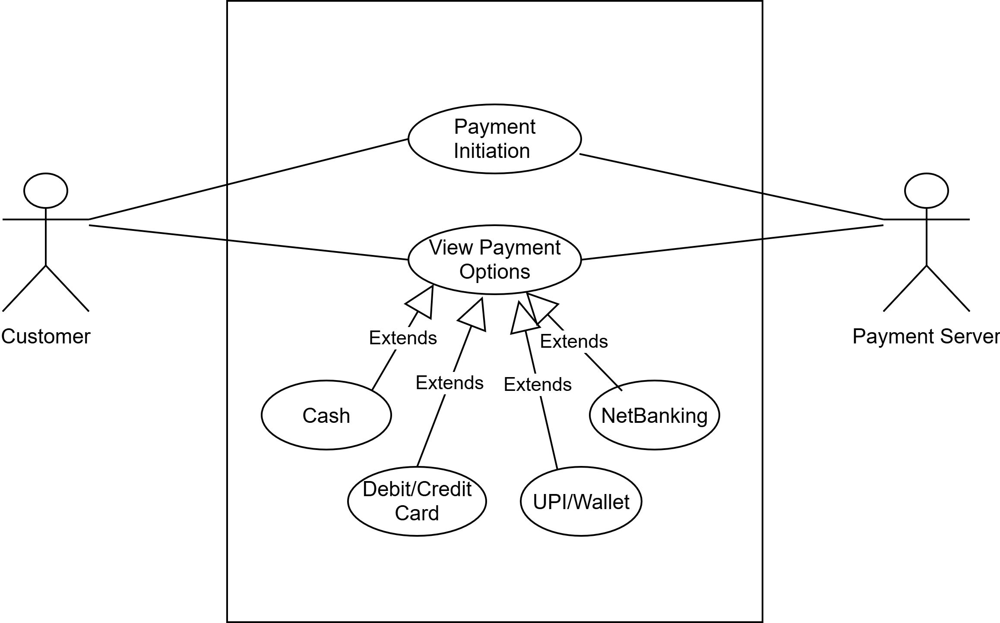

Q2. Derive Boundary Classes, Controller classes, Entity Classes.
Answer:
Boundary Classes: Classes that handle the interaction between the system and external actors (users or other systems).
Purpose: Represent the UI screens, forms, dialogs, or APIs that users interact with.
Examples (from payment system):
- PaymentUI (screen where customer chooses payment method)
- CardPaymentBoundary, WalletInterface, etc.

Controller Classes: Classes that coordinate and manage the flow of the use case. Act as intermediaries between boundary and entity classes
Purpose: Implement business logic and decide how entities and boundaries interact.
Examples (from payment system):
- PaymentinitiatedController (decides whether payment goes via Card, Wallet, Cash, NetBanking)
- CardpaymentController
Entity Classes: Classes that represent real-world business objects or data that must be stored
Purpose: Model persistent information and system state.
Examples (from payment system):
- CardPayment
- WalletPayment
- CashPayment
- NetBankingPayment

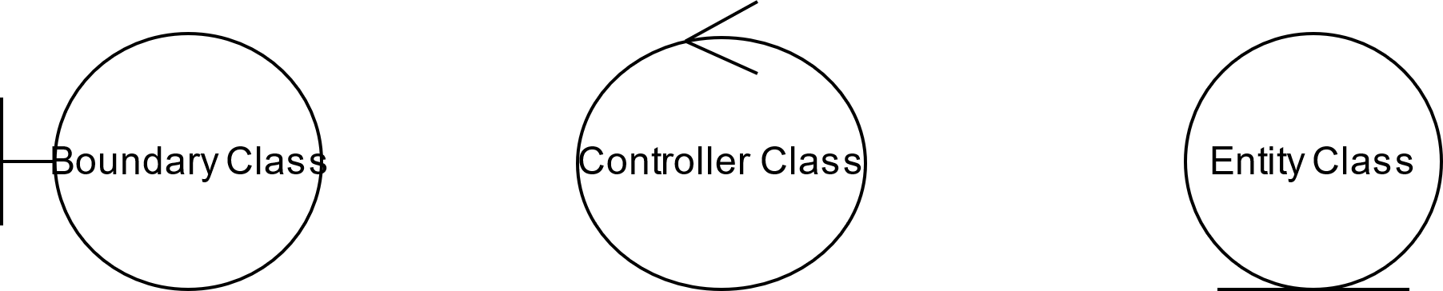

Q3. Place these classes on a three tier Architecture
Answer:
1)Presentation Layer (UI Layer) – Boundary Classes
Responsible for interacting with the Customer (Actor).
Classes:
-PaymentUI
-CardPaymentBoundary
-WalletInterface
2) Business Logic Layer (Application Layer) – Controller Classes
Layer contains the core business logic and the processing rule. It handles communication between the UI and the database
-PaymentinitiatedController
-CardpaymentController

3. Data Layer (Persistence Layer) – Entity Classes
Responsible for storing/retrieving and maintaining data.
Classes:
-CardPayment
-WalletPayment
-CashPayment
-NetBankingPayment

Q4. Explain Domain Model for Customer making payment through Net Banking
Answer: A Domain Model represents the real-world objects (entities), their attributes, and the relationships involved in a business scenario.
It’s a conceptual representation that defines the structure, relationships, and behaviour of entities within a specific problem domain.

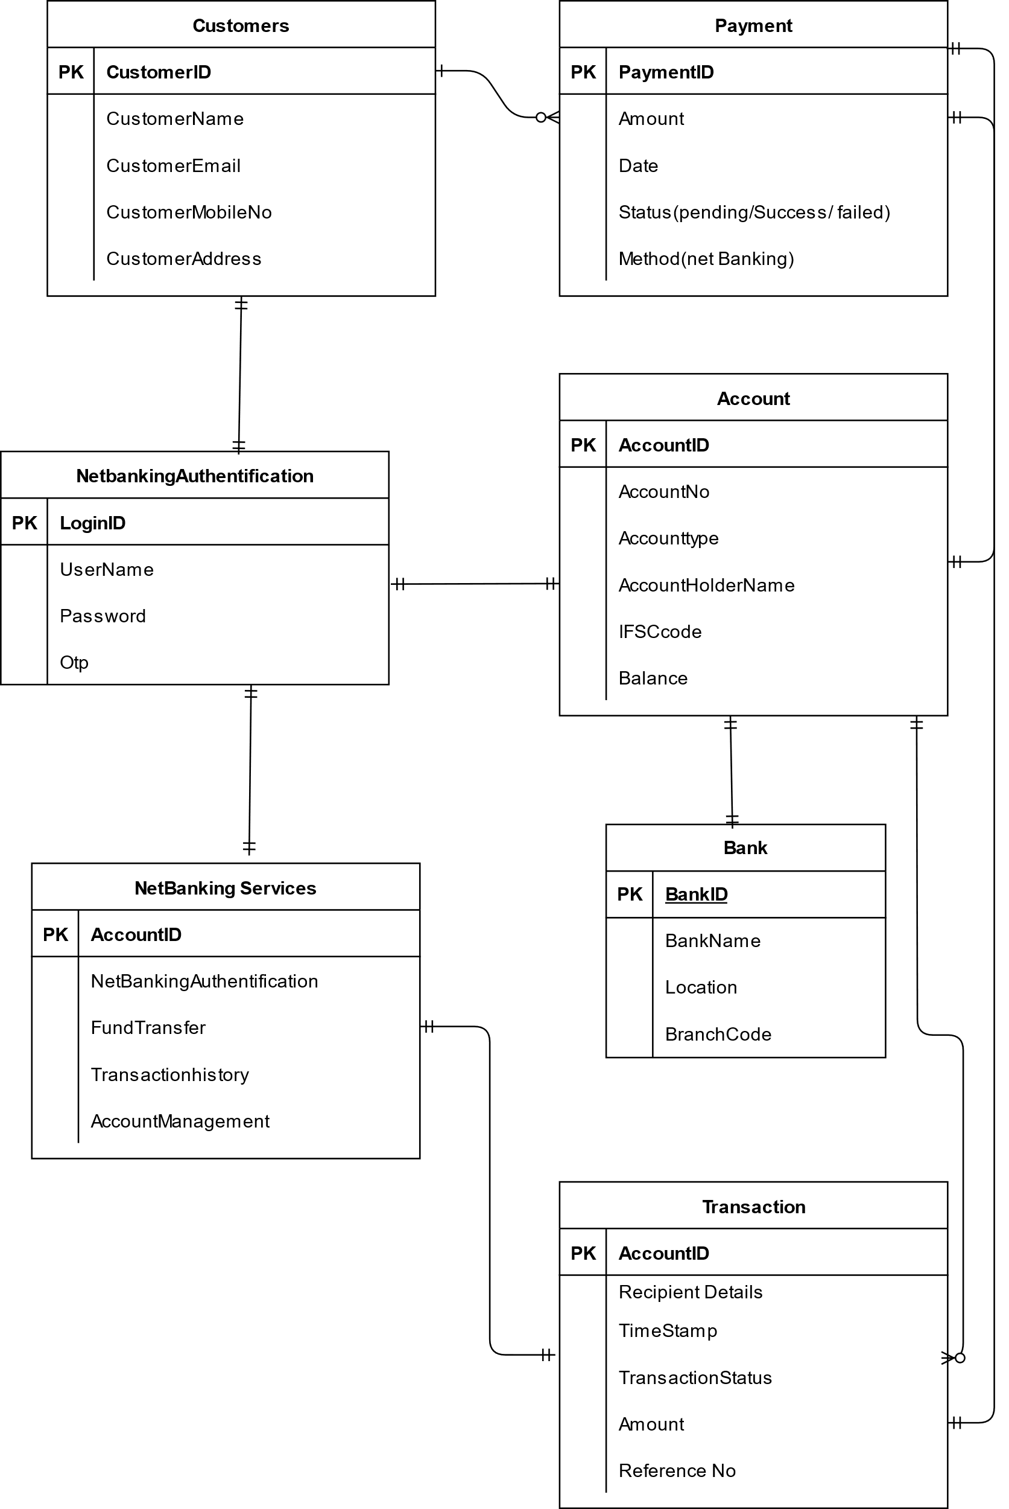
Q5. Draw a sequence diagram for payment done by Customer Net Banking
Answer: A sequence diagram is a type of interaction diagram used in software engineering and systems design to illustrate how process operate with one another and in what order.

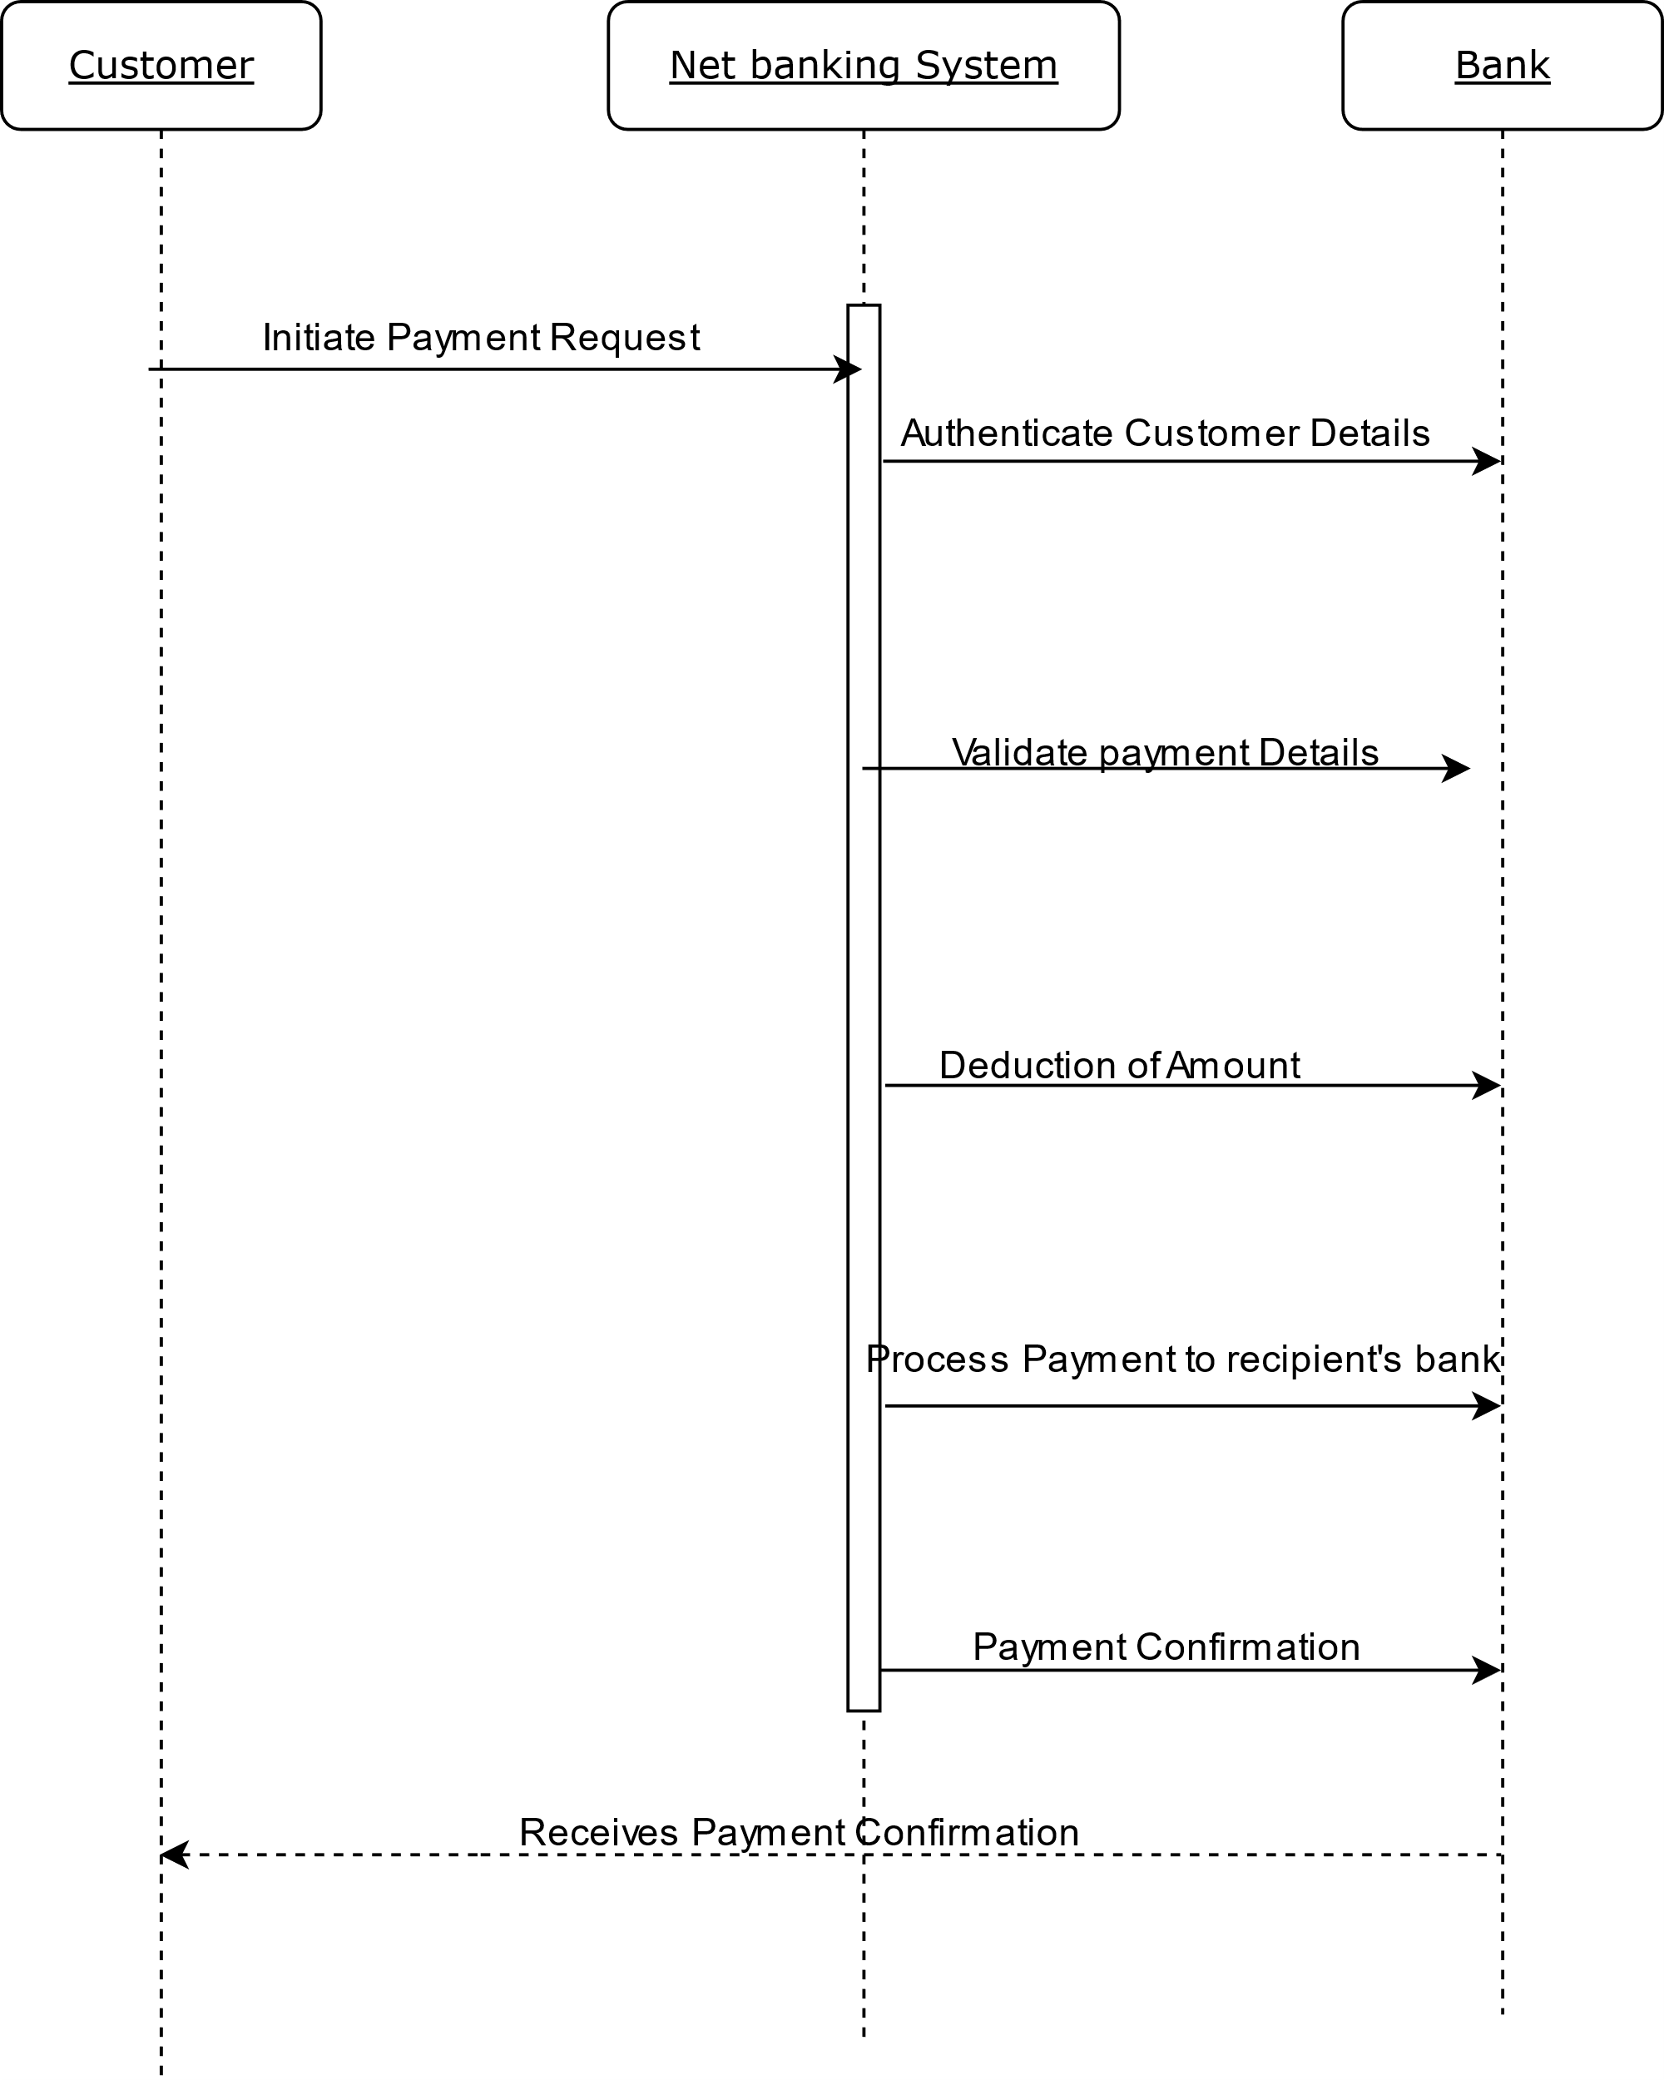

Q6. Explain Conceptual Model for this Case
Answer: A Conceptual Model is a high-level representation of the system’s key concepts (entities), their relationships, and how they support business processes.
It’s a simplified view often used to help people understand communicate or design complex systems.
Key elements of a Conceptual Model:
1) Entities- Customer, Product, Order & Payment
2) Attributes- customerId, name, email, phoneNumber
3) Relationships- Example, a customer place an order
Key Concepts (Entities)
- Customer – The person making the payment.
- Payment – The transaction initiated by the customer.
- NetBanking – The payment method used.
- Bank – The external financial institution that validates and processes the payment.
- Payment Gateway – Middleware that connects our system with the bank.
- Receipt/Confirmation – Acknowledgment returned after successful payment.
Relationships
- A Customer initiates a Payment.
- The Payment is processed via NetBanking.
- The Payment Gateway communicates with the Bank to validate credentials and process funds.
- The Bank confirms the payment status (success/failure).
- A Receipt/Confirmation is generated and shared with the Customer
Conceptual Flow (Business Perspective)
- Customer logs in → selects Net Banking option.
- Customer provides bank details (bank name, user ID, password).
- Payment Gateway securely redirects request to the Bank system.
- Bank validates credentials and processes transaction.
- Bank sends response (success/failure) back to Payment Gateway.
- System updates Payment status and generates Receipt.
- Customer receives confirmation.
Q7: What is MVC architecture? Explain MVC rules to derive classes from use case diagram and guidelines to place classes in 3-tier architecture
Answer: MVC (Model–View–Controller) is a software design pattern used to separate an application into three interconnected components:
Model (M) → Manages data and business logic (entities, rules, persistence).
View (V) → Represents the UI/Boundary layer, how the data is displayed to the user.
Controller (C) → Handles interaction logic; receives user input, processes it, and updates the Model/View accordingly
Key benefits of using MVC are modularity, testability, reusability, scalability, improved collaboration.
MVC Architecture Rule
1) Combination of one Actor and an use case results in one boundary class
2) Combination of two Actor and an use case results in two boundary classes
3) Combination of three Actor and an use case results in three boundary classes and so on..
4) Use case will result in a controller class
5) Each Actor will result in one entity class
Guidelines to place identified MVC Classes in a 3 Tier Architecture
1) Place all Entity Classes in DB layer
2) Place Primary actor associated boundary class in application layer
3) Place Controller Class in Business Logic Layer
4) If Government body influence or Reusability is there with any of remaining Boundary Classes, place them in Business Logic Layer else place them in Application Layer

Q8. Explain BA contributions in project (Waterfall Model – all Stages)
Answer:

Stage | Activities (BA Role) | Artifacts & Resources
Pre Project | Identify business needs, feasibility study, initial problem statement, value proposition | BA-Business Case, Feasibility Report
Planning | Support project manager in defining scope, high-level requirements, and timelines | BA- Project Charter, Scope Document
Project Initiation | Identify stakeholders, define BA approach, prepare communication plan | BA- Stakeholder Register, RACI Matrix
Requirement Gathering | Elicit requirements via interviews, workshops, surveys, Prepare BRD and plan for entire use cases diagrams and sign off on BRD | BA, PM -BRD (Business Requirement Document), Use Case Diagrams
Requirement Analysis | Convert Business Requirements into Functions, Analyze and prioritize requirements, resolve conflicts, create process/data models | Resources- BA, PM, Tech Team- Network, Solution and DB architect. Artifacts- Requirement Traceability Matrix (RTM), FRS, SRS, Process Flows, UML Diagrams
Design | Validate design against requirements, review prototypes, ensure business alignment, requirement walkthrough. Ask for test cases | Resources- BA, PM, Tech Team- Network, Solution and DB architect, GUI Designer. Artifacts- System Design Documents (SDD), Wireframes, UI Mockups, HDD
Development | Clarify requirements to developers, support change requests, ensure business logic fits. BA can ask of Unit test plan, Unit test case , Unit tets results. Test Report and review of test cases with the team | Resources- Programmers, Developers. Artifacts- Requirement Clarification Logs, Updated RTM, LDD/CDD application
Testing | Support QA team, System integration Testing, validate coverage, assist in defect logs. Plan and execute | Resources- Testers. Artifacts- Test Plan, Test Cases, Defect Logs
UAT | Support user acceptance testing, ensure solution meets business needs, collect sign-off | UAT Plan, UAT Scripts, Sign-off Document

Q9. What is conflict management? Explain using Thomas – Kilmann technique
Answer: Conflict Management is the process of handling disputes, disagreements, or differences of opinion between individuals or groups in a constructive way.
- Goal: Reduce negative impact of conflict while finding a solution that is acceptable to all parties.
- Importance: Prevents project delays, improves collaboration, and builds stronger relationships.
Thomas–Kilmann Conflict Management Technique (TKI Model)
The Thomas–Kilmann model is one of the most widely used conflict management frameworks.
It defines 5 conflict-handling styles, based on two dimensions:
- Assertiveness → the extent to which a person tries to satisfy their own concerns.
- Cooperativeness → the extent to which a person tries to satisfy others’ concerns.
Conflict Management 5 Strategies
1. Competing (High Assertiveness, Low Cooperativeness)
- “I win – You lose” approach.
- Person pursues their own concerns at others’ expense.
- Useful when quick, decisive action is needed (e.g., emergencies).
- Risk: Damages relationships.
2. Collaborating (High Assertiveness, High Cooperativeness)
- “Win – Win” approach.
- Both parties work together to find a solution that satisfies everyone.
- Useful for complex problems requiring creative solutions.
- Requires time and trust.
3. Compromising (Moderate Assertiveness, Moderate Cooperativeness)
- “Lose – Lose (to some extent)” approach.
- Each party gives up something to reach a middle ground.
- Useful when there’s time pressure and both sides have equal power.
- Risk: Solution may be suboptimal.
4. Avoiding (Low Assertiveness, Low Cooperativeness)
- “No win – No lose” approach.
- Person withdraws from the conflict, neither pursuing their own nor others’ concerns.
- Useful for cooling-off period or when the issue is trivial.
- Risk: Issue may resurface later.
5. Accommodating (Low Assertiveness, High Cooperativeness)
- “I lose – You win” approach.
- Person neglects own concerns to satisfy others.
- Useful when the relationship is more important than the issue.
- Risk: May lead to resentment if overused.

Q10. List down the reasons for project failure
Answer: Project failures usually happen because of management issues, poor planning, or technical problems. Here’s a list of the common reasons for project failure:
1. Poor Project Planning
- Unclear goals and objectives
- Unrealistic timelines or budgets
- No proper risk management
- Inadequate resource allocation
2. Requirement Issues
- Incomplete or vague requirements
- Frequent scope changes (scope creep)
- Lack of stakeholder involvement in defining requirements
3. Communication Gaps
- Miscommunication between team members and stakeholders
- No proper documentation
- Lack of regular updates or feedback loops
4. Lack of Stakeholder & Management Support
- Minimal involvement from top management
- Stakeholders not providing timely feedback
- Conflicts of interest among stakeholders
5. Team-Related Issues
- Lack of skilled resources
- High staff turnover
- Poor collaboration and teamwork
- No proper training provided
6. Technical Failures
- Wrong choice of technology
- Low-quality design or coding practices
- Inadequate testing → defects in production
- Ignoring integration and security aspects
7. Risk & Change Management Failures
- Ignoring risks until they become problems
- Ineffective handling of changes
- No contingency planning

8. Monitoring & Control Failures
- No clear KPIs or success metrics
- Poor tracking of progress (time, cost, quality)
- Lack of corrective actions when project goes off-track
9. External Factors
- Regulatory changes
- Market shifts or competition
- Vendor or supplier failures
Projects usually fail due to unclear requirements, weak planning, lack of communication, poor resource/skill management, technical flaws, and lack of stakeholder support.
Q11. List the Challenges faced in projects for BA
Answer:
Challenges Faced by Business Analysts in Projects
1. Requirement-Related Challenges
- Gathering unclear, incomplete, or conflicting requirements
- Managing frequent scope changes (scope creep)
- Difficulty in getting stakeholders to prioritize requirements
- Bridging the gap between business needs and technical team understanding
2. Stakeholder Challenges
- Unavailability or lack of engagement from key stakeholders
- Conflicting interests among stakeholders
- Difficulty in managing expectations
- Handling difficult stakeholders who resist change
3. Communication Challenges
- Miscommunication between business & technical teams
- Working with cross-cultural or geographically distributed teams
- Lack of proper documentation or standardized templates
- Over-reliance on assumptions rather than confirmation
- Conducting Meetings among teams working at different time zones.
4. Technical Challenges
- Limited domain knowledge in new/complex industries
- Understanding legacy systems or outdated technologies
- Ensuring requirements consider integration, security, and compliance
- Difficulty in translating business language into technical specifications
5. Change Management Challenges
- Resistance to process or system changes from end users
- Difficulty in training and preparing users for new systems
- Balancing innovation vs. practicality in solutions
6. People Management
- Coordinating with different people and different teams
7. Maintaining project Health
- Ensure overall project health is in good shape and delivered as per the time- lines without any issues
A BA faces challenges mainly in requirements gathering, stakeholder management, communication gaps, project constraints, technical limitations, and managing organizational change
Q12. Write about Document Naming Standards
Answer: A document numbering standards is a systematic approach to assigning unique identifiers to various documents created and used throughout the development process.
Objectives of Document Naming Standards
- Consistency – All documents follow the same naming pattern.
- Traceability – Easy to track versions, owners, and purposes.
- Clarity – Provides clear understanding of the document content without opening it.
- Avoid Duplication – Prevents multiple documents with similar but unclear names.
- Collaboration – Helps team members quickly locate and share files.
Example- Suppose we have a project with ID “AGRI105”, and we are working with a BRD.
Project ID: AGRI105
Document Type: BRD
Version: 1.0
Date- 21-08-2025
The document identifier could be : AGRI105-BRD-1.0-2025-08-21
The format can be vary from company to company as per their standards.

Q13. What are the Do’s and Don’ts of a Business analyst
Answer:
Sr. No | Do's | Don’t's
1 | Consult an SME for clarifications in requirements | Nevar say no to the client
2 | Go to the client with a plain mind with no assumptions. Listen carefully and completely until the client is done, and then you can ask queries. | There is no word as "By Default".
3 | try to extract maximum leads to the solution from the client himself | Never imagine anything in terms of GUI
4 | Concentrate on the important requirements | Don’t interrupt the client when he is giving you the problem
5 | Question the existence of existence and question everything | never try to give solutions to the client straight away with your previous experience and assumptions/

Q14. Write the difference between packages and sub-systems
Answer:
Packages | Sub- systems
Packages are collection of components which are not reusable in nature | Sub- systems are collection of components which are reusable in nature
Application development companies work on packages | Product Development companies work on Sub systems
Q15. What is camel-casing and explain where it will be used
Answer: Camel-casing is a naming convention in which multiple words are written together without spaces, and each word after the first one starts with a capital letter
Example:
- customerName
- paymentGatewayController
- validateUserInput
It looks like the humps of a camel, hence the name.
Uses: It is mainly used for naming variables, functions, identifiers and classes.
Q16. Illustrate Development server and what are the accesses does business analyst has?
Answer: A Development Server is the environment where developers build, integrate, and test the application before moving it to production environments.
It is mainly used for:
- Writing & compiling code.
- Unit testing.
- Integrating modules.
- Debugging issues.
- Preparing code for QA/testing teams.
BA Access in Development Server
A Business Analyst usually has limited or read-only access in the Development environment, because the BA’s role is not to code, but to analyze, validate, and support testing.
Read-only Access to Application
- To check screen layouts, navigation flows, and features being developed.
- To validate if requirements are implemented correctly.

Q17. What is Data Mapping
Answer: Data Mapping is the process of connecting data from one source to another. It like creating a guide or map that shows how data in one place corresponds to data in another place.
This is especially important when you are moving data between different systems or databases to ensure that the data stays consistent and accurate
Data mapping is important to
- Ensures data integrity during migration.
- Helps in system integration projects
- Reduces errors, mismatches, and duplication
Q 18. What is API. Explain how you would use API integration in the case of your application Date format is dd-mm-yyyy and it is accepting some data from Other Application from US whose Date Format is mm-dd-yyyy.
Answer: API (Application Programming Interface) is a set of rules and tools that allows one software application to communicate with another.
It defines the methods and data formats that applications can use to request and exchange information.
Example:
-A Payment Gateway API allows your app to connect with banks or wallets.
- A Weather API provides weather data to your mobile app.
API Integration in Our Application
Suppose our application is a Payment Management System. It needs to accept some data (like customer info, payment date, transaction details) from another External US-based Application via an API.
Problem:
- Our System Date Format = dd-mm-yyyy
- External US Application Date Format = mm-dd-yyyy
- If data is not handled properly → errors, mismatches in reports, wrong transactions.
As a BA, you would:
- Specify in the Interface Requirement Document (IRD):
-Which fields carry date values
-Expected format (dd-mm-yyyy)
-Transformation rules (mm-dd-yyyy → dd-mm-yyyy)
- Update Data Mapping Document (DMD):
-Show field mapping between US app & our app
- Work with Developers:
- Ensure transformation logic is coded in middleware or API handler
- Test with QA team:
-Verify date conversion works correctly in test cases

