**Q1: Business Process Model (5 Marks)**

**Goal:** Create an online agriculture store for farmers to easily procure seeds, fertilizers, and pesticides.  
**Inputs:**

* Requirements from stakeholders (e.g., Mr. Henry, manufacturers, and farmers).
* Feedback on AS-IS processes.
* Technical resources like hardware and software tools.

**Resources:**

* APT IT SOLUTIONS team (BA, Developers, Testers, Network Admin, etc.).
* Budget of INR 2 Crores.
* Timeframe of 18 months.

**Outputs:**

* Fully functional web/mobile application.
* Improved accessibility for farmers to buy agricultural products.

**Activities:**

1. Requirement gathering and stakeholder meetings.
2. Analysis and design of the application.
3. Development, testing, and deployment.
4. Support and maintenance post-launch.

**Value to End Customer:**

* Time and cost savings for farmers in remote areas.
* Direct communication with manufacturers.
* Enhanced agricultural productivity.

**Q2: SWOT Analysis (5 Marks)**

**Strengths:**

* Backing of experienced team and resources.
* CSR initiative with a high budget allocation.
* Direct impact on improving farmers' livelihoods.

**Weaknesses:**

* Lack of technical familiarity among rural users.
* Potential infrastructure challenges in remote areas.

**Opportunities:**

* Expansion to other agricultural regions.
* Integration of advanced features like AI-based crop suggestions.

**Threats:**

* Competition from similar platforms.
* Risk of cyber-security breaches.

**Q3: Feasibility Study (5 Marks)**

**Technological Feasibility:**

* Use of Java, a robust technology for scalable web and mobile applications.
* Availability of skilled Java developers in-house.

**Operational Feasibility:**

* Strong stakeholder involvement (farmers, manufacturers).
* Positive social impact aligns with CSR goals.

**Economic Feasibility:**

* Budget of 2 Crores INR is sufficient for the outlined tasks.

**Schedule Feasibility:**

* 18-month timeline aligns with project scope and resource availability.

**Q4: Gap Analysis (5 Marks)**

**AS-IS Process:**

* Farmers rely on intermediaries or local suppliers with limited inventory.
* Time-consuming and costly procurement process.

**TO-BE Process:**

* Farmers browse a digital platform to select and purchase products directly from manufacturers.
* Cost-effective and time-efficient delivery model.

**Gap:**

* Lack of technical infrastructure addressed by the proposed app.

**Q5: Risk Analysis (10 Marks)**

**BA Risks:**

* Miscommunication with stakeholders.
* Incomplete or unclear requirements.

**Project Risks:**

* Budget overruns.
* Delays due to resource unavailability.

**Mitigation Strategies:**

* Regular requirement validation sessions.
* Clear documentation and stakeholder sign-off.
* Effective time management through tools like Gantt charts.

**Q6: Stakeholder Analysis (RACI Matrix) (8 Marks)**

| **Role** | **Responsible (R)** | **Accountable (A)** | **Consulted (C)** | **Informed (I)** |
| --- | --- | --- | --- | --- |
| Mr. Henry |  | A | C | I |
| Mr. Pandu |  |  | C | I |
| Mr. Dooku |  |  | C | I |
| Mr. Karthik | R | A |  |  |
| Development Team | R |  |  | I |

**Q7: Business Case Document (8 Marks)**

**Executive Summary:**  
The project aims to create an online store for farmers to procure agricultural products conveniently, improving productivity and reducing costs.

**Problem Statement:**  
Farmers in remote areas struggle with accessibility to seeds, fertilizers, and pesticides.

**Proposed Solution:**  
A web/mobile application connecting manufacturers directly with farmers.

**Benefits:**

* Easy accessibility.
* Reduced dependency on intermediaries.

**Financial Overview:**  
Budget of INR 2 Crores with a development timeline of 18 months.

**Q8: Four SDLC Methodologies (8 Marks)**

1. **Waterfall Model:** Sequential stages, clear milestones.
2. **V-Model:** Verification and validation at every stage.
3. **Spiral Model:** Risk-focused iterative approach.
4. **Scrum Model:** Agile framework emphasizing flexibility.

**Q9: Waterfall vs. V-Model (5 Marks)**

**Differences:**

1. **Waterfall:** Linear, each phase depends on the previous phase.
2. **V-Model:** Validation occurs parallel to development stages.

**Recommendation:**  
V-Model suits this project due to its validation steps at every stage, reducing errors.

**Question 10: Waterfall Vs. V-Model**

**Differences Between Waterfall and V-Model**

| **Aspect** | **Waterfall Model** | **V-Model** |
| --- | --- | --- |
| **Definition** | A linear sequential model where each phase must be completed before moving to the next. | An extension of the Waterfall model where each development phase is linked to a corresponding testing phase. |
| **Process Flow** | Sequential and linear. | Sequential but with parallel validation for every development phase. |
| **Testing Phase** | Testing is performed only after development is complete. | Testing begins simultaneously with the corresponding development phase. |
| **Flexibility** | Rigid and inflexible to changes during later stages. | Rigid but allows early defect detection through parallel testing. |
| **Error Detection** | Errors are identified late in the process, increasing costs and rework. | Errors are detected early due to continuous validation. |
| **Project Suitability** | Suitable for projects with well-defined requirements that are unlikely to change. | Suitable for projects where quality assurance is critical and defects need to be minimized early. |

**Question 11: Model Choice for the Project: V-Model**

**Reasons for Choosing V-Model:**

1. **Early Detection of Errors:**
   * This project involves diverse stakeholders and complex requirements, making early defect detection essential to reduce rework costs and delays.
2. **Alignment with Project Needs:**
   * Parallel validation ensures that the requirements are correctly implemented, which is critical for an application catering to farmers unfamiliar with technology.
3. **Quality Assurance:**
   * The application’s usability, reliability, and accuracy are paramount since it directly impacts farmers’ livelihoods.
4. **Clear Traceability:**
   * The V-Model's emphasis on traceability between requirements, development, and testing phases ensures alignment with stakeholders' expectations.
5. **Risk Minimization:**
   * By validating every phase, the model minimizes risks associated with unclear requirements or development errors.

**Conclusion:**

**The V-Model is more suitable for this project than the Waterfall model because of its focus on quality and its ability to catch issues early in the process. This ensures a smoother development lifecycle and a reliable final product.**

**Q12: Gantt Chart (5 Marks)**

Develop a Gantt chart with the following phases:

1. **RG (Requirement Gathering).**
2. **RA (Requirement Analysis).**
3. **Design.**
4. **Development (D1, D2, D3, D4).**
5. **Testing (T1, T2, T3, T4).**
6. **UAT and Deployment.**

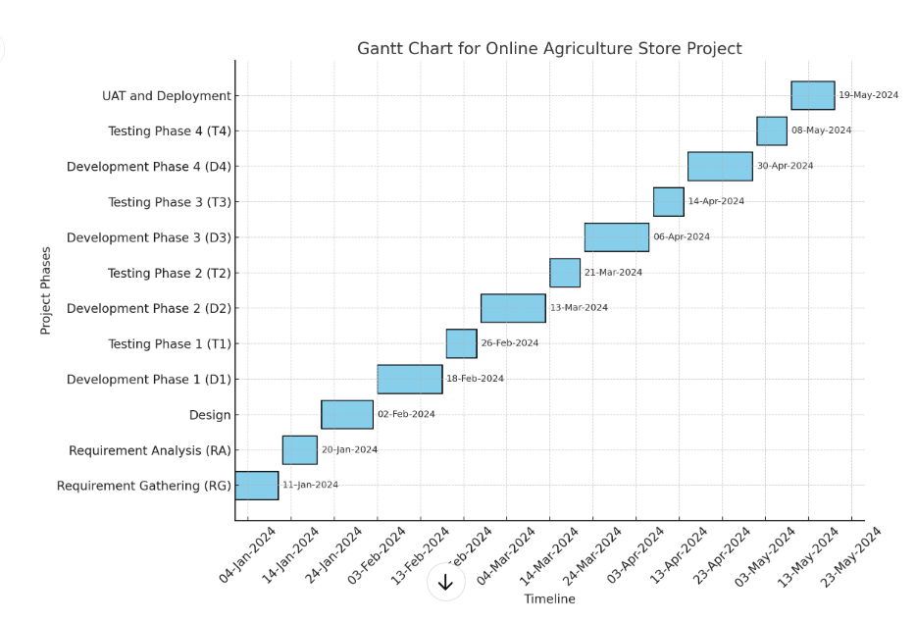

It reflects the timeline for all phases, starting from Requirement Gathering (RG) to UAT and Deployment, with durations and sequential dependencies

**Question 13: Fixed Bid Vs Billing Projects:**

**Definition of Each Type**

1. **Fixed Bid Project:**
   * The client and vendor agree on a fixed price for the entire project, irrespective of the actual effort or time spent.
   * Suitable for well-defined projects with clear scope and requirements.
2. **Billing Project (Time & Material):**
   * The client is billed based on the actual hours worked by the team and the materials used.
   * Ideal for projects with evolving requirements or unclear scope.

**Key Differences:**

| **Aspect** | **Fixed Bid** | **Billing (Time & Material)** |
| --- | --- | --- |
| Cost Structure | Fixed price agreed upfront. | Costs vary based on actual time and resources utilized. |
| Scope Flexibility | Limited; scope changes may require contract renegotiation. | High; allows flexibility to adapt to changing requirements. |
| Risk | Risk is higher for the vendor as they must bear any unforeseen costs. | Risk is shared; client bears additional costs for scope changes. |
| Project Type | Suitable for short-term, well-defined projects. | Suitable for long-term or dynamic projects. |
| Client Control | Limited; the vendor manages the project to meet deliverables. | High; the client is more involved in daily operations. |
| Timeline | Strictly defined and agreed upon initially. | Can evolve; timelines are adjusted as per changing needs. |

**Q14: Timesheets of a BA (20 Marks)**

1. **Design Stage:** Requirement documentation, wireframes, use-case creation.

|  |  |  |  |
| --- | --- | --- | --- |
| Date | Activity | Hours Spent | Description |
| Day 1 | Requirement elicitation | 4 | Conducted interviews with stakeholders to gather requirements. |
| Day 2 | Functional requirement documentation | 6 | Created detailed Functional Requirement Specification (FRS). |
| Day 3 | Use-case creation | 5 | Defined use cases for core functionalities. |
| Day 4 | Wireframe design | 5 | Designed wireframes for the application interface. |
| Total |  | 20 |  |

1. **Development Stage:** Continuous requirement clarification.

|  |  |  |  |
| --- | --- | --- | --- |
| Date | Activity | Hours Spent | Description |
| Day 1 | Requirement clarification meetings | 4 | Addressed developer queries and clarified requirements. |
| Day 2 | Requirement changes documentation | 6 | Updated requirement documents based on stakeholder feedback. |
| Day 3 | Support development team | 5 | Provided real-time support for requirement alignment. |
| Total |  | 15 |  |

1. **Testing Stage:** Test case validation, defect triaging.

|  |  |  |  |
| --- | --- | --- | --- |
| Date | Activity | Hours Spent | Description |
| Day 1 | Test case review | 3 | Reviewed test cases prepared by QA team. |
| Day 2 | Test execution support | 4 | Supported testers during test case execution. |
| Day 3 | Defect triaging | 5 | Helped prioritize and assign defects. |
| Total |  | 12 |  |

**UAT:** End-user feedback sessions.

|  |  |  |  |
| --- | --- | --- | --- |
| Date | Activity | Hours Spent | Description |
| Day 1 | User training preparation | 5 | Prepared training materials for farmers and manufacturers. |
| Day 2 | UAT session | 6 | Conducted UAT session with end users and documented feedback. |
| Day 3 | Feedback analysis | 5 | Analysed feedback and proposed system updates. |
| Total |  | 16 |  |

1. **Deployment:** Documentation handover, training sessions.

|  |  |  |  |
| --- | --- | --- | --- |
| Date | Activity | Hours Spent | Description |
| Day 1 | Training session | 6 | Conducted training sessions for farmers on app usage. |
| Day 2 | Final documentation handover | 4 | Handover of user manuals, training materials. |
| Day 3 | Post-deployment support | 5 | Supported stakeholders with initial queries. |
| Total |  | 15 |  |

**Consolidated Hours Per Stage:**

|  |  |
| --- | --- |
| **Stage** | **Hours** |
| Design | 20 |
| Development | 15 |
| Testing | 12 |
| UAT | 16 |
| Deployment & Implementation | 15 |
| **Total Hours** | **78** |